**Lab 01: 8051 Assembly Language Programming using MOV and ADD Instructions**

**Last, First Name: Khan, Umar , Last 4 Student ID:7331.**

**Purpose:**

The purpose of this lab is to continue to help students know the software development tool Keil uVision, learn how to use Keil to edit, compile, simulate an Assembly program starting to use two simple arithmetic instructions MOV and ADD. This project also aims to understand the usage of registers, PC, machine code, and ROM address

**Tasks:**

1. Follow the tutorial, Keil tutorial.pdf posted on Beachboard Labs folder; finish all the steps up to simulation. When you create your source file, use “lab01” shown below. Run the program on the simulation and demonstrate it to the instructor.

==========================================================

; This program is called "lab01".

; 1. Type in the program, compile and simulate it.

==========================================================

ORG 0H ;START AT LOCATION 0

MOV R5, #25H ;LOAD 25H INTO REGISTER R5

MOV R7, #34H ;LOAD 34H INTO REGISTER R7

MOV A, #0 ;CLEAR ACCUMULATOR REGISTER A TO BE 0

ADD A, R5 ;ADD CONTENTS OF R5 TO A, NOW A = 25H

ADD A, R7 ;ADD CONTENTS OF R7 TO A, NOW A = 25H+34H=59H

ADD A, #12H ;ADD 12H TO A, NOW A = 59H+12H = 6BH

HERE: SJMP HERE ;STAY IN THIS LOOP

END ;END OF THE PROGRAM

1. Verify the execution of the program
2. Upload your report into the dropbox in beachboard with the following items
   1. Source code

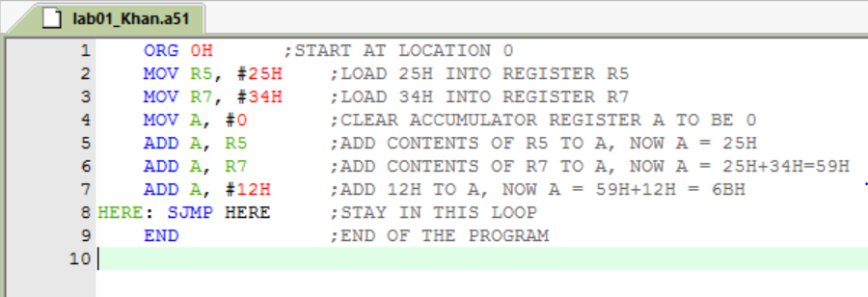

* 1. Build output after the Translate

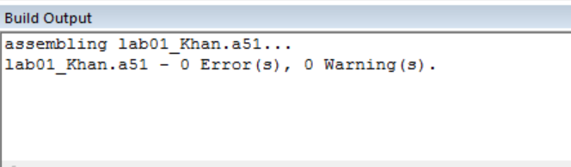

* 1. Build output after the Build

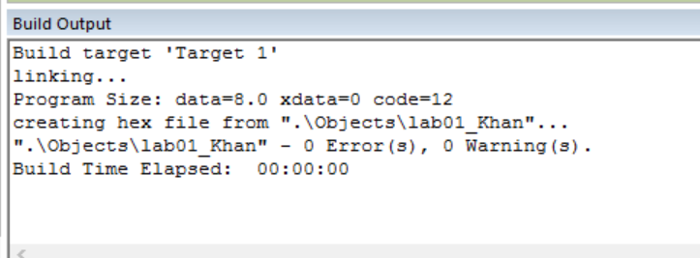

* 1. Register Window and Disassembly Window after the Debug

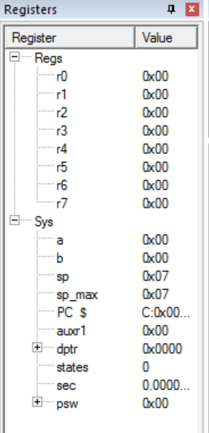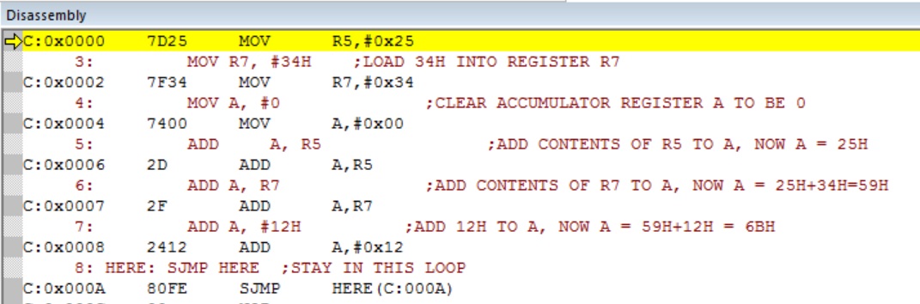

* 1. Address 0003 contains which opcode or which operand?

The MOV operand

* 1. What is the values of registers R5, R7, and A when PC is pointed to address 0004? Attach corresponding screenshots here.

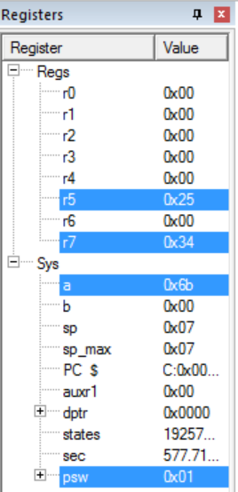

* 1. Memory window

