It's not just any certification.

It's the one that can get you ahead

In a world where enterprise success is increasingly dependent on information systems and information technology, the trust customers, clients, employees and other stakeholders have for an enterprise can quickly dissipate in the face of a data security breach. As the growing number of high-profile breaches demonstrates, information security failures can result in significant damage to an enterprise’s bottom line as well as its reputation. To ensure greater alignment between organizations’ information security programs and their broader goals and objectives, more and more enterprises and government agencies expect, and even require, their information security professionals to hold the Certified Information Security Manager® (CISM®) certification.

CISM Training and Certification course
36 hours of instructor-led training
CISA Online test engine
Blended learning delivery model
97% passing rate
CISM Certified Trainers
Get certified at an affordable price

CISA

The uniquely management-focused CISM certification promotes international security practices and recognizes the individual who manages, designs, and oversees and assesses an enterprise’s information security. CISM means higher earning potential and career advancement. Recent independent studies consistently rank CISM as one of the highest paying and sought after IT certifications.

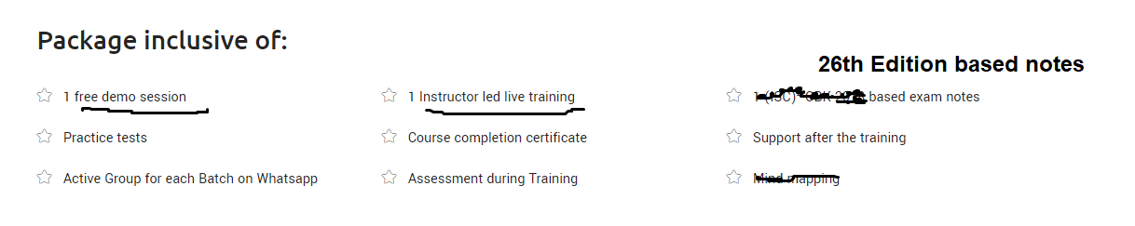

CISM Certification Job Practice Areas by Domain

The job practice domains and task and knowledge statements are as follows:
Domain 1—Information Security Governance (24%)
Domain 2—Information Risk Management (30%)
Domain 3—Information Security Program Development and Management (27%)
Domain 4—Information Security Incident Management (19%)

Why Employers Hire CISMs?
Enterprises and government agencies increasingly recognize, require and expect their IS and IT professionals to hold CISM certification. .
CISM employees:
- Identify critical issues and customize company-specific practices to support the governance of information and related technologies
- Bring credibility to the enterprise for which they are employed
- Take a comprehensive view of information systems security management and their relationship to organizational success
- Demonstrate to enterprise customers their commitment to compliance, security and integrity; ultimately contributing to the attraction and retention of customers
- Ensure that there is improved alignment between the organization's information security program and its broader goals and objectives
- Provide the enterprise with a certification for Information security management that is recognized by multinational clients and enterprises, lending credibility to the enterprise

CISM Exam Details

Exam Information
- Duration : 4 Hours
- Number of questions: 150
- Question format: Multiple Choice
- Passing marks: 450 out of 800
- Exam language: English, French, German, Brazilian, Portuguese, Spanish, Japanese, Simplified Chinese, Korean, Visually Impaired
- Delivery Method: CBT

Reference can be used for landing page design
https://www.isaca.org/info/certificationlanding/cisa/cisa.html?cid=SEM_1226600&appeal=sem&gclid=Cj0KCQjwnZXbBRC8ARIsABEYg6DBFduJ0l3THoHkjqX_LglCpHvpmGpm1ILw3sD0Gl6Qe_uPxupZmRAaAv9dEALw_wcB&gclsrc=aw.ds

