UKMARS GEMINI Build Guide

Introduction
GEMINI
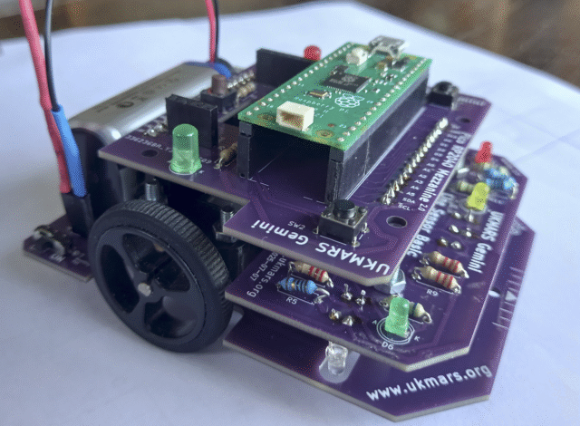
GEMINI is a new robot based around the proven design principles of UKMARSBOT while adding the power of the Raspberry Pi Pico or Pi Pico W processor to allow programming in MicroPython.
Like the basic UKMARSBOT robot, this design is equally at home in the maze or on a line following track.
The 3-level design means that if you want to use an alternative MCU processor this can be done by just amending the top PCB for the new processor and fitting it to the remaining PCBs.
The design is completely Open Source and is fully described in these pages and the links within them. The design has been produced with KiCAD a free CAD CAM program. The best way to access reference material including this guide is to visit https://github.com/ukmars/gemini/

Where to get your Printed Circuit Boards (PCBs)
Gemini comprises 4 printed circuit boards (PCBs).
- a main chassis board hosting motors, battery and power
- a mezzanine board for the MCU processor and expansion slots
- a line sensor board for line following and drag racing
- a wall sensor board for wall following and maze solving
The main chassis board and the 2 sensor boards are common to all the different processors, but the mezzanine board is tailored to a specific processor module. The version described in this build guide has the mezzanine board designed for use with the Raspberry Pi Pico or Pico W processor board.
Members of UKMARS can obtain a copy of the 4 boards for free from the UKMARS Chairman. If you need more PCBs, or prefer to order your own boards, you can send a zipped copy of the Gerber files which can be downloaded from GitHub to your preferred PCB supplier (e.g. https://jlcpcb.com/ or www.pcbway.com) and they will ship the PCBs directly to you.

What’s in this Build Guide
This guide goes through the build process step by step:
Section 2 Tools and Components A list of the tools you will need together with where to find the parts needed to build a Gemini Robot
Section 3 Main Chassis – Buggy How to populate the main chassis PCB with the electronic components and connectors
Section 4 Fitting Encoders and Mounting Motors How to attach encoders to the motors, mount the motors and connecting them up
Section 5 Line Sensor Board How to populate the line sensor PCB with its electronic components,
Section 6 Wall Sensor Board How to populate the wall sensor PCB used for wall following and maze solving with its electronic components,
Section 7 Mezzanine Processor Board How to populate the mezzanine PCB with its processor and other electronic components
Section 8 Putting it all together How to connect the PCBs and mechanical parts together to make the complete system
Section 9 Testing, Coding and Further Reading How to test your robot and links to the design documents including: the main circuit diagrams and sample code.
Appendix A – Example Bill Of Materials (BOM) A sample list of all the components needed to build a Gemini robot
Appendix B – Resistor Colour Code Chart How to identify the value of a resistor from the colour bands on the body of the resistor

How to access reference and support documents
The easiest way to access all the designs, support documents and code examples is to visit out GitHub repo at https://github.com/ukmars/gemini/
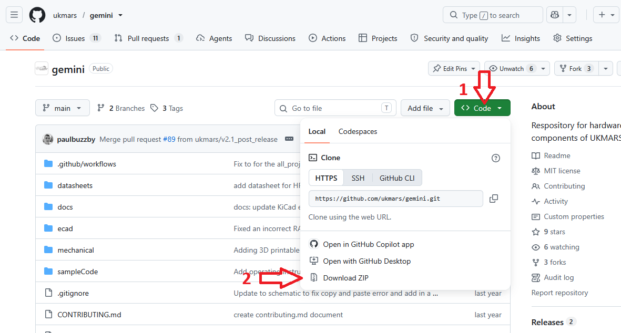
First click on the green button labelled “Code” then select “Download ZIP” from the drop down. A ZIP folder containing all the materials will be downloaded to your device and you can browse through the downloaded folders and files to find what you need. This build guide can be found in the “docs” folder of our repository.
If you are familiar with GitHub you can clone the repository to your device and ensure that you are kept up to date when items change.

Getting Started
Before you start building the GEMINI robot you will need to get yourself organised!
- read through this build guide and get familiar with the contents
- Have a look at the Tools and Components page and make a list of the tools and parts that you need to get.
- Where you have options, such as for motors, encoders and batteries, read the Choosing Motors, Choosing Batteries and Fitting Encoders pages to help you decide what specific items you want
- Identify suppliers and part numbers for the parts that you will order. Group them by supplier and get as many as you can from a few suppliers as this will reduce your postage costs. Don’t forget that you will only be able to get the main PCB and sensor PCBs from UKMARS unless you want to get these PCBs produced yourself. Remember that parts bought on EBay that are coming from abroad may take some weeks or longer to be delivered.
- Follow through this guide step by step to build your GEMINI robot
Throughout this guide if there is an optional alternative method or component the alternative is shown in italics. The intended design is always shown in normal text and the alternatives in italics should only be used where you are sure that they meet your needs.

Tools and Components

Tools
The robot is designed to be built with a limited set of tools.
You will need the following:
- A soldering iron with a small bit, plus solder
- A small pair of side cutters for clipping component leads and wires to length
- A small pair of pliers for holding parts and nuts while being tightened and optionally a long-nosed pair.
- Flat and cross head screwdrivers for tightening nuts and bolts
- A digital multi meter to measure voltages and resistance values. Typically, under £10 on ebay

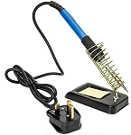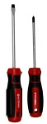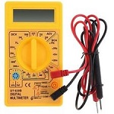

Components
A list of all the components you will need is included in the Bill Of Materials(BOM) list that you will find in the “docs” folder in the repository. If you have downloaded the zip folder as described in section 1.3 How to access reference and support documents you will find the file “all_projects_bom.csv” in the “docs” folder or you can view it here https://github.com/ukmars/gemini/blob/main/docs/all_projects_bom.csv
The BOM includes item references for two major suppliers: Rapid Electronics https://www.rapidonline.com/ and RS Online https://uk.rs-online.com/web/. One of the design goals of GEMINI is to use widely available components. Components can be purchased from other suppliers as long as they meet the specifications in the design documents. The item references are included to help to identify which components need to be purchased. UKMARS does not endorse any specific supplier other suppliers such as https://uk.farnell.com/ are available.
An example of the BOM is included at Appendix A – Example Bill Of Materials (BOM) to this document and can be used for information. The latest definitive BOM is published here https://github.com/ukmars/gemini/blob/main/docs/all_projects_bom.csv

Choosing Motors
One of the key decisions that needs to be made is which motors to use. The robot is designed to use two N20 12mm micro gearmotors. These are widely available on Ebay and electronics and hobby robotics sites from £5 to £20 each.

The Best Choice for New Constructors
This section describes the choices that need to be made to select the best motor for your robot. If you are new to building robots and find all the choices a bit daunting it is recommended that you use a Pololu or Pimoroni 6-volt N20 gearmotor with extended back shaft and a gear ratio of either 20:1 or 30:1. If you can get a high-power version then that will be an advantage.

Encoders
Basic line following, wall following and drag racing can be achieved without encoders but if you want your robot to perform at the best level achievable or you aspire to maze solving, they will be needed. It is much better to fit the relatively cheap encoders in the initial build so that you can accurately measure speed and distance covered.
To fit encoders directly to the motors you need to buy the motors that have an extended back shaft out of the opposite side of the motor to the gearbox. This will reduce your range of available motors but if you search on the internet for “micro metal gearmotor extended back shaft” you should find suitable ones either on EBay or from suppliers such as Pimoroni or Pololu.
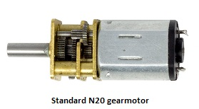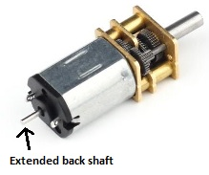

Gear Ratio
These N20 motors come in a very wide range of available gear ratios, from typically 5:1 to over 1000:1. A low gear ratio such as 10:1 will allow your robot to go faster, but it will be more difficult to control as you will have less torque available. The suggested gear ratio is 20:1 but anything between 10:1 and 60:1 is likely to be OK depending on the wheel size used. If you want to use encoders then Pimoroni have extended back shaft 6-volt ones at 11:1, 20:1 and 50:1 gear ratios, all of which would work well. Pololu have similar extended back shaft motors with gear ratios of 5:1, 10:1, 30:1 and 50:1.

Motor Voltage
The robot is designed for use with motors rated at 6 volts. Using a battery that delivers between 7.5 and 9 volts means that there is plenty of voltage available for 6-volt motors, with a bit spare to allow for some occasional over voltage power being applied to the motors. Make sure that the motors you use are rated at 6 volts and not 12 volts as some will be.

Power Rating
Some vendors offer gearmotors come in different power ratings: Low, Medium, High and High with carbon brushes. The power rating will affect the top speed of the motor (the speed of the robot) and the torque (how fast it can accelerate or control the speed). If you choose a motor that has no stated power rating it will probably be low or medium and will work just fine.
For comparison, a 10:1 6 volt gearmotor from Pololu with no load on it will have the following characteristics:
High Power——————— 3000 RPM 3.0 oz/in torque
High power (carbon brush) – 3000 RPM 2.4 oz/in torque
Medium Power —————– 2200 RPM 1.5 oz/in torque
Low Power ———————- 1300 RPM 1.4 oz/in torque
The High Power motor will require higher current and consume more battery power but is worth using if you want to get maximum performance.

Mechanical parts not in the BOM

Item | Description | Part numbers and supplier options
Wheels and Tyres | Pololu Wheel 32×7mm Pair available in black or white. Alternatively, you can 3D print some 32mm diameter wheels for a 3mm D shaft and use O rings for tyres. | Pi Hut SKU: POL-1087 or SKU: POL-1088<br><br>https://thepihut.com/products/pololu-wheel-32x7mm-pair-black
Motor Mounts | You need 2 motor mounts. They can be 3D printed if you have the capability or you can buy the Pololu motor mounts. 3D print models can be found in the \mechanical folder. GeminiN20MotorMount.STL | Pi Hut code SKU: POL-989 https://thepihut.com/products/pololu-micro-metal-gearmotor-bracket-pair-black
Encoders and encoder cables | Pimoroni JST connected encoders in sideways orientation. These encoders come in 2 orientations and the correct version is included int the link in the next column.  You will also need two 6 pin 1mm pitch JST-SH cables to connect the motor encoder to the main board. An adaptor is used to convert the JST-SH cable to 2.54 pitch to connect it to J1 and J2. | https://thepihut.com/products/micro-metal-motor-encoder-mmme-pack-of-2?  https://thepihut.com/products/jst-gh-1-25mm-pitch-6-pin-cable-100mm-long  https://amzn.eu/d/hsau12j
Encoder adapter board | This board converts JST-SH to 2.54 pins. This does make soldering of the robot easier. You can omit this part if you are comfortable soldering wires from a JST-SH cable direct to the chassis board. Soldering directly to the chassis board is for experienced builders only as it increases the risk of problems connecting the motors and encoders. | https://thepihut.com/products/breakout-for-6-pin-jst-sh-style-connector-side-entry
Battery and connector | The battery should be a PP3 9Volt block. Lithium Ion rechargeables with micro-USB charging socket are ideal. Prefer 1200mAH capacity or greater | https://amzn.eu/d/i8hoP5S  https://amzn.eu/d/cmckSHt  Rapid Online Order Code: 18-0092

Nuts and bolts | If you are using the Pololu motor mounts you will need 2 M2 x 30mm bolts and nuts for the rear support of the mezzanine board. If you are using 3D printed mounts with 3mm holes, you need 2 M3 30mm bolts, 2 M3 20mm bolts and 4 M3 nuts. Ebay is a good place to order small quantities of M2 and M3 hardware | Rapid Online Order Code: 51-3852  Rapid-Online Order Code: 51-3437  https://www.ebay.co.uk/str/kaysfasteners
Stackable Headers | Used to make the connections between the chassis board and the mezzanine board, 2 connectors 1x6 at 2.54” pitch are required. Stackable headers for many devices are available and can be cut down to provide the 2 connectors required. | https://thepihut.com/products/stacking-header-set-for-raspberry-pi-pico
Stand Offs | Used for mounting the sensor and mezzanine boards. Lots of ways to do this but a pack of standoff's makes this simple. A nylon screw and nut can be used as a skid. | https://amzn.eu/d/eMlVNY3
Screen | Not part of the core build and not essential, but adding a small 1” OLED screen to your robot can be helpful. Choosing the right component the screen can be plugged directly into J5 of the mezzanine board.  The important thing with a screen is the pin order which needs to be Gnd, Vcc, SCL, SDA left to right as seen from the top. Other screens can be used but will require custom connectors. *Warning* The screens available from Pimoroni can be used but their GND and Vcc pins are reversed when compared to the mezzanine board connector. EXTREME care needs to be taken if wiring these. | https://www.amazon.co.uk/Fasizi-Serial-Display-Headers-Arduino/dp/B09Z27KV42

Main Chassis – Buggy
This is the main chassis top of the Gemini V2.1 board
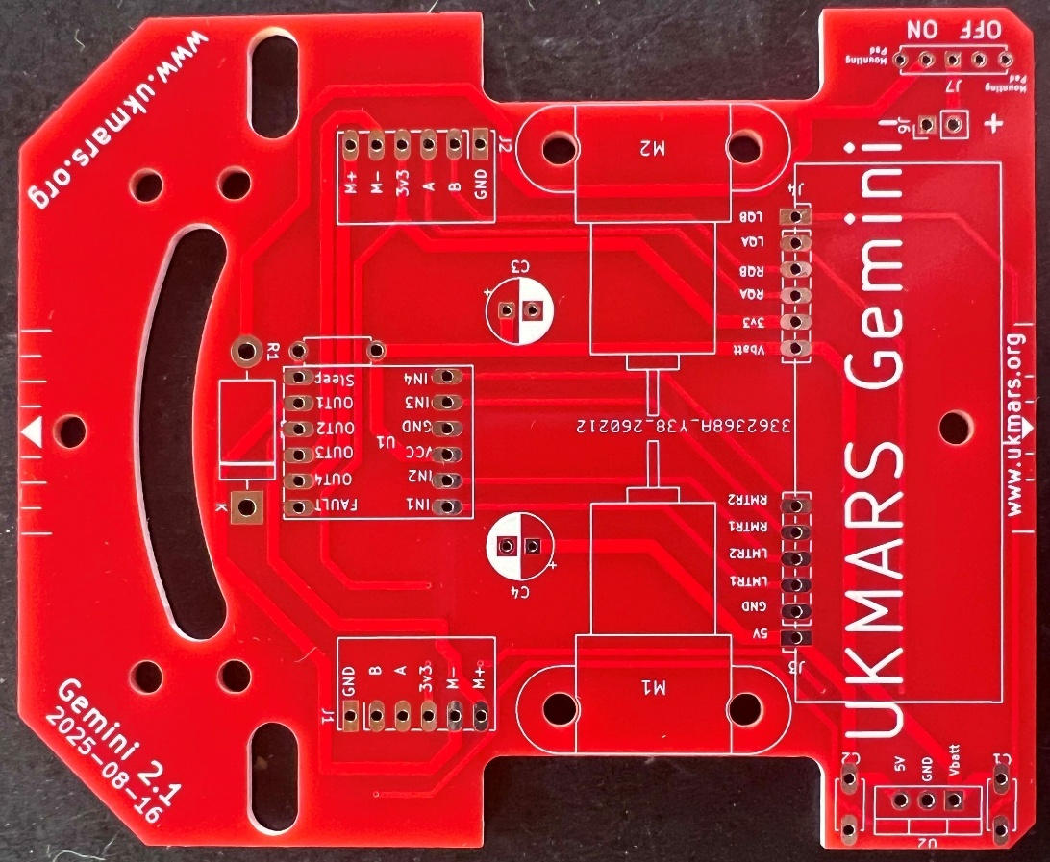
and this is the bottom of the Gemini V2.1 board:
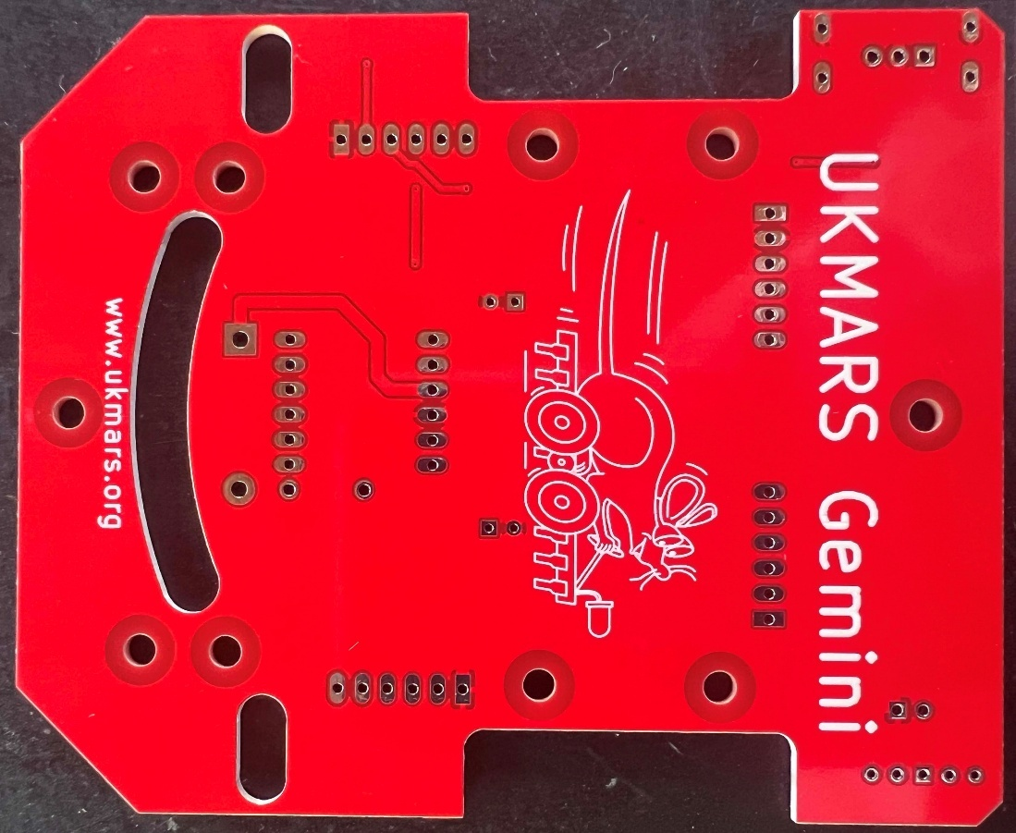
Do not worry if some of the photos in this guide show different colour PCBs, the instructions are the same for your version 2.1 boards.

DRV8833 Motor Controller Board
We will start with the DRV8833 motor controller board. If your DRV8833 board has not got headers soldered in already, put the headers into a breadboard to hold them upright Then put the board on top of them to enable you to solder the headers to the board. Yor 6 pin headers have a short and long lead. Put the long lead into the breadboard and solder the short leads onto the DRV8833 board.
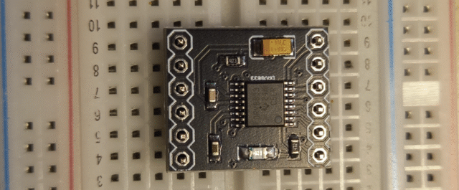
Now you can solder the DRV8833 board onto the main chassis board. Ensure that you put the board in the right way round as shown below with the large yellow capacitor on the left side. Then solder the 2 sets of 6 pins on the bottom of the board.
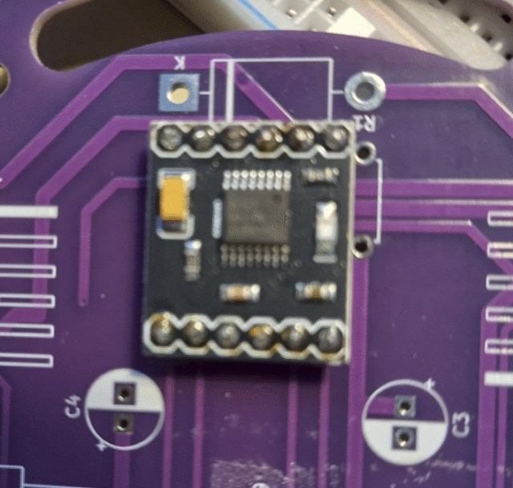
Next we will add the 47K ohm sleep wake resistor R1 and the polarity protection diode which are next to the DRV8833 board. The 47K ohm resistor (marked yellow purple orange) does not matter which way round it goes, but the protection diode MUST have the silver band on it next to the hole marked K (for cathode). Depending which diode you use it may be larger than the one shown. Solder in both of these components on the bottom of the board.
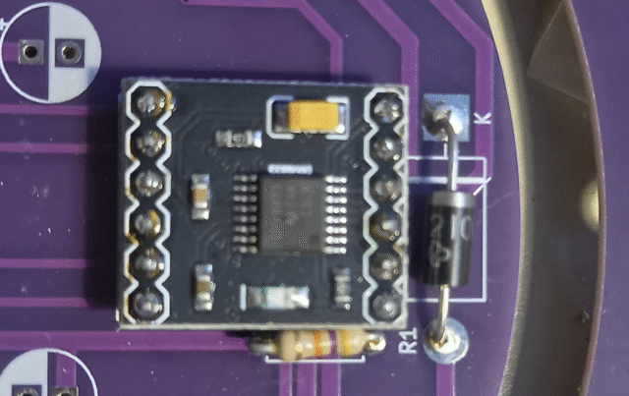
Next, we will add the two 100uF electrolytic capacitors C3 and C4. Note that both of these are polarised and MUST go in the right way round. The lead on the grey side of the capacitor with the minus sign on it goes in the hole shown white on the printing on the board. Note that the left one of these has the negative side pointing forward and the other has the negative side pointing backwards as shown here. You capacitors may be smaller than these shown depending on the voltage rating and source. Solder both of them on the bottom of the board.
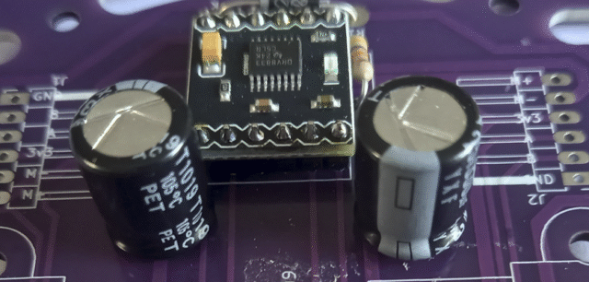

5 Volt Regulator
Next we will add the 5Volt regulator U2. Put it in so that the flat side is on the outer edge of the board and the black section is towards the labels for 5V, GND and Vbatt. Solder it on the bottom of the board.
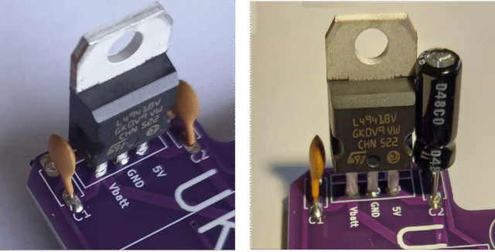
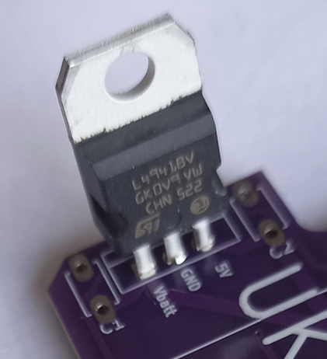
Using the LM7805 you will have a 0.22uF capacitor for C1 and a 0.1uF capacitor for C2. These can be inserted either way round.

(If you choose to use an alternative regulator eg the L4941BV the capacitors will have different values and you may need to use a polarised capacitor for C2).

Sockets to Connect the Mezzanine Board J3 & J4
Next add the two 6 pin sockets that will connect to the Mezzanine board. If you have a longer strip of sockets, cut them at the 7th socket, which will leave 6 clean sockets to put on the board. Solder one end in first then check that they are fully seated squarely on the board before soldering in the other 5 pins. Repeat for both 6 pin sockets.
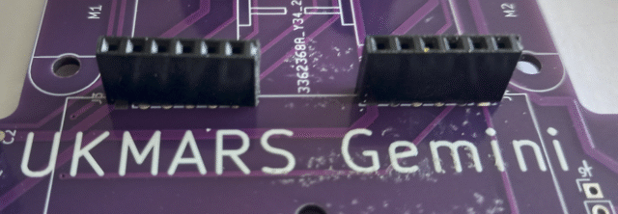

On/Off Switch and Battery Connector
Next we will add the on/off switch and battery connector. The on/off switch may just have 3 pins as this one shown or it may also have 2 extra pins used to give extra support to the switch at each end. If you only have 3 pins on your switch, solder it into the middle 3 holes leaving a mounting pad hole at each end. Then add the 2 pin battery connector. Several different 2 pin styles can be used. A simple unpolarised 2 pin connector is shown here.
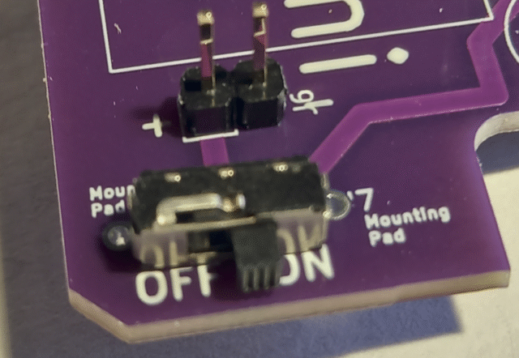

Connectors for Motors and Encoders J1 & J2
Next we add the motor and encoder connectors J1 and J2 These are two 6 pin JST breakout boards that connect the 2 motor power leads and the 4 encoder leads. The photo shows an early prototype board but the assembly process is the same for the version 2.1 boards.
To solder the 6 pin header to the breakout boards use the same technique described for DRV8833 Motor Controller Board Put the header into a breadboard to hold it upright Then put the board on top of the header to enable you to solder the headers to the board. The header is on one side of the breakout board so you will need to support the other side with a matchstick or similar to keep the board level. Your 6 pin headers have a short and long lead. Put the long lead into the breadboard and solder the short leads onto the breakout board.
Now you can solder the breakout boards onto the main chassis board. Then solder the 2 sets of 6 pins on the bottom of the boards.
Your main chassis board is now ready to add the motors.
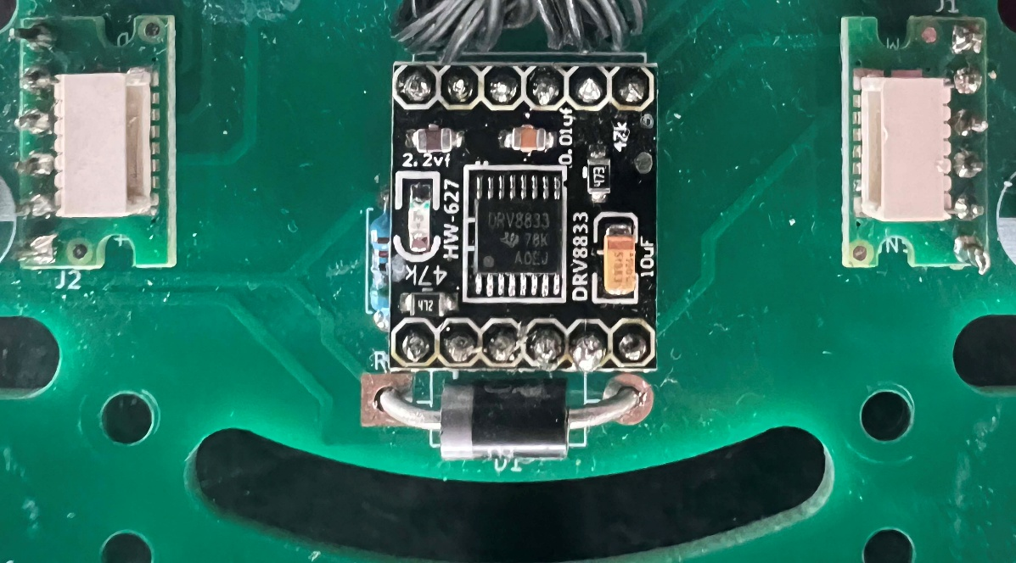
If you are not installing encoders, you only need to connect the 2 motor power leads marked M+ and M- You could connect the motor power leads directly to these pads either using right angled header or soldering directly to the board. Take care if you are soldering directly that the joint is sound, complete and has not created any short circuits with nearby components or pads.

Fitting Encoders and Mounting Motors

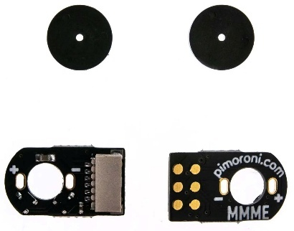
Fitting Encoders
GEMINI is designed to use Pimoroni JST connected magnetic encoders in sideways orientation. These only require the encoder shims to be soldered to the motor terminals and the magnets pressing onto the end of the extended shaft so that they are just clear of the components on the encoder shim. Connection from the motor and encoder to the chassis board is achieved through a short JST cable.
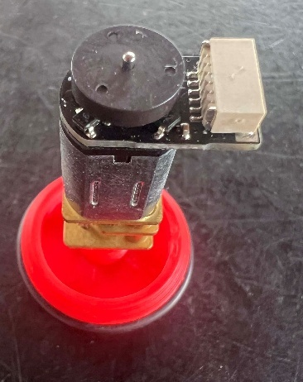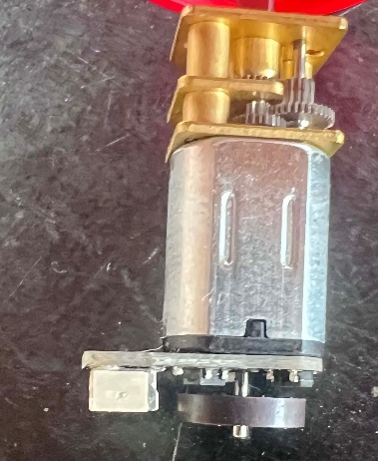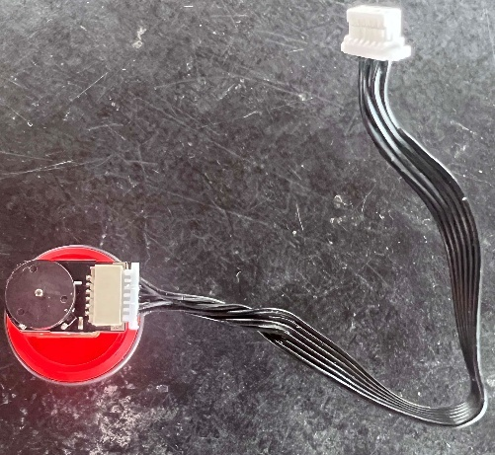
Note that the face of the circular magnets that has dimples must face away from the motor. If you install this upside down, the encoder will not work.
Other encoders from Pololu are available that require 6 wires to be soldered to the encoder and have smaller pads to connect to the motor. These are much fiddlier to install and are not recommended. Pimoroni sometimes offer 50:1 motors with the encoder pre-fitted. This can save you a step if you think a 50:1 motor will be quick enough for you. More motors are being offered with encoders pre-fitted – only use these if you are confident that the pin-out is the same as Pimoroni and that they will physically fit on the robot!

Mounting Motors
Now that you have fitted your encoders and attached a short JST cable you are ready to mount you motor/encoder assembly onto the chassis board.
The example here uses standard Pololu motor mounts and substitutes M2 30mm bolts for the rear mounting holes. These long bolts will securely attach the Mezzanine board when it is ready to be assembled.

Organise the nuts, bolts, washers and motor mount then place the motor mount over the gearbox of your motor.
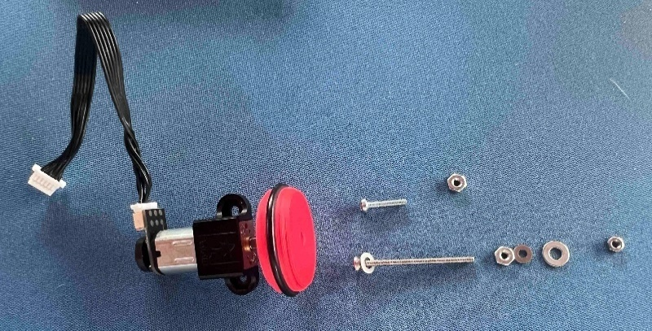
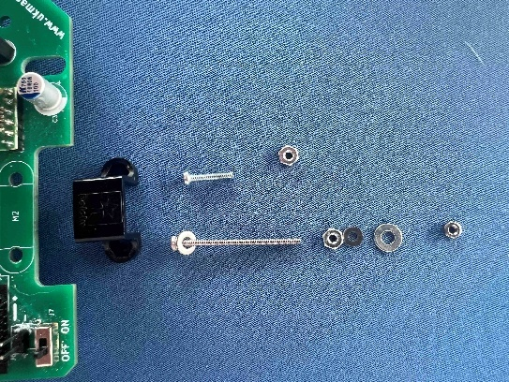

Start with the front mounting hole and the short bolt. Slip the nut into the motor mount (fiddly) then screw the bolt through from the bottom of the board securing the motor to the board. Do not completely tighten at this stage as you will need to ensure the motor is properly aligned when the second bolt is installed.
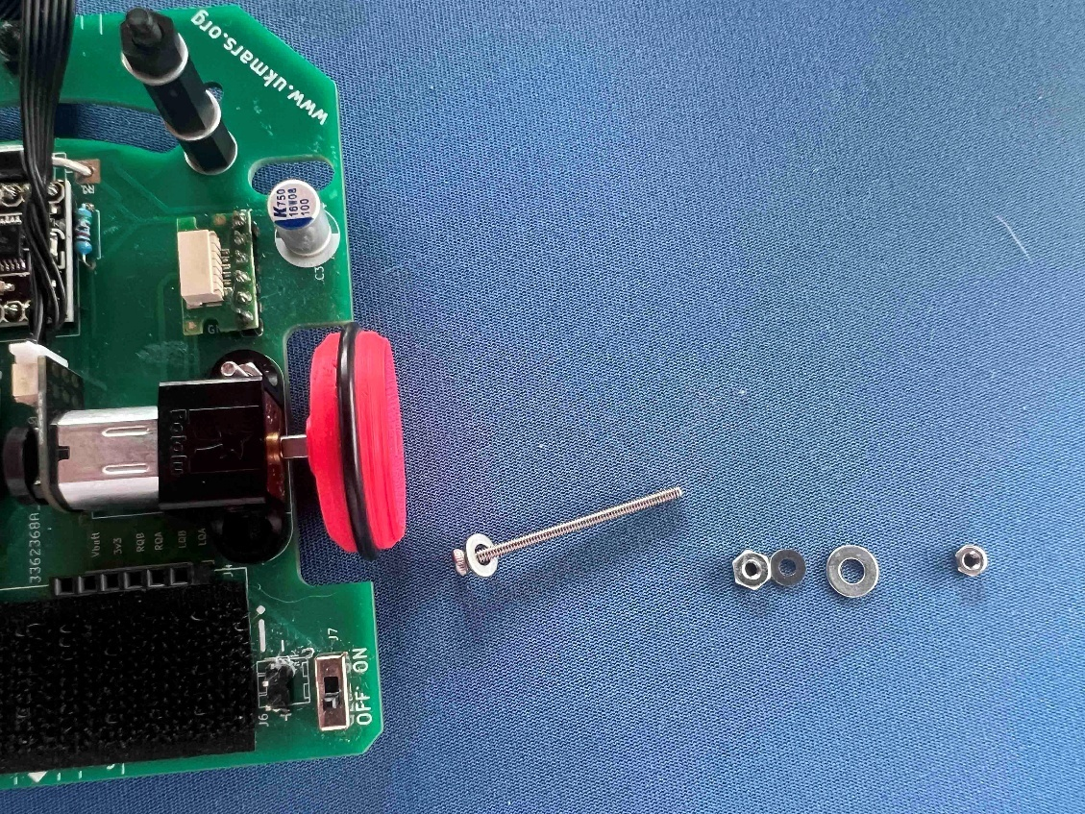

Next slip the original nut that came with the Pololu motor mount into the motor mount and feed the long bolt through from the bottom of the board and secure the motor to the board. Before tightening both bolts make sure the motor is properly aligned. The long bolt will now act as a stud to secure the Mezzanine board. You may need a washer between the bolt head and the board depending on the style of bolt you are using.
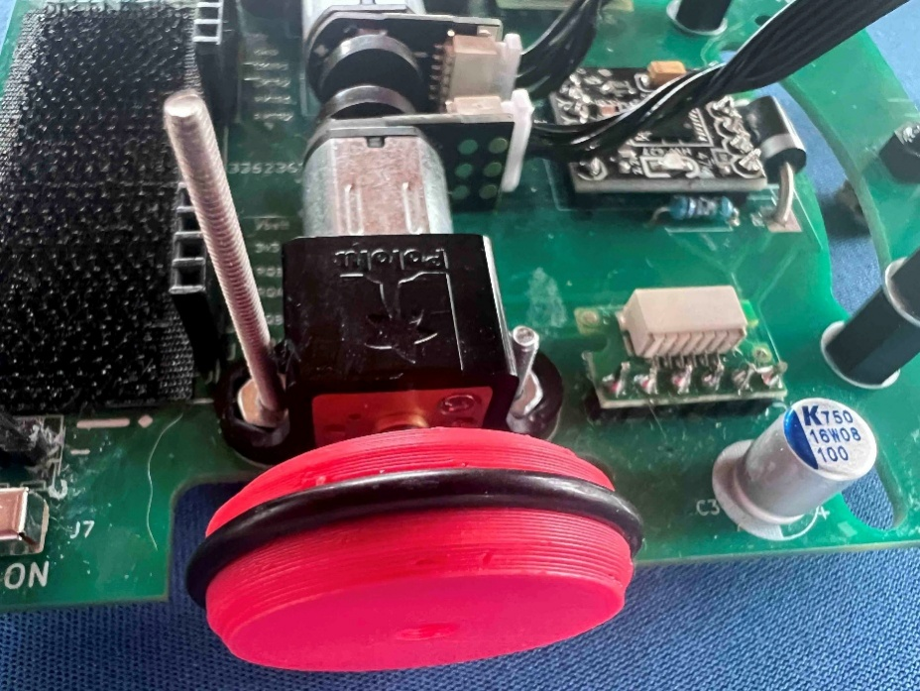

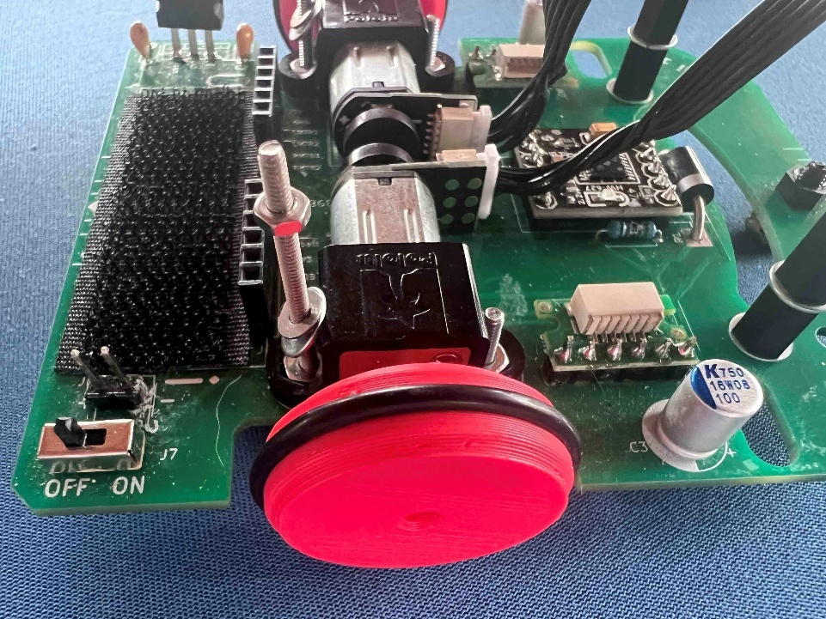
Loosely fit the nuts and washer to the rear studs that will be used to fix the Mezzanine board so that they are to hand for assembly.

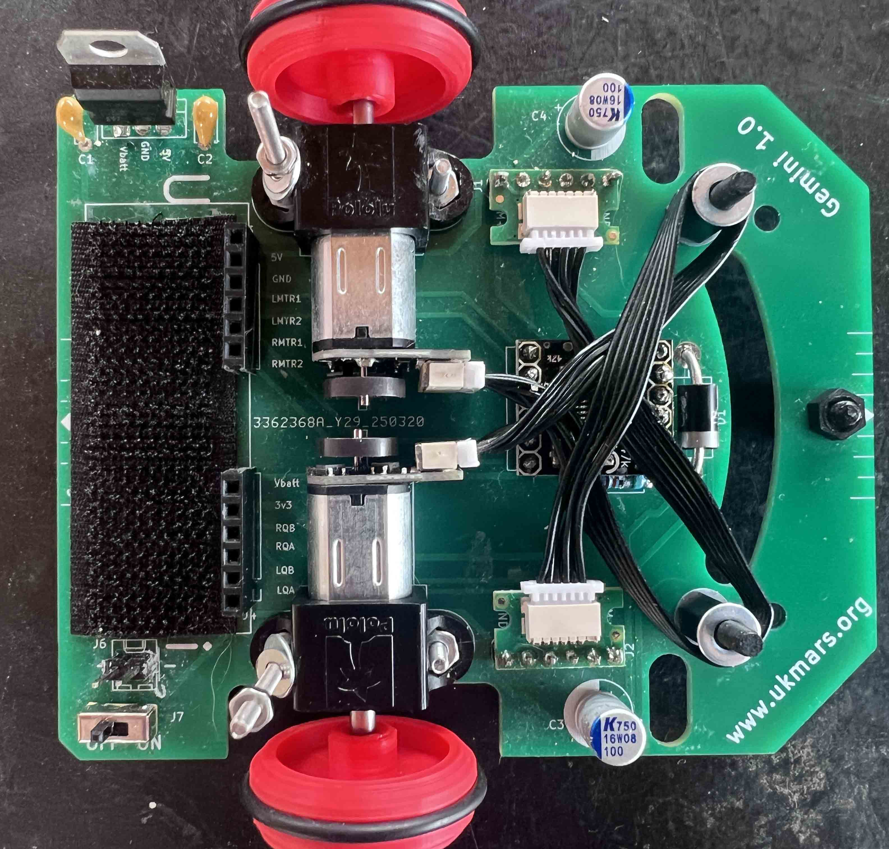
Finally, you can connect the JST cables into the sockets on the chassis board. Excess cable can be tidied up by taking the cables around the sensor board stand-offs.

Note: When removing the wheels from the shafts DO NOT just try to pull them off as you may damage the gearbox on the motor. If you are using Pololu wheels use a small screwdriver to expand the slit in the wheel hub to open up the D shape loosening its grip and slide the wheel off the shaft.
If you are using 3D printed wheel with no expansion slit use a small screwdriver inserted between the gearbox and the wheel hub, and lever the wheel off the shaft this way.
If you are using 3D printed motor mounts based on https://github.com/ukmars/gemini/blob/main/mechanical/GeminiN20MotorMount.stl
then you will need two M3 30mm bolts, two shorter M3 bolts, four M3 nuts and some M3 washers. If you are able to print these mounts they are less fiddly than the Pololu mounts and the M3 bolts are easier to work with than the M2 bolts on the Pololu mounts.
You are now ready to decide which sensor board you want to build to fit to this GEMINI robot. You only need to build one, either
- the Line Sensor Board for line following, drag racing and the pursuit challenge or
- the Wall Sensor Board for wall following and maze solving.
You may choose to build both sensor boards so that your GEMINI robot can be re-purposed to either sets of challenges but you can always come back later to build your second choice of sensor board. If you are new to robot building, the line events offer a gentler learning curve to acquiring the necessary skills.

Line Sensor Board
This is a view of the top of the PCB
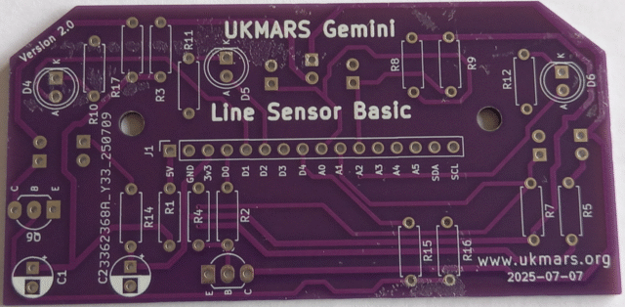
This is the bottom of the PCB
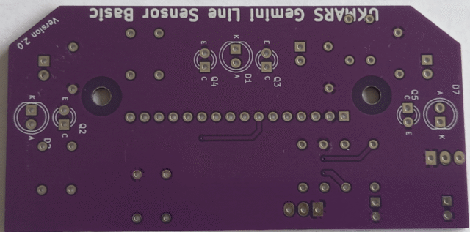

The Resistors
We start by adding the resistors. There are 15 of these of 6 different values so be careful which ones go where. Bend the leads over as close to the body of the resistors to get them to fit into the holes. The descriptions in the text give the colour coding for 3 band resistors. You can identify the correct value resistors (3,4 or 5 band) using Appendix B – Resistor Colour Code Chart
Check the value of your resistors with your multi-meter before you solder them in.
R7, R8, R9 and R14 are all 680 ohms (colour banded green, grey, brown) so put these in first. (The resistors shown in these photographs are for a pre-production board and are not 680 ohms so yours will have a different colour coding -check they are 680 ohms before soldering,)
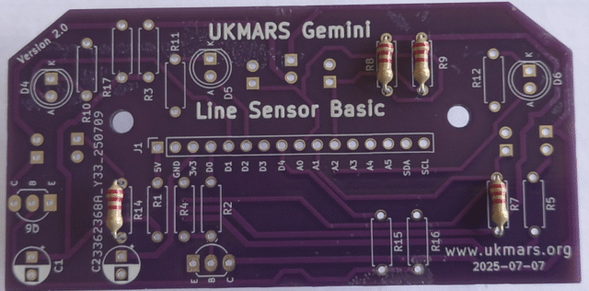
Then add R3, R5 and R17 which are all 10 ohms (colour banded brown, black, black) shown here with blue bodies.
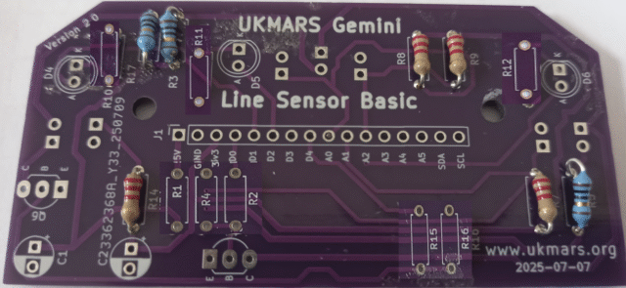

Then add R10, R11 and R12 which are all 680 ohms (colour banded green, grey, brown)
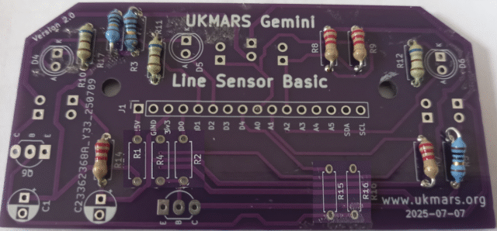
Then add R4 and R16 which are 10K ohms (colour banded brown, black, orange)
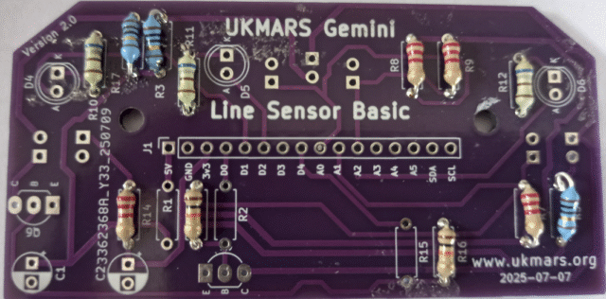
Then add R2 and R15 which are 390 ohms (colour banded orange, white, brown) Do not get these mixed up with 39 ohm resistors which have just the final band different.
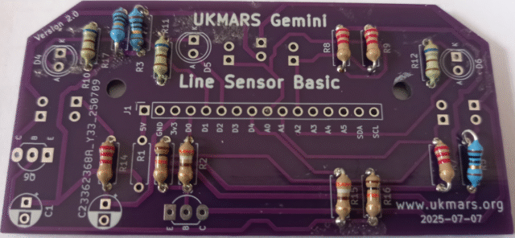

Then finally add R1 which is 47 ohms or 33 ohms (colour banded orange, orange, black). Either value is ok.
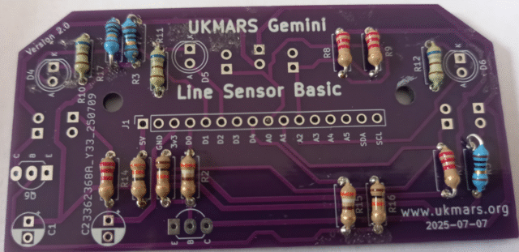
You should now have all 15 resistors in place. Check them before going further with the build.

The Transistors
New we will add the two BC337-40 transistors Q1 and Q6. Insert them so that the flat side matches the flat side shown on the screen print. Q1 has the flat side at the back, while Q6 has the flat side at the front.
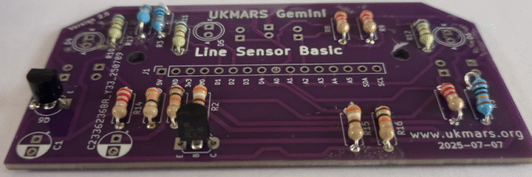

The Indicator LEDs
Now put in the 3 indicator LEDs D4, D5 and D6 put the longer lead at the hole marked A (for Anode) It is suggested that you use one red, one yellow and one green one to make it easiest to tell which is lit when it is moving. These are the low current LEDs just used as indicators. Do not put the high brightness RED LEDs in these positions
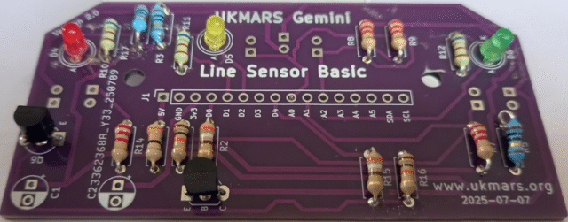

The Capacitors
Next to go on the top of the board are the electrolytic capacitors C1 and C2. Ensure that they go in with the negative strip on the side of the capacitors at the back of the board where the white segment is shown on the screen print.
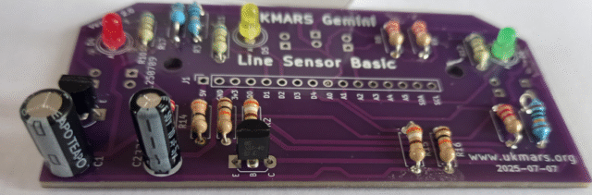

The Mezzanine Connector J1
The last item to go on the top of the board is the 16-way female socket which will make the connection to the mezzanine board for all the circuits. Solder this in carefully on the bottom of the board, making sure that it is seated fully down on the board and upright.
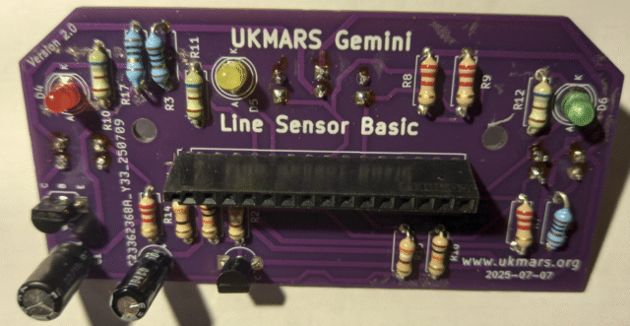

Devices on the Underside of the Board
The other parts go on the underside of the board and are soldered on the top. These devices will look down through the apertures in the chassis board to sense the line geometry. The LEDs are the larger 5mm parts and the phototransistors the smaller 3mm parts.

Illumination LEDs
First put in the 3 illumination LEDs One goes in the centre and one on each side. Make sure that the long lead goes on the hole marked A (for Anode). Note that on one side the Anode is towards the front and on the other side it is towards the back. The base of the LEDs need to stand proud of the board by about 5mm. To get this correct amount, spread the leads slightly before you put them in the holes then put them in until the slight notch on the leads touches the board. Now solder one lead then check both the distance from the board and that the LED is standing precisely upright. If needed, adjust the height or angle then solder the other lead.
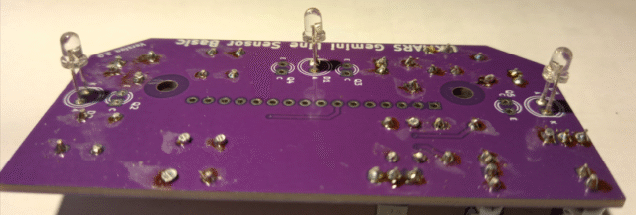

Phototransistors
Now put in the 4 BPW85C phototransistors Q2, Q3, Q4 and Q5. Make sure that the long lead goes in the hole marked E (for Emitter). Set them at the same height off the board as the LEDs and use the same process as above to get the height and angle correct. Note that the emitter is towards the back of the board for Q5 while for all the other three the emitter is towards the front
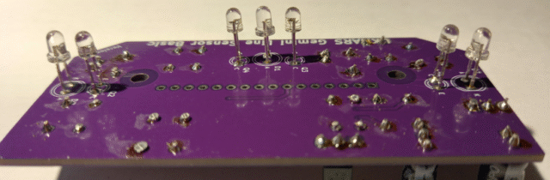
Your line sensor board is now complete

Wall Sensor Board
This is the view of the top of the PCB
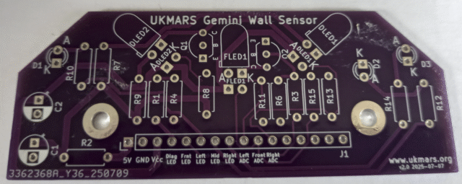
This the bottom of the PCB
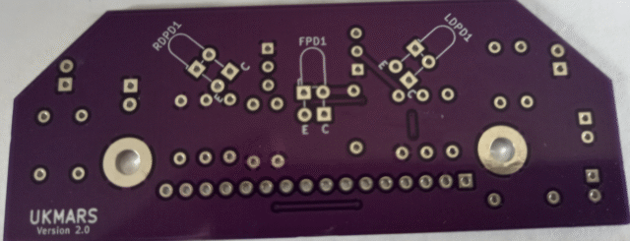

The Resistors
We start by adding the resistors. There are 14 of these of 7 different values so be careful which ones go where. Bend the leads over as close to the body of the resistors to get them to fit into the holes.
The descriptions in the text give the colour coding for 3 band resistors. You can identify the correct value resistors (3,4 or 5 band) using Appendix B – Resistor Colour Code Chart
Check the value of your resistors with your multi-meter before you solder them in.
First add the resistor R2, 33 ohms (colour banded orange, orange, black) which is used for power decoupling and then R7, R8 and R9 resistors of 10 ohms (colour banded Brown, black, black) which are the three wall illumination LED load resistors
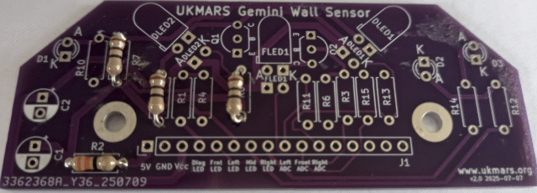
Next add R1 and R3 both 390 ohms (colour coded orange, white brown) used to current limit the current to the bases of the two transistors which switch the LEDs off and on
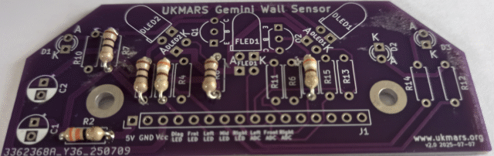
Then add R4 and R6 both 10K ohms (colour banded brown, black, orange) which provide the bias for the base of the transistors
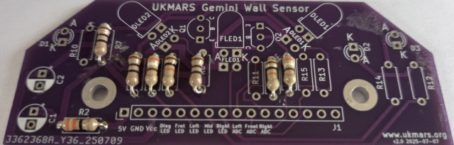
Now add the 3 phototransistor load resistors. R11 and R13 are 2.2K ohms (colour coded red, red, red) but R15 is 1.8k ohms (colour coded brown, green, red). This is to give the front sensor more range.
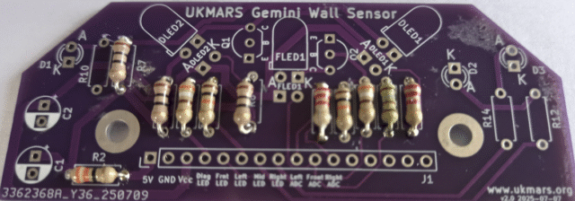
Finally go in the 3 indicator LED load resistors R10, R12 and R14, all at 680 ohms (colour coded green, grey, brown)
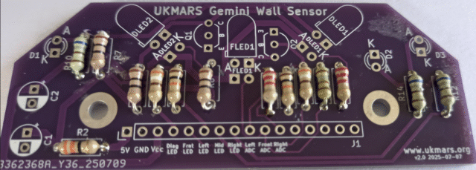

The Indicator LEDs
Next add the 3 low current indicator LEDs D1, D2 and D3. Make sure that the long lead goes into the hole marked A (for Anode) Note that not all of the LEDs are oriented in the same direction. Use 3 different colours for them e.g. red, yellow and green as shown here:
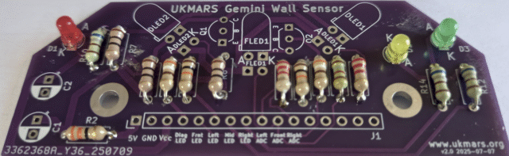

The Transistors
Now we will add the 2 transistors Q1 and Q2 marked BC337-40 Make sure that they go in with the flat side as shown towards the text FLED1 matching the layout shown on the board
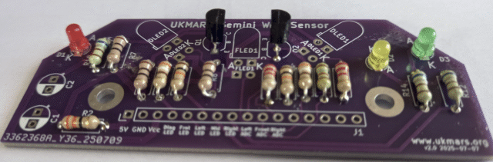

The Mezzanine Connector J1
Now we can add the 16-way female socket that connects to the mezzanine board. Solder in a pin at each end then check that it is seated fully down on the PCB and upright before soldering in the rest of the pins
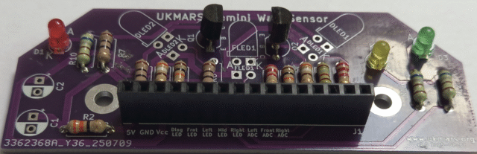
Now we just have the wall illumination LEDs and phototransistors to go in.

The Illumination LEDs
The three LEDs sit on the top of the board and are soldered beneath, but the phototransistors sit below the board and are soldered on the top. You must put the LEDs in first using the holes closest to the outline of the LED with the long lead going in the hole marked A (for Anode), as shown here.
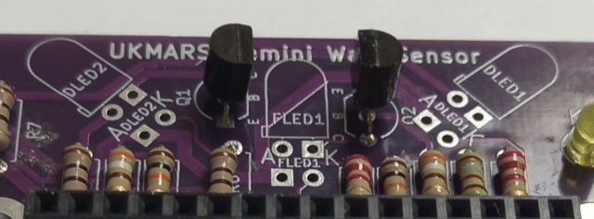
Bend the LEDs like this, making sure that the long lead is on the left ready to go in the A hole. Do not mount these too tightly to the board because you will need to adjust their posture later.
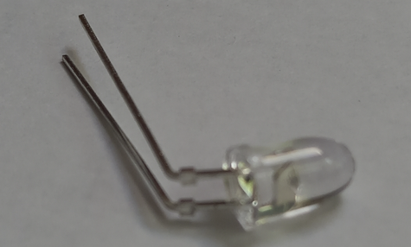
Once they are soldered they should look like this
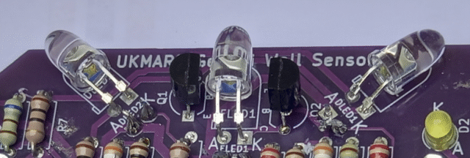

The Phototransistors
Now turn the board over and add the 3 BPW85C phototransistors RDPD1, FPD1 and LDPD1 putting the long lead in the hole marked E (for Emitter). Solder them on the top of the board just behind where the LED leads go through. The phototransistors should point in the same direction as the LEDs, one forward and two angled at about 45 degrees towards the side. Put a piece of paper beneath the leads while you solder them so that they do not short on the LED contacts below as shown.
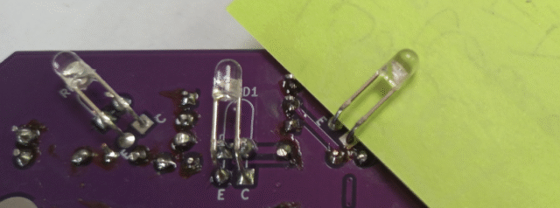

The Capacitors
Then we will add the 2 100uF 16V electrolytic smoothing capacitors. They should be the 7mm high versions as specified in the parts list. They are polarised so make sure that the minus sign on the side goes to the back of the board on the white section of printing.
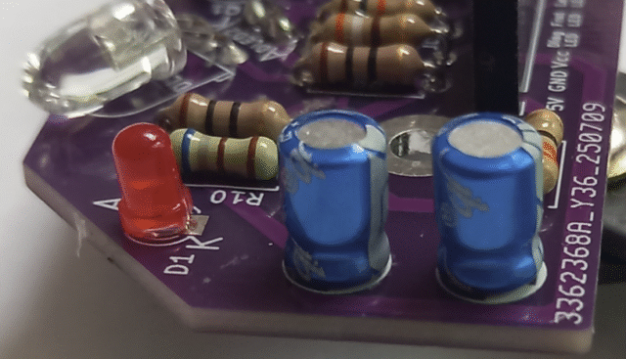
Your wall sensor board is now complete

Mezzanine Processor Board
This is the top of the Gemini V2 Mezzanine board for the Raspberry Pi Pico RP2040 processor.
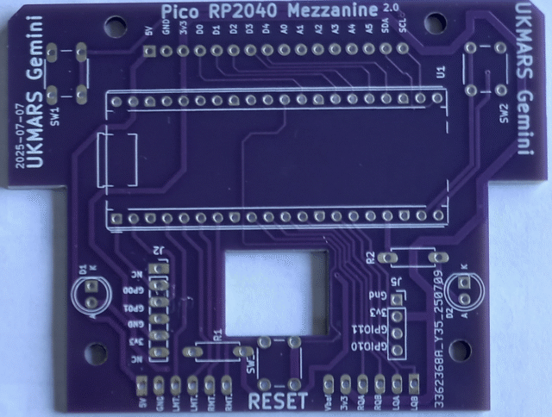
And this is the bottom of the Mezzanine board for the Raspberry Pi Pico RP2040 processor.
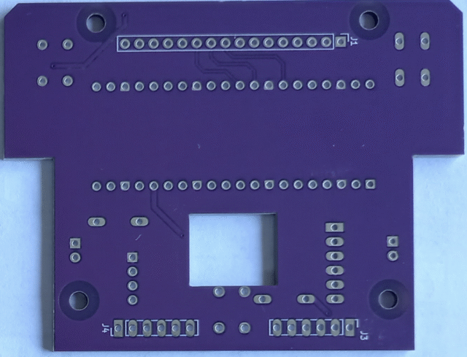
There are only a few components to be added other than connectors.

The Switches
We will start by adding the 3 tactile switches SW1, SW2 and SW3 the RESET button. They will only go in one way round so carefully align the pins on then and push then through so as to fit flush on the board, then solder them in. Here are the positions of tactile switches SW1 and SW2 at the front of the board.
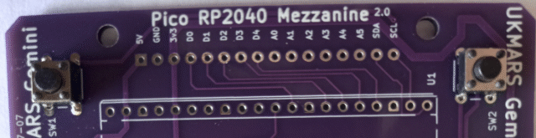
This is followed by tactile switch SW3 on the back of the board next to the word RESET
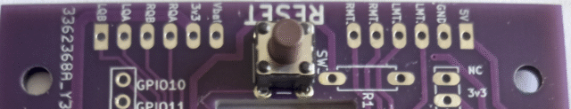

The Resistors
Next are R1 and R2, the 680 ohm (coded green, grey, brown) LED load resistors.
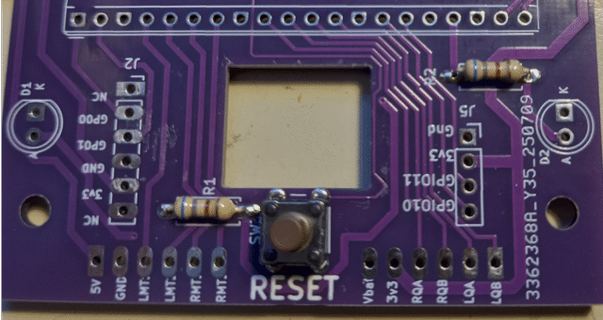

The Indicator LEDs
Note also the position of LEDs D1 and D2 which are marked K(for cathode) and A (for Anode) in the image above. The long lead goes in the side marked A and the short lead goes in the side marked K. Two different colour LEDs are recommenced as shown below. Do not use blue or white ones as they require higher voltages so may not work.
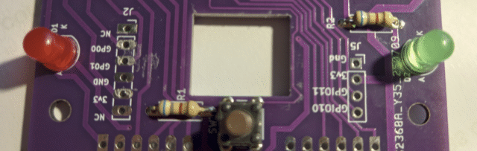

Connectors and Sockets
Now we are ready to add headers and sockets. The sensor board connector at the front of the board uses a 16-pin header. It is put in on the underside of the board and hence soldered on the top surface as shown.
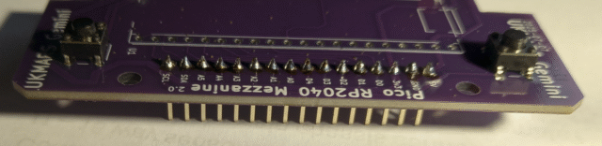
Then add the two breakout sockets J2 and J5. J2 is a 6 pin socket and J5 is a 4 pin socket. Solder them on the bottom of the board next to the LEDs as shown.
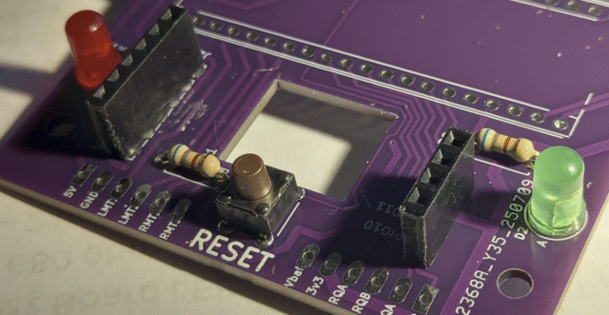
Now add the two 6 pin connectors which go below the board and are soldered on the top of the board. They are either side of the RESET tactile switch.
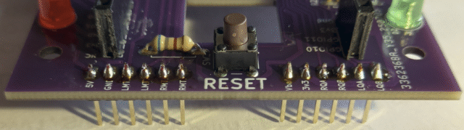
If your Pico Processor board is to be socketed, add the two 20 pin sockets for that,
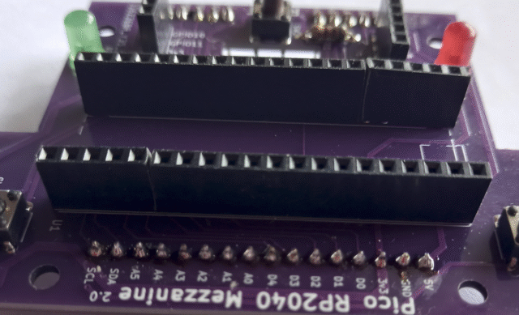
Putting the Pico into the socket means that it will now look like this: Make sure that it is put in so that the USB micro socket matches the square shown on the screen print and next to tactile switch SW1
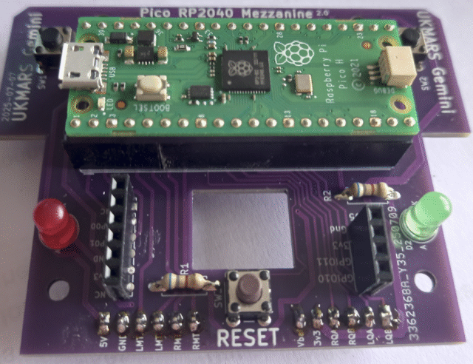
Your mezzanine processor board is now complete.

Putting It All Together
Now you have assembled all the PCBs it’s time to build the complete GEMINI robot.

Skids
The GEMINI robot only has 2 wheels like a chariot so it needs skids front and rear to keep it level. The robot needs to be able to rock up and down at the front and rear so that under acceleration the wheels are in contact and the robot is rocked back onto the rear skid for stability. Under braking the front skid stabilises the robot.
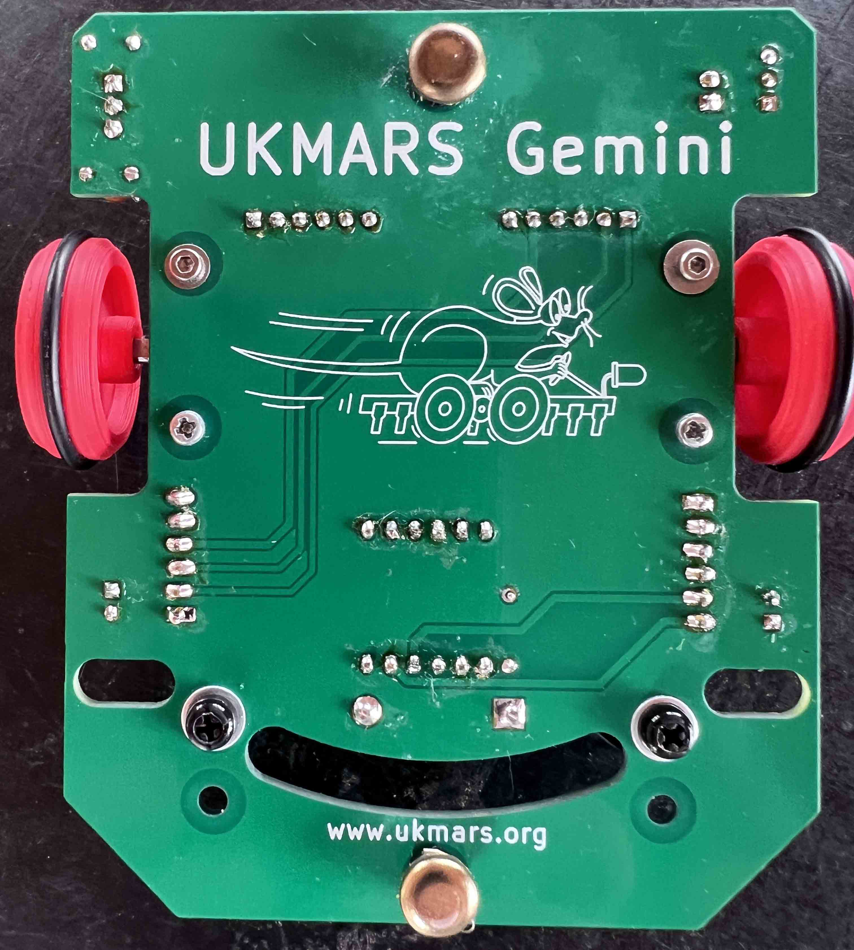

If you do not allow enough up and down movement between acceleration and braking your robot will get “beached” when both skids are in contact with the running surface and the wheels will not make sufficient contact to gain traction. Too much freedom to rock up and down and your sensors will become ineffective either shining down into the surface or up into the sky.
It is worth spending some time to get this setup correctly. The free up and down movement at the front of the robot should be about 3mm (the difference between the lowest point and the highest point constrained by the skids with the wheels on the ground).

Materials to Make Skids
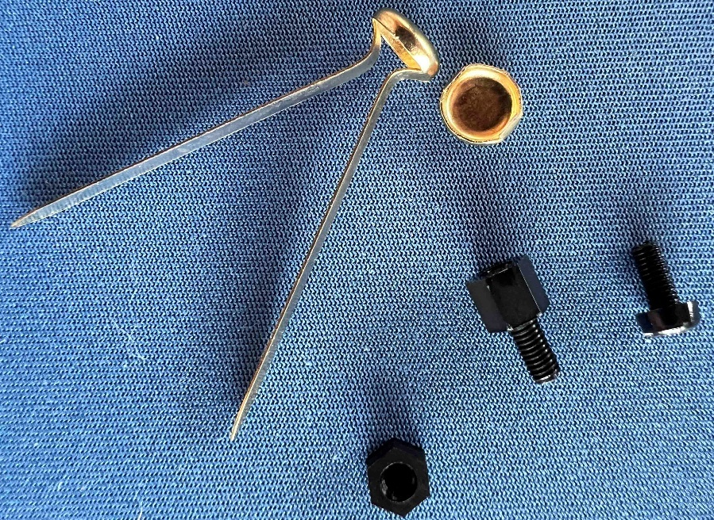
Skids can readily be made from plastic stand-off parts using the head cut from a metal paper fastener as shown. Height adjustment is achieved by filing down the plastic parts until the desired heights are reached and glueing the fastener head over the plastic stud. Remember to allow for the fastener head to adjust the heights before glueing!

Front Skid
It is easy to attach the front skid to the dedicated hole in the PCB, simply insert the threaded end of the skid and secure with a nut.
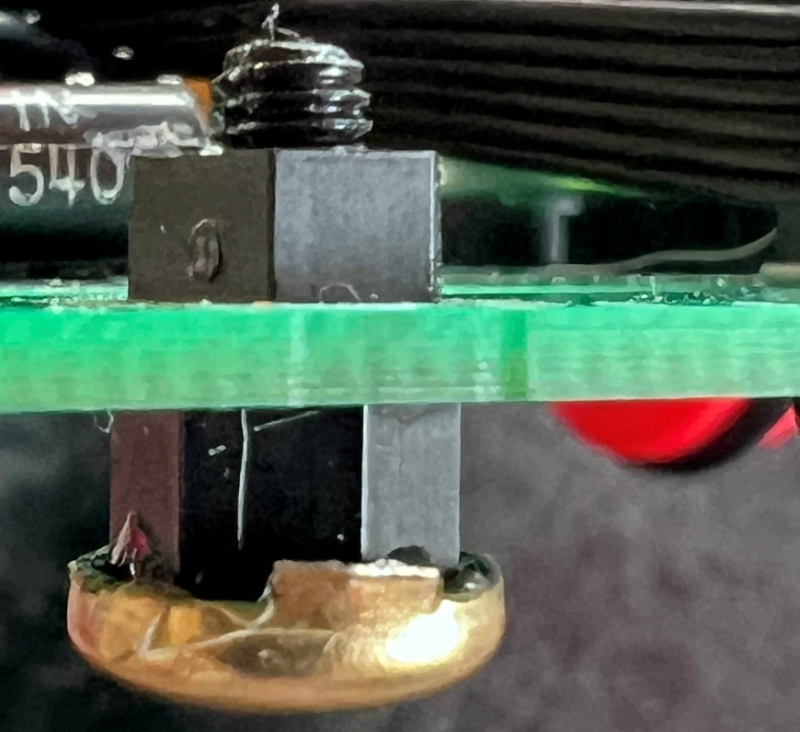

Rear Skid
It is better to glue the rear skid into the dedicated hole on the chassis board and make sure that none of the threaded end of you skid protrudes above the top of the chassis board. This leaves the space reserved for the battery flat and it will sit much better. Velcro is a good way to secure your battery.
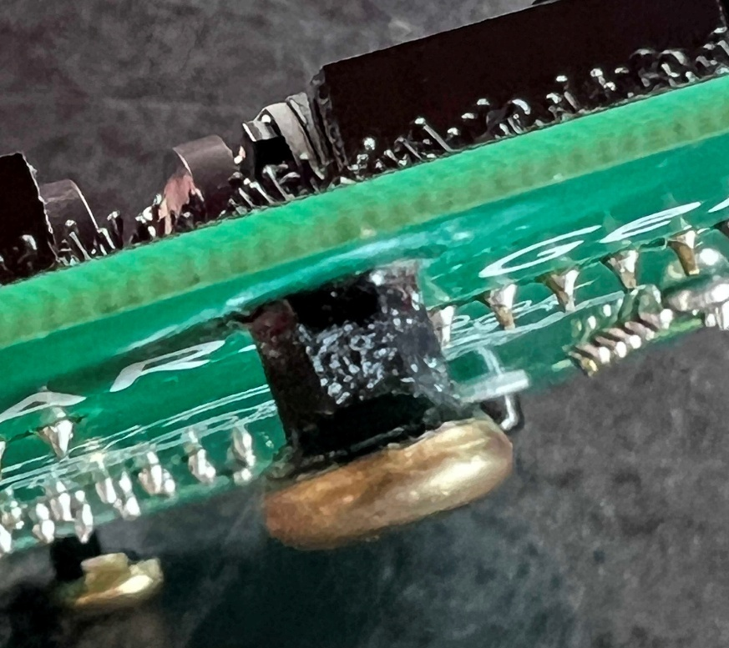

Attach the Sensor Board to the Chassis
The sensor board is attached to the chassis boar using M3x8+6mm stand-offs. This means the diameter of the thread is 3mm the body of the stand-off is 8mm and the threaded stud is a further 6mm long.
The stand-off is attached to the chassis board by inserting M3x6mm bolts through the holes in the chassis board and screwing the stand-offs down onto these.
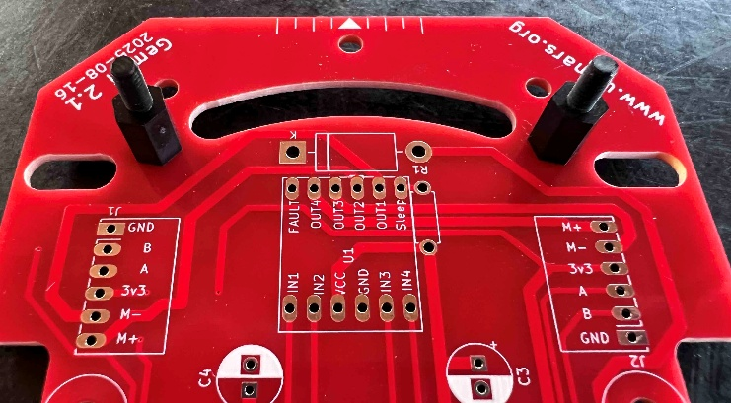
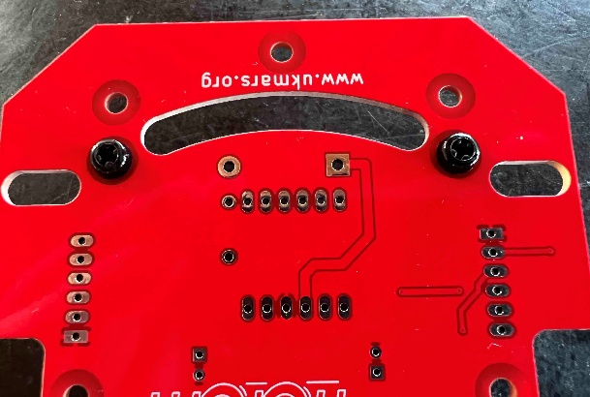

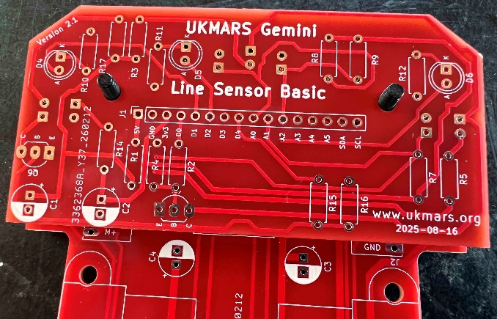
The sensor board is placed over the protruding studs of these stand-offs and secured in place by screwing down 2 M3x10+6mm stand-offs
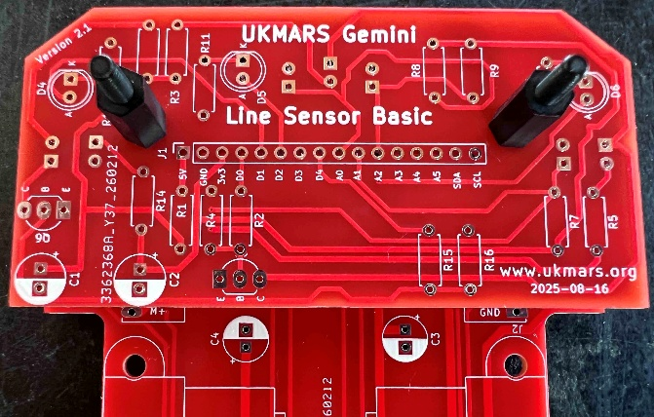

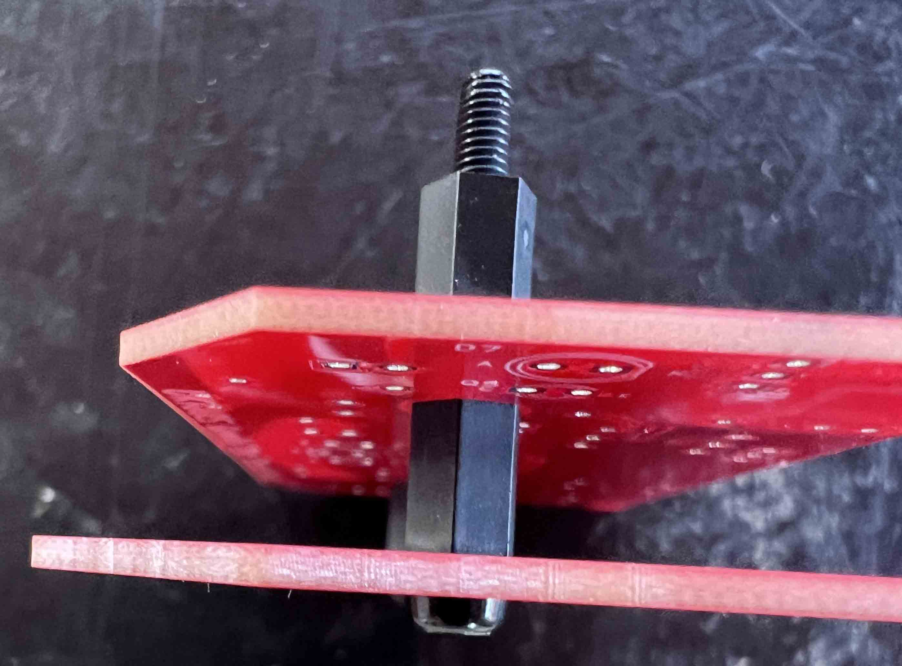

Attach the Mezzanine Processor Board
The connections between the chassis and mezzanine boards are achieved using extended headers inserted into J4 and J5 on the chassis board.
First prepare two 6pin extended header sockets by cutting down a strip of extended header. Shorten the conductor pins of the header so that they can fully insert into the standard headers for J4 and J5 and sit snuggly on top of the standard header socket.
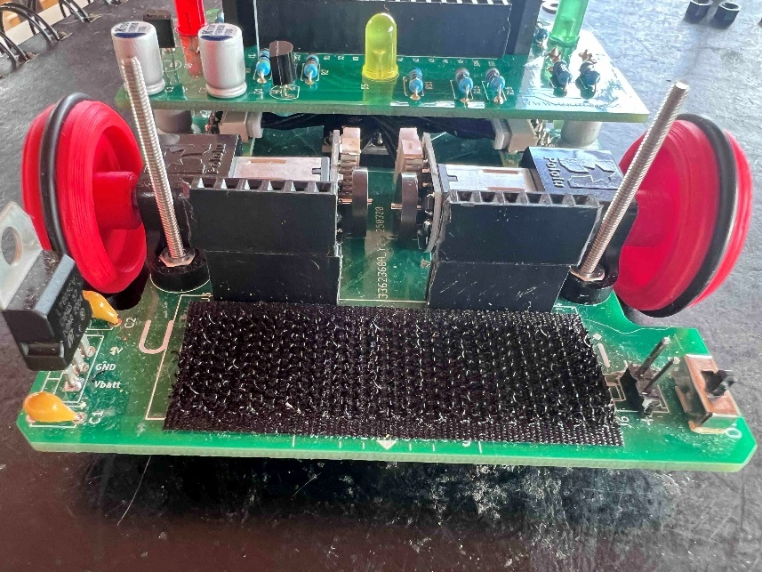
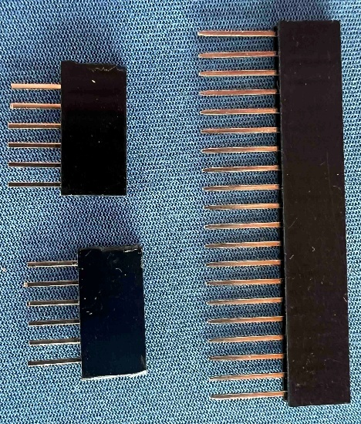

Now carefully place your mezzanine board onto the chassis and sensor boards aligning the mounting studs from these boards through the holes in the mezzanine board. Do not press the mezzanine board down.

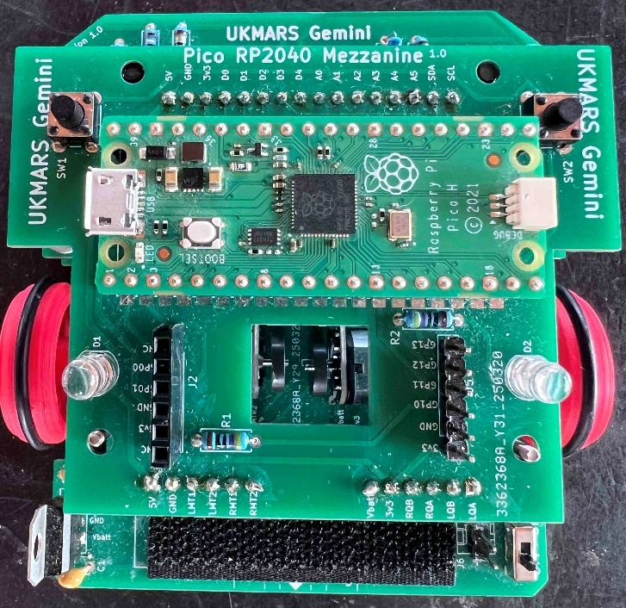

Check to make sure that all the connecting pins are properly aligned with their receiving sockets.
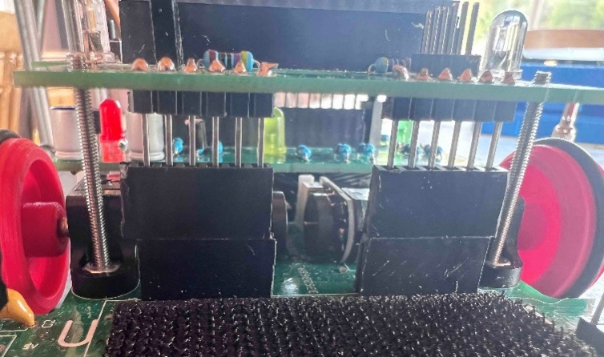
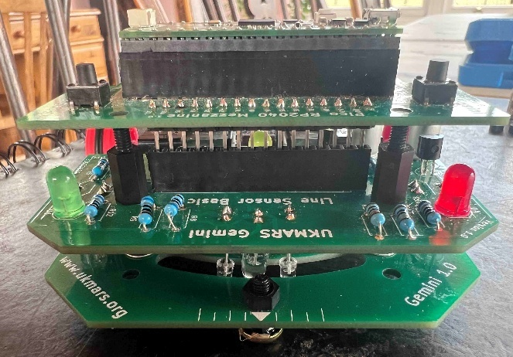

When you are sure that everything is lined up properly, gently and evenly press the mezzanine board down into the sockets on the chassis and sensor boards.
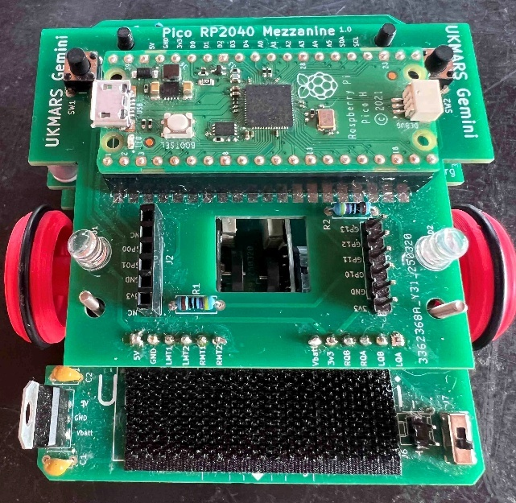

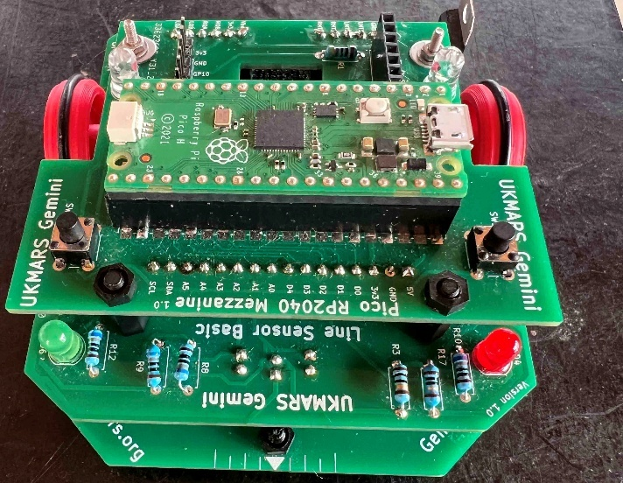
Now secure the boards with the nuts and washers. Do not overtighten these nuts or you will start to bend the PCBs.
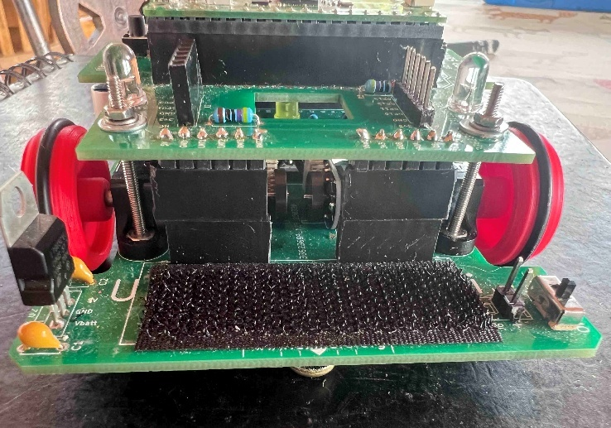

The mezzanine board will be at a very slight angle to the chassis board and this is perfectly fine, note the sensor board is parallel to the chassis board and this is important for reliable sensor readings.
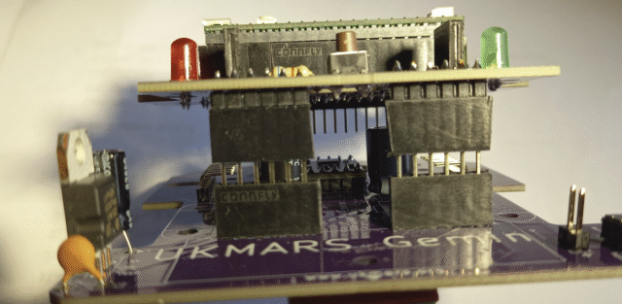
If you are offended by the slight angle of the mezzanine board you can cut the extended header pins to a longer length leaving exposed pins between the headers.
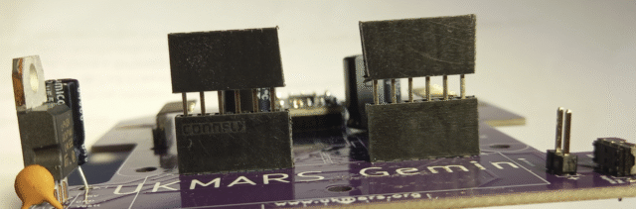

This method is not recommended as it is mechanically weaker and leaves exposed conductors between the 2 boards that could be shorted accidentally.

Connect the Battery – Your GEMINI robot is complete!
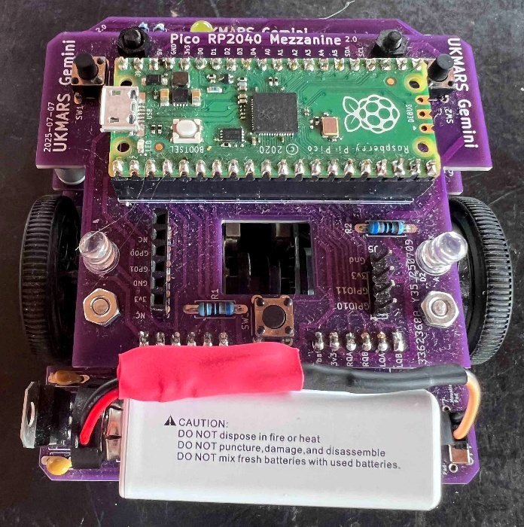
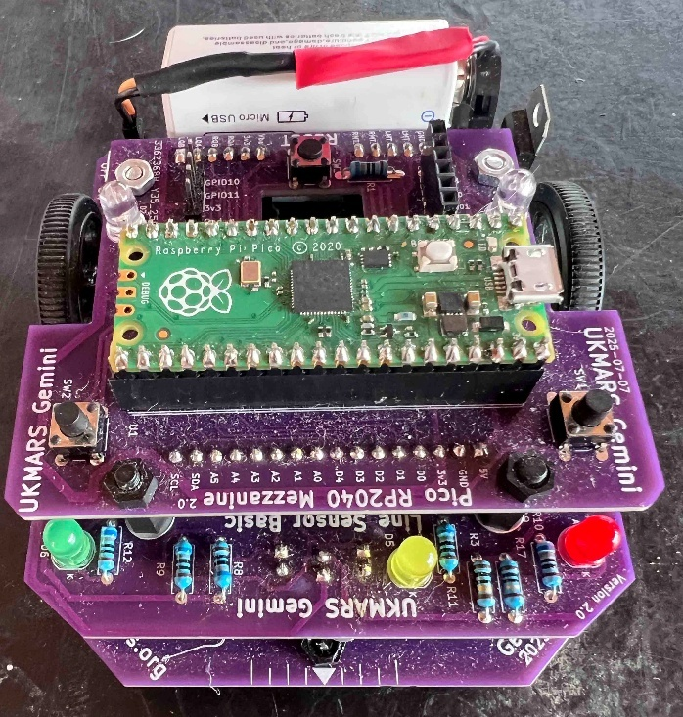

Testing, Coding and Further Reading
The easiest and best way to access all the designs, support documents and code examples is to visit out GitHub repo at https://github.com/ukmars/gemini/
See How to access reference and support documents

Test your GEMINI Hardware
Check that everything is working as it should be. If you are building with the line follower sensor board there is diagnostic software published on the GitHub repository:
https://github.com/ukmars/gemini/blob/main/sampleCode/lineFollowerDiagnostics/GeminiLFdiagnostics.py
If you are building with the maze sensor board, modify the line follower board diagnostics to reflect the pin assignments and usages for the different sensor board.

Reference Documents
Documents including schematics and board layouts are published on the GitHub repository:
https://github.com/ukmars/gemini/tree/main/docs

Example Code
An example line follower program to help get started is published on the GitHub repository:
https://github.com/ukmars/gemini/blob/main/sampleCode/GeminiLineFollower.py

An example line follower program to help get started is published on the GitHub repository:
https://github.com/ukmars/gemini/blob/main/sampleCode/DH_WallFollow_example.py

GitHub Repository
Visit our GitHub repository and download a zip copy or clone to your device to have instant access to all the support materials.
https://github.com/ukmars/gemini

Appendix A – Example Bill Of Materials (BOM)
This BOM was accurate in August 2026 and is included to show the information that is available. Please see https://github.com/ukmars/gemini/blob/main/docs/all_projects_bom.csv for the current BOM.
Project | Reference | Value | Qty | Note | Description | RSONLINE | RAPID
Line Sensor | C1 C2 | 100uF | 2 |  | Polarized capacitor | 176-3779 | Nov-09
Line Sensor | D1 D2 D7 | TLCR5800 | 3 |  |  | 818-7540 | 55-0066
Line Sensor | D4 | Radius | 1 |  |  | "228-6004 or 228-5562 or 713-3974 or 813-4845" | 56-0400
Line Sensor | D5 | Line | 1 |  |  | "228-6004 or 228-5562 or 713-3974 or 813-4845" | 56-0405
Line Sensor | D6 | S/Finish | 1 |  |  | "228-6004 or 228-5562 or 713-3974 or 813-4845" | 56-0410
Line Sensor | J1 | Conn_01x16 | 1 | https://uk.rs-online.com/web/p/pcb-sockets/6816820 Need to be cut down | Generic connector, single row, 01x16, script generated (kicad-library-utils/schlib/autogen/connector/) | 681-6820 | 19-0087
Line Sensor | Q1 Q6 | BC337-40 | 2 |  |  | 671-1119 | 50-3113
Line Sensor | Q2 Q3 Q4 Q5 | BPW85C | 4 |  |  | 815-1263
Line Sensor | R1 | 47R | 1 |  | Resistor | 707-8817 | 62-0334
Line Sensor | R2 R15 | 390R | 2 |  |  | 707-7634 | 62-0360
Line Sensor | R3 R5 R17 | 10R | 3 |  |  | 707-8580 | 62-0326
Line Sensor | R4 R16 | 10K | 2 |  |  | 707-7745 | 62-0394
Line Sensor | R7 R8 R9 R10 R11 R12 R14 | 680R | 7 |  |  | 707-8211 | 64-0068
Chassis | BT1 | 9v Battery | 1 |  | PP3 9v Battery
Chassis | C1 | 0.22uF | 1 | Maximum height is 10mm | Unpolarized capacitor | 194-0629 | Nov-49
Chassis | C2 | 0.1uF | 1 | Maximum height is 10mm | Unpolarized capacitor | 538-1433 | Nov-42
Chassis | C3 C4 | 100uF, 16V | 2 | Maximum height is 10mm |  | 176-3779 176-3779 | Nov-09
Chassis | D1 | 1N5401 | 1 | Polarity protection diode |  | 628-9451
Chassis | J1 J2 | Pololu Item #4772 | 2 | 6 pin 0.1" breakout 6 pin header, 0.1", male | Single row, 01x06, JST-SH breakout |  | 22-0795
Chassis | J3 J4 J6 J7 | Conn_01x06 | 4 | Might be easier and cheaper to just cut from bigger lengths 0.1" pitch, polarised, any type | https://uk.rs-online.com/web/p/pcb-headers/6812994 | 681-2994 | 01-5723 08-5765 78-0566
Chassis | M1 M2 | N20 MOTOR | 2 | Sidways or regular would work for starting out 50:1 gearbox is recommended commercial mounts need bushing for screws | https://shop.pimoroni.com/products/micro-metal-motor-encoder?variant=39888423321683 | NA
Chassis | R1 | 47K | 1 |  | Resistor | 707-8369 | 62-0410
Chassis | U1 | DVR8833_DC_Controller | 1 |  | DC Motor Controller https://amzn.eu/d/csv7cRr as an option
Chassis | U2 | LM7805_TO220 | 1 |  | Positive 1A 35V Linear Regulator, Fixed Output 5V, TO-220 | 793-1346
Mezzanine | D1 D2 | LED | 2 |  | Light emitting diode | "228-6004 or 228-5562 or 713-3974 or 813-4845" | 56-0400 and 56-0405
Mezzanine | J1 J2 J3 J4 J5 | Conn_01x16 | 5 | Might be easier and cheaper to just cut from bigger lengths Cut from a bigger strip of 2.54 header | Generic connector, single row, 01x16, script generated (kicad-library-utils/schlib/autogen/connector/) Generic connector, single row, 01x06, script generated (kicad-library-utils/schlib/autogen/connector/) Generic connector, single row, 01x04, script generated | 681-3007 681-2994 | 08-7948 01-5723 01-5835
Mezzanine | R1 R2 | 680R | 2 |  | Resistor | 707-8211 | 64-0068
Mezzanine | SW1 SW2 SW3 | TACT_SW | 3 |  | TACT switch 6mm 4.5mm | 479-1390P | 78-3821
Mezzanine | U1 | Pico | 1 |  |  |  | 08-7949 and 75-1230
Wall Sensor | C1 C2 | 100uF, 16v | 2 |  | Unpolarized capacitor | 739-6799 | Nov-19
Wall Sensor | D1 D2 D3 | LED | 3 |  | Light emitting diode | "228-6004 or 228-5562 or 713-3974 or 813-4845" | 56-0400 or 56-0405 or 56-0410
Wall Sensor | DLED1 DLED2 FLED1 | TLCR5800 | 3 |  | Light emitting diode | 818-7540
Wall Sensor | FPD1 LDPD1 RDPD1 | BPW85C | 3 |  | Photodiode | 815-1263
Wall Sensor | J1 | Conn_01x16 | 1 | https://uk.rs-online.com/web/p/pcb-sockets/6816820 Can also be found on ebay slightly cheaper | Generic connector, single row, 01x16, script generated (kicad-library-utils/schlib/autogen/connector/) | 681-6820 | 19-0087
Wall Sensor | Q1 Q2 | BC337-40 | 2 |  | NPN transistor, emitter/base/collector | 671-1119 | 50-3113
Wall Sensor | R1 R3 | 390R | 2 |  | Resistor | 707-7634 | 62-0360
Wall Sensor | R10 R12 R14 | 680R | 3 |  | Resistor | 707-8211
Wall Sensor | R11 R13 | 2k2 | 2 |  | Resistor | 707-8255 | 62-0378
Wall Sensor | R15 | 1k8 | 1 |  | Resistor | 707-8675 | 62-0376
Wall Sensor | R2 | 33R | 1 |  | Resistor | 707-8805 | 62-0334
Wall Sensor | R4 R6 | 10K | 2 |  | Resistor | 707-7745 | 62-0394
Wall Sensor | R7 R8 R9 | 10R | 3 |  | Resistor | 707-8580 | 62-0326

Appendix B – Resistor Colour Code Chart
