1. Verified
2. Panels : 10 Error Max: 1.9955644360e-01

press any key to advance to next refinement

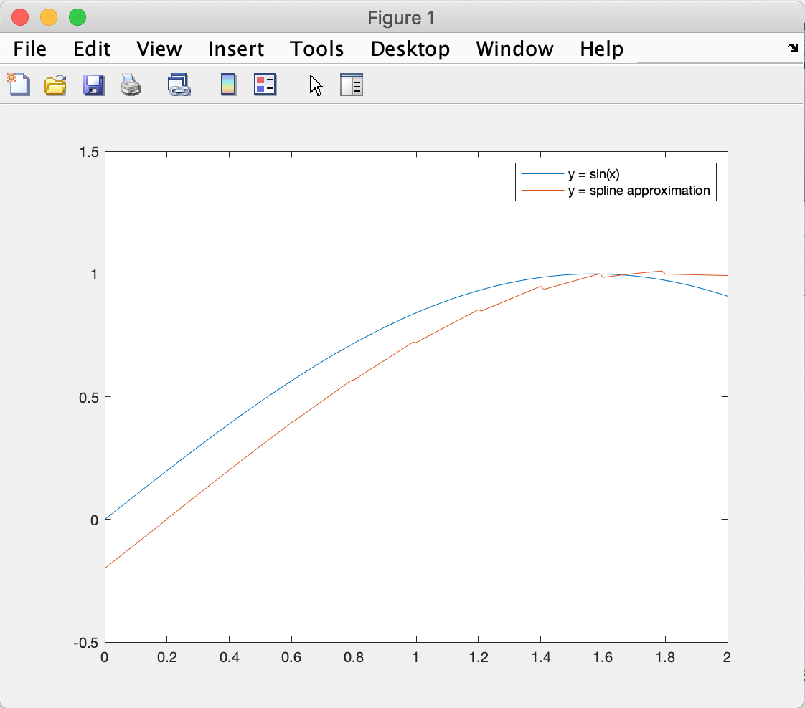

# panels Error Convergence

10 1.9955644360e-01 0.0000000000e+00

20 9.9944472216e-02 0.0000000000e+00

40 4.9993056424e-02 1.0018051971e+00

80 2.4999131972e-02 1.0004509566e+00

160 1.2499891494e-02 1.0001127177e+00

320 6.2499864367e-03 1.0000281781e+00

The order of convergence is around 1

d)