# 计算机病毒学

Linux磁盘数据



学号：0x091395

姓名：uknowho

主要代码

#include "dialog.h"

#include "ui_dialog.h"

#include <sys/types.h>

#include <fcntl.h>

#include <unistd.h>

#include <sys/stat.h>

Dialog::Dialog(QWidget *parent) :

QDialog(parent),

ui(new Ui::Dialog)

{

ui->setupUi(this);

current_cursor=0;

Dialog::on_btn_prev_clicked();

}

Dialog::~Dialog()

{

delete ui;

}

void Dialog::on_btn_prev_clicked()

{

int fd=::open("/dev/block/8:0", O_RDONLY); //disk data

//int fd=::open("/dev/mem", O_RDONLY); //RAM data READ FAILED!

char buf[0x200]={0}; //read 1 sector data once

if(current_cursor!=0)

::lseek64(fd,(--current_cursor)*0x200,SEEK_SET);//dao shanqv tou

else

::lseek64(fd, 0, SEEK_SET); //begin to read

if(read(fd, buf, 0x200))

{ //show data

ui->te_show_data->setText(diskFormat(buf, 0x200));

ui->et_page_num->setText(QString::number(current_cursor));

::close(fd);

}

else

return;

}

void Dialog::on_btn_next_clicked()

{

current_cursor++; //ditto

int fd=::open("/dev/block/8:0", O_RDONLY);

char buf[0x200]={0};

::lseek64(fd,current_cursor*0x200,SEEK_SET);

if(read(fd, buf, 0x200))

{

ui->te_show_data->setText(diskFormat(buf, 0x200));

ui->et_page_num->setText(QString::number(current_cursor));

::close(fd);

}

else

return;

}

void Dialog::on_btn_jump_clicked()

{

bool ok=false; //function var

long sector_num=ui->et_page_num->toPlainText().toLong(&ok, 10);

if(ok)

{

if(sector_num<0)

return;

int fd=::open("/dev/block/8:0", O_RDONLY);

char buf[0x200]={0};

::lseek64(fd,sector_num*0x200,SEEK_SET);

if(read(fd, buf, 0x200))

{

ui->te_show_data->setText(diskFormat(buf, 0x200));

//ui->et_page_num->setText(QString::number(current_cursor));

::close(fd);

}

else

return;

}

}

QString Dialog::diskFormat(char *buf, int size)

{

QString data="OFFSET 00 01 02 03 04 05 "

"06 07 08 09 0A 0B "

"0C 0D 0E 0F\n0000 ";

QString text="";

for(int i=0; i<size; i++)

{

if(i!=0 && i%16==0)

{

data+=" "+text;

data+=QString::asprintf("\r\n%04X ", i);

text="";

}

else if(i!=0 && i%8==0)

{

data+=" ";

text+=" ";

}

data+=QString::asprintf("%02X ", buf[i]&0xFF); //tongyi shuju changdu 8bit

if(isprint(buf[i]))

text+=QString::asprintf("%c", buf[i]); //readable var print

else

text+="."; //non-readable var repalced with .

}

return (data+" "+text); //retrun data.

}

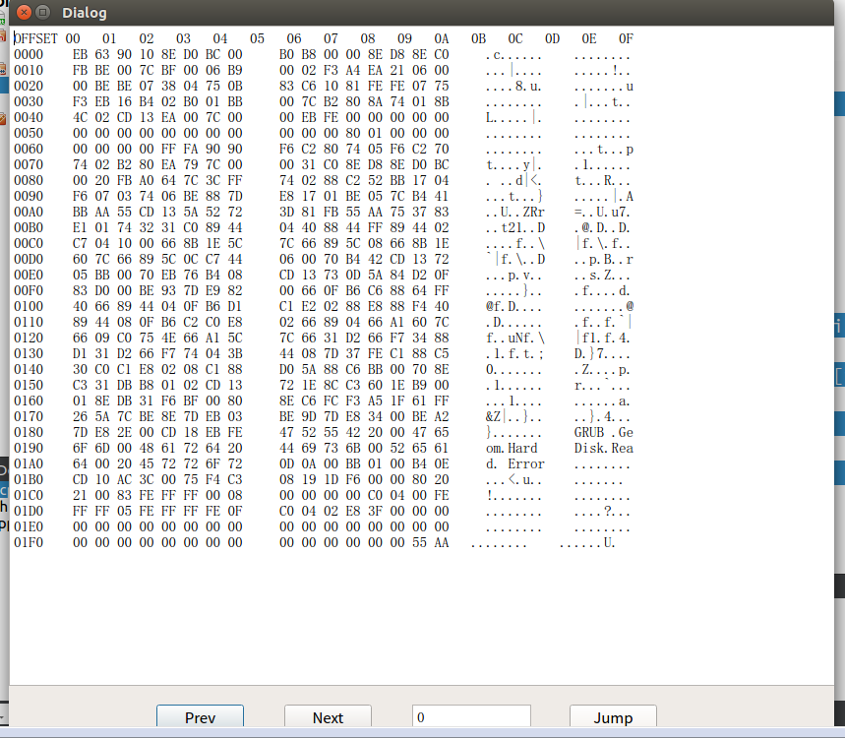

三个功能函数，分别对应 PREV NEXT JUMP

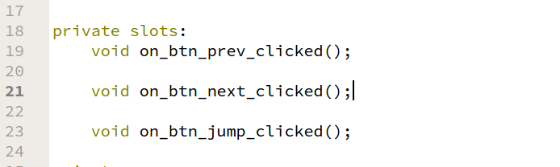

界面控件

3 BUTTON 2 TEXT_EDIT

