# 计算机图形学

实验5

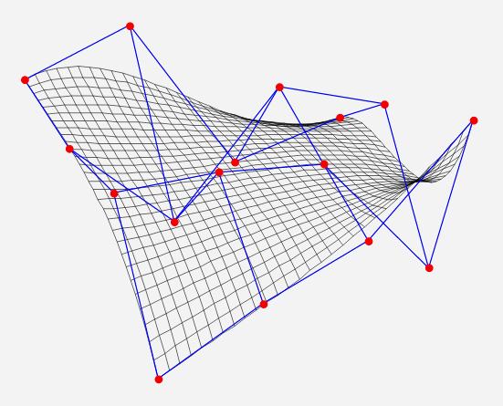

学号：0x091395

姓名：uknowho

一、 实验目的

1. 绘制精美图案

二、 实验原理

**蝴蝶结：**

void CMFCApplication1View::DrawRose()

{

CDC *pDC=GetDC();

int d,k,x1,x2,y1,y2;

float pi,a,e;

CPen pen;

pen.CreatePen(PS_SOLID,1,RGB(0xff,0,0));

CPen *pOldPen = pDC->SelectObject(&pen);

pi = 3.1415926;

d = 80;

for (a = 0; a<=2 * pi; a+= pi/360)

{

e = d * (1+0.25*sin(4*a));

e = e * (1 + sin(8*a));

x1 = int(320+e*cos(a));

x2 = int(320+e*cos(a + pi/8));

y1 = int(200+e*sin(a));

y2 = int(200+e*sin(a + pi/8));

pDC->MoveTo(x1,y1);

pDC->LineTo(x2,y2);

}

}

**正叶线：**

void CMFCApplication1View::DrawLeaf()

{

CDC *pDc=GetDC();

CPen pen;

pen.CreatePen(PS_SOLID,1,RGB(0,0,0xff));

CPen *pOldPen = pDc->SelectObject(&pen);

int a,n,cx,cy,gx,gy,flag,k;

double r,p,th,x,y,pi;

a = 160;n = 2;pi = 3.1415926;

cx = 700;

cy = 500;

flag = 0; k = 200;

for (p = 1; p >= 0.2; p-=0.2)

{

for (th = 0; th <= 2*pi+0.1; th += pi/k)

{

r = fabs(a*cos(n*th)*p);

x = r*cos(th);

y = r*sin(th);

gx = int(cx+x);

gy = int(cy+y);

if (flag == 0)

{

pDc->MoveTo(gx,gy);

}

flag = 1;

pDc->LineTo(gx,gy);

}

flag = 0;

}

pDc->SelectObject(pOldPen);

}

三、 实验内容及结果

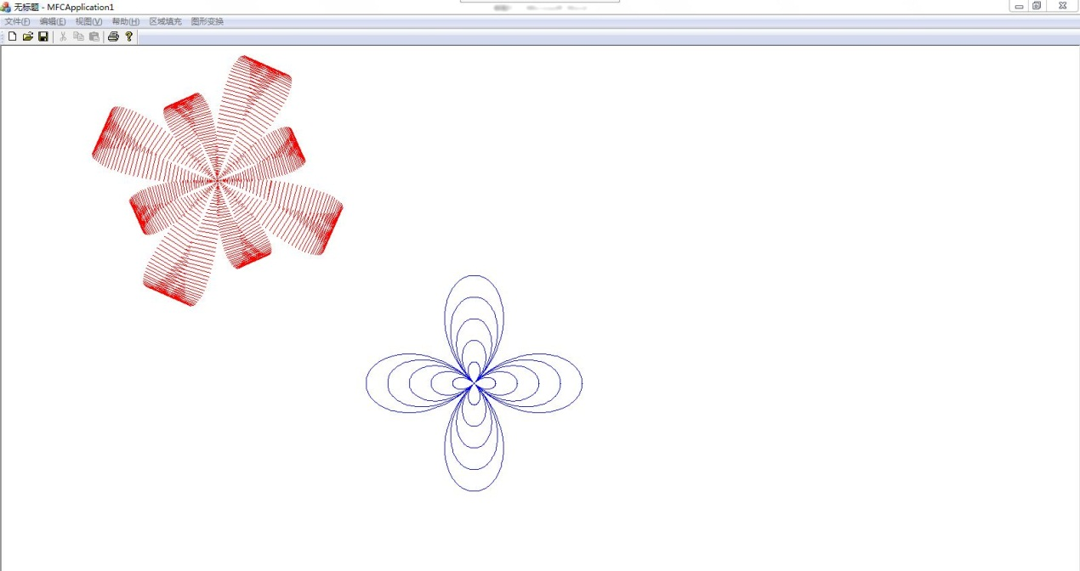

图1 实验结果