Detailed Project Synopsis & Report
SkillRise AI: Smart E-Learning & Placement Preparation Platform
Project Title: SkillRise AI: Smart E-Learning & Placement Preparation Platform

Domain: Artificial Intelligence, Full-Stack Web Development, E-Learning
Language/Tech: Python, Flask, MongoDB Atlas, HTML5, CSS3, JavaScript, Google Gemini

Candidate Details
- Name of Student: [Your Name]
- Roll Number: [Your Roll Number]
- Department: Computer Science and Engineering
- Institution: [Your Institution Name]
- Project Guide: [Guide Name / Designation]

ABSTRACT

In the modern competitive job market, candidates require a diverse set of capabilities, including technical coding skills, quantitative aptitude, verbal and logical reasoning, and fluent communication. Traditional e-learning platforms often offer fragmented resources, forcing students to navigate multiple applications. Furthermore, static study materials fail to adapt to a student's individual learning speed and style.

SkillRise AI is an all-in-one, gamified, and AI-driven placement preparation ecosystem designed to address these gaps. By utilizing the advanced reasoning capabilities of the Google Gemini Large Language Model (LLM), SkillRise AI offers dynamically updated learning roadmaps, an interactive coding playground with real-time AI debug explanations, automated quantitative/reasoning tests, and a communication coach that provides real-time vocabulary and grammar analytics. Additionally, it features an interactive, Hinglish-speaking AI Coding Coach that teaches programming through stories, analogies, and edge-case testing, reducing the learning barrier for non-native English speakers. The platform includes a custom Object-Document Mapper (ODM) that bridges SQL-style syntax with MongoDB Atlas, establishing a robust and scalable cloud-based database foundation.

Keywords: Artificial Intelligence, Gemini LLM, E-Learning, Placement Preparation, Hinglish Coach, Flask, MongoDB Atlas, Gamification.

2.1 INTRODUCTION

The gap between academia and industry readiness is a major challenge for graduating students. Placement preparation involves mastering multiple domains:
1. Core Technical Skills: Data Structures, Algorithms, and Software Engineering.
2. Cognitive Skills: Quantitative Aptitude, Logical Reasoning, and Verbal Ability.
3. Communication Skills: Interview conversations and professional writing.
SkillRise AI combines these domains into a single, unified web application. It uses artificial intelligence to create a personalized study assistant for every student, offering structured learning plans, interactive exercises, and progress tracking.

2.2 PROBLEM STATEMENT

Current e-learning models suffer from several limitations:
- Fragmented Tools: Students must use one tool for coding, another for aptitude tests, and a third for communication prep.
- Lack of Personalization: Materials are static and do not adjust to the user's current skill level.
- Passive Learning: Reading articles or watching videos without interactive feedback leads to lower retention rates.
- Language Barriers: Complex technical concepts are often explained in dense English, making it difficult for students from non-English speaking backgrounds.

2.3 PROPOSED SYSTEM

SkillRise AI addresses these issues with several key features:
- Centralized Hub: A unified portal for coding, aptitude, typing, communication, and notes.
- Personalized AI Roadmap: An AI engine that generates customized daily tasks based on the user's profile and progress.
- Interactive AI Coach: A tutor that explains concepts in Hinglish (Hindi + English) using real-world analogies.
- Gamification: Features like streaks, experience points (XP), and badges to increase engagement and consistency.

SYSTEM REQUIREMENT

3.1 HARDWARE REQUIREMENTS
- Client Side (Student):
- Processor: Dual-Core 2.0 GHz or higher.
- RAM: 4 GB minimum.
- Storage: Modern web browser cache storage.
- Server Side (Deployment):
- Processor: Quad-Core 2.4 GHz or higher.
- RAM: 8 GB minimum (to handle concurrent requests and AI stream pipelines).
- Storage: 20 GB SSD storage minimum.
3.2 SOFTWARE REQUIREMENYTS
- Operating System: Windows 10/11, macOS, or Linux (Ubuntu 20.04+ recommended).
- Development Environment: Python 3.9+, Visual Studio Code.
- Runtime Backend: Flask 3.0.3, WSGI server.
- Database: MongoDB Atlas (Cloud NoSQL Cluster), SQLite (local testing fallback).
- API Dependencies: Google GenAI SDK (`google-genai`), Python requests, PyMongo.
- Frontend Frameworks: HTML5, CSS3, ES6 JavaScript, Lucide Icons.

3.3 FEASIBILITY STUDY

- Technical Feasibility: The project uses Python and Flask, which have mature ecosystems. Integrating the Google Gemini API provides advanced reasoning capabilities without the need to host and maintain large local models, making the system lightweight and scalable.
- Operational Feasibility: The user interface is designed with a modern, glassmorphic layout. This provides an intuitive experience for students, requiring no prior training to navigate the dashboard, coding arena, or aptitude tests.
- Economic Feasibility: The development stack relies on open-source technologies (Python, Flask, SQLite/MongoDB Community). Google Gemini API offers cost-effective pricing tiers for educational tasks, making the platform economically viable.

SYSTEM DESIGN & ARCHITECTURE
4.1 SYSTEM BLOCK DIAGRAM
The architecture follows a Model-View-Controller (MVC) pattern, adapted for RESTful communications and external AI services.

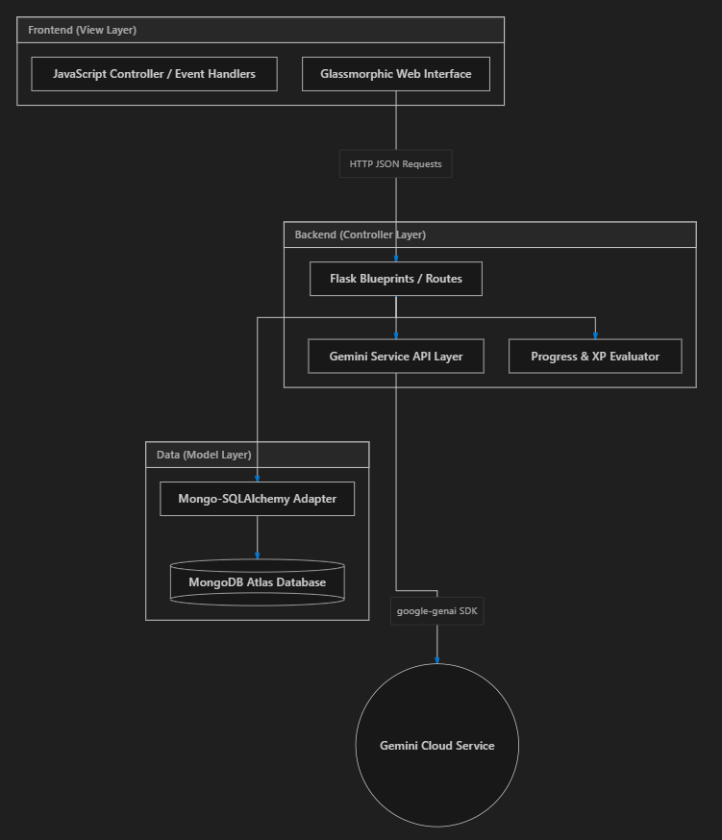
4.2 DATA FLOW DIAGRAM (DFD LEVEL 1)

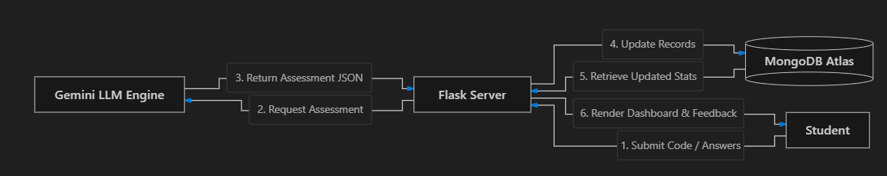

DETAILED MODULE DESCRIPTION

SkillRise AI consists of several key modules:
5.1 PERSONALIZED DAILY ROADMAP MODULE
- Input: User profile stats, current level, goal, and study time.
- Processing: The roadmap engine queries the database, formats a user profile JSON, and prompts Gemini to generate a tailored 6–8 task daily study plan covering multiple domains.
- Output: A structured interactive list of daily tasks on the dashboard.
5.2 PROFRAMMING ARENA MODULE
- Input: User code input (Python/JS/Java) and the student's questions.
- Processing: The system evaluates standard logic or sends code blocks to Gemini for code analysis, explanation, optimization recommendations, and edge-case validation.
- Output: Real-time feedback, detailed step-by-step code analysis, and code walkthroughs.
5.3 AI COMMUNICATION COACH AND HINGLISH AI COACH
- Communication Coach: Evaluates text for grammatical errors, vocabulary range, and clarity. It outputs an improved sentence structure along with explanation tips in Hindi.
- Hinglish Coding Coach: A conversational chat interface. The tutor responds in Hinglish, using real-world analogies and stories to explain programming concepts step-by-step.

DATABASE SCHEMA & DATA MODELING

The system uses a custom database adapter layer that allows MongoDB collections to be queried and manipulated using standard SQLAlchemy-like syntax in Python.
6.1 COLLECTION SCHEMA DESIGN
1. User Collection (`users`)
Field Name | Data Type | Default Value | Description
`id` | Integer (Primary Key) | Auto-increment | Unique identifier
`name` | String(100) | 'Student' | User's display name
`goal` | String(200) | 'Improve Skills' | Target placement goal
`xp` | Integer | 0 | Total experience points
`level` | Integer | 1 | Calculated Level: `(xp // 500) + 1`
`streak` | Integer | 0 | Number of consecutive active days
`last_activity_date` | Date | Current Date | Timestamp of last activity
`typing_speed` | Integer | 20 | Words Per Minute (WPM) baseline
`programming_level` | Integer | 1 | Programming rating (1 to 10)
`aptitude_level` | Integer | 1 | Aptitude rating (1 to 10)

2. Daily Roadmap Collection (`daily_roadmaps`)
Field Name | Data Type | Default Value | Description
`id` | Integer (Primary Key) | Auto-increment | Unique identifier
`user_id` | Integer | Foreign Key | Owner user id
`day_number` | Integer | 1 | Target day of roadmap
`plan_json` | Text (JSON String) | - | Comprehensive JSON task list
`completed_tasks` | Text (JSON String) | '[]' | List of completed task ids
`completed` | Boolean | False | True if all tasks finished

3. Quiz Results Collection (`quiz_results`)
Field Name | Data Type | Default Value | Description
`id` | Integer (Primary Key) | Auto-increment | Unique identifier
`user_id` | Integer | Foreign Key | Student identifier
`subject` | String(50) | - | Quiz category (e.g. Aptitude)
`score` | Integer | 0 | Correct answers
`accuracy` | Float | 0.0 | Calculated percentage
`weak_topics` | Text (JSON String) | '[]' | AI flagged weak areas

SYSTEM TESTING

7.1 System Testing Strategy
The platform undergoes a multi-phase testing strategy:
1. Unit Testing: Individual route functionalities and helper utilities are tested in isolation (e.g., verifying that the custom MongoDB adapter correctly parses query limits and filters).
2. Integration Testing: Ensuring the Flask server, the database collections, and the Gemini API client interact correctly. This includes verifying that raw markdown responses from Gemini are successfully stripped and parsed into structured JSON.
3. API Fallback Testing: Testing the system's behavior when the Gemini API is unavailable or the API key is missing. This confirms that the platform correctly falls back to predefined local questions, roadmaps, and notes.

FUTURE SCOPE

- Voice-Based Mock Interviews: Expanding the Communication Coach to evaluate audio inputs, providing real-time feedback on pronunciation and speech pacing.
- Shared Leaderboards: Introducing group dashboards, team challenges, and peer-to-peer coding arenas to increase student collaboration.
- Auto-Execution Sandbox: Integrating a secure, containerized sandbox environment (e.g., Pyodide or Docker micro-containers) to run and validate user-submitted code against pre-configured test cases.

CONCLUSION

SkillRise AI provides a unified platform for placement preparation. By combining technical coding challenges, aptitude tests, typing practice, and communication coaching under a single dashboard, it reduces the need for fragmented tools. The integration of the Google Gemini API enables personalized study plans and interactive coaching, helping students build their skills and prepare for their careers.

References / Bibliography

1. Grinberg, M. (2018). *Flask Web Development: Developing Web Applications with Python*. O'Reilly Media.
2. Banker, K. (2011). *MongoDB in Action*. Manning Publications.
3. Google GenAI Documentation. (2024). *Gemini Models & API reference guides*. Google AI Studio.
4. Chodorow, K. (2013). *MongoDB: The Definitive Guide*. O'Reilly Media.

