**Some Optimization Models of Tool Path Problem with Constraints**

Alexander Petunin1, Pavel Chentsov1,2, Evgeniy Ivanko1,2

1Ural Federal University, Yekaterinburg, Russia,

2Institute of mathematics and Mechanics, UBr RAS, Yekaterinburg, Russia

Abstract: The problem of tool path optimization for CNC sheet metal cutting equipment is considered. Sheet metal cutting equipment includes laser/plasma/gas/water-jet machines and some others. Users of CAD/CAM systems develop numerical control programs for the cutting equipment after nesting of parts onto the sheet. The control programs contain information about tool path. The tool path is a routing of cutter head used for cutting of sheet material. Classification and the correspondent mathematical models of tool path problem are considered. The tasks of cost/time minimization for various types of cutting techniques are formalized. Mathematical formalization of technological constraints for these tasks is also described. Unlike the known analogs this formalization allows to consider constraints of thermal cutting. In some cases, the optimization tasks can be interpreted as discrete optimization problem (generalized travel salesman problem with additional constraints, GTSP). In paper also the developed exact algorithm and some heuristic algorithms of tool path optimization based on described models is reported. Results of computing experiments for some instances are given. Last section of paper descriebs TSP approach to simplified cutting problem

*Keywords:* Tool path problem, CNC sheet metal cutting machines, control programs, technological constraints, thermal cutting, segment cutting, discrete optimization, TSP, GTSP, dynamic programming, greedy algorithm

1. INTRODUCTION

In various industries many parts are produced from sheet materials by CNC equipment. Such kind of equipment includes, for instance, machines for laser, plasma, gas, and water-jet cutting. Special software (Computer-Aided Manufacturing, CAM systems) provides an automation of development of NC (numerical control) programs. Generating of NC programs is next step after nesting that is positioning parts onto sheet material. Optimization of sheet utilization reduces the cost of sheet material used for parts producing. The nesting problem was not considered in this study. The control programs contain information about tool path for CNC machine and some technological commands. Optimization of tool path reduces time and cost of cutting process. First classification of problem was conducted by Hoeft and Palekar (1997). Tool path problems are usually divided into 4 classes depending on cutting technique and its parameters (see, for Example, Dewil et al. (2015)):

1. *Continuous Cutting Problem (CCP).*
2. *Endpoint Cutting Problem (ECP).*
3. *Intermittent Cutting Problem (ICP).*
4. *Generalized Traveling Salesman Problem (GTSP).*

Petunin (2015) offered new classification of cutting techniques and described one more class of problem: *Segment Continuous Cutting Problem (SCCP).*

The tool path includes the following components (see Fig.1, Fig.2):

* pierce points (piercings);
* points of switching the tool off;
* tool trajectory from piercing upto point of switching the tool off;
* lead-in (tool trajectoryy from piercing upto the entry point on the equidistant contours);
* lead-out (tool trajectoryy from exit point on equidistant contour up to tool switching off point);
* Airtime motions (linear movement from tool switching off point upto the next piercing).

Entry point in an equidistant contour

Point for the switching off of tool

Piercing

Contour

of part

Lead-in

Lead-out

An equidistant contour

Direction of the cutting

Figure 1. Scheme of the standard cutting technique

Fig. 2 shows an example of non-standard cutting techniques. In practice CAM systems users often use the various cutting technique interactively to get technologically admissible solutions. Trajectories of lead-in to the contour and lead-out (exit of contour) also can be different (along the straight line, along the arc, “in corner” and etc.). Decrease of the sheet material deformation is provided in particular by lead-in "in corner" of part (Fig.3).

Automatic methods are developed generally to discrete models (GTSP and ECP). Some heuristic algorithms are offered by Lee and Kwon (2006), Verhoturov and Tarasenko (2008), Xie and al. (2009), Yang et al. (2010), Dewil et al. (2011, 2015, 2015a), Jing and Zhige (2013), Helsgaun (2014). For GTSP class without technological constraints the effective approximate algorithms offered by Karapetyan and Gutin (2011, 2012) also can be used. For the same class of problems with precedence constraints Petunin and al. (2014, 2015a) described an exact algorithm based on method of dynamic programming.

Initial location of tool

Airtime motion

11

23

Figure 2. Example of cutting for two parts (three contours) by using technique "chain cutting"

Figure 3. Example of lead-in ''in corner''

The existing mathematical models and algorithms do not consider many technological constraints of the thermal cutting process in particular heuristic rules “part hardness rule” and “sheet metal hardness rule”. The latter was described by Petunin (2009). In this paper we formalize this kind of constraints and describe a new formalization of the tool path problem concerning cutting technique we used. In certain cases we will interpret the considered optimizing tasks as problems of discrete optimization with additional constraints. In paper the results of computing experiments for some instances are also given

2. CLASSIFICATION OF THE CUTTING TECHNIQUES AND FORMAL DEFINITION OF TOOL PATH

*Definition 1*. Segment of cutting ****is a tool trajectory from piercing  upto point of switching the tool off ..

*Definition 2*. Basic segment  is a part of segment  without trajectory lead-in and trajectory lead-out.

Let's consider that unlike a cutting segment the corresponding basic segment has no direction of cutting, i.e. it contains only geometry information. In Fig. 4 (see also Fig.2) two basic segments are allocated with dashed lines of orange and yellow color.

Lead-in 1

Lead-out 1

Lead-out 2

Lead-in 2

Figure 4. Illustration of term “basic segment” for example given in Fig.2

All the cutting techniques we divide into three classes:

1. Standard cutting.
2. Multi-contour cutting.
3. Multi-segment cutting.

Standard cutting technique assumes:

* Piercings number is equal to contours number and parts number;
* Cutter head runs each closed equidistant contour of part to cut exactly once from beginning to end.

At the same time the basic segment coincides with this closed contour.

The multi-contour cutting cuts several contours in one segment of cutting. External contours of parts are cut jointly with the only piercing without switching cutter head off.

The multi-contour cutting can be itself divided into 2 classes: “chain” cutting (see Fig.2), and multi-section cutting. The latter assumes that some contours can be cut piecemeal. Example of Multi-section cutting is in Fig.5.

Figure 5. Multi-section cutting: “Snake” technique

Multi-segment cutting cuts single contour in several segments of cutting (Fig. 6).

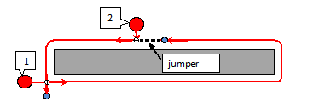

Figure 6. Multi-segment cutting: “Jumper” technique

Let  to be finite set of two-dimensional geometrical objects. These objects are geometrical models of flat parts. Each object is described by one or several closed curves (boundary contours). Let also *N* to be number of external and the internal closed contours , that describe parts positions (the nesting) on sheet material. . Example of nesting is shown in Fig. 7 (*n*=18*, N*=23).

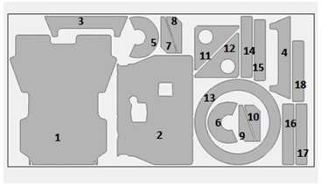

Figure 7. Nesting example with parts containing internal contours

Let *K* be the number of segments the tool path consists of. . Single segment may contain one contour, a few contours (for the multi-contour cutting), or a part of contour (for multi-segment cutting). Sequence of segments is a permutation , i.e. the ordered set of natural numbers from 1 to *K* or bijection on a set. Thus, the tool path is defined by a tuple:

 (1)

Fig.8 shows the scheme of tool path route for the nesting given on fig. 7. The tool path contains 21 segments. For cutting of external contours of parts 7 and 8, and also of 9 and 10 the Multi-contour cutting is used (brown color). All other 19 contours are cutting by the standard cutting.

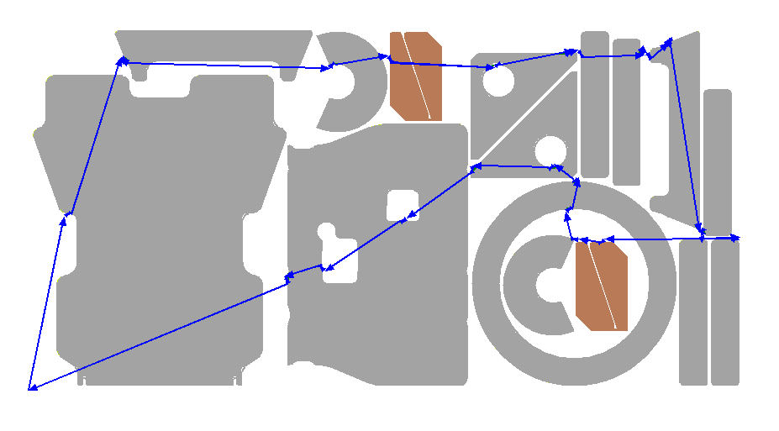

Figure 8. Example of tool path consisting of 21 cutting segments

During development of NC programs for CNC sheet metal cutting machines the problems of tool path optimization arise. As optimization criteria in these problems the parameters of cutting time and cost are considered. They are calculated by following formulas:

 (2)

 (3)

Here is length of idling tool path; is length of working tool path; is speed of idling tool path;  is speed of the working tool path;  is cost of idling tool path unit; is cost of working tool path unit;  is numbers of piercing; is time of one piercing; is cost of one piercing.

If various piercing types are used then (2) becomes:

 (4)

when *p* is number of used piercing types;  is numbers of *j* type piercing; is time of one *j* type piercing. The cutting cost *Fcost* is calculated by:

 (5)

whenis cost of one *j* type piercing.

In (2)-(5) the values of speed of working and idling tool path, time of one piercing are usually constant for concrete material and manufacturing equipment. If standard cutting technique (when numbers of piercing equal numbers of cutting contours) is applied then numbers of piercing are constant too.In (3) and in (5) *Con*, *Coff* and *Cpt* are values depending on type of CNC cutting machines, cutting technologies, thickness and type of material.

Any objective function (2)-(5) for the tool path depends on elements of tuple (1). Further we will consider the main technological restrictions for admissible values of elements .

3. FORMALIZATION OF CONSTRAINTS FOR THE TOOL PATH

*3.1. Constraints for coordinates of piercings*

This type of constraints is determined by cutting technology features. Piercing shall occur at sufficient distance from part contour. The distance is defined by technological parameters. Coordinates of piercings are calculated to fall into admissible geometrical area. Fig.9 shows an admissible geometrical area of piercings for external contours of parts  and . A minimum admissible distance from a contour of part upto piercing is equal to 25 mm.

By   we will denote theequidistant contours of contours , remote from them at a distance *d* ().  are external equidistant contours for external contours of parts and at same time  are internal equidistant contours for internal contours of parts.

Let *ОUT* is a set of indexes of external contours, аnd *IN* is respectively a set of indexes of internal contours, i.e. . Let's notice that if  (all contours are external) then . Let is a half with (a half allowance) for the cutting process. Then trajectories of the cutting segments for cutting of parts  has to contain all contours , i.e. .

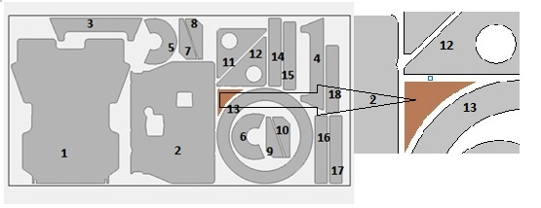Figure 9. Example of admissible geometrical area for piercings (brown color)

Let *d1* is a minimum admissible distance from a equidistant contour  upto any piercing. By  we will denote the two-dimensional geometrical objects restricted by closed contours  . Then piercings and points of switching the tool off for each cutting segment  shall meet the following conditions:   (6)  (7)

As it is easy to notice the sets meeting conditions (6) and (7) have cardinality of continuum. At the same time the main approach to the solution of optimizing tasks (2)-(5) is a reducing of set of admissible tool paths upto discrete set. In our formulation it means need of choice of discrete subset of admissible values of elements for tuple (1). The easiest way for the solution of this task at the choice of admissible values for is formation of the discrete set on borders of geometrical areas (6) and (7). In Fig. 10 finite set of admissible pierсings for the reviewed example is shown.

Value of *d1* (minimum admissible distance from a basic segment upto any piercing) is equal to 25 mm.

.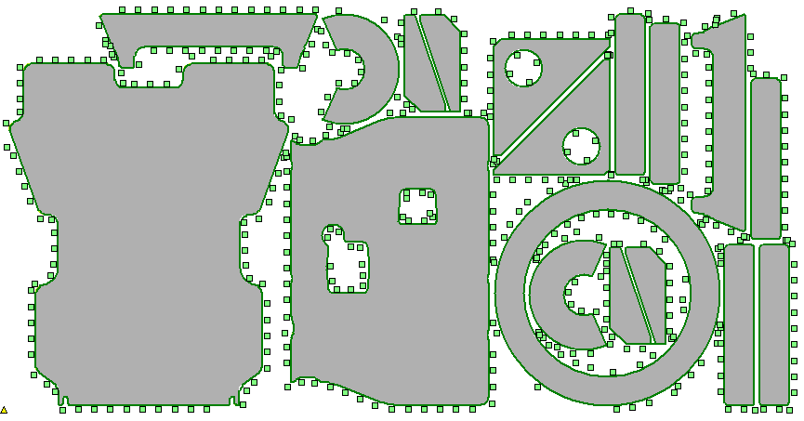

Figure 10. Example of finite set of piercings (green color)

*3.2. Constraints “A part hardness rule”.*

This kind of the additional restrictions for values of the piercing coordinates is formulated by Petunin (2009) in form of the heuristic recommendation for the technologists-programmers developing the NC programs. It is caused by thermal deformations of material in case of thermal cutting of parts. Its sense consists in the following.

The place of piercing and the direction of the cutting are chosen so that at first the contour sites located in close proximity to material border, or to border of the cut-out area were cut, and completion of the cutting happened on a site of the contour adjoining on the "hard" part of the sheet.

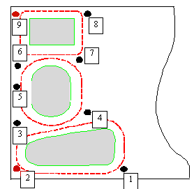

Figure 11. Illustration of “A part hardness rule” at choice of admissible piercings for 3 contours

Fig. 11 shows an Example with 3 parts (3 contours) and with 9 possible piercings.

If all contours are cutting clockwise, then the set of piercings 1, 4, 7 is the most preferable. If contour is cutting counterclockwise then piercings 4, 7, 8 (or 4,6,8) are admissible. Points 2,9 are inadmissible under any conditions.

The following formalization of the rule is offered. For each point , meeting a condition (7) and taking into account the direction of the cutting we form two-dimensional area (hardness area) bounded by a basic segment with length of *L* and by an equidistant contour where *R* – the area radius. From two other parties the area is bounded by pieces of straight lines, perpendicular to a basic segment. One of these pieces begins in a point of switching off of the tool (see Fig. 12). On this example for the cutting of a part *A4* two possible piercings *M1* and *M2* and the points of switching off of the tool corresponding to them are allocated. The formal rule of admissibility of the chosen couple (piercing, a point of switching off of the tool) is that the created hardness area (yellow color) should not have nonempty crossings with already cut out parts or with boundaries of the sheet material. In the given example the cutting segment from the beginning in *M1* point meets this requirement. For a segment from the beginning in the *M2* the respective hardness area has nonempty crossing with part *A1* but the part was already deleted from a sheet.

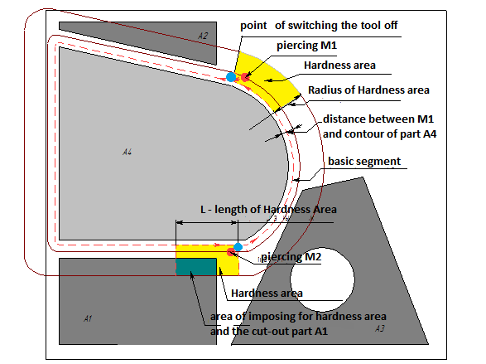

Figure 12. Geometric formalization of “A part hardness rule”

*3.3. Precedence constraints*

This kind of constraints imposes the restrictions on the sequence of the cutting segments . Constraint is caused by technological features of CNC cutting machines that do not allow cutting the internal contour accurately if external contour has already been cut because the part after the cutting can change its position on the cutting table.

A constraint is described in many publications concerning routing algorithm development (see, for Example, Verhoturov and Tarasenko (2008), Dewil et al. (2011)). Formalization and realization of this constraint usually does not causes technical difficulties. Petunin and al. (2014) shows that reduction of admissible permutations  allows in some problems of big dimension to use algorithms of global optimization for searching exact solutions.

*3.4. Constraints “A sheet hardness rule”.*

This constraint imposes the restrictions also on the sequence of the cutting segments . Constraint is caused by technological features of thermal cutting (Petunin (2009)). The rule is a set of heuristic recommendations for the choice of an order of the cutting and is used mainly at interactive mode of the NC programs generation. In Fig.13 some simple recommendations about the choice of the sheet party with which it is necessary to begin the cutting process are shown.

A sheet hardness rule also contains many other recommendations of the concerning methods of reduction of thermal deformations. Mathematical formalization of the rule is the complex problem. The mechanism of the accounting of similar constraint was offered by Chentsov A.A. and Chentsov A.G. (2013) for the solution of the megalopolises problem (see also Chentsov and Salii (2015)). When developing algorithms of optimization for tasks (2)-(5) we used this model that allowed to formalize the constraint 3.4.

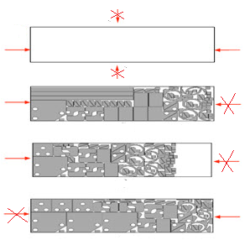

Figure 13. Rules of the choice of the sheet party at thermal cutting

4. DISCRETE MODELS OF OPTIMIZATION PROBLEMS FOR THE TOOL PATH ROUTING

As the main optimization problem we consider *Segment Continuous Cutting Problem (SCCP)* for objective functions (2)-(5) (see Petunin (2014)). SCCP assumes that for the received nesting the number *K* of the used segments is in advance defined and basic segments are defined. Thus the optimizing problem of searching of tuple (1) optimizing objective function is reduced to searching of points  and also to searching of optimum sequence . It is easy to see, that this problem belongs to the class of the discrete optimization and at the same time to a class of the continuous optimization. Transition to the discrete model is carried out due to selection of finite set of admissible piercings  and points of switching off of the tool  for each given basic segment . Selection procedure is described in paragraph 3.1. We assume that for each point  of possible piercings one point of switching off of the tool is defined. Thus the problem of SССP can be interpreted as the generalized traveling salesman problem (GTSP) with additional constraints 3.2. - 3.4. For the solution of GTSP the mathematical model of megalopolises based on the special scheme of a dynamic programming offered by A.Chentsov is used. The following algorithms for solution of SCCP are developed:

* Exact algorithm based on a dynamic programming;
* Genetic algorithm;
* Iterative greedy algorithm;
* Special option of iterative greedy algorithm for the accounting of a constraint 3.4.

All algorithms allow to consider the constraints 3.1 and 3.3. The iterative algorithm includes the accounting of constraints 3.2. Special option of algorithm considers all constraints. Now we develop the precise algorithm considering all technological restrictions of the thermal cutting. In fig. 14 the example of the exact solution of discrete option of SCCP in form of GTSP with additional constraints for objective function (2) is given. Fig. 15 shows the tool path for case of thermal technology of the cutting.

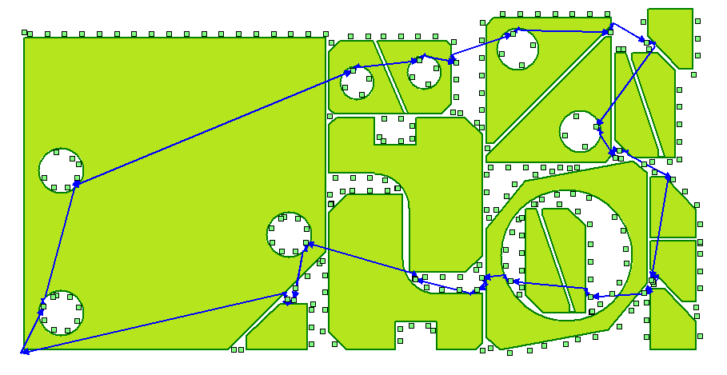

Figure 14. Example of the optimum tool path for SCCP

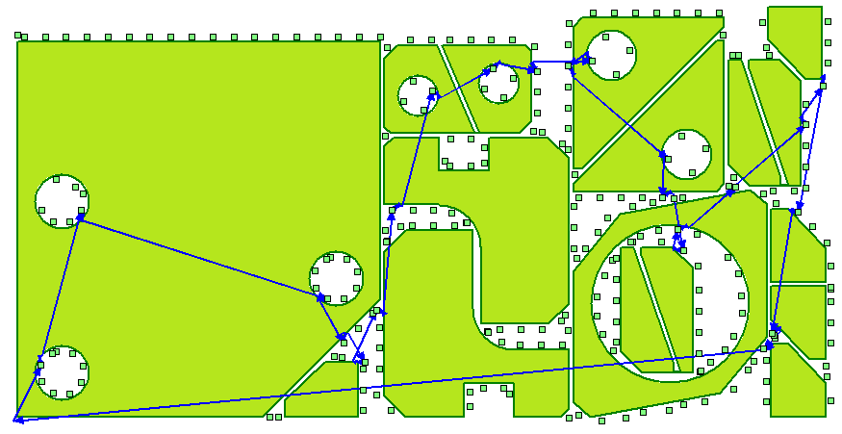

Figure 15. Example of the tool path for the thermal cutting

In the next section we give TSP approach to simplified cutting problem, where segment solution appears naturally.

1. ONE IDLING PATH OPTIMIZATION APPROACH RESULTING IN SEGMENT CUTTING

Let us consider the problem of idling path minimization. Below we propose a way to reduce this problem to classical TSP with complicated weight matrix and thus to summon a vast number of powerful TSP solution techniques for the original engineering problem.

We suppose for the simplicity that the points allowed for piercing lie right on the contour and form a closed polyline cutting all the edges of which is equal to the cutting the correspondent contour itself:

$∀i∈\overline{1,N} {\tilde{C}}_{i}=\left(M_{1}^{i},…,M_{m_{i}}^{i}\right),$ (8)

where all edges ${(M}_{j}^{i},M_{j+1}^{i})$ should necessarily be traced by the cutter (for the simplicity we take $M_{m_{i}+1}^{i}$ as $M_{1}^{i}$). It is not a weakening simplification as usually in general case the “real” trace along contour between each two piercings is known.

While the closed contour polylines should be traced obligatory there are different rational strategies of selecting start and finish points of a contour and moving between contours (minimizing idling path), depending on the parameters of the cutting machine. For example, if we have a metal cutter which takes a considerable time to pierce metal sheet before it can start cutting and the speed of operating run is much less than the speed of idling path, then idling path optimization is not essential and both greedy (see Fig.16a) and optimal sequential (Fig.16b) approaches are applicable (but not Fig.16c, because any additional interruptions connected with pulling out of the cutter are “too expensive”). If cutting speed is comparable to idling path speed, but piercing is still expensive, then optimal sequential approach seems to be the choice. Finally, if all the time costs (piercing and moving between two arbitrary points on the sheet in both operating and idling modes) are comparable as it happens in case of laser cutting of thin materials or plotter machine, then it is rational to use tracing with interruptions approach (Fig.16c).

a b c

Fig. 16. Different approaches to cutting head routing and relative lengths of their idling path (dotted line): a – greedy (100%); b – optimal run, where each contour is associated with only one enter and only one exit point (78%); c – with segments allowed (50%)

Greedy algorithm (used for construction Fig. 16a) is rather simple: we start tracing from the nearest point to the start (point 1 in Fig.16a) and trace continuously the contour which it belongs; after finish we find the nearest unvisited contour point (point 2 in Fig.16a) and switch to it and to the corresponding contour; continue this procedure until there are no untraced contours (with points 3 and 4 in Fig.16a) and return to the start. As we know from the work of P.A. Chentsov (2014) greedy algorithm may be strongly enhanced to consider many difficult cutting constraints arising from practice, while it remains applicable in terms of computational resources and time.

Optimal run algorithm (Fig.16b) may be constructed on the basis of GTSP and also takes into account many different practical constraints. A considerable number of previous works were devoted to this topic (see the detailed description in, for example, in Chentsov (2013) , Petunin (2015a)), so we do not discuss it here.

The practical approach to the rational segmental cutting method (our main topic for this section, Fig.16c) is based on the reduction of idling path optimization (BRO) problem to double sized TSP with a special weight matrix.

We assume, that initially some movement cost function $d_{0}$ is known for all ordered pairs of potential piercings (in the simplest case $d_{0}$ is Euclidean distance). The first peculiarity of BRO in comparison with TSP is the necessity to trace all the edges of closed polyline of each contour. We force traveling salesman to move along the contour edges by adding to their weights negative numbers of large absolute values:

$$d_{1}\left(M_{j}^{i},M_{j+1}^{i}\right):=d_{1}\left(M_{j}^{i},M_{j+1}^{i}\right)-2Ω,$$

$$d_{1}\left(M_{j+1}^{i},M_{j}^{i}\right):=d_{1}\left(M_{j+1}^{i},M_{j}^{i}\right)-2Ω,$$

where

$$Ω=\sum_{i_{1},j_{1},i_{2},j_{2}}{d_{0}(M_{j_{1}}^{i_{1}}},M_{j_{2}}^{i_{2}}).$$

This transformation guarantees that cutting head will trace as many edges of contour polylines as it would be allowed by TSP path limitation (do not visit any potential piercing more than once), as missing even one edge with cost smaller than $-Ω$ will increase the total cost of TSP path by more than $Ω$, which cannot be compensated by any idling path optimization.

Moving inside contours is not a parameter for optimization – we have to trace all the contours along anyway – so equal intra-contour distance changes will not affect the structure of final optimal idling path. After the optimal TSP route is constructed with the cost $Ξ\left(Ω\right)$, the cost of initial BRO may be restored easily:

$$Ξ\left(BRO\right)=Ξ\left(Ω\right)+2Ωm,$$

where

$$m=\sum_{i=1}^{K}{m_{i}}$$

is the total number of piercings in our discretization (which is equal to the total number of mandatory edges of contour polylines that were disturbed by our weights transformation).

The second peculiarity is connected with the piercing cost or the cost needed to start tracing any contour (e.g. perforating the initial bore in case of a cutting machine). To consider this peculiarity it is sufficient to increase the cost of all the movements between contours by piercing cost $C_{pt}$:

$$d_{2}\left(M_{1},M_{2}\right)=\left\{\begin{aligned}d_{1}\left(M_{1},M_{2}\right), if{ M}_{1},M_{2} belong to \\ the same contour; \\ d_{1}\left(M_{1},M_{2}\right)+C_{pt}, otherwise.\end{aligned}\right.$$

Introducing $d_{2}$ to our TSP allows “travelling salesman” to make the best choice (in terms of overall cost minimization) between optimal sequential and segment methods of routing automatically for each particular inter-contour movement. If piercing cost is large we have the situation of Fig.16b, where we try to minimize the number of switches between contours. If $C_{pt}$ is small, the optimal route will tend to switch more often (see Fig.16c).

The third peculiarity that differs the considered routing problem from TSP is that each piercing of each polyline may become an enter or an exit point and thus may be visited twice (see points 1-4 in Fig.16a and b). To consider this peculiarity, we duplicate each vertex

$M_{j}^{i}→\{{\tilde{M}}_{j}^{i}\left(1\right),{\tilde{M}}_{j}^{i}\left(2\right)\}$ (9)

with the correspondent changes to the cost function, where duplicates preserve their parent’s costs $∀i_{1},j_{1},i_{2},j_{2} ∀ k_{1},k_{2}∈\{1,2$}:

$$d_{3}\left({\tilde{M}}_{j_{1}}^{i_{1}}\left(k_{1}\right),{\tilde{M}}_{j_{2}}^{i_{2}}\left(k_{2}\right)\right)=d_{2}\left(M_{j_{1}}^{i_{1}},M_{j_{2}}^{i_{2}}\right).$$

Finally after above three transformations it is easy to see that the optimal solution of the resulting TSP with cities as duplicated piercings and distance function $d_{3}$ will be the optimal solution of the initial BRO problem.

We have considered a simplified cutting problem without any practical constraints (see Section 3). Although this simplified model may be applied to some cutting problems directly (for example, water jet cutting of the details which do not possess holes (inner contours)), it is easy to widen the application area taking into account that many different constraints may be considered at the stage of the resulting TSP solution. For example, if we take precedence constraints (see Section 3.3), we may include them in dynamical programming algorithm (see Petunin et al. (2014, 2015a)) or use a special version of branch-and-cut method (Ascheuer et al. (2000)) or easily adapt Lin-Kernigan heuristic (Lin and Kernigan (1973)).

Below we propose a computation experiment to estimate the effectiveness of the discussed TSP reduction. In the experiment we consider a relatively large cutting problem (without precedence constraints) (see Fig. 17a,b). We suppose that piercing cost $C_{pt}$ is equal to zero (e.g. laser cutting of thin material). After discretization (8) and duplication (9) the number of piercings $m$ is equal to 6740. It is too large travelling salesman problem for direct solution in general case, that is why we used well known Lin-Kernigan heuristic (Concorde (2003)) to get an acceptable solution in considerable time.

The solution was obtained in 27 seconds at AMD Phenom II X6 1055T 2.8GHz, RAM 6Gb, Windows 10 x64. If we take the length of idling path, constructed by greedy algorithm (briefly described below Fig.16) as 100% (see Fig.17a corresponding to the case of Fig.16a), then the length of idling path obtained using the proposed TSP reduction and the following application of Lin-Kernigan heuristic is 30.2% (see Fig.17b corresponding to the case of Fig.16c). This experiment clearly shows the applicability and effectiveness of both the proposed TSP reduction and the segment cutting approach in general in large scale cutting problems.

a

b

Figure 17. Two idling paths for a complex cutting problem (contour cutting pass is not shown as it is identical for all correct paths): a – greedy movement of the cutting head; b – Lin-Kernigan solution of the proposed TSP reduction (vast majority of idling paths between close contours in picture b are too small to be shown)

AKNOWLEDGMENTS

The work was supported by Act 211 Government of the Russian Federation, contract № 02.A03.21.0006

REFERENCES

Ascheuer, N., Jünger, M., Reinelt, G. (2000) A Branch & Cut Algorithm for the Asymmetric Traveling Salesman Problem with Precedence Constraints. *Computational Optimization and Applications*. Volume 17, Issue 1, pp 61-84

Chentsov, A. G., Salii, Ya. V. (2015) [A model of “nonadditive” routing problem where the costs depend on the set of pending tasks](http://www.mathnet.ru/eng/vyuru247). *Vestnik YuUrGU. Ser. Mat. Model. Progr*., 8:1, 24–45

Chentsov, A.A., Chentsov, A.G. (2013) Dynamic programming in the routing problem with constraints and cost depending on a list of tasks*. Doklady Mathematics.* T. 88. V.3. 2013. pp. 637-640.

Chentsov, P.A. About one application of greedy algorithm for the solution of the generalized salesman problem. *Proceedings of the 16h International Workshop on Computer Science and Information Technologies.* Sheffield. England. 2014. Vol.2. pp.148-151.

Dewil, R., Vansteenwegen, P., Cattrysse, D., Laguna, M., Vossen, T. (2015) An improvement heuristic framework for the laser cutting tool path problem. *International Journal of Production Researc*h., **53 (6)** (2015), pp. 1761–1776.

Dewil, R., Vansteenwegen, P., Cattrysse, D. (2014) Construction heuristics for generating tool paths for laser cutters. *International Journal of Production Research,* Mar. 2014, 1-20.

Dewil, R., Vansteenwegen, P., Cattrysse, D. (2015a). Sheet Metal Laser Cutting Tool Path Generation: Dealing with Overlooked Problem Aspects, *Key Engineering Materials,* Vol. 639, pp. 517-524, 2015

Helsgaun, K. (2014). Solving the Equality Generalized Traveling Salesman Problem Using the Lin-Kernighan-Helsgaun Algorithm. *Tech. Rep. December 2013*, Roskilde University, Roskilde

Hoeft, J., Palekar, U. S. (1997). Heuristics for the plate-cutting traveling salesman problem. *IIE Transactions*, **29,** 719-731.

Jing, Y., Zhige, C., 2013. An Optimized Algorithm of Numberical Cutting-Path Control in Garment Manufacturing. *Advanced Materials Research* **796,** 454–457.

Karapetyan, D., Gutin G. (2011) Lin-Kernighan Heuristic Adaptations for the Generalized Traveling Salesman Problem. *European J. of Operational Research* 208 (3): 221–232.

Karapetyan. D., Gutin, G. (2012) Efficient Local Search Algorithms for Known and New Neighborhoods for the Generalized Traveling Salesman Problem. *Eur. J. Oper. Res,* 219(2):234-251.

Lee, M-K., and K-B. Kwon. (2006). Cutting path optimization in CNC cutting processes using a two-step genetic algorithm. *Int. J. of Production Research,* **44 (24):** 5307–5326

Lin, S.; Kernighan, B. W. (1973). An Effective Heuristic Algorithm for the Traveling-Salesman Problem. *Operations Research* 21 (2): 498–516

Concorde TSP Solver Lin–Kernighan heuristic software, downloaded in April 2016, http://www.math.uwaterloo.ca/tsp/concorde/downloads/downloads.htm

Petunin, A. (2009). About some strategies of the tool path modelling at the control programs generation for the flame cutting machines. *Vestnik UGATU*, vol. 13, **2(35),** 280-286.

Petunin, A., Chentsov, A.G, Chentsov, P.A. (2014). Local dynamic programming incuts in routing problems with restrictions. *Vestn. Udmurtsk. Univ. Mat. Mekh. Komp. Nauki*, no. 2, 56–75.

Petunin, A. A., Chentsov, A. G., & Chentsov, P. A. (2015a). About a routing problem of the tool motion on sheet cutting. *Modelirovanie i Analiz Informatsionnykh Sistem [Modeling and Analysis of Information Systems]*, *22*(2), 278-294.

Petunin, [Aleksandr A.](http://scitation.aip.org/search?value1=Aleksandr+A.+Petunin&option1=author&option912=resultCategory&value912=ResearchPublicationContent) (2015). [Modeling of tool path for the CNC sheet cutting machines](http://scitation.aip.org/content/aip/proceeding/aipcp/10.1063/1.4936740)// *AIP conference proceedings. 41st International Conference on Applications of Mathematics in Engineering and Economics (AMEE)*, Sozopol, BULGARIA, JUN 08-13, 2015, **1690**., pp.060002-1 – 060002-7.

Verkhoturov, M.A., Tarasenko, P. Yu. (2008). *Mathematical provision of problem of tool path optimization at flat shape nesting based on “chained” cutting.* Vestnik USATU. Upravlenie, VTiT. Ufa: USATU, V.10, №2 **(27**), pp. 123-130.

Xie, S. Q., Gan, J., Wang, G. G., Vn, C., (2009). Optimal process planning for compound laser cutting and punch using Genetic Algorithms. *International Journal of Mechatronics and Manufacturing Systems*. 2 (1/2), 20-38.

Yang, W. B., Zhao, Y. W., Jie, J., Wang, W. L. (2010). An Effective Algorithm for Tool-Path Airtime. Optimization during Leather Cutting. *Advanced Materials Research.* **102**, 373-377