About some types of constraints in problems of routing

Petunin A.A.1, Polishuk E.G.1, Chentsov A.G.2, Chentsov P.A.2, Ukolov S.S.1

1 Ural Federal University, Yekaterinburg, Russia

2 Institute of Mathematics and Mechanics, Ural Branch of the Russian Academy of Sciences, Yekaterinburg, Russia

**Absract.** Many routing problems arising in diﬀerent applications can be interpreted as a discrete optimization problem with additional constraints. The latter include generalized travelling salesman problem (GTSP), to which task of tool routing for CNC thermal cutting machines is sometimes reduced. Technological requirements bound to thermal ﬁelds distribution during cutting process are of great importance when developing algorithms for this task solution. These requirements give rise to some speciﬁc constraints for GTSP. This paper provides a mathematical formulation for the problem of thermal ﬁelds calculating during metal sheet thermal cutting. Corresponding algorithm with its programmatic implementation is considered. The mathematical model allowing taking such constraints into account considering other routing problems is discussed either.

# Introduction

In various industries many parts are produced from sheet materials by CNC equipment. Such kind of equipment includes, for instance, machines for laser, plasma, gas, and water-jet cutting. Special software (Computer-Aided Manufacturing, CAM systems) provides an automation of development of NC (numerical control) programs. Generating of NC programs is next step after nesting that is positioning parts onto sheet material. Optimization of sheet utilization reduces the cost of sheet material used for parts producing. The nesting problem is not considered in this study. The control programs contain information about tool path for CNC machine and some technological commands. Optimization of tool path reduces time and cost of cutting process. First classification of problem was conducted by Hoeft and Palekar (1997). Tool path problems are usually divided into 4 classes depending on cutting technique and its parameters (see, for Example, Dewil et al. (2015)):

1. *Continuous Cutting Problem (CCP).*
2. *Endpoint Cutting Problem (ECP).*
3. *Intermittent Cutting Problem (ICP).*
4. *Generalized Traveling Salesman Problem (GTSP).*

Petunin (2015) offered new classification of cutting techniques and described one more class of problem: *Segment Continuous Cutting Problem (SCCP).*

## Tool Path Components

The tool path contains the following components (see Fig.1):

* Pierce points (piercings);
* Points of switching the tool off;
* Tool trajectory from piercing up to point of switching the tool off;
* Lead-in (tool trajectory from piercing up to the entry point on the equidistant contours);
* Lead-out (tool trajectory from exit point on equidistant contour up to tool switching off point);
* Airtime motions (linear movement from tool switching off point up to the next piercing).

Entry point in an equidistant contour

Point for the switching off of tool

Piercing

Part contour

Lead-in

Lead-out

An equidistant contour

Direction of the cutting

**Figure 1.** Scheme of the standard cutting technique

## Cutting Techniques

All the cutting techniques can be divided into three classes:

1. Standard cutting.
2. Multi-contour cutting.
3. Multi-segment cutting.

Standard cutting technique assumes:

* Piercings number is equal to contours number and parts number;
* Cutter head runs each closed equidistant contour of part to cut exactly once from beginning to end.

The multi-contour cutting cuts several contours in one segment of cutting. External contours of parts are cut jointly with the only piercing without switching cutter head off. Multi-segment cutting cuts single contour in several segments of cutting (see Fig. 2).

|  |  |
| --- | --- |
|  |  |
| a) “Snake” technique of multi-contour cutting | b) “Jumper” technique for multi-segment cutting |
| **Figure 2.** Advanced cutting techniques | |

# Formal Definition of Tool Path

Let *A1, A2, … An* to be finite set of two-dimensional geometrical objects (representations of parts to cut) Each object is described by one or several closed curves (boundary contours). Let also *N* to be number of external and the internal closed contours *C1, C2, … CN*, that describe parts positions (the nesting) on sheet material. .

We define cutting segment ****is a tool trajectory from piercing  up to point of switching the tool off .. Basic segment  is a part of segment  without trajectory lead-in and trajectory lead-out.

Unlike full segment (which is oriented), its basic segment can be cut in both directions, it contains only geometric information.

Let *K* be the number of segments the tool path consists of. . Single segment may contain one contour, a few contours (for the multi-contour cutting), or a part of contour (for multi-segment cutting). Sequence of segments is a permutation *i1, i2, … iK*, i.e. the ordered set of natural numbers from 1 to *K* or bijection on a set.

Finally, the tool path is defined by a tuple:

 (1)

During development of NC programs for CNC sheet metal cutting machines the problems of tool path optimization arise. As optimization criteria in these problems the parameters of cutting time *tcut* and cost *Fcost* are considered. They are calculated by following formulas:

 (2)

 (3)

Here *Loff* is length of idling tool path; *Lon* is length of working tool path; *Voff* is speed of idling tool path; *Von* is speed of the working tool path; *Coff* is cost of idling tool path unit; *Con* is cost of working tool path unit; *Npt* is numbers of piercing; *tpt* is time of one piercing; *Cpt* is cost of one piercing.

Objective functions (2) and (3) for the tool path depend on elements of tuple (1). Let us consider technological constraints on tuple  elements.

# Tool Path Constraints Formalization

As we mentioned above, the tool path routing problem is often reduced to the Generalized Traveling Salesman Problem (GTSP), since a lot of algorithms are known to exist to solve it. Unfortunately, most solutions are not feasible for tool path routing problem due to many technological restrictions, especially dealing with thermal deformations during cutting process. These restrictions are mostly empirical, but after mathematical formalization they impose some strict constraints on the elements of tuple (1). In some cases these constraints can be used to significantly reduce dimension of problem space, leading to decreasing computation complexity.

## Precedence Constraint

For most CNC cutting machines when some part (bounded with a closed contour) has been cut, nothing prevents it from slightly moving on the cutting table. Therefore, one cannot reliably cut inner contours (holes) of that part. This also applies to other parts, positioned in the holes of the former one.

This constraint is well known and described in many papers (e.g. Verhoturov and Tarasenko (2008), Dewil et al. (2011)). Its formalization and implementation usually doesn’t meet with great difficulties.

In terms of tuple (1), this constraint imposes restrictions on permutation *I = {i1, i2,… iK}*. Petunin and al. (2014) showed that this reduction of feasible permutations allows some algorithms that get exact solutions for some problems of big dimension.

## Piercing Coordinates Constraints

This constraint is due to another technological feature of sheet cutting. Material deformation in the beginning of cutting segment (point of piercing) is usually greater than in its other points. So, the piercing point must lay at event greater distance from part boundary than cutting itself. Exact values of these two distances depend on technological parameters. In terms of tuple (1) this constraints narrows the choice of feasible piercing points *Mi* for every segment *Si*. (see Fig. 3)

Let us denote as  an equidistant contour for part boundary  offset with a distance d .  is two-dimensional shape, bounded by .

Next, let *OUT* is a set of external contours indexes, while *IN* is a set of internal contours indexes, i.e. . When , all contours are external.

Let  is a half width (a half allowance) for the cutting process. Then trajectories of the cutting segments for cutting of parts *A1, A2,… An* has to contain all contours :



Let  is a minimal distance from piercing point to equidistant contour (defined by technology). Then piercing points and tool switching off points must meet the following conditions (see Fig. 3):

 (4)

 (5)

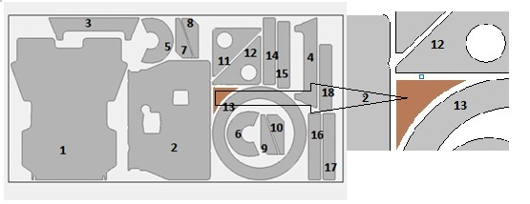

**Figure 3**. Feasible piercing area is marked with brown color.

Having all feasible positions for piercing points *Mi* found, one can reduce full tool path optimization problem (which is both continuous and discrete optimization problem) to discrete one simply by selecting finite set of possible piercing points on the border of area, defined by (4), see Fig. 4.

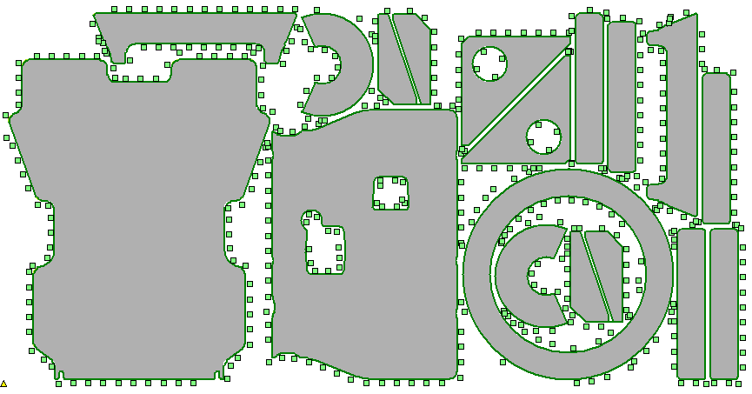

**Figure 4.** Example of finite set of piercing points

## Part Hardness Rule

This restriction is caused by thermal deformations of part during cutting process. It was first described by Petunin (2009) as an empirical rule for NC program development (mostly manual).

In terms of tuple (1) it deals with choice of piercing points *Mi* and cutting direction for every cutting segment *Si*. Briefly, cutting should start next to sheet border or already cut area and finish in “hard” area, i.e. next to not cut yet area (see Fig. 5).

|  |  |  |  |  |  |  |  |  |  |  |  |  |  |  |  |  |  |  |  |  |  |
| --- | --- | --- | --- | --- | --- | --- | --- | --- | --- | --- | --- | --- | --- | --- | --- | --- | --- | --- | --- | --- | --- |
|  | |  |  |  |  |  | | --- | --- | --- | --- | --- | | Part | Piercing points | | | | | 3 | (~~6~~) | (7) CW | (8) CCW | (~~9~~) | | 2 | (4) CW | (~~5~~) | (6) CCW | (7) CW+CCW | | 1 | (1) CW | (~~2~~) | (3) CCW | (4) CW+CCW | |
| **Figure 5.** Part hardness rule demonstration  (3 parts with 9 possible piercing points; cut from bottom to top) | |

### Formalization of Part Hardness Rule

For piercing point  and its corresponding switching off point  (meeting conditions (4) and (5)) we build two-dimensional “hardness” area, bounded by basic segment (ended in ) of length L, equidistant contour  (with radius also determined by technological parameters) and two straight line segments, perpendicular to the base segment (see Fig. 6). This area should lay entirely in (not cut yet) sheet areas. In the following example piercing point M1 is valid, while M2 is not.

Thus defined “hardness” area can be used to prohibit some (otherwise feasible) values of tuple (1) or as penalty for objective function (3) with some heuristic coefficient.

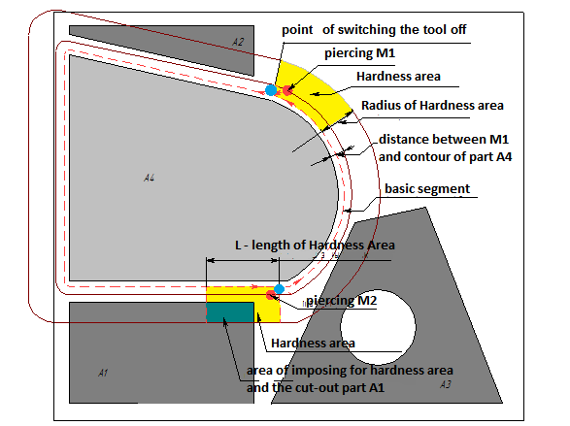

**Figure 6.** “Part hardness rule” formalization

### Thermal Distribution Calculations

A series of numerical experiments was conducted to better understand a nature of Part Hardness Rule. For predefined sheet size, nesting, beam radius and power and cutting speed thermal filed was directly calculated using:

* Heat equation: 
* Initial conditions: 
* And boundary conditions: 

Where  is temperature,  is sheet area, left after cutting of all previous parts and  is boundary of latter area.

For computation purposes  was discretized (split into tetrahedra) as well as cutting time interval. Example of such a calculation is on Fig. 7.

|  |  |
| --- | --- |
|  |  |
| a) Initial nesting | b) Thermal distribution calculated |
| **Figure 7.** Direct calculation of thermal field distribution | |

The results of these experiments are in good accordance with aforementioned Part Hardness Rule (see Fig. 8). When piercing point is selected according to rule, the resulting average temperature is somewhat lower, leading to lower thermal deformations.

|  |  |
| --- | --- |
|  |  |
| a) Against Part Hardness Rule, <T> = 480°С | b) According to Part Hardness Rule, <T> = 362°С |
| **Figure 8.** Selection of piercing point | |

These calculations can be also used as another (or additional) considerations for selecting piercing points and cutting directions. So far it is not practical though, for it takes too much time to calculate the whole thermal distribution for all the cutting process. More investigations in this direction are necessary.

## Sheet Hardness Rules

As well as Part Hardness Rule, this series of constraints is to minimize thermal deformations during thermal cutting process. Unlike the former it primarily deals with second part (permutation) of tuple (1). It defines sequence of parts cutting. It is also mainly empirical.

The following rules are known:

* Start from sheet short edge
* Long narrow parts, located next to sheet edge should be cut first
* If a big free area (having no parts nested) exists, cutting should start from opposite sheet side
* Start from the side with greater heat release (smaller parts or greater total perimeter)
* Avoid uncut “islands”
* Avoid long narrow uncut areas

There exist also many other recommendations concerning thermal deformations reduction. Mathematical formalization of these rules is the complex problem. The mechanism of the accounting of such constraints was offered by Chentsov A.A. and Chentsov A.G. (2013) for the solution of the megalopolises problem. See also Chentsov and Salii (2015).

# Discrete optimization algorithms

As the main optimization problem we consider *Segment Continuous Cutting Problem (SCCP)* for objective functions (2) and (3), see Petunin (2014). It assumes we have predefined nesting and then we fix segments to cut *Si* with their basic segments. Optimization problem reduces to finding positions for points  and integer permutation *I={i1, i2,… iK}*. This is both continuous and discrete optimization problem, but it can be easily reduced to discrete optimization by selecting finite set of possible piercing points (as mentioned in above).

Thus SCCP can be interpreted as GTSP, with additional aforementioned constraints.

For the solution of GTSP the mathematical model of megalopolises based on the special scheme of a dynamic programming offered by A. Chentsov is used. The following algorithms for solution of SCCP are developed:

* Exact algorithm based on a dynamic programming (see Fig. 9a);
* Genetic algorithm;
* Iterative greedy algorithm with Part Hardness Rule
* Special option of iterative greedy algorithm with Sheet Hardness Rules

All the algorithms consider the Precedence Constraints and the Piercing Points Coordinated Constraint.

An exact algorithm considering all the constraints of thermal cutting is under active development now (see Fig. 9b).

|  |  |
| --- | --- |
| Fig15 | 16-2 |
| a) Exact SCCP solution | b) Solution with thermal cutting constraints |
| **Figure 9.** Results of tool path optimizations | |

# AKNOWLEDGMENTS

The work was supported by Act 211 Government of the Russian Federation, contract № 02.A03.21.0006

# References

1. Chentsov, A. G., Salii, Ya. V. (2015) A model of “nonadditive” routing problem where the costs depend on the set of pending tasks. *Vestnik YuUrGU. Ser. Mat. Model. Progr*., 8:1, 24–45
2. Chentsov, A.A., Chentsov, A.G. (2013) Dynamic programming in the routing problem with constraints and cost depending on a list of tasks*. Doklady Mathematics.* T. 88. V.3. 2013. pp. 637-640.
3. Dewil, R., Vansteenwegen, P., Cattrysse, D., Laguna, M., Vossen, T. (2015) An improvement heuristic framework for the laser cutting tool path problem. *International Journal of Production Researc*h., **53 (6)** (2015), pp. 1761–1776.
4. Dewil, R., Vansteenwegen, P., Cattrysse, D. (2011) Cutting path optimization using tabu search, *Key Engineering Materials*, Vol 473. pp.739-748, 2011
5. Dewil, R., Vansteenwegen, P., Cattrysse, D. (2014) Construction heuristics for generating tool paths for laser cutters. *International Journal of Production Research,* Mar. 2014, 1-20.
6. Dewil, R., Vansteenwegen, P., Cattrysse, D. (2015a). Sheet Metal Laser Cutting Tool Path Generation: Dealing with Overlooked Problem Aspects, *Key Engineering Materials,* Vol. 639, pp. 517-524, 2015
7. Hoeft, J., Palekar, U. S. (1997). Heuristics for the plate-cutting traveling salesman problem. *IIE Transactions*, **29,** 719-731.
8. Petunin, A. (2009). About some strategies of the tool path modelling at the control programs generation for the flame cutting machines. *Vestnik UGATU*, vol. 13, **2(35),** 280-286.
9. Petunin, A., Chentsov, A.G, Chentsov, P.A. (2014). Local dynamic programming incuts in routing problems with restrictions. *Vestn. Udmurtsk. Univ. Mat. Mekh. Komp. Nauki*, no. 2, 56–75.
10. Petunin, A. A., Chentsov, A. G., & Chentsov, P. A. (2015a). About a routing problem of the tool motion on sheet cutting. *Modelirovanie i Analiz Informatsionnykh Sistem [Modeling and Analysis of Information Systems]*, *22*(2), 278-294.
11. Petunin, Aleksandr A. (2015). Modeling of tool path for the CNC sheet cutting machines// *AIP conference proceedings. 41st International Conference on Applications of Mathematics in Engineering and Economics (AMEE)*, Sozopol, BULGARIA, JUN 08-13, 2015, **1690**., pp.060002-1 – 060002-7.
12. Verkhoturov, M.A., Tarasenko, P. Yu. (2008). *Mathematical provision of problem of tool path optimization at flat shape nesting based on “chained” cutting.* Vestnik USATU. Upravlenie, VTiT. Ufa: USATU, V.10, №2 **(27**), pp. 123-130.