Iterative algorithm for the generalized segmental continuous cutting problem with optimization time constraint
Aleksandr Petunin¹²[0000-0003-2540-1305] and Stanislav Ukolov¹[0000-0002-9946-6446]
¹ Ural Federal University, 19 Mira Str., Ekaterinburg 620002, Russia
² IMM UB RAS, 16 S.Kovalevskaya Str., Ekaterinburg 620108, Russia
a.a.petunin@urfu.ru
Abstract. The paper proposes a new algorithm for solving one class of the tool path problems for CNC sheet cutting machines (the generalized segmental continuous cutting problem, GSCCP) with an additional parameter limited the calculation time for finding an optimal solution. As input data in the GSCCP, 2D layout of nested parts and a finite set of subtasks for optimizing the cutting path are used. Each subtask contains a set of so-called basic cutting segments, which determine the trajectories of tool movement between the points for material piercing and the points for switching tool off. Each subtask can be solved independently within the specified calculation time. The best solution found for the all subtasks is a solution to the GSCCP problem. The proposed iterative algorithm involves quantizing the total computation time. Moreover, within each time quant, all subtasks are also solved sequentially by calculation the upper and lower bounds. Initial upper bounds can, for example, be obtained using any fast heuristic based on effective combinatorial optimization methods. Next, for each of them, the procedure for searching for the lower boundary is launched. The next iteration of the solution process is performed taking into account the adjusted bounds. The solution procedures are interrupted when the specified time quant is reached, or upon obtaining a guaranteed exact solution. The effectiveness of the algorithm is illustrated by practical examples. It is also shown that for generate a set of finite set of subtasks for GSCCP, it is advisable to use neural networks.
Keywords: Cutting path, Tool Path Problem, Segment Cutting, Optimization time, Iterative algorithm, Time Quantizing, Lower and upper bounds, Classification Problem
- Introduction
This paper explores the issue of solving the generalized problem of continuous segment cutting (GSCCP) [1]. This problem belongs to the class of Tool Path Problem [2] or Cutting Path Determination Problem [3]. When optimizing the toolpath route, either the cost of cutting is used as an objective function [4]:
$F_{cost}=L_{on}C_{on}+L_{off}C_{off}+N_{pt}C_{pt}$
or its time:
$$T_{cut}=\frac{L_{off}}{V_{off}}+ \frac{L_{on}}{V_{on}}+N_{pt}t_{pt}$$
where L_{off} is the length of the air move, L_{on} is the length of the cutting segments, C_{on} is the cost of the air move, C_{off} is the cost of cutting, C_{pt} is the cost of one piercing, V_{off} is the air move speed, V_{on} is the cutting speed, N_{pt} is the number of piercing points, t_{pt} is time of piercing operation. GSCCP is an extension of the well-known classification of Cutting Path Problems [2] as a special case of the general ICP problem (see Fig.1).

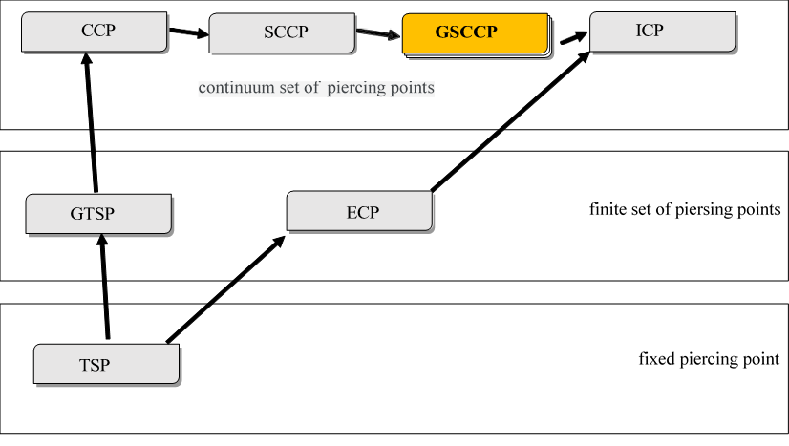
Fig. 1. Extended classification of Cutting Path Problems
Most developed TSP, GSP and ECP cutting path problems, the objective functions that need to be optimized, Fcost and Tcut, are actually reduced to determining the length of the tool movement through the air, or the algorithms do not contain an estimate of the accuracy of the solution, because based on metaheuristics [5-9]. Almost all modern optimization algorithms for Cutting Path Problems use discrete optimization models. An overview of the algorithms for solving this kind of problems is given in [2,10].
This study uses the full objective function Tcut [4] and evaluates the accuracy of the solution.
- Description of the algorithm
To solve the generalized GSCCP routing problem, it is natural to rely on already developed algorithms for solving problems of simpler classes. The general scheme of the algorithm is presented below in the form of pseudocode:
Input: $Nest$ – parts placed on the sheet
$K$ – iteration count
$N$ – number of instances of segment cutting tasks
$Δt$ – time slice for one task
# Total calculation time $T ⩽K⋅N⋅Δt$
Output: $Route$ – toolpath

# Generating task instances
for i = 1 to N
${Task}_{i }←add_bridges(Nest)$
# Correction of the objective function to the complete problem
${Task}_{i }.Δ←\left({Task}_{i }.N_{pt}⋅T_{pt}+\frac{{Task}_{i }.L_{on}}{V_{on}}\right)⋅V_{off}$
end for

# Finding upper bounds
for i = 1 to N
${Task}_{i }.UB←PCGLNS({Task}_{i })$
end for

# Main loop
for j = 1 to K
# Update the upper bounds
$UB←\min_{i}\left({Task}_{i }.UB+{Task}_{i }.Δ\right)$
for i = 1 to N
${Task}_{i }.UB←\min_{}\left({Task}_{i }.UB,UB-{Task}_{i }.Δ\right)$
end for
# Partial calculation of task instances
for i = 1 to N
if ${Task}_{i }.finished$ then
continue # The task has been completed
end if
${branch_bound(Task}_{i }, Δt)$
# Cutting off “uninteresting” subtasks
if ${Task}_{i }.UB<{Task}_{i }.LB$ then
delete ${Task}_{i }$
$N←N-1$
end if
end for
end for
$$i←\underset{i}{argmin}\left({Task}_{i }.UB+{Task}_{i }.Δ\right)$$
return ${Task}_{i }.Nodes$
  - Building an ensemble of problems
The initial data for solving the GSCCP problem is the so-called “nesting layout”, that is, the placement of parts to be cut on a sheet of material. An example of such a nesting layout is shown in Fig. 2, it contains 19 parts and 38 contours.
To construct other instances of the cutting task, the original nesting layout can be modified in two main ways:
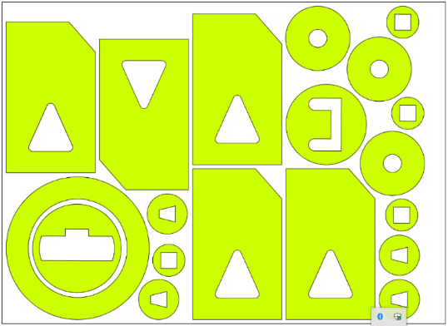
Fig. 1. Example of a nesting layout
- Multi-contour cutting - several contours are combined into one
- Multi-segment cutting - one of the contours is divided into several parts
In this work, the multi-contour cutting technique is used and the combination of contours is performed using “bridges”, that is, a jumper connecting two closely lying contours. An example of using a “bridge” when cutting two rectangular parts is shown in Fig. 3.
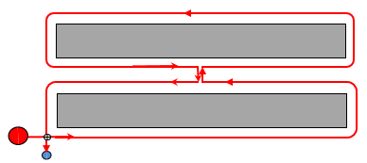
Fig. 2. Multi-contour cutting of two parts using a “bridge”
In this study, bridges of zero width were used, so when adding one “bridge” to the nesting layout
- The number of circuits is reduced by 1
- The number of insertion points N_{pt} is reduced by 1 either
- The tool stroke length L_{on} is increased by double bridge length (which is usually chosen as the minimum)
In the practical use of bridges, the stroke length L_{on} may even decrease, depending on the geometry of the bridge.
Thus, due to a different set of jumpers from one Nest, several copies of the Task_{i} cutting task are obtained, differing in the number of contours, insertion points and air move length. However, they all compete for the lowest cutting time T_{cut}. In order to make it convenient to compare the results obtained for different instances of problems, a correction is calculated for each of them.
$Δ_{i }=\left(N_{pt}⋅T_{pt}+\frac{L_{on}}{V_{on}}\right)⋅V_{off}$
with the understanding that for each instance the idle path length $L_{off}$ is calculated as usual, and the full objective function is calculated simply as $L_{off}+Δ_{i }$. As it is easy to see, the problem of forming "promising" subtasks of GSCCP for searching a global extremum belongs to the class of clustering problem [11]. In the future, neural networks are supposed to be used to generate the ensemble of subtasks GSCCP.
  - Search for suboptimal solutions
To search for solutions of individual instances of routing problems constructed at the previous stage, one can use any algorithm that allows to refine the solution estimates during the work. In this work, the algorithm previously developed by the authors [12] was applied.
It turned out to be convenient to separate the first step of this algorithm, which consists in finding a solution to the problem using the PCGLNS heuristic [13]. Since this heuristic works very quickly (a few seconds on problems with several boundary contours), it can be run for all instances of problems and obtain solutions that are close to optimal for all of them. An example of such a solution is shown in Fig. 4. For further operation of the described algorithm, the length of the obtained solution is used, which is the upper estimate UB of the optimal solution. The upper bound for the solution to the complete GSCCP problem can be found as $UB=\min_{}{{UB}_{i}+Δ_{i }}$.
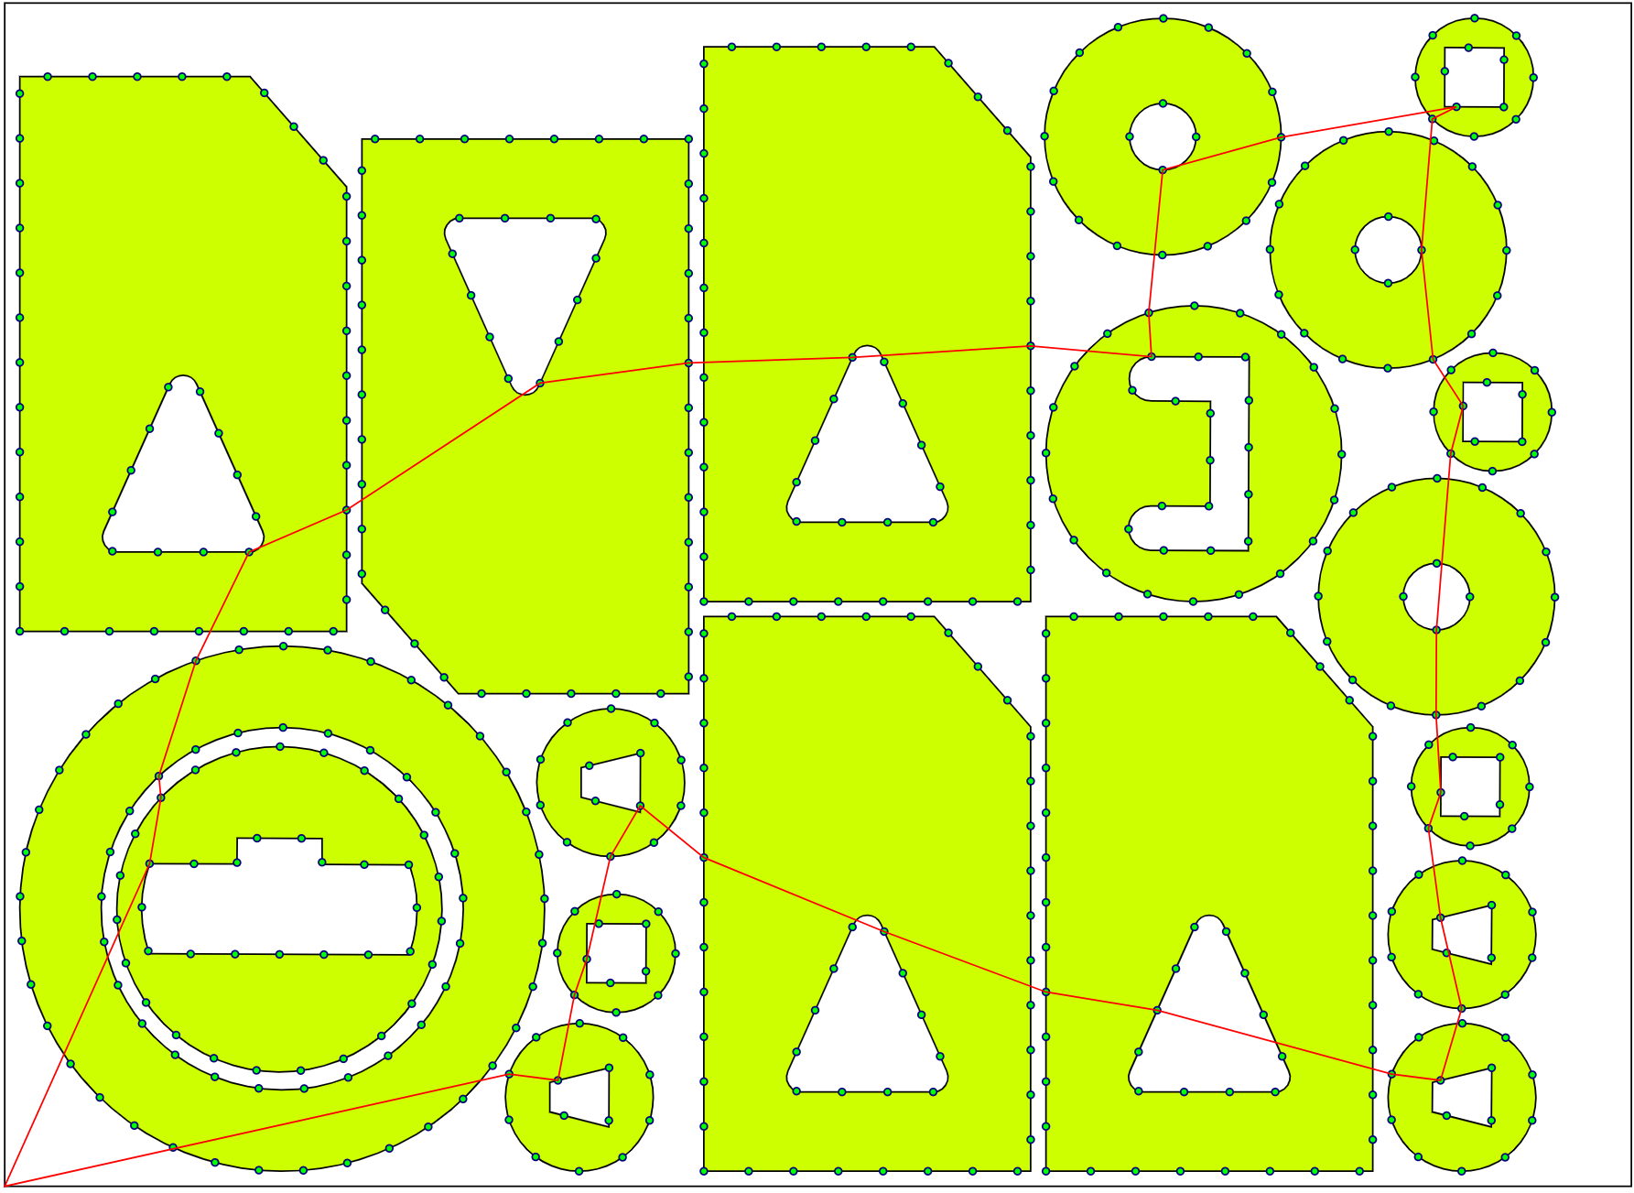
Fig. 3. An example of a route built using PCGLNS heuristics
  - Parallel refinement of estimates
Next, we begin to construct lower bounds ${LB}_{i}$ for each of the subproblems, as described in [12]. An estimate is constructed for the prefix of the complete solution as the sum of two estimates - a path along the prefix with a known order of traversal of the contours and a solution to the cutting problem for the subtask obtained by removing all contours included in the prefix. Dynamic programming is used to estimate the first path, and the subproblem in turn is simplified to an assignment problem or, in the case of a small size, to a traveling salesman problem.
After the next estimate ${LB}_{i}$ is obtained, it is used for cutting off according to the natural rule: if ${LB}_{i}>{UB}_{i}$, then such a prefix is considered unpromising and does not participate in further calculations along with all its descendants, that is prefixes of greater length. This allows to significantly reduce calculation time.
In this work, it is proposed to further strengthen this pruning mechanism due to the fact that the best of the upper bounds of all problem instances is used as the upper bound. Thus, the cutoff condition takes the form:
$${LB}_{i}>\min_{}\left({UB}_{i },UB-Δ_{i }\right)$$
A numerical experiment, see below, shows that such pruning indeed significantly reduces the size of the traversal tree compared to the case of a single independent routing task. Moreover, it is theoretically and practically possible that for all prefixes of a certain length for one of the tasks, the strengthened cutoff rule is satisfied, thereby, this entire subtask can be discarded and stop participating in further calculations. This means that the solution to this particular problem in itself, although exists, is not of interest to the main goal of GSCCP. Of course, this also helps reduce the time required to solve the main problem.
On the other hand, if one of the subproblems is completely solved, then for it we will already obtain an optimal solution ${UB}_{i}^{OPT}$, which can lead to a decrease in the total upper bound for UB and thereby further increase the cutoff for the remaining problems.
In view of this, it turns out to be reasonable to organize the calculation for all subtasks in parallel mode, either by forced interleaving after a certain time slice, as shown in the pseudocode, or in true parallel mode with the exchange of information about the resulting estimates, whether the computing power of the equipment used allows.
  - Completing the algorithm
The described algorithm almost immediately provides some solution to the GSCCP problem through the use of the PCGLNS heuristic. It is very often optimal, or at least very close to it.
Next, the process of calculation and gradual refinement/increase of the lower estimate occurs in the process of parallel solution of all subtasks. As individual subproblems find their solution, one can also refine the solution found, which nevertheless still remains suboptimal for the main GSCCP problem. This computation can be very time consuming for large size problems since all cutting problems are NP-hard. However, this process can be stopped at any time when the required accuracy is achieved or the time limit is exhausted. In this case, the result is a solution that may not be optimal, and at the same time a lower estimate for the optimal solution.
If the calculation is completed, that is, it is possible to traverse the decision tree for all subproblems of the original GSCCP problem, then we obtain its exact solution along with a guarantee of its optimality.
- Numerical experiment
To assess the performance of the proposed scheme, 5 nesting layouts [14] were used, described in Table. 1. For each layout, its designation, the number of parts on it, the number of closed contours limiting them, the total perimeter of all contours and the number of potential piercing points obtained by discretizing the contours in increments of 10 to 30 mm are indicated. Fig. 1 shows the nesting layout p3xl_5.
Table 1. Nesting layouts
Nesting  layout | Parts | Contours | L_{on},  mm | Piercing  points
p3xl_1 | 16 | 32 | 12040 | 586
p3xl_2 | 17 | 35 | 8783 | 861
p3xl_3 | 16 | 32 | 10698 | 521
p3xl_4 | 18 | 36 | 7193 | 696
p3xl_5 | 19 | 38 | 17233 | 557
For each nesting layout, 4 instances of cutting subtasks were generated. One is the cutting card itself and 3 more by adding several “bridges” to the original cutting card. Information about them is in Table. 2, for each instance the designation, the number of added “bridges” are indicated, UB is the length of the solution given by the PCGLNS heuristic, LB₀ is the roughest lower estimate of the solution, N_{pt} is the number of piercing points and L_{on} is the total perimeter of all contours including the “bridges”.
Table 2. Cutting Subtask Instances
Name | Bridges | UB, mm | LB₀, mm | N_{pt} | L_{on}, мм
p3xl_1 | 0 | 2289 | 1296 | 32 | 12040
p3xl_1-A | 3 | 2284 | 1314 | 29 | 12104
p3xl_1-B | 4 | 2287 | 1304 | 28 | 12131
p3xl_1-C | 6 | 2283 | 1360 | 26 | 12172
p3xl_2 | 0 | 1629 | 919 | 35 | 8783
p3xl_2-A | 3 | 1629 | 932 | 32 | 8845
p3xl_2-B | 4 | 1627 | 892 | 31 | 8873
p3xl_2-C | 8 | 1628 | 968 | 27 | 8971
p3xl_3 | 0 | 2114 | 1152 | 32 | 10698
p3xl_3-A | 4 | 2014 | 1192 | 28 | 10782
p3xl_3-B | 4 | 2017 | 1156 | 28 | 10799
p3xl_3-C | 6 | 2010 | 1149 | 26 | 10837
p3xl_4 | 0 | 1702 | 937 | 36 | 7193
p3xl_4-A | 3 | 1701 | 938 | 33 | 7263
p3xl_4-B | 5 | 1699 | 972 | 31 | 7297
p3xl_4-C | 8 | 1698 | 989 | 28 | 7405
p3xl_5 | 0 | 3272 | 1908 | 38 | 17233
p3xl_5-A | 3 | 3260 | 1919 | 35 | 17302
p3xl_5-B | 6 | 3261 | 1915 | 32 | 17371
p3xl_5-C | 7 | 3253 | 1935 | 31 | 17439
  - Selection of process parameters.
In this work, the objective function T_{cut} is actually used - the cutting time, which includes the cutting speed V_{on}, the idle speed V_{off} and the piercing operation time T_{pt} as parameters. All of them depend on the specific technological equipment, sheet material and its thickness. Some of the most commonly used values for these parameters are summarized in Table. 3. For each material, depending on the thickness, the time for one piercing operation, cutting speed for different qualities and idle speed are indicated.
Table 3. Cutting technological parameters
Material | Thickness,  mm | T_{pt}, s | V_{on}, m/s |  | V_{off},  m/s
Material | Thickness,  mm | T_{pt}, s | Good  quality | Medium  quality | V_{off},  m/s
Carbon steel  Ст10кп | 1 | 0,8 | 0,112 | 0,158 | 0,85
Carbon steel  Ст10кп | 1,2 | 0,9 | 0,088 | 0,127 | 0,85
Carbon steel  Ст10кп | 1,5 | 1,1 | 0,088 | 0,127 | 0,85
Carbon steel  Ст10кп | 2 | 1,2 | 0,072 | 0,103 | 0,85
Carbon steel  Ст10кп | 2,5 | 1,7 | 0,060 | 0,087 | 0,85
Carbon steel  Ст10кп | 3 | 2,1 | 0,048 | 0,070 | 0,85
Carbon steel  Ст10кп | 3,5 | 2,2 | 0,044 | 0,063 | 0,85
Carbon steel  Ст10кп | 3,9 | 2,2 | 0,044 | 0,063 | 0,85
Carbon steel  Ст10кп | 4 | 2,5 | 0,040 | 0,057 | 0,85
Carbon steel  Ст10кп | 5 | 2,7 | 0,037 | 0,053 | 0,85
Carbon steel  Ст10кп | 8 | 3 | 0,025 | 0,037 | 0,85
Carbon steel  Ст10кп | 10 | 3,2 | 0,022 | 0,030 | 0,85
Carbon steel  Ст10кп | 15 | 4 | 0,013 | 0,018 | 0,85
Aluminium  Амг3М | 1 | 1,3 | 0,105 | 0,175 | 0,85
Aluminium  Амг3М | 2 | 2 | 0,065 | 0,108 | 0,85
Aluminium  Амг3М | 3 | 3 | 0,032 | 0,052 | 0,85
Aluminium  Амг3М | 5 | 4 | 0,017 | 0,028 | 0,85
Stainless Steel  12Х18Н10Т | 1 | 1 | 0,105 | 0,175 | 0,85
Stainless Steel  12Х18Н10Т | 1,5 | 1,5 | 0,083 | 0,140 | 0,85
Stainless Steel  12Х18Н10Т | 2 | 1,8 | 0,062 | 0,103 | 0,85
Stainless Steel  12Х18Н10Т | 2,5 | 2,2 | 0,050 | 0,083 | 0,85
Stainless Steel  12Х18Н10Т | 3 | 2,8 | 0,042 | 0,068 | 0,85
Stainless Steel  12Х18Н10Т | 4 | 3,3 | 0,028 | 0,047 | 0,85
Stainless Steel  12Х18Н10Т | 5 | 4 | 0,022 | 0,035 | 0,85
Stainless Steel  12Х18Н10Т | 6 | 4,5 | 0,017 | 0,027 | 0,85
Stainless Steel  12Х18Н10Т | 8 | 5 | 0,008 | 0,015 | 0,85
Stainless Steel  12Х18Н10Т | 10 | 6 | 0,005 | 0,010 | 0,85
To conduct a numerical experiment with the nesting layouts described above, the following parameter values were chosen: V_{on} = 0.105; V_{off} = 0.85; T_{pt} = 0.
  - Calculation results
For all 5 nesting layouts, calculations were carried out according to the described scheme. Fig. 4 shows, as an example, all 4 solutions to subtasks for the cutting card p3xl_2. It can be seen that although generally similar, they are slightly different.
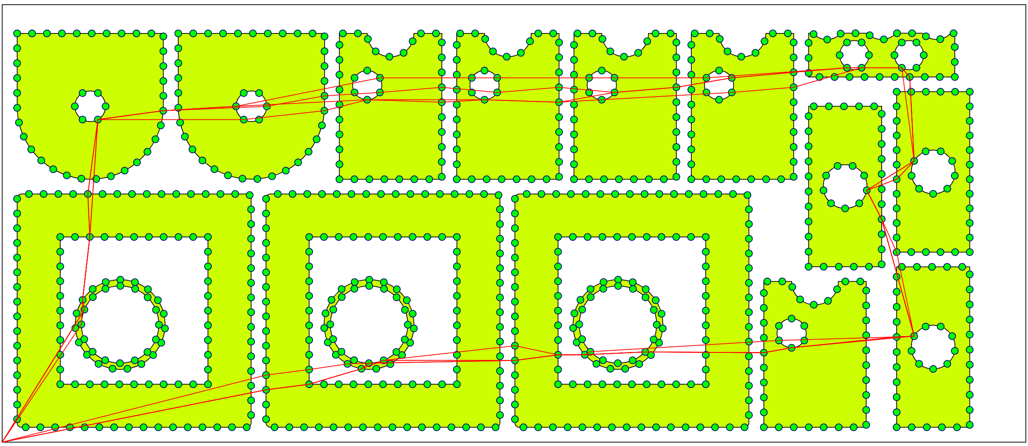
Fig. 4. Solutions to subtasks of the GSCCP problem
Of greatest interest, however, is the mutual influence of the subtasks on the pruning mechanism and thereby reducing the computational complexity of the original GSCCP problem. This can be assessed by recalculating the upper estimate of UB, shown in Table. 4. For each instance of the task, except for the data from Table. 2, the correction Δ and the updated upper limit UB' are also shown.
Table 4. Mutual influence of subtasks
Name | UB | LB₀ | L_{on} | Δ | UB'
p3xl_1 | 2289 | 1296 | 12040 | 97467 | 2289
p3xl_1-A | 2284 | 1314 | 12104 | 97985 | 1771
p3xl_1-B | 2287 | 1304 | 12131 | 98203 | 1552
p3xl_1-C | 2283 | 1360 | 12172 | 98535 | 1220
p3xl_2 | 1629 | 919 | 8783 | 71100 | 1629
p3xl_2-A | 1629 | 932 | 8845 | 71602 | 1127
p3xl_2-B | 1627 | 892 | 8873 | 71829 | 900
p3xl_2-C | 1628 | 968 | 8971 | 72622 | 107
p3xl_3 | 2114 | 1152 | 10698 | 86603 | 2114
p3xl_3-A | 2014 | 1192 | 10782 | 87283 | 1434
p3xl_3-B | 2017 | 1156 | 10799 | 87420 | 1296
p3xl_3-C | 2010 | 1149 | 10837 | 87728 | 989
p3xl_4 | 1702 | 937 | 7193 | 58229 | 1702
p3xl_4-A | 1701 | 938 | 7263 | 58796 | 1135
p3xl_4-B | 1699 | 972 | 7297 | 59071 | 860
p3xl_4-C | 1698 | 989 | 7405 | 59945 | 14
p3xl_5 | 3272 | 1908 | 17233 | 139505 | 3272
p3xl_5-A | 3260 | 1919 | 17302 | 140064 | 2713
p3xl_5-B | 3261 | 1915 | 17371 | 140622 | 2155
p3xl_5-C | 3253 | 1935 | 17439 | 141173 | 1604
It can be seen that with the selected technological parameters, virtually all fourth instances (-C) will be excluded from the calculation after the first pass of the branch-and-bound algorithm [12] according to the condition ${LB}_{0}>UB'$.
Table 5 shows the calculation performance for the case when all subproblems are solved independently of each other. For each subtask, its name, the duration of the calculation, the number of processed layers (that is, what length of prefixes were calculated; the depth of the search tree) and the total number of processed prefixes (the size of the search tree), the change in the lower estimate during the calculation and the result obtained or Timeout, if the calculation was interrupted due to the exhaustion of the time limit (20 hours).
Table 5. Independent solution of routing subproblems
Subtask | Time, s | Layers | Prefixes | LB₀ | LB_{max} | Solution
p3xl_1-A | 70072 | 29 | 538704 | 1328 | 2130 | 2283
p3xl_1-B | 271 | 28 | 18363 | 1304 | 2140 | 2302
p3xl_2-A | 30756 | 10 | 261442 | 932 | 1629 | Timeout
p3xl_2-B | 22433 | 14 | 253358 | 892 | 1198 | Timeout
p3xl_3-A | 16 | 2 | 86 | 1192 | 1271 | Timeout
p3xl_3-B | 35175 | 28 | 345857 | 1156 | 1835 | 2012
p3xl_4-A | 12541 | 8 | 185483 | 938 | 1110 | Timeout
p3xl_5-A | 10317 | 7 | 194378 | 1919 | 2129 | Timeout
p3xl_5-B | 42097 | 8 | 327747 | 1915 | 2117 | Timeout

Unfortunately, in the current software implementation of the branch and bound algorithm, if the time limit is exhausted, information about the last layer, whose processing has not been completed, is lost and does not appear in the table. The actual counting time is 72000 (20 hours). This is especially striking for the subtask p3xl_3-A, where layer 3 turned out to be so large that it could not be calculated in a reasonable time.
Table 6 contains similar data, but for the case when tasks exchange information about boundaries, due to which it is possible to significantly increase the number of cut branches. In all cases, the calculation was stopped due to complete cutoff, that is, all problems were discarded and did not contribute to the solution of the original GSCCP problem. Also tables 5 and 6 did not include “trivial” cases that do not add anything to the comparison - that is, those that passed a full calculation or were discarded at the very first layer.
Table 6. Collaborative solution of routing subproblems
Subtask | Time, s | Layers | Prefixes | LB₀ | LB_{max} | Solution
p3xl_1-A | 92 | 15 | 652 | 1328 | 1736 | Stop
p3xl_1-B | 75 | 9 | 61 | 1304 | 1473 | Stop
p3xl_2-A | 199 | 11 | 85 | 932 | 1086 | Stop
p3xl_2-B | 84 | 3 | 17 | 892 | 897 | Stop
p3xl_3-A | 61 | 9 | 108 | 1192 | 1306 | Stop
p3xl_3-B | 49 | 8 | 44 | 1156 | 1253 | Stop
p3xl_4-A | 78 | 8 | 106 | 938 | 1110 | Stop
p3xl_5-A | 1779 | 23 | 76269 | 1919 | 2637 | Stop
p3xl_5-B | 73 | 8 | 45 | 1915 | 2117 | Stop
Comparison of information from tables 5 and 6 show the strong impact of the new pruning mechanism; it radically reduces the size of the search tree and, as a consequence, the calculation time. The depth of the search tree also usually decreases, although here the effect is not so clear - for the above-mentioned subtask p3xl_3-A, on the contrary, it was possible to calculate the previously hopeless layer 3, as well as layers from 4 to 9.
- Conclusion
The paper proposes a new algorithm for solving the cutting tool routing problem for the class of GSCCP routing problems. A cooperative pruning mechanism has been developed to radically reduce computational complexity.
It should be noted that the effectiveness of this cutting mechanism very much depends on the technological parameters of the equipment, the cutting allowance and the geometry of the “bridges”, so additional studies of this influence and the search for the most interesting relationships between these parameters are probably required - both from a theoretical point of view and in practice.
In addition, one can make a cautious assumption that the computational complexity of algorithms for solving problems of the GSCCP class and similar ones may turn out to be comparable to the complexity of much better studied classes, primarily GTSP, which opens the way to solving the full ICP routing problem. In the future, neural networks are supposed to be used to generate the ensemble of subtasks GSCCP.

References
- .Petunin A., General Model of Tool Path Problem for the CNC Sheet Cutting Machines, IFAC-PapersOnLine, Volume 52, Issue 13, 2019, Pages 2662-2667, https://doi.org/10.1016/j.ifacol.2019.11.609.
- Dewil R. Vansteenwegen P, Cattrysse D A review of cutting path algorithms for laser cutters. Int.J. Adv. Manuf. Technol 87(5-8), 2016, Pages 1865-1884.
- Fernandes Silva, Everton & Oliveira, Larissa & Oliveira, José & Toledo, Franklina. Exact approaches for the cutting path determination problem. Computers & Operations Research. 112. 104772. (2019). 10.1016/j.cor.2019.104772.
- Tavaeva A, Petunin A, Ukolov S et al (2019) A Cost Minimizing at Laser Cutting of Sheet Parts on CNC Machines. In: MOTOR’2019: Mathematical Optimization Theory and Operations Research. Communications in Computer and Information Science (2019) vol. 1090. Springer, Cham. doi:10.1007/978-3-030-33394-2_33.
- Cuellar-Usaquén et al., Cuellar-Usaquén D., Palacio A., Ospina E., Botero M., Álvarez-Martínez D., Modeling and solving the endpoint cutting problem, International Transactions in Operational Research 30 (2) (2023) 800–830.
- Eapen, N.A., Heckendorn, R.B. Cutting path optimization for an automatic cutter in polynomial time using a 3/2 approximation algorithm. Int J Adv Manuf Technol 113, 3667–3679 (2021). https://doi.org/10.1007/s00170-021-06842-9
- Junior, B.A.; de Carvalho, G.N.; Santos, M.C.; Pinheio, P.R.; Celedonio, J.W.L. Evolutionary Algorithms for Optimization Sequence of Cut in the Laser Cutting Path Problem. Appl. Sci. 2023, 13, 10133. https://doi.org/10.3390/ app131810133
- Yu, W. and Lu, L. (2014). A route layoutning strategy for the automatic garment cutter based on genetic algorithm. In Evolutionary Computation (CEC), 2014 IEEE Congress on, 379–386. IEEE
- Hajad, M., Tangwarodomnukun, V., Jaturanonda, C. et al. Laser cutting path optimization using simulated annealing with an adaptive large neighborhood search. Int J Adv Manuf Technol 103, 781–792 (2019). https://doi.org/10.1007/s00170-019-03569-6
- Amaro Junior, B.; Santos, M.C.; de Carvalho, G.N.; de Araújo, L.J.P.; Pinheiro, P.R. Metaheuristics for the Minimum Time Cut Path Problem with Different Cutting and Sliding Speeds. Algorithms 2021, 14, 305. https://doi.org/10.3390/a14110305.
- Yizhang Wang, Jiaxin Qian, Muhammad Hassan, Xinyu Zhang, Tao Zhang, Chao Yang, Xingxing Zhou, Fengjin Jia, Density peak clustering algorithms: A review on the decade 2014–2023, Expert Systems with Applications, Volume 238, Part A, 121860, https://doi.org/10.1016/j.eswa.2023.121860. (2024).
- Khachay M., Ukolov S., Petunin A. Problem-specific branch-and-bound algorithms for the precedence constrained generalized Traveling Salesman Problem //International Conference on Optimization and Applications. – Cham: Springer International Publishing, 2021. – С. 136-148.
- Khachay M., Kudriavtsev A., Petunin A. PCGLNS: A heuristic solver for the precedence constrained generalized traveling salesman problem //International Conference on Optimization and Applications. – Cham: Springer International Publishing, 2020. – С. 196-208.
- Petunin, A. et al. (2021). Library of Sample Image Instances for the Cutting Path Problem. In: Del Bimbo, A., et al. Layout Recognition. ICPR International Workshops and Challenges. ICPR 2021. Lecture Notes in Computer Science, vol 12665. Springer, Cham. https://doi.org/10.1007/978-3-030-68821-9_21.

