# Introduction

The growing needs to improve the technological processes of cutting sheet material on CNC (computer numerical control) machines generates various optimization tasks. These tasks include the tasks of routing the tool of laser, plasma, gas, and hydro abrasive CNC machines during the design of control programs for cutting shaped parts. An example of the scheme of the designed cutting route is in Fig. 1.

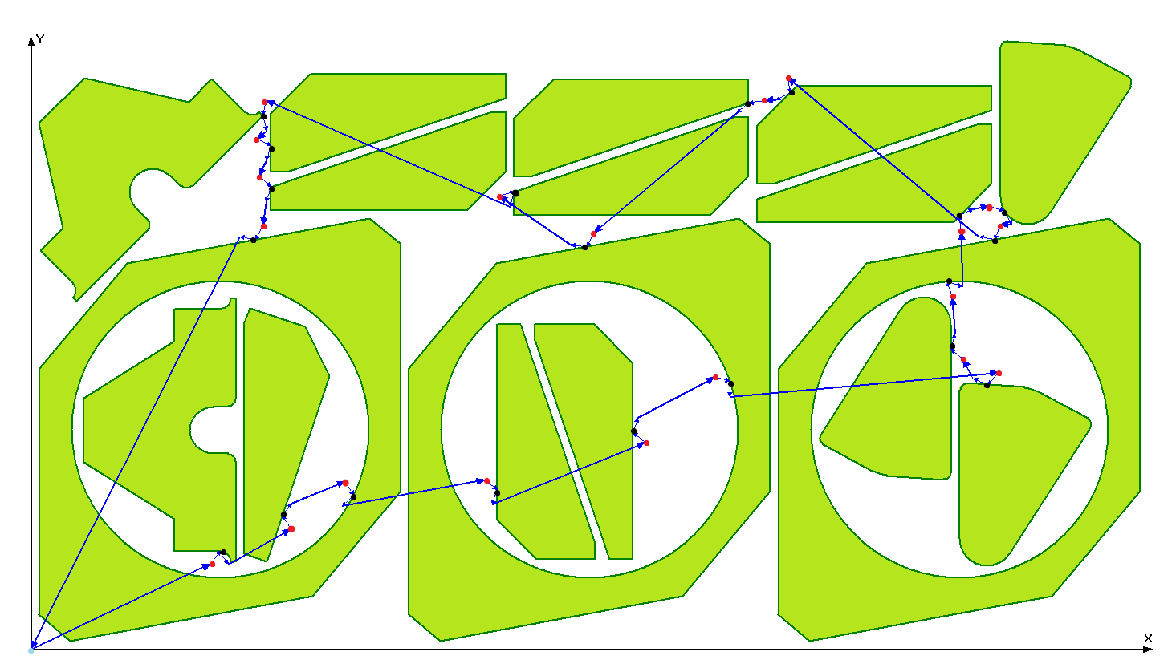

Figure 1. Example of cutting path for CNC machine for 17 parts (20 contours)

Pierce points into sheet material are highlighted in red. Due to technological requirements, these points cannot lie on the boundary contours of the parts to be cut and in this example, they are separated from them by a fixed amount, and each contour is cut out entirely. There are other contour cutting techniques in which cutting the entire contour is not a requirement. The entry points of the active tool into the contour itself are highlighted black on the Fig. 1.

As an optimization criterion in the routing tasks of a CNC machine, time and cost parameters of the designed cutting route are usually considered. In particular, the cutting time for the designed route is calculated by the following formula:

* * *

Depending on the cutting techniques used and methods for selecting tool entry points into part contours, as well as methods for selecting exit points from the contour, there are seven main classes of tasks shown in Fig. 2.

These seven classes can, in turn, be attributed to two large groups of tasks that differ in the cardinality of the sets from which the entry points to the contours are selected.

1) tasks with a finite set of possible entry points (TSP, GTSP, ECP)

2) tasks in which the points of entry into the circuit can be selected from the sets of continual cardinalities (CCP, SCCP, GSCCP, ICP).

GSCCP

GSCCP

TSP

GTSP

CCP

ECP

SCCP

ICP

GSCCP

Finite set of piercing points for each contour

Fixed piercing point for each contour

Continuum set of possible piercings and

contour entry points

Figure 2. Classification of cutting path problems for CNC sheet cutting machines

It should be noted that, because of their complexity, the problems of the second group remain practically unexplored. Note some publications on this topic []. This article discusses the simplest class of problems for this group: the CCP (Continuous Cutting Problem) class. According to the definition, the cutting process in the problems of this class is carried out according to the following rules: the cutting path passes through each contour to be cut once. The tool can hook the contour at any point of its perimeter but must cut the entire contour before it moves to the next contour. Respectively, the same point must be used to enter and exit the contour. It is usually assumed that the piercing points into the material, which, due to the technological requirements of cutting, do not coincide with the points of entry into the contour, are uniquely determined by the selected contour entry points and are at a fixed distance from the contours. In this paper, we consider the following optimization problem: it is necessary to devise a tool movement path such that the total cutting time of a given set of flat contours is minimal.

# Statement of the problem

There are several closed contours on the plane. It is necessary to find the order of cutting contours and entry points on them so that the tool path length is minimal, i.e. the length of the polyline with the vertices on the contours should have a minimum length. There is a technological constraint: if contour A lies inside another contour B, then the internal contour must be cut before the external one, i.e. the vertex of the polyline lying on the contour A has a smaller number than the vertex on the contour of B.

We denote the contours $C_{1},C_{2}…C_{n}⊂R^{2}$ (each contour consists of linear segments and arcs of circles). We are to find a permutation $π$ of numbers (1, … n) and points $P_{1},P…P_{n}(P_{i}∈C_{π(i)})$, so that the length of the polyline ${\{P}_{1},P_{2}…P_{n}\}$ is the smallest.