**A Cost Minimizing at Laser Cutting of Sheet Parts on CNC Machines**

Tavaeva A.F.1a, Petunin A.A.2b, Kurennov D.V.2c, Krotov V.I.3d

*1AO «Production association “Urals Optical and Mechanical Plant”», Vostochnaya str., 33b, Yekaterinburg, 620100, Russia*

*2Ural Federal University named after the first President of Russia B.N. Yeltsin, Mira str., 19, Yekaterinburg, 620002, Russia*

*3JSC “Technocomproject”, Ingenernaya str., 43, 5, Yekaterinburg, 620010, Russia*

*a)*[*tavaeva_a_f@bk.ru*](mailto:tavaeva_a_f@bk.ru)

*b)[aapetunin@gmail.com](mailto:aapetunin@gmail.com)*

*c)[d.v.kurennov@urfu.ru](mailto:d.v.kurennov@urfu.ru)*

*d)* [*wikrot@yandex.ru*](mailto:wikrot@yandex.ru)

**Abstract.** The problem of cost minimizing at laser cutting of sheet parts on CNC machines is considered. As an objective function the cost function of cutting process is used. The model of exact cost function calculation is presented depending on the number of frames in the NC program. In order to solve the optimization problem the special cutting techniques are used. There are multi-contour and multi-segment cutting techniques. In this paper the special cutting techniques for common geometrical types of contours widely used in blank production of engineering plant are presented. The results of the computational experiment which show a statistically significant improvement of the objective function value compared with using the standard cutting techniques are presented.

**Keywords: CNC laser cutting machines; thermal cutting; tool path optimization; cost of cutting process; cutting techniques.**

1. **Introduction**

Recently the CNC sheet cutting machines are widely used in blank production of engineering plant. In particular such machines include thermal cutting machines (laser, flame and plasma cutting). The CNC thermal cutting machines are worked by NC programs. During development of NC program the some features and restrictions are arisen.

Before cutting of part contour the piercings must be selected (fig.1). Piercings are operations where the laser cutting tool initiates the material. Piercings is selected according to the material type, its thickness and cutting parameters. In order to avoid material beading and part deformation the piercings must be selected by some distance from contour.

During thermal cutting the “burning out” and “sweeping” of material are occurred. Due to the fact the contour of parts and cutting tool path are not matched. The cutting tool is moved by equidistant curve of contour (fig.1).

The set of precedence constraint is taken into account [1]. In [2] shown that the precedence constraint is due to the features of portal type machine. The contour is fully cut, it detaches from the rest of the material and can possibly shift its position, and thus the additional cuts within this area may be inaccurate [3]. Consequently if the outer contour consists of inner contour, then inner contour need to be cut before the outer contour is cut. Fig. 1 presents example of cutting precedence of contour by number 1-3.

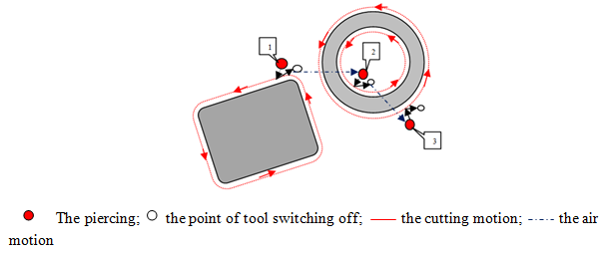

Fig.1. The cutting scheme example of two parts using standard cutting technique

During development of NC program the optimization problems of cutting tool path are arisen. The cutting cost  are one of numerical characteristics that defines the effectiveness of NC program for special set of parts.  is calculated by [4]:

 (1.1)

 is length of air tool path;  is length of working tool path;  is cost of air tool path unit;  is cost of working tool path unit;  is numbers of piercing;  is time of one piercing;  is cost of one piercing.

In general when using different types ( ) of piercing the  is calculated by:

 (1.2)

The problem of cost function minimization is considered as *generalized travelling salesman problem (GTSP) with restrictions* [4, 5]. The formalization of minimization problem of cutting time and cost for CNC sheet cutting machines is presented in [4].

In [11, 12] the following classes of cutting tool routing problems for CNC sheet cutting machines are allocated:

* The Traveling Salesman Problem – TSP;
* The Generalized Traveling Salesman Problem – GTSP;
* The Continuous Cutting Problem – CCP;
* The End Point Cutting Problem – ECP;
* Intermittent Cutting Problem – ICP;
* Based on conception of contours cutting by segment [13] the new class of optimization tool routing problem is presented [13] – Segment Continious Cutting Problem (SCCP).

In optimization problem (1.2) there are difficulties in calculating the basic parameters,  depending on many factors. For CNC laser cutting machines ,  depend on the type of laser used in CNC machine, type and thickness of treatment material. The dependence on selected factors is defined by analytically or tabular functions. The formulas of ,  calculation and their values may significantly differ for various CNC sheet cutting machines. It is worth nothing that time per pierce in laser cutting process is calculated in [6]. In [7] the laser cutting cost is compared with water jet, plasma and oxygen cutting costs when treatment sheet material of St3 (thicknesses ∆=3-10 mm). In [8] the assessment of plasma and CO2 laser cutting machines operating cost is performed. But it should be noted that the calculation of mentioned above parameters remains outside the scope of modern research, hence the research for , calculation and consequently exact calculation of cost function  is actual problems today, which is solved in this article.

As seen from (1.2)  also depends on  and , in turn  depends on value of working tool speed . The value of  is usually constant parameter which is programming during the NC program development, but as the practical shows [9, 10] the value of actual working speed of cutting tool is varied by various technological factors and parameters of NC programs. Consequently problem of accurate calculation of cost function (1.2) in optimization problem of tool path routing is arisen. In order to solve the encountered problem the need of correction parameters calculation for  values is emerged. It should be noted that the question of exact calculation of  values is remained open, then there is a need of research in order to calculate the correction parameters of  values and consequently cutting cost in this article for CNC laser cutting machines.

It is observed that  and  are interdependent. In some cases the reduction of  leads to some increase of total cutting tool path length value  due to cutting motion between contours. Wherein the length of air path  is reduced.

The problem of cost function minimization (1.2) during treatment of figured parts from sheet material at CNC cutting machines is solved by the optimization of parameters  and . As the practice shows the length of cutting tool motion  and numbers of pierce points have the greatest impact on the cutting cost compared with the length of air tool motion . Depending on the thickness and type of material the  can reach up to 33% from  and at the same time can exceed the  by three orders [14]. Consequently the most interest are the methods of solving the problem aimed at the minimizing  and .

Analyze of existing methods of cost function minimizing showed that airtime and length of air motion are usually minimized when optimizing the path of cutting tool. In some works an algorithms for optimizing the airtime of cutting tool are considered. Yang et al. [15] described the tool path airtime optimization problem in leather cutting. They proposed the hybrid intelligence algorithm. Castelino et al. [16] described an algorithm for minimizing the airtime of cutting tool by optimally connecting the tool path. They considered the heuristic methods that are used in order to obtain the optimal or near optimal solutions. Murzakaev et al [17] considered the problem of cutter air motion length minimization. The model is presented for standard cutting technique. In order to minimize cutter air motion length the three metaheuristics (Simulated Annealing, Threshold Accepting, Great Deluge Algorithm) were chosen. They proposed the generalized scheme of problem solving. Chen et al [18] proposed algorithm of air motion path minimizing. They divided into two sub-optimal problems (pattern cutting order and entry/exit cutting point) and solve ones using an ant colony optimization algorithm (min-max ant system). Lee and Kwon [19] considered tool path problem and proposed two-step genetic algorithm. The aim is to minimize the air moving of cutting tool. They combined global search for piercing optimization and local search for part sequencing. Sherif et al [20] presented the two stage sequential optimization procedure for nesting and cutting sequence. The objectives are maximizing material utilization and minimization of laser cutting tool air motion. They considered simulated annealing algorithm in order to find the near optimal cutting tool path.

It should be noted that the deficiency of research in the field of reducing the numbers of pierce points  and length of cutting tool motion  in solving the optimization problem (1.2). In [21] the authors consider the problem of pierce point numbers reducing in thermal cutting of sheet material in terms of graph theory. It should be noted that the precedence constrain was not taken into account and the intersection of the existing cuts is allowed. The problem of cutting path optimization in terms of cutting of parts group with one of pierce point is considered in [22]. The last stage of solving the problem (optimization of the cutter routing at idle) is reduced to the TSP. In [23] the problem of tool routing optimization at CNC machines is formulated and the mathematical model of total cutting time minimization is proposed by using standard and special cutting techniques. Verhoturov et al. [24] present “chained” cutting technique in order to minimize the numbers of pierce points.

The one of cutting time and cost minimization methods is application of special cutting techniques. In order to optimize the cutting parameters and to observe the necessary cutting requirements the some special cutting techniques are used. There are “chained” cutting [24], common cut [25], partial cutting of contour with the subsequent completion of the contour cutting after cutting the contour of another part, et al. Petunin and Krotov [25] proposed the classification of various cutting techniques used to form the cutting tool path. The cutting techniques are classified into three main classes: standard cutting, multi-contour cutting and multi-segment cutting technique. The every contour is cut with pierce point by using *standard cutting technique*. The numbers of pierce points equal numbers of contours. The several contours are cut in one cutting segment with one pierce point by using *multi-contour cutting technique*. For example, the multi-contour cutting includes “chained” cutting, common cut. The several cutting segments are cut with several pierce points by using *multi-segment technique*.

The considered techniques applied for various types of parts and their effectiveness for different types are varied. In some cases the effectiveness reaches the minimum value. For this reason in order to minimize  the development of special cutting techniques for various geometrical types of parts is actual problem today. The circle, polygon parts are often found during sheet-working production in engineering industry. The treatment of parts without additional cut is impossible with the help of the existing multi-contour cutting techniques. Due to this fact the special cutting technique for circle and polygon parts is proposed in this article.

The article is organized as follows. The model of  calculation and basic parameters,  is presented in Section 2.1. Exact calculation of  values and values of correction coefficients for  is given in Section 2.2. The special cutting technique for circle and polygon parts is proposed in Section 3. The results of the computational experiment, which shows a statistically significant improvement in the value of the objective function compared to using the standard cutting technique, are presented in Section 4.

1. **The exact calculation of cost function**  **in cutting sheet material at CNC laser CO2 machine**
   1. **The model of basic cost parameters**, . **calculation**

The most important economic characteristic of the developed NC program quality is the cost  of cutting parts at CNC machine.  includes the costs of electricity and expendable materials, maintenance of a CNC machine and other operating costs incurred during cutting. The problem of exact calculation of cost function  in optimizing of cutting tool route related with search of adequate value , which calculation depends on basic parameters , .

The problem of accurate calculation of cutting cost in optimization problem of cutting tool routing applied to CNC laser cutting machine (laser type is CO2) is considered. In order to calculate  the following notations for cost parameters calculation on 1 m of cutting tool motion are entered:  - the cost of expendable materials (for example, adjudge, protective glass, gas tubes); * -* the cost of technological gas (nitrogen or oxygen depending on processed material); * -* the cost of cutting gas (when working on a gas flow laser);  - the cost of electricity;  - the cost related with salary of accompanying personnel;  - amortization of equipment. In general the  is calculated by:

 (1.3)

In order to calculate  the additional notations are entered: * -* the time spent on 1 m of cutting tool motion, h.; * -* the electricity costs for 1 hour of CNC laser machine work on cutting motion, kW/h; * -* technological gas consumption, m3/h *;  -* laser gas consumption, m3/h;  - electricity cost per 1 kW;  - the cost of 1 m3 laser gas;  - the cost of 1 m3 technological gas;  - the cost of expendable materials unit;  - serviceable life of expendable materials; - cost of 1 h work of accompanying personnel; *A –* amortization of 1 h work of CNC laser cutting machine; *N* - useful life of equipment;  - .initial cost of the CNC laser cutting machine.

The  are calculated by:

. (1.4)

Similarly ; (1.5)

; (1.6)

**. (1.7)

** (1.8)

** (1.9)

In order to calculate  the following notations are entered: – the electricity costs for 1 hour of CNC laser machine work on air motion, kW/h; ** – the time spent on 1 m of air tool motion, h. Consequently the  is calculated by:

. (1.10)

In order to calculate  the following notations for cost parameters calculation on 1 pierce point are entered:  - the cost of expendable materials (for example, adjudge, protective glass, gas tubes); * -* the cost of technological gas (nitrogen or oxygen depending on processed material); * -* the cost of cutting gas (when working on a gas flow laser);  - the cost of electricity;  - the cost related with salary of accompanying personnel;  - amortization of equipment. In general the  is calculated by:

**. (1.11)

In order to calculate  the additional notations are entered: – the electricity costs for 1 pierce point, kW/h; ** – the time spent on 1 pierce point, h. Consequently the  is calculated by:

**; (1.12)

; (1.13)

;  (1.14)

. (1.15)

** (1.16)

** (1.17)

During calculation of  and  the following parameters  and  must be taken into account when processing of material at flow-through gas laser machines. The parameter  must be considered during calculation of  when technological gas is applied.

Consequently,  can be written as follows:

 (1.18)

The main expendable materials for gas laser include: swivel mirrors, focusing lenses, protective glasses, nozzles, adjusting units, gas tubes. The main expendable materials for fiber laser are nozzles, protective glasses, focusing lenses. And for the case of using solid-state lasers, the expendable materials are optical pumping lamps, protective glasses, mirrors, a quantron, an active element. In [14] the values of cost parameters  and  is presented by taken into account the above parameters (1.3)-(1.17) for CNC laser cutting machine by example ByStar 3015. For each type of material the parameters  and  is calculated by taken into account that  As the practical shows [9,10] the value of actual working speed of cutting tool is varied by various technological factors and parameters of NC programs. Consequently problem of accurate calculation of cost function (1.2) in optimization problem of tool path construction is arisen. In order to solve the encountered problem the need of correction parameters calculation for  values is emerged.

* 1. **The calculation of cutting tool speed  and correction coefficient depending on the complexity of part contours by example of the CNC laser cutting machine ByStar 3015**

The inaccuracy of the actual cutting time and cost calculation is due to the fact that **,** which is programmedas constant value in NC program, is actually varied by various technological factors. It was found that increasing of frames numbers in NC program for various sets of parts, which have the same total perimeter of the contours, the actual  is decreased [9,10]. The reasons why NC program can contain a large numbers of frames is mainly due to the contours of complex geometry (for example, splines) when converting from CAD systems to a CAM are divided into a large numbers of geometric primitives due to the difference of geometric file formats (for example, on segments of straight lines and circular arcs), i.e. approximated by simple geometric primitives. The difference in formats is due to the fact that almost all CNC systems are equipped with only linear and circular interpolators. As a rule the approximation of a complex geometry reduces to a linear approximation.

The functional dependence of  should be determinedby science - based table functions or analytically. The algorithmization of objective function (1.2) calculation based on science – based determination of function parameters is requirement for the development of cutting tool path optimization algorithms. The cutting tool route is optimal only if the objective function is adequate calculated. For this reason the exact parameters values of objective function (1.2) must be calculated.

The some practical results on determining the dependence of cutting tool speed on numbers of frames in NC program are given below [10]. Based on received results the objective function (1.2) can exactly calculated and optimal cutting tool route can developed.

The research was conducted for following materials: 10кп (thickness ∆=1-10 mm) and АМг3М (thickness ∆=1-10 mm). In order to conduct experiments the 150 NC programs for cutting of various types of parts with numbers of frames ** () for 10кп and 150 NC programs for cutting of various types of parts with numbers of frames **  for АМг3М.

The statistical materials were processed by using “Mathcad”. Based on received results the following findings were made:

1. The actual average speed of cutting tool speed  is monotonically decreasing function depending on frames numbers of NC program (fig.2);
2. The predetermined cutting tool speed  coincides with the actual average speed when the numbers of frames reaches a certain threshold value *N*. When the frames numbers , then the actual speed is greater than predetermined cutting tool speed, if the frames numbers of NC program is arisen () then the actual speed is less than predetermined cutting tool speed of NC program (in the experiments the reduction of average actual cutting tool speed value compared with predetermined cutting tool speed in NC program is 70%);
3. The threshold value *N* is variedfor different thickness and grade of material.

In order to present the results of computational experiments the following notations are introduced: *n* – frames numbers of NC program;  - the actual speed of cutting too; *N* – the frames numbers when ;  - the sum of squared deviations of the original data from the values of the approximation functions at these points.

When approximation the point chart of the dependence of actual speed on the numbers of frames by approximating curves in “Mathcad” it was established for all values of studied grade materials and thickness that values of  are achieved by using logarithmic approximation function.

Fig.2, presents following results for material of АМг3М with ∆=1 mm.

Similar results were obtained for АМг3М with ∆=2-5 mm and 10кп with ∆=1-10 mm. The summarized results for all investigated material grades and thicknesses are given in table 1. The results show the formulas for calculating the actual cutting tool speed of CNC laser machines by example ByStar3015.

Taking into account this data during calculation of the objective function (1.2) the correction of  values is performed depending on frames numbers in NC program for each valid cutting tool route. In the case of using the other thicknesses of material, which are not included in table 1, it is proposed to apply simple methods, for example, for АМг3М with ∆=2.5 mm an arithmetic average of  values for ∆=2 and 3 mm can be used. When using material of other grades, it is necessary to conduct additional researches or use the available data of material with similar physical properties.

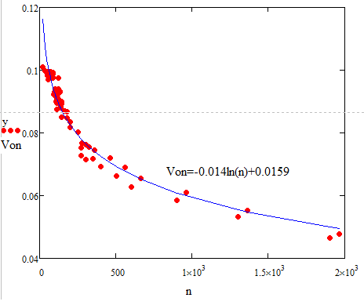

Fig.2. The change of the real cutting tool speed for АМг3М, ∆=1 mm

Table 1.

The generalized table of formulas for calculating of cutting tool speed by example CNC laser cutting machine ByStar3015

|  |  |  |
| --- | --- | --- |
| Material and thickness of material ∆ | The formulas for cutting tool speed calculation | |
| 10кп, ∆=1 mm |  |  |
|  |  |
| 10кп, ∆=2 mm |  |  |
|  |  |
| 10кп, ∆=3 mm |  |  |
|  |  |
| 10кп, ∆=3.5 mm |  |  |
|  |  |
| 10кп, ∆=4 mm |  |  |
|  |  |
| 10кп, ∆=8 mm |  |  |
|  |  |
| 10кп, ∆=10 mm |  |  |
|  |  |

Continuation of table 1

|  |  |  |
| --- | --- | --- |
| Material and thickness of material ∆ | The formulas for cutting tool speed calculstion | |
| АМг3М, ∆=1 mm |  | |
| 0,0013 | |
| АМг3М, ∆=2 mm |  |  |
|  |  |
| АМг3М, ∆=3 mm |  |  |
|  |  |
| АМг3М, ∆=5 mm |  |  |
|  |  |

1. **The special cutting techniques used during optimization of cutting tool route**
   1. **The classification of special cutting techniques**

The special cutting techniques used during minimization of basic objective function are classified into three classes [13]:

* Continuous cutting (standard cutting);
* Multi-contour cutting;
* Multi-segment cutting.

In the case of standard cutting techniques the each contour is cut by one pierce points, motion from one contour to another is carried out by air (fig.1). The multi-contour cutting cuts several contours in one cutting segment. Multi-segment cutting cuts one contour in several cutting segments.

For example, the multi-contour cutting technique includes “chained” cutting (fig.2), snake cutting technique (fig.3), common cut (fig.4).

Using of “chained” cutting technique the cutting of contours is performed by one piercing and the moving to next contour is carried out by cutting motion of cutter (fig. 2).

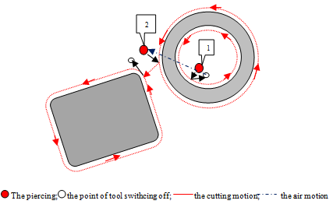

Fig.2. The cutting scheme example of two parts using “chained” cutting technique

The common cut is applied to cut the contours containing straight-lines. The straight-lines of contours are common boundary of nesting contours (fig. 3).The common rectilinear boundary allows to place parts with half allowance for cutting (i.e. kerf). The common cut reduces waste material, cutting and air motion of cutter.

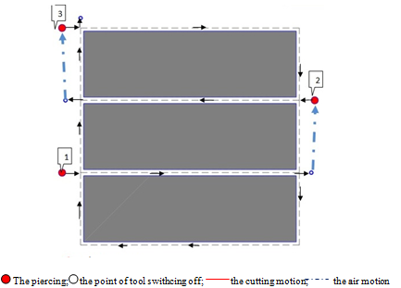

Fig.3. The cutting scheme example of two parts using common cut

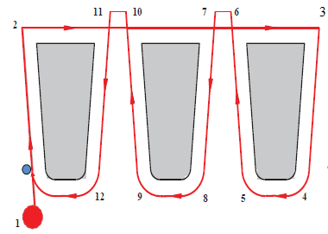

Fig.4. The cutting scheme example of two parts using snake cutting

Due to the fact that existing special cutting techniques do not always provide expected performance of their use the development of special cutting techniques for some groups of geometrical types contours, which are provided the significantly reduced of basic cutting parameters  is actual problem today. In Section 3.2 the special cutting techniques are proposed for the most common geometric types of contours used in blank production of engineering plant.

In the current scientific literature the conditions of effective application of special cutting techniques are not given. For example, application of “chained” or snake cutting is carried out by additional cuts  between contours that increases the . For this reason the permissible values of  need to know otherwise the effectiveness of “chained” or snake cutting application will be reduced to a negative result and value of  will take the value of more than when using standard cutting. In [14] the values of  based on model presented on Section 2.1 are presented.

* 1. **The classification of special cutting techniques for circle and polygon parts**

The one method of cutting time and cost minimization is application of special cutting techniques.

In engineering industry the geometrical forms of most parts are polygon and circle. This paper considers the special cutting techniques for polygons and circles parts. The special cutting techniques use more complexity algorithm in contrast to standard cutting technique.

In [26] the cutting techniques for circle and triangle parts were proposed. The effectiveness conditions of proposed techniques were obtained. Solving problem of irregular cutting the method of parts association in group or “block” is often used. During nesting the “block” is similarly the one part, i.e. the all movements / rotations are made simultaneously with all the details included in the “block”. The association in “blocks” is actually in our case. Figure 5 presents the scheme of circle parts cutting using special cutting technique.

The continuous cutting of parts is performed. At first the upper sectors are cut. At second the lower sectors are cut last. Wherein moving from one sector to another is implemented by cutting motion (fig.5). The proposed cutting technique reduces the number of piercing, air motions, but increases the cutting motion. Consequently the cutting motion length of cutter needs to be taken into account when moving from one contour to another. These cutting costs should not exceed the costs of piercing. Based on results [26], the algorithm of cutting tool route automation for CAD/CAM “SIRIUS” was developed. While cutting tool routing the Part Hardness Rule is taken into account [27]. The proposed algorithm is applicable for any size circles and allows to automatically build the cutting tool route.

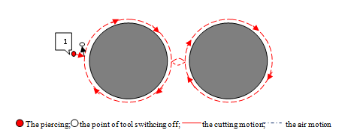

Fig.5. The cutting scheme example of two circle parts using special cutting

The special cutting technique for triangle parts was proposed [26]. In engineering manufacturing the most geometrical form of parts is polygon. Therefore the algorithm of cutting tool route automation for polygon parts was developed based on proposed special cutting technique for CAD/CAM “SIRIUS”. While cutting tool routing the Part Hardness Rule is taken into account [27]. The algorithm can be used by designing NC program in interactive mode. The features of proposed technique are the reducing of piercing, the cutting and air motions of cutter. The proposed algorithm is applicable for various one-sided symmetry polygons. The proposed technique significantly reduces numbers of piercing, cutting and air motions of cutter for polygon parts. The polygons can be arranged in the cell type. Fig. 6 presents the cutting scheme of triangle parts. The parts are combined by “blocks” and within each “block” the cutting is performed by one piercing. Moving from one “block” to another is implemented by air.

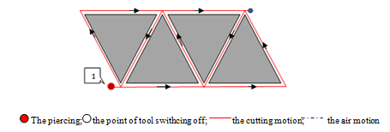

Fig.6. The cutting scheme example of four triangle parts using special cutting techniques

In order to evaluate the effectiveness of developed special cutting techniques the computing experiments were conducted at CAD/CAM “SIRIUS” and obtained results is presented in Section 4.

1. **Computational experiments**

Based on algorithms presented on Section 3.2 the cutting tool route for nesting is automatically built at CAD/CAM “SIRIUS”. In order to evaluate the the effectiveness of developed special cutting techniques the four nesting is obtained by using standard (fig.7,9) and special (fig.8,10) cutting techniques for various types of parts including circles (fig.7,8) and polygon (fig.9,10) parts.

Fig.7 presents the cutting tool path built for various geometrical types of parts including circles using standard cutting techniques. Fig.8 presents the cutting tool path built for various geometrical types of parts including circles using special cutting techniques.

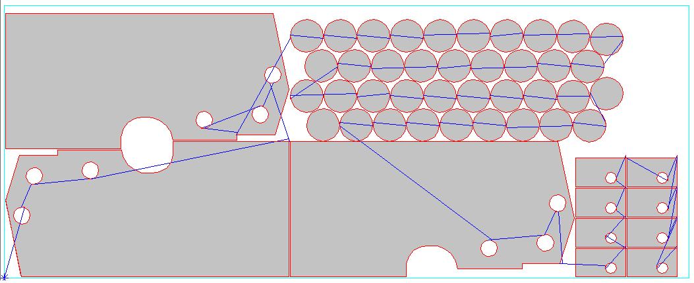

Fig.7. The cutting scheme example of parts using standard cutting technique

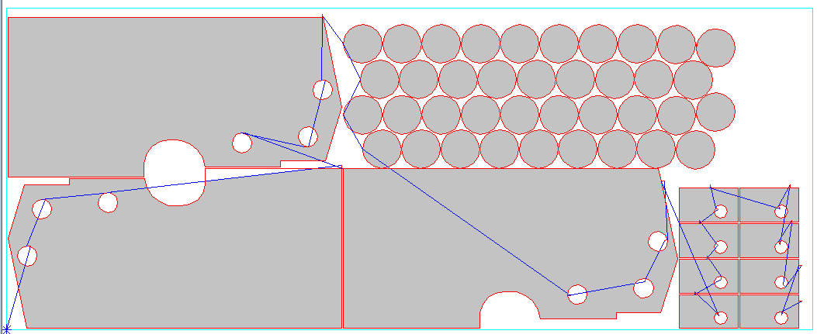

Fig.8. The cutting scheme example of parts using special cutting technique

Table 2 presents computational results of basic cutting parameters and values of  for obtained NC programs developed based on cutting tool path for nesting (fig.7-10). The calculation of  was carried out by using model presented in Section 2.1 and 2.2. The results are calculated for AMg3M ∆= 5 mm. The following notations in table 2 are used: *n –* numbers of frames in NC program;  - the cutting cost calculated taking into account that ;  - the cutting cost calculated taking into account that  and depends on the frames numbers of NC program.

Fig.9 presents the cutting tool path built for various geometrical types of parts including polygons and circles using standard cutting techniques. Fig.10 presents the cutting tool path built for various geometrical types of parts including polygons and circles using special cutting techniques.

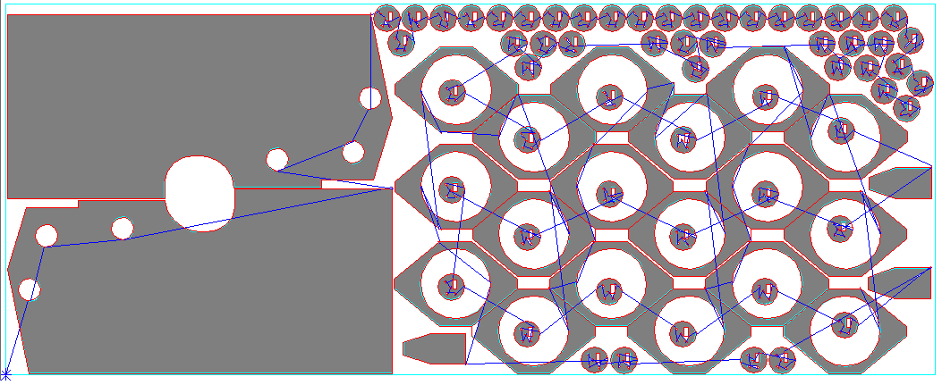

Fig.9. The cutting scheme example of parts using special cutting technique

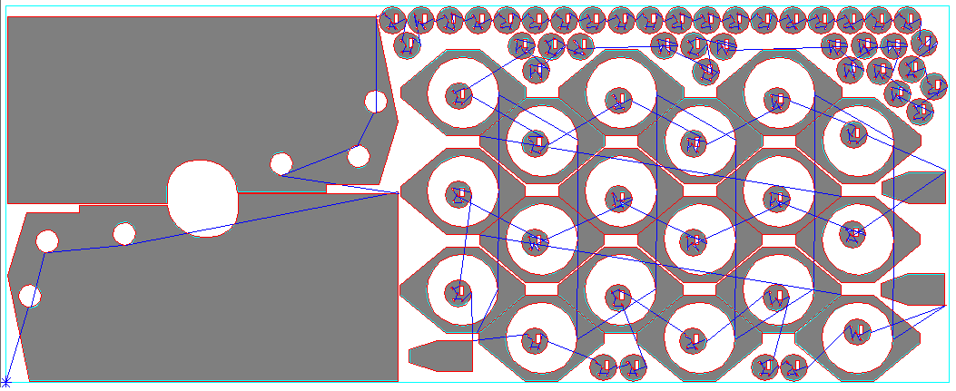

Fig.10. The cutting scheme example of parts using special cutting technique

The results presented in table 2 indicate that the basis cutting parameters are reduced by using special cutting techniques compared with standard cutting. In turn the reduction of ,  and  leads to reduction of  by 14% using special cutting technique (fig.10) compared with standard cutting (fig.9).

Table 2

The results of  calculation

|  |  |  |  |  |  |  |  |  |
| --- | --- | --- | --- | --- | --- | --- | --- | --- |
| Material and thickness | Cutting techniques type | Basic cutting parameters | | | n | , rub | , rub | % |
|  | , m | , m |
| AMg3M, ∆=5 | Standard (fig.7) | 66 | 63.3 | 20.34 | 169 | 22908.32 | 28519.79 | 4.5 |
| Special (fig.8) | 32 | 63.55 | 11.46 | 21890.75 | 27524.38 |
| Standard (fig.9) | 407 | 117.78 | 50.47 | 888 | 51790.31 | 67100.44 | 4.7 |
| Special (fig.10) | 361 | 114.93 | 47.61 | 49371.17 | 64310.82 |

1. **Conclusins**

In this article the following results were obtained:

1. The problem of cutting tool path optimization on CNC machines was considered. The model of cost function  and basic parameters calculation is presented for CNC laser cutting machines.  includes the costs of electricity and expendable materials, maintenance of a CNC machine and other operating costs incurred during cutting. The problem of exact calculation of cost function  in optimizing of cutting tool route related with search of adequate value , which calculation depends on basic parameters , ;
2. The value of actual working speed of cutting tool is varied by various technological factors and parameters of NC programs. The problem of accurate calculation of cost function (1.2) in optimization problem of tool path construction is solved in this article. The correction parameters for  values is presented for type of material AMg3M (∆=1-5 mm) and St10kp (∆=1-10 mm);
3. The one of cutting time and cost minimization methods is application of special cutting techniques. In order to optimize the cutting parameters and to observe the necessary cutting requirements the some special cutting techniques are used. In this article the effective special cutting techniques for the common geometrical types of parts u widely used in blank production of engineering plant are developed:
4. The computational experiments shown that application of presented special cutting technique allows to reduce the basic cutting parameters of ,  and  compared with standard cutting techniques. The calculation of  is performed by model presented in Section 2.1. In turn the calculation of  is carried out by values of  and  the results show value of  when  is 30% lower than value of  when . The basic parameters of ,  and  are reduced. For example, when using the special cutting technique is reduced by 11 % compared with standard cutting. The reduction of ,  and  leads to reduction of  by 5 % using special cutting technique (fig.10) compared with standard cutting (fig.9).

**References**

1. A. Petunin: About some strategies of tool routing when designing NC programs applied to thermal cutting machines, Vestnik UGATU, Upravlenie, VTiT, №2 (35), 2009, pp. 280-286 (in Russian)
2. A. Petunin, A. Tavaeva: Optimization of tool route for CNC shape cutting machines provided that working stroke speed is not constant value, Fundumental Research, №6-1, 2015, pp. 56-62 (in Russian)
3. R. Dewil, P. Vansteenwegen, D. Cattrysse: Sheet metal laser сcutting tool path generation: dealing with overlooked problem aspects, Key Engineering Materials, Vol. 639, 2015, pp. 517-524
4. A. Petunin. The two problems of cutting tool routing for CNC figured cutting machines. In: ITIPM’14. 2nd International conference “Intelligent Technologies for Information Processing and Management”, Russia, Ufa, 2014. Vol. 1, p 215-220 (in Russian)
5. A. Petunin, A. Chentsov, P. Chentsov. About one problem of cutting tool routing during sheet cutting. Model.Anal.Inform.Sist., 2015, Vol.22, p.278-297 (in Russian)
6. E. Konnikova, A. Kyklina. The specific of time per pierce determining when calculating of production cost using laser cutting technology. Economica I ypravlenie narodnim hozyaistvom. №2 (30), 2016, p.41-49 (in Russian)
7. A. Milcin, M. Shabanov, M.Lysych, V. Romanov. The modern cutting methods of sheet materials. Actualnye napravleniya nauchnykh issledovanii XXI: teoriya i praktika. 2015, T.3, №2-1(13-1), p.83-87 (in Russian).
8. A. Shaparev, A. Savina. Technological and economical comparison of plasma and CO2 laser cutting of sheet material. Nauka I sovremennost. 2016, №3(9), p.181-189 (in Russian).
9. A.A. Petunin and A.F. Tavaeva, Optimization of tool route for CNC shape cutting machines provided that working stroke speed is not constant value, Fundamental researches, №6, 2015, 56-62 (in Russian).
10. A. Tavaeva., D. Kurennov. Optimization of cutting process for CNC thermal and water-jet machines. AIP Conference Proceedings. Vol. 1690, 2015. http://dx.doi.org/10.1063/1.4936681
11. R. Dewil, P. Vansteenwegen, D. Cattrysse. A review of cutting path algorithms for laser cutters. International Journal of Manufacturing Technologies. 87 (5-8). 1865-1884 pp. 2016.
12. J. Hoeft, U. Palekar. Heuristics for the plate – cutting traveling salesman problem. IIE Transactions. Vol. 29, Issue 9. 719-731 pp. 1997.
13. Petunin A.A. Modeling of tool path for the CNC sheet cutting machines. AIP Conference Proceedings. 2015. http://dx.doi.org/10.1063/1.4936740
14. Tavaeva A, Petunin A (2018) The accurate calculation of parts treatment cost from sheet metal on the CNC laser cutting machine in problem of tool routing optimization. J Modeling, Optimization and Information Technologies https://moit.vivt.ru/?p=7489&lang=ru (in Russian)
15. W. Yang, Y. Zhao,J. Jie,W. Wang: An effective algorithm for tool path airtime. Optimization during leather cutting, Advanced Materials Research, 2010, pp. 373-377
16. K. Castelino, R. D’Souza, P. Wright: Toolpath optimization for minimizing airtime during machining, Journal of Manufacturing Systems, 2003, pp. 173-180
17. R. Murzakaev, V. Shilov, A. Burylov: Application of metaheuristic algorithms to minimize idle running length of cutting tool, Journal of PNRPU Bulletin. Electrotechnics, Information Technologies, Control Systems, 2015, №14, pp.123-136 (in Russian)
18. M. Chen, X. Li,K. Nang: Optimal air-move path generation based on MMAS algorithm, International Journal of Production Research, 2017, vol.52, Issue 24, pp. 7310-7323
19. M. Lee, K. Kwon: Cutting path optimization in CNC cutting processes using a two-step genetic algorithm, International Journal of Production Research, 2006, pp. 5307-5326
20. S. Sherif, N. Jawahar, M. Balamurali: Sequental optimization approach for nesting and cutting sequence in laser cutting, Journal of Manufacturing Systems, 2014, Vol.33, Issue 4, pp. 624-628
21. U. Manber., S.Israni. Pierce point minimization and optimal Torch path determination in flame cutting. Journal of Manufacturing Systems. Vol.3, No 1. 81-89 pp. 1984.
22. V. Frolovskii. The automation of NC program design in thermal cutting at CNC machines. Inf. Technologii v proektirovanii i proizvodstve.2005, №4, p.63-66 (in Russian)
23. R. Faizrahmanov, R. Murzakaev, A. Burylov, V. Pristupov. The minimization of total cutting time taking into account technologies for CNC machines. EHlektrotekhnika. 2016, №11, p.7-12 (in Russian)
24. M. Verhoturov, P. Tarasenko: Mathematical provision of tool path problem at flat shape nesting based on “chained” cutting, Vestnik UGATU, Upravlenie, VTiT, №2 (27), 2008, pp. 123-130 (in Russian)
25. A. Petunin, V. Krotov: About classification of cutting techniques for CNC machines and problem of tool path optimization, Materialovedenie, Mashinostroenie, Energetika, 2015, pp. 466-475 (in Russian)
26. A. Tavaeva, A. Petunin, V. Krotov. About effectiveness of special cutting techniques in developing of NC programs for CNC thermal cutting machines. Proceedings of the Workshop on Computer Science and Information Technologies (CSIT’2017), Germany, 2017, Vol.№1,p. 221-227
27. A. Petunin. About strategies of cutting tool routing during NC program development on CNC thermal cutting machines. Vestnik UGATU, Upravlenie, VTiT, №2 (35), 2009, pp. 280-286 (in Russian)