Simulating Thermal Sheet Cutting of Figured Parts

Mikhail Verkhoturov*. Alexandr Petunin**, Galina Verkhoturova*, Danil Zaripov

*Ufa State Aviation Technical University, Ufa, Russia (e-mail: verhotur@vmk.ugatu.ac.ru).

** Ural Federal University, Yekaterinburg, Russia (e-mail: a.a.petunin@urfu.ru)

**Abstract**: The problem of modeling the process of thermal cutting of sheet material is considered, which occurs during cutting using laser, gas, etc. equipment. The goal is to solve the problem of optimizing the toolpath, considering thermal effects in the material being cut. The statement of the problem is given. An approach to modeling the change in temperature of the material being cut is proposed based on a discrete representation of information. The results of the computational experiment are given.

*Keywords*: Tool path problem, CNC sheet cutting machines, Thermal deformations, Constraints, TSP, Discrete representation.

1. INTRODUCTION

One of the important and promising areas of modeling is the objects and processes of industrial production of a particular product. The process of creating any product begins with the manufacture of its elementary structural components - parts. Parts represent the bulk of objects in any industrial plant. In the production cycle of creating products, the stage of their manufacture is one of the most time-consuming and complex. In addition, many enterprises are currently operating in single and small-scale production. Due to the large range of parts in the manufacture of blanks, problems arise in organizing the technological design of cutting and procurement operations, see Wäscher et al. (2007).

In the process of cutting sheet materials into figured blanks, one of the most important stages is the construction of the path of the cutting tool. For the manufacture of blanks and parts from sheet materials, figured cutting machines with numerical control (CNC) are used. Laser cutting has gained popularity, which uses a focused laser beam that heats the surface at a specified point to the evaporation temperature of the material, see Dewil et al. (2016). By moving the laser beam along a given route, a cut of the material of the desired shape is created. Optimization of the path of the cutting tool can reduce the cost of cutting and improve the quality of the resulting parts, see Yang et al. (2010); Tavaeva et al. (2019b,a).

Typically, path optimization comes down to minimizing tool free travel and reducing plunge points. However, when forming such a route, compliance with the temperature regime of the material is not considered. Depending on the order of cutting out the figures, the temperature of the material being cut can vary greatly in different local areas, cause overheating of the material with its subsequent deformation and lead to a deterioration in the quality of the resulting parts, see Petunin (2019); Petunin et al. (2016); Chentsov et al. (2018), Sonawane et al. (2020).

In this regard, it becomes necessary to consider the thermal factor, which makes it possible to improve the quality of the obtained workpieces in comparison with the usual minimization of the idle path. To do this, two approaches are currently used: 1) formalization of heuristic rules developed by experienced technologists for interactive tool routing and 2) application of CAE systems to simulate temperature fields in the material that occur during thermal cutting. The first approach includes the “part stiffness” rule, which limits the choice of permissible pierce points for the next part to cut, and the “sheet stiffness” rule, which, in turn, imposes restrictions on the selection of the next part to be cut when forming the route, see Petunin and Stylios (2016). The second approach is implemented, for example, in the works of Mejia et al. (2018); Petunin et al. (2019); Verkhoturov et al. (2021).

Of other works that consider thermal deformations of the material to some extent when modeling the cutting route, we note Lagerkvist et al. (2013); Hajad et al. (2019); Balamurali et al. (2019). In Mejia et al. (2018) more accurate and faster thermal estimation methods have been developed. Although this line of research is encouraging, more detailed study of the relationship between material temperature and acceptable route options is required. It is important to note that Dewil et al. (2015); Petunin et al. (2019) and Levichev et al. (2020) shows the practical possibility of applying the heuristic approaches of the GTSP/megacities theoretical model to the problem of modeling the tool path for thermal cutting machine while simultaneously considering the temperature of the material. At the same time, the presented results of calculations in all works, considering the thermal aspects of the tool routing of a CNC thermal cutting machine, do not yet look very convincing in terms of real optimization of the time and cost of the cutting process. The main reason for this is that the proposed methods for reducing the problems associated with thermal deformation of the metal during cutting are mainly of a qualitative nature. It can be reliably asserted that, to date, no exact numerical data have been obtained on the magnitude of geometric distortions of parts when choosing one or another cutting route, depending on the degree of implementation of the heuristic rules of "rigidity" or depending on the distribution of temperature fields during thermal cutting. The value of thermal deformations is also significantly affected by the brand, the thickness of the material, and the features of the equipment. Research in this area, in fact, has not yet been carried out. Therefore, the mathematical formalization of dynamic constraints in instrument routing problems causes obvious difficulties.

On the other hand, if we talk about modeling as close to reality as possible, then “synchronization” with the cutting process under consideration is necessary, and, first, with the real temperature that certain points of a particular material being cut have so far.

2. PROBLEM STATEMENT

**Let**:

L(axb) – rectangular area to be cut (see Fig.1, Fig.2).

{Si} – parts to cut, where i = 1 ÷ n – part number.

{Cij} – parts’ contours, where i – part number,

j is the number of the part Si contour, j = 1 ÷ mi (mi≥ 1 is the number of external and internal contours of the part Si);

{Pij} – pierce points onto contours, where i is the number of the part, j is the number of the contour of the part Si.

Pstart – the initial position of the cutting tool.

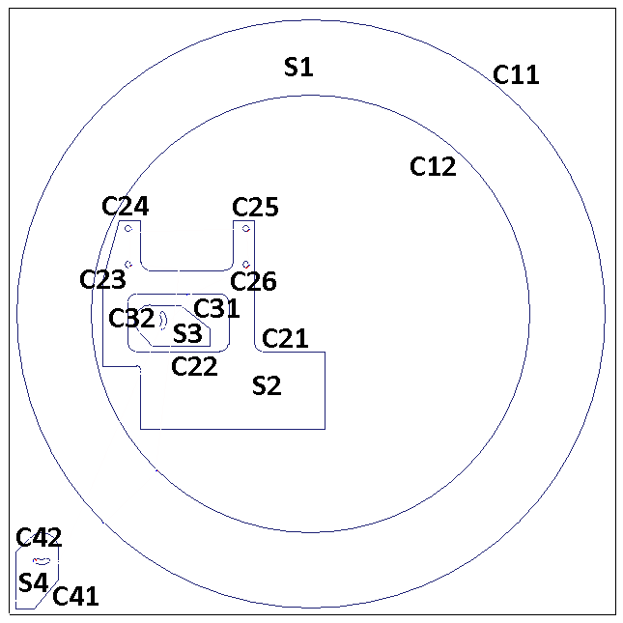

Figure 1. Nesting plan (parts Si & their contours Cij)

**Find**:

Such $R^{*}$ that

$T(Tr\left(R^{*}\right), L)≤t_{max}$, where:

R = (Pstart, … , Pij, … , Pstart) is a sequence of contour inset points, where i = 1 ÷ n, j = 1 ÷ mi;

Tr(R) is the path of the cutting tool when moving along the sequence of points R.

T(Tr(∙), L) is a function that determines the maximum temperature of the point (x, y) $(0≤x≤a, 0≤y≤b)$ of the sheet L being cut during cutting along the path Tr(∙).

It should be noted that the problem may not have a solution for certain values of $t_{max}$ less than a certain value $t_{MAX}$, because when cutting, the metal is heated to its melting temperature and this temperature spreads over the entire area of the sheet.

Accordingly, when the cutting tool moves at a given speed over all parts cut, a situation may arise in which there will be no areas of the sheet having a temperature less than ${(t}_{max}-delta)$. Therefore, if you start cutting a part located in such a zone, the temperature will rise more than the value of $t_{max}$.

In practice, this problem can be solved only by suspending the cutting process for some time until certain areas of the sheet are cooled to an acceptable temperature. However, in practice this approach is not applied.

In this context, it makes sense to talk about minimizing the number of overheatings, and not about avoiding to exceed the value of $t_{max}$. Which is further described in the paper.

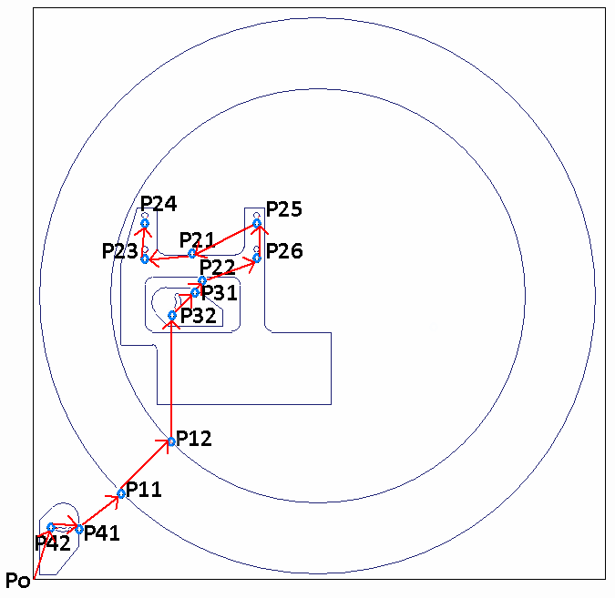

Figure 2. Nesting plan   
(toolpath through pierce points Pij into contours Cij;   
P0 – starting point)

Such an approach when constructing the path of the cutting tool, which does not consider the nesting of the internal contours of the parts in its external contours, as well as the possibility of placing parts in the internal contours of other ones, can lead to the following problems:

1. Parts/contours that are not connected with the sheet after cutting out can be displaced/deformed due to thermal effects and the presence of internal stresses that have been present in the sheet since its manufacture, respectively, parts/contours that are inside the cut contours/parts, in this case will be cut out also with an offset, i.e., incorrect.
2. Overheating of this part/contour and contours/parts inside it/it is possible in the process of subsequent cutting of the contours/parts located inside the considered one, again since there is no connection with the "basic" material, which would be a heat sink.

When solving the problem under consideration, it is necessary to consider **additional constraints** on the “connectivity” of parts/contours located inside other contours/parts with the “main” part of the sheet (uncut contours/parts should not remain inside the cut blanks/contours).

Let $Q_{ij}$ be the serial number of cutting the contour $C_{ij}$, ${(Q}_{ij}>0, Q_{ij}∈Z)$.

When passing from the contour $C_{ij}$ to the contour $C_{kl}$: $Q_{kl}-Q_{ij}=1$.

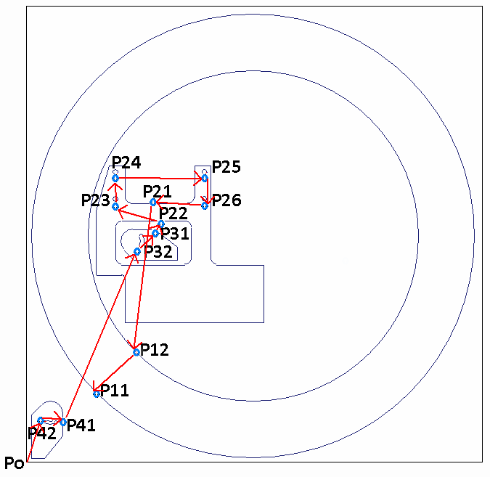

Figure 3. Nesting plan and tool path through pierce points considering connectivity constraints.

**Restriction of the "internal - external" connectivity**: When constructing the path of the cutting tool, you must first cut out all the internal contours of the part, and then process its external contour:

$$∀C_{kj},C_{k1} : {Q_{k1}-Q}_{kj}=1, j>1$$

The following condition must be met:

$$∀C_{kb} :b>1 ∃Q_{kb} :Q_{kb}≤Q_{kj}, 0<Q_{k1}-Q_{kb}<m_{k}$$

**Restriction of connection "external - internal"**: Let ${IN}_{C_{il}}=D_{k}$ be the set of all parts located inside the inner contour $C_{il}$ of the part *Si* at the first nesting level. Before you start cutting the contour $C_{il}$, you need to cut out all the parts that are in the set ${IN}_{C_{il}}$

$$∀C_{k1} : D_{k}∈{IN}_{C_{il}}, l∈\left(1; m_{i}\right]∃Q_{k1} : Q_{k1}<min⁡\{Q_{il}\}_{l=2}^{m_{i}}$$

An example of the path of the toolpath for the nesting plan above, considering the above "connectivity" restrictions, is shown in Fig.3.

1. SOLUTION APPROACH

In this formulation, the problem is reduced to one of the most well-known discrete optimization problems - the traveling salesman problem (TSP; see Gutin and Punnen (2006)) and belongs to the class of NP-hard problems. The main problem in its solution lies in the difficulty of determining the temperature of any point of the sheet in the process of cutting it along particular path. It is not possible to solve this problem analytically.

In this regard, an approach was developed based on the discrete representation of information, which was tested and gave good results in solving problems of two-dimensional and three-dimensional placement of objects of complex geometric shapes, see Verkhoturov et al. (2016).

The main idea of this approach is the “direct” modeling of parts placed on a sheet in computer memory, carried out based on the discrete-logical structure of random-access memory. In our case, this is a representation of memory in the form of an n-dimensional matrix, each element of which is such a section of it that corresponds to the concept of a point of the allocation area. In the simplest case, the matrix of points is two-dimensional (n=2), and for more accurate modeling of sheet heating and temperature propagation over it, a three-dimensional matrix (n=3) can be used, and the size of the third coordinate Z depends on the thickness of the material.

Let’s consider the two-dimensional case.

In the process of modeling, it is necessary to solve two main tasks:

* Simulate the heating of the points of the cutting area during cutting (for example, by a laser beam).
* Simulate the spread of temperature over the sheet, considering the thermal conductivity of the sheet material from points located on the cutting path of parts to cut, as well as heat transfer to the environment. At this stage, it is also necessary to provide that, after cutting the material, the corresponding areas / points of the sheet are melted and filled, in general, with air, which has a different, usually much lower, thermal conductivity than the material being cut (metal, for instance).

Let's consider each stage in more detail.

Heating of the cutting area during cutting

When the cutting tool moves along the path Tr(∙), those points of the cutting area (sheet L), through which it passes during piercing and actual cutting of the contour Cij, are heated to the melting temperature of the corresponding material.

Temperature spread

The following principle of temperature distribution in a discrete space is proposed (Fig. 4):

1) For each area of 9 points (with 8-connectivity), point P with the highest temperature is selected (Fig. 4a).

2) Then the new temperature of the selected point P is calculated depending on:

T is the point temperature.

∆T is the amount of heat transferred to each neighboring point.

Count - the number of neighboring points.

Kconductivity – coefficient of heat distribution (0≤Kconductivity≤1).

Kloss - coefficient of heat transfer to the environment (0≤Kloss≤1);

∆T = P.T * Kconductivity

P.T = (P.T - ∆T * count) * Kloss.

3) For each of the neighboring points S (Fig.4b). the temperature is calculated considering the increment ∆T depending on the coefficient of thermal conductivity Kconductivity and heat loss to the external environment Kloss (Fig. 4c):

|  |  |  |
| --- | --- | --- |
| a) | b) | c) |

Figure 4. 2D model of heat distribution

Following is the pseudocode of the algorithm to implement "Additional Constraints".

**def** Main

**begin**

Generate_set_of_cutting_contours_W()

**while** *W≠ ø*

Select_contour_from_W_to_cut()

Cut_selected_path_and_update_set_W()

**end** **while**

**end**

**def** Generate_set_of_cutting_contours_W(

**begin**

*W= ø*

**for** i := 1 **to** n

**for** j := 1 **to** *mi*

**if** j = 1 **then**

**if** *INDi∖Cij== ø* **then** *W= WUCij*

**else**

**if** *INCij== ø* **then** *W= WUCij*

**end if**

**end for**

**end for**

**end**

**def** Cut_selected_path_and_update_set_W

**begin**

*W= W∖Ckz*

*IN Dk = IN Dk∖Ckz*

**if** z = 1 **then**

*IN С01 = IN С01∖Dk*

**for** i := 1 **to** n

**if** *Di∈ IN С01* **then**

**for** j := 2 **to** *mi*

**if** *Сij∈ IN Di* **then** *Dk∈ IN Cij*

**begin**

*IN Cij = IN Cij∖Dk*

**if** *IN Cij= ø* **then** *W= W $∪$ Сij*

**end**

**end for**

**end if**

**end** **for**

**else**

**if** *IN Dk∖Ck1 == ø* **then** *W = W $∪$ Ck1*

**end if**

**end**

4. COMPUTATIONAL EXPERIMENT

To test the developed methods and algorithms, a computational experiment was carried out based on an example from Verkhoturov (2007).

The number of local overheating of the material was chosen as an indicator in modeling the cutting process, considering thermal effects.

Four algorithms were compared: "Shortest path", "Minimization of overheating", "Random transitions" and "Minimization of the path and overheating considering real-time temperature", developed in this work, and based on real-time temperature estimations.

The results of the experiments are presented in Table 1.

Figure 5 shows an example of a cutting considering "Additional restrictions". Red color shows areas with increased temperature or in the process of cutting or "local overheating", in the process of cooling down with decreasing temperature, the corresponding areas are shown in yellow.

Table 1. Experimental results

|  |  |  |
| --- | --- | --- |
| Algorithm | Air move, cm | Overheating count |
| Shortest path | 2788 | 518 |
| Overheating minimization | 33787 | 460 |
| Random transitions | 45952 | 451 |
| Minimize travel and overheating with real-time temperature | 11176 | 456 |

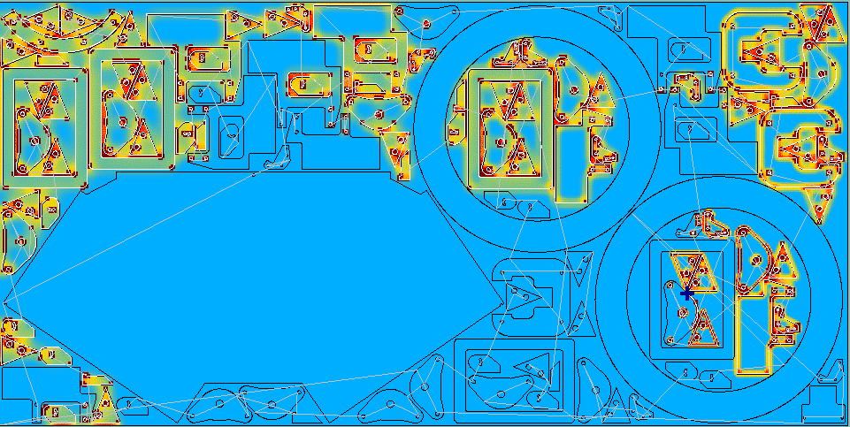

a)

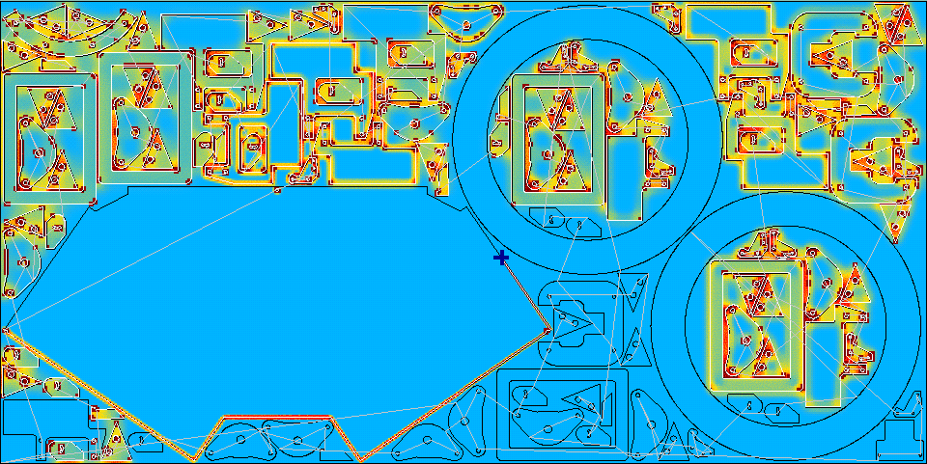

b)

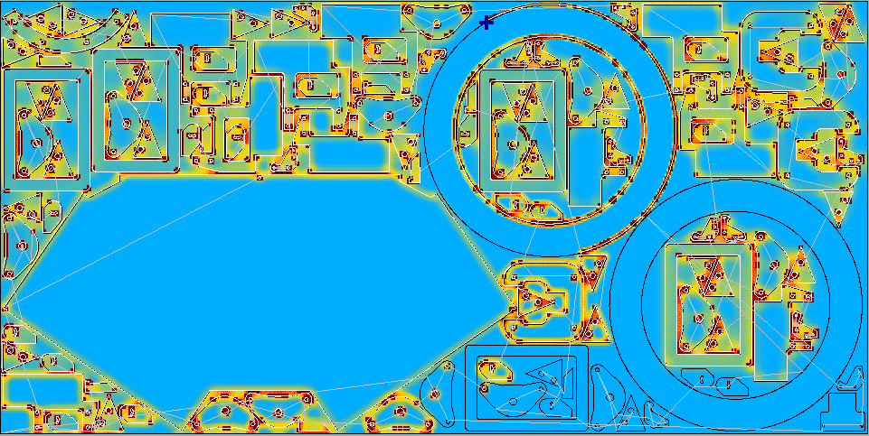

c)

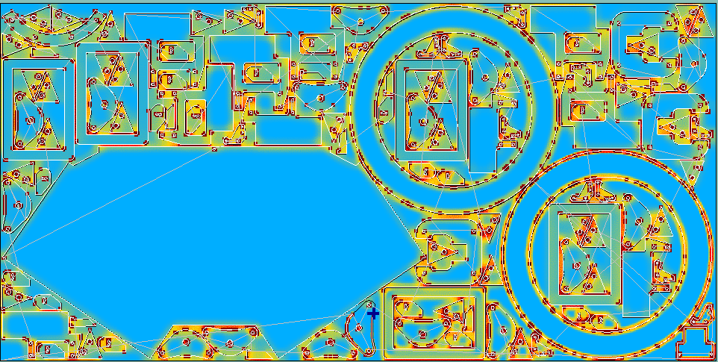

d)

Figure 5. Nesting plan, tool path considering the "Additional restrictions" and the change in the sheet temperature during the cutting process (a – d).

# 5. CONCLUSIONS

The paper considered an approach to solving the problem of modeling the process of thermal cutting of a flat material, considering thermal effects, based on a discrete representation of information, including a mathematical model, methods, algorithms, and software. According to the results of the experiment, the algorithm developed by the authors showed an efficiency 26% higher than the "Shortest Path" algorithm. The length of the idling path when using the developed algorithm increased by 2.4 times compared to the "Shortest Path" algorithm.

# REFERENCES

Balamurali, M., Jawahar, N., Balaji, S., and Manichandran, T. (2019). Realization of effective laser blanking process by heat zone spread resistance coating and optimization methods. Materials Research Express, 6(4), 046416. doi: 10.1088/2053-1591/aafc01.

Chentsov, A.G., Chentsov, P.A., Petunin, A.A., and Sesekin, A.N. (2018). Model of megalopolises in the tool path optimisation for CNC plate cutting machines. International Journal of Production Research, 56(14), 4819–4830. doi: 10.1080/00207543.2017.1421784.

Dewil, R., Vansteenwegen, P., and Cattrysse, D. (2015). Sheet Metal Laser Cutting Tool Path Generation: Dealing with Overlooked Problem Aspects, volume 639. Trans Tech Publications Ltd. doi: 10.4028/www.scientific.net/KEM.639.517.

Dewil, R., Vansteenwegen, P., and Cattrysse, D. (2016). A review of cutting path algorithms for laser cutters. International Journal of Advanced Manufacturing Technology, 87(5), 1865–1884. doi:10.1007/s00170-016-8609-1.

Gutin, G. and Punnen, A.P. (eds.) (2006). The traveling salesman problem and its variations. Springer Science & Business Media.

Hajad, M., Tangwarodomnukun, V., Jaturanonda, C., and Dumkum, C. (2019). Laser cutting path optimization using simulated annealing with an adaptive large neighborhood search. International Journal of Advanced Manufacturing Technology, 103(1), 781–792. doi:10.1007/s00170-019-03569-6.

Lagerkvist, M.Z., Nordkvist, M., and Rattfeldt, M. (2013). Laser Cutting Path Planning Using CP. In Principles and Practice of Constraint Programming, 790–804. Springer, Berlin, Germany. doi:10.1007/978-3-642-40627-0 58.

Levichev, N., Rodrigues, G.C., and Duflou, J.R. (2020). Real-time monitoring of fiber laser cutting of thick plates by means of photodiodes. Procedia CIRP, 94, 499–504.

Mejia, D., Moreno, A., Arbelaiz, A., Posada, J., Ruiz- Salguero, O., and Chopitea, R. (2018). Accelerated Thermal Simulation for Three-Dimensional Interactive Optimization of Computer Numeric Control Sheet Metal Laser Cutting. Journal of Manufacturing Science and Engineering, 140(3). doi:10.1115/1.4038207.

Petunin, A.A., Polishuk, E.G., Chentsov, A.G., Chentsov, P.A., and Ukolov, S.S. (2016). About some types of constraints in problems of routing. AIP Conference Proceedings, 1789(1), 060002. doi:10.1063/1.4968494.

Petunin, A.A., Polyshuk, E.G., Chentsov, P.A., Ukolov, S.S., and Krotov, V.I. (2019). The termal deformation reducing in sheet metal at manufacturing parts by CNC cutting machines. IOP Conference Series: Materials Science and Engineering, 613(1), 012041. doi: 10.1088/1757-899x/613/1/012041.

Petunin, A. (2019). General Model of Tool Path Problem for the CNC Sheet Cutting Machines. IFAC-PapersOnLine, 52(13), 2662–2667. doi: 10.1016/j.ifacol.2019.11.609.

Petunin, A.A. and Stylios, C. (2016). Optimization Models of Tool Path Problem for CNC Sheet Metal Cutting Machines. IFAC-PapersOnLine, 49(12), 23–28. doi: 10.1016/j.ifacol.2016.07.544.

Sonawane, S., Patil, P., Bharsakade, R., and Gaigole, P. (2020). Optimizing tool path sequence of plasma cutting machine using TSP approach. E3S Web of Conferences, 184, 01037. doi:10.1051/e3sconf/202018401037.

Tavaeva, A.F., Petunin, A.A., and Polishchuk, E.G. (2019a). Methods of Cutting Cost Minimizing in Problem of Tool Route Optimization for CNC Laser Ma- chines. In Proceedings of the 5th International Conference on Industrial Engineering (ICIE 2019), 447–455. Springer, Cham, Switzerland. doi:10.1007/978-3-030- 22063-1 48.

Tavaeva, A., Petunin, A., Ukolov, S., and Krotov, V. (2019b). A Cost Minimizing at Laser Cutting of Sheet Parts on CNC Machines. In Mathematical Optimization Theory and Operations Research, 422–437. Springer, Cham, Switzerland. doi:10.1007/978-3-030-33394-2 33.

Verkhoturov, M., Verkhoturova, G., Zaripov, D., Kon- dratyeva, N., and Valeev, S. (2021). Digital twin of the process of thermal cutting of flat material into figured parts. In CEUR Workshop Proceedings, 209–219.

Verkhoturov, M. (2007). The two-dimensional irregular cutting stock problem: optimization allocation and path of cutting instrument. Vestnik USATU, 9(2), 106–118.

Verkhoturov, M., Petunin, A., Verkhoturova, G., Danilov, K., and Kurennov, D. (2016). The 3D Object Packing Problem into a Parallelepiped Container Based on Discrete-Logical Representation. IFAC-PapersOnLine, 49(12), 1–5. doi: 10.1016/j.ifacol.2016.07.540.

Wäscher, G., Haußner, H., and Schumann, H. (2007). An improved typology of cutting and packing problems. European Journal of Operational Research, 183(3), 1109– 1130. doi: 10.1016/j.ejor.2005.12.047.

Yang, W.B., Zhao, Y.W., Jie, J., and Wang, W.L. (2010). An Effective Algorithm for Tool-Path Air- time Optimization during Leather Cutting, volume 102-104. Trans Tech Publications Ltd. doi: 10.4028/www.scientific.net/AMR.102-104.373.