Using PCGTSP Algorithm for Solving Generalized Segment Continuous Cutting Problem

Alexander Petunin*. Michael Khachay**. Stanislav Ukolov*. Pavel Chentsov**

*Ural Federal University, Ekaterinburg, Russia  
**Krasovsky Institute of Mathematics and Mechanics, Ekaterinburg, Russia

**Abstract**: The problem of optimal tool routing for CNC sheet cutting machines, known as the Cutting Path Problem or Tool Path Problem is considered in one of the most general formulation of the Generalized Segment Continuous Cutting Problem (GSCCP). The heuristic algorithm developed by the authors and oriented to discrete optimization problems in the form of a generalized traveling salesman problem with order constraints (PCGTSP) is shown to be effectively applied to tackle this problem. This branch-and-bound algorithm, combined with the use of dynamic programming and a specialized heuristic solver, makes it possible to obtain optimal solutions for problems of small dimension in a relatively short time compared to known exact algorithms, as well as to find effective lower and upper bounds for the optimal solutions for large-scale problems. The conclusions are illustrated by solving several model examples.

*Keywords*: Cutting Path Problem, Optimization, Branch-and-Bound, Dynamic Programming, Generalized Traveling Salesman Problem, Precedence Constraints

1. INTRODUCTION

As the main task in this paper, we consider the problem of routing the tool of CNC sheet cutting machines, known as the Cutting Path Problem or Tool Path Problem, see Dewil et al. (2015a). This problem occurs at the stage of development of control programs for the NC machine, which specify the tool path and several commands to set the parameters for cutting sheet material to obtain parts of known shapes and sizes. The necessary data for the tool path design for NC machine is defined by the information about the cutting maps developed at the stage of cutting design and gives rise to the task of irregular figure cutting of sheet material (the problem of "nesting"), see Dowsland and Dowsland (1995). From the point of view of geometric optimization, this problem belongs to the class of Cutting & Packing problems, see Alvarez-Valdes et al. (2018), for which, like for route optimization problems, polynomial complexity solving algorithms are not known.

Among modern researchers of the Cutting Path Problem, one should single out R. Dewil and his colleagues, see Dewil et al. (2015a, 2016, 2015b). In these works, an attempt is made to link the features of laser cutting with routing algorithms. In Dewil et al. (2016) an overview of routing algorithms related to figure sheet cutting on NC machines is given. The authors classify the existing routing literature into six classes of problems: the continuous cutting problem (CCP), the endpoint cutting problem (ECP), the intermittent cutting problem (ICP), the polygon traversal problem (TPP), the traveling salesman problem (TSP), and the generalized problem traveling salesman (GTSP). All the listed classes of problems, except CCP, use discrete mathematical models. The routing problem in the general case of cutting can be considered as ICP. However, the literature on ICP is very scarce, and most scientific articles are limited to solving problems of other classes.

# 2. GSCCP model

In Petunin (2019), based on the introduced concepts of “cutting segment” and “basic cutting segment”, it was possible to distinguish a fairly wide subclass of tasks in the ICP class, which are reduced to the CCP and GTSP classes. The class is called Generalized Segment Continuous Cutting Problem (GSCCP). This concept made it possible, in particular, to solve problems of different classes, in which it is possible to use different cutting techniques within the same route. The cutting segment here means the tool path between the pierce point and the corresponding tool off point, and the base segment is the part of the cutting segment without the initial part of the path between the pierce point and the tool entry point into the contour (lead-in), and the end part between the exit point from the contour and the tool turning off point (lead-out).

Note that the problem of toolpath routing for sheet cutting machines involve the imposition of mandatory restrictions on the the task solution, the so-called. precedence constraints, which are caused by the technological features of sheet cutting. These constraints very often make it possible to significantly reduce the computational complexity of the problem being solved.

For problems of small dimension, it is possible to use exact algorithms, see Chentsov et al. (2018) for example. The papers Khachay et al. (2020, 2021) describe new algorithms focused on discrete optimization problems in the form of a generalized traveling salesman problem with precedence constraints (PCGTSP). These algorithms are based on some ideas from Salman et al. (2020), the branch and boundary method in combination with the use of the dynamic programming apparatus and the specialized heuristic solver PCGLNS. Initially, they were supposed to be used for GTSP class problems, but a specialized converter developed made it possible to use these algorithms to solve GSCCP segment cutting problems.

In the next section, using a number of model examples, it will be shown that the new algorithms make it possible to obtain optimal solutions for problems of small dimension in a relatively short time compared to the DP algorithm, and also to find effective lower and upper bounds for the optimal solution for problems of large dimension.

# 3. NUMERICAL EXPERIMENTS

## 3.1. Experimental setup

For the purpose of evaluating algorithms performance, the special nesting plan was used, containing 19 plain parts and 24 contours, see Fig. 1. Position if 224 feasible pierce points are also depicted along the contours.



Figure 1. Original nesting plan.

To modify set of cutting segments for the nesting plan, two bridges were added, as seen at Fig. 2, yielding 17 parts bounded by 22 contours. Thus, two new complex parts appeared, marked with figures 1 and 2 at Fig. 2.

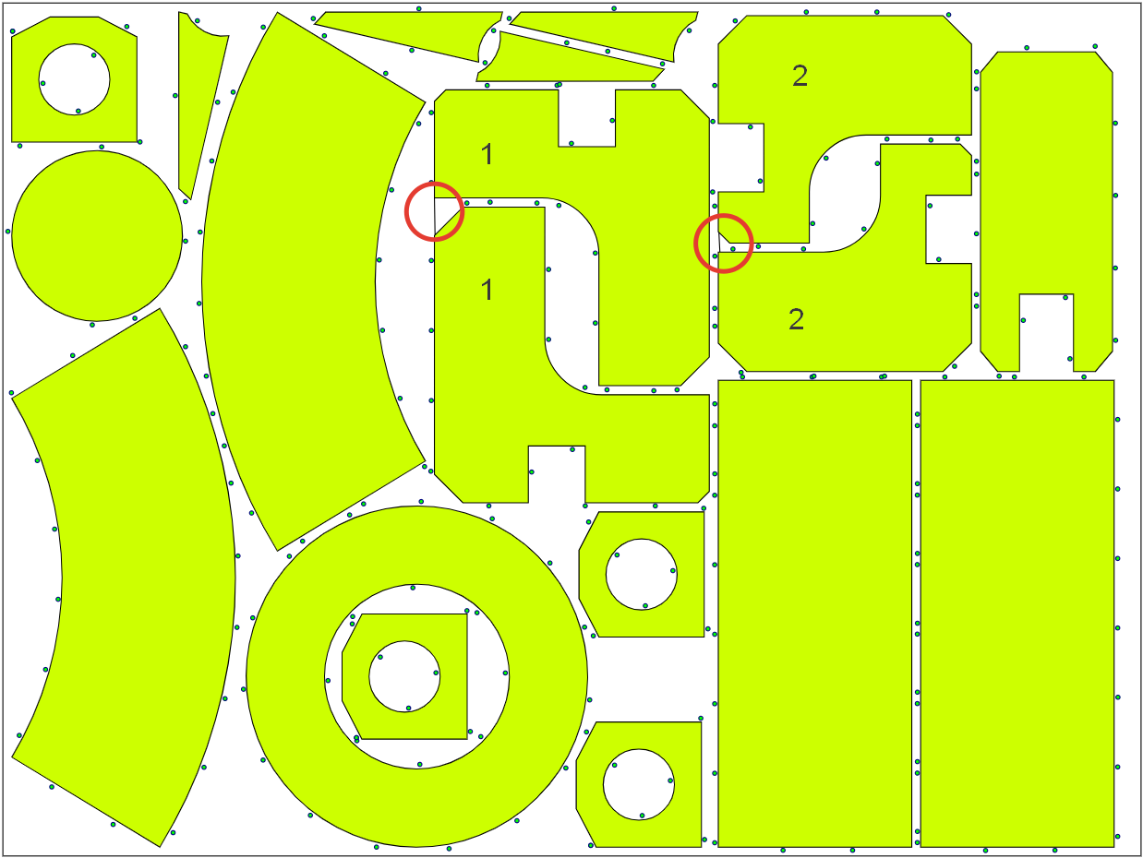

Figure 2. Position of two bridges

Further, another four bridges were created at the original nesting plan, see Fig. 3, yielding 15 parts and 20 contours. Three new complex parts are also marked with figures 1, 2, and 3, where part 1 is identical to that of Fig. 2, while part 2 is slightly bigger.

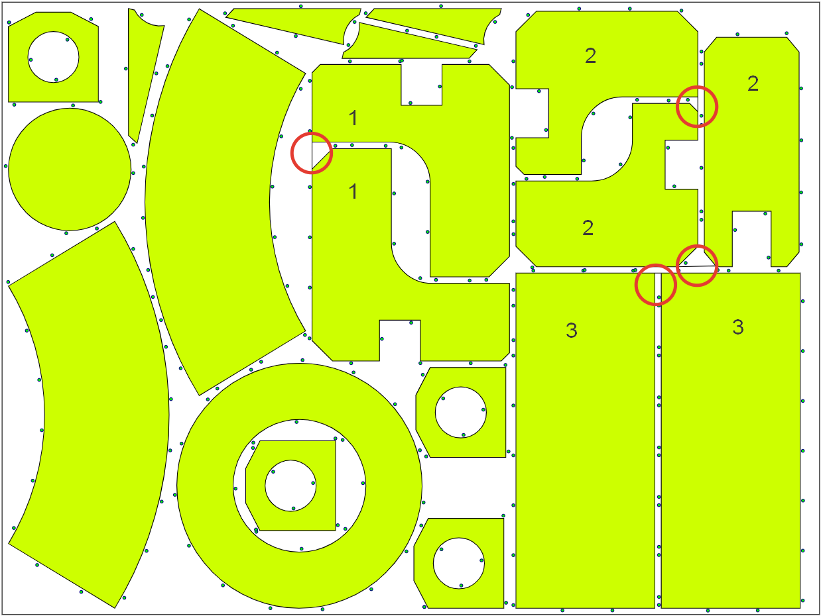

Figure 3. Position of four bridges.

All three instances were solved to optimality with two algorithms: DP (Dynamic programming) scheme, see Chentsov et al. (2018), which is proven to find optimal solution for problem instances below 33 contours; new problem-specific Branch-and-Bound algorithm, see. Khachay et al. (2021), pre-seeded with solution by PCGLNS heuristics, see Khachay et al. (2020).

Numerical experiments were conducted on the ordinary workstation with Intel Core i5 CPU at 1.60 GHz with 8 Gb of RAM.

## 3.2. Results

All the problem instances were successfully solved by both algorithms. Solution of original instance without bridges are on Fig. 4 for DP and Fig. 5 for B-n-B.

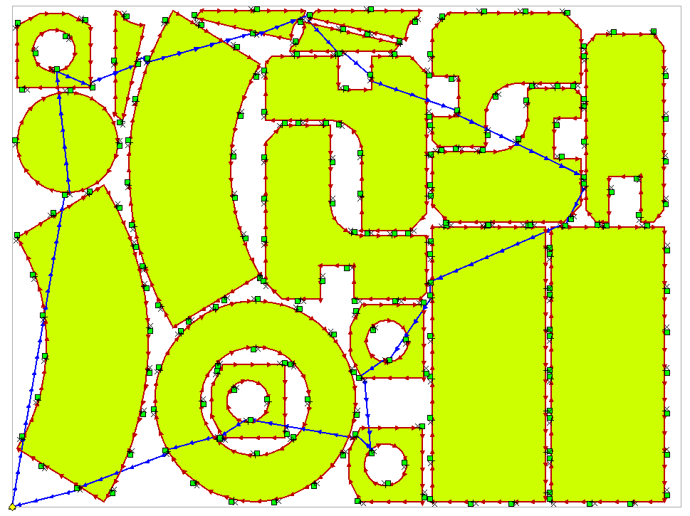

Figure 4. Solution of 24 contours instance with DP.



Figure 5. Solution of 24 contours instance with B-n-B.

Solutions of the second instance of 22 contours and 17 parts are on Fig. 6 and Fig. 7 respectively for DP and B-n-B algorithms. Note the two paths are almost identical in this case.

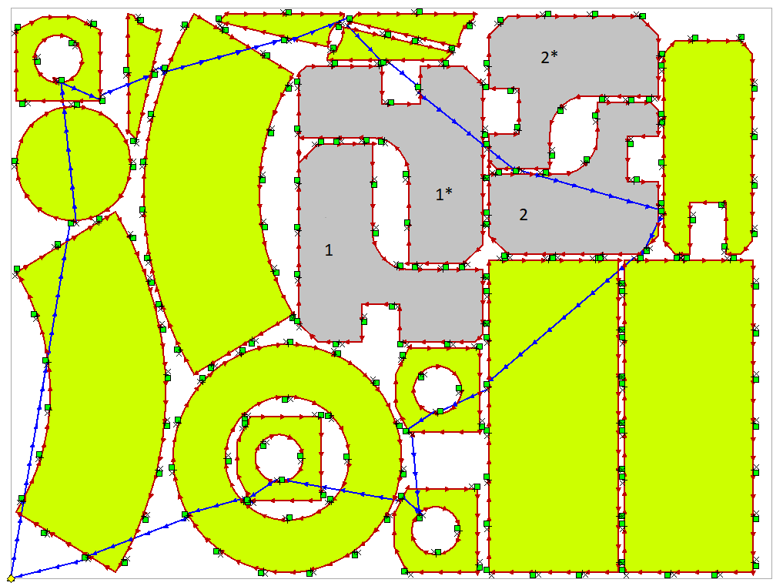

Figure 6. Solution of 22 contours instance with DP.

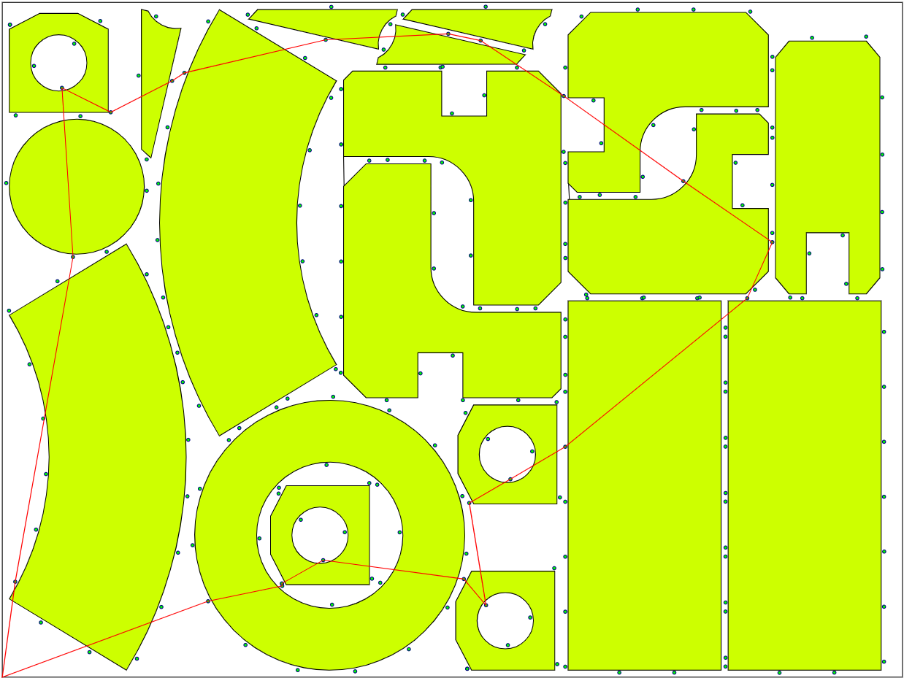

Figure 7. Solution of 22 contours instance with B-n-B.

And finally, solutions of smallest 20 contours instance are at Fig. 8 and Fig. 9. They look even more similar.

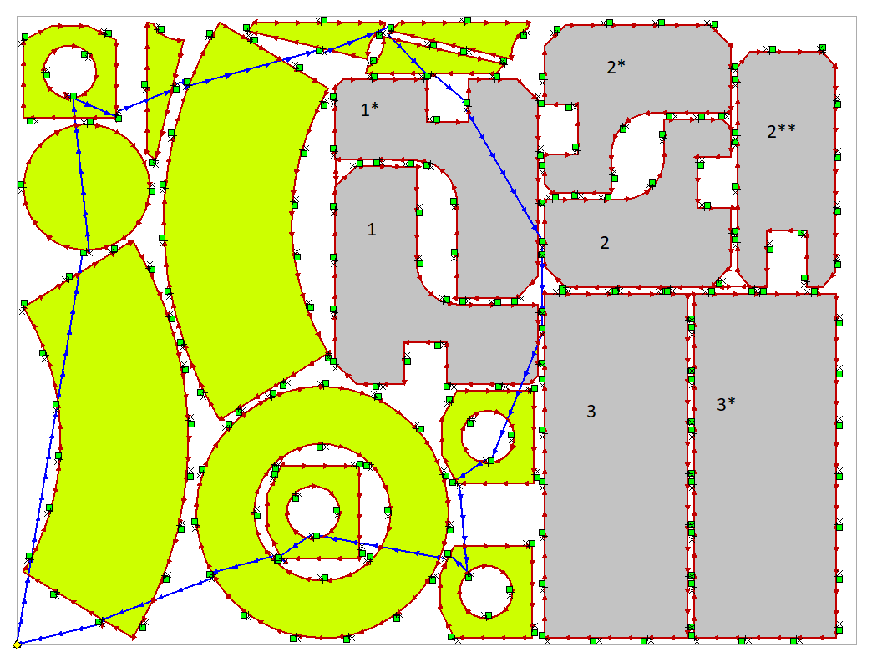

Figure 8. Solution of 20 contours instance with DP.

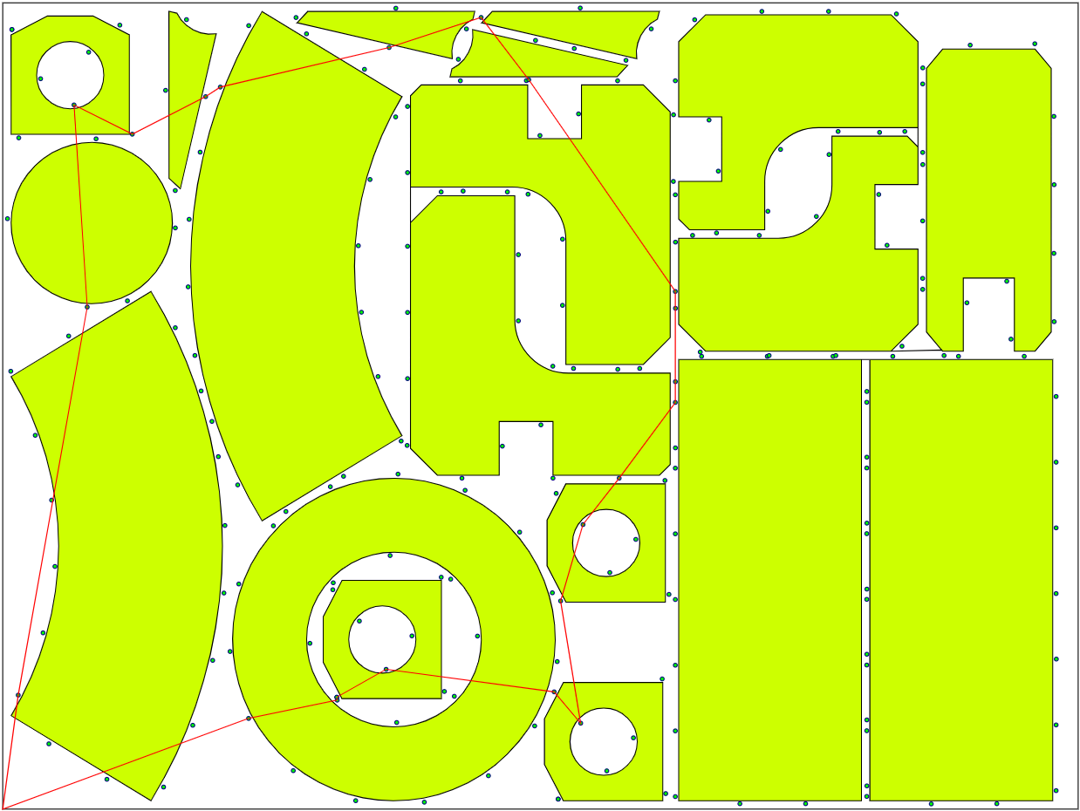

Figure 9. Solution of 20 contours instance with B-n-B.

Table 1. Solutions

|  |  |  |  |  |  |  |  |  |
| --- | --- | --- | --- | --- | --- | --- | --- | --- |
| **Problem instance** | | **DP** | | | | **B-n-B** | | |
| **#C** | **#P** | **Calc time (min:s)** | **Route (mm)** | **Cut time (s)** | **Calc time (s)** | | **Route (mm)** |
| 24 | 19 | 42:12 | 5340.12 5820.12 | 168 | 4.5 | | 5411 5411.16 |
| 22 | 17 | 4:01 | 5254.13 5634.13 | 133 | 4.1 | | 5380 5382.02 |
| 20 | 15 | 2:14 | 4709.12 5109.12 | 140 | 3.6 | | 4782 4786.55 |

All the solutions are summarized in Table 1. For each algorithm and problem instance time is specified in minutes and seconds. For DP solution length two values provided: air move length and full route length without contours, i.e., air move length with lead-in and lead-out. Estimated cutting time in seconds is also calculated. For B-n-B solution, two lengths are integer one (since current implementation of algorithms uses integer calculus) and its exact floating-point value.

## 3.3. Discussion

It can be easily seen, that both algorithms give solutions very similar to each other, both visually and numerically. The main reason for the slight difference in solutions is that DP algorithm due to its maturity considers the technological constraints of thermal cutting and distinguishes piercing points and tool off points, while B-n-B consider them as one point. This leads to slight decrease in air move length during optimization while simultaneously adding constant lead-in and lead-out distances to resulting toolpath.

Another reason for difference is that current implementation of PCGLNS and B-n-B algorithms uses integer arithmetic, so they often allow several optimal solutions with the same integer length. For example, during numerical experiments another solution for 22 contours case was obtained, slightly different from the one on the Fig. 7.

From the other hand, PCGLNS heuristic offers the great performance, giving high quality solutions in literally seconds. Even in case of hundreds of contours, high quality solutions can be obtained in minutes or tens of minutes, which make it useful in practical application, including development of control program for CNC cutting machines.

From that point of view, an idea of *Segment Cutting* seems very promising. Comparing 20 contours case against original 24 contours one we see not only 11% decrease of route length, but also lower (by 17%) number of piercing points. Both changes reduce time and cost of cutting process.

In contrast with lightning speed of obtaining solution, estimation of its lower bound is rather slow due to exponential time complexity. For example, solution at Fig. 9 (4782 mm) was proven to be optimal in almost 5 hours. This time can be improved both with parallel calculation as well as by reimplementing B-n-B algorithm using more performant programming language, C++for instance.

Thus, as can be seen from Table 1, the minimum total cutting time is achieved by optimal tool routing for the set of segments shown in Fig.6., while the optimal trajectory for the set of segments in Fig. 4 was obtained almost 10 times faster than the DP method. We also note that solutions for all 3 subtasks of the SGCCP problem (24, 22 and 20 cutting segments), were proven to be optimal ones.

# REFERENCES

Alvarez-Valdes, R., Carravilla, M.A., and Oliveira, J.F. (2018). Cutting and packing. doi:10.1007/978-3-319-07153-4 43-1.

Chentsov, A.G., Chentsov, P.A., Petunin, A.A., and Sesekin, A.N. (2018). Model of megalopolises in the tool path optimisation for CNC plate cutting machines. *International Journal of Production Research*, 56(14), 4819–4830. doi:10.1080/00207543.2017.1421784.

Dewil, R., Vansteenwegen, P., and Cattrysse, D. (2015a). *Sheet Metal Laser Cutting Tool Path Generation: Dealing with Overlooked Problem Aspects*, volume 639. Trans Tech Publications Ltd. doi: 10.4028/www.scientific.net/KEM.639.517.

Dewil, R., Vansteenwegen, P., and Cattrysse, D. (2016). A review of cutting path algorithms for laser cutters. *International Journal of Advanced Manufacturing Technology*, 87(5), 1865–1884. doi:10.1007/s00170-016-8609-1.

Dewil, R., Vansteenwegen, P., Cattrysse, D., Laguna, M., and Vossen, T. (2015b). An improvement heuristic framework for the laser cutting tool path problem. *International Journal of Production Research*, 53(6), 1761–1776. doi:10.1080/00207543.2014.959268.

Dowsland, K.A. and Dowsland, W.B. (1995). Solution approaches to irregular nesting problems. *European Journal of Operational Research*, 84(3), 506–521. doi: 10.1016/0377-2217(95)00019-M.

Khachay, M., Kudriavtsev, A., and Petunin, A. (2020). PCGLNS: A heuristic solver for the Precedence Constrained Generalized Traveling Salesman Problem. In N. Olenev, Y. Evtushenko, M. Khachay, and V. Malkova (eds.), *Optimization and Applications*, volume 12422 of *Lecture Notes in Computer Science*, 196–208. Springer International Publishing, Cham. doi:10.1007/978-3-030-62867-3 15.

Khachay, M., Ukolov, S., and Petunin, A. (2021). Problem-Specific Branch-and-Bound Algorithms for the Precedence Constrained Generalized Traveling Salesman Problem. In N. Olenev et al. (eds.), *Optimization and Applications*, volume 13078 of *Lecture Notes in Computer Science*, 136–148. Springer Nature Switzerland AG, Cham, Switzerland. doi:10.1007/978-3-030-91059-4 10.

Salman, R., Ekstedt, F., and Damaschke, P. (2020). Branch-and-bound for the Precedence Constrained Generalized Traveling Salesman Problem. *Operations Research Letters*, 48(2), 163–166. doi: 10.1016/j.orl.2020.01.009.