Using PCGTSP Algorithm for Solving Generalized Segment Continuous Cutting Problems

Alexander Petunin*. Michael Khachay**. Stanislav Ukolov*. Pavel Chentsov**

*Ural Federal University, Ekaterinburg, Russia  
**Krasovsky Institute of Mathematics and Mechanics, Ekaterinburg, Russia

**Abstract**: These instructions give you guidelines for preparing papers for IFAC conferences. Use this document as a template to compose your paper if you are using Microsoft Word 2016 or later. Otherwise, use this document as an instruction set. Please use this document as a “template” to prepare your manuscript. For submission guidelines, follow instructions on paper submission system as well as the Conference website.

*Keywords*:.Thermal cutting, Optimization, Branch-and-Bound, Dynamic Programming, Algorithm, Heuristics, Generalized Traveling Salesman Problem, Precedence Constraint

1. INTRODUCTION

Lorem ipsum dolor sit amet, consectetur adipiscing elit, sed do eiusmod tempor incididunt ut labore et dolore magna aliqua. Ut enim ad minim veniam, quis nostrud exercitation ullamco laboris nisi ut aliquip ex ea commodo consequat. Duis aute irure dolor in reprehenderit in voluptate velit esse cillum dolore eu fugiat nulla pariatur. Excepteur sint occaecat cupidatat non proident, sunt in culpa qui officia deserunt mollit anim id est laborum.

# 2. SECTION

Lorem ipsum dolor sit amet, consectetur adipiscing elit, sed do eiusmod tempor incididunt ut labore et dolore magna aliqua. Ut enim ad minim veniam, quis nostrud exercitation ullamco laboris nisi ut aliquip ex ea commodo consequat. Duis aute irure dolor in reprehenderit in voluptate velit esse cillum dolore eu fugiat nulla pariatur. Excepteur sint occaecat cupidatat non proident, sunt in culpa qui officia deserunt mollit anim id est laborum.

# 3. NUMERICAL EXPERIMENTS

## 3.1. Experimental setup

For the purpose of evaluting algorithmsperformance, the special nesting plan was used, containing 19 plain parts and 24 contours, see Fig. 1. Position if 224 feasible pierce points are also depicted along the contours.



Figure 1. Original nesting plan.

To modify set of cutting segments for the nesting plan, two bridges were added, as seen at Fig. 2, yielding 17 parts bounded by 22 contours. Thus, two new complex parts appeared, marked with figures 1 and 2 at Fig. 2.

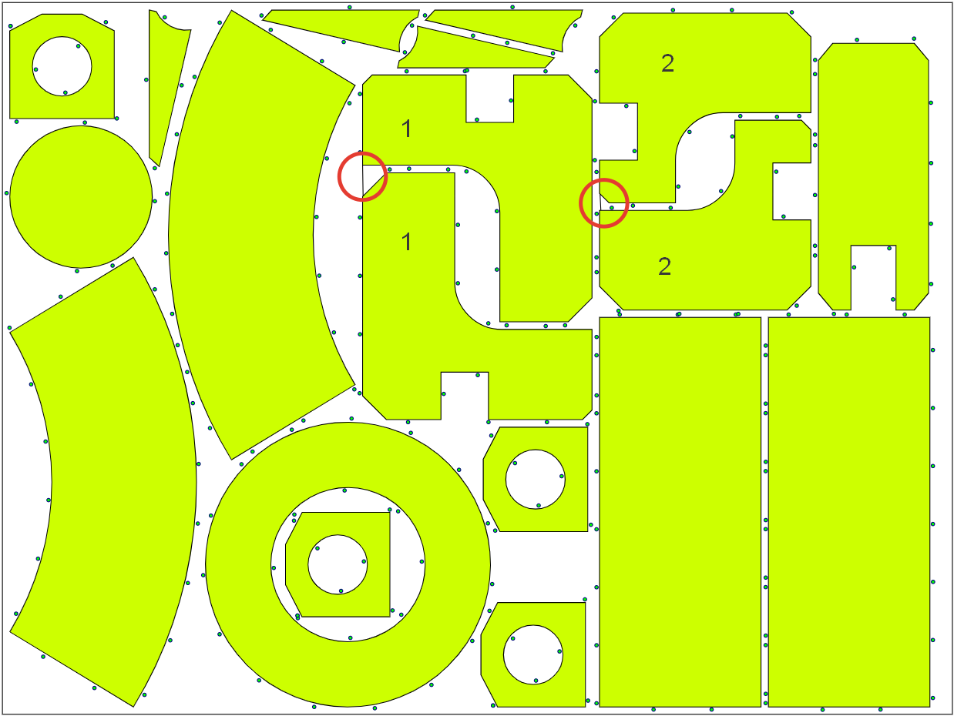

Figure 2. Position of two bridges

Further, another four bridges were created at the original nesting plan, see Fig. 3, yielding 15 parts and 20 contours. Three new complex parts are also marked with figures 1, 2, and 3, where part 1 is identical to that of Fig. 2, while part 2 is slightly bigger.

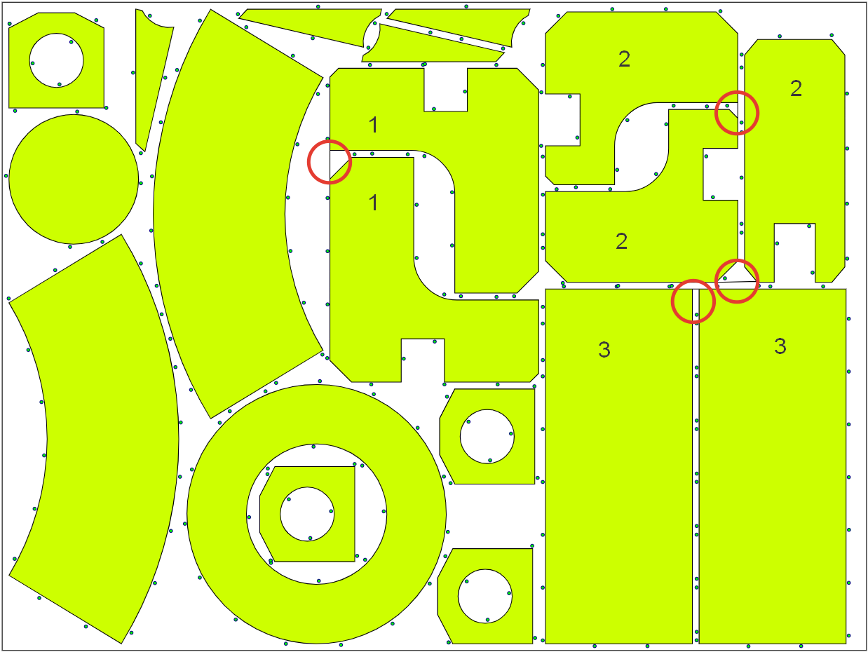

Figure 3. Position of four bridges.

All three instances were solved to optimality with two algorithms: DP (Dynamic programming) scheme, see Chentsov et al. (2018), which is proven to find optimal solution for problem instances below 33 contours; new problem-specific Branch-and-Bound algorithm, see. Khachay et al. (2021), pre-seeded with solution by PCGLNS heuristics, see Khachay et al. (2020).

Numerical experiments were conducted on the ordinary workstation with Intel Core i5 CPU at 1.60 GHz with 8 Gb of RAM.

## 3.2. Results

All the problem instances were successfully solved by both algorithms. Solution of original instance without bridges are on Fig. 4 for DP and Fig. 5 for B-n-B.

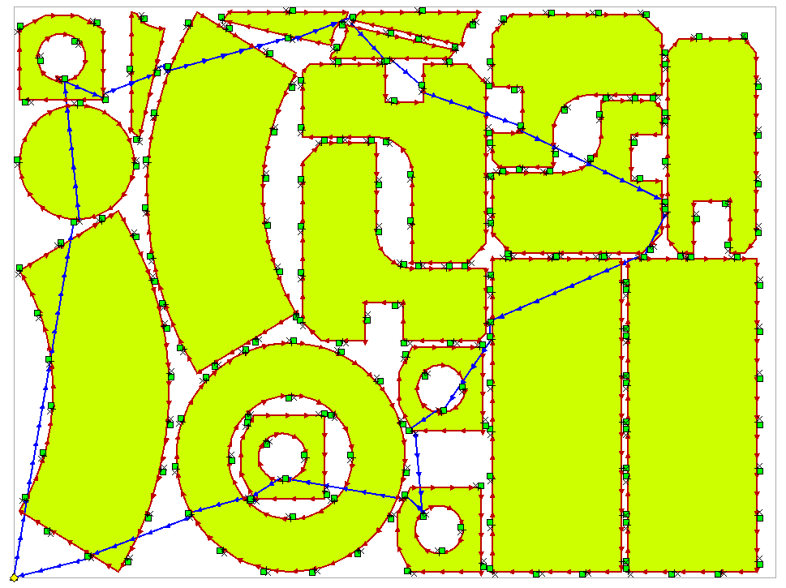

Figure 4. Solution of 24 contours instance with DP.



Figure 5. Solution of 24 contours instance with B-n-B.

Solutions of the second instance of 22 contours and 17 parts are on Fig. 6 and Fig. 7 respectively for DP and B-n-B algorithms. Note the two paths are almost identical in this case.

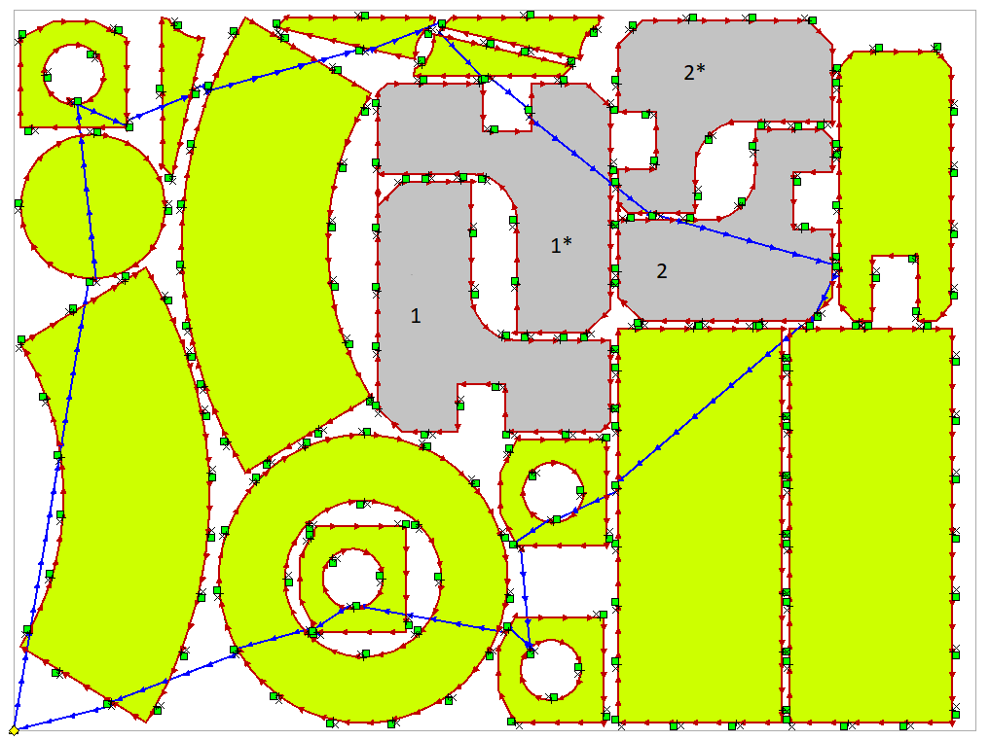

Figure 6. Solution of 22 contours instance with DP.



Figure 7. Solution of 22 contours instance with B-n-B.

And finally, solutions of smallest 20 contours instance are at Fig. 8 and Fig. 9. They look even more similar.

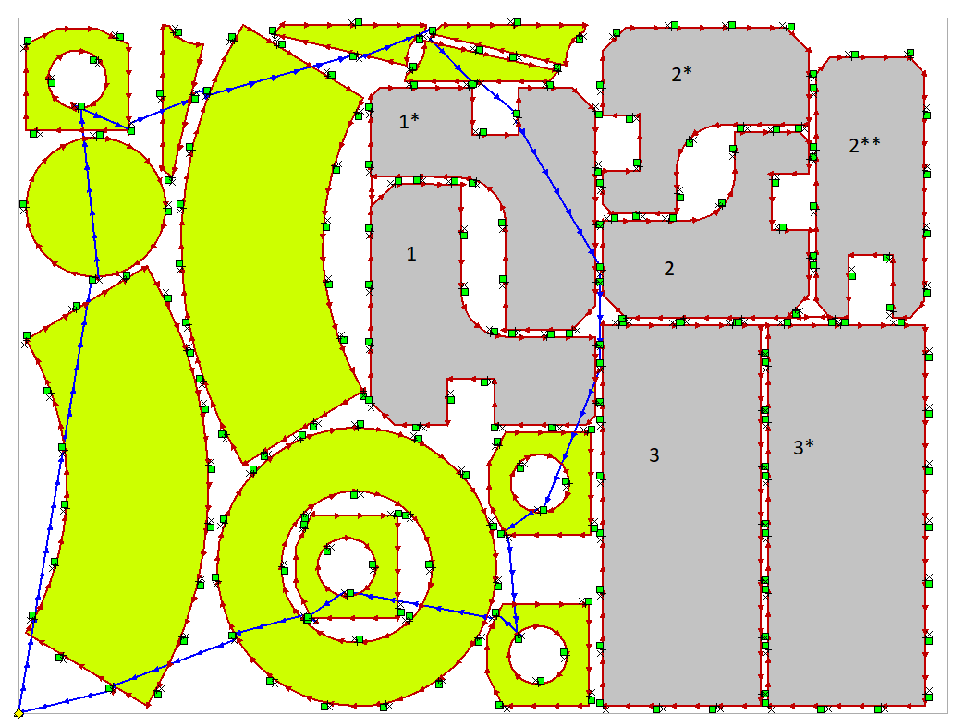

Figure 8. Solution of 20 contours instance with DP.



Figure 9. Solution of 20 contours instance with B-n-B.

All the solutions are summarized in Table 1. For each algorithm and problem instance time is specified in minutes and seconds. For DP solution length two values provided: air move length and full route length without contours, i.e., air move length with lead-in and lead-out. For B-n-B solution, two lengths are integer one (since current implementation of algorithms uses integer calculus) and its exact floating-point value.

Table 1. Solutions

|  |  |  |  |  |  |
| --- | --- | --- | --- | --- | --- |
| **Problem instance** | | **DP** | | **B-n-B** | |
| **Contours** | **Parts** | **Time (s)** | **Route (mm)** | **Time (s)** | **Route (mm)** |
| 24 | 19 | 42’12 | 5340.12 5820.12 | 4.5 | 5411 5411.16 |
| 22 | 17 | 4’01 | 5259.65 5679.65 | 4.1 | 5380 5382.02 |
| 20 | 15 | 2’14 | 4709.12 5109.12 | 3.6 | 4782 4786.55 |

## 3.3. Discussion

It can be easily seen, that both algorithms give solutions very similar to each other, both visually and numerically. The main reason for the slight difference in solutions is that DP algorithm due to its maturity considers the technological constraints of thermal cutting and distinguishes piercing points and tool off points, while B-n-B consider them as one point. This leads to slight decrease in air move length during optimization while simultaneously adding constant lead-in and lead-out distances to resulting toolpath.

Another reason for difference is that current implementation of PCGLNS and B-n-B algorithms uses integer arithmetic, so they often allow several optimal solutions with the same integer length. For example, during numerical experiments another solution for 22 contours case was obtained, slightly different from the one on the Fig. 7.

From the other hand, PCGLNS heuristic offers the great performance, giving high quality solutions in literally seconds. Even in case of hundreds of contours, high quality solutions can be obtained in minutes or tens of minutes, which make it useful in practical application, including development of control program for CNC cutting machines.

From that point of view, an idea of *Segment Cutting* seems very promising. Comparing 20 contours case against original 24 contours one we see not only 11% decrease of route length, but also lower (by 17%) number of piercing points. Both changes reduce time and cost of cutting process.

In contrast with lightning speed of obtaining solution, estimation of its lower bound is rather slow due to exponential time complexity. For example, solution at Fig. 9 (4782 mm) was proven to be optimal in almost 5 hours. This time can be improved both with parallel calculation as well as by reimplementing B-n-B algorithm using more performant programming language, C++for instance.

# 6. CONCLUSIONS

A conclusion section is not required. Although a conclusion may review the main points of the paper, do not replicate the abstract as the conclusion. A conclusion might elaborate on the importance of the work or suggest applications and extensions.

# REFERENCES

Chentsov, A.G., Chentsov, P.A., Petunin, A.A., and Sesekin, A.N. (2018). Model of megalopolises in the tool path optimisation for CNC plate cutting machines. *International Journal of Production Research*, 56(14), 4819–4830. doi:10.1080/00207543.2017.1421784.

Khachay, M., Kudriavtsev, A., and Petunin, A. (2020). PCGLNS: A heuristic solver for the Precedence Constrained Generalized Traveling Salesman Problem. In N. Olenev, Y. Evtushenko, M. Khachay, and V. Malkova (eds.), *Optimization and Applications*, volume 12422 of *Lecture Notes in Computer Science*, 196–208. Springer International Publishing, Cham. doi:10.1007/978-3-030-62867-3 15.

Khachay, M., Ukolov, S., and Petunin, A. (2021). Problem-Specific Branch-and-Bound Algorithms for the Precedence Constrained Generalized Traveling Salesman Problem. In N. Olenev et al. (eds.), *Optimization and Applications*, volume 13078 of *Lecture Notes in Computer Science*, 136–148. Springer Nature Switzerland AG, Cham, Switzerland. doi:10.1007/978-3-030-91059-4 10.

Petunin, A.A., Polishchuk, E.G., and Ukolov, S.S. (2019). On the new Algorithm for Solving Continuous Cutting Problem. *IFAC-PapersOnLine*, 52(13), 2320–2325. doi: 10.1016/j.ifacol.2019.11.552.

Salman, R., Ekstedt, F., and Damaschke, P. (2020). Branch-and-bound for the Precedence Constrained Generalized Traveling Salesman Problem. *Operations Research Letters*, 48(2), 163–166. doi:10.1016/j.orl.2020.01.009.