# TASK-1

***-- Database Creation***

CREATE TABLE StudentInfo (

STU_ID INT PRIMARY KEY,

STU_NAME VARCHAR(50),

DOB DATE,

PHONE_NO VARCHAR(15),

EMAIL_ID VARCHAR(100),

ADDRESS VARCHAR(200)

);

CREATE TABLE CoursesInfo (

COURSE_ID INT PRIMARY KEY,

COURSE_NAME VARCHAR(50),

COURSE_INSTRUCTOR_NAME VARCHAR(50)

);

CREATE TABLE Enrollmentinfo (

ENROLLMENT_ID INT PRIMARY KEY,

STU_ID INT,

COURSE_ID INT,

ENROLL_STATUS VARCHAR(20),

FOREIGN KEY (STU_ID) REFERENCES StudentInfo(STU_ID),

FOREIGN KEY (COURSE_ID) REFERENCES CoursesInfo(COURSE_ID)

);

***-- Data Creation***

*-- Sample data for StudentInfo*

INSERT INTO StudentInfo (STU_ID, STU_NAME, DOB, PHONE_NO, EMAIL_ID, ADDRESS)

VALUES

(1, 'Miit Sajnani', '1999-12-27', '123-456-7890', 'miit@email.com', 'ABC Chennai road'),

(2, 'Bhawya Puri', '2002-06-25', '987-654-3210', 'Bhawya@email.com', 'DEF Pondycherry road'),

(3, 'Ganesh', '1996-10-25', '980-604-3010', 'Ganesh@email.com', 'PQR Bangalore road');

*-- Sample data for CoursesInfo*

INSERT INTO CoursesInfo (COURSE_ID, COURSE_NAME, COURSE_INSTRUCTOR_NAME)

VALUES

(101, 'Math 101', 'Prof. Krish'),

(102, 'Science 101', 'Prof. Keerthana');

*-- Sample data for Enrollmentinfo*

INSERT INTO Enrollmentinfo (ENROLLMENT_ID, STU_ID, COURSE_ID, ENROLL_STATUS)

VALUES

(1, 1, 101, 'Enrolled'),

(2, 1, 102, 'Enrolled'),

(3, 2, 101, 'Enrolled');

**-- Retrieve Student Information**

-- a) Retrieve student details, including name, contact information, and enrollment status

SELECT SI.STU_NAME, SI.PHONE_NO, SI.EMAIL_ID, EI.ENROLL_STATUS

FROM StudentInfo SI

INNER JOIN Enrollmentinfo EI ON SI.STU_ID = EI.STU_ID;

**-- b) Retrieve a list of courses in which a specific student is enrolled**

SELECT CI.COURSE_NAME

FROM CoursesInfo CI

INNER JOIN Enrollmentinfo EI ON CI.COURSE_ID = EI.COURSE_ID

WHERE EI.STU_ID = 1;

**-- c) Retrieve course information, including course name and instructor information**

SELECT CI.COURSE_NAME, CI.COURSE_INSTRUCTOR_NAME

FROM CoursesInfo CI;

**-- d) Retrieve course information for a specific course**

SELECT CI.COURSE_NAME, CI.COURSE_INSTRUCTOR_NAME

FROM CoursesInfo CI

WHERE CI.COURSE_ID = 101;

**-- e) Retrieve course information for multiple courses**

SELECT CI.COURSE_NAME, CI.COURSE_INSTRUCTOR_NAME

FROM CoursesInfo CI

WHERE CI.COURSE_ID IN (101, 102);

**-- f) Test the queries to ensure accurate retrieval of student information**

-- Reporting and Analytics (Using Joining Queries)

**-- a) Retrieve the number of students enrolled in each course**

SELECT CI.COURSE_NAME, COUNT(EI.STU_ID) AS ENROLLED_STUDENTS

FROM CoursesInfo CI

LEFT JOIN Enrollmentinfo EI ON CI.COURSE_ID = EI.COURSE_ID

GROUP BY CI.COURSE_NAME;

-- b) Retrieve the list of students enrolled in a specific course

SELECT SI.STU_NAME

FROM StudentInfo SI

INNER JOIN Enrollmentinfo EI ON SI.STU_ID = EI.STU_ID

WHERE EI.COURSE_ID = 101;

-- c) Retrieve the count of enrolled students for each instructor

SELECT CI.COURSE_INSTRUCTOR_NAME, COUNT(EI.STU_ID) AS ENROLLED_STUDENTS

FROM CoursesInfo CI

LEFT JOIN Enrollmentinfo EI ON CI.COURSE_ID = EI.COURSE_ID

GROUP BY CI.COURSE_INSTRUCTOR_NAME;

-- d) Retrieve the list of students who are enrolled in multiple courses

SELECT SI.STU_NAME

FROM StudentInfo SI

INNER JOIN Enrollmentinfo EI ON SI.STU_ID = EI.STU_ID

GROUP BY SI.STU_ID

HAVING COUNT(EI.ENROLLMENT_ID) > 1;

-- e) Retrieve the courses that have the highest number of enrolled students

SELECT CI.COURSE_NAME, COUNT(EI.STU_ID) AS ENROLLED_STUDENTS

FROM CoursesInfo CI

LEFT JOIN Enrollmentinfo EI ON CI.COURSE_ID = EI.COURSE_ID

GROUP BY CI.COURSE_NAME

ORDER BY ENROLLED_STUDENTS DESC;

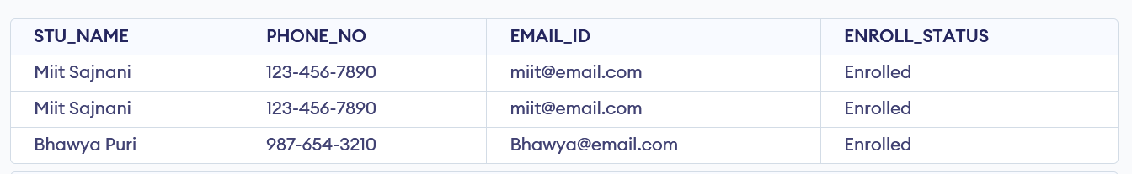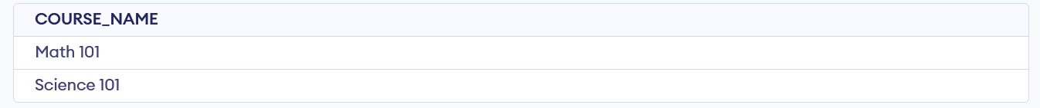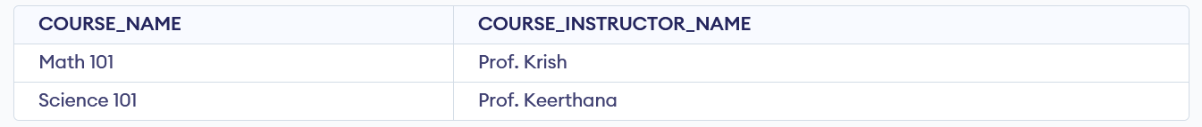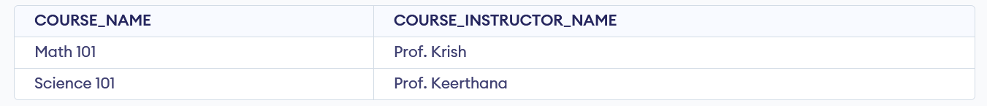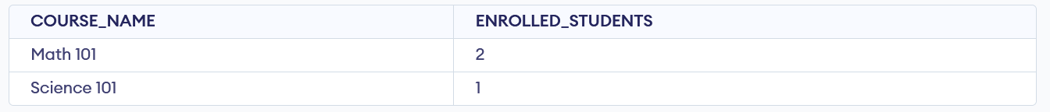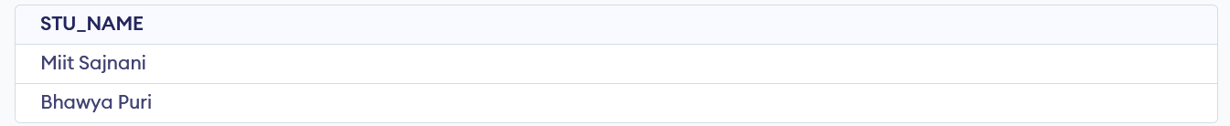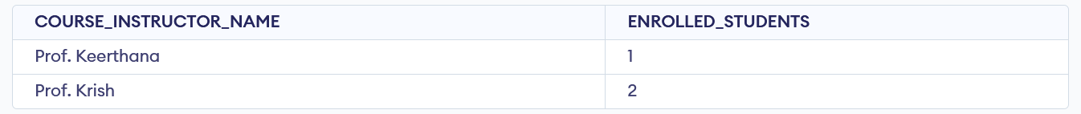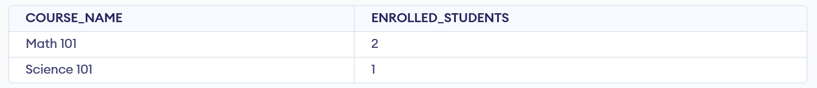

# Task 2

**-- 1. Database Setup**

CREATE DATABASE student_database;

\c student_database;

**-- 2. Create student_table**

CREATE TABLE student_table (

Student_id serial PRIMARY KEY,

Stu_name text,

Department text,

email_id text,

Phone_no numeric,

Address text,

Date_of_birth date,

Gender text,

Major text,

GPA numeric,

Grade text

);

**-- 3. Data Entry**

INSERT INTO student_table (Stu_name, Department, email_id, Phone_no, Address, Date_of_birth, Gender, Major, GPA, Grade)

VALUES

('Miit Doe', 'Computer Science', 'Miit@example.com', 1234567890, '123 Main St', '1999-05-15', 'Male', 'Computer Science', 3.8, 'B'),

('Bhawya Smith', 'Mathematics', 'Bhawya@example.com', 9876543210, '456 Elm St', '2000-08-20', 'Female', 'Math', 4.2, 'A'),

('John Johnson', 'Physics', 'John@example.com', 5555555555, '789 Oak St', '1998-03-10', 'Male', 'Physics', 3.5, 'C'),

('Balaji Lee', 'Biology', 'Balaji@example.com', 3333333333, '567 Pine St', '2001-01-05', 'Female', 'Biology', 4.5, 'A'),

('David Brown', 'Chemistry', 'david@example.com', 4444444444, '345 Birch St', '1997-11-25', 'Male', 'Chemistry', 3.9, 'B'),

('Emily White', 'History', 'emily@example.com', 6666666666, '234 Cedar St', '1999-09-15', 'Female', 'History', 4.0, 'B'),

('Keerti Davis', 'Economics', 'Keerti@example.com', 7777777777, '432 Maple St', '2000-07-30', 'Male', 'Economics', 3.7, 'C'),

('Olivia Taylor', 'Psychology', 'olivia@example.com', 9999999999, '543 Walnut St', '1998-12-05', 'Female', 'Psychology', 4.3, 'A'),

('Krish Wilson', 'Political Science', 'krish@example.com', 8888888888, '876 Redwood St', '1996-04-18', 'Male', 'Political Science', 3.4, 'C'),

('Monica Anderson', 'English', 'Monica@example.com', 2222222222, '321 Cedar St', '2000-06-20', 'Female', 'English', 4.1, 'B');

**-- 3. Student Information Retrieval**

SELECT *

FROM student_table

ORDER BY Grade DESC;

**-- 4. Query for Male Students**

SELECT *

FROM student_table

WHERE Gender = 'Male';

**-- 5. Query for Students with GPA less than 5.0**

SELECT *

FROM student_table

WHERE GPA < 5.0;

**-- 6. Update Student Email and Grade**

UPDATE student_table

SET email_id = 'newemail@example.com', Grade = 'A'

WHERE Student_id = 1; -- Update the student with the specific ID

**-- 7. Query for Students with Grade "B"**

SELECT Stu_name, EXTRACT(YEAR FROM age(Date_of_birth)) AS Age

FROM student_table

WHERE Grade = 'B';

**-- 8. Grouping and Calculation**

SELECT Department, Gender, AVG(GPA) AS Average_GPA

FROM student_table

GROUP BY Department, Gender;

**-- 9. Table Renaming**

ALTER TABLE student_table RENAME TO student_info;

**-- 10. Retrieve Student with Highest GPA**

SELECT Stu_name

FROM student_info

ORDER BY GPA DESC

LIMIT 1;

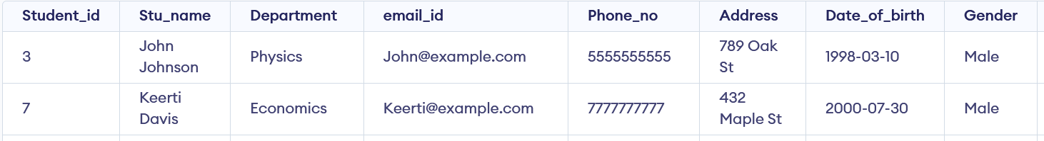

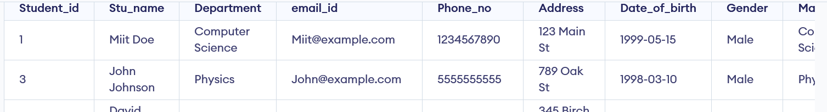

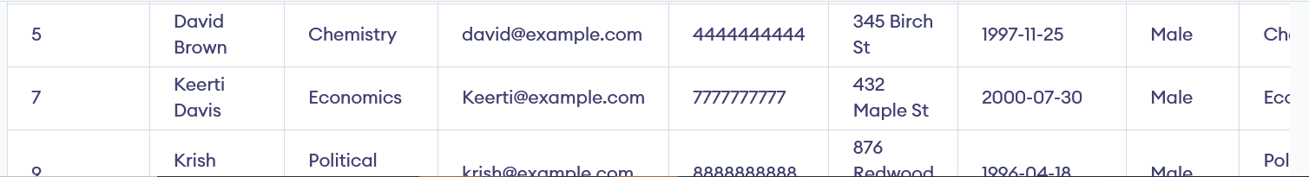

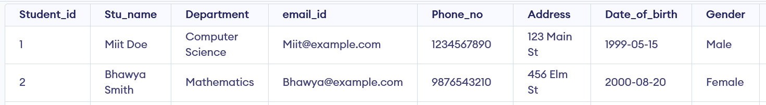

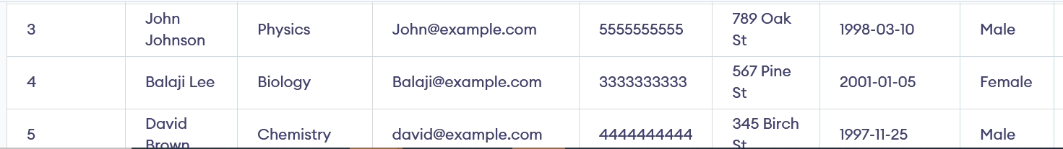

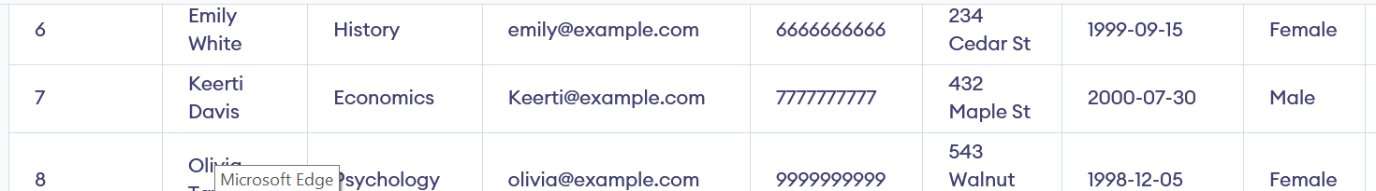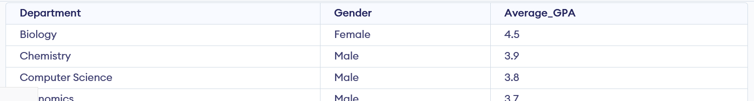

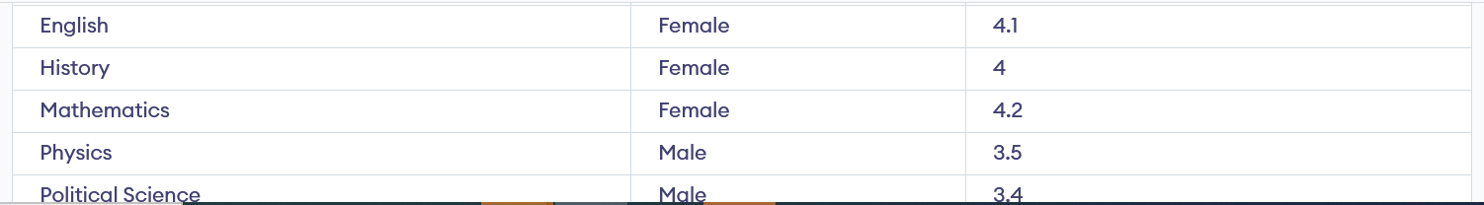



# Task 3

**-- 1. Database Creation**

--CREATE DATABASE EventsManagement;

--\c EventsManagement;

**-- 1. Create Events table**

CREATE TABLE Events (

Event_Id serial PRIMARY KEY,

Event_Name text,

Event_Date date,

Event_Location text,

Event_Description text

);

**-- 2. Create Attendees table**

CREATE TABLE Attendees (

Attendee_Id serial PRIMARY KEY,

Attendee_Name text,

Attendee_Phone text,

Attendee_Email text,

Attendee_City text

);

**-- 3. Create Registrations table with foreign key constraints**

CREATE TABLE Registrations (

Registration_Id serial PRIMARY KEY,

Event_Id INT,

Attendee_Id INT,

Registration_Date date,

Registration_Amount numeric,

FOREIGN KEY (Event_Id) REFERENCES Events(Event_Id),

FOREIGN KEY (Attendee_Id) REFERENCES Attendees(Attendee_Id)

);

**-- 2. Data Creation**

-- Sample data for Events

INSERT INTO Events (Event_id,Event_Name, Event_Date, Event_Location, Event_Description)

VALUES

(1,'Conference', '2023-12-15', 'Convention Center', 'Annual tech conference'),

(2,'Workshop', '2023-10-20', 'Training Center', 'Web development workshop'),

(3,'Seminar', '2023-11-05', 'University Auditorium', 'Marketing trends seminar');

**-- Sample data for Attendees**

INSERT INTO Attendees (Attendee_id,Attendee_Name, Attendee_Phone, Attendee_Email, Attendee_City)

VALUES

(1,'John Doe', '123-456-7890', 'john@example.com', 'New York'),

(2,'Jane Smith', '987-654-3210', 'jane@example.com', 'Los Angeles'),

(3,'Mike Johnson', '555-555-5555', 'mike@example.com', 'Chicago');

**-- Sample data for Registrations**

INSERT INTO Registrations (Event_Id, Attendee_Id, Registration_Date, Registration_Amount)

VALUES

(1, 1, '2023-12-01', 50.00),

(1, 2, '2023-11-25', 50.00),

(2, 1, '2023-10-15', 75.00);

**-- 3. Manage Event Details**

-- a) Inserting a new event

INSERT INTO Events (Event_Name, Event_Date, Event_Location, Event_Description)

VALUES ('Exhibition', '2024-02-10', 'Art Gallery', 'Art exhibition');

**-- b) Updating an event's information**

UPDATE Events

SET Event_Location = 'Museum'

WHERE Event_Id = 4; -- Update the event with a specific ID

**-- c) Deleting an event**

DELETE FROM Events

WHERE Event_Id = 3; -- Delete the event with a specific ID

**-- 4. Manage Track Attendees & Handle Events**

-- **a) Inserting a new attendee**

INSERT INTO Attendees (Attendee_Name, Attendee_Phone, Attendee_Email, Attendee_City)

VALUES ('Sarah Lee', '333-333-3333', 'sarah@example.com', 'San Francisco');

-- **b) Registering an attendee for an event**

INSERT INTO Registrations (Event_Id, Attendee_Id, Registration_Date, Registration_Amount)

VALUES (1, 3, '2023-12-05', 50.00); -- Register Sarah Lee for the conference

**-- 5. Develop queries**

**-- Retrieve event information**

SELECT * FROM Events;

**-- Generate attendee lists for a specific event**

SELECT A.Attendee_Name

FROM Attendees A

INNER JOIN Registrations R ON A.Attendee_Id = R.Attendee_Id

WHERE R.Event_Id = 1; -- Replace 1 with the event ID you want to retrieve attendees for

**-- Calculate event attendance statistics (count of attendees for each event)**

SELECT E.Event_Name, COUNT(R.Attendee_Id) AS Attendee_Count

FROM Events E

LEFT JOIN Registrations R ON E.Event_Id = R.Event_Id

GROUP BY E.Event_Name;

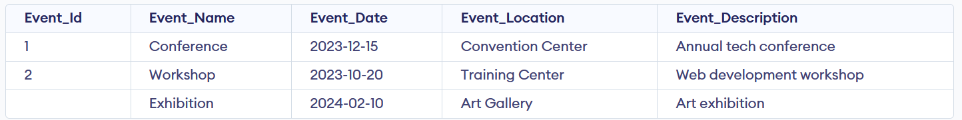

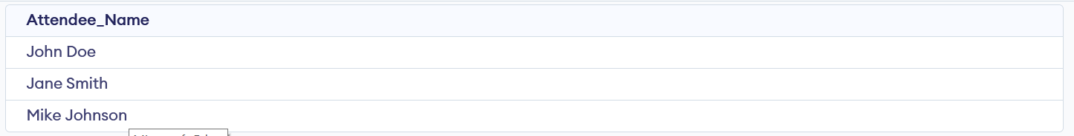

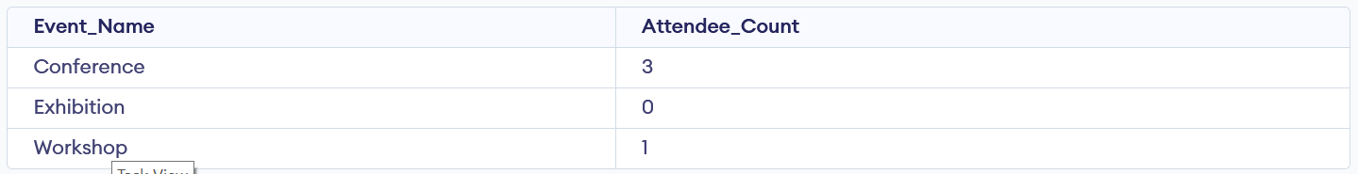

# Task 4

-- Database: Sales Data

-- DROP DATABASE IF EXISTS "Sales Data ";

CREATE DATABASE "Sales Data "

WITH

OWNER = postgres

ENCODING = 'UTF8'

LC_COLLATE = 'English_United States.1252'

LC_CTYPE = 'English_United States.1252'

TABLESPACE = pg_default

CONNECTION LIMIT = -1

IS_TEMPLATE = False;

--1) Database creation

Create table Sales_sample (Product_Id Int, Region Varchar(50), On_date Date,

Sales_Amount Numeric);

--2) Data Creation

Insert into Sales_sample (Product_Id, Region, On_date, Sales_Amount) values

('1', 'East', '2023-11-10', '20000'),

('2', 'West', '2023-08-19', '50000'),

('2', 'East', '2023-11-21', '40000'),

('3', 'North', '2023-07-20', '15000'),

('4', 'North', '2023-08-07', '45000'),

('2', 'South', '2023-08-24', '45000'),

('5', 'North', '2023-11-22', '20000'),

('5', 'West', '2023-11-11', '60000'),

('3', 'East', '2023-09-19', '50000'),

('1', 'West', '2023-09-29', '70000')

;

Select * from Sales_Sample;

--3) OLAP operations

--a) Drill down

Select Region, Product_Id, Sum(Sales_Amount) as Sales_Amount

From Sales_Sample

Group By 1,2

Order By Region, Product_Id, Sales_Amount;

--b) Roll Up

Select Region, Product_Id, Sum(Sales_Amount) as Sales_Amount

From Sales_Sample

Group By Rollup (1,2)

Order By Region;

--c) Cube

Select Region, Product_Id, On_Date, Sum(Sales_Amount) as Sales_Amount

From Sales_Sample

Group By Cube (1,2,3)

Order By Region, Product_Id, On_Date, Sales_Amount;

--d) Slice

Select Region, Product_Id, On_Date, Sum(Sales_Amount) as Sales_Amount

From Sales_Sample

Where Region in('North', 'South') OR On_Date between To_date('2023-08-20','YYYY-MM-DD') And To_Date('2023-10-20','YYYY-MM-DD')

Group By 1,2,3

Order By Region, Product_Id, On_Date, Sales_Amount;

--e) Dice

Select Region, Product_Id, On_Date, Sum(Sales_Amount) as Sales_Amount

From Sales_Sample

Where Region in('North', 'South') AND Product_Id IN (1,2) AND On_Date between To_date('2023-08-20','YYYY-MM-DD') And To_Date('2023-10-20','YYYY-MM-DD')

Group By 1,2,3

Order By Region, Product_Id, On_Date, Sales_Amount;

