SmartSplit Nepal
Split less. Settle smarter.
A Group Expense Splitting and Smart Settlement Platform
with Machine Learning for Expense Categorisation and Spending Forecasting
Submitted by
Utsuk Kharel
BSc (Hons) Computer Science with Artificial Intelligence
Sunway College Kathmandu
Kathmandu, Nepal
September 2026

Abstract
Shared expenses are a routine part of student and family life in Nepal, and they are still tracked mostly in notebooks, chat messages and memory. The result is familiar: nobody is certain who owes whom, small debts are forgotten, and settling up takes far more individual payments than it needs to.
SmartSplit Nepal is a web application that records shared expenses in Nepali rupees, computes each member’s net position, and reduces settlement to the smallest practical number of payments. A greedy debt-minimisation algorithm pairs exact matches first and then repeatedly settles the largest debtor against the largest creditor, which guarantees that a group of n members can settle in at most n − 1 payments; in the demonstration trip this turns ten direct transfers into three. All money is handled in integer paisa so that group totals always reconcile exactly, and payments can be recorded as cash or completed through the eSewa and Khalti test gateways.
Two supervised machine-learning models were added to the platform. The first predicts an expense category from its free-text description, so the app can suggest a category while the user is still typing; it reaches 97.2% accuracy and 0.96 macro F1 on a held-out split that is grouped by wording, so no description is seen in both training and testing. The second estimates what a group might spend in the coming month from its own recent history, the same month last year and the real Nepali festival calendar, and gives a one-line reason for each estimate; across two held-out windows it achieves a mean absolute error of Rs. 22,985 against Rs. 30,691 for the best naive baseline.
Because no public dataset of Nepali household transactions exists, a dataset of 12,822 expenses across fifteen households and 36 months was constructed from published Nepali price data and a festival calendar of 118 festivals, occasions and wedding seasons on their real dates from 2023 to 2027, with every price and date traceable to a cited source. The report states plainly what this dataset is and is not, and reports the resulting limitations rather than presenting the models as more capable than they are.
The system is built with Django REST Framework, PostgreSQL and React, and is verified by 71 automated tests, a linted production build and an end-to-end browser run of the full demonstration scenario, all executed on every push through GitHub Actions.
Keywords: expense splitting, debt minimisation, text classification, time-series forecasting, Django REST Framework, React, PostgreSQL, eSewa, Khalti, Nepal.

Table of Contents

1. Introduction

1.1 Background
Any group that spends money together accumulates a web of small debts. A group of five friends on a trip to Pokhara might produce twenty expenses in three days, each paid by whoever happened to have cash, and each shared by a different subset of the group. Reconstructing who owes whom at the end of such a trip is tedious, error-prone and socially awkward, and the awkwardness is precisely why many of these debts are quietly written off.
Existing international applications solve part of this problem, but they assume a context that does not match Nepal. They format amounts in Western conventions rather than the lakh-based grouping used here, they identify people by email rather than by mobile number, they use categories drawn from a different everyday life, and they connect to payment services that are not available to Nepali users. Digital wallets such as eSewa and Khalti are now widely used in Nepal, and any application about settling debts between people here ought to acknowledge them.

1.2 Problem statement
Three problems motivate this project. First, shared expenses are recorded informally, which makes disputes hard to resolve because there is no shared record of what was spent and who benefited. Second, even when balances are known, groups settle them inefficiently: everyone pays everyone, producing many more transactions than are mathematically necessary. Third, the act of recording an expense is itself friction; the more fields a user must fill in, the less likely they are to record anything at all.

1.3 Objectives
The project set out to:
- Build a complete, working web application in which users can create groups, add members by Nepali mobile number or invitation link, and record shared expenses with equal, custom or percentage splits.
- Compute each member’s net balance exactly, using integer paisa arithmetic so that rounding can never make a group’s balances fail to sum to zero.
- Implement and demonstrate a settlement algorithm that minimises the number of payments required to clear a group.
- Support realistic settlement flows: cash, an in-app simulation, and the official eSewa and Khalti test gateways.
- Apply machine learning where it genuinely reduces user effort or adds insight, namely suggesting an expense category from its description and estimating what a group might spend in the coming month, with a short reason shown to the user.
- Construct a dataset appropriate to the Nepali context, with every price grounded in a published source and every festival on its real date, and evaluate the models honestly against baselines.
- Verify the whole system with automated tests and continuous integration, and document it well enough for another developer to run and extend it.

1.4 Scope and limitations of scope
The application runs locally on a developer machine and is aimed at small groups. It handles a single currency, the Nepali rupee. No real money moves through the system at any point: gateway integration uses the official test environments, and every simulated payment screen is labelled as such. Public merchant payment APIs are designed to pay a business rather than a friend, so the gateway step confirms that a payment was made and the application then records the settlement between the two members. These boundaries are discussed further in Chapter 7.

2. Background and Related Work

2.1 Existing expense-sharing applications
Splitwise is the best-known application in this space and popularised the idea of simplifying debts within a group. Similar features appear in Settle Up, Tricount and in the payment-linked splitting offered by wallet providers in several countries. These applications demonstrate that the core interaction is well understood: record an expense, choose who shared it, and read a balance.
What they do not offer is local fit. Amount formatting, phone-based identity, category vocabulary and payment rails are all assumptions that travel poorly, and none of them integrate with eSewa or Khalti. SmartSplit Nepal therefore keeps the interaction model that users already find intuitive and rebuilds the surrounding assumptions for a Nepali audience.

2.2 The debt simplification problem
Reducing a set of mutual debts to the fewest possible payments is a known problem in combinatorial optimisation, and finding the true minimum is NP-hard in the general case: it is equivalent to partitioning the participants into the largest possible number of subsets whose net balances each sum to zero. Practical systems therefore use a greedy approximation, which is what this project implements and what Chapter 3 describes in detail. The approximation is attractive because it is fast, easy to explain to a user, and guarantees a useful bound: each payment fully settles at least one participant, so a group of n members needs at most n − 1 payments.

2.3 Text classification for financial transactions
Assigning a category to a transaction from its description is a standard supervised text-classification task, used widely by banking and budgeting applications. Term frequency-inverse document frequency (TF-IDF) with a linear classifier remains a strong baseline for short texts, and it has two practical advantages over a neural approach in this setting: it trains in seconds on a laptop, and the learned weights can be inspected, which matters for a project that must be explained rather than merely demonstrated. Character n-grams are commonly added when the text contains misspellings or transliteration, which is exactly the situation for Romanised Nepali entries such as khaja, khaaja and tarkari.

2.4 Short-horizon spending forecasting
Forecasting a household’s spending is usually approached either with classical time-series models such as ARIMA and exponential smoothing, or by turning the series into a supervised learning problem through lagged features. With only three years of monthly data and fifteen series, the lag-feature approach is the more practical: it allows several households to be pooled into a single model, and it makes the seasonal effects explicit as features rather than latent components. Festival seasonality is the dominant effect in the Nepali calendar; published reporting on Dashain puts the rise in petroleum consumption alone at about 29 percent, alongside a broad retail surge.

3. System Analysis and Design

3.1 Architecture
The system follows a conventional three-tier separation. A React single-page application runs in the browser and holds no business logic beyond presentation; a Django REST Framework API owns every rule about money, membership and settlement; PostgreSQL stores the data. The two halves communicate only over HTTP with token authentication, which keeps the API usable by any future client, including a mobile application.
React (Vite) ──HTTP + token──> Django REST Framework ──> PostgreSQL
│ │
│ ├── settlements/algorithm.py (debt minimisation)
│ ├── expenses/splitting.py (paisa arithmetic)
│ ├── settlements/gateways.py (eSewa, Khalti)
└── CategorySuggestion.jsx ───────> insights/predictor.py ──> ml/models/*.joblib
ForecastCard.jsx
A deliberate decision was to compute balances on demand rather than store them. A stored balance is a cache, and a cache that disagrees with the underlying expenses is worse than no cache at all; recomputing from expenses and settlements means the answer is always consistent with the record.

3.2 Data model
Six Django applications divide the domain: users, groups, expenses, settlements, notifications, and insights (the machine-learning service). The core entities are:
Entity | Purpose | Key fields
User | Custom user model; login by email or Nepali mobile number | email, phone_number (^9[78]\d{8}$), full_name, picture
Group | A trip, flat, family or project that shares expenses | name, group_type, is_trip, start_date, end_date
GroupMember | Membership and role | group, user, role (owner/member)
GroupInvitation | Shareable link and QR invitation | token (10 chars), expires after 7 days
Expense | One shared expense | description, amount, category, date, paid_by, split_method, receipt
ExpenseSplit | One participant’s share of one expense | expense, user, amount
Settlement | A payment from one member to another | payer, recipient, amount, method, status, transaction_id
Activity / Notification | Audit trail and user alerts | group, actor, action, amount, is_read
Table 1: Core entities of the data model.

3.3 Money: paisa arithmetic
Every amount is converted to integer paisa before any arithmetic is performed, and converted back only for display. Floating-point arithmetic on rupees would introduce rounding drift that eventually breaks the invariant the whole application depends on, namely that the members’ balances in a group sum to exactly zero. When a division leaves a remainder, the remaining paisa are distributed one at a time to the first participants rather than being dropped, so the parts always add up to the whole.

3.4 The smart settlement algorithm
For each member, the net balance is computed as the amount they paid, minus their share of all expenses, plus settlements they have paid, minus settlements they have received. A positive balance means the member should receive money; a negative balance means they should give. Only successful settlements are counted, so a pending or failed payment never affects a balance.
The settlement plan is then produced in two passes:
- Exact matches first. Any debtor whose debt equals a creditor’s credit is paired directly, since that single payment clears two people at once.
- Greedy matching. The largest remaining debtor pays the largest remaining creditor the smaller of the two amounts. That payment removes at least one participant from the list, and the process repeats.
Because every payment settles at least one person, a group of n members needs at most n − 1 payments. In the demonstration dataset, ten direct debts between five friends reduce to three payments.
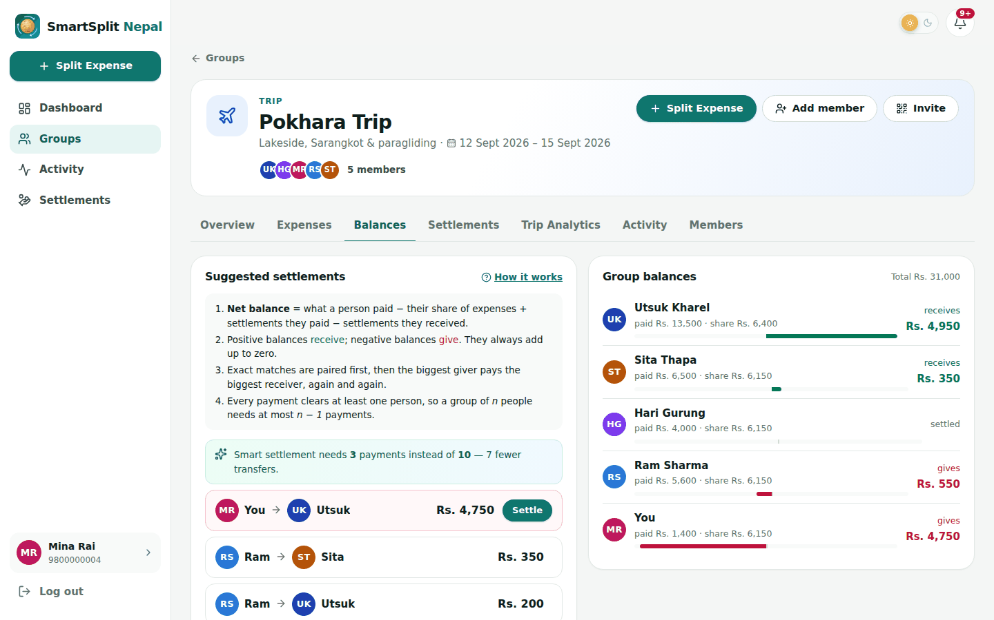
Figure 1: Group balances and the suggested settlement plan.

3.5 Payments
Settlement supports three channels. Cash is recorded directly by the payer and confirmed by the recipient. The in-app simulation reproduces the eSewa and Khalti flows without network access, which makes the application demonstrable anywhere. The test gateway mode uses the official sandbox environments: eSewa ePay v2 with an HMAC-SHA256 signature over the transaction fields, and Khalti KPG-2 with a server-side lookup call to verify the payment before the settlement is marked successful. Every settlement receives a transaction identifier of the form SMRT-KHL-20260924-X5BRF and a printable receipt.

4. Machine Learning
Two supervised models were built. Both are trained in a single Jupyter notebook, ml/notebooks/smartsplit_ml.ipynb, exported as joblib artefacts, and served by the Django API.
Model | Task | Algorithm chosen | Where it appears
Expense category classifier | Multi-class text classification into 9 categories | Logistic Regression | Quick Split wizard, step 1
Spending forecaster | Regression on a monthly series, with explanations | Random Forest | Group Overview tab
Table 2: The two models and where they are used.

4.1 The dataset and why it had to be constructed
No public dataset of individual Nepali household transactions exists, and collecting real transactions from users was not feasible within the timescale of the project or appropriate without consent. The dataset is therefore synthesised, but it is not invented. Every amount is drawn from a price range recorded in ml/data/price_reference.csv, which lists 51 published Nepali price points with the source and date of each, and every festival falls on its real date from ml/data/festival_calendar.csv. This distinction is stated wherever the dataset is described, in the notebook, in the repository documentation and here.
Item | Value used | Source
Petrol, diesel, kerosene | Rs. 200 per litre (Kathmandu band) | Nepal Oil Corporation retail price
LPG cylinder (14.2 kg) | Rs. 2,050 – 2,060 | Nepal Oil Corporation / market rate
Electricity | Rs. 11 – 13 per unit by slab | NEA domestic tariff, FY 2082/83
Vegetables | potato Rs. 48/kg, onion Rs. 90/kg, tomato Rs. 70/kg | Kalimati wholesale, 1 September 2026
Khasi meat | Rs. 1,300 – 1,600 per kg | Retail meat price guide; Dashain fixed rates
Marigold garland (Tihar) | Rs. 1,000 each | Nepal News, Tihar 2025
Mobile data packs | NTC 20 GB Rs. 399; Ncell combos Rs. 199 – 699 | Published operator packs
Home internet | Rs. 775 – 999 per month equivalent | WorldLink, Vianet, Subisu, ClassicTech
Kathmandu – Pokhara bus | Rs. 1,200 – 2,000 (deluxe to VIP) | Operator timetables
Cinema ticket | Rs. 150 – 800 by hall and seat | Showtime Nepal price comparison
Student room rent | Rs. 5,000 – 7,000 per month | Kathmandu rental listings
Semester fee, private college | Rs. 60,000 – 110,000 | Published fee guides
Table 3: Examples of the published prices underpinning the dataset.

4.1.1 The Nepali festival calendar
Festivals are the largest single influence on household spending in Nepal, and most of them follow the lunar calendar, so their dates move every year. Dashain began on 22 September in 2025 but on 11 October in 2026. The first version of this dataset used a fixed rule that treated October and November as the festival months, which placed most of the 2025 Dashain spending in the wrong month. It was replaced by a calendar of 118 entries covering 2023 to 2027, each with its start, main day and end, and a source for the dates.
Kind | Festivals and events
Major | Dashain, Tihar
Festivals | Haritalika Teej, Chhath, Holi, Nepali New Year, Maghe Sankranti (Maghi), Sonam Lhosar, Gyalpo Lhosar, Tamu Lhosar, Eid al-Fitr, Eid al-Adha, Mangsir wedding season
Occasions | Janai Purnima, Krishna Janmashtami, Maha Shivaratri, Buddha Jayanti, Mata Tirtha Aunsi (Mother’s Day), Kushe Aunsi (Father’s Day), Shree Panchami, Gai Jatra, Indra Jatra, Yomari Punhi, Christmas, New Year’s Eve, Valentine’s Day, Magh–Falgun and Baisakh–Asar wedding seasons
Personal | Birthdays, which recur on the same date every year for each household
Table 4: Festivals and events included in the dataset.
For each festival, ml/festivals.py records what households typically buy: new clothes, khasi meat, tika dakshina and bus tickets home for Dashain; marigold garlands, diyo, dry fruits and Bhai Tika gifts for Tihar; a red saree, pote and a dar party for Teej; rakhi and kwati for Janai Purnima; fruits and temple offerings for Krishna Janmashtami. Prices come from the price reference where a published figure exists. The number of purchases each festival causes is a modelling assumption ranked by the size of the festival, and is described as such.
Households celebrate according to a profile. Everyone keeps the national festivals; a Newar family also keeps Gai Jatra, Indra Jatra and Yomari Punhi; a Madhesi family keeps Chhath and has a larger Holi; a Magar student celebrates Maghi as the new year; Tamang, Sherpa and Gurung households keep their own Lhosar; a Muslim household keeps both Eids and a Christian household keeps Christmas. Families celebrate on a larger scale than a student in a hostel, and most festival shopping is dated before the main day rather than after it.

4.1.2 How a year is generated
The generator simulates fifteen households of five kinds — hostel student, student living at home, working bachelor, family and trip group — over 36 months, producing 12,822 expenses with 5,342 distinct descriptions. Festival, wedding and birthday purchases account for 14.2% of expenses and 15.5% of all money spent.
- Recurring bills recur. Rent, electricity, water, internet and school fees appear every month at a level fixed for each household, the gas cylinder every second month, and semester fees in two months of the year.
- Each household has a persistent character: its own spending level, its own typical number of expenses per month, and a slow trend.
- Festivals, weddings and birthdays happen on their real dates, and everyday spending rises inside the Dashain and Tihar windows; transport rises by 29 percent, the reported increase in petroleum consumption during Dashain. Vegetables cost more in the monsoon and electricity use rises in winter.
- Ambiguity is added deliberately. About one entry in seven is drawn from descriptions that genuinely belong to more than one category, such as "Snacks during movie", "Hotel dinner" or "Gas cylinder", each labelled from a probability distribution. This places a realistic ceiling on achievable accuracy.
The generator is deterministic, so running python ml/build_dataset.py reproduces the dataset exactly and every figure in this report can be regenerated.
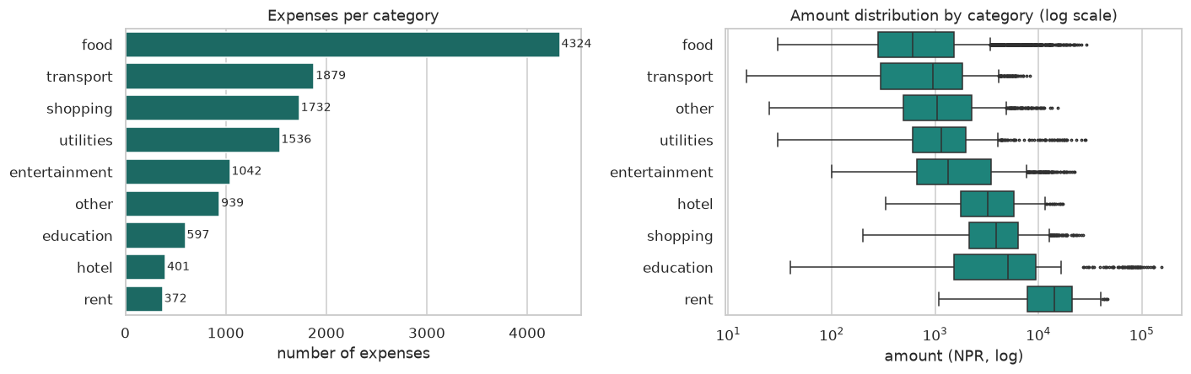
Figure 2: Class distribution and the spread of amounts per category (log scale).
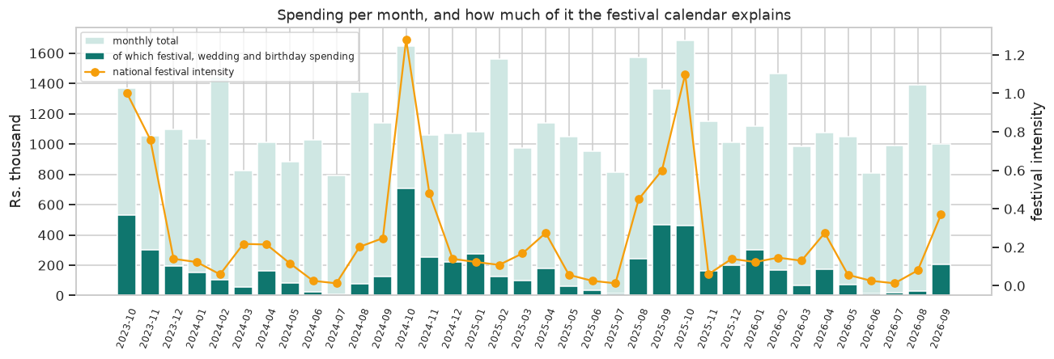
Figure 3: Monthly spending across all households, the part attributable to festivals, weddings and birthdays, and the national festival intensity.
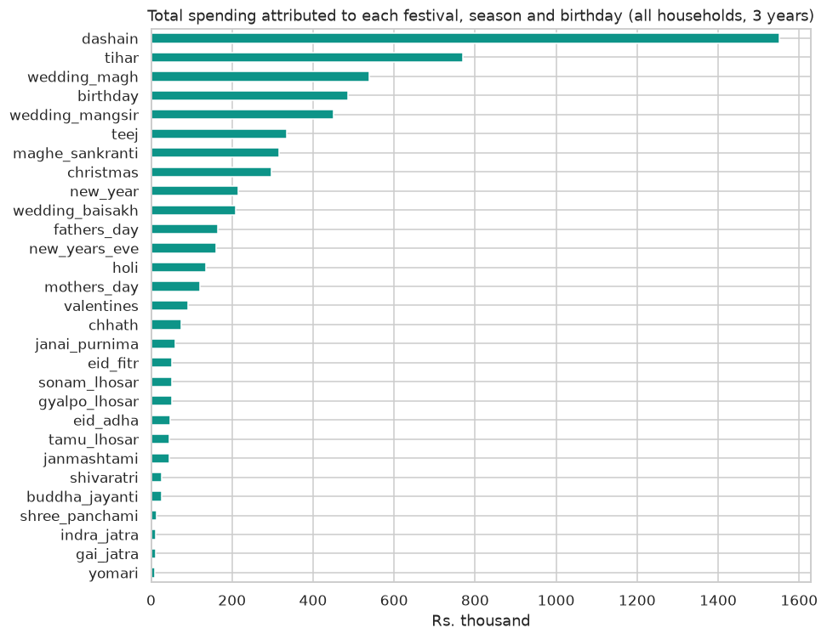
Figure 4: Total spending attributed to each festival, season and birthday over three years.

4.2 Category classifier

4.2.1 Preprocessing and features
Descriptions are lower-cased and reduced to letters; digits are removed because quantities such as "5 litre" or "3 months" say nothing about the category and would only inflate the vocabulary. The text is then vectorised as a union of two TF-IDF representations: word unigrams and bigrams, and character n-grams of length three to five within word boundaries. The character n-grams matter because users type inconsistently, and a purely word-based model would treat khaja and khaaja as unrelated tokens.

4.2.2 Avoiding a leakage artefact
An early version of the experiment reported accuracy of 100 percent. That number was not a result but an artefact: many people describe an expense in exactly the same words, so a random split placed identical text in both the training and test sets, and the model was being scored partly on sentences it had memorised. The split was therefore changed to group rows by their cleaned text, using GroupShuffleSplit for the train/test division and GroupKFold for cross-validation, which guarantees that no wording appears on both sides. All figures reported below come from that grouped split.
This is worth recording explicitly, because the corrected number is lower and the uncorrected one would have looked better.

4.2.3 Model selection and results
Three candidates were compared by five-fold grouped cross-validation on macro F1, which is the right metric here because the classes are imbalanced and plain accuracy would be flattered by the dominance of the food category.
Model | CV macro F1 | Std. dev. | CV accuracy
Logistic Regression | 0.9595 | 0.0247 | 0.9627
Linear SVM | 0.9579 | 0.0247 | 0.9609
Multinomial Naive Bayes | 0.9535 | 0.0169 | 0.9619
Table 5: Cross-validated comparison of the three classifier candidates.
Logistic Regression was selected and evaluated once on the held-out test set, where it reached 97.2% accuracy and 0.9607 macro F1, against a majority-class baseline of about 30 percent. An additional experiment appended a coarse amount band as an extra token; it improved macro F1 and is used by the deployed model.
Category | F1
education | 1.000
entertainment | 0.978
food | 0.975
hotel | 0.926
other | 0.971
rent | 0.864
shopping | 1.000
transport | 0.965
utilities | 0.967
Table 6: Per-class F1 on the held-out test set.
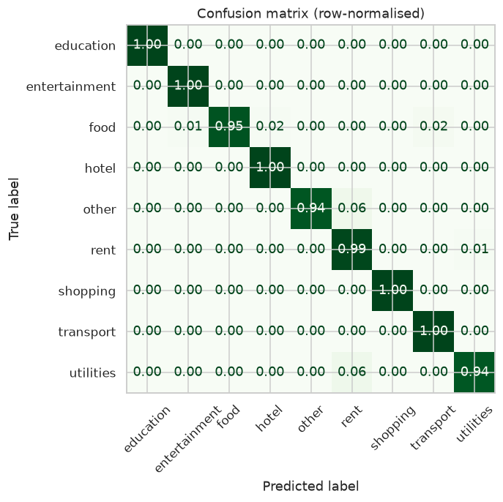
Figure 5: Row-normalised confusion matrix for the category classifier.
The weakest classes are rent and hotel, and the confusion matrix shows where their errors go: descriptions such as "Room rent and wifi together", "Hotel dinner" or "Taxi to hotel" sit between two categories by design. These are precisely the ambiguous entries introduced on purpose. A human reading only the description would hesitate over the same entries, which means the remaining error is a property of the task rather than a deficiency of the model, and it is the reason the application presents the answer as a suggestion that can be overridden with one click.

4.3 Spending forecaster

4.3.1 Formulation
Expenses are aggregated into 540 household-months. Every feature is information that exists before the month being predicted:
Feature | What it captures
Last three months and their average | The group’s usual level and recent trend
Same month last year | Birthdays, a household’s own festivals and anything else that repeats annually, without the app needing to know what they are
Festival intensity of the target month | The national calendar as one number per month (Dashain 1.0, Tihar 0.7, Teej 0.25 and so on), spread across the days each festival covers
Festival intensity of the current month | Spending that falls back after a festival month
Month of the year (sine and cosine) | Season
Group type | Family, roommates, college or trip
Table 7: Features used by the forecaster.
The festival intensity of the target month is legitimate information because the calendar is published in advance, and the application computes it for any future month from the same file. The same-month-last-year feature deserves a note: the application never stores anyone’s birthday, but if a group spent unusually in a given month last year, that figure already contains the reason. Before a household has a full year of history, the recent average stands in for it and a flag tells the model so.

4.3.2 Evaluation and results
Evaluation uses time-series cross-validation over two held-out windows: September 2025 to February 2026, which contains Dashain 2025, and March to September 2026. Each window is predicted by a model trained only on the months before it. Two naive forecasts are scored alongside the models: repeating last month’s total, and the average of the previous three months.
Features | Model | MAE (Rs.) | MAPE | Fold 1 | Fold 2
Festival calendar + same month last year | Random Forest | 22,985 | 0.417 | 23,188 | 22,781
Oct/Nov flag (old) | Random Forest | 25,282 | 0.438 | 21,981 | 28,583
Festival calendar | Gradient Boosting | 25,298 | 0.465 | 24,823 | 25,774
baseline | Naive (3-month average) | 30,691 | 0.482 | 35,357 | 26,025
baseline | Naive (last month) | 35,283 | 0.552 | 36,036 | 34,530
Table 8: Forecast comparison: the best model for each feature set, and the naive baselines.
Random Forest with the festival calendar and the same-month-last-year feature was selected. It improves on the old calendar-blind rule by about 9 percent and on the better naive baseline by about 25 percent. The calendar on its own is roughly level with the old flag; most of the gain comes from adding the same month last year. In the window containing Dashain 2025, the old flag happened to score slightly better, and the table reports both windows rather than only the average so that this is visible.
The relative error nonetheless remains about 41.7%. This is a property of the problem rather than a tuning failure: one trip or one semester fee moves a month more than any lagged feature can anticipate. The application therefore presents the forecast as a range, and words it as what might happen.
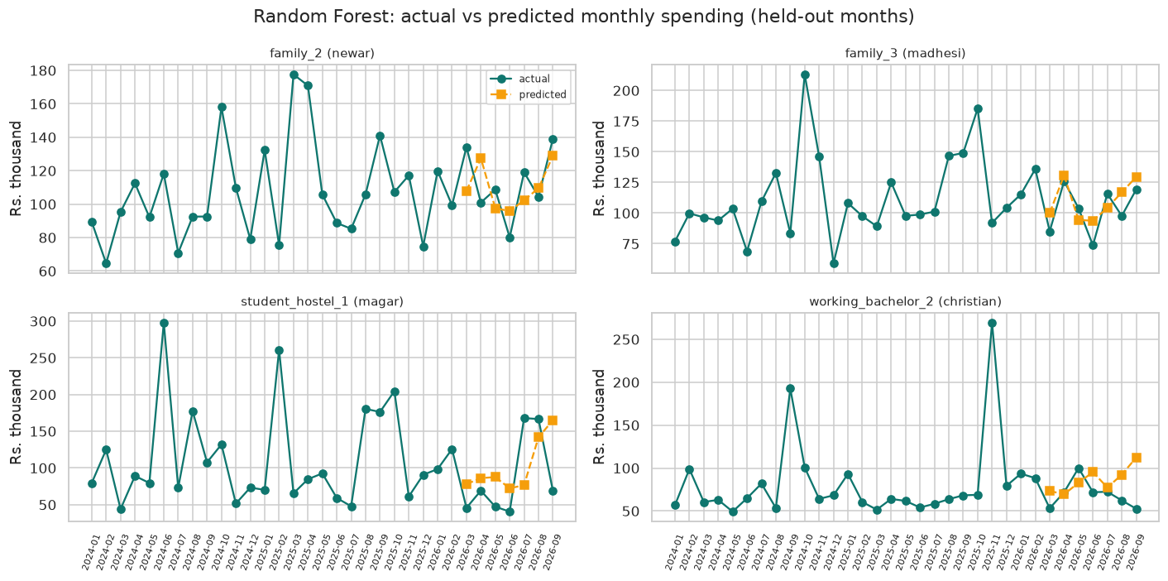
Figure 6: Actual against predicted monthly spending for four households with different celebration profiles, over the second held-out window.
Group type | Mean actual (Rs.) | MAE (Rs.) | MAPE
college | 61,762 | 16,687 | 0.371
family | 1,01,508 | 25,516 | 0.278
roommates | 80,664 | 28,705 | 0.423
trip | 22,869 | 14,293 | 1.002
Table 9: Forecast error by group type, second held-out window.
In absolute rupees the error follows the size of each group’s spending. In relative terms the family series, dominated by recurring bills, is predicted most closely, and trip groups are by far the hardest, since their spending arrives in bursts.
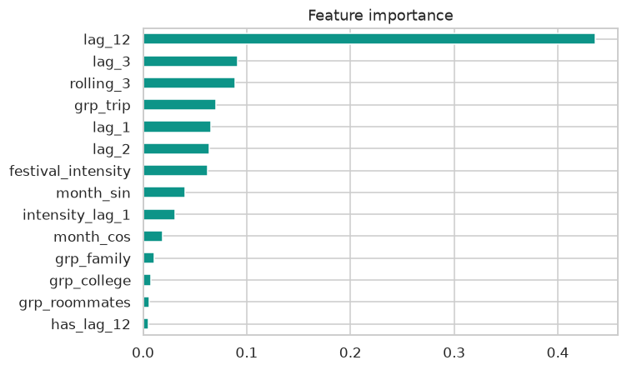
Figure 7: Feature importance for the selected forecaster.

4.3.3 Rejected alternatives
Two alternatives were tried and rejected. The fixed October-and-November flag was the first version of the festival feature, and was replaced for the reasons given in Section 4.1.1. Predicting the month’s total relative to the previous three months’ average was also tried, since a scale-free target would transfer more safely to groups much smaller than the training households; it lost clearly to the naive baselines, because dividing by a noisy denominator discarded the level information that carries most of the signal. The deployment risk it was meant to solve is handled instead by the serving clamp described in Section 5.4.

4.4 The reason under each forecast
A number on its own invites the question "why?". Under the predicted amount the forecast card therefore shows one or two short sentences, built from the same inputs the model receives. The first says what the group has spent this month and mostly on what; the second says whether the coming month might be higher, lighter or much like usual, and names the most important national festival in it if there is one. For the demonstration flat in October 2026 it reads:
You’ve spent Rs. 39,000 in September so far, mostly on rent. October might come in higher, around Rs. 73,842, with Dashain on 11–25 Oct.
The same logic produces, for other months, sentences such as "December might come in higher, around Rs. 63,643, with the Mangsir wedding season on 16 Nov – 15 Dec" or "July might look much like usual, around Rs. 42,222". The line was deliberately kept short: a longer, itemised explanation was built first and then cut back, because on a small card it read as clutter rather than help. The fuller details (categories, festival dates, the same month last year and whether the safety clamp applied) remain available in the API response for anyone who wants them.
Two principles govern the wording. First, every statement about the future is phrased as a possibility — might, could — and never as a certainty, which matches the measured error of the model. Second, the sentence describes what the forecast is based on; it does not claim to be an exact attribution of how the model weighed each input, which a Random Forest does not provide in a form that could be stated honestly in one sentence.
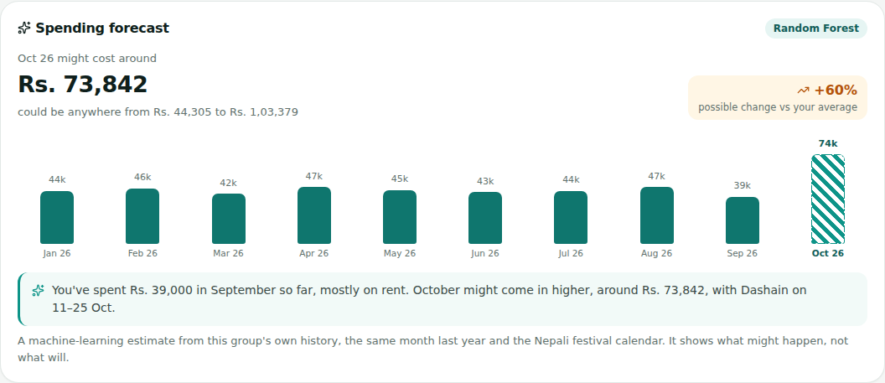
Figure 8: The forecast card on a group’s Overview tab, with its one-line reason.

5. Implementation

5.1 Technology
Layer | Technology
Backend | Python 3.11+, Django 5.1, Django REST Framework, token authentication
Database | PostgreSQL 14+ via psycopg2
Frontend | React 19, Vite, React Router 7, Axios, Lucide icons, qrcode.react
Machine learning | scikit-learn 1.9, pandas, joblib, Jupyter, matplotlib, seaborn
Payments | eSewa ePay v2 test environment, Khalti KPG-2 sandbox, in-app simulation
Quality | 71 Django tests, oxlint, Playwright end-to-end run, GitHub Actions CI
Table 10: Technology used in each layer.

5.2 Backend
The API exposes roughly forty endpoints across the six applications, all requiring token authentication except registration, login and the health check. Permissions are enforced at the object level: membership of a group is checked before any of its expenses, balances or settlements can be read, and destructive operations are restricted to the group owner. Validation is deliberately duplicated between the frontend and the backend, on the principle that a client-side check is a convenience and a server-side check is the rule.

5.3 Frontend
The React application is organised around a small number of contexts: authentication state and the stored token, a UI context providing toasts and confirmation dialogs, and a theme context implementing light and dark mode. Data fetching goes through a single useApi hook so that loading, error and retry behave the same way everywhere. The interface is responsive, with a sidebar on desktop and a bottom navigation bar on phones, and every screen has an explicit empty state rather than a blank area.
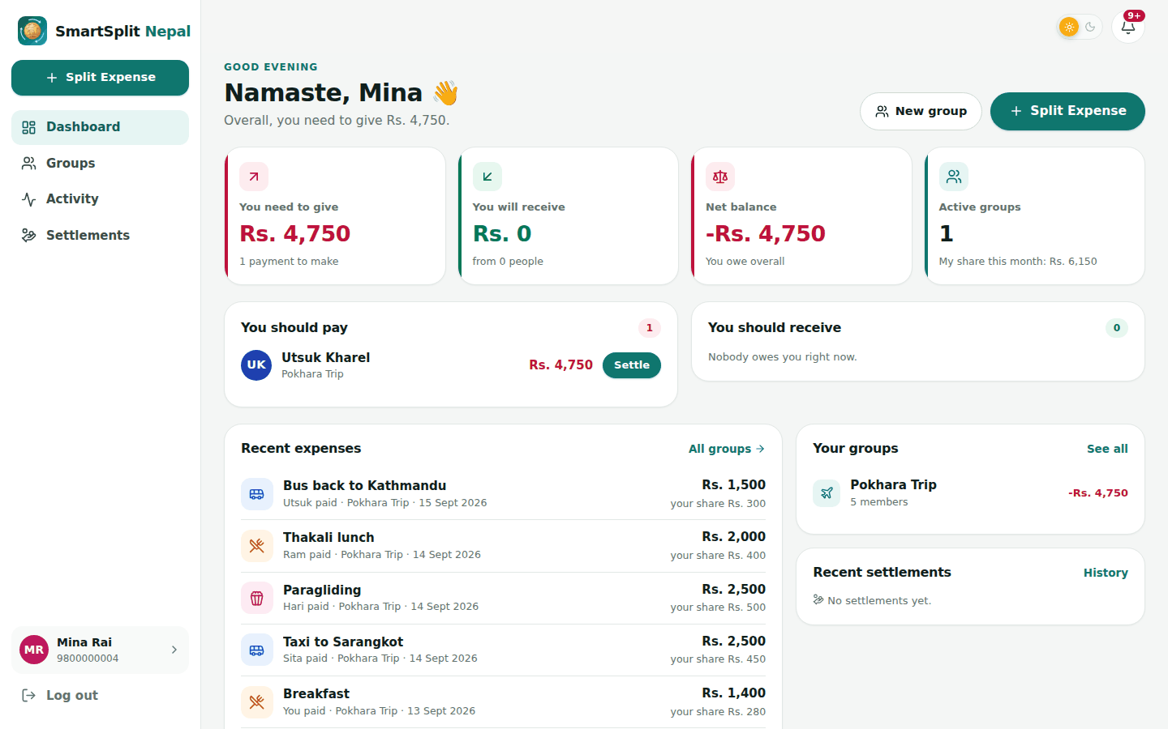
Figure 9: Dashboard: what the user owes, what they are owed, and recent activity.

5.4 Serving the models
A dedicated Django application, insights, loads the two joblib artefacts on first use and keeps them in memory. Three decisions define its behaviour:
- Graceful degradation. If the model files are absent, category suggestion falls back to keyword matching and the forecast falls back to a three-month average. Each response carries a source field reporting which path produced it, so the behaviour is visible rather than silent, and the application runs correctly on a clone where the notebook has never been executed.
- A serving clamp. The forecaster is trained on households spending tens of thousands of rupees a month, and a real group in the application may be far smaller. The served prediction is therefore clamped to between 0.6 and 1.6 times the group’s own three-month average, so an out-of-range input can never produce an absurd figure.
- The suggestion never overrides the user. It is shown only above 35 percent confidence, only when it differs from the category already selected, and it can be dismissed.
- A running month is completed before it is used. If the latest month is the current one, its remaining days are filled in at the group’s recent daily rate.
- The festival calendar travels with the model. The forecaster artefact contains the national festival intensity and the festival details for every month to December 2027, so the API needs no extra files to give a forecast its reason.
POST /api/ml/suggest-category/
{ "description": "Tourist bus Kathmandu to Pokhara", "amount": 1400 }

{ "category": "transport", "confidence": 0.9912,
"alternatives": [ { "category": "hotel", "confidence": 0.0031 } ],
"source": "model" }
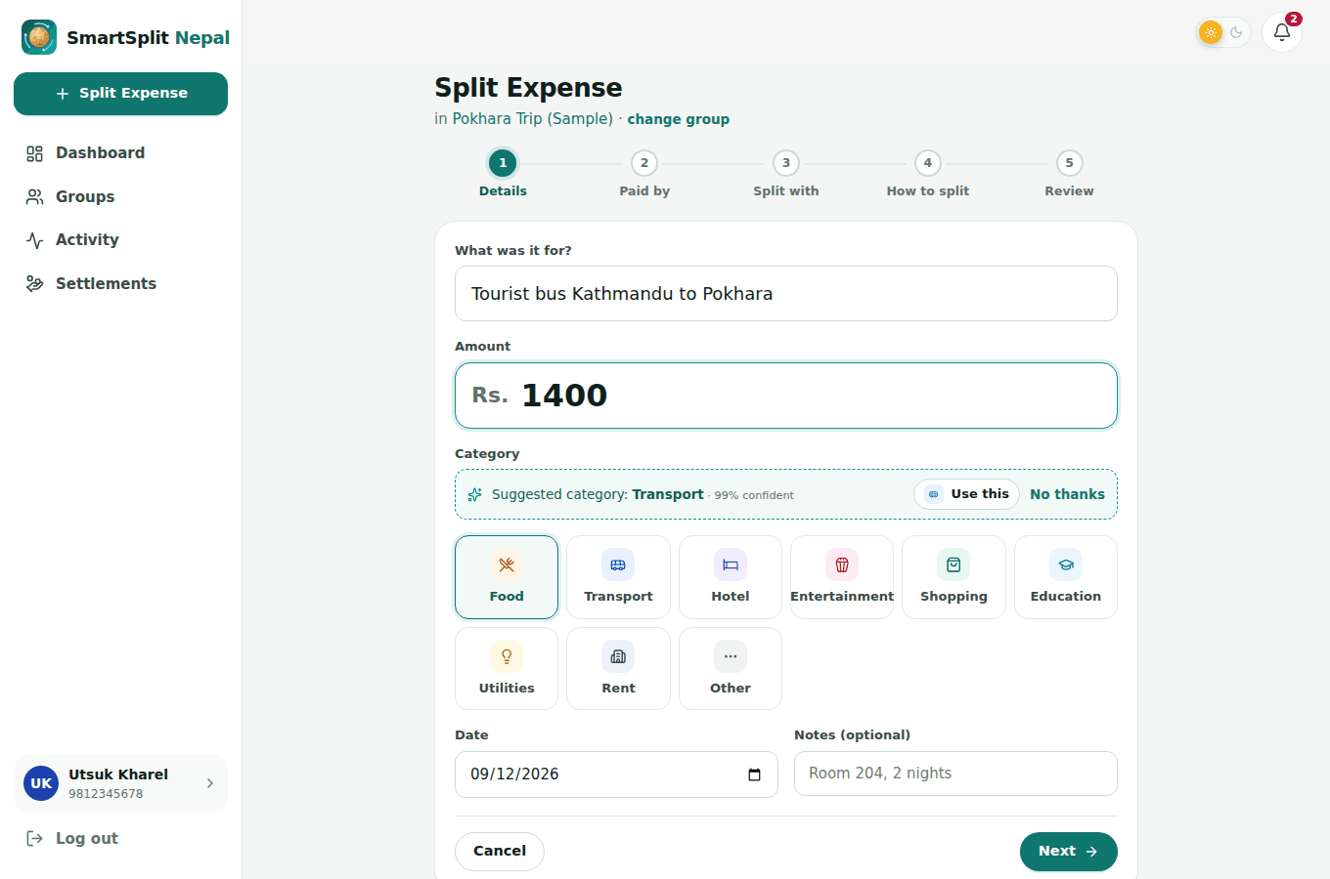
Figure 10: The classifier suggesting a category while the expense is being entered.
Figure 11: The forecast card on a group’s Overview tab, showing history, the prediction and its range.

6. Testing and Results

6.1 Strategy
Testing operates at three levels. Unit tests cover the pure functions where an error would be silent and costly: paisa conversion, the three split methods including remainder distribution, balance computation and the settlement algorithm. API tests exercise every endpoint through the HTTP layer with real authentication, covering permissions, validation errors and the payment flows. An end-to-end Playwright script drives a real browser through the full demonstration scenario, from registration to a printed receipt, and fails if the browser console reports any error.
Suite | Count | What it covers
Unit and API tests (Django) | 71 | Money arithmetic, splits, balances, settlement algorithm, permissions, gateways, ML endpoints, forecast wording and fallbacks
Frontend lint and build | — | oxlint across src/, then a production Vite build
End-to-end (Playwright) | 1 scenario | Registration, group creation, invitations, expenses, settlement, receipts, mobile layout
Continuous integration | every push | Both jobs run on GitHub Actions against a real PostgreSQL service
Table 11: Verification performed on every change.

6.2 Results against the objectives
Every objective set out in Section 1.3 was met. The application runs end to end on a developer machine; balances always sum to zero because all arithmetic is in integer paisa; the settlement algorithm reduces the demonstration group from ten direct debts to three payments; cash, simulated and test-gateway settlements all complete and produce receipts; and the two machine-learning models are trained, evaluated and integrated rather than left as a separate notebook.
Measure | Result
Settlement efficiency (demo group of 5) | 10 direct debts reduced to 3 payments
Category classifier accuracy (held-out, grouped split) | 97.2%
Category classifier macro F1 | 0.9607
Forecast MAE, selected model (two held-out windows) | Rs. 22,985
Forecast MAE, old October/November rule | Rs. 25,282
Forecast MAE, best naive baseline | Rs. 30,691
Festival calendar | 118 entries, 2023–2027, sourced
Automated tests passing | 71 of 71
Console errors in the end-to-end run | 0
Table 12: Headline results.

6.3 Problems encountered
Three problems are worth recording because their resolution shaped the final system.
The first was the leakage artefact described in Section 4.2.2, where duplicate descriptions across the train/test split produced a perfect score. It was resolved by grouping the split on the description text.
The second appeared when the forecaster was first served through the API: for a demonstration group spending around Rs. 41,000 a month, the model predicted over Rs. 90,000. The model was extrapolating from households considerably larger than the group in front of it. The response was twofold: the festival multipliers in the generator were lowered to figures that could be defended from published reporting, and the serving layer was given the clamp described in Section 5.4.
A further problem was found only when the festival model was examined closely. The first dataset treated October and November as the festival months every year, but Dashain follows the lunar calendar: in 2025 it began on 22 September. The fixed rule had quietly moved a large part of that year’s festival spending into the wrong month, and the forecaster had learned from it. The fix was the sourced festival calendar described in Section 4.1.1, and the comparison in Table 8 shows the effect of the change.
The third was subtler. Two scikit-learn pipelines were initially built sharing a single feature-extraction object; because a pipeline does not clone its steps, fitting the second pipeline refitted the shared vectoriser and silently invalidated the first model, which then failed at prediction time with a mismatched feature count. The fix was to construct a fresh feature union per pipeline. It is noted here because the failure was silent until the model was used, which is the kind of defect that unit tests on the serving layer are there to catch.

7. Limitations
- The dataset is synthesised from published prices rather than collected from users. Its prices and seasonality are realistic and sourced, but individual behaviour is modelled, not observed, and no conclusion in this report should be read as a measurement of real Nepali household behaviour.
- The number of purchases each festival causes is a modelling assumption ranked by festival size. The dates and prices are sourced; the volumes are not measured.
- Thirty-six months across fifteen households is a small basis for forecasting. The model captures the festival calendar, annual repeats and recent momentum, but it cannot anticipate one-off events, and its relative error reflects that.
- The festival calendar runs to December 2027. Beyond that the application reuses the same month from the latest year it knows, which is only approximate for lunar festivals, so the calendar will need extending.
- The classifier handles Romanised Nepali and English. Text entered in Devanagari would require transliteration or a retrained vectoriser.
- Confidence scores are calibrated on this dataset alone, so the percentage shown beside a suggestion should be read as a relative measure of certainty rather than a guaranteed probability.
- No real money moves through the system. Wallet integration uses the official test environments, and because public merchant APIs pay a business rather than an individual, the gateway confirms a payment and the application records the settlement between members.
- The application runs on localhost and supports a single currency. Deployment, multi-currency support and push notifications are outside the scope of this project.

8. Conclusion and Future Work
SmartSplit Nepal set out to make shared expenses in a Nepali context both accurate and quick to settle, and to apply machine learning where it genuinely earns its place. The result is a complete application: groups, phone-based member discovery, QR and link invitations, three split methods computed exactly in paisa, a settlement plan that provably needs at most n − 1 payments, wallet and cash settlement with receipts, trip analytics, and a polished interface with light and dark modes.
The machine-learning component is integrated rather than adjacent. The classifier removes a step from the most frequent interaction in the application, and it does so at 97.2% accuracy on descriptions it has never seen. The forecaster gives a group a sense of the month ahead, grounded in the real Nepali festival calendar and bounded by a range that reflects its measured error, and it gives its reason in a single plain sentence, always as what might happen rather than what will. Both degrade gracefully when their artefacts are unavailable, and both are covered by automated tests.
Equally important is what the project chose not to claim. The perfect classification score was investigated and discarded as leakage; the dataset is described as synthesised wherever it appears; a festival rule that placed Dashain in the wrong month was found and replaced; the forecaster is reported against naive baselines and across two windows rather than one; and the limitations above are stated rather than omitted.

8.1 Future work
- Retrain on real corrections. Every time a user overrides a suggested category, that is a labelled example from the real distribution, and it is by far the most valuable data the system could collect.
- Read receipts automatically. Optical character recognition on the receipt photos already stored would let the amount, date and vendor be filled in without typing.
- Support Devanagari input, through transliteration or a multilingual vectoriser.
- Extend the forecast to per-category predictions, so a group can see where the increase is expected rather than only the total.
- Add recurring expenses and reminders, which the recurring-bill structure of the dataset already models.
- Deploy the application and build a mobile client against the existing API, and explore a wallet partnership that would allow a real person-to-person payout.

References
Django Software Foundation. Django documentation, version 5.1. https://docs.djangoproject.com/
Encode. Django REST Framework documentation. https://www.django-rest-framework.org/
Pedregosa, F. et al. (2011). Scikit-learn: Machine Learning in Python. Journal of Machine Learning Research, 12, 2825–2830.
eSewa. ePay v2 developer documentation (test environment). https://developer.esewa.com.np/
Khalti. Payment Gateway (KPG-2) documentation. https://docs.khalti.com/
Nepal Oil Corporation. Retail selling price of petroleum products. https://noc.org.np/retailprice
Nepal Electricity Authority. Domestic electricity tariff, FY 2082/83.
Kalimati Fruits and Vegetables Market Development Committee. Daily wholesale price bulletin, 1 September 2026.
National Statistics Office, Nepal. Nepal Living Standards Survey IV, 2022/23. https://data.nsonepal.gov.np/
eStartup Nepal. Economics of Dashain in Nepal: spending, remittances and market impact. https://estartupnepal.com/article/economics-of-dashain-in-nepal
Showtime Nepal. Cinema ticket price comparison. https://www.showtimenepal.com/theater/ticket-prices
PriceNepal. NTC and Ncell data pack comparison; ISP plan comparison; LPG price. https://www.pricenepal.com/
Office Holidays. Nepal public holidays 2023, 2024, 2025, 2026 and 2027. https://www.officeholidays.com/countries/nepal/
The Kathmandu Post (2024, 12 October). Vijaya Dashami being marked today.
Nepal Hiking Team. Dashain festival dates, 2025 and 2026. https://www.nepalhikingteam.com/dashain-festival
timeanddate.com. Laxmi Puja (Tihar) in Nepal. https://www.timeanddate.com/holidays/nepal/laxmi-pujan-tihar
Calendarific. Janai Purnima dates in Nepal. https://calendarific.com/holiday/nepal/janai-purnima
Public Holidays Asia. Shree Krishna Janmashtami in Nepal. https://publicholidays.asia/nepal/shree-krishna-janmashtami/
Radio Nepal (2025, 27 April). Matatirtha Aunsi, Mother’s Day, being observed today.
Nepal News (2025, 20 October). Flower prices skyrocket during Tihar, a single marigold costs Rs 40.
Onlinekhabar. Another wedding season in Nepal: why too few dates for too many couples every year.

Appendix A: Repository Structure
SmartSplit-Nepal/
├── backend/ Django project
│ ├── config/ settings (.env), URLs, health check
│ ├── common/ paisa and NPR helpers, test helpers
│ ├── users/ custom user, auth, profile, search, seed_demo
│ ├── groups/ groups, members, invitations, analytics, forecast action
│ ├── expenses/ expenses, splits, receipts, split calculator
│ ├── settlements/ balance engine, smart settlement, eSewa/Khalti
│ ├── notifications/ activity timeline, notifications
│ └── insights/ machine-learning serving layer and tests
├── frontend/ React single-page application
├── ml/ dataset, notebook and exported models
│ ├── data/ price_reference.csv, festival_calendar.csv, expenses.csv,
│ │ monthly_spending.csv, households.csv
│ ├── notebooks/ smartsplit_ml.ipynb
│ ├── models/ category_clf.joblib, spend_forecast.joblib, metrics.json
│ ├── festivals.py festival dates, what each festival makes people buy
│ └── build_dataset.py
├── documentation/ architecture, database, API, algorithm, ML, testing, demo
├── SETUP.md complete macOS setup and troubleshooting
└── README.md

Appendix B: Running the Project
# 1. Database
psql postgres -c "CREATE USER smartsplit WITH PASSWORD '...' CREATEDB;"
psql postgres -c "CREATE DATABASE smartsplit OWNER smartsplit;"

# 2. Backend
cd backend && python3 -m venv venv && source venv/bin/activate
pip install -r requirements.txt
cp .env.example .env # set SECRET_KEY and DATABASE_PASSWORD
python manage.py migrate
python manage.py seed_demo --owner you@example.com --history 13
python manage.py runserver

# 3. Frontend (second terminal)
cd frontend && npm install && npm run dev

# 4. Retrain the models (optional)
pip install -r ml/requirements.txt
python ml/build_dataset.py
jupyter notebook ml/notebooks/smartsplit_ml.ipynb

