A Deep Learning approach for Kannada handwritten character recognition

# 1st U K Samarth

*dept. of electronics and communication KLE Technological University*

Hubli, India [01fe21bec126@kletech.ac.in](mailto:01fe21bec126@kletech.ac.in)

# 2nd Srushthi Joshi

*dept. of electronics and communication KLE Technological University*

Hubli, India [01fe21bec130@kletech.ac.in](mailto:01fe21bec130@kletech.ac.in)

# 3rd Satish Chikkamath

*dept. of electronics and communication KLE Technological University*

Hubli, India [chikkamath@kletech.ac.in](mailto:chikkamath@kletech.ac.in)

# 4th Nirmala S R

*dept.of electronics and communication KLE Technological University*

Hubli, India [nirmala.s@kletech.ac.in](mailto:nirmala.s@kletech.ac.in)

# 5th Suneeta Budihal

*dept. of electronics and communication KLE technological university*

Hubli, India

suneeta_vb@kletech.ac.in

***Abstract*—Handwritten character recognition is a crucial process that involves converting handwritten text on different surfaces such as paper and postcards into digital formats, making it distinguishable from scanned images. Remarkable advancements have been made in this field, particularly in India, where many languages with complex scripts like Kannada, English, and Marathi are used. Kannada is one of the widely used languages in the southern part of India, and recognizing its handwritten characters is a challenging one task due to its complicated script. The article explains how CNN, a type of dense net, is used to recognize Kannada’s handwritten characters. This technology can help protect many historical documents from damage and destruction, a significant achievement. The article also highlights that the versatility of this machine learning model extends beyond Kannada and can be used in various applications and technology development. The proposed research has used CNN and transfer learning due to its efficient layers, and the data set from Kaggle consisted of 16 classes of 25 images each for experimentation. The results showed a remarkable 97.50 percent accuracy in 50 epochs, demonstrating the potential of the CNN network in character recognition.**

***Index Terms*—Kannada, handwritten recognition, transfer learning, CNN**

1. Introduction

Handwritten Kannada character recognition is a technology that converts handwritten text into a digital text format. This recognition technology has various real-world applications in many fields like reading handwritten amounts on bank checks, automated recognition of addresses on email, and processing forms with specified constraints which increases its accuracy. This helps transform historical documents into digital text format, which helps preserve valuable knowledge from the risk of damage and ensures long life or long-term preservation [3]. In everyday life, handwritten text is a very much used method for recording information.[2]. The handwritten recognition process or system accepts handwritten form as inputs and recognized characters as outputs [2].

India is a country with diverse languages. Some of the popular languages spoken are Hindi, Marathi, Kannada, Telugu and Tamil. Each language has its unique script. Kannada is one of the most widely spoken languages in India, with 49 characters consisting of 34 consonants and 16 vowels. Each consonant has a corresponding ottakshara, which results in a total of 19668 characters. Every character has its shape and sound qualities, which makes it visually distinct. However, this also makes it challenging to convert handwritten text, as handwriting varies from person to person and may have variations in size and thickness. To train deep learning models, labeled datasets are essential. However, creating such datasets for a large number of characters can be time-consuming and expensive. To overcome this challenge, transfer learning has been introduced. In this approach, knowledge from an existing system with labeled data is transferred to train a new system with similar characteristics. This enables robust training of deep learning models even with limited labeled data.

In today’s digital world, character recognition technology is especially important for online character recognition. With the rise of smart devices like mobiles, touch screens are used in all areas, making real-time recognition of handwritten characters a necessity. This technique is more complex than others, and the limited availability of datasets has become a major problem in this area of technology. A standard dataset with a wide range of character examples is essential for training and evaluating character recognition systems. In addition, evolving scripts and languages have resulted in a need for character classification. This is due to similarities between characters from different scripts. This research focuses on transfer learning, which is a specialized branch of deep learning networks. This technique is used to address the challenges faced by many researchers in this area.

Numerous studies have investigated the architecture of neural networks for classifying Kannada characters, both in online and offline systems. However, the accuracy achieved so far is not satisfactory. We are implementing transfer learning, followed by our modifications to the remaining layers. Therefore, we aim to improve this technique by using a transfer learning approach using a pre-trained model as VGG net16 to achieve maximum accuracy.

1. LITERATURE SURVEY

In this discussion, we will explore the previous research conducted on Kannada handwritten character recognition. Handwritten character recognition has been a topic of much research, and this literature survey aims to review the previous work done on Kannada handwritten character recognition to enhance the method and increase accuracy.

In a paper by Roshan Fernandes and Anisha P Rodrigues (2019), titled ”Kannada Handwritten Script Recognition using Machine Learning Techniques,” two methods were used to im- plement the model - Tesseract tool and Convolutional Neural Network (CNN). They achieved accuracy of 86 percent and 87 percent, respectively. However, accuracy can be improved by using a good dataset. When it comes to identifying mixed- font handwriting, the Tesseract tool faces issues. But with the CNN method, it can be handled with more accuracy.

In another paper from 2019, the authors attempted to recog- nize Kannada characters using the Random Forest Classifier, Multinomial Naive Bayes Classifier (MSNBC), and CNN, achieving a maximum accuracy of 57 percent with CNN as compared to the other two methods where they obtained low accuracy of near 5 percent. Hence, they concluded that the CNN method provides more accurate results.

In a paper from 2023, the authors researched Kannada handwritten character recognition and used the Dense Net algorithm, which is a type of CNN, achieving an accuracy of 93.87 percent.

In a paper from 2020, Satya Sangram Sahoo et al. tried the model in Telugu and Kannada languages. They propagated images through a Convolutional Neural Network and classified between Kannada and Telugu characters, using feature extrac- tion, and fine-tuning. In the case of fine-tuning, they achieved

89.92 percent accuracy.

In a paper from 2017, Rajini Kumari Sah et al. classified Kannada characters using the SVM classifier. In a paper from 2020, Kusumika Krori Dutta et al. trained and tested for the 10 characters in the Kannada language. They performed character image processing and implemented both the Decision tree-based and Random tree-based models.

In a research paper titled "Online Kannada Character Recognition Using SVM Classifier" (2017) by Rajni Kumari Sah and Dr. K Indira, a dataset consisting of 2940 samples of single, double, and triple stroke Kannada characters was captured using an iBall 5540U Pen Tablet. Seven features like normalization coordinates, trajectory, and deviations were extracted. The SVM classifier was trained, and the best features were selected to achieve an average accuracy of 97.14 percent 97.55 percent, and 92.65 percent. The SBM was used, particularly with a kernel scale of 2, to achieve an accuracy of 98.38 percent.

In the paper titled "Kannada Confusing Character Recognition and Classification Using Random Forest and SVM" by Shobha Rani N and Bipin Nair B J(2021), the authors used the random forest and SVM algorithms to achieve accuracy. The process involved bounding boxes, feature extraction, and template matching. The random forest algorithm classified different sets of line types for each character, and then the SVM algorithm was applied to the trained feature vectors. The overall accuracy achieved was 78 percent. In essence, this approach

combines traditional machine learning techniques for character recognition.

1. PROPOSED PIPELINE

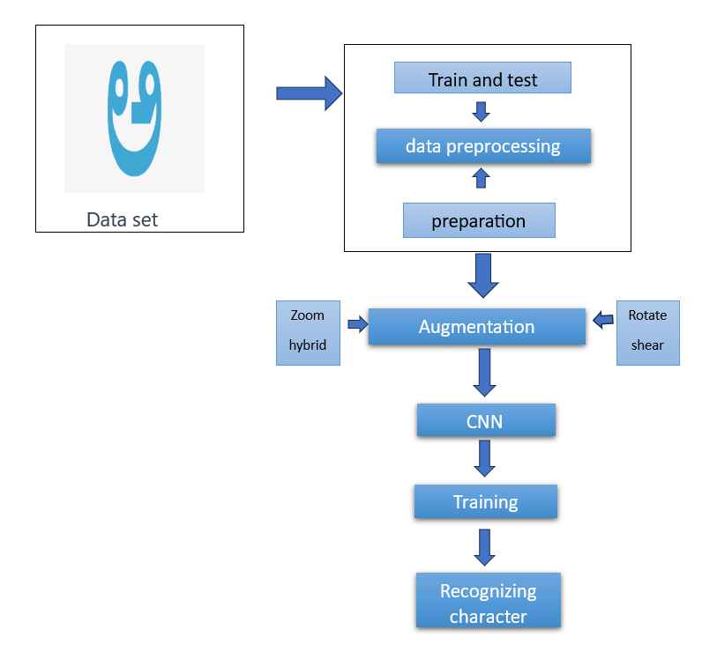

Fig 1. Pipeline

1. DATA SET AND PREPROCESSING
2. *Data set details*

We have used the Char74K dataset in this paper. With 657 handwritten Kannada characters in the collection and 25 samples for each, there are 16425 images overall of vowels, consonants, and numerals. However, we only chose vowels for our model. Vowels in Kannada consist of 16 characters. To enlarge the dataset, we have added a few more images in the dataset. There are 50 images in each class after the dataset has been expanded. The images in the dataset had dimensions of 1200 x 900 pixels.

*B. Preprocessing*

Data preparation plays an important role in laying the foundation for building an efficient model. It involves cleaning the data, handling missing values, and performing feature selection to identify and retain the most relevant variables. This enhances efficiency and the quality of data preparation predicts how well the model will perform when exposed to new and diverse scenarios. In Pre-processing the original images of 1200x900 pixels are to be resized to 224x224 pixels before it fed to the model. The dataset is divided into training and testing sets based on an 80:20 ratio. The training set has 40 images from each class, while the testing set includes the remaining 10 images from each class. In total, there are 640 images for training and 160 images for testing.

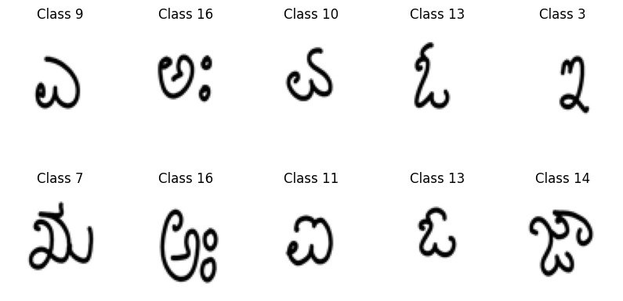

Fig 2. Preprocessing output

1. DATA AUGMENTATION

Data augmentation is a technique used to increase the size of a dataset of images. This technique involves modifications such as zooming and adjusting contrast. By zooming in on the handwritten character images, it becomes easier to further process and validate them. This process is useful for improving the accuracy and overall performance of the model.

* Zoom
* Hybrid
* Rotate
* Shear

Above all takes place which prepares data for further process

1. METHODOLOGY

Transfer learning is a concept in machine learning that uses the knowledge gained from a pre-trained model to solve a similar kind of problem. Here we are predicting the Kannada handwritten characters, By using the transfer learning of CNN, the knowledge of the pre-trained model can be used to classify the Kannada characters.

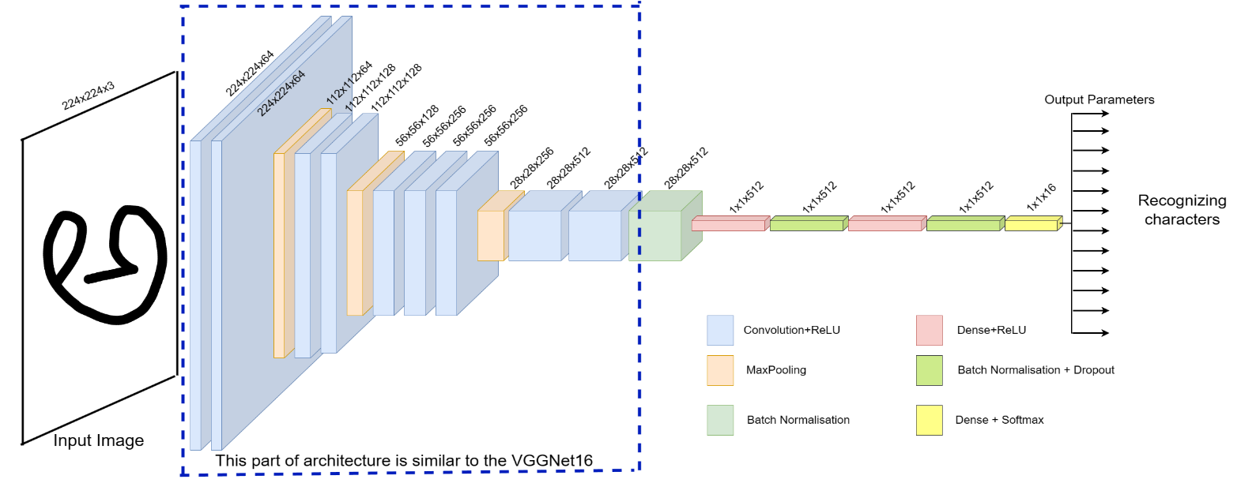

Fig 3. Architecture

The VGGNet-16 model requires an RGB image with the dimensions of 224x224 pixels. It has13 convolutional layers and fully connected 3 layers. The architecture is divided into 5 sets of convolutional layers followed by max-pooling. Once the input image passes through these layers, the model generates a vector with 1000 values. This vector represents the classification probability of various classes. The softmax function is then applied to these values to get the final probability distribution for the model. All the hidden layers used in VGGNet-16 have ReLU activation functions.

VGGNet-16 is the pre-trained model that is used in the Transfer learning approach in this paper. These are the steps of the VGGNet16 that are taken in the architecture.

a. In the CNN (VGG net), the input image is scanned by the convolutional 2D layer using filters or kernels. These filters extract features from various parts of the image to create a feature map. In this process, multiple small filters are used to extract hierarchical features

b. After applying convolutional filters, a ReLU activation function is applied element-wise to the feature map. This introduces non-linearity by replacing negative values with zero, allowing the model to learn more complex patterns in the data.

c. Max pooling layer Feature maps are reduced to lower spatial dimensions, reducing representation size while re- retaining significant features. This improves computational efficiency and translation invariance.

d. Flattening layer After all layers are flattened, the layer is converted into a one-dimensional vector. This process is suitable for input from spatial information.

e. Fully connected layers After being flattened, the data is passed through a series of fully connected layers that capture high-level semantic features and relationships.

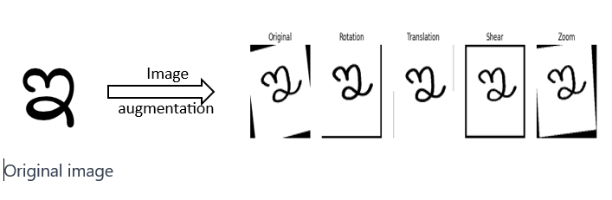

Original image

Fig 4 . Data augmentation

f. Softmax activation The softmax layer transforms the raw scores or logits into probabilities. Each element in the output vector represents the probability that the input image belongs to a specific class. The class with the high probability is considered the predicted class.

Combining all layers in VGG Net 16 enables the model to systematically learn hierarchical features from input images and make predictions by assigning probabilities to different classes, thereby improving image classification tasks.

A pre-trained network will extract those feature vectors and those features and use them in the classification process. Fine-tuning is the process of removing the top layers from the existing model and adding a layer on top of the model to get better performance for the model. Here we have removed the top layers from the VGGNet16 architecture and we have added the additional dense layers to the model architecture.

During the training phase, the model learns patterns from the labeled dataset by adjusting its parameters to make accurate predictions. This process involves feature engineering and the selection of an appropriate model architecture. It includes forward propagation, loss calculation, and backpropagation. The training is an iterative process that often spans multiple epochs, in which the model understands the data and undergoes regular validation checks to ensure its generalization to unseen data. After the completion of the training process, the model undergoes a testing process where it uses a separate set of unseen data to evaluate its performance. This involves applying the model to the input data, comparing its predictions with the actual outcomes, and assessing its performance using metrics tailored to the specific task, whether it’s classification or regression

1. RESULTS AND DISCUSSION

This section will present the result of what we have achieved after training the Kannada handwritten recognition model using the Transfer learning approach using the pre-trained model as VGGNet-16. We have trained the model for Vowels which consists of 16 characters. After training the network for about 40 epochs and obtained a training accuracy of 99.86 percent in the training phase and for the validation, phase got an accuracy of 97.50 percent.

This is the confusion matrix that we have obtained for the test dataset.

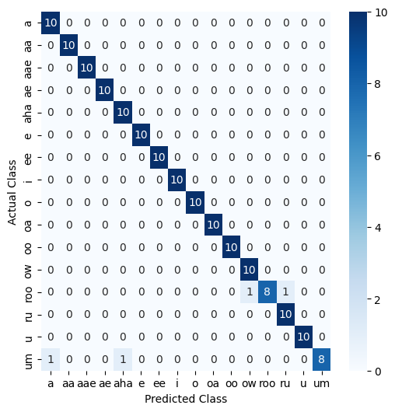

Fig 4. Confusion matrix

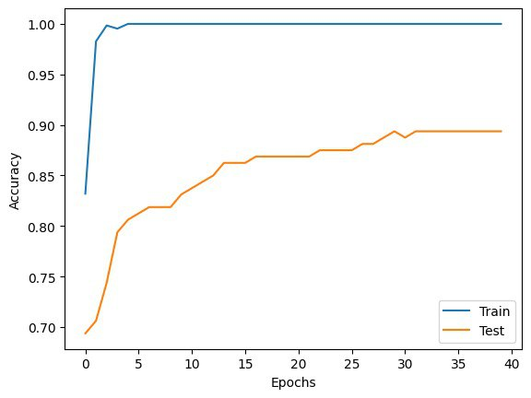

Fig 5. Model accuracy without augmentation

Using data augmentation can help prevent overfitting and improve accuracy, as shown in the figure where there is a significant gap between the test and train data.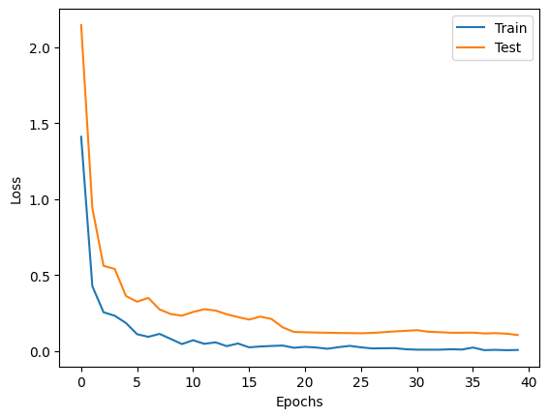

Fig 6. Model loss

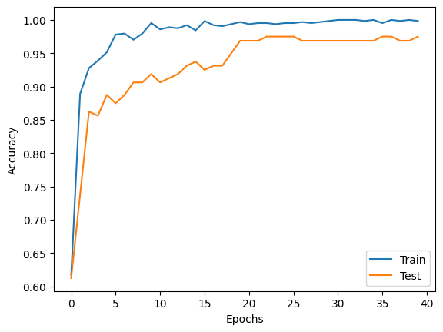

Fig 7. Model accuracy

In the figures above, it is shown how accuracy increases with each epoch and how loss or error reduces with each epoch. The small gap between the test and train graphs shows that the model is well-trained and has well convergence without overfitting.

1. CONCLUSION

The current model is capable of recognizing all 16 swaras, which are classes in Kannada. It is a unique implementation that uses CNN VGG16 and can identify all different font styles. The accuracy of the model was 86% before augmentation, but after data augmentation, the number of images increased, resulting in an accuracy of 97.50%, which is better than previous results. However, creating a huge dataset is required for this model, and it is still an active research field. Since the process is about identifying characters, the same approach can be applied to other languages such as Dravidian, Hindi, and more.

REFERENCES

1. R. Fernandes and A. P. Rodrigues, "Kannada Handwritten Script Recognition using Machine Learning Techniques," 2019 IEEE International Conference on Distributed Computing, VLSI, Electrical Circuits and Robotics (DISCOVER), Manipal, India, 2019, pp. 1-6, doi: 10.1109/DISCOVER47552.2019.9008097.
2. K. G. Joe, M. Savit and K. Chandrasekaran, "Offline Character recognition on Segmented Handwritten Kannada Characters," 2019 Global Conference for Advancement in Technology (GCAT), Bangalore, India, 2019, pp. 1-5, doi: 10.1109/GCAT47503.2019.8978320.
3. S. Vijaya Shetty, R. Karan and H. Sarojadevi, "A Kannada Handwritten Character Recognition System Exploiting Machine Learning Approach," 2023 International Conference on Applied Intelligence and Sustainable Computing (ICAISC), Dharwad, India, 2023, pp. 1-7, doi: 10.1109/ICAISC58445.2023.10199168.
4. S. Sahoo, P. Kumar B. and R. Lakshmi, "Offline handwritten character classification of the same scriptural family languages by using transfer learning techniques," 2020 3rd International Conference on Emerging Technologies in Computer Engineering: Machine Learning and Internet of Things (ICETCE), Jaipur, India, 2020, pp. 1-4, doi: 10.1109/ICETCE48199.2020.9091744.
5. R. K. Sah and K. Indira, "Online Kannada Character Recognition Using SVM Classifier," 2017 IEEE International Conference on Computational Intelligence and Computing Research (ICCIC), Coimbatore, India, 2017, pp. 1-6, doi: 10.1109/ICCIC.2017.8524435.
6. K. K. Dutta, S. A. S, A. Victor, A. G. Nathu, M. Ayman Habib and D. Parashar, "Kannada Alphabets Recognition using Decision Tree and Random Forest Models," 2020 3rd International Conference on Intelligent Sustainable Systems (ICISS), Thoothukudi, India, 2020, pp. 534-541, doi: 10.1109/ICISS49785.2020.9315972.
7. ]. S. R. N, B. Nair B J, A. M R and P. M L, "Kannada Confusing Character Recognition and Classification Using Random Forest and SVM," 2021 3rd International Conference on Signal Processing and Communication (ICPSC), Coimbatore, India, 2021, pp. 537-541, doi: 10.1109/ICSPC51351.2021.9451798.
8. Chauhan, Vinod Kumar, Sukhdeep Singh, and Anuj Sharma. "HCR-Net: A deep learning based script independent handwritten character recognition network." arXiv preprint arXiv:2108.06663 (2021).
9. K. D. Devi and P. U. Maheswari, "Insight on character recognition for calligraphy digitization," 2017 IEEE Technological Innovations in ICT for Agriculture and Rural Development (TIAR), Chennai, India, 2017, pp. 78-83, doi: 10.1109/TIAR.2017.8273690.
10. Rani, N. Shobha, et al. "Deep learning network architecture based Kannada handwritten character recognition." 2020 second international conference on inventive research in computing applications (ICIRCA). IEEE, 2020.
11. Kannada (2023) Wikipedia. Available at: https://en.wikipedia.org/wiki/Kannada (Accessed: 16 October 2023).
12. D. K. Gowda and V. Kanchana, "Kannada Handwritten Character Recognition and Classification Through OCR Using Hybrid Machine Learning Techniques," 2022 IEEE International Conference on Data Science and Information System (ICDSIS), Hassan, India, 2022, pp. 1-6, doi: 10.1109/ICDSIS55133.2022.9915906.
13. G. Ramesh, G. N. Sharma, J. M. Balaji and H. N. Champa, "Offline Kannada Handwritten Character Recognition Using Convolutional Neural Networks," 2019 IEEE International WIE Conference on Electrical and Computer Engineering (WIECON-ECE), Bangalore, India, 2019, pp. 1-5, doi: 10.1109/WIECON-ECE48653.2019.9019914.
14. K. K. Dutta, S. Arokia Swamy, A. Banerjee, D. R. B, C. R and D. Vaprani, "Kannada Character Recognition Using Multi-Class SVM Method," 2021 11th International Conference on Cloud Computing, Data Science & Engineering (Confluence), Noida, India, 2021, pp. 405-409, doi: 10.1109/Confluence51648.2021.9376883.
15. A. Kashyap and A. Kumara B, "OCR of Kannada Characters Using Deep Learning," 2022 Trends in Electrical, Electronics, Computer Engineering Conference (TEECCON), Bengaluru, India, 2022, pp. 35-38, doi: 10.1109/TEECCON54414.2022.9854842.
16. E. X. Gu, "Convolutional Neural Network Based Kannada-MNIST Classification," 2021 IEEE International Conference on Consumer Electronics and Computer Engineering (ICCECE), Guangzhou, China, 2021, pp. 180-185, doi: 10.1109/ICCECE51280.2021.9342474.
17. S. P. Salim, A. James and C. Saravanan, "Proposed method to Malayalam Handwritten Character Recognition using Residual Network enhanced by multi-scaled features," 2019 1st International Conference on Innovations in Information and Communication Technology (ICIICT), Chennai, India, 2019, pp. 1-5, doi: 10.1109/ICIICT1.2019.8741444.
18. S. V. Rajashekararadhya and P. Vanaja Ranjan, "Neural network based handwritten numeral recognition of Kannada and Telugu scripts," TENCON 2008 - 2008 IEEE Region 10 Conference, Hyderabad, India, 2008, pp. 1-5, doi: 10.1109/TENCON.2008.4766450.
19. M. K. Gupta, S. Vikram, S. Dhawan and A. Kumar, "Handwritten OCR for word in Indic Language using Deep Networks," 2023 10th International Conference on Signal Processing and Integrated Networks (SPIN), Noida, India, 2023, pp. 389-394,doi: 10.1109/SPIN57001.2023.10117106.
20. S. Pasha and M. C. Padma, "Handwritten Kannada character recognition using wavelet transform and structural features," 2015 International Conference on Emerging Research in Electronics, Computer Science and Technology (ICERECT), Mandya, India, 2015, pp. 346-351, doi: 10.1109/ERECT.2015.7499039.