INDUSTRIAL
TRAINING REPORT
ON
SCHOOL MANAGEMENT
SYSTEM
(Web Application)

Prepared By :
UTTAM KUMAR SINGH
(22SDSCE01242)
DIPLOMA IN COMPUTER ENGINEERING
Semester – 6th

Year: 2024-25

Under the guidance of
PROF. MILAN SAVALIYA
(Internal Guide)



SCHOOL OF DIPLOMA STUDIES
RK. UNIVERSITY
RAJKOT (GUJRAT-INDIA) 360020.
TABLE OF CONTENT

Acknowledgement………………………………………..…………………….3

Abstract……………………………...…………………………...……………..4

Chapter 1 – Introduction……...…………………………………………….5-7
Chapter 2 – System Requirements……………………………………………8
Chapter 3 – Company Profile……………………………………………........9
Chapter 4 – System Analysis……………………………………………..10-14
Chapter 5 – System Design…………...…...……………………………...15-18
Chapter 6 – References………………………………………………………19
Chapter 7 – Conclusion ……………………………………………………...20

ACKNOWLEDGEMENT

Knowledge in itself is a continuous process. At this moment of our substantial enhancement, I rarely find words to express our gratitude towards those who were constantly involved with me.

I would like to express my sincere gratitude to those individuals who contributed to the successful of this School Management System project. Their guidance, support, and encouragement played a crucial role in making this project a reality.

I would like to thanks our Internal guide “Prof. Milan Savaliya” who advised and gave me moral support through duration of my project. Without their constant encouragement we could not have been able to achieve what I learned.

It is a genuine pleasure to express my profound gratitude and deep regard to my Internal guide “Prof. Milan Savaliya” for their exemplary guidance, monitoring and constant encouragement.

ABSTRACT

A school management system can be defined as a platform designed to enable the efficient running of your institution through digitization and automation of various academic and administrative operations. The software will play the role of a school data management system and allow you complete jobs involving bulk data management flawlessly and quickly.

The pandemic has changed the way the world used to operate. The biggest change has possibly been experienced by educational institutions. This has made it mandatory for all schools to use intelligently designed school management software.

A well-designed school management system will reduce the workload of staff, help both students and teachers to save time, enable cost reduction, and also enhance data security. All these will eventually increase your institution’s cost-effectiveness and productivity.

CHAPTER 1: INTRODUCTION

1.1 Project Summary:

School Management Systems Plays an essential role in the current educational system. School authorities all over the world are engaged in a lot of day-to-day administrative and academic activities to manage and provide a better academic experience to students effectively. However, maintaining and keeping track of school administrative activities is not an easy process in the fast-growing world. It requires hard work and often it is time-consuming.

To better perform the school administrative activities of educational institute and to assure parents the real-time progress and security of their children, educational institutes utilizes School Management software nowadays. Such applications often offer many features that help to enhance the performance of schools with minimum efforts. School Management software does it by avoiding the manual paper works and automation of many academic and administrative activities. Now let us take a look at why institutes need to implement it.

Here is Description of School Management System Project :-
Admin Panel:-
1. Manage Students. (Add, edit and delete).
2. Manage Teachers. (Add, edit and delete).
3. Manage Parents of Students. (Add, edit and delete).
4. Manage Attendance. (Add, edit and delete).
5. Manage Classes, Subjects and Assign Subjects to Teachers And Assign Class Teacher to All Classes.
6. Manage Examination like Exam scheduling, Exam report, Add Marks and Exam Result etc.
7. Manage Fees (Add fees by cash).
8. Manage Notice Board (Add, edit and delete).
9. Send Notice on Email According To User.
10. Manage Homework (Add, edit and delete).
11. Check Submitted Homework.
12. Chat Module Chat With All the User.

Teacher Panel:-
1. See the Own Student whose class teacher he is.
2. See the Classes and Their Respective Subjects and their Schedule.
3. See the Exam Timetables of Own Students.
4. Manage Marks of students. (Add or update).
5. Manage Attendance of students. (Add, edit and delete).
6. Manage Notice Board (Add, edit and delete).
7. Send Notice on Email According To User.
8. Manage Homework (Add, edit and delete).
9. Check Submitted Homework.
10. Chat Module Chat With All the User.

Student Panel:-
1. See their own fees Paid Or Remaining and Pay fees by online through paypal.
2. See their Subjects.
3. See their Class Timetables.
4. See their Exam Timetables
5. See their Exam results.
6. See their Attendance.
7. See their Notice On Dashboard or Email.
8. See their Homework and submit it.
9. Chat Module Chat With All the User.

Parents Panel:-
1. See their Students.
2. See their Student's Subject, Class Timetables, Exam Timetables, Exam results, Attendance and Homework.
3. See their Notice on Dashboard or Email.
4.Parents can also pay fees by online through paypal. And see the Paid or Remaining fees.
5. Chat Module Chat With All the Admin, their student and their student’s teacher.

1.2 Aim and Objective:

Aim:
The primary aim of this project is to develop an efficient School Management System that automates and digitalize academic processes and manage all details of about Teachers, Students, Parents, Classes, Subjects and Attendance etc.

Objective:
The main objective of the School Management System is to manage the details of Schools, Students, Classes, Teachers, Subjects, Parents, Attendance, Homework, Fees, Class Timetables, Exam Timetables and Exam Results. The project is totally built at administrative end and thus only the administrator is guaranteed the access.

1.3 Uses of Application

The School Management System is beneficial for various stakeholders, including:

- Schools: Automates schools operations, reducing paperwork and improving efficiency.

- Admin: Manage all the details of students, teachers and parents, classes, subject, and etc.

- Teachers: Allows easy access to student details, their parents details, and own Class schedules, Add marks of student, Add attendance, and Chat with all the users.

- Students: Enable to See their subjects, attendance, class Timetable, Exam Timetable, Results, Notice, Homework and Chat with all the users.

- Parents: Enable to See their student, his subject, his Attendance, his Class Timetable, his Exam Timetable, his Exam Results, his Homework, own Notice and Chat with his student and Teachers.

CHAPTER 2: SYSTEM REQUIREMENTS

2.1 Hardware and Software requirements

To ensure smooth functioning of the School Management System
the following hardware and software requirements must be met:

Hardware Requirement :-
- Processor : - Intel Core i3/i5 & above.
- Ram :- 4GB/8GB & above.
- Storage :- 100GB HDD/ 256GB SSD & above.
- Network :- Stable Internet Connection.

Software Requirement :-
- Operating System :- Windows 10/11, MacOs, Linux.
- Language :- HTML, CSS, JavaScript, PHP Framework (Laravel).
- Server :- Apache Server (Laragon).
- Database :- MySQL (PhpMyAdmin).
- Development Tools :- Visual Studio Code.
- Browser :- Any Web Browser (Google Chrome, Mozill FireFox).
- Security :- bcrypt for password encryption.

CHAPTER 3: COMPANY PROFILE

Company Name : Immersive mobile Designs (Imobile Designs).

“iMobile Designs” is a mobile and web application development company that specializes in creating user-friendly digital experiences. They work with businesses of all sizes.

About Company:-
iMobile Designs (Immersive Mobile Designs Private Limited) is a premier IT solutions provider with a global reach, committed to delivering transformative technology solutions and services. Established in year 2013, our goal is to empower organizations by integrating advanced technology to foster growth, enhance efficiency, and achieve lasting success.

At iMobile Designs, we strive to be at the forefront of technological innovation. Our mission is to equip businesses and individuals with the tools and knowledge they need to thrive in a digital world. We focus on creating tailored solutions that address specific challenges, drive operational excellence, and support strategic objectives.

Services :-
- AI/ML Technologies (Python, Generative AI, etc).
- Web Development (HTML, CSS, REACT JS, NEXT JS, etc).
- Mobile App Development (IOS, FLUTTER, ANDROID, etc).
- UI/UX Design (FIGMA, PHOTOSHOP, SKETCH, etc).
- Database Technologies (MYSQL, MONGODB, SQLITE, etc).
- Backend Technologies (PHP, LARAVEL, NODE.JS, EXPRESS.JS, PYTHON).
- Cloud Services (AZURE, GCP, AWS).
- Staff Augmentation (SOFTWARE DEVELOPMENT, MARKETING STAFF).
- SEO Services (TECHINAL SEO, CONTENT SEO, etc).

CHAPTER 4: SYSTEM ANALYSIS

4.1 SYSTEM OVERVIEW
School Management Systems Plays an essential role in the current educational system. School authorities all over the world are engaged in a lot of day-to-day administrative and academic activities to manage and provide a better academic experience to students effectively. However, maintaining and keeping track of school administrative activities is not an easy process in the fast-growing world. It requires hard work and often it is time-consuming.

To better perform the school administrative activities of educational institute and to assure parents the real-time progress and security of their children, educational institutes utilizes School Management software nowadays. Such applications often offer many features that help to enhance the performance of schools with minimum efforts. School Management software does it by avoiding the manual paper works and automation of many academic and administrative activities. Now let us take a look at why institutes need to implement it.

4.2 Existing System vs. Proposed System

4.2.1 Limitations of the Existing System (Manual Process)

- Time-consuming: Managing student records, scheduling class timetable or exam timetable, and billing manually leads to inefficiencies.
- Data Redundancy: Repetitive data entry increases errors and inconsistencies.
- Security Risks: Paper records are prone to loss, damage, and unauthorized access.
- Limited Access: Records are only available physically, restricting accessibility to authorized personnel.

4.2.2 Advantages of the Proposed System

The School Management System overcomes these limitations by digitizing school operations.

Feature Existing System (Manual) Proposed System(SMS)
Data Storage Paper-Based records Centralized MySQL database
Student Records Physical files Secure electronic records
Fee Receipts Handwritten receipts Automatic generated receipts

4.3 Functional Requirements

Functional requirements define the specific operations the system should perform.

4.3.1 User Roles

- Admin: Manages all details of schools.
- Teachers: Manage all details of student.
- Student: Allow to see their subject attendance, class timetable, exam timetable, exam result and etc.
- Parents: Allow to see their student, his subject, attendance, class timetable, exam timetable, exam result and etc.

4.3.2 Core Functionalities

- User Authentication:
  - Secure login and role-based access using bcrypt for password hashing.
- Student Management:
  - Add, update, and retrieve student records.
  - Maintain Attendance and Marks of students.

- Notice:
  - Notice will send on user’s email through the admin’s email id.

- Fee Payments:
  - Automated fee receipt generation.
  - Integration with online payment gateways for cashless transactions

4.4 Non Functional Requirements

    - The system should be easy to use.
    - The System should be available 24 hours.
    - The system should response at the time.
    - System should provide specific information to specific user.
    - The system should not fail.
    - Right information is available to right student and teacher at right time.

4.5 System Diagrams

4.5.1 Entity-Relationship (ER) Diagram

The ER Diagram defines the database structure and how entities relate to each other.

Entities:
- Student (student id, first name, last name, mobile no, address).
- Administrator (admin id, first name, last name).
- Teachers/Faculty (id, first name, last name, email, address).
- Attendance (id, subject id, class id, student id).
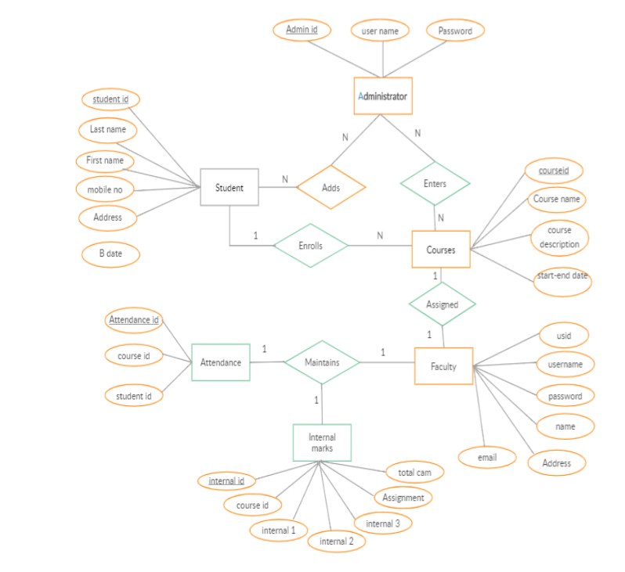

4.5.2 Data Flow Diagram (DFD)

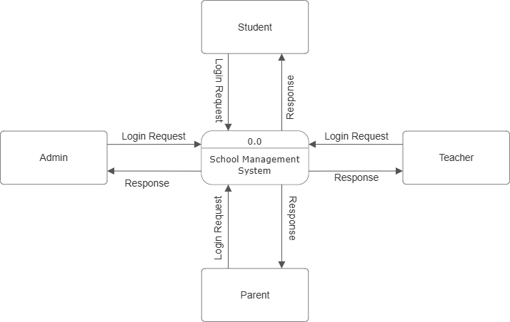

DFD Level 0 School Management System
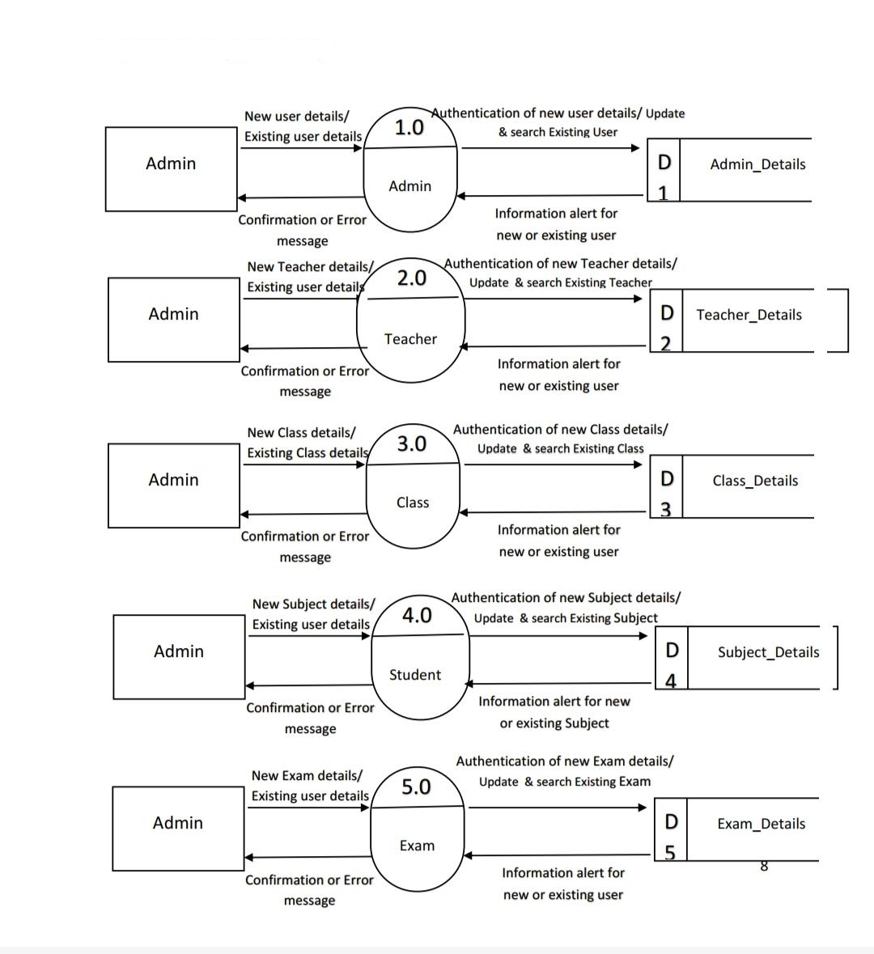
DFD Level 1 School Management System (Admin)
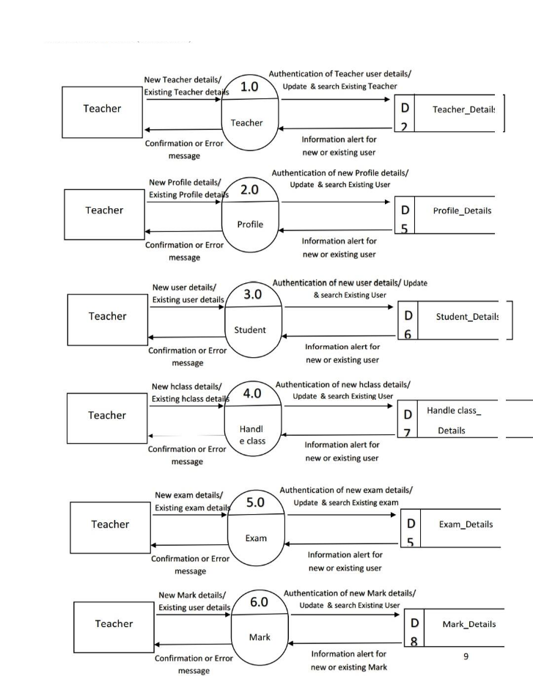
DFD Level 1 School Management System (Teacher)

CHAPTER 5: SYSTEM DESIGN

Entities and Relationships (ER) Diagram : School Management System

Data Flow Diagram (DFD): School Management System

Level 0 :-
DFD Level 0 School Management System
DFD Level 1 School Management System (Admin)
DFD Level 1 School Management System (Teacher)

Activity Diagram: School Management System

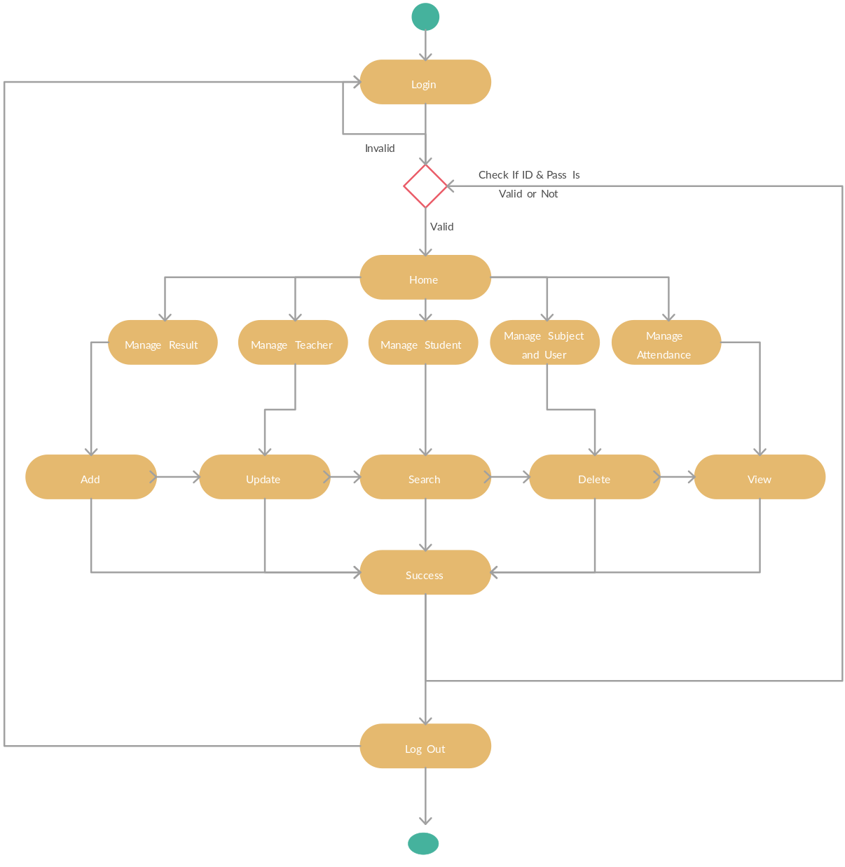

Use Case Diagram: School Management System

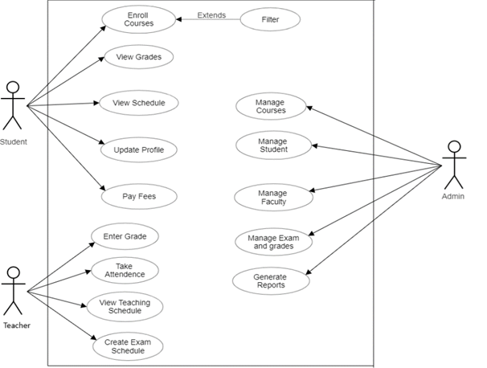

CHAPTER 6: REFERENCES

- www.google.com
- www.adminlte.io
- www.github.com
- www.youtube.com
- www. geeksforgeeks.org

CHAPTER 7: CONCLUSION

A “School Management System” can help schools improve efficiency, communication, and the quality of education. It can also help schools streamline administrative tasks and focus on teaching.

“School Management System” can improve the way that schools manage their finances. This includes the ability to track student fees, generate invoices, and receive payments. This can make it easier for schools to manage their budgets and reduce the risk of errors.

A “School Management System” can help schools modernize education management and adapt to the digital age.

Benefits of a School Management System:-
- Improved communication: Teachers, students, and parents can communicate more easily.
- Enhanced efficiency: Schools can save time and money by reducing manual record-keeping and data processing errors.
- Improved student experience: Schools can provide a seamless educational experience by tracking student progress, attendance, and course completion.
- Improved teacher-parent relationships: Schools can keep parents updated on their children's learning.
- Improved human resources management: Schools can manage payrolls, leaves, and the hiring process.

