Alien Zoo Design - Frontend:

1. Upon clicking on the link tot he study, a user is lead to an introductory page (startScene.js):

|  |  |
| --- | --- |
| Experimental Group | Control Group |
| Ein Bild, das Text enthält.  Automatisch generierte Beschreibung🡪 user is informed to see summary + get feedback what choice would have led to a better result | Ein Bild, das Text enthält.  Automatisch generierte Beschreibung🡪 user is informed to get see summary + choices of other users at that point in time (will be just random data points) |

1. Upon clicking start, users see the welcome page (stableScene.js). IDENTICAL FOR BOTH GROUPS.

**Problems / ToDos:** Layout is squished. Parameters ‚window.innerWidth‘ and ‚window.innerHeight‘ probably assigned before fullscreen was reached?

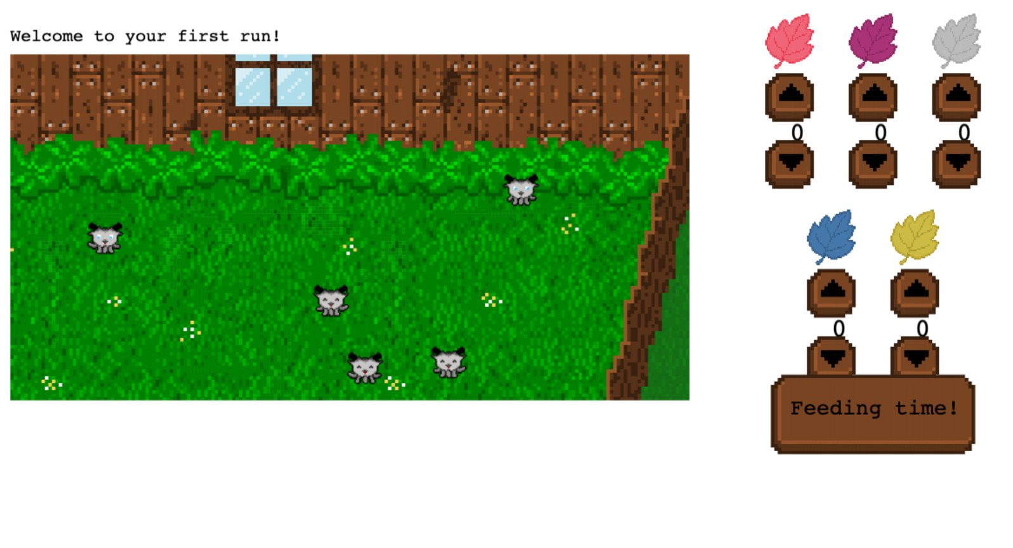

1. User makes selection, hits ‚Feeding time!‘ and gets directed to a Scene informing him that „feeding is in progress“ (progressScene.js). IDENTICAL FOR BOTH GROUPS.  
   Here, in the background, counterfactuals should be computed for the experimental group.

[PREVIEW NOT AVAILABLE]

**Problems / ToDos:** Could not call „await api.computeNewShubNo()“ function here – appearantly not available?

1. After each third trial, user sees the stable again and hast to choose „Get Feedback“ to go on (stableScene.js). IDENTICAL FOR BOTH GROUPS.

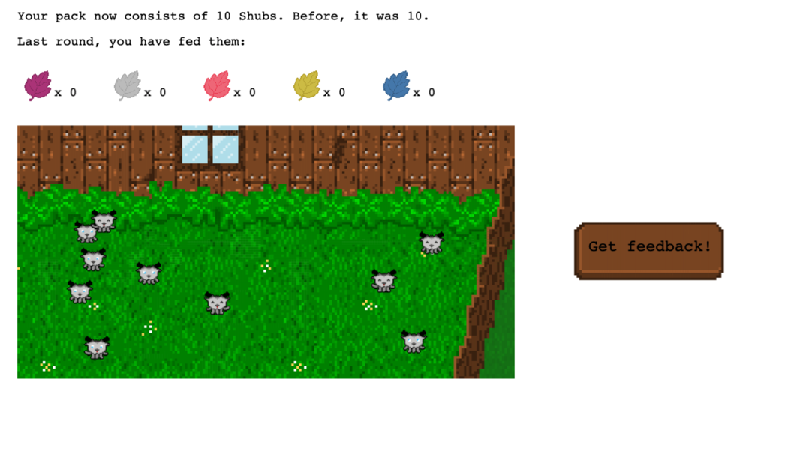

1. feedbackScene.js: User gets feedback. Both groups see past choices. Experimental group sees what choice would have been better (CF!). Control group sees „plant choices other users made“ (= just random data points).

|  |  |
| --- | --- |
| Experimental Group | Control Group |
|  |  |

1. Then back to stableScene.js again – steps 3. And 4. repeat for 3 trials until feedback is shown again (step 5).
2. After 5 x 3 trials, users land on endScene.js. IDENTICAL FOR BOTH GROUPS.

Ein Bild, das Text enthält.
