Criterion B: Design
Table of Contents:
- Complete Diagram ……………………………………………………………………..2
- Flowchart 1: Removing a Patient ……………………………………………..……....3
- Main Menu Diagram ……………………………………………………………...…...4
- PatientInfo Window Diagram ………………………………………………...……....5
- Flowchart 2: Displaying a Patient’s Info ………………………………………...…...6
- (Add/Edit) Patient Window Diagram ………………………………………………...7
- Flowchart 3: Adding a Patient …………………....……………………………….….8
- Flowchart 4: Editing a Patient ………………………………………………………..9
- Select Teeth Windows Diagram ……………………………………………………..10
- Flowchart 5: Selecting Teeth ………………………………………………………...11
- UML Diagram ………………………………………………………………………..12
- Test Plan ………………………………………………………………………………13

Complete Diagram
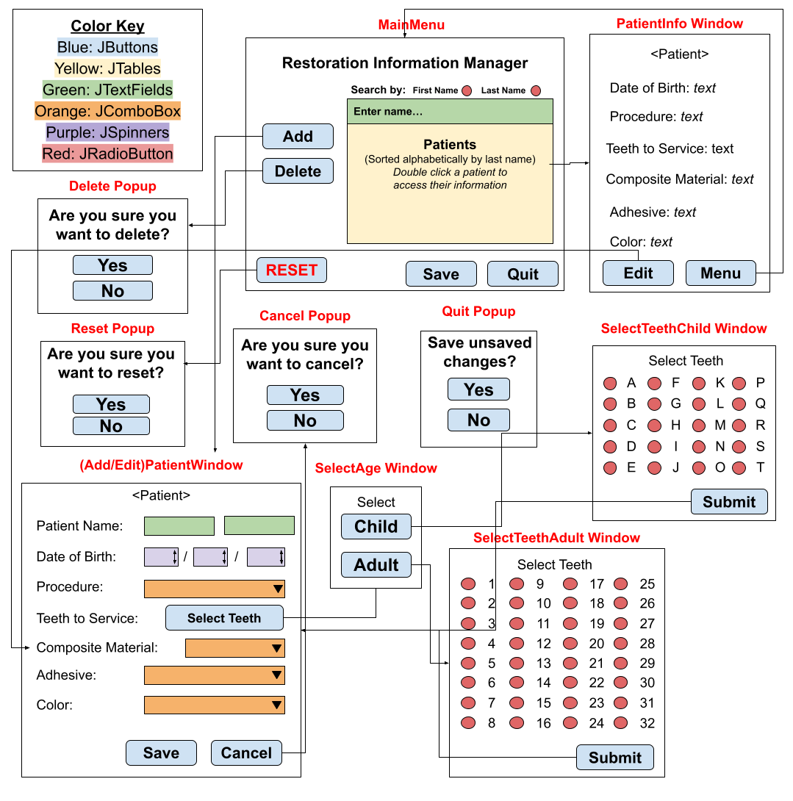

Flowchart 1: Removing a Patient
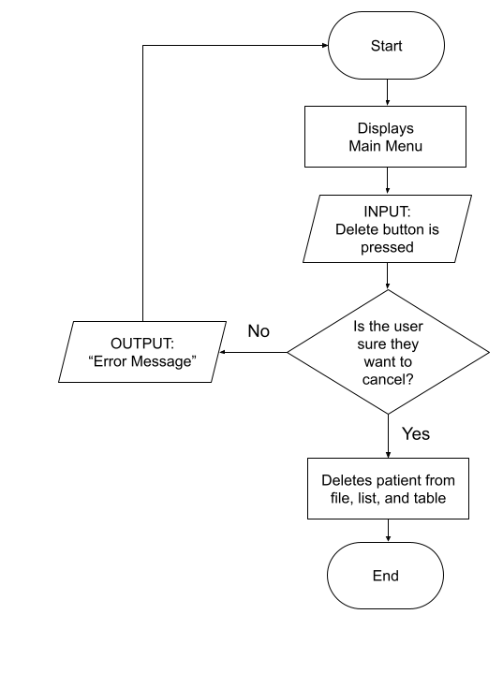

Main Menu Diagram
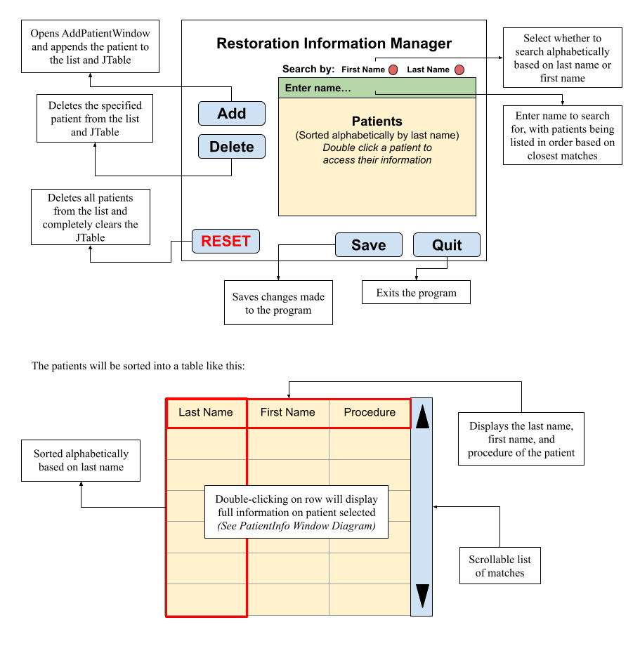

PatientInfo Window Diagram

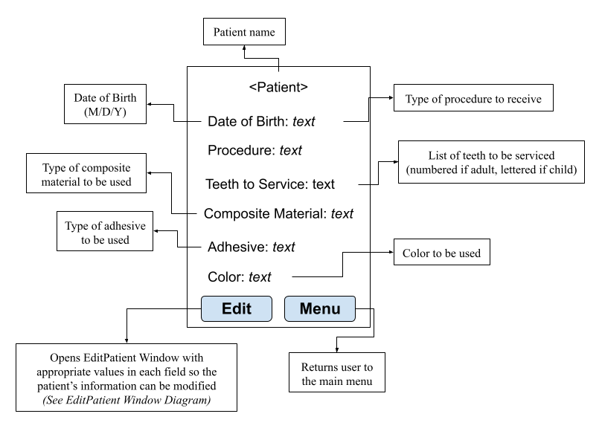

Flowchart 2: Displaying a Patient’s Info
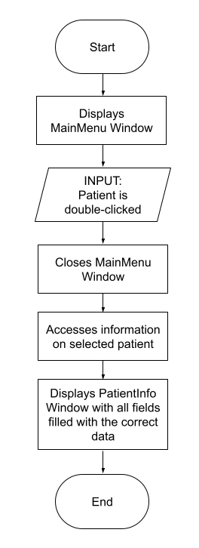

(Add/Edit)Patient Window Diagram

All fields will be blank when adding a patient and filled with existing patient information when editing a patient.
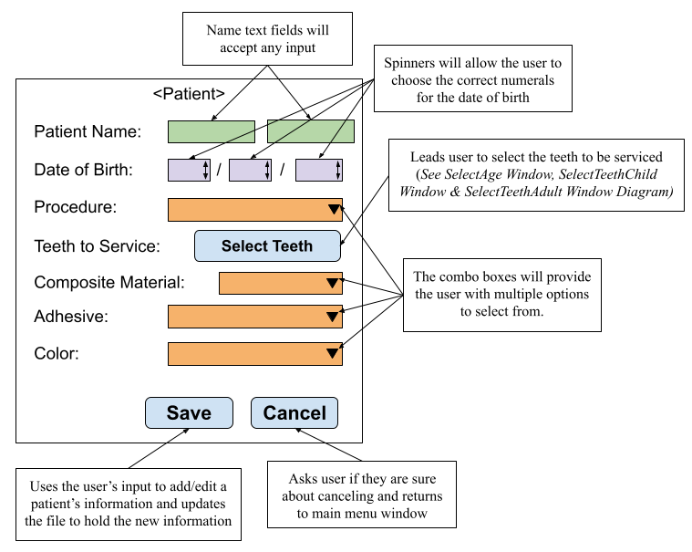

Flowchart 3: Adding a Patient
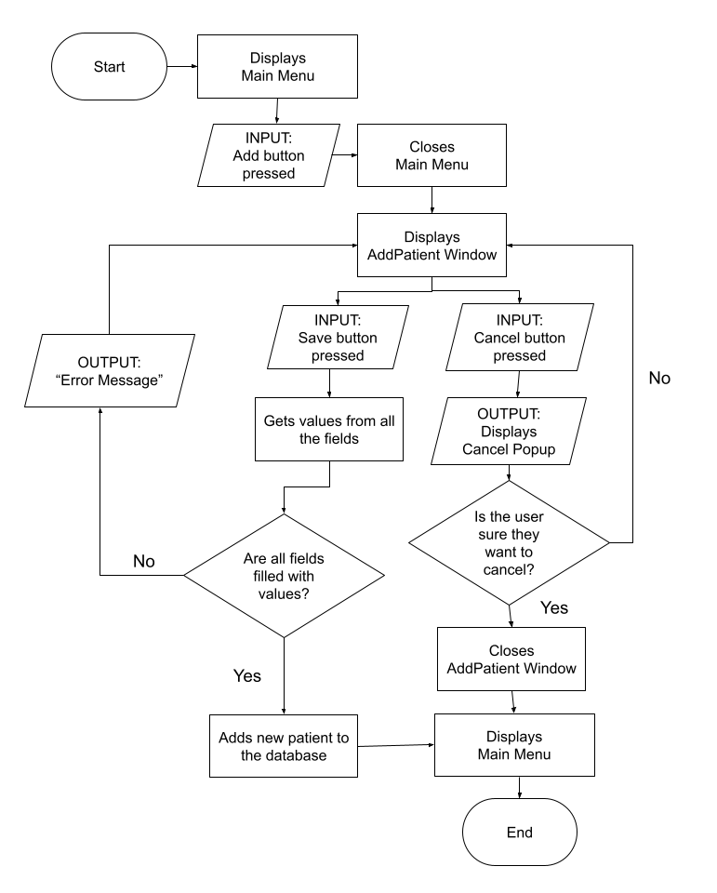
Flowchart 4: Editing a Patient

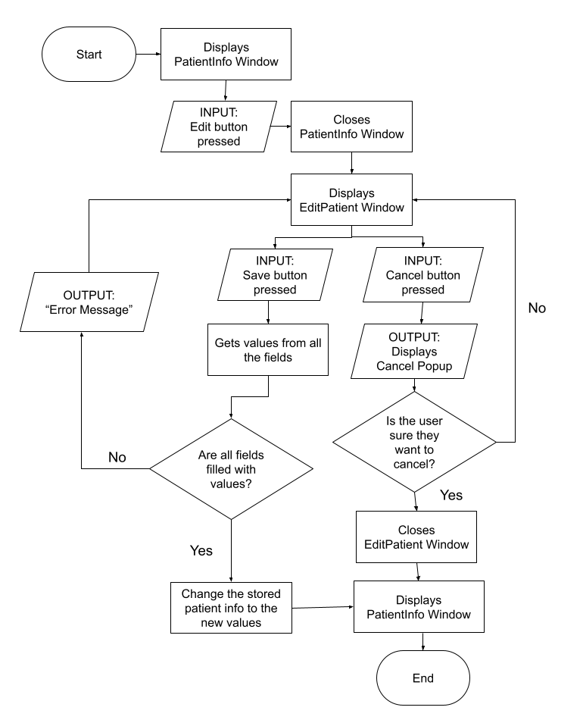

Select Teeth Windows Diagram

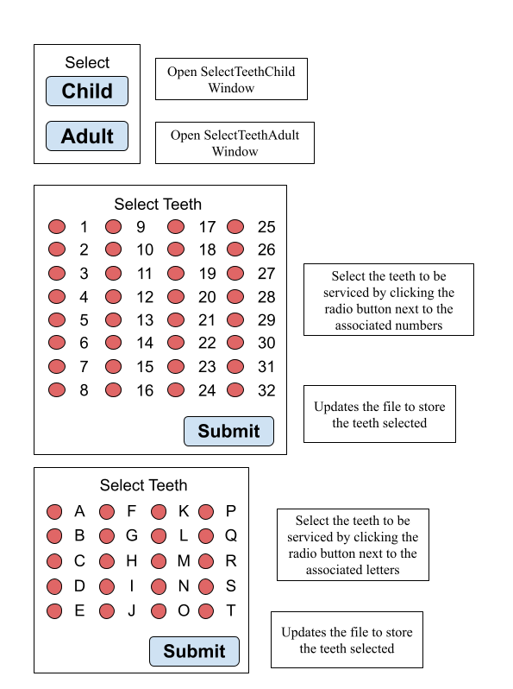
Flowchart 4: Selecting Teeth

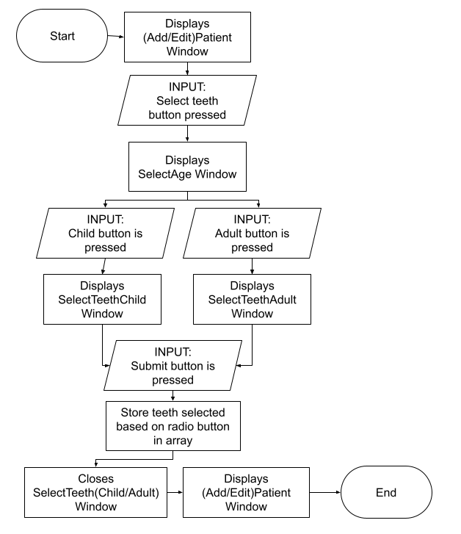

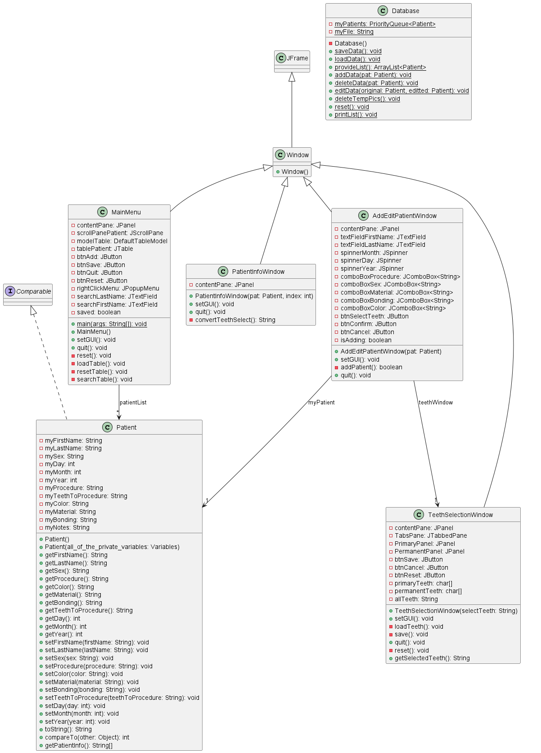
UML Diagram

Test Plan

Test Type | Nature of Test | Example
Upon opening the program, check that the main menu shows up | Check that the main menu both appears with the correct layout | Main menu pops up with the buttons in the correct location
Check that the delete button works | Click a patient from the table and press the delete button to delete them | A patient is selected. The delete button is pressed. The patient is gone from the table
Check that the patient info window works | Double-click a patient and check the patient info window that pops up for correct info | Patient “John Smith” is double-clicked and “John Smith’s” correct information is displayed
Check that the add function works | Press the add button, fill out the add patient window, press the save button, and double-click the newly added patient on the table to view their patient info window | Patient “Joe Snow” is added with restoration type “filling”. Their patient info window shows that their name is “Joe Snow” and their restoration type is “filling”
Check that the reset button works | Press the reset button, check the table, close and reopen the program, and then check the table again | The table is empty after pressing the reset button still empty after reopening the program
Check that the save button works | Press the save button, close and reopen the program, and then check the table. Also check the file containing the program’s database | The table has the same patients with the same info before and after closing and reopening the program. The database file matches the table
Check that the edit function works | Press the edit button on a patient’s info window, edit their info on the edit patient window, save the changes, and then review their patient info window | Patient “Jill Jane’s” date of birth is changed from “01/01/2001” to “01/01/1983”. Their patient info window reflects this change
Check that the teeth selection function works | Add/edit a patient and use the teeth selection function to select certain teeth. Check their “teeth to be serviced” portion of the patient’s info window | Adult patient “Billy Bob” is added with teeth “#1, 2, and 3,” selected. Their patient info window shows that the teeth to be serviced are “#1, 2, and 3”
Check that the name search function works | Press one of the radio button options (first or last name) and search for a patient. Check how the table is sorted | Patients “Rob”, “Robert”, and “Bob” are added. Searching by first name with the name “Rob” the table is sorted in the order of “Rob”, “Robert” and then “Bob

