QUoRDs - Content Access Quality Assurance

Software Overview

One of the main goals of QA application in QUoRDs project is a comparison step where we compare a screenshot of original site with a screenshot stored in Wayback machine using SIFT features extraction methods, PSNR metrics and OCR analysis. The second goal is to detect blank pages in a digital collection. Additionally file size could be taken into account in order to detect empty pages.

- Use Case: Quantify access content quality
  - Capture snapshots of selected pages, e.g. slash-pages, during the crawl.
  - Render the archive via Wayback and the live site, using PhantomJS to make images.
  - Compare them (apply image analysis methods: SIFT, PSNR) and flag very different ones.
- Use Case: Render of archive version and alert if there are a lot of blank pages
  - Apply feature extraction algorithm
  - Perform OCR analysis
  - JPG size could be used as a proxy for ‘blankness’ or complexity of the image
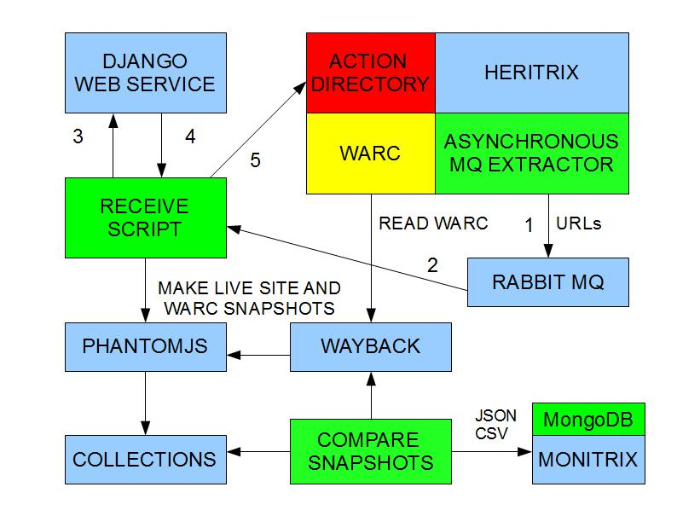
Figure 1. This picture demonstrates main dependencies in Quality Assurance Workflow.

In Figure 1 with numbers 1 to 5 are presented already existing in BL steps for the crawl process. Additionally by changing receive script original images are stored as image files for associated URL. When crawl is completed WARC file is accessible via Wayback tool by URL. The script bl_compare_screenshots.py compares original and Wayback image by passing image path and image URL respectively. We compare both screenshots using SIFT features extraction method (see Figure 2) and OCR analysis. The image comparison employing PSNR metric can be used additionaly or instead of SIFT method. Additionally file size is taken into account in order to detect empty pages. Comparison result is stored in Mongo DB for using in Monitrix tool and in output.txt file in CSV format. Optionally the image analysis for blank page is supported. The bl_compare_screenshots.py file compiles screenshots harvested in real-time during the crawl process with associated screenshot from Wayback tool.

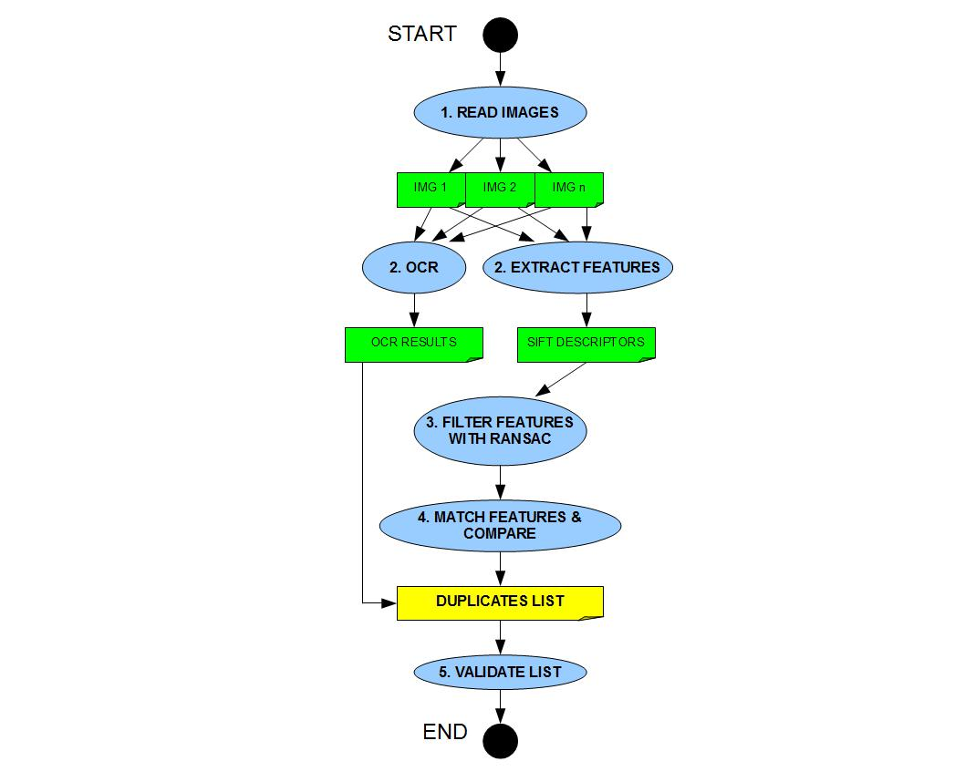
Figure 2. Duplicate detection workflow.
Essential parameters for content access quality assurance are:
1. Path to the first harvested screenshot
2. Path to the second harvested screenshot - in our case a Wayback file
3. Output file name
4. Threshold for high similarity (between 0 and 100) for SIFT comparison
5. Threshold for small differences (between 0 and previous threshold) for SIFT comparison
6. Optional step for subset of the file list could be defined
7. Optional threshold for image comparison with PSNR metric

In order to address the correct screenshot from the Wayback machine we should note the timestamp of the associated WARC file and use it for URL creation.

Format for storing in Mongo database of analysis result
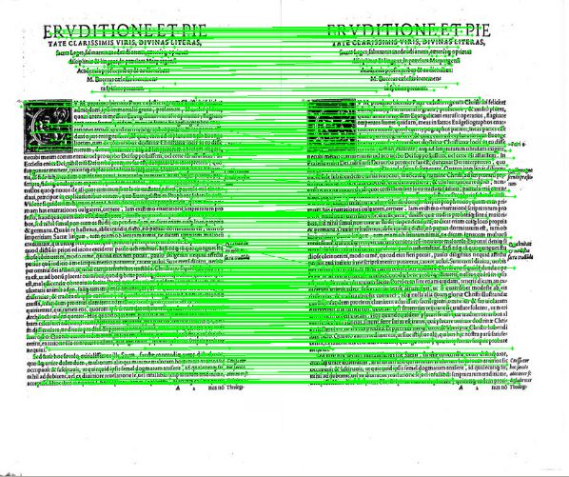
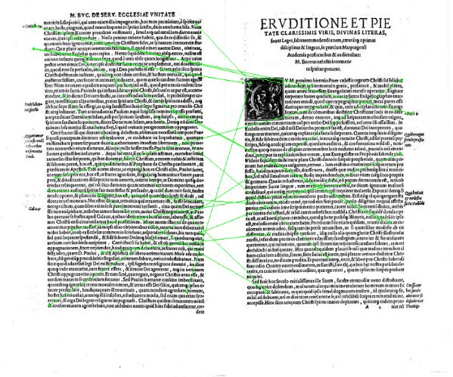

Figure 3. Evaluation results samples from book identifier 151694702 for duplicate detection with SIFT feature matching approach: (a) similar pages with 419 matches, (b) different pages with 19 matches.
Feature- and OCR-based screenshot comparison for quality assurance in digital libraries has JSON format for Mongo DB injection and CSV format for log file. The meaning of the particular fields is current timestamp, wayback timestamp, original link, wayback machine link, number of SIFT features for the original file, number of SIFT features for the wayback file, number of matches (see Figure 3), conclusion message, threshold 1, threshold 2, OCR measurement, original screenshot size, wayback file size, PSNR similarity value, PSNR threshold, PSNR message and image name of the original site. Whereas --threshold1 is the threshold for high similarity (between 0 and 100) and --threshold2 is the threshold for small differences (between 0 and threshold 1 value). The optional parameter --step is the subset size of the original collection can be used in order to reduce calculation time by analyzing only part of collection.

The collection name in Mongo DB is currently “test-collection”.

log = {"current_time": current_time,
"execution_time": execution_time,
"orig_web_url": orig_link,
"wayback_image": wayback_link,
"wayback_timestamp": wayback_timestamp,
"fc1": fc1,
"fc2": fc2,
"mc": mc,
"msg": msg,
"ts1": ts1,
"ts2": ts2,
"ocr": ocr,
"img1_size": img1_size,
"img2_size": img2_size,
"psnr_similarity": psnr_similarity,
"psnr_threshold": psnr_threshold,
"psnr_msg": psnr_msg,
"orig_image": orig_link_path}

Starting and Using of Web Service Application
- cd /opt/test_django/quords
- ./StartMongo.sh
- ./StartDjango.sh
- optionally ./CleanMongo.sh
- optionally ./CleanDjangoDb.sh

The method “compare_images_by_path_and_link_ext” from quords_utils.py script compares original image passed by path with wayback screenshots passed by URL. Optionally comparison can be extended by OCR and PSNR analysis. The OCR or PSNR analysis will be active if ocr_flag or respectively psnr_flag is true. The PSNR threshold psnr_th is a float value. 1 means that images are different and “inf” means that images are fully the same. The higher is a PSNR value the higher is the image similarity. Note that comparison analysis results are written to output.txt (added on the end of the file) and to MongoDB. Original site images calculated during the analysis are stored in /opt/test_django/quords/qa/orig folder.

Samples for web service queries:

Compare two images applying OCR and PSNR analysis:
http://127.0.0.1:8000/qa/compare?i1=http://www.acses.org.uk/&i2=http://www.webarchive.org.uk/thumbs/66158797/66128255c.jpg&ocr=true&psnr=true

{siftMatchedPoints: 262, totalSiftPoints: 1715, ocrMatch: 1515, psnrSimilarity: 2.76701}

Compare two images applying OCR analysis and skip PSNR analysis (see flags on the end of the query):
http://127.0.0.1:8000/qa/compare?i1=http://www.acses.org.uk/&i2=http://www.webarchive.org.uk/thumbs/66158797/66128255c.jpg&ocr=true&psnr=false

{siftMatchedPoints: 261, totalSiftPoints: 1709, ocrMatch: 1515, psnrSimilarity: None}

Compare two images applying PSNR analysis and skip OCR analysis (see flags on the end of the query):
http://127.0.0.1:8000/qa/compare?i1=http://www.acses.org.uk/&i2=http://www.webarchive.org.uk/thumbs/66158797/66128255c.jpg&ocr=false&psnr=true

{siftMatchedPoints: 258, totalSiftPoints: 1712, ocrMatch: 0, psnrSimilarity: 2.76581}

Compare the whole collection of screenshot pairs (original, wayback) extracting them from a seed file and employ the PSNR metric analysis:
http://127.0.0.1:8000/qa/comparecollection?seed=/opt/test_django/quords/qa/thumbs.urls.seed.txt&psnr=true

for the first 20 entries in seed list given by BL (without ocr):
{siftMatchedPoints: 252, totalSiftPoints: 1681, ocrMatch: 0, psnrSimilarity: 2.6929}
{siftMatchedPoints: 0, totalSiftPoints: 0, ocrMatch: 0, psnrSimilarity: 6.2071}
{siftMatchedPoints: 0, totalSiftPoints: 0, ocrMatch: 0, psnrSimilarity: 6.2071}
{siftMatchedPoints: 0, totalSiftPoints: 0, ocrMatch: 0, psnrSimilarity: 6.2071}
{siftMatchedPoints: 109, totalSiftPoints: 4854, ocrMatch: 0, psnrSimilarity: 4.59937}
{siftMatchedPoints: 98, totalSiftPoints: 4855, ocrMatch: 0, psnrSimilarity: 4.59547}
{siftMatchedPoints: 86, totalSiftPoints: 4854, ocrMatch: 0, psnrSimilarity: 4.59725}
{siftMatchedPoints: 85, totalSiftPoints: 4895, ocrMatch: 0, psnrSimilarity: 4.61495}
{siftMatchedPoints: 71, totalSiftPoints: 4855, ocrMatch: 0, psnrSimilarity: 4.60281}
{siftMatchedPoints: 70, totalSiftPoints: 4856, ocrMatch: 0, psnrSimilarity: 4.60109}
{siftMatchedPoints: 101, totalSiftPoints: 4855, ocrMatch: 0, psnrSimilarity: 4.6058}
{siftMatchedPoints: 268, totalSiftPoints: 1552, ocrMatch: 0, psnrSimilarity: 6.30102}
{siftMatchedPoints: 77, totalSiftPoints: 1552, ocrMatch: 0, psnrSimilarity: 6.00044}
{siftMatchedPoints: 103, totalSiftPoints: 1552, ocrMatch: 0, psnrSimilarity: 5.98311}

CSV entry samples are stored in /opt/test_django/quords/output.txt e.g.:
2013-03-21 15:01:44.855518;1.09455895424;http://www.acses.org.uk/;http://www.webarchive.org. uk/thumbs/66158797/66128255c.jpg;66158797;1681;52;252;VERY DIFFERENT;60;30;0;438699; 21483;2.6929;3.0;DIFFERENT;http://127.0.0.1:8000/qa/orig/1363878100.14.png;

Created original files are stored in /opt/test_django/quords/qa/orig/ and accessible by e.g. http://127.0.0.1:8000/qa/orig/1363878181.78.png

Installation Details
The source code for comparison and blank page detection web services is stored in Github repository https://github.com/ukwa/monitrix-imaqa and prepared for Django Web Server. The root directory contains some sample files, helping scripts for management of MongoDb, Django, local Wayback, Tomcate software, folders “qa” and “quords”. The application name is "qa" and associated source code is in "qa" folder. The folder "quords" comprises files necessary for web service. Installation guidelines and tips can be found in the file "guidelines". The main functionality is implemented in quords_utils.py. urls.py, views.py and models.py are serving for web service connection. The script blank.py implements blank page detection using Tesseract tool. The script compare_screenshots.py implements SIFT comparison. The test_psnr.py makes it possible to test image comparison using PSNR metric employing Imagemagick tool. bl_compare_screenshots.py is a test script written in order to meet different input requirements specific for BL internal processes e.g. the first input parameter is URL and second input parameter is a path to the file. Receive and send scripts were used during the testing phase for handling of RabbitMQ and PhantomJS tools. Thums.urls.seed.txt comprises link pairs (wayback and original site) for testing purpose, whereas the full list is in the root directory. Original images created during the analysis are stored in folder “orig”. Resulting CSV file output.txt is located in the root directory. A data/db directory should be created in order to store analysis results in MongoDB. The folder “blankdir” comprises some samples of blank pages for testing purpose. In order to use VirtualBox with a shared folder it is necessary to install VirtualBox Guest Additions.

Dependencies of the software for image comparison and quality assurance

- Python 2.7 or 2.6 with associated packages e.g. “numpy” for image processing and “pymongo” for MongoDB driver.
- OpenCV in the last version (currently 2.4.3). cv2 package should be moved to “dist” folder in order to be accessible.
- Phantomjs currently version 1.8.1.
- Django simple-rest module if you are going to use image comparison as a web service.
- MongoDB
- Tesseract tool for OCR if you are using analysis for blank page.
- Wayback tool if you are running it locally.
- For using the comparison scripts as an application of Django Web Service we apply simple_rest package: https://github.com/freshplum/django-simple-rest

