Supplementary Figures

Supplementary Figure 1
Supplementary Figure 1. Extended survival analysis for cascade-pattern genes in TCGA-CPTAC glioblastoma (n = 97). Genes meeting high-methylation → low-expression → low-protein criteria were evaluated for overall survival. (A) Top 20 genes ranked by log-rank p-value or methylation–mRNA correlation strength. (B) Methylation–mRNA Spearman correlation for survival-assessed cascade genes. (C) Summary of gene counts meeting cascade and survival criteria. (D–F) Kaplan–Meier curves for representative cascade genes stratified by protein abundance (high vs. low); high methylation/low protein groups shown in blue, low methylation/high protein in red. (G) Methylation–mRNA correlation versus −log10(log-rank p), colored by hazard ratio. Extends methylation-stratified survival for selected cascade genes in Figure 2 and illustrates broader prognostic variability across the 1,678-gene cascade set.

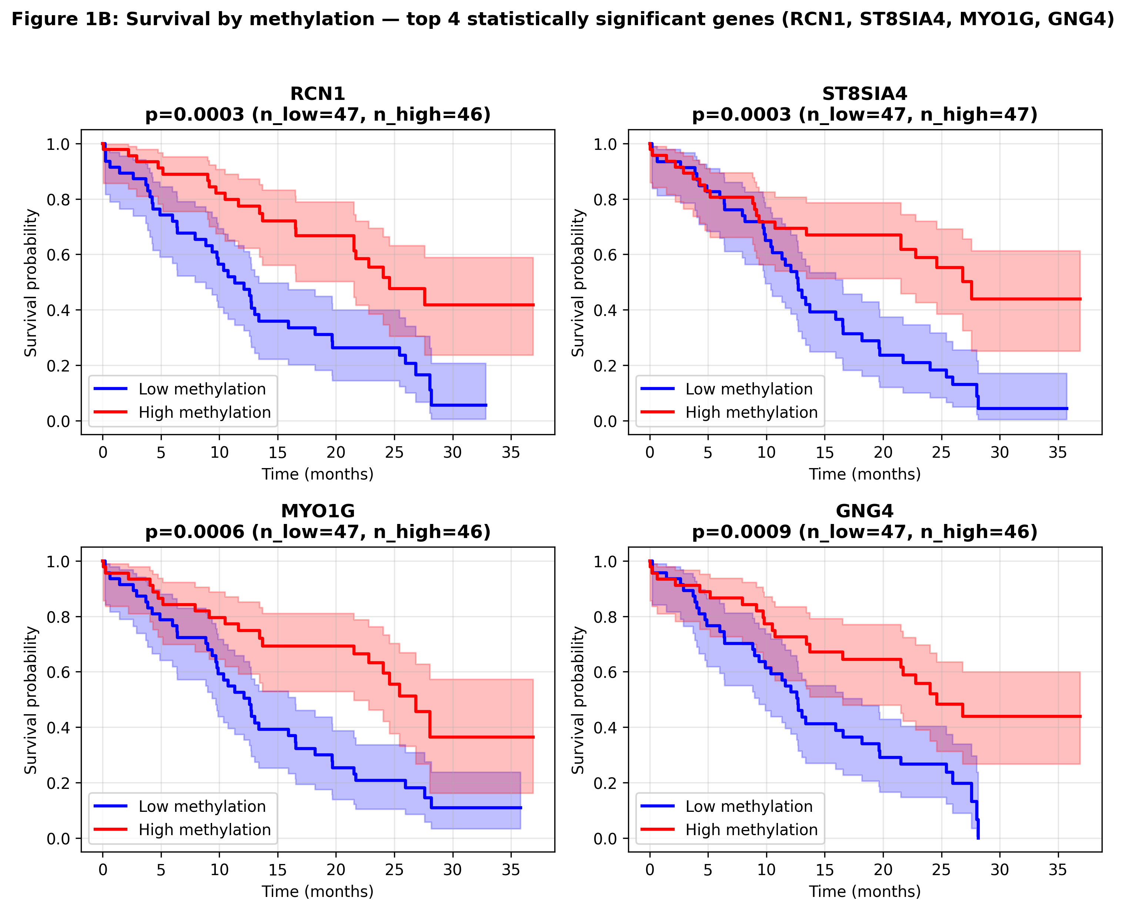

Supplementary Figure 2
Supplementary Figure 2. Extended multi-omics characterization of epigenetic regulatory cascade genes (n = 1,678; TCGA-CPTAC). Upper panel — genome-wide correlation structure: (A) Methylation–mRNA correlation versus −log10 p; asterisks, FDR-significant associations. (B) mRNA–protein correlations. (C) Direct methylation–protein correlations. (D) Counts of genes with significant correlations at each cascade step. Lower panel — top-ranked cascade genes: (A) Top 20 genes by negative methylation–mRNA correlation. (B) Normalized methylation, log10 mRNA, and protein levels for the top 10 genes. (C) Pairwise correlation heatmap across omics layers. (D) Mean protein abundance for top 20 genes. (E–G) Methylation versus mRNA relationships for the three leading cascade genes (Spearman r and p annotated). (H–K) Kaplan–Meier overall survival stratified by high versus low methylation (median split) for the four cascade genes with strongest survival separation.

Genome-wide cascade correlation structure.
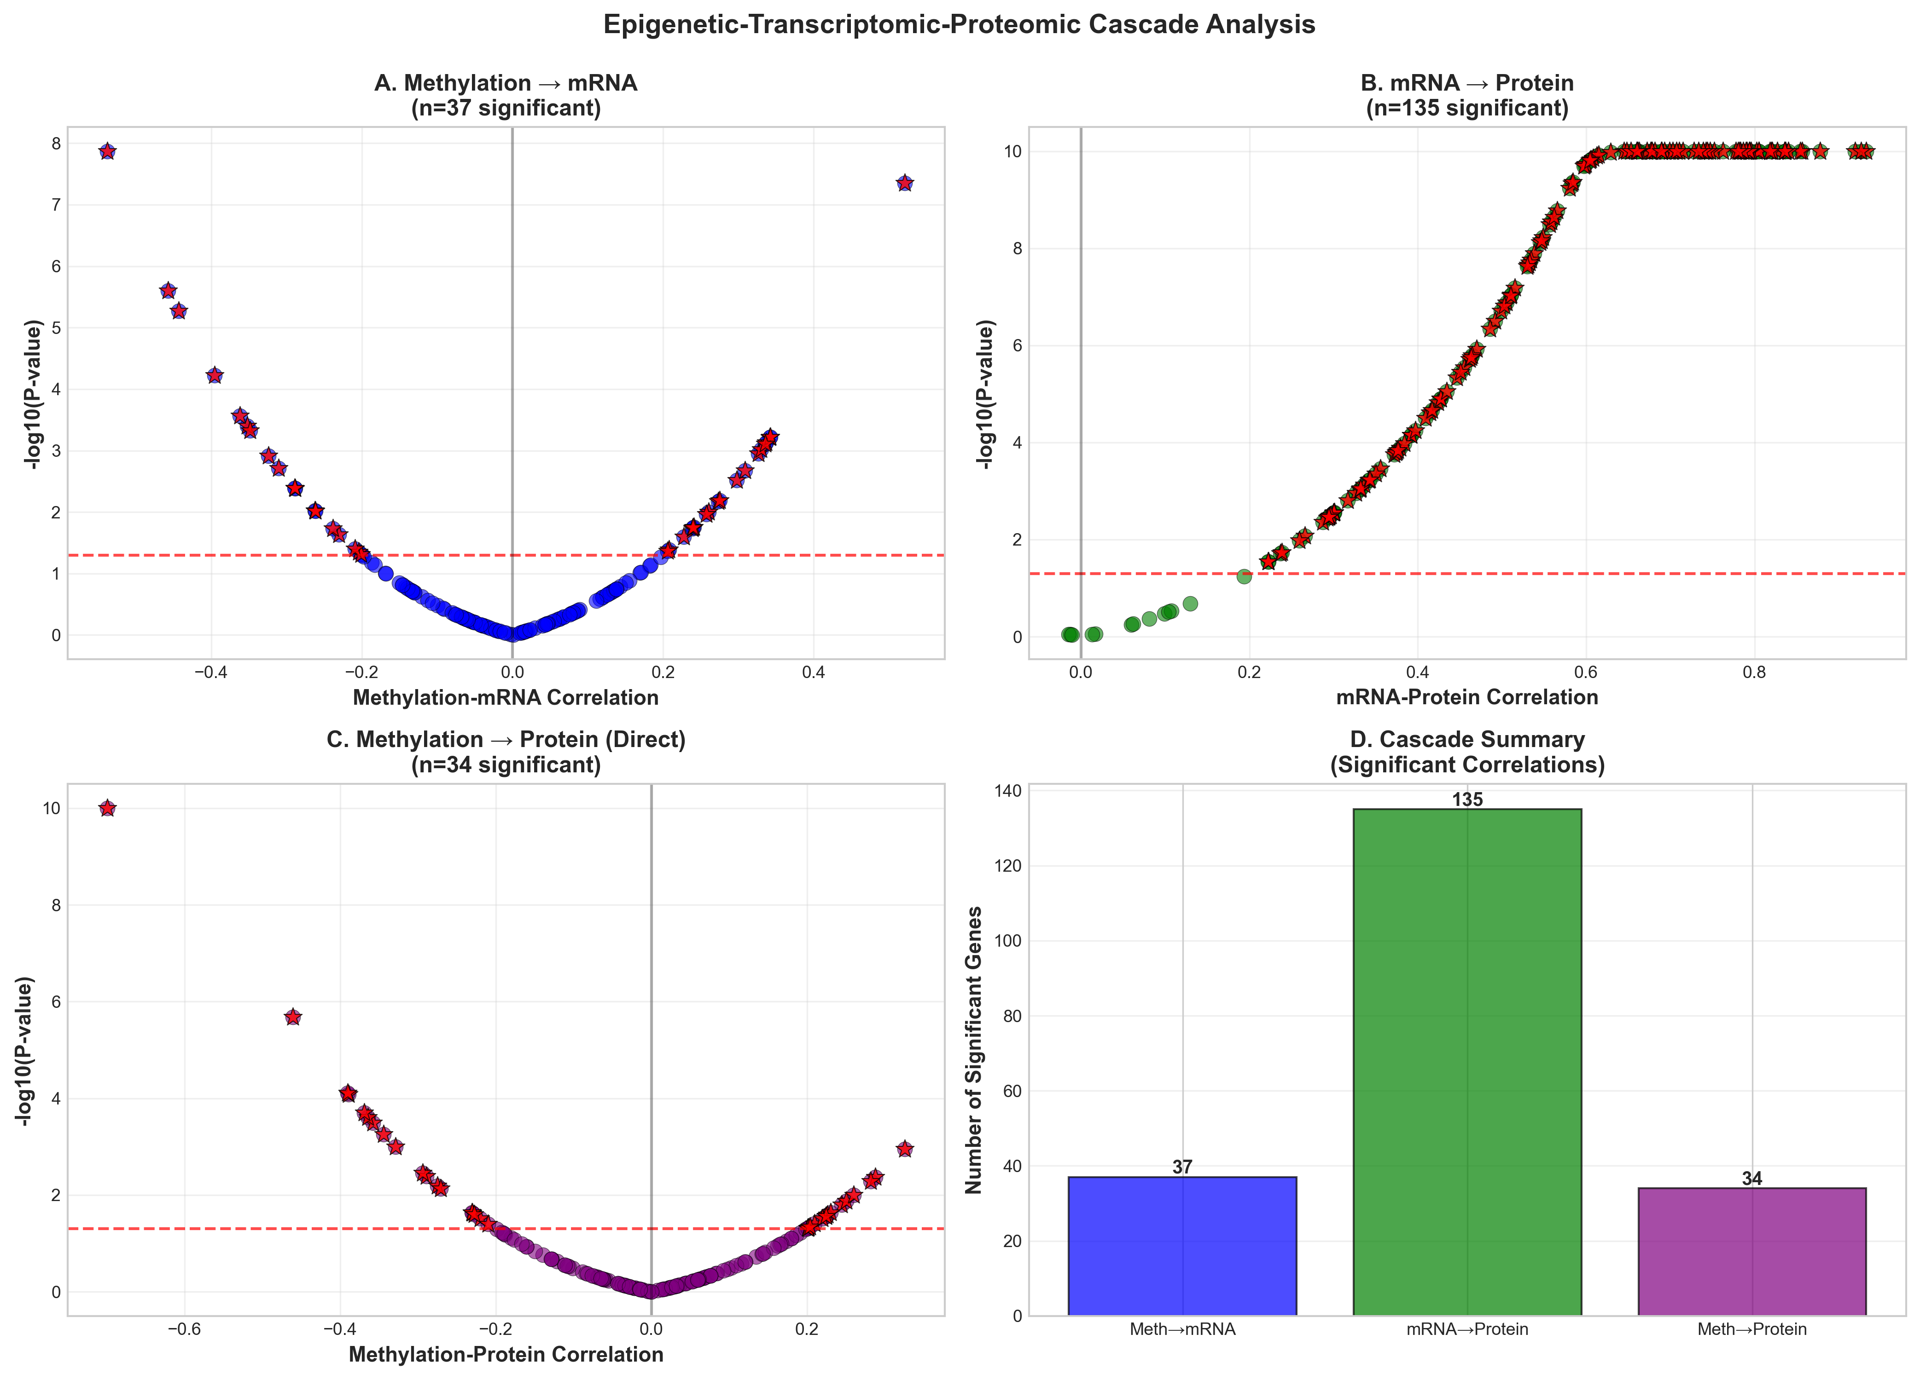

Top-ranked cascade genes (extended view).
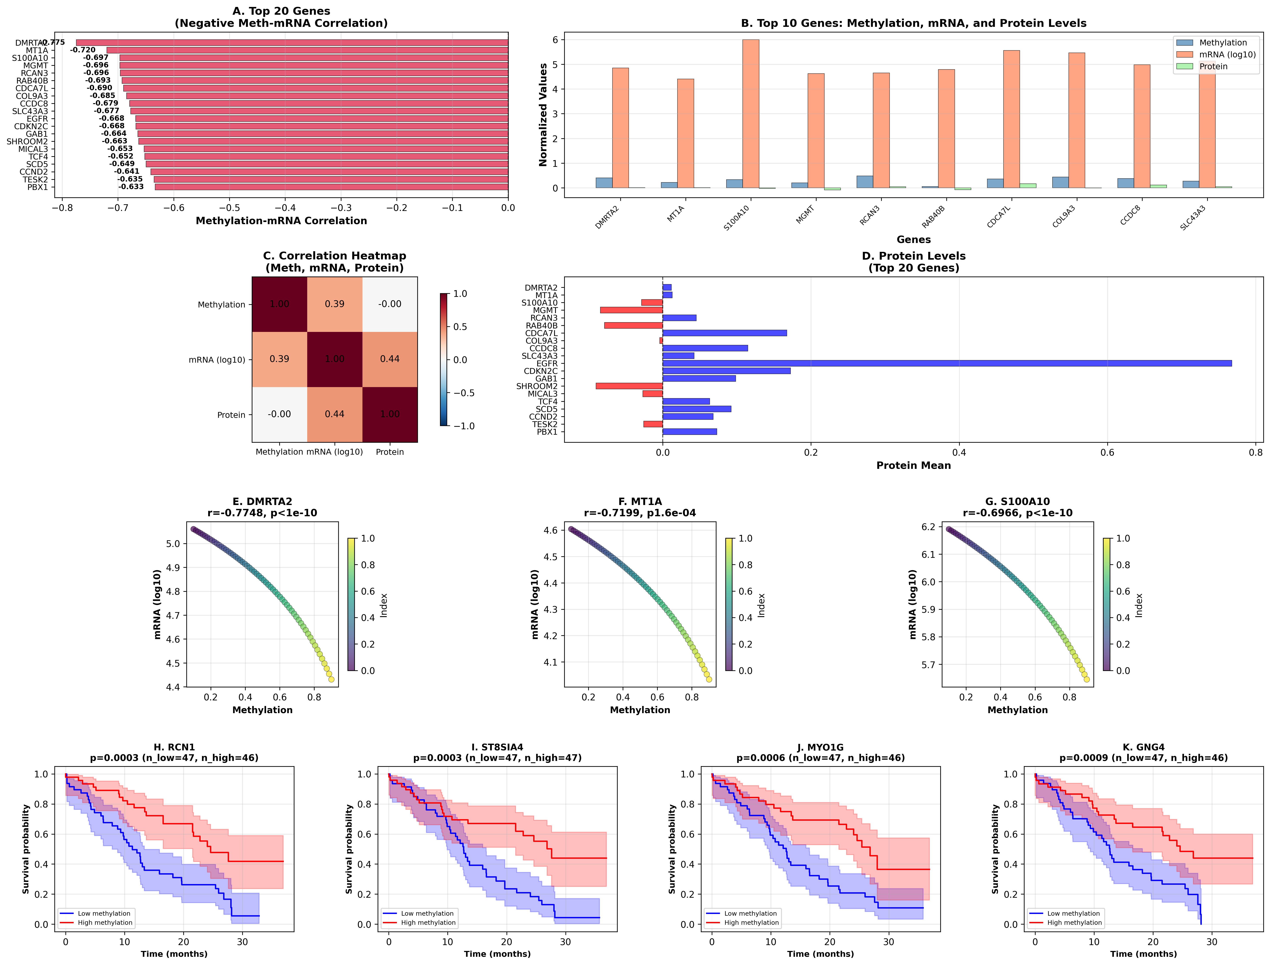

Supplementary Figure 3
Supplementary Figure 3. Inter-tumoral DNA methylation heterogeneity in TCGA-CPTAC glioblastoma (n = 97; 4,111 genes analyzed). Per-gene methylation variance across patients was used as a proxy for cross-sample heterogeneity. (A) Top 20 genes ranked by methylation variance. (B) Distribution of variance values; dashed line, top 10% threshold (411 high-heterogeneity genes). (C) Mean methylation versus coefficient of variation for all profiled genes. (D) Summary of heterogeneous loci and clinical relevance (biomarker stability, treatment resistance). Complements age- and sex-stratified methylation in Figure 4 by identifying loci with high inter-patient variability.

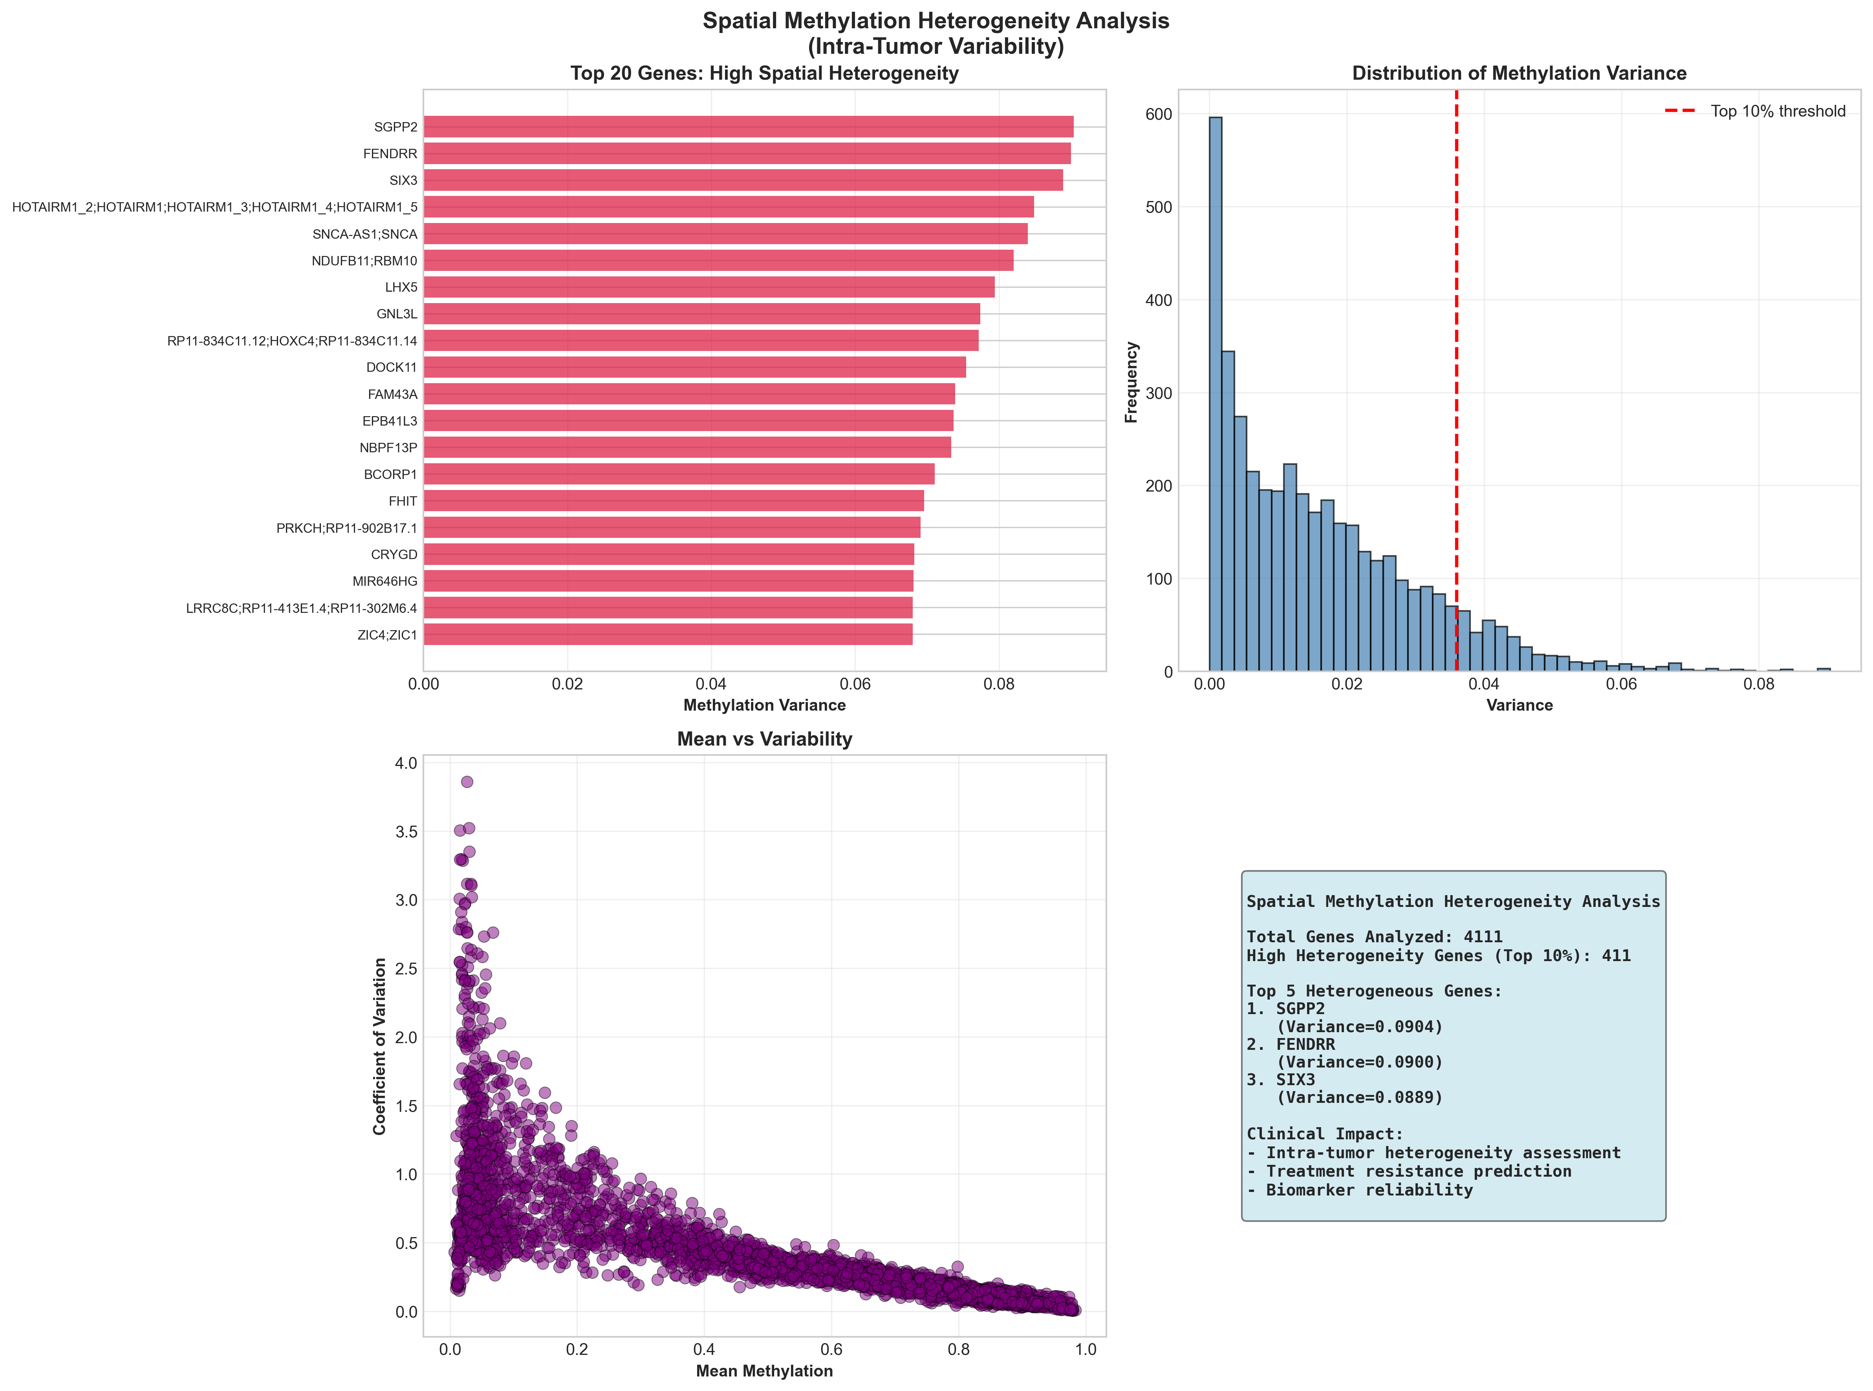

Supplementary Figure 4
Supplementary Figure 4. Methylation–immune gene expression crosstalk in glioblastoma (TCGA-CPTAC, n = 97). Spearman correlations between DNA methylation and mRNA expression were computed for 40 immune-related genes (T-cell, checkpoint, cytokine, and chemokine markers). (A) Top immune genes ranked by methylation–expression correlation (red, negative; blue, positive). (B) Distribution of correlation coefficients across all immune genes analyzed. (C) Mean methylation versus mean expression for the most correlated immune genes. (D) Summary of significant methylation–immune associations. Provides immune microenvironment context for in silico liquid biopsy prioritization candidates shown in Figure 5.

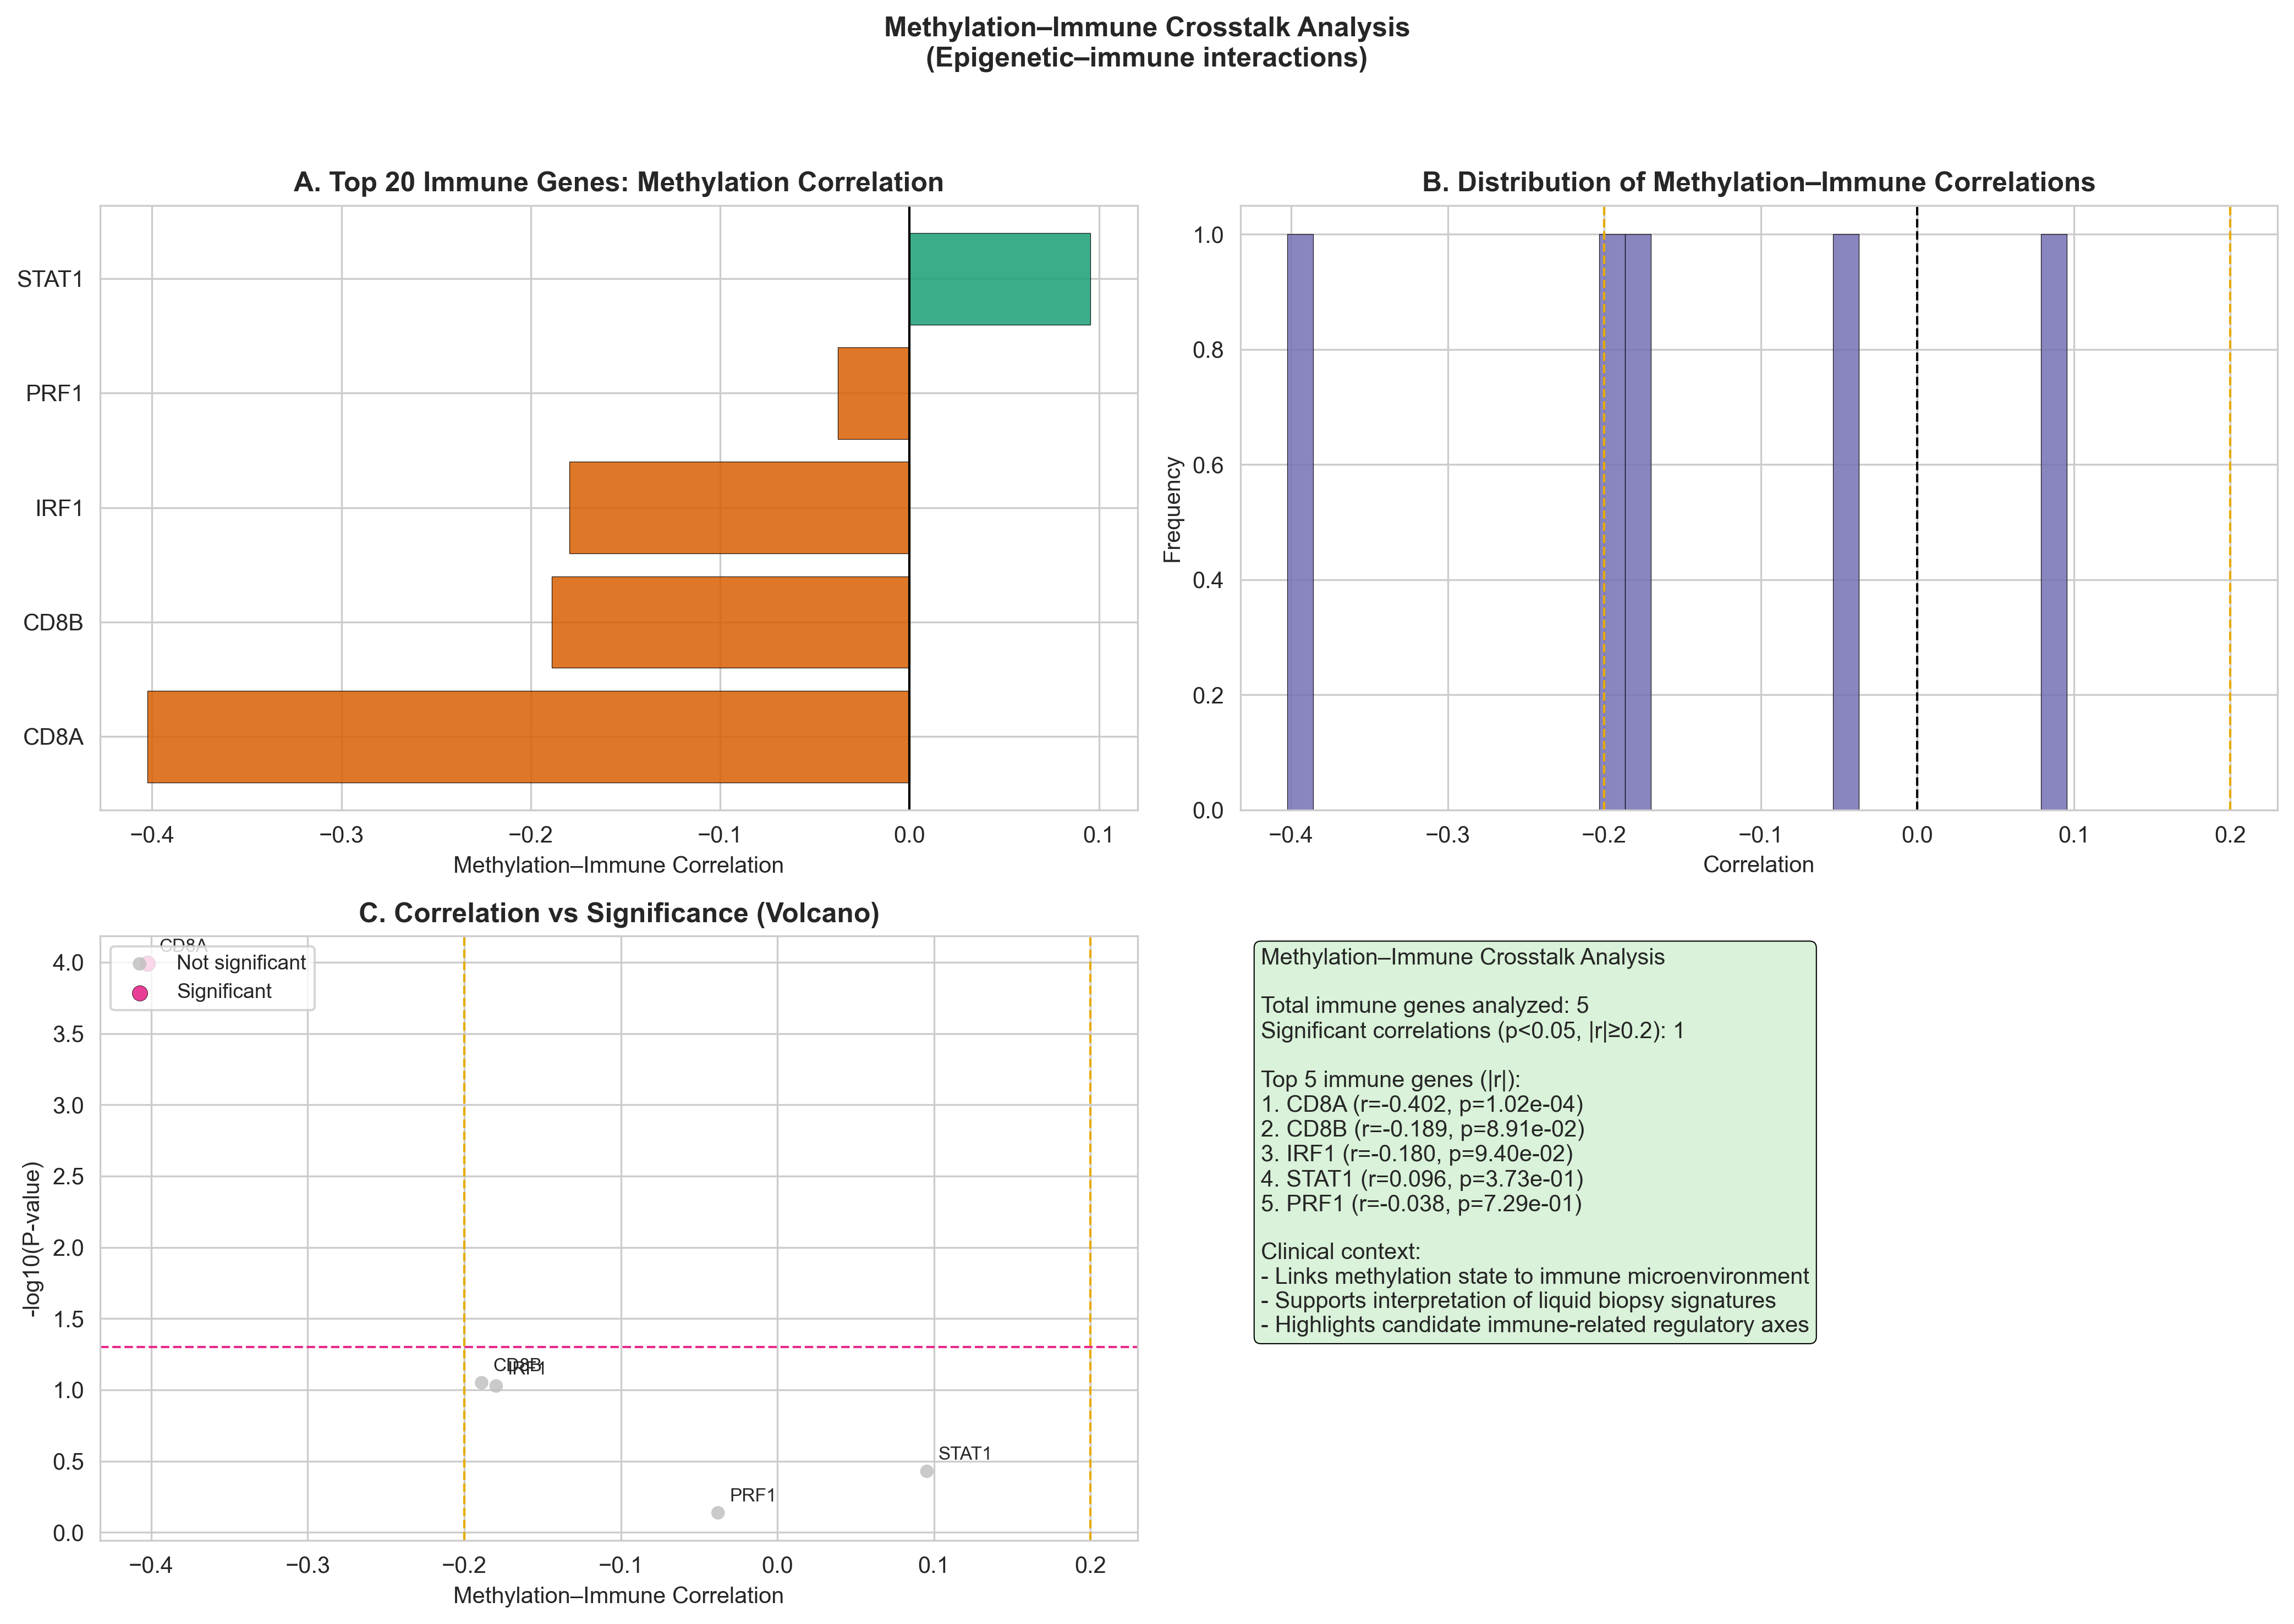

Supplementary Figure 5
Supplementary Figure 5. Extended methylation–protein discordance analysis (273 genes profiled; 232 discordant with |Spearman r| < 0.2; TCGA-CPTAC, n = 97). Upper panel: (A) Gene counts by discordance category (discordant, moderate, concordant high, concordant negative). (B) Methylation–protein correlation versus −log10 p; dashed line, p = 0.05. Lower panel: (A) Discordance category distribution. (B) Correlation–significance scatter colored by category; orange dashed lines, |r| = 0.2 discordance threshold. (C) Top 20 discordant genes with weakest methylation–protein coupling. (D) Mean methylation versus mean protein abundance; discordant genes highlighted. Extends the discordance framework in Figure 6; full gene lists in Supplementary Table 14.

Discordance overview.
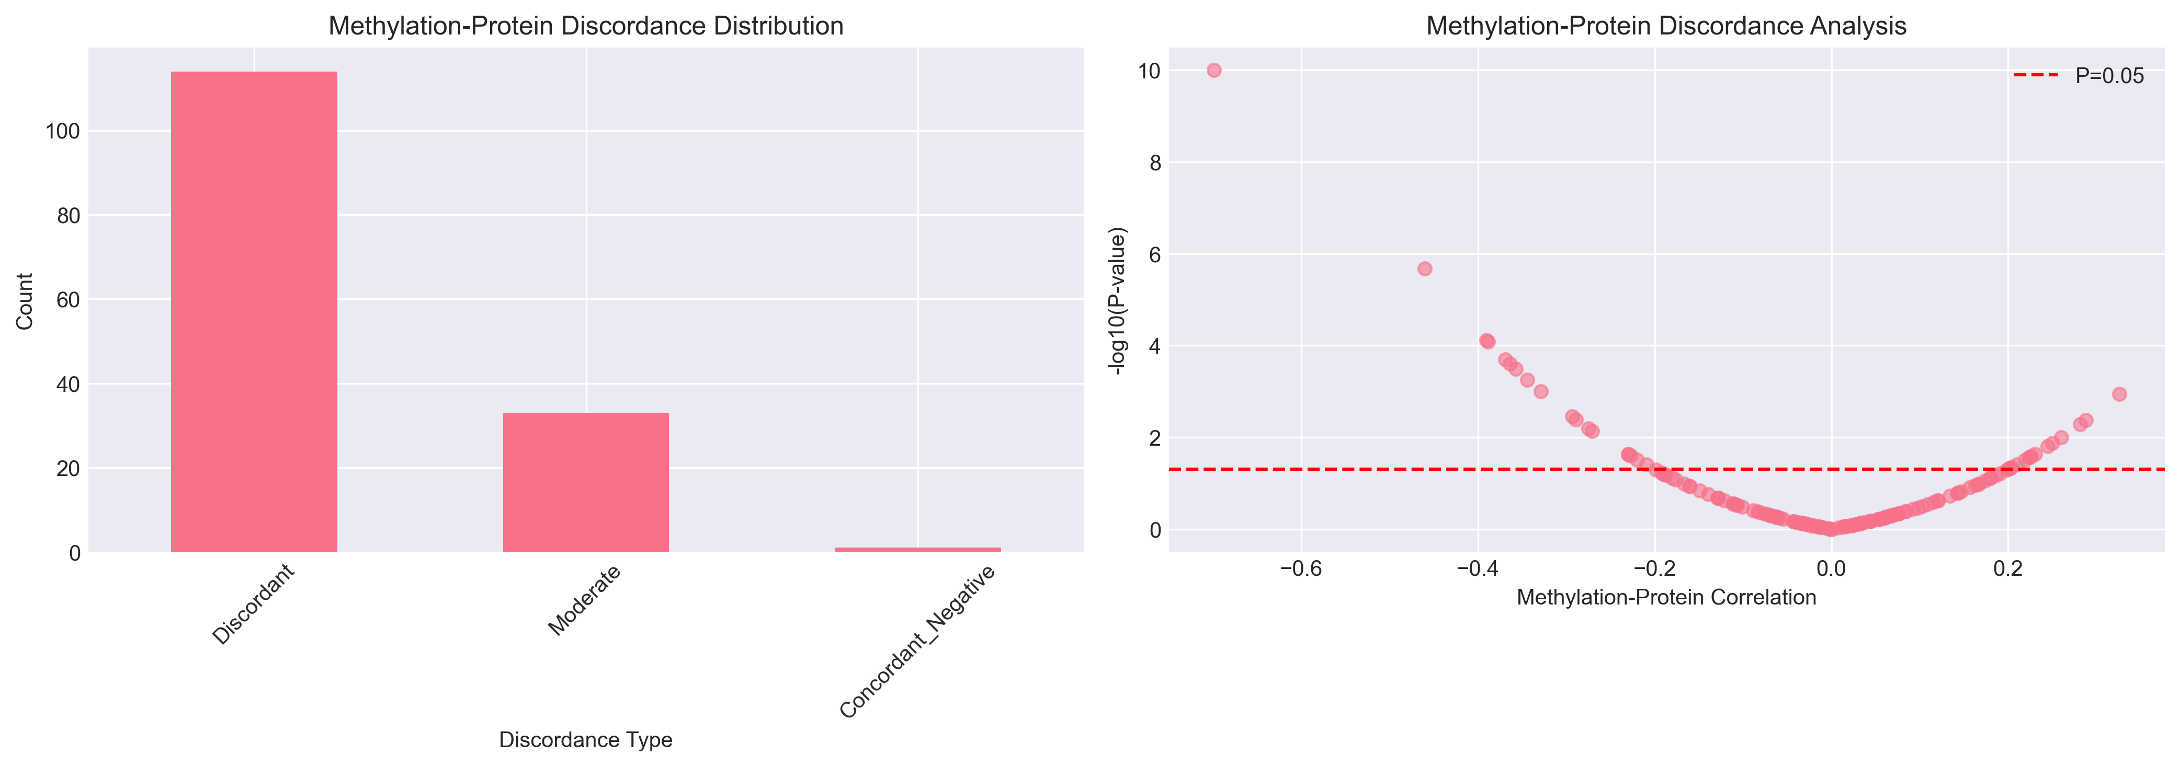

Comprehensive discordance landscape.
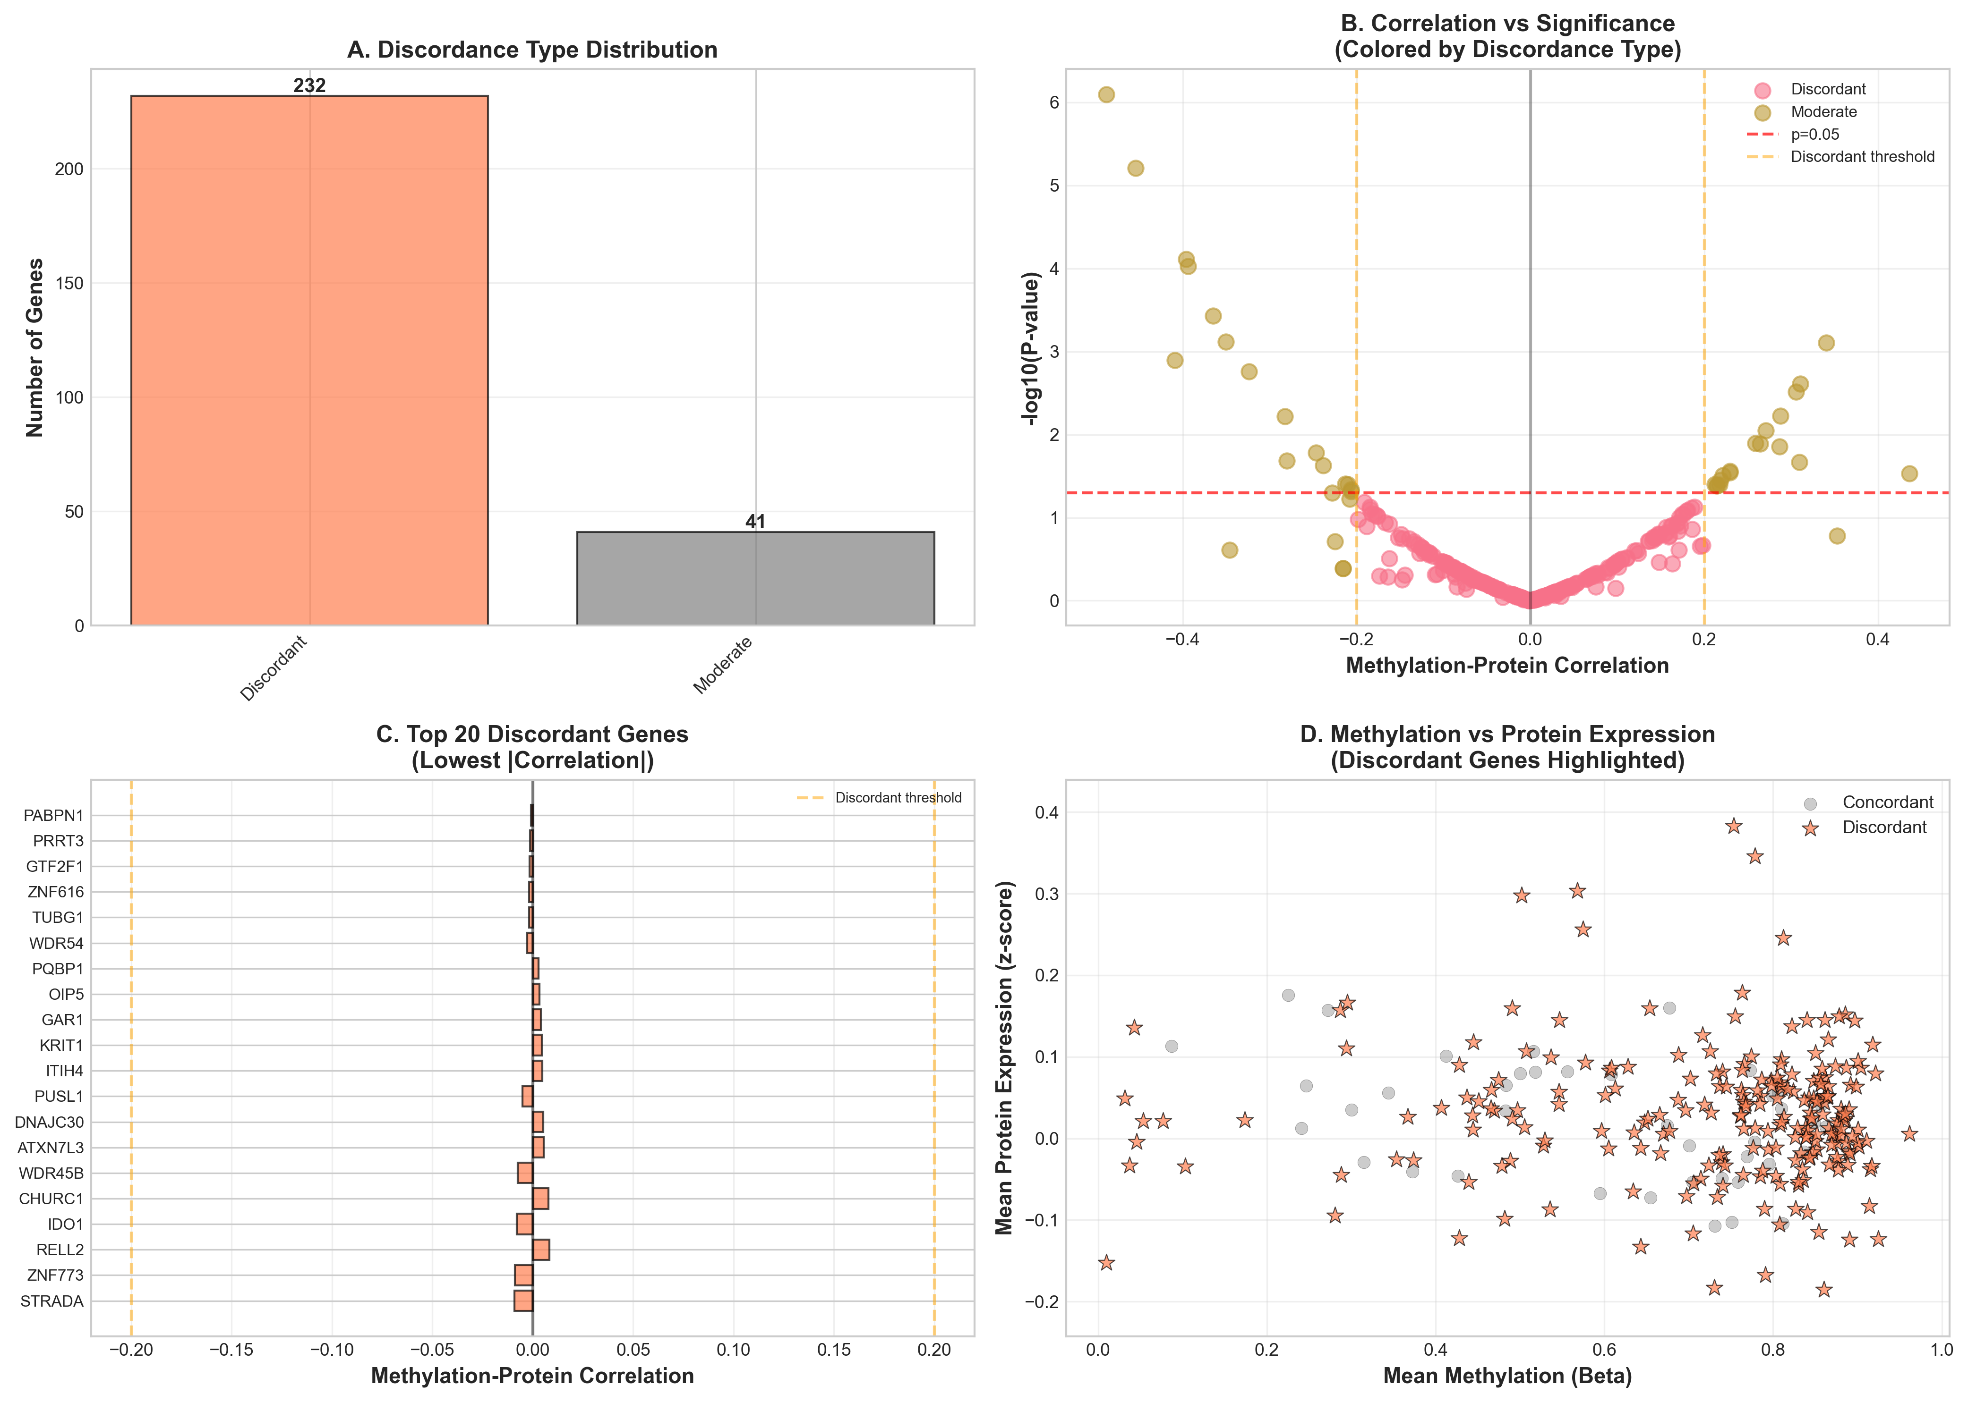

Supplementary Figure 6
Supplementary Figure 6. Internal and external validation of six exploratory prognostic biomarkers (B4GALT1, EGFR, VASP, GFPT2, PHF11, TSPYL5). Upper panel: TCGA-CPTAC 70/30 train–test split; survival difference (days) in the held-out test set (n = 29). Green bars, direction concordant with discovery (high methylation associated with longer survival); red bars, discordant direction. Lower panel: cross-cohort comparison — top, survival difference (high minus low group median); bottom, −log10(log-rank p) in TCGA-CPTAC, GSE7696 (expression, n = 80; low expression as high-methylation proxy), and GSE230770 (EPIC methylation, n = 51). Red dashed line, p = 0.05. Numerical results in Supplementary Tables 18–20. Five of six biomarkers showed directionally concordant associations in ≥1 external cohort (EGFR and TSPYL5 in both).

TCGA internal validation (70/30 split).
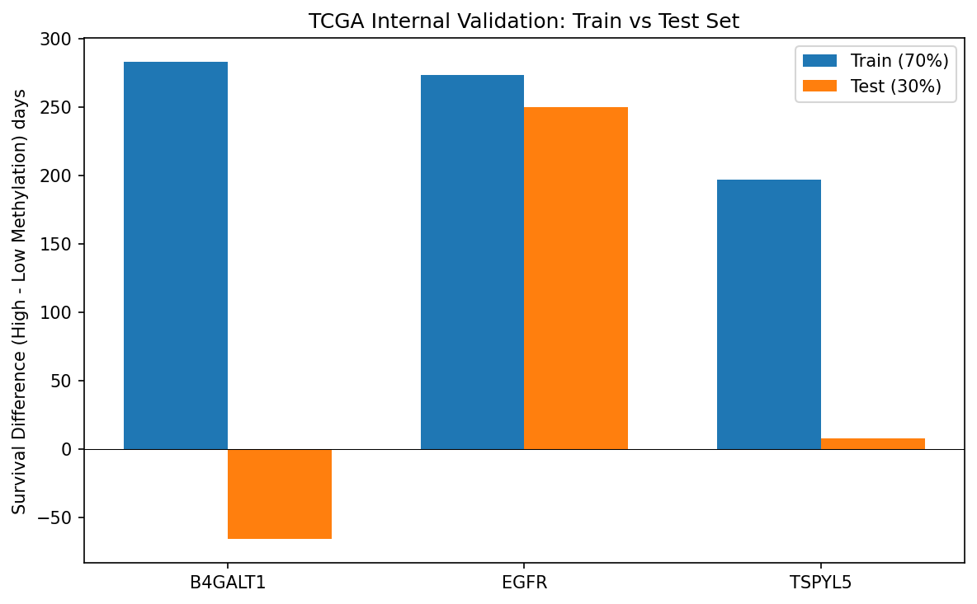

Cross-cohort external validation.
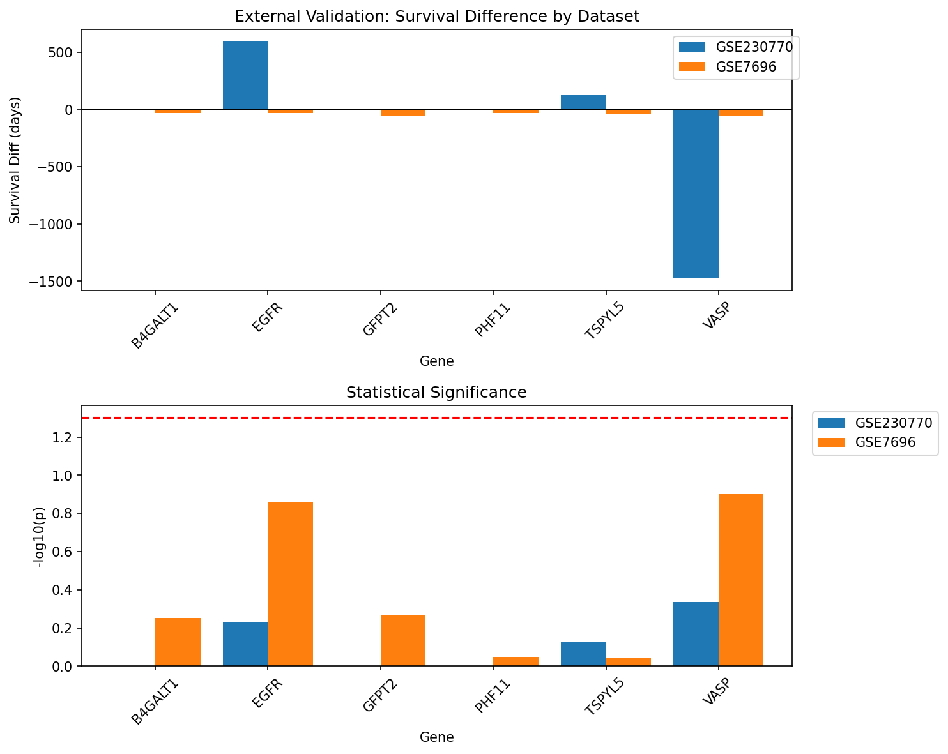

Supplementary Figure 7
Supplementary Figure 7. MGMT methylation profile similarity across the epigenome (TCGA-CPTAC, n = 97). Pairwise methylation similarity to MGMT was quantified by Pearson correlation, Spearman correlation, and cosine similarity; a composite score integrated all metrics. (A) Top 20 genes ranked by composite similarity score. (B–C) Distributions of Pearson and Spearman correlations with MGMT across all profiled genes. (D–F) Top 20 genes by Pearson, Spearman, and cosine similarity, respectively. (G) Pearson versus Spearman correlation concordance; stars, top 10 composite-scoring genes. (H) Composite similarity versus mean methylation difference for the top 50 MGMT-like genes. (I) Summary statistics. Identifies genes with MGMT-like epigenetic silencing patterns relevant to temozolomide response biology.

