Online Resource 2
Journal of Neurology
Article title: Progression from myeloneuropathy to cerebral disease in men with X-linked adrenoleukodystrophy studied using a Human Phenotype Ontology-based approach
Authors: Senol Dogan, Wolfgang Köhler, Caroline Bergner, Julia Lier, Sina Sadeghi, Toralf Kirsten
Corresponding author: Senol Dogan, Institute for Medical Informatics, Statistics and Epidemiology, Medical Faculty, Leipzig University, Härtelstr. 16-18, 04107 Leipzig, Germany. E-mail: Senol.Dogan@medizin.uni-leipzig.de
Contents
Supplementary Methods; Tables S1-S10; Fig. S1.
Supplementary Methods
Handling of negative entries and visit dates
Many examination fields of the registry store free text. In the seizure field, 344 of 358 visit entries stated that the patient had no epilepsy and no seizures. A simple rule that counts every non-empty entry as a finding would class 127 of 215 patients (59.1%) as having seizures. With the rule applied in this study, only 2 patients had a seizure finding, and the other four cerebral subgroups did not change (Table S1 and Fig. S1). The effect was seen in every baseline profile (Table S2). Visit dates also matter. If undated visits are kept and sorted last, they can enter the first visits of a patient. In 52 of the 154 men this would set the follow-up time to 0.1 months. For this reason only dated visits were used in all analyses.
Supplementary tables and figure
Table S1 Number of patients with each cerebral HPO subgroup under a simple rule and under the rule applied in this study
HPO subgroup | All patients, simple rule | All patients, applied rule | Men, simple rule | Men, applied rule
Cognitive | 38 | 38 | 35 | 35
Psychiatric | 32 | 32 | 23 | 23
Seizure | 127 | 2 | 89 | 2
Cranial nerve | 22 | 22 | 17 | 17
Movement or ataxia | 54 | 54 | 43 | 43

The simple rule counts every non-empty entry as a finding. The applied rule counts explicit negative entries as absent. Counts cover the first five visits of each of the 215 patients with a myelopathic start, of whom 154 were men.
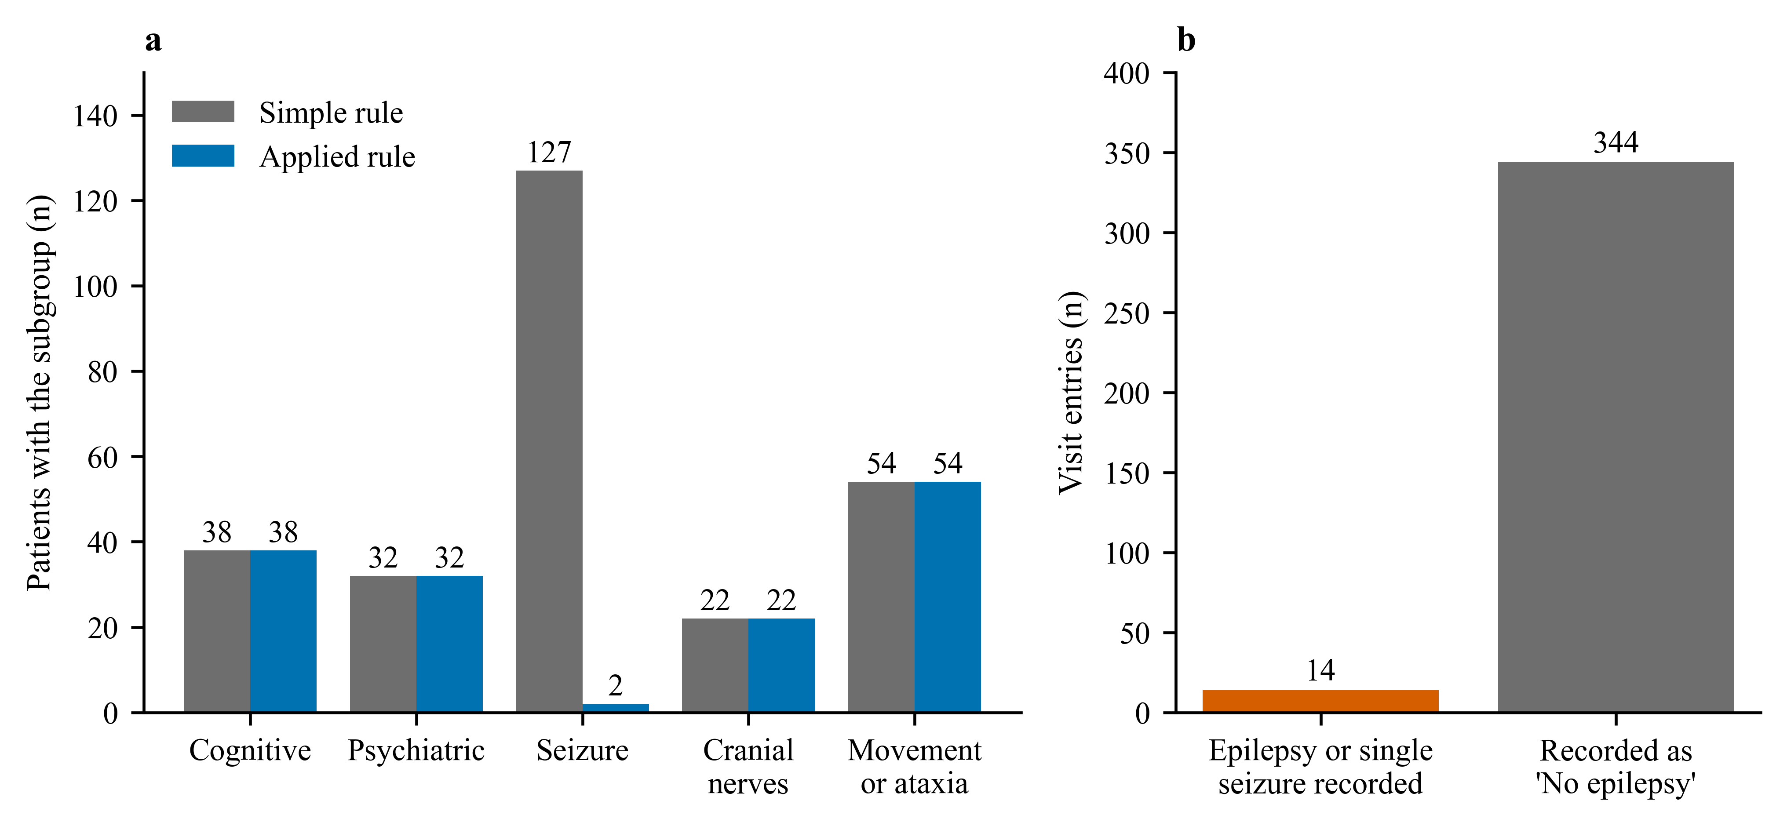
Fig. S1 Effect of the handling of negative entries. a Number of patients counted in each cerebral HPO subgroup under the simple rule and under the applied rule (n = 215). b Entries of the seizure field in all visit forms, split by their meaning
Table S2 Patients with a seizure finding by baseline myelopathic profile under the simple rule and the applied rule
Baseline profile | Patients, n | Simple rule, n (%) | Applied rule, n (%)
Autonomic | 16 | 6 (37.5%) | 0 (0.0%)
Autonomic + Motor/Gait/Balance | 24 | 14 (58.3%) | 0 (0.0%)
Autonomic + Motor/Gait/Balance + Sensory | 6 | 5 (83.3%) | 0 (0.0%)
Motor/Gait/Balance | 136 | 81 (59.6%) | 2 (1.5%)
Motor/Gait/Balance + Sensory | 18 | 11 (61.1%) | 0 (0.0%)
Sensory | 15 | 10 (66.7%) | 0 (0.0%)

Table S3 Entries of the seizure field in the visit forms of the 215 patients
Entry | Meaning under the applied rule | Visit entries, n
No epilepsy, no epileptic seizures | Counted as absent | 344
History of singular epileptic seizure(s), no epilepsy | Counted as present | 8
Diagnosis of epilepsy | Counted as present | 6

Table S4 Penalised multivariable Cox models (ridge penalty 0.1)
Model | Factor | Hazard ratio (95% CI) | p
Profile model (ridge 0.1) | Sensory symptoms at start | 0.82 (0.31 to 2.18) | 0.69
Profile model (ridge 0.1) | Motor, gait or balance symptoms at start | 0.24 (0.05 to 1.22) | 0.086
Profile model (ridge 0.1) | Autonomic symptoms at start | 0.47 (0.18 to 1.20) | 0.11
Clinical model (ridge 0.1) | Age at first visit (per 10 years) | 0.91 (0.62 to 1.35) | 0.64
Clinical model (ridge 0.1) | Adrenal insufficiency documented | 1.33 (0.60 to 2.94) | 0.48

Table S5 Discrimination of the Cox models measured by the concordance index (C-index)
Model | Apparent C-index | Optimism | Corrected C-index | Bootstrap samples
Profile model | 0.67 | 0.054 | 0.616 | 300
Clinical model | 0.577 | 0.048 | 0.529 | 300
Age only | 0.543 | 0.02 | 0.523 | 300

A C-index of 0.50 means no discrimination.
Table S6 Smallest hazard ratio detectable with 80% power
Factor | Prevalence | Events | Smallest detectable hazard ratio
Sensory symptoms at start | 0.164 | 20 | 5.43
Motor, gait or balance symptoms at start | 0.91 | 20 | 8.97
Autonomic symptoms at start | 0.269 | 20 | 4.11
Adrenal insufficiency documented | 0.537 | 20 | 3.51

Table S7 Sensitivity analyses and log-rank tests
Analysis | Men | Events | Sensory profile, HR (95% CI) | Autonomic profile, HR (95% CI) | Age per 10 years, HR (95% CI)
Primary analysis with all follow-up and any CALD record | 67 | 20 | 0.86 (0.28 to 2.63) | 0.36 (0.10 to 1.25) | 0.83 (0.51 to 1.37)
Without records of arrest after transplantation only | 67 | 20 | 0.86 (0.28 to 2.63) | 0.36 (0.10 to 1.25) | 0.83 (0.51 to 1.37)
First five visits only | 67 | 11 | 0.94 (0.20 to 4.48) | 1.11 (0.29 to 4.24) | 0.66 (0.32 to 1.35)
At least 12 months of follow-up | 66 | 20 | 0.86 (0.28 to 2.63) | 0.36 (0.10 to 1.25) | 0.83 (0.51 to 1.37)

HR, hazard ratio. The analysis that removed records of arrest after transplantation gave the same result as the main analysis because no event was based on such a record alone. Log-rank tests were as follows.
Factor | Men with factor, n | Events with factor | Men without factor, n | Events without factor | Log-rank p
Sensory profile | 11 | 4 | 56 | 16 | 0.79
Autonomic profile | 18 | 4 | 49 | 16 | 0.094
Motor, gait or balance profile | 61 | 18 | 6 | 2 | 0.021
Adrenal insufficiency | 36 | 13 | 31 | 7 | 0.37

Table S8 HPO subgroups at the index examination and later (n = 99 men with examination data)
HPO subgroup | Any record, n | Any record, % | At index examination, n | First recorded later, n
Cognitive | 39 | 39.4 | 32 | 7
Psychiatric | 28 | 28.3 | 17 | 11
Seizure | 3 | 3.0 | 3 | 0
Cranial nerve | 22 | 22.2 | 16 | 6
Movement or ataxia | 54 | 54.5 | 46 | 8

Table S9 Most frequent HPO terms behind each cerebral subgroup (examination visits of men)
Subgroup | HPO term | Name | Examination visits with the term, n
Cognitive | HP:0011446 | Abnormality of mental function | 88
Cognitive | HP:0031987 | Concentration or attention problems | 77
Cognitive | HP:0001268 | Mental deterioration | 62
Psychiatric | HP:0000708 | Atypical behavior | 61
Psychiatric | HP:0000716 | Depression | 32
Psychiatric | HP:0007018 | Attention deficit hyperactivity disorder | 0
Seizure | HP:0001250 | Seizure | 14
Cranial nerve | HP:0001291 | Abnormal cranial nerve morphology | 14
Cranial nerve | HP:0002015 | Dysphagia | 13
Cranial nerve | HP:0000496 | Abnormality of eye movement | 12
Movement or ataxia | HP:0001317 | Abnormal cerebellum morphology | 123
Movement or ataxia | HP:0007010 | Poor fine motor coordination | 29
Movement or ataxia | HP:0001337 | Tremor | 12

Table S10 Landmark analysis of HPO findings at the index examination (n = 48, 12 events)
Finding at index examination | Men with finding, n | Events with finding | Events without finding | Hazard ratio (95% CI) | p | Adjusted p
Cognitive or psychiatric finding at first examination | 5 | 2 | 10 | 4.40 (0.81 to 24.07) | 0.087 | 0.24
Movement or ataxia finding at first examination | 16 | 4 | 8 | 1.61 (0.43 to 6.01) | 0.48 | 0.48
Cranial nerve finding at first examination | 2 | 1 | 11 | 3.41 (0.41 to 28.36) | 0.26 | 0.34
Any cerebral HPO finding at first examination | 20 | 6 | 6 | 3.03 (0.74 to 12.38) | 0.12 | 0.24

