Progression from myeloneuropathy to cerebral disease in men with X-linked adrenoleukodystrophy studied using a Human Phenotype Ontology-based approach

Senol Dogan^{1,2,†,*}, Wolfgang Köhler^{3,†}, Caroline Bergner³, Julia Lier³, Sina Sadeghi^{1,2}, Toralf Kirsten^{1,2}

¹Institute for Medical Informatics, Statistics and Epidemiology, Medical Faculty, Leipzig University, Härtelstr. 16-18, 04107 Leipzig, Germany
²Department of Medical Data Science, Medical Informatics Center, University of Leipzig Medical Center, Liebigstr. 18, 04103 Leipzig, Germany
³Department of Neurology, University of Leipzig Medical Center, Liebigstr. 20a, 04103 Leipzig, Germany
†These authors contributed equally to this work
*Corresponding author: Senol Dogan, Senol.Dogan@medizin.uni-leipzig.de

ORCID iDs
Senol Dogan, https://orcid.org/0000-0001-7358-4850
Wolfgang Köhler, https://orcid.org/0000-0002-6058-9545
Caroline Bergner, https://orcid.org/0000-0002-0327-1389
Julia Lier, https://orcid.org/0000-0002-8454-9425
Sina Sadeghi, https://orcid.org/0000-0001-9914-1775
Toralf Kirsten, https://orcid.org/0000-0001-7117-4268
Acknowledgements
We thank the patients and their families, the clinical teams who entered data into the registry, and the Human Phenotype Ontology consortium for maintaining the ontology. In addition, we also thank the Open Access Publishing Fund of Leipzig University.

Abstract
Background
X-linked adrenoleukodystrophy (X-ALD) often presents in men as a myeloneuropathy that can convert to inflammatory cerebral adrenoleukodystrophy (cerebral ALD). The risk of this conversion is poorly defined, and standardised Human Phenotype Ontology (HPO) phenotypes have not been used to study it.

Methods
In this retrospective study of the Leipzig leukodystrophy registry, the clinical authors developed an original HPO Symptom Grouping Dataset that maps 135 examination items to 133 HPO terms in three myelopathic and five cerebral subgroups. We included men with a myelopathic onset and at least one dated visit. The outcome was the first visit at which the treating neurologist recorded cerebral ALD. We used Kaplan-Meier estimates and Cox models.

Results
Of 146 men, 65 already had cerebral ALD at their first visit. Among 67 men at risk, followed for a median of 86 months, 20 converted. Cumulative incidence was 6.5% at 3 years, 10.2% at 5 years and 24.3% (95% confidence interval 13.8 to 40.7) at 10 years. No baseline factor was associated with conversion after correction for multiple testing. Cognitive findings were recorded in 63.0% of men with cerebral ALD and in 11.1% of men without (adjusted p < 0.001), but most HPO-coded cerebral findings were already present at the first examination.

Conclusions
About one in four men with myeloneuropathy and no cerebral disease at their first visit developed cerebral ALD within 10 years, and baseline features did not identify them. The new HPO grouping supports multicentre natural history studies but does not replace magnetic resonance imaging surveillance.
Keywords: Adrenoleukodystrophy, Adrenomyeloneuropathy, Cerebral adrenoleukodystrophy, Human Phenotype Ontology, Progression of Leukodystrophy

Introduction
X-linked adrenoleukodystrophy (X-ALD) is a peroxisomal disorder caused by pathogenic variants in the ABCD1 gene. In men, it leads to a slowly progressive myeloneuropathy, to primary adrenal insufficiency, or to cerebral ALD (CALD), an inflammatory demyelinating process of the brain [1]. These manifestations are not separate diseases but can follow one another in the same man. Gait disturbance, sensory symptoms and bladder dysfunction are common manifestations in adult men [2, 3]. For these men, the central clinical question is whether and when cerebral disease will follow.
Reported frequencies of cerebral progression in adult men differ widely. In Dutch men with adrenomyeloneuropathy, cerebral demyelination developed in 19% over about 10 years in one study [4] and in 63% in a later study [5]. An Italian cohort reported cerebral progression in 7% of men over 18 years [6]. A nationwide Danish cohort reported cerebral disease in 44% of men by the age of 60 years [7]. Referral patterns, case definitions and length of follow-up may explain part of this gap. Early detection matters, because treatment is most effective at an early stage of demyelination [1, 8]. International recommendations therefore describe magnetic resonance imaging (MRI) protocols and surveillance schedules [1, 9, 10]. Research on risk prediction has focused on imaging and blood markers [11-13]. Whether routine clinical findings recorded in registries carry information about later cerebral disease is largely unknown.
The Human Phenotype Ontology (HPO) provides a standardised and computable vocabulary for clinical findings in rare diseases [14]. It allows data from different centres to be pooled without loss of meaning. HPO-coded data have been used to describe outcomes in another rare disease [15], while broader phenome-wide coding has identified morbidities in leukodystrophies [16]. Standards such as the GA4GH Phenopacket schema build on HPO to exchange clinical data between registries [17]. To our knowledge, HPO has not been applied to X-ALD, and the transition from myeloneuropathy to cerebral disease has not been studied with standardised phenotypes. A search of PubMed and Europe PMC in October 2026 found no cohort study that combined X-ALD with HPO.
Here we introduce an HPO Symptom Grouping Dataset that the clinical authors developed for this study, and we apply it to men with X-ALD and a myelopathic onset. We had three aims. First, we estimated the cumulative incidence of conversion to cerebral disease. Second, we tested whether baseline clinical features and HPO-coded findings were associated with conversion. Third, we described how HPO-coded cerebral findings relate to clinically recognised cerebral ALD.
Methods
Data source and reporting
This is a retrospective cohort study based on the Leipzig leukodystrophy registry (LD-R). The registry stores data in REDCap [18]. The extract held 2,761 records of 378 patients with a diagnosis of adrenoleukodystrophy, adrenomyeloneuropathy or X-ALD. Records belong to a baseline form, visit forms and other forms. Each visit form contains the visit date, the disease manifestation chosen by the treating neurologist, and an examination section with HPO-coded findings. We report the study according to the STROBE and RECORD statements [19, 20]. The cohort definition and the outcome were chosen after an earlier exploratory analysis of the same registry, which summarised co-occurrence of myelopathic and cerebral findings in a Markov transition matrix and explored a hidden Markov model of visit sequences. No result of that analysis is used here. The results should therefore be read as hypothesis generating.
Study population
We included men with at least one myelopathic symptom on the baseline checklist of symptoms before the first visit. These symptoms were motor dysfunction, gait disturbance, sensory disorder or bladder dysfunction. Men also needed at least one visit with a valid date. Time zero was the first dated visit.
Women were excluded by design. In women with X-ALD, neurological disease usually begins in mid or late adulthood as a slowly progressive myelopathy and peripheral neuropathy [21-23]. Men present earlier and progress faster than women [24]. Cerebral ALD is extremely rare in women, and international recommendations therefore advise against routine screening for cerebral disease in female patients [1]. Including women would have added a group with almost no risk of the outcome and a different natural history, which would dilute the risk set and bias the estimate of conversion in men.
Outcome
The outcome was the first dated visit at which the treating neurologist recorded cerebral ALD in the disease manifestation field. This field has four relevant options. They are first description of progressive CALD, progressive CALD at any visit, arrested CALD without transplantation and arrested CALD after transplantation. Any of the four options counted as a cerebral ALD record. MRI data were not part of the extract. Some men already had cerebral ALD at the start. This meant a cerebral record at the first visit or cerebral disease as the first manifestation at onset. They were described but not included in the risk set. Men with only one dated visit had no follow-up and were also not included. Follow-up ended at the last dated visit.
Baseline variables
The myelopathic profile came from the baseline checklist. A sensory profile was defined as a sensory disorder, a motor, gait or balance profile as motor dysfunction, gait disturbance or a cerebellar movement disorder, and an autonomic profile as bladder dysfunction. Age at the first visit was calculated from month and year of birth. Disease duration was the time from the year of first neurological symptoms to the year of the first visit. Adrenal insufficiency was defined as a record at onset or at the first dated visit.
HPO Symptom Grouping Dataset
For this study, the clinical authors developed a new HPO Symptom Grouping Dataset (Online Resource 1). The dataset links each examination item of the registry visit form to an HPO term, assigns the term to one of three myelopathic or five cerebral subgroups, and records the neuroanatomical structure most likely responsible for the finding, such as the cerebral cortex, the prefrontal and subcortical network, the cerebellum or the pyramidal tract. It contains 135 entries, 89 cerebral and 46 myelopathic, which correspond to 133 distinct HPO identifiers. Two identifiers occur twice because the same sign can arise from different structures, for example dysmetria of cerebellar or of spinal and peripheral origin. All identifiers were checked against the HPO release of 24 November 2025, using the HPO resource described by Gargano et al. [14]. The cerebral subgroups were cognitive, psychiatric, seizure, cranial nerve, and movement or ataxia. The myelopathic subgroups were sensory, motor or gait or balance, and autonomic (Fig. 1). To our knowledge, this is the first disease-specific HPO grouping for X-ALD that links phenotype terms to both the spinal and the cerebral compartment.
HPO coding
Examination findings were mapped to HPO terms with this dataset. A finding was counted only when the entry was an explicit yes or a checked box, or a text that described a clinical finding. Entries that began with "no" or that said unknown or not applicable were counted as absent. A diagnosis of epilepsy and a history of a single seizure were counted as present. Visits without a valid date were not used. Online Resource 2 shows how a simpler rule that counts every non-empty entry as a finding would change the counts (Tables S1 to S3 and Fig. S1).
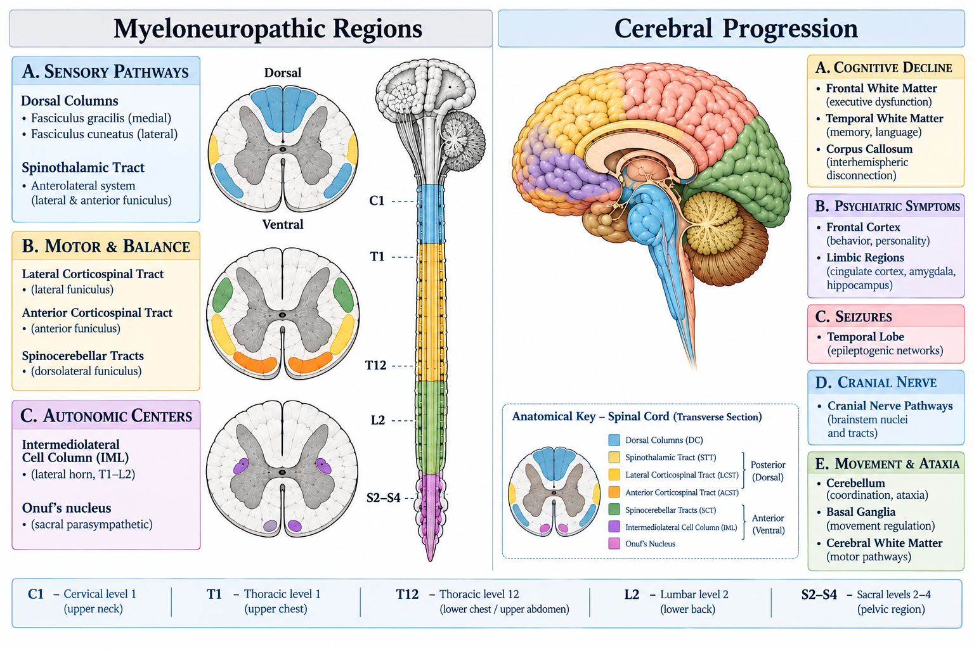
Fig. 1 Grouping of myelopathic and cerebral symptoms in the HPO Symptom Grouping Dataset developed for this study. The left side shows the three myelopathic subgroups and the spinal structures linked to them. The right side shows the five cerebral subgroups and the brain regions linked to them. The figure explains the grouping and does not describe a causal pathway from myelopathy to cerebral disease. The schematic illustration was created with GPT-5.6 Luna AI.
Analysis of HPO-coded findings
For HPO findings, the index examination was the first dated visit with examination data. We counted a finding as present at the start if it was recorded at the index examination, and as later if it first appeared afterwards. We next tested whether the subgroups carried clinical meaning by comparing the proportion of men with each subgroup among those with and without a cerebral ALD record at any visit, using Fisher exact tests. In a landmark analysis, we took the index examination as time zero. We included men without a cerebral ALD record at that time and with later visits. We then assessed whether an HPO finding at the index examination was associated with a later cerebral ALD record.
To describe timing, we used men with at least one dated visit that had examination data and looked at their first five such visits. For each subgroup we counted the months from the index examination to the first visit with a finding of that subgroup. Findings already present at the index examination were assigned a time of zero. We also grouped the men by their baseline myelopathic profile and combined profiles with fewer than 10 men into one group called other profiles. For each group we calculated the share of men with each cerebral subgroup. Finally, for each of the three myelopathic features, we calculated how often each cerebral subgroup was recorded in men with that feature. These descriptive analyses were not tested and were not adjusted for the length of follow-up.
Statistical analysis
We described continuous variables as median and interquartile range, and categorical variables as number and percentage. Cumulative incidence of a first cerebral ALD record was estimated as one minus the Kaplan-Meier survival function, with 95% confidence intervals (CI). Baseline factors were tested with univariable Cox proportional hazards models and log-rank tests. Because only 20 events were available, we did not build a large multivariable model. We fitted two small ridge-penalised models, one with the three symptom profiles and one with age and adrenal insufficiency. Discrimination was measured by the concordance index (C-index), corrected for optimism with 300 bootstrap samples. A C-index of 0.5 indicates discrimination no better than chance. We controlled the false discovery rate with the Benjamini-Hochberg method within each family of tests. We also report the smallest hazard ratio that the study could detect with 80% power. Sensitivity analyses limited follow-up to the first five visits, required at least 12 months of follow-up, and removed records of arrest after transplantation. Vital status had no exact date in the extract, so death could not be modelled as a competing event [25]. The cumulative incidence is therefore an upper bound. Because the models are exploratory and small, we followed the TRIPOD+AI reporting items for the description of the modelling steps [26]. Analyses were done in Python with the lifelines package [27], pandas and scipy. All tests were two-sided with a significance level of 0.05.
Results
Cohort
The registry extract held 2,761 records of 378 patients. A myelopathic symptom was on the baseline checklist for 215 patients, of whom 154 were men and 61 were women. Eight men had no dated visit, which left 146 men for analysis (Fig. 2). At the first dated visit, these men had a median age of 34.5 years (Table 1). They had a median of 4 dated visits over a median follow-up of 53.7 months. Cerebral ALD was already recorded at the first visit or as the first manifestation at onset in 65 men (44.5%). Fourteen of the 15 men with a cerebral symptom on the baseline checklist belonged to this group. The other 81 men had no cerebral record at the start. Of these, 14 had one dated visit only, so the risk set contained 67 men.
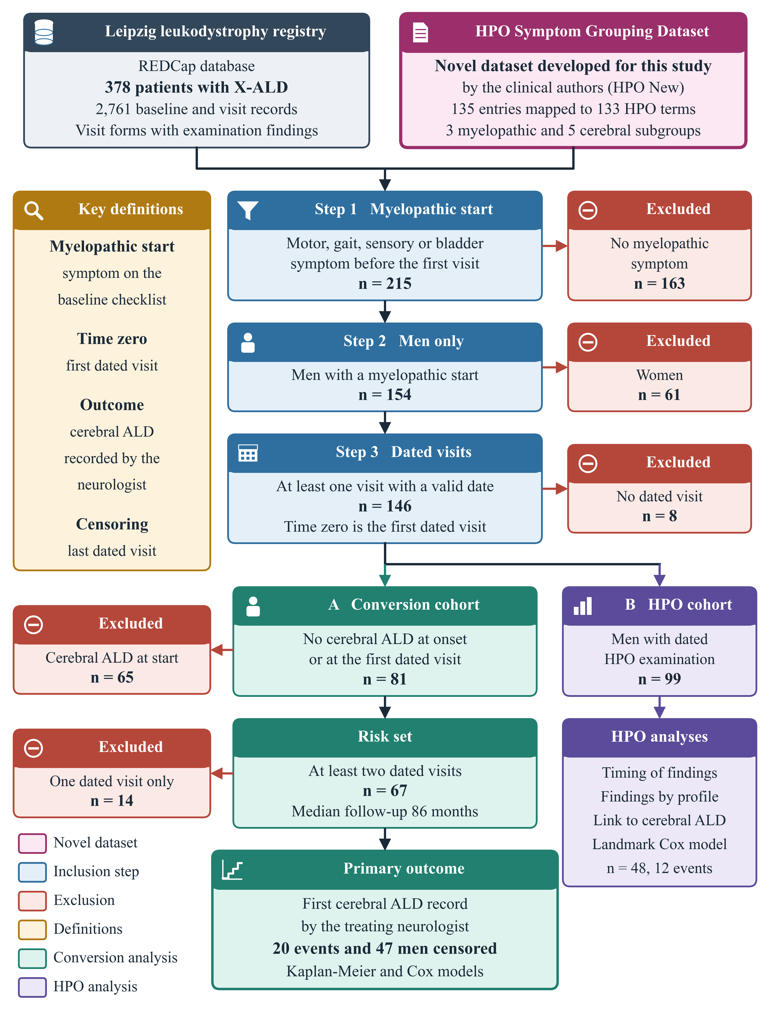
Fig. 2 Study design and flow of patients. The HPO Symptom Grouping Dataset was developed by the clinical authors for this study. Boxes on the right show exclusions. Arm A is the conversion cohort of men without cerebral ALD at onset or at the first dated visit and with at least two dated visits. Arm B contains the men with dated HPO-coded examination data. ALD, adrenoleukodystrophy. HPO, Human Phenotype Ontology. X-ALD, X-linked adrenoleukodystrophy
Table 1 Baseline characteristics of the men
Characteristic | All men with dated visits | Cerebral ALD already recorded at start | Risk set for conversion analysis
Men, n | 146 | 65 | 67
Age at first visit, years, median (IQR) | 34.5 (28.6 to 43.4), data for 145 men | 34.2 (28.7 to 44.8), data for 65 men | 34.5 (28.6 to 39.9), data for 67 men
Years from symptom onset to first visit, median (IQR) | 6.0 (2.0 to 10.0) | 5.0 (1.0 to 12.0) | 6.0 (3.0 to 9.8)
Number of dated visits, median (IQR) | 4.0 (2.0 to 7.0) | 2.0 (2.0 to 6.0) | 6.0 (4.0 to 9.0)
Follow-up, months, median (IQR) | 53.7 (7.9 to 118.5) | 31.7 (1.8 to 77.6) | 86.0 (53.8 to 187.0)
Sensory profile, n (%) | 26 (17.8%) | 10 (15.4%) | 11 (16.4%)
Motor, gait or balance profile, n (%) | 130 (89.0%) | 57 (87.7%) | 61 (91.0%)
Autonomic profile, n (%) | 31 (21.2%) | 11 (16.9%) | 18 (26.9%)
Adrenal insufficiency documented, n (%) | 91 (62.3%) | 48 (73.8%) | 36 (53.7%)
Cerebral symptom on baseline checklist, n (%) | 15 (10.3%) | 14 (21.5%) | 0 (0.0%)
Stem cell transplantation recorded, n (%) | 24 (16.4%) | 15 (23.1%) | 9 (13.4%)

IQR, interquartile range. Values are median (IQR) or number (percentage). The checklist lists symptoms that were present before the first visit.
Cumulative incidence of cerebral ALD
The median follow-up in the risk set was 86.0 months (interquartile range 53.8 to 187.0), which gave 582.6 person-years. Twenty men had a first cerebral ALD record. The median time from the first visit to this record was 109.7 months (interquartile range 46.3 to 177.5). The crude rate was 3.4 per 100 person-years. No man had an event within 12 months. The cumulative incidence was 6.5% (95% CI 2.5 to 16.4) at 36 months, 10.2% (95% CI 4.7 to 21.3) at 60 months and 24.3% (95% CI 13.8 to 40.7) at 120 months (Fig. 3 and Table 2). When follow-up was limited to the first five visits, only 11 events were found instead of 20.
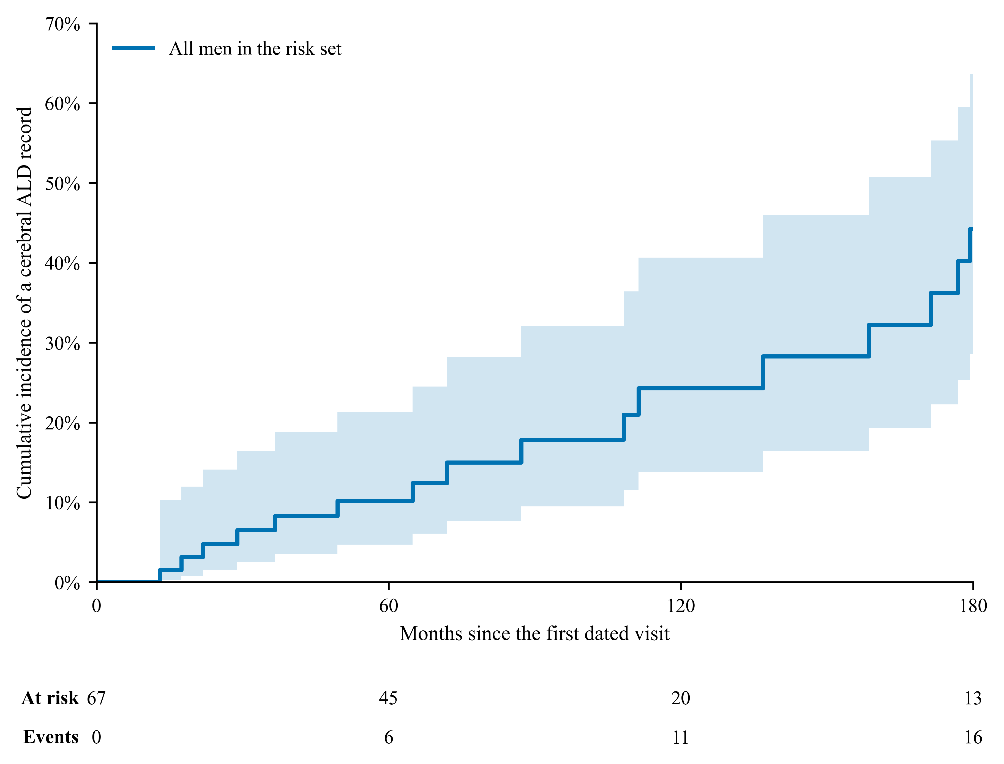
Fig. 3 Cumulative incidence of a first cerebral ALD record in men with a myelopathic start and no cerebral ALD record at the start (n = 67). The line shows one minus the Kaplan-Meier estimate and the shaded area shows the 95% confidence interval. The numbers below the plot are the men still at risk and the cumulative number of events. The plot ends at 180 months because few men were followed longer
Table 2 Cumulative incidence of a first cerebral ALD record
Group | At risk at 36 months | Cumulative incidence at 36 months, % (95% CI) | At risk at 120 months | Cumulative incidence at 120 months, % (95% CI)
All men at risk | 53 | 6.5% (2.5 to 16.4) | 20 | 24.3% (13.8 to 40.7)
Sensory profile present | 9 | 9.1% (1.3 to 49.2) | 5 | 20.5% (5.5 to 60.7)
Sensory profile absent | 44 | 5.9% (1.9 to 17.3) | 15 | 25.1% (13.3 to 44.4)
Autonomic profile present | 16 | 5.6% (0.8 to 33.4) | 6 | 22.5% (7.2 to 57.9)
Autonomic profile absent | 37 | 6.9% (2.3 to 20.0) | 14 | 25.3% (13.0 to 45.6)
Motor, gait or balance profile present | 50 | 3.7% (0.9 to 14.0) | 20 | 22.3% (12.0 to 39.4)
Motor, gait or balance profile absent | 3 | 33.3% (9.6 to 80.5) | 0 | 33.3% (9.6 to 80.5)

CI, confidence interval. Only six men had no motor, gait or balance symptom at the start, so the estimates for that group are very imprecise.
Baseline factors and conversion
None of the six baseline factors was significant after adjustment for multiple testing (Table 3 and Fig. 4a). A motor, gait or balance profile had a hazard ratio of 0.18 (95% CI 0.04 to 0.92, p = 0.039, adjusted p = 0.24). Only six men did not have this profile, and two of them had an event, so this estimate is unstable. Adrenal insufficiency had a hazard ratio of 1.54 (95% CI 0.60 to 3.91). The hazard ratio for age was 0.83 per 10 years (95% CI 0.51 to 1.37). The two penalised multivariable models gave similar estimates (Online Resource 2, Table S4). The optimism-corrected C-index was 0.62 for the profile model, 0.53 for the model with age and adrenal insufficiency, and 0.52 for age alone (Online Resource 2, Table S5). With 20 events, the study could detect hazard ratios of 3.5 or more for the most balanced factor and 9.0 or more for the least balanced factor (Online Resource 2, Table S6). The sensitivity analyses gave results in the same direction (Online Resource 2, Table S7).
Table 3 Univariable Cox models for the first cerebral ALD record (n = 67, 20 events)
Factor | Men with factor, n | Events with vs without factor | Hazard ratio (95% CI) | p | Adjusted p
Sensory profile | 11 | 4 of 11 vs 16 of 56 | 0.86 (0.28 to 2.63) | 0.79 | 0.79
Motor, gait or balance profile | 61 | 18 of 61 vs 2 of 6 | 0.18 (0.04 to 0.92) | 0.039 | 0.24
Autonomic profile | 18 | 4 of 18 vs 16 of 49 | 0.36 (0.10 to 1.25) | 0.11 | 0.32
Adrenal insufficiency | 36 | 13 of 36 vs 7 of 31 | 1.54 (0.60 to 3.91) | 0.37 | 0.71
Age at first visit, per 10 years | Continuous | NA | 0.83 (0.51 to 1.37) | 0.48 | 0.71
Disease duration, per 5 years | Continuous | NA | 1.08 (0.77 to 1.52) | 0.65 | 0.79

CI, confidence interval. Adjusted p values use the Benjamini-Hochberg method across the six tests. A hazard ratio below 1 means a lower rate of a cerebral ALD record.
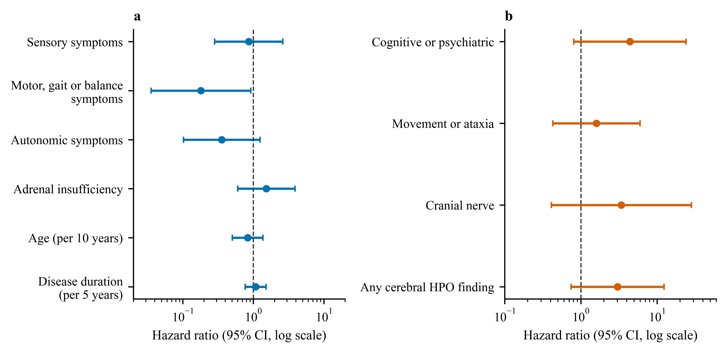
Fig. 4 Hazard ratios with 95% confidence intervals on a logarithmic scale. Univariable Cox models for factors at the first visit (n = 67, 20 events). b Landmark analysis of HPO findings at the first examination (n = 48, 12 events). The dashed line marks a hazard ratio of 1
HPO-coded cerebral findings
Of the 146 men, 99 had at least one dated visit with HPO-coded examination data. These men had 280 such visits. Only 58 men had examination data at the first dated visit. At any visit, movement or ataxia was recorded in 54 (54.5%), cognitive findings in 39 (39.4%), psychiatric findings in 28 (28.3%), cranial nerve findings in 22 (22.2%) and seizures in 3 (3.0%). Table S8 in Online Resource 2 shows how many of these findings were present at the index examination. Each subgroup was dominated by one or two general HPO terms (Online Resource 2, Table S9).
For the timing of findings, we used only the first five examination visits of the same 99 men, so the counts below are slightly lower than those for any visit. A median of 1 examination visit (interquartile range 1 to 4) was available within the first five visits. Most findings were already present at the index examination, so the median time to first appearance was zero months for every subgroup (Table 4). Within these visits, a cognitive finding was recorded in 38 men (38.4%), and in 32 of them at the index examination. The numbers were 27 (27.3%) for psychiatric findings, 21 (21.2%) for cranial nerve findings and 53 (53.5%) for movement or ataxia findings. Seizure findings were recorded in 3 men only (3.0%), all at the index examination. Among the myelopathic subgroups, motor, gait or balance findings were recorded in 95 men (96.0%), autonomic findings in 92 (92.9%) and sensory findings in 84 (84.8%). Because most men had a single examination visit, these times show when a finding was first documented and not when it began.
Table 4 Months from the index examination to the first documentation of each subgroup (n = 99 men)
Category | Subgroup | Men, n (%) | At index, n | Mean | Median | Min | Max | SD
Cerebral | Cognitive and higher mental function impairment | 38 (38.4%) | 32 | 11.4 | 0.0 | 0.0 | 179.3 | 34.8
Cerebral | Psychiatric and behavioral symptoms | 27 (27.3%) | 17 | 9.7 | 0.0 | 0.0 | 64.9 | 17.7
Cerebral | Seizure and epilepsy spectrum | 3 (3.0%) | 3 | 0.0 | 0.0 | 0.0 | 0.0 | 0.0
Cerebral | Cranial nerves | 21 (21.2%) | 16 | 13.5 | 0.0 | 0.0 | 179.3 | 40.2
Cerebral | Movement disorders and ataxia spectrum | 53 (53.5%) | 46 | 12.0 | 0.0 | 0.0 | 275.6 | 43.6
Myeloneuropathic | Sensory impairment and pain | 84 (84.8%) | 77 | 4.4 | 0.0 | 0.0 | 168.9 | 21.1
Myeloneuropathic | Motor, gait, balance dysfunction | 95 (96.0%) | 92 | 3.3 | 0.0 | 0.0 | 168.9 | 20.1
Myeloneuropathic | Autonomic nervous system dysfunction | 92 (92.9%) | 80 | 8.9 | 0.0 | 0.0 | 179.3 | 31.4

Only the first five dated visits with examination data were used. Times are in months. A finding at the index examination counts as zero. At index, men in whom the finding was present at the index examination. SD, standard deviation.
Table 5 and Fig. 5 show cerebral findings by baseline profile. Three groups had at least 10 men. They were the motor, gait or balance profile (64 men), the autonomic plus motor, gait or balance profile (13 men) and a group of other profiles (22 men) that combined four smaller profiles. Movement or ataxia findings were recorded in about half of the men in each group (53.1% to 54.5%). Cognitive findings were recorded in 42.2% of men with a motor, gait or balance profile, 23.1% of men with the autonomic plus motor profile and 36.4% of men with other profiles. These differences were not tested, and the groups were small.
Table 5 Cerebral HPO subgroups recorded in the first five examination visits, by baseline myelopathic profile
Profile | Men, n | Cerebral subgroup | Men with finding, n | % | Mean time, months
Autonomic + Motor/Gait/Balance | 13 | Cognitive and higher mental function impairment | 3 | 23.1 | 0.0
Autonomic + Motor/Gait/Balance | 13 | Psychiatric and behavioral symptoms | 2 | 15.4 | 6.6
Autonomic + Motor/Gait/Balance | 13 | Seizure and epilepsy spectrum | 0 | 0.0 | NA
Autonomic + Motor/Gait/Balance | 13 | Cranial nerves | 1 | 7.7 | 0.0
Autonomic + Motor/Gait/Balance | 13 | Movement disorders and ataxia spectrum | 7 | 53.8 | 44.6
Motor/Gait/Balance | 64 | Cognitive and higher mental function impairment | 27 | 42.2 | 13.7
Motor/Gait/Balance | 64 | Psychiatric and behavioral symptoms | 20 | 31.2 | 8.9
Motor/Gait/Balance | 64 | Seizure and epilepsy spectrum | 3 | 4.7 | 0.0
Motor/Gait/Balance | 64 | Cranial nerves | 16 | 25.0 | 17.3
Motor/Gait/Balance | 64 | Movement disorders and ataxia spectrum | 34 | 53.1 | 6.1
Other profiles | 22 | Cognitive and higher mental function impairment | 8 | 36.4 | 8.0
Other profiles | 22 | Psychiatric and behavioral symptoms | 5 | 22.7 | 14.1
Other profiles | 22 | Seizure and epilepsy spectrum | 0 | 0.0 | NA
Other profiles | 22 | Cranial nerves | 4 | 18.2 | 1.7
Other profiles | 22 | Movement disorders and ataxia spectrum | 12 | 54.5 | 9.6

The mean time is counted from the index examination among men with the finding. Profiles with fewer than 10 men were combined as other profiles.
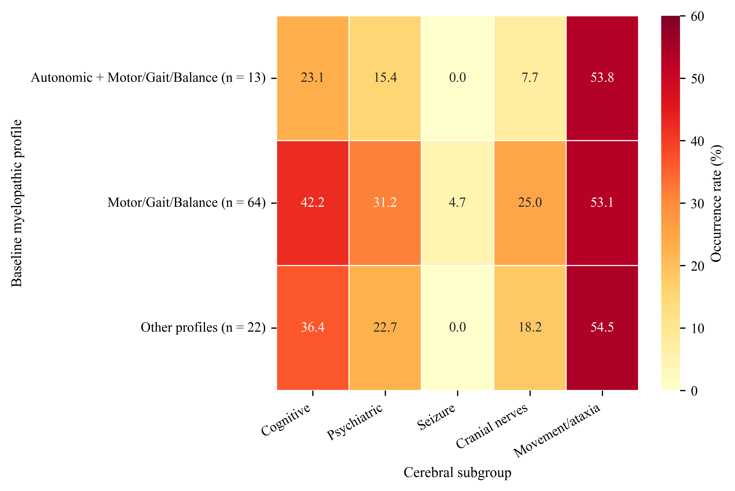
Fig. 5 Share of men with each cerebral HPO subgroup recorded in the first five examination visits, by baseline myelopathic profile. Values are percentages. Profiles with fewer than 10 men are combined as other profiles
Fig. 6 shows the same data for each myelopathic feature. The numbers of men were 18 with a sensory feature, 91 with a motor, gait or balance feature and 22 with an autonomic feature, and men could have more than one feature. The thickest arrows led to movement or ataxia and to cognitive findings in all three groups, while the arrows to seizure findings were thin or absent. The share with a cognitive finding was 27.8% in men with a sensory feature, 37.4% in men with a motor, gait or balance feature and 31.8% in men with an autonomic feature.
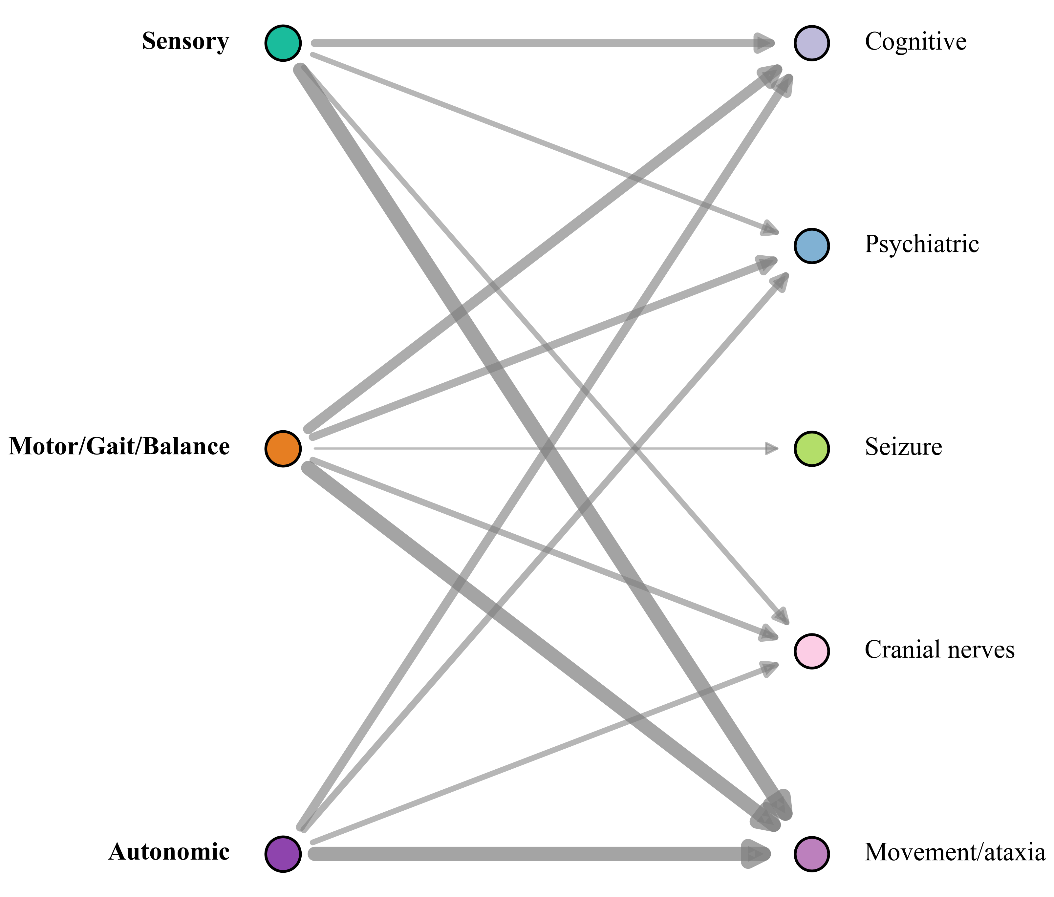
Fig. 6 Association between myelopathic features and cerebral HPO subgroups. Arrow thickness shows the share of men with each myelopathic feature in whom the cerebral subgroup was recorded in the first five examination visits. The diagram shows associations and not a causal pathway.
Of these 99 men, 54 had a cerebral ALD record at some time and 45 did not. Cognitive findings were recorded in 63.0% of men with a cerebral ALD record and in 11.1% of men without. The corresponding figures with and without a record were 40.7% and 13.3% for psychiatric findings, 35.2% and 6.7% for cranial nerve findings, and 68.5% and 37.8% for movement or ataxia findings. All four differences remained significant after adjustment (adjusted p < 0.01). Seizure findings were rare in both groups (5.6% and 0.0%, adjusted p = 0.25). Table 6 and Fig. 7 show the details.
Table 6 Men with each HPO subgroup recorded at any visit, by cerebral ALD record
HPO subgroup | Cerebral ALD record (n = 54) | No cerebral ALD record (n = 45) | p | Adjusted p
Cognitive | 34 (63.0%) | 5 (11.1%) | <0.001 | <0.001
Psychiatric | 22 (40.7%) | 6 (13.3%) | 0.003 | 0.004
Seizure | 3 (5.6%) | 0 (0.0%) | 0.25 | 0.25
Cranial nerve | 19 (35.2%) | 3 (6.7%) | <0.001 | 0.002
Movement or ataxia | 37 (68.5%) | 17 (37.8%) | 0.003 | 0.004

Values are number (percentage). Fisher exact test, with Benjamini-Hochberg adjustment across five tests.
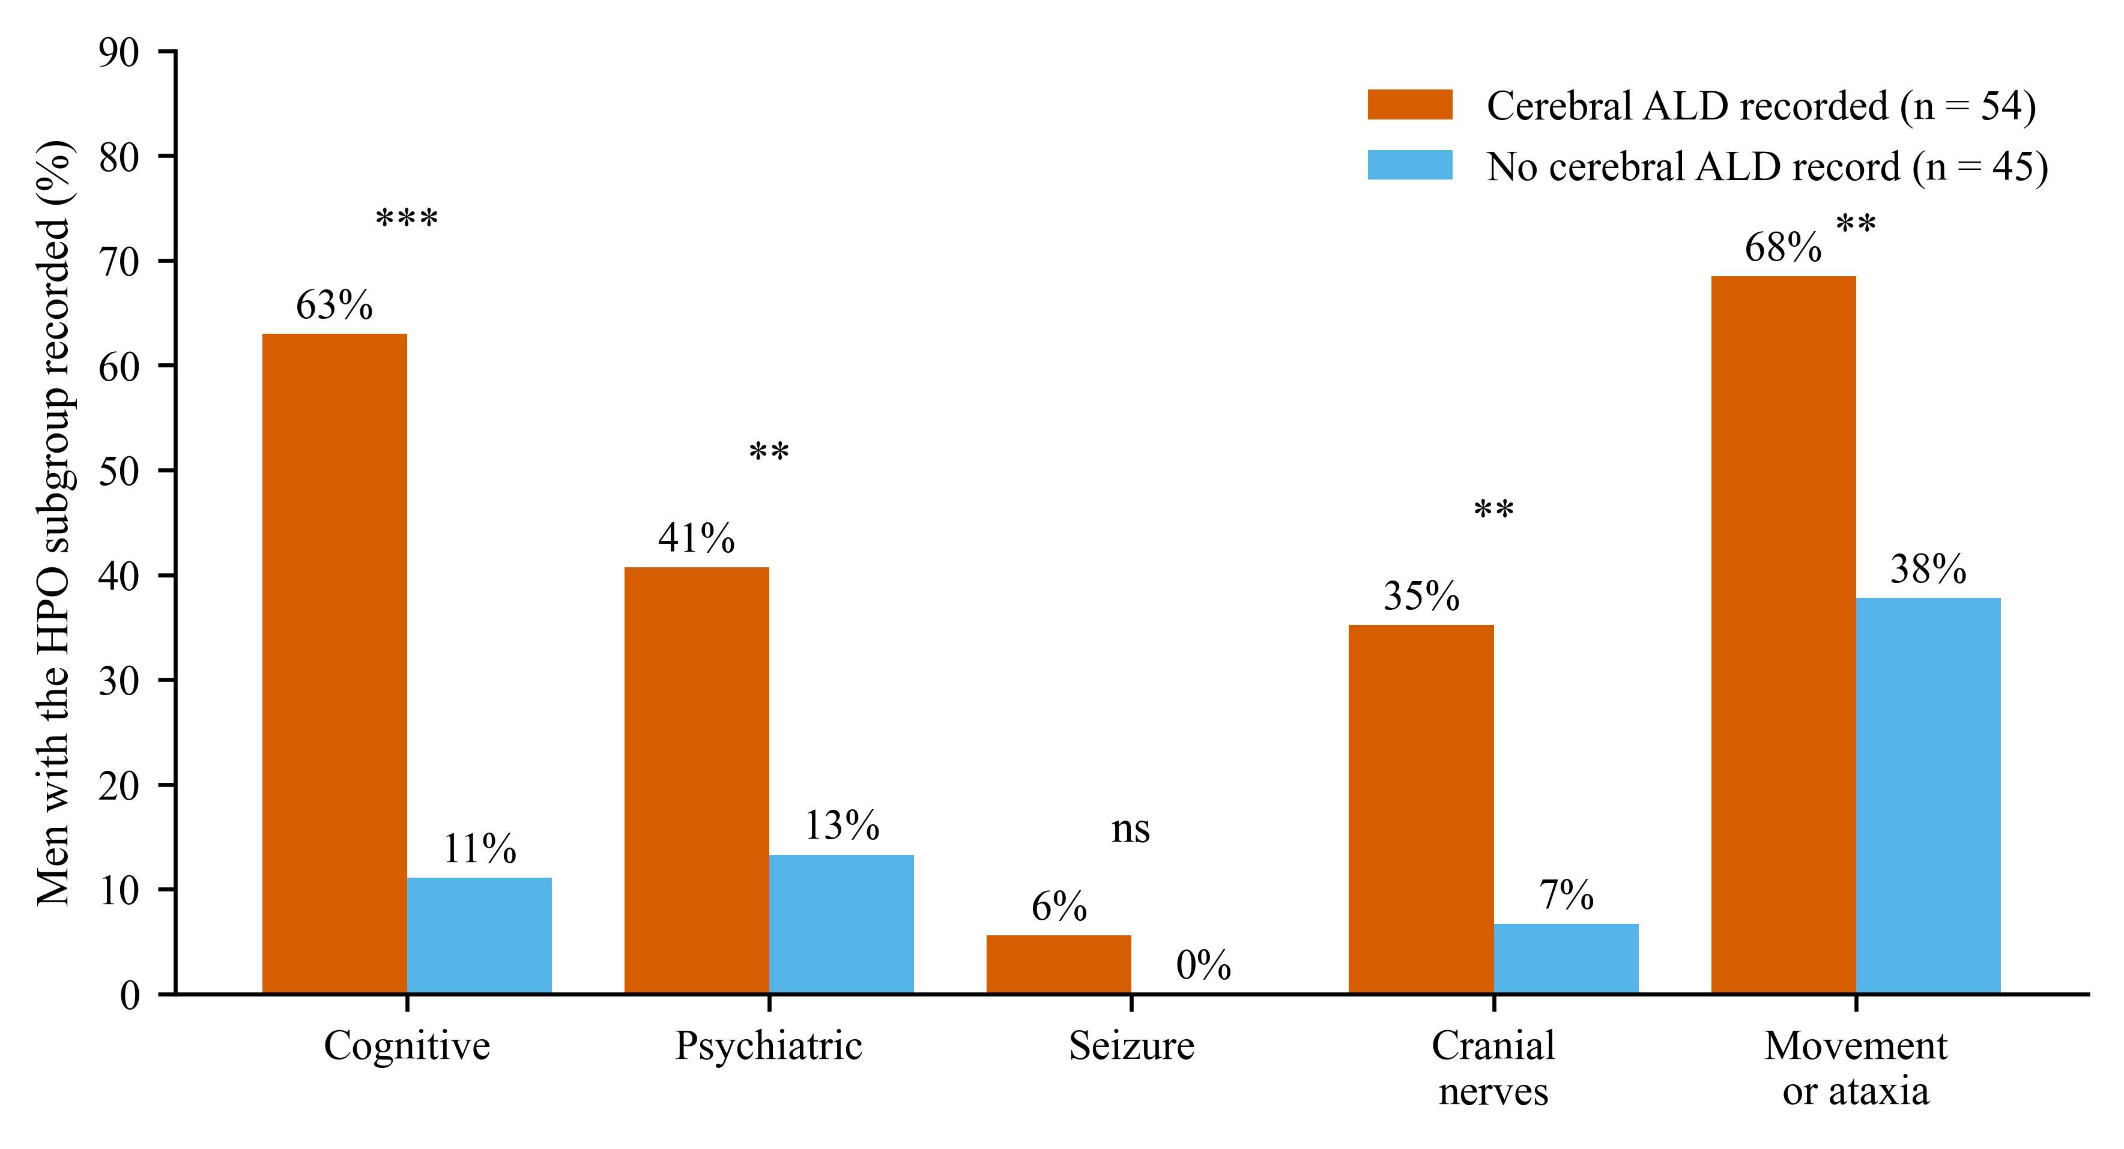
Fig. 7 Share of men with each HPO subgroup recorded, by cerebral ALD record. Stars mark adjusted p values (* below 0.05, ** below 0.01, *** below 0.001, ns not significant). In the landmark analysis, 48 men had no cerebral ALD at the index examination and had later visits. Of these, 12 later had a cerebral ALD record. A cognitive or psychiatric finding at the index examination was present in 5 men and had a hazard ratio of 4.40 (95% CI 0.81 to 24.07, p = 0.087). Any cerebral HPO finding was present in 20 men and had a hazard ratio of 3.03 (95% CI 0.74 to 12.38, p = 0.12). None of these results was significant, and the intervals were wide (Fig. 4b and Online Resource 2, Table S10).
Discussion
Main findings
In this registry cohort of men with X-ALD and a myelopathic onset, almost half (45%) already had a cerebral ALD record at their first dated visit. Among those who did not, the cumulative incidence of a first cerebral ALD record reached about one in four at 10 years. Symptom profile, age, disease duration and adrenal insufficiency did not distinguish men who converted from those who did not. With a newly developed HPO grouping, cognitive, psychiatric and cranial nerve findings were strongly enriched in men with cerebral ALD, whereas movement or ataxia findings were common irrespective of cerebral status. To our knowledge, this is the first study to describe the transition from myeloneuropathy to cerebral disease in X-ALD with standardised HPO phenotypes.
Comparison with the literature
The cumulative incidence of 24.3% at 10 years lies within the wide range reported for adult men. It is close to the 19% found in 68 Dutch men with adrenomyeloneuropathy over a mean of 9.5 years [4]. A later Dutch study found cerebral demyelination in 17 of 27 men about 10 years after the onset of myelopathy [5]. The Italian cohort found cerebral progression in 7% over 18 years [6], and the Danish cohort found cerebral disease in 44% of men by the age of 60 years [7]. These studies measured time from diagnosis, from inclusion in a cohort or from birth. We started at the first dated visit and described men who already had cerebral disease at that visit separately. Our estimate therefore refers to new conversion only and covers a shorter time at risk. Our figure comes from a tertiary leukodystrophy centre. Such centres often see men who were referred because of cerebral concern. This may raise both the share with cerebral disease at the start and the later incidence. Our outcome is the first record in a visit form and not an MRI-defined event, which also limits direct comparison.
Two recent studies used data from the same centre. The first described the natural history of 364 patients with X-ALD and related very long-chain fatty acid levels to clinical scores and disease manifestations [24]. It found that these levels had limited prognostic value for individual patients. The second measured lesion growth on MRI in men who already had cerebral ALD, with data from three centres [13]. Neither study followed men from a myelopathic start to a first cerebral record, and neither used HPO-coded examination findings. Our study therefore covers the step between these two, from myelopathy alone to the start of cerebral disease. Some men may appear in more than one of these studies, but the questions, cohort definitions and outcomes differ.
We found no baseline factor that reliably predicted conversion. This fits the view that the course of a single man is hard to forecast from routine clinical data. Blood markers such as neurofilament light chain have been proposed for risk prediction, but the authors of one major study advised caution when applying them to adults [11]. In men without cerebral involvement, high plasma neurofilament light chain predicted faster progression of myelopathy over seven years, but cerebral conversion was not the outcome of that study [28]. Adrenal insufficiency, a well-described manifestation of X-ALD [29], had a hazard ratio above 1, but the interval was wide. A larger study could test this link. The motor, gait or balance profile showed a lower hazard, yet only six men lacked it, so we do not interpret this result.
HPO-coded findings and cerebral disease
Cognitive, psychiatric and cranial nerve findings were much more common in men with a cerebral ALD record. This agrees with neuropsychological testing in 172 adults, which found largely intact cognition in adrenomyeloneuropathy and marked deficits in active cerebral ALD [30]. These subgroups therefore carry clinical meaning in a registry setting. Movement or ataxia findings were also frequent in men without such a record (37.8%). This may reflect cerebellar and brainstem involvement in myeloneuropathy, so this subgroup should not be read as a marker of cerebral inflammatory disease alone. Seizure findings were rare, with 3 of 99 men affected. In boys, seizures were found in 29% of those with cerebral ALD and in 5.7% of those without cerebral involvement [31]. In adult men with a myelopathic start, seizures seem to be a much less common sign of cerebral disease. Most findings were already present at the first examination, and a finding at that time did not clearly predict a later cerebral ALD record. Both the HPO findings and the cerebral ALD record come from the same visit and the same clinician. The comparison therefore shows consistency and not independent validation.
Correct handling of negative entries is essential when HPO codes are taken from registry forms. In our data, a simple rule that counts every non-empty entry as a finding would have classed most patients as having seizures (Online Resource 2, Table S1). Registries should store an absent finding as an explicit negative, and computable standards such as Phenopackets can mark a feature as excluded [17].
A reusable and newly developed HPO-based phenotyping approach for X-ALD
The HPO Symptom Grouping Dataset is the main methodological contribution of this work. It translates routine examination items into ontology terms that are shared across centres, and it adds an anatomical layer that separates spinal and peripheral from cerebral involvement. This structure reflects the way neurologists reason about X-ALD and allows registries with different forms to pool their data [14, 17]. HPO-based approaches have been used in other rare diseases [15], while phenome-wide coding has been applied to leukodystrophies [16], but an HPO-based approach has not been reported in X-ALD. Because the dataset is provided in full, other centres can apply, test and extend it. The GA4GH Phenopacket schema can carry these HPO terms between registries, including an explicit mark when a finding is absent [17]. RareLink can export REDCap data into FHIR and Phenopackets [32], and the ROME module can annotate REDCap fields with ontology terms [33]. Together these tools would allow the present grouping to be reused across centres without redesign of local forms.
Implications
HPO-coded examination findings may help to describe the course of disease in registries, but they cannot replace imaging. Guidelines recommend structured MRI protocols [1, 10], and lesion growth in adults varies strongly between men [13]. Our data do not support the use of baseline symptom profiles to reduce the intensity of surveillance.
Limitations
This is a retrospective single-centre study. The number of events was small, so confidence intervals are wide and the power was low. The outcome is a clinician record in a visit form and was not confirmed by MRI in this extract. Event times are limited by the spacing of visits, with a median gap of about 13 months. Death could not be modelled as a competing event. Examination data were missing at the first visit for many men, which makes the index examination later than the first visit in part of the cohort. Most men also had only one examination visit, so the timing of HPO findings could not be described reliably. The choice of outcome and cohort followed an earlier exploratory analysis. We did not have genotype, very long-chain fatty acid or neurofilament data. Women were excluded by design, so the results apply only to men.
Future work
Pooling registries from several centres would increase the number of events and allow external validation. Adding MRI scores and blood markers would show whether clinical codes add information beyond them. Registries should also test their coding rules on a sample of records that is checked by hand. Continuous-time hidden Markov models can estimate unobserved disease stages and transition rates from irregularly timed repeated examinations [34]. An exploratory hidden Markov model from the earlier analysis of this registry is not reported, because most men had only one or two examination visits and the model could not be estimated reliably. Registries with scheduled HPO-coded examinations would allow such models to describe the path from myeloneuropathy to cerebral disease in more detail.
Conclusions
In men with X-ALD and a myelopathic onset, about one in four of those without cerebral disease at their first visit developed a cerebral ALD record within 10 years. Baseline symptoms, age and adrenal insufficiency did not predict conversion. A clinician-curated HPO model showed that cognitive, psychiatric and cranial nerve findings are closely linked to cerebral disease, although most were documented once it was already present. This approach can support standardised natural history studies across centres, and our results now need confirmation in larger multicentre cohorts with MRI data.
Supplementary Information
Online Resource 1 (ESM_1.xlsx). HPO Symptom Grouping Dataset developed for this study, with the 135 examination items, their HPO identifiers, subgroups and neuroanatomical localisation.
Online Resource 2 (ESM_2.pdf). Supplementary Methods on the handling of negative entries and visit dates, Tables S1 to S10 and Fig. S1.
Statements and Declarations
Funding
This work was supported by the projects Leuko-Expert (grant no. ZMVI1-2520DAT94) and Tag-White (grant no. 100602109).
Competing interests
The authors declare that they have no competing interests.
Ethics approval
This study was performed in line with the principles of the Declaration of Helsinki.
Consent to participate
Authors to confirm the consent procedure.
Consent to publish
Not applicable, because the article contains no individual identifying data.
Data availability
The data of the registry contain sensitive patient information and cannot be shared publicly. The HPO Symptom Grouping Dataset developed for this study is provided as Online Resource 1. De-identified aggregate tables are given in Online Resource 2. Access to patient-level data is possible on reasonable request and subject to registry governance and ethics approval. The HPO Symptom Grouping Dataset, supplementary tables and submission materials are also available at https://github.com/ul-mds/Progression-of-Leukodistrophy.
Code availability
The analysis code and study repository are available at https://github.com/ul-mds/Progression-of-Leukodistrophy.
Author contributions
S.D. designed the analysis, performed the statistical work and wrote the first draft. W.K., developed the HPO Symptom Grouping Dataset, provided clinical and long-term expertise. C.B. and J.L. helped to interpret the data and revised the manuscript. S.S. contributed to the analysis and revised the manuscript. T.K. supervised the project and revised the manuscript. All authors read and approved the final manuscript.
References
1. Engelen M, van Ballegoij WJC, Mallack EJ et al (2022) International Recommendations for the Diagnosis and Management of Patients With Adrenoleukodystrophy: A Consensus-Based Approach. Neurology 99:940-951. https://doi.org/10.1212/WNL.0000000000201374
2. Huffnagel IC, van Ballegoij WJC, van Geel BM, Vos JMBW, Kemp S, Engelen M (2019) Progression of myelopathy in males with adrenoleukodystrophy: towards clinical trial readiness. Brain 142:334-343. https://doi.org/10.1093/brain/awy299
3. Corre CS, Grant N, Sadjadi R, Hayden D, Becker C, Gomery P, Eichler FS (2021) Beyond gait and balance: urinary and bowel dysfunction in X-linked adrenoleukodystrophy. Orphanet J Rare Dis 16:14. https://doi.org/10.1186/s13023-020-01596-1
4. van Geel BM, Bezman L, Loes DJ, Moser HW, Raymond GV (2001) Evolution of phenotypes in adult male patients with X-linked adrenoleukodystrophy. Ann Neurol 49:186-194. https://doi.org/10.1002/1531-8249(20010201)49:2<186::aid-ana38>3.0.co;2-r
5. de Beer M, Engelen M, van Geel BM (2014) Frequent occurrence of cerebral demyelination in adrenomyeloneuropathy. Neurology 83:2227-2231. https://doi.org/10.1212/WNL.0000000000001074
6. Benzoni C, Moscatelli M, Lanteri P et al (2026) Adrenoleukodystrophy in adults: phenotypic characterisation and natural history in a large cohort. J Neurol Neurosurg Psychiatry 97:483-492. https://doi.org/10.1136/jnnp-2025-337540
7. Videbæk CS, Dunø M, Lindquist SG, Larsen VA, Kjær MW, Melgaard L, Nielsen JE, Grønborg SW, Lund AM (2025) Nationwide Study of the Epidemiology and Clinical Features of X-Linked Adrenoleukodystrophy in Denmark. Mol Genet Metab 146:109265. https://doi.org/10.1016/j.ymgme.2025.109265
8. Eichler F, Duncan CN, Musolino PL et al (2024) Lentiviral Gene Therapy for Cerebral Adrenoleukodystrophy. N Engl J Med 391:1302-1312. https://doi.org/10.1056/NEJMoa2400442
9. Mallack EJ, Turk BR, Yan H et al (2021) MRI surveillance of boys with X-linked adrenoleukodystrophy identified by newborn screening: Meta-analysis and consensus guidelines. J Inherit Metab Dis 44:728-739. https://doi.org/10.1002/jimd.12356
10. Yska HAF, Golse M, Galanaud D et al (2026) Use of Brain MRI in Cerebral Adrenoleukodystrophy: International Recommendations for Screening, Monitoring, and Research. Neurology 106:e214657. https://doi.org/10.1212/WNL.0000000000214657
11. Weinhofer I, Rommer P, Gleiss A et al (2023) Biomarker-based risk prediction for the onset of neuroinflammation in X-linked adrenoleukodystrophy. EBioMedicine 96:104781. https://doi.org/10.1016/j.ebiom.2023.104781
12. Jaspers YRJ, Yska HAF, Bergner CG et al (2024) Lipidomic biomarkers in plasma correlate with disease severity in adrenoleukodystrophy. Commun Med (Lond) 4:175. https://doi.org/10.1038/s43856-024-00605-9
13. Ponleitner M, Lier J, Bracoud L et al (2026) Analysis of Interindividual Lesion Progression Variability in Adult Cerebral Adrenoleukodystrophy. Neurology 107:e218407. https://doi.org/10.1212/WNL.0000000000218407
14. Gargano MA, Matentzoglu N, Coleman B et al (2024) The Human Phenotype Ontology in 2024: phenotypes around the world. Nucleic Acids Res 52:D1333-D1346. https://doi.org/10.1093/nar/gkad1005
15. Shu B, Shen H, Shao X, Luo F, Li T, Zhou Z (2022) Human phenotype ontology annotation and cluster analysis for pulmonary atresia to unravel clinical outcomes. Front Cardiovasc Med 9:898289. https://doi.org/10.3389/fcvm.2022.898289
16. Bonkowsky JL, Wilkes J, Ying J, Wei WQ (2020) Novel and known morbidities of leukodystrophies identified using a phenome-wide association study. Neurol Clin Pract 10:406-414. https://doi.org/10.1212/CPJ.0000000000000783
17. Jacobsen JOB, Baudis M, Baynam GS et al (2022) The GA4GH Phenopacket schema defines a computable representation of clinical data. Nat Biotechnol 40:817-820. https://doi.org/10.1038/s41587-022-01357-4
18. Harris PA, Taylor R, Thielke R, Payne J, Gonzalez N, Conde JG (2009) Research electronic data capture (REDCap)—a metadata-driven methodology and workflow process for providing translational research informatics support. J Biomed Inform 42:377-381. https://doi.org/10.1016/j.jbi.2008.08.010
19. von Elm E, Altman DG, Egger M, Pocock SJ, Gøtzsche PC, Vandenbroucke JP, STROBE Initiative (2007) The Strengthening the Reporting of Observational Studies in Epidemiology (STROBE) statement: guidelines for reporting observational studies. Lancet 370:1453-1457. https://doi.org/10.1016/S0140-6736(07)61602-X
20. Benchimol EI, Smeeth L, Guttmann A, Harron K, Moher D, Petersen I, Sørensen HT, von Elm E, Langan SM, RECORD Working Committee (2015) The REporting of studies Conducted using Observational Routinely-collected health Data (RECORD) statement. PLoS Med 12:e1001885. https://doi.org/10.1371/journal.pmed.1001885
21. Engelen M, Barbier M, Dijkstra IM et al (2014) X-linked adrenoleukodystrophy in women: a cross-sectional cohort study. Brain 137:693-706. https://doi.org/10.1093/brain/awt361
22. Huffnagel IC, Dijkgraaf MGW, Janssens GE, van Weeghel M, van Geel BM, Poll-The BT, Kemp S, Engelen M (2019) Disease progression in women with X-linked adrenoleukodystrophy is slow. Orphanet J Rare Dis 14:30. https://doi.org/10.1186/s13023-019-1008-6
23. Grant NR, Li Y, De La Rosa Abreu L, Becker C, Wishart BD, Nagy A, Eichler FS, Sadjadi R (2025) Disease Burden in Female Patients With X-Linked Adrenoleukodystrophy. Neurology 104:e213370. https://doi.org/10.1212/WNL.0000000000213370
24. Lier J, Ponleitner M, Popp D et al (2026) Natural History of Clinical Phenotypes and Their Biochemical Correlates in Adult X-Linked Adrenoleukodystrophy. J Inherit Metab Dis 49:e70176. https://doi.org/10.1002/jimd.70176
25. Austin PC, Lee DS, Fine JP (2016) Introduction to the analysis of survival data in the presence of competing risks. Circulation 133:601-609. https://doi.org/10.1161/CIRCULATIONAHA.115.017719
26. Collins GS, Moons KGM, Dhiman P et al (2024) TRIPOD+AI statement: updated guidance for reporting clinical prediction models that use regression or machine learning methods. BMJ 385:e078378. https://doi.org/10.1136/bmj-2023-078378
27. Davidson-Pilon C (2019) lifelines: survival analysis in Python. J Open Source Softw 4:1317. https://doi.org/10.21105/joss.01317
28. Kabak EG, Voermans MMC, Heijst H, Teunissen CE, Engelen M (2026) Prognostic Value of Neurofilament Light Chain and Glial Fibrillary Acidic Protein in ALD-Related Myelopathy. Ann Clin Transl Neurol 13:2114-2123. https://doi.org/10.1002/acn3.70386
29. Huffnagel IC, Laheji FK, Aziz-Bose R, Tritos NA, Marino R, Linthorst GE, Kemp S, Engelen M, Eichler F (2019) The Natural History of Adrenal Insufficiency in X-Linked Adrenoleukodystrophy: An International Collaboration. J Clin Endocrinol Metab 104:118-126. https://doi.org/10.1210/jc.2018-01307
30. Schäfer L, Roicke H, Fischer M, Sühnel A, Köhler W (2021) Cognitive Functions in Adult-Onset Phenotypes of X-Linked Adrenoleukodystrophy. Ann Neurol 90:266-273. https://doi.org/10.1002/ana.26141
31. Page N, Nagy AM, Eichler FS, Ream MA (2025) Seizures in childhood cerebral adrenoleukodystrophy. Dev Med Child Neurol 67:1494-1500. https://doi.org/10.1111/dmcn.16321
32. Graefe ASL, Rehburg F, Alkarkoukly S et al (2025) RareLink: scalable REDCap-based framework for rare disease interoperability linking international registries to FHIR and Phenopackets. NPJ Genom Med 10:72. https://doi.org/10.1038/s41525-025-00534-z
33. Meigen C, Klopfenstein SAI, Groselj-Strele A, Löbe M, Mang JM, Thewes D, Rezniczek GA (2026) REDCap Ontology Annotation Made Easy (ROME) - A REDCap Module for Simplified Metadata Element Annotation. Stud Health Technol Inform 336:1227-1231. https://doi.org/10.3233/SHTI260394
34. Liu YY, Li S, Li F, Song L, Rehg JM (2015) Efficient Learning of Continuous-Time Hidden Markov Models for Disease Progression. Adv Neural Inf Process Syst 28:3599-3607.

