**Proposed Architecture by Dicks**

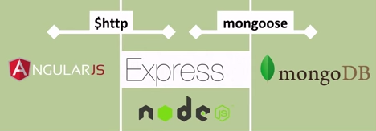

**Node JS Architecture**

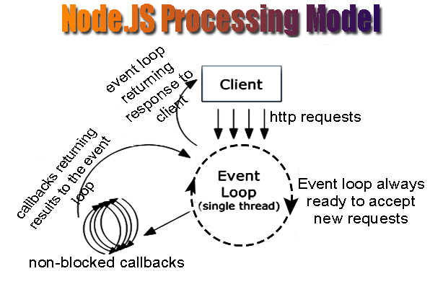

*Node JS is event driven single threaded server programming*

**Pros of Node.JS –**

1. It is actually a server that can execute JavaScript.

2. Open source, cross-platform to develop real-time web applications is Node.

3. Since it runs single-threaded event-based loop, all executions become non-blocking.

4. The asynchronous event-driven IO assists concurrent request handling.

5. The server as well as the client-side uses the similar coding piece resulting into an easy deployment of various web applications making them more effective.

6. Node package modules (npm), has already increased in size and is still growing.

7.Its suitable for mangoDB and there is no need for JSON conversion

8.[real-time audio or video encoding](https://transloadit.com/blog/2010/12/realtime-encoding-over-150x-faster)(we can steam big files)

9.Real time dashboard

**Cons of Node.JS –**

1. One of the biggest drawbacks of Node.js is that it isn’t consistent. It’s several development firms feel that the API keeps enhancing at frequent intervals.

2. It doesn’t support relational databases.

3. If you want to enhance the scalability of Node.js, having an asynchronous programming approach is essential. But developers have a split opinion on this as several feel that this approach is quite complex than the linear blocking I/O programming. Additionally, it also makes the code messy.

4. Unsuitable for large and complicated web applications as Node.js at present, isn’t supportive to both multi-threaded programming’s.

5. Identifying Node JS Resources.

6.Node.js is not suited for CPU-intensive tasks

**Where Node can be the best solution**

**Web Socket Server**

The non-blocking architecture of node makes it the best suited solution for socket server applications or broadcasting like applications. Chat servers can become more efficient and real time using Node.js as their base.

**Fast file upload client**

With node you can upload multiple files at a time. That means it is possible that a part of file1 and another part of file2 is in the server at a given point of time. This approach makes file uploading dramatically fast.

**Data streaming**

As node deals with callback concept, it can easily be used for streaming data flow. It can be really useful for Travel industry where they fetch results from different APIs of different suppliers.

**Ad server**

Well, I personally think Ad servers should be the fastest servers. Because, from a advertiser’s point of view, if I can load the ads before all the contents of the page is loaded, I may catch the visitor. Another is if my ads load slower, the visitor might navigate to somewhere else. So ad servers really need to be fast and thus Node should be used.

**Stock exchange software**

Things has to be very much real time in case of stock updates. Node helps us to develop real time web applications.