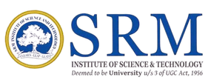
Sustain U – Issue Report

SRM Institute of Science and Technology Sustain U – Digital Issue Reporting System

Student Details

Student Name
Registration Number
Degree / Department
Email ID
Phone Number

Issue Details

Issue Category
Issue Description
Urgency /Severity
Date Reported

Location Information

Building Name
Floor Number
Room / Area Description

Issue Status

Current Status | In Progress / Resolved
Date Resolved

Image Evidence

Before Resolution:

Students Uploaded Photo should be printed here.

After Resolution:

Maintenence Uploaded Photo should be printed here

Generated via Sustain-U | Date:

