“OpenCart theme and Module development” book say “OpenCart is an e-commerce shopping cart application built with its own in-house framework which uses MVCL (Model, view, controller, and language)pattern. Thus, each module in OpenCart also follows the MVCL pattern. The controller creates logic and gathers data from the model and it passes data to display in the view.”
OpenCart is based on this MVCL pattern. Let’s see what is MVCL pattern:
- The user request to the controller through URL,
- The controller loads the language and set the variable for any text used in the data.
- If data is needed from the database controller loads the model, ask for results and model send back results, then controller set results to data.
- All these data are sent to View which renders and shows the output.
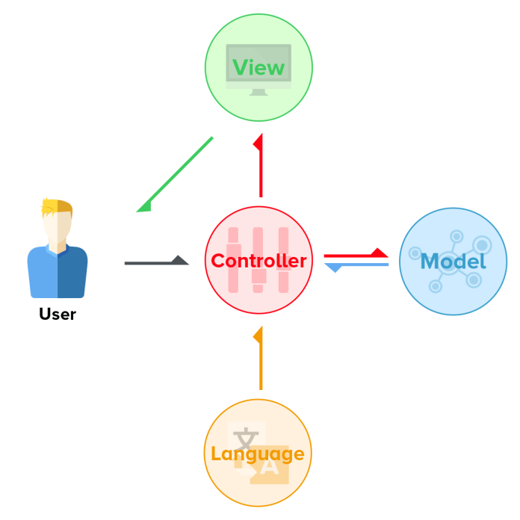From OpenCart.com
In the catalog and admin directories, you can see a tree structure of MVCL so whenever we create modules or pages we follow these directories structure:
- Controller – The controller loads the language and set the variable for any text used in the data. If data is needed from the database controller loads the model, ask for results and model send back results, then controller set results to data.
- Model – Database layer – All calls to the database are done. It is to structure DB calls so that all other files have access to the same DB queries.
- View – Presentation/Template/display layer – This is where the HTML and designing are done in the respective tpl files.
- Language – Localization/Language – This is layer is to make the translation easy, variables and text are assigned and these folder files are translated to the respective language with the same variables name.
OpenCart handles each request with a simple pattern for every incoming request are interpreted by the routing URL “route=” and passed to controller class matching the URL route part which returns Response objects. The controller is the only file in the MVC-L framework to be accessed by URL in OpenCart. The controller is where all logic goes: it’s where you interpret the request and create a response.
It’s that easy! Yes!
- Each request executes a front controller file
- The routing system determines which Controller class index method will be executed based on information from the request and routing URL you’ve passed.
- Returns the appropriate Response object.
Let’s see some example
http://webocreation.loc/index.php?route=account/login
Here “route=account/login”, it means that the controller to find in Opencart is catalog/controller/account/login.php as there is no third one so by default the method is index().
http://webocreation.loc/index.php?route=account/return/add
Here “route=account/return/add”, it means that the controller to find in Opencart is catalog/controller/account/return.php and method is add().

