Business Template

Subject areas
Logo / Image

Contents
Business Description 3
1.1 the Benefits of implementing a database. Project Vision 3
2 Model description 3
2.1 Definitions & Acronyms 3
2.2 Logical Scheme 3
2.3 Objects 3

Business Description

the Benefits of implementing a database. Project Vision
The proposed database supports the operation of a car-sharing service where users can reserve vehicles, perform trips, and pay for usage. The system must track vehicles, users, reservations, trips, and maintenance activities in a consistent and historically traceable way.
A relational database addresses several operational problems. First, it centralizes data about vehicles, users, and trips so that the system can determine which vehicles are available and which users are currently using them. Without a structured database, it would be difficult to reliably track vehicle availability and usage.
Second, the database ensures data integrity and consistency. Primary keys guarantee that each entity is uniquely identified, while foreign keys ensure that relationships between entities remain valid. For example, a trip cannot exist without a valid user and vehicle. Constraints such as unique identifiers for vehicle VIN numbers and user emails prevent duplication.
Third, the system must preserve historical information. Instead of overwriting previous data, the model records events such as trips, maintenance activities, and vehicle status changes in separate tables. This allows the system to reconstruct past operational states and analyze historical activity.
The structure is also designed to scale without major redesign. New users, vehicles, locations, or maintenance records can be added without modifying the core schema. If the service expands to additional cities or introduces new vehicle categories, these can be added through existing tables without structural changes.
To maintain data correctness as the system grows, the database includes constraints such as:
- primary keys to uniquely identify records
- foreign keys to enforce relationships between tables
- unique constraints for identifiers like VIN numbers or email addresses
- check constraints to restrict invalid values (for example rating values between 1 and 5)
These mechanisms ensure that the database maintains reliable and consistent data as the platform grows.

Model description

Definitions & Acronyms
User – a registered customer of the car-sharing service who can reserve and use vehicles.
Vehicle – a car available within the car-sharing fleet.
Vehicle Type – a classification of vehicles that determines pricing characteristics.
Trip – a usage session during which a user unlocks a vehicle, drives it, and ends the ride.
Reservation – a temporary booking that allows a user to hold a vehicle before starting a trip.
Vehicle Status – the operational state of a vehicle at a specific moment (available, reserved, in use, or maintenance).
Maintenance Record – documentation of maintenance work performed on a vehicle.
Inspection – a technical check of a vehicle performed by an employee to verify its condition.
Location – a geographic position where vehicles may be parked or where trips may begin or end.

Logical Scheme

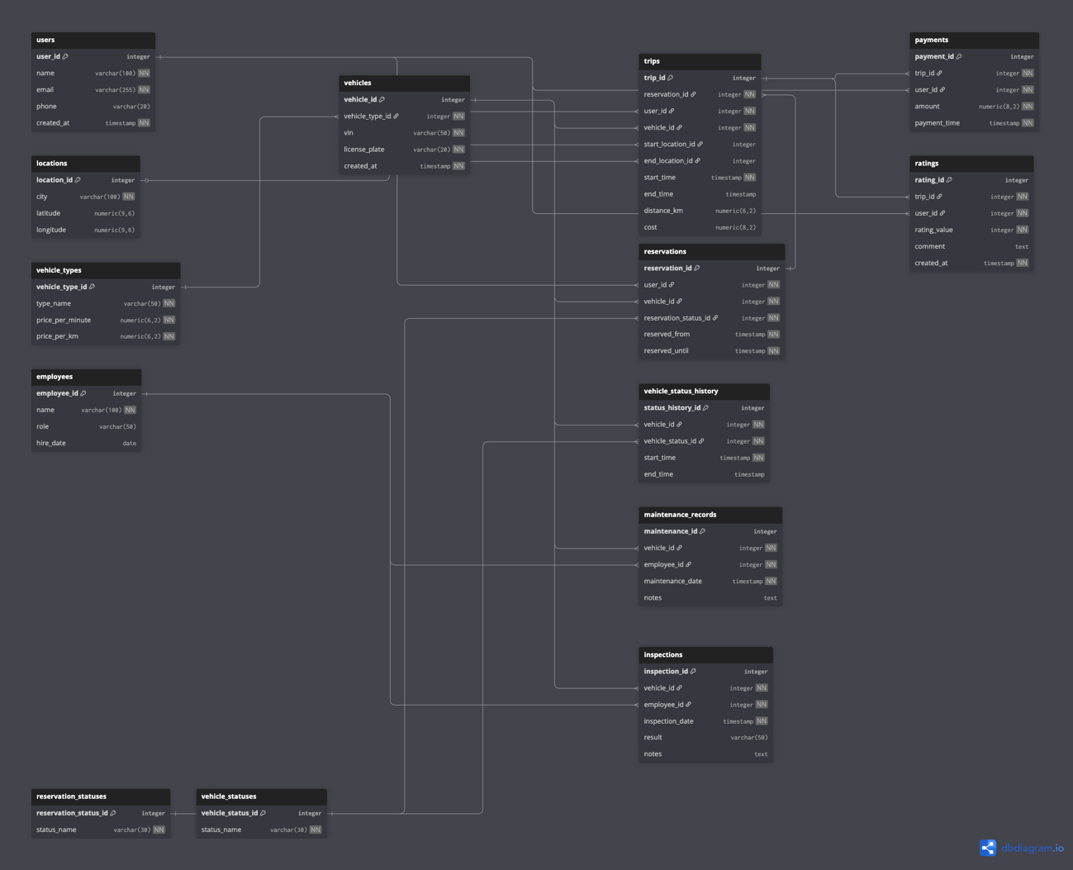

Most Difficult Modeling Decision
The most difficult modeling decision involved representing vehicle availability over time.Initially, it seemed possible to store vehicle status directly in the vehicles table. However, this approach would overwrite previous states and make it impossible to reconstruct historical availability. To solve this problem, a separate table called vehicle_status_history was introduced. Each record represents a time interval during which a vehicle had a specific status. When the status changes, a new record is inserted instead of updating the previous one. This design ensures that historical data is preserved and allows the system to analyze past vehicle availability.

Data Anomalies Prevented
The database design prevents several types of data anomalies.
Update anomalies are avoided because information about vehicles, users, and vehicle types is stored in separate tables. For example, updating pricing information for a vehicle type does not require modifying every vehicle record.
Insertion anomalies are prevented because entities such as vehicles and users can exist independently of operational events such as trips or reservations.
Deletion anomalies are avoided because historical events are stored in dedicated tables. Deleting an active vehicle from service does not remove the trip history or maintenance records associated with that vehicle.

Scalability of the Model
The model is designed to remain scalable as the system grows. New users, vehicles, and maintenance activities can be added without changing the structure of the database.
If the service expands to additional cities, the locations table allows trips and vehicles to be associated with different geographic areas without redesigning the schema.

Potential Future Changes
The component most likely to evolve is the pricing structure. If the company introduces dynamic pricing, discounts, or subscription plans, additional tables could be added to represent pricing rules. These changes would affect pricing-related tables but would not require modifications to the core entities such as users, vehicles, or trips.

Objects
Car Sharing Service – Database Documentation (Corrected)

Table: users
The users table stores registered customers of the car-sharing platform. Each row represents one person who can create reservations, perform trips, make payments, and leave ratings. Normalization level: 3NF. All attributes are atomic, all non-key attributes depend only on the primary key user_id, and there are no transitive dependencies.
Field description:
Field name | Field description | Data type | Conditions
user_id | Primary key. Unique identifier of the user. | integer | PK, NOT NULL
name | Full name of the user. | varchar(100) | NOT NULL
email | Email address of the user. | varchar(255) | NOT NULL, UNIQUE
phone | Phone number of the user. | varchar(20) | NULL
created_at | Timestamp when the account was created. | timestamp | NOT NULL, DEFAULT now()
Comments on table relationships:
One-to-many relationship between users (user_id) and reservations (user_id) – one user can create many reservations, but each reservation belongs to one user.
One-to-many relationship between users (user_id) and trips (user_id) – one user can perform many trips over time.
One-to-many relationship between users (user_id) and payments (user_id) – one user can make many payments for completed trips.
One-to-many relationship between users (user_id) and ratings (user_id) – one user can leave many ratings.
Example with data:
user_id | name | email | phone | created_at
1 | Asan Asanov | asan@mail.com | +12345678 | 2026-03-01 10:00:00
2 | Akylai Usonova | akylai@mail.com | +87654321 | 2026-03-02 11:30:00

Table: vehicle_types
The vehicle_types table stores categories of vehicles and their pricing parameters. It is separated from vehicles to avoid repeating the same type and pricing attributes for every car. Normalization level: 3NF. All attributes depend only on vehicle_type_id, with no partial or transitive dependencies.
Field description:
Field name | Field description | Data type | Conditions
vehicle_type_id | Primary key. Unique identifier of the vehicle type. | integer | PK, NOT NULL
type_name | Name of the vehicle category. | varchar(50) | NOT NULL, UNIQUE
price_per_minute | Base price charged per minute of usage. | numeric(6,2) | NOT NULL, CHECK >= 0
price_per_km | Base price charged per kilometer. | numeric(6,2) | NOT NULL, CHECK >= 0
Comments on table relationships:
One-to-many relationship between vehicle_types (vehicle_type_id) and vehicles (vehicle_type_id) – one vehicle type can classify many vehicles.
Example with data:
vehicle_type_id | type_name | price_per_minute | price_per_km
1 | Economy | 0.30 | 0.50
2 | Premium | 0.50 | 0.80

Table: vehicles
The vehicles table stores cars available in the fleet. It contains stable vehicle-level attributes and is referenced by operational tables such as reservations, trips, maintenance, inspections, and status history. Normalization level: 3NF. All non-key attributes depend only on vehicle_id. The primary identifier is vehicle_id, while vin is a business attribute with a UNIQUE constraint, not the row identifier.
Field description:
Field name | Field description | Data type | Conditions
vehicle_id | Primary key. Unique identifier of the vehicle record. | integer | PK, NOT NULL
vehicle_type_id | Reference to the vehicle type. | integer | FK, NOT NULL
vin | Vehicle identification number. | varchar(50) | NOT NULL, UNIQUE
license_plate | Official registration number. | varchar(20) | NOT NULL, UNIQUE
created_at | Timestamp when the vehicle was added to the fleet. | timestamp | NOT NULL, DEFAULT now()
Comments on table relationships:
One-to-many relationship between vehicle_types (vehicle_type_id) and vehicles (vehicle_type_id) – each vehicle belongs to one vehicle type.
One-to-many relationship between vehicles (vehicle_id) and reservations (vehicle_id) – one vehicle can be reserved many times.
One-to-many relationship between vehicles (vehicle_id) and vehicle_status_history (vehicle_id) – one vehicle can have many historical status records.
One-to-many relationship between vehicles (vehicle_id) and trips (vehicle_id) – one vehicle can participate in many trips over time.
One-to-many relationship between vehicles (vehicle_id) and maintenance_records (vehicle_id) – one vehicle can have many maintenance operations.
One-to-many relationship between vehicles (vehicle_id) and inspections (vehicle_id) – one vehicle can have many inspections.
Example with data:
vehicle_id | vehicle_type_id | vin | license_plate | created_at
1 | 1 | VIN123456789 | AB123CD | 2026-03-01 09:00:00
2 | 2 | VIN987654321 | BC234DE | 2026-03-01 09:15:00

Table: locations
The locations table stores geographic points used as trip starting and ending locations. It is separated to avoid repeating location data in every trip row. Normalization level: 3NF. All attributes depend only on location_id.
Field description:
Field name | Field description | Data type | Conditions
location_id | Primary key. Unique identifier of the location. | integer | PK, NOT NULL
city | City where the location is situated. | varchar(100) | NOT NULL
latitude | Latitude coordinate. | numeric(9,6) | NULL
longitude | Longitude coordinate. | numeric(9,6) | NULL
Comments on table relationships:
One-to-many relationship between locations (location_id) and trips (start_location_id) – one location can be the start point for many trips.
One-to-many relationship between locations (location_id) and trips (end_location_id) – one location can be the end point for many trips.
Example with data:
location_id | city | latitude | longitude
1 | Bishkek | 42.874600 | 74.569800
2 | Bishkek | 42.880000 | 74.590000

Table: reservation_statuses
The reservation_statuses table stores normalized reservation status values. It prevents repeated free-text status labels in the reservations table and improves consistency. Normalization level: 3NF. The table stores one reference concept, and all attributes depend only on reservation_status_id.
Field description:
Field name | Field description | Data type | Conditions
reservation_status_id | Primary key. Unique identifier of the reservation status. | integer | PK, NOT NULL
status_name | Name of the reservation status. | varchar(30) | NOT NULL, UNIQUE
Comments on table relationships:
One-to-many relationship between reservation_statuses (reservation_status_id) and reservations (reservation_status_id) – one status can be assigned to many reservations.
Example with data:
reservation_status_id | status_name
1 | active
2 | completed

Table: reservations
The reservations table stores booking events created by users before trips begin. It connects users with vehicles and records the reservation time window. Reservation status is normalized into a separate lookup table. Normalization level: 3NF. All non-key attributes depend only on reservation_id, and status text is removed to avoid transitive dependency through a repeated label.
Field description:
Field name | Field description | Data type | Conditions
reservation_id | Primary key. Unique identifier of the reservation. | integer | PK, NOT NULL
user_id | User who created the reservation. | integer | FK, NOT NULL
vehicle_id | Vehicle being reserved. | integer | FK, NOT NULL
reservation_status_id | Reference to normalized reservation status. | integer | FK, NOT NULL
reserved_from | Reservation start timestamp. | timestamp | NOT NULL
reserved_until | Reservation end timestamp. | timestamp | NOT NULL
Comments on table relationships:
One-to-many relationship between users (user_id) and reservations (user_id) – one user can create many reservations.
One-to-many relationship between vehicles (vehicle_id) and reservations (vehicle_id) – one vehicle can appear in many reservations over time.
One-to-many relationship between reservation_statuses (reservation_status_id) and reservations (reservation_status_id) – each reservation has one normalized status.
One-to-one relationship between reservations (reservation_id) and trips (reservation_id) – one reservation can lead to zero or one trip, and each trip must reference one reservation.
Example with data:
reservation_id | user_id | vehicle_id | reservation_status_id | reserved_from | reserved_until
1 | 1 | 1 | 1 | 2026-03-03 08:00:00 | 2026-03-03 08:30:00
2 | 2 | 2 | 2 | 2026-03-03 09:00:00 | 2026-03-03 09:30:00

Table: vehicle_statuses
The vehicle_statuses table stores normalized vehicle status values such as available, reserved, in_use, and maintenance. It prevents repeated text values in the vehicle status history table. Normalization level: 3NF. It stores one reference concept and has no partial or transitive dependencies.
Field description:
Field name | Field description | Data type | Conditions
vehicle_status_id | Primary key. Unique identifier of the vehicle status. | integer | PK, NOT NULL
status_name | Name of the vehicle status. | varchar(30) | NOT NULL, UNIQUE
Comments on table relationships:
One-to-many relationship between vehicle_statuses (vehicle_status_id) and vehicle_status_history (vehicle_status_id) – one normalized status can be used in many history records.
Example with data:
vehicle_status_id | status_name
1 | available
2 | in_use

Table: vehicle_status_history
The vehicle_status_history table preserves historical changes in vehicle availability. Each row represents a time interval during which a vehicle had a particular status. Status values are normalized through the vehicle_statuses table. Normalization level: 3NF. All attributes depend only on status_history_id, and the status label itself is separated into a reference table.
Field description:
Field name | Field description | Data type | Conditions
status_history_id | Primary key. Unique identifier of the history row. | integer | PK, NOT NULL
vehicle_id | Vehicle whose status is being recorded. | integer | FK, NOT NULL
vehicle_status_id | Reference to normalized vehicle status. | integer | FK, NOT NULL
start_time | Timestamp when the status became effective. | timestamp | NOT NULL
end_time | Timestamp when the status ended. | timestamp | NULL
Comments on table relationships:
One-to-many relationship between vehicles (vehicle_id) and vehicle_status_history (vehicle_id) – one vehicle has many status history rows.
One-to-many relationship between vehicle_statuses (vehicle_status_id) and vehicle_status_history (vehicle_status_id) – each history row uses one normalized status.
Example with data:
status_history_id | vehicle_id | vehicle_status_id | start_time | end_time
1 | 1 | 1 | 2026-03-01 09:00:00 | 2026-03-03 08:00:00
2 | 1 | 2 | 2026-03-03 08:00:00 | 2026-03-03 08:25:00

Table: trips
The trips table stores vehicle usage sessions performed by users. Each trip is linked to a reservation, user, vehicle, and start/end locations. This reflects the business assumption that every trip goes through a reservation. Normalization level: 3NF. All non-key attributes depend only on trip_id, and lookup data is separated into reference tables where appropriate.
Field description:
Field name | Field description | Data type | Conditions
trip_id | Primary key. Unique identifier of the trip. | integer | PK, NOT NULL
reservation_id | Reference to the reservation that led to the trip. | integer | FK, NOT NULL, UNIQUE
user_id | User performing the trip. | integer | FK, NOT NULL
vehicle_id | Vehicle used in the trip. | integer | FK, NOT NULL
start_location_id | Trip starting location. | integer | FK, NULL
end_location_id | Trip ending location. | integer | FK, NULL
start_time | Timestamp when the trip started. | timestamp | NOT NULL
end_time | Timestamp when the trip ended. | timestamp | NULL
distance_km | Distance traveled during the trip. | numeric(6,2) | NULL, CHECK >= 0
cost | Calculated cost of the trip. | numeric(8,2) | NULL, CHECK >= 0
Comments on table relationships:
One-to-one relationship between reservations (reservation_id) and trips (reservation_id) – each trip must come from one reservation, and one reservation can produce at most one trip.
One-to-many relationship between users (user_id) and trips (user_id) – one user can perform many trips.
One-to-many relationship between vehicles (vehicle_id) and trips (vehicle_id) – one vehicle can be used in many trips over time.
One-to-many relationship between locations (location_id) and trips (start_location_id) – one location can be the start point for many trips.
One-to-many relationship between locations (location_id) and trips (end_location_id) – one location can be the end point for many trips.
One-to-one relationship between trips (trip_id) and payments (trip_id) – one trip generates one payment record.
One-to-one relationship between trips (trip_id) and ratings (trip_id) – one completed trip can have one rating.
Example with data:
trip_id | reservation_id | user_id | vehicle_id | start_location_id | end_location_id | start_time | end_time | distance_km | cost
1 | 1 | 1 | 1 | 1 | 2 | 2026-03-03 08:05:00 | 2026-03-03 08:35:00 | 12.50 | 10.00
2 | 2 | 2 | 2 | 2 | 1 | 2026-03-03 09:05:00 | 2026-03-03 09:40:00 | 8.20 | 8.56

Table: employees
The employees table stores staff members responsible for technical inspections and maintenance tasks. It is separated so employee information is not duplicated in operational maintenance and inspection rows. Normalization level: 3NF. All attributes depend only on employee_id.
Field description:
Field name | Field description | Data type | Conditions
employee_id | Primary key. Unique identifier of the employee. | integer | PK, NOT NULL
name | Full name of the employee. | varchar(100) | NOT NULL
role | Job role of the employee. | varchar(50) | NULL
hire_date | Date the employee started work. | date | NULL
Comments on table relationships:
One-to-many relationship between employees (employee_id) and maintenance_records (employee_id) – one employee can perform many maintenance operations.
One-to-many relationship between employees (employee_id) and inspections (employee_id) – one employee can perform many inspections.
Example with data:
employee_id | name | role | hire_date
1 | John Smith | mechanic | 2024-01-15
2 | Anna Lee | inspector | 2024-02-01

Table: maintenance_records
The maintenance_records table stores maintenance operations performed on vehicles by employees. It also implements the many-to-many relationship between vehicles and employees because one employee can service many vehicles and one vehicle can be serviced by many employees over time. Normalization level: 3NF. All attributes depend only on maintenance_id, and no non-key attribute depends on another non-key attribute.
Field description:
Field name | Field description | Data type | Conditions
maintenance_id | Primary key. Unique identifier of the maintenance record. | integer | PK, NOT NULL
vehicle_id | Vehicle that was serviced. | integer | FK, NOT NULL
employee_id | Employee who performed the maintenance. | integer | FK, NOT NULL
maintenance_date | Timestamp of the maintenance event. | timestamp | NOT NULL
notes | Additional notes about the work performed. | text | NULL
Comments on table relationships:
Many-to-many relationship between vehicles and employees implemented through maintenance_records – this table links one vehicle and one employee for a specific maintenance event.
Many-to-one relationship from maintenance_records (vehicle_id) to vehicles (vehicle_id) – each maintenance record belongs to one vehicle.
Many-to-one relationship from maintenance_records (employee_id) to employees (employee_id) – each maintenance record belongs to one employee.
Example with data:
maintenance_id | vehicle_id | employee_id | maintenance_date | notes
1 | 1 | 1 | 2026-03-04 10:00:00 | oil change
2 | 2 | 1 | 2026-03-04 11:00:00 | brake check

Table: inspections
The inspections table stores technical inspection events performed on vehicles by employees. It is separate from maintenance because an inspection may occur without repair work. Normalization level: 3NF. All attributes depend only on inspection_id.
Field description:
Field name | Field description | Data type | Conditions
inspection_id | Primary key. Unique identifier of the inspection record. | integer | PK, NOT NULL
vehicle_id | Vehicle that was inspected. | integer | FK, NOT NULL
employee_id | Employee who performed the inspection. | integer | FK, NOT NULL
inspection_date | Timestamp of the inspection. | timestamp | NOT NULL
result | Inspection result. | varchar(50) | NULL
notes | Additional inspection notes. | text | NULL
Comments on table relationships:
One-to-many relationship between vehicles (vehicle_id) and inspections (vehicle_id) – one vehicle can have many inspections.
One-to-many relationship between employees (employee_id) and inspections (employee_id) – one employee can perform many inspections.
Example with data:
inspection_id | vehicle_id | employee_id | inspection_date | result | notes
1 | 1 | 2 | 2026-03-04 09:00:00 | OK | No issues found
2 | 2 | 2 | 2026-03-04 09:30:00 | OK | Tires acceptable

Table: payments
The payments table stores payment transactions generated by completed trips. It is separated from trips because payment is a distinct business event and may require its own controls and constraints. Normalization level: 3NF. All attributes depend only on payment_id.
Field description:
Field name | Field description | Data type | Conditions
payment_id | Primary key. Unique identifier of the payment. | integer | PK, NOT NULL
trip_id | Reference to the trip being paid for. | integer | FK, NOT NULL, UNIQUE
user_id | Reference to the paying user. | integer | FK, NOT NULL
amount | Payment amount. | numeric(8,2) | NOT NULL, CHECK >= 0
payment_time | Timestamp of payment. | timestamp | NOT NULL
Comments on table relationships:
One-to-one relationship between trips (trip_id) and payments (trip_id) – each trip generates one payment.
One-to-many relationship between users (user_id) and payments (user_id) – one user can make many payments.
Example with data:
payment_id | trip_id | user_id | amount | payment_time
1 | 1 | 1 | 10.00 | 2026-03-03 08:36:00
2 | 2 | 2 | 8.56 | 2026-03-03 09:41:00

Table: ratings
The ratings table stores user feedback for completed trips. It is kept separate because feedback is an optional post-trip event and does not belong directly to the trip core attributes. Normalization level: 3NF. All attributes depend only on rating_id, and created_at has a default value for insertion consistency.
Field description:
Field name | Field description | Data type | Conditions
rating_id | Primary key. Unique identifier of the rating. | integer | PK, NOT NULL
trip_id | Reference to the rated trip. | integer | FK, NOT NULL, UNIQUE
user_id | Reference to the user who left the rating. | integer | FK, NOT NULL
rating_value | Numeric rating value. | integer | NOT NULL, CHECK between 1 and 5
comment | Optional text feedback. | text | NULL
created_at | Timestamp when the rating was created. | timestamp | NOT NULL, DEFAULT now()
Comments on table relationships:
One-to-one relationship between trips (trip_id) and ratings (trip_id) – one completed trip can have one rating.
One-to-many relationship between users (user_id) and ratings (user_id) – one user can leave many ratings.
Example with data:
rating_id | trip_id | user_id | rating_value | comment | created_at
1 | 1 | 1 | 5 | Great trip | 2026-03-03 08:40:00
2 | 2 | 2 | 4 | Good overall | 2026-03-03 09:45:00

