Suggested Reviewers
Anne-Ruxandra Carvunis (de novo gene origination)
Erich Bornberg-Bauer (de novo gene origination)
Stephan Schneuwly (Zn regulation in Drosophila)
Erna Davydova (METTL9 biochemistry)

Title: Naturally arising de novo open reading frames as potential zinc chelators in Drosophila melanogaster

Authors: UnJin Lee¹*

¹Laboratory of Evolutionary Genetics and Genomics, The Rockefeller University, New York, NY, 10065, USA
*Correspondence to: ulee@rockefeller.edu

Abstract:
A central open problem in the study of de novo gene origination is that the molecular mechanisms and functions driving the emergence of such evolutionarily young, de novo protein-coding genes remain poorly understood. Metal chelation, a simple, directly selectable activity that both requires no specific interaction partners and is also compatible with intrinsic disorder, is one possible function. This possibility was tested using sequence signatures in 7,849 transcriptionally supported, still-segregating Drosophila melanogaster de novo open reading frames. Interestingly, these new open reading frames (neORFs) are enriched for bis-histidine motifs at the metal-coordination-competent spacings H-x-H and H-x-x-x-H and show no enrichment at the incompatible even spacings relative to repeat-masked intergenic ORFs. Notably, these neORFs were also found to lack the C-x-x-C grammar of canonical metal-binding proteins. I report that this H-x-H bis-histidine signal is generated by translation of (CA)ₙ microsatellites into His-Thr-His in Drosophila melanogaster, as evidenced by a CAC-codon bias within H-x-H motifs and a fourfold threonine enrichment at the central position. I propose that recurrent microsatellite expansion supplies Drosophila with a distributed, independently originated class of candidate metal-binding de novo peptides. I then trace one neORF (ZMEG) from conserved ancestral non-coding sequence to a transcribed, melanogaster-lineage open reading frame whose (CA)9-derived His run presents a candidate His32–His36 bis-histidine site. I propose that such de novo proteins may constitute a class of molecules united not by common descent but by their shared origin in evolvable repeat sequence, highlighting the importance of emergence bias in molecular evolution.

Introduction
Are de novo genes real?
While the majority of work on new gene origination, or the appearance of evolutionarily young genes, has been focused on duplicate gene evolution and gene family expansions (Zhang 2003), much effort has been made to both establish and validate the existence of genes that have arisen de novo, i.e. protein-coding genes that have arisen from ancestrally inactive genomic sequences (Van Oss & Carvunis 2019). Early work focused particularly on understanding this phenomenon on both a species (Levine et al. 2006) and population (Zhao et al. 2014) level within Drosophila. Despite lingering doubts, subsequent follow-up work has been performed in order to characterize the biophysical properties of such de novo genes (Grandchamp et al. 2023; Wilson et al. 2017; Peng & Zhao 2024), revealing common trends, such as high levels of intrinsic disorder and short ORF length (Peng & Zhao 2024) — effects that have generally been ascribed to pre-adaptation (Wilson et al. 2017; Wilson & Masel 2011), and the ambush hypothesis (Seligmann & Pollock 2004). Despite this work, widespread acceptance of the existence of de novo genes has been hampered by the lack of ascribable function for these genes.

Prior efforts have attempted to explain the evolutionary forces driving the origination and retention of these genes, such as the proto-gene (Carvunis et al. 2012), transcription-first (Van Oss & Carvunis 2019), and pre-adaptation models (Wilson & Masel 2011; Wilson et al. 2017). However, such models are generally unsatisfying in that they do not directly tackle the question of function. One exception is the recently proposed cultivator model of de novo gene origination (Lee et al. 2024b; Lee et al. 2025), which posits that the transcriptional activation of a new promoter is a crude but highly evolvable mechanism that selects for transcriptional activity not of the newly evolved de novo transcript, but of its neighboring genes through physical, distance-based effects such as transcriptional interference (Fukaya, et al. 2016; Keller et al. 2023; Leyes Porello et al. 2026) or supercoiling mediated coupling (Johnstone & Galloway 2022). Indeed, such rapid evolvability has been shown to be critical in the understanding of the evolutionary trajectories of duplicate genes arising via some form of emergence bias (Fuqua & Vakirlis 2026), either through the innovation-amplification-divergence model (Bergthorsson et al. 2007; Näsvall et al. 2012), and/or the enhancer capture-divergence model (Lee et al. 2024a). However, the cultivator model remains unsatisfying, as it can only provide an evolutionary mechanism describing the earliest stages of de novo gene origination, i.e. non-coding RNA (ncRNA), and remains unsatisfactory for explaining the persistence and function of protein-coding de novo genes.

The general acceptance of de novo origination has also been further hampered by key confounding technical factors found in many de novo gene studies, e.g. short peptide length (Peng & Zhao 2024), and the natural limits of homology identification in divergent species (Weisman et al. 2020). Instead, putative de novo gene origination events are difficult to untangle from the duplication-based origination mechanisms underlying orphan genes (Tautz & Domazet-Lošo 2011) — duplicate genes that have diverged so rapidly from their parental gene that homology is impossible to detect (Weisman et al. 2020). However, the recent explosion of high-quality genome annotations of a vast number of species has accelerated the study of de novo genes, providing increased support for claims of de novo origination beyond the absence of detectable homology. For example, phylostratigraphic methodologies heavily rely on synteny to positively demonstrate the absence of transcriptional units in ancestral states (Grandchamp et al. 2023; Carvunis et al. 2012; Vakirlis et al. 2020b). While such approaches do not necessarily exclude the possibility of duplication, either symmetrically in tandem or asymmetrically over larger distances that traverse across topologically associating domains (TADs), they do allow for the positive identification of an absence of a transcription unit at an ancestral locus. Other efforts have also utilized direct identification of ancestral sequence in combination with synteny to positively identify the lack of transcription via the usage of mock annotations in outgroup species (Lee et al. 2025). By using RNA-seq data from outgroup species, such an approach can definitively demonstrate that sequences ancestral to de novo genes (used here to include both protein-coding and ncRNA genes) were truly transcriptionally inactive (Lee et al. 2025). However, this approach has been used mostly to identify de novo non-coding RNAs, leaving a gap in our understanding of how de novo protein coding genes may arise naturally.

What do de novo proteins do?
A comprehensive analysis of protein function provides the following list of possible mechanisms driving de novo gene fixation. First is pre-adaptation, the claim that selection acts to minimize the genomic harm done by previously fixed de novo proteins subsequent to the neutral fixation of a random protein-coding gene (Wilson et al. 2017; Wilson & Masel 2011). Unlike the other putative functions listed here, this function — or lack thereof — is driven by negative selection against some unknown deleterious interaction. Another possibility is the appearance of a fortuitous but beneficial interaction with some number of pre-existing interaction partners that drives the new de novo protein to fixation. Possible sub-mechanisms include general protein-protein interaction via disordered regions (Peng & Zhao 2026), the refinement of regulatory function of pre-existing genes (Lee et al. 2024b), or the titration of thermodynamic properties of liquid-liquid phase separated condensates (LLPS). This last possibility also opens the door to more interesting possibilities, allowing for the potential of de novo proteins playing roles in cellular-scale phenomena either via direct interaction with condensates or surface adsorption (Brangwynne et al. 2009). One concrete example would be similar in nature to the duplicate gene HP6/Umbrea, a known heterochromatin protein (Ross et al. 2013; Greil et al. 2007). Another potential mechanism would be membrane-based interactions (Vakirlis et al. 2020a). Whatever the case, protein-protein interactions often have strong sequence-specific signatures in the form of short linear motifs (SLiM)(Kumar et al. 2024), such as in the case of the known PxVxL signature found in HP6/Umbrea (Ross et al. 2013).

One previously under-appreciated possibility is that de novo proteins may act as chelating agents, a function that is highly consistent with commonly observed properties of de novo genes such as intrinsic disorder. This is an attractive possibility, as chelation provides a simple, direct, selectable function that does not specifically require interaction between a nascent de novo protein and the rest of the proteome. While some degree of interaction is likely to occur between nascent de novo proteins and other proteins, variants producing such proteins are expected to be retained so long as the net selective effect of such incidental interactions remains positive. Further refinement or purging of such deleterious interactions could be explained by pre-adaptation (Wilson & Masel 2011), but the mechanism driving the original fixation events remains to be explained under that model.

Two primary signatures are known to be associated with chelation. First, pairs of cysteine residues in the configuration C-C or C-x-x-C are widely recurring motifs in metal- and disulfide-coordinating proteins (Fomenko & Gladyshev 2003). In Drosophila, proteins bearing these motifs, such as the cysteine-rich metallothioneins, are transcriptionally induced by the MTF-1 (metal-responsive transcription factor 1) pathway (Zhang et al. 2001). Additionally, pairs of histidine molecules are also known motifs for chelation due to histidine’s partially protonated imidazole residue (Sundberg & Martin 1974). The ordering for these histidines is critical for establishing metal-binding function, manifesting as H-x-H and H-x-x-x-H motifs, where x is an uncharged residue (Vallee & Auld 1990). Importantly, H-H and H-x-x-H motifs are disfavored for metal-binding function, as the imidazole residues chelate only when both residues converge on the same ion (Sundberg & Martin 1974; Alberts et al. 1998; Karlin & Zhu 1997). Because histidine is itself the substrate of METTL9-family protein histidine methyltransferases, whose methylation can attenuate metal binding, any (CA)n-derived histidine site is in principle subject to post-translational control (Davydova et al. 2021; Cao et al. 2024). In order to test for bis-histidine residue chelation as a mechanism driving de novo protein origination and retention, I utilized an existing dataset of high-confidence, population-level, new expressed ORFs (neORFs) to test for enrichment of histidine chelation-associated amino acid signatures in a panel of 7867 transcriptionally supported, young de novo proteins (neORFs) that are still segregating in Drosophila melanogaster (Materials and Methods)(Grandchamp et al. 2023). Importantly, neORFs consist of the category of de novo ORFs that appear in fewer than 7 strains out of a total of 7 independent, iso-female lines of D. melanogaster (Grandchamp et al. 2023). I then identify and analyze potential biochemical function of a candidate chelating neORF, which I term zmeygorynych (ZMEG), after the mythological three-headed dragon described in Eastern Slavic folklore.

Results
neORFs are enriched for H-x-H bis-histidine coordinate chemistry
To test for potential enrichment of bis-histidine-driven chelation in de novo proteins, the relative number of various H-(x)n-H configurations was calculated for three classes of validated, transcriptionally active genes: neORFs (N=7,849, ℓ_{0.5}=64 aa), transcriptionally inactive, intergenic, repeat-masked ORFs (N=1,472,446, ℓ_{0.5}=22 aa), and known metal-binding proteins from UniProt (KW-0479)(N=856, ℓ_{0.5}=538 aa). Specifically, the number of motifs of each category was calculated, then compared to the number of motifs expected by chance alone (Materials and Methods). In addition to a cyclic pattern of enrichment for odd n, consistent with bis-histidine chelation, the number of detected H-x-H patterns in neORFs was significantly enriched over the expectation from repeat-masked intergenic ORFs extracted from the D. melanogaster genome (Figure 1A). Additionally, no significant difference was found in the inert H-x-x-H configuration. The relative number of neORFs again increases in the H-x-x-x-H configuration, then continues to repeat in a cyclical manner, consistent with the geometry of bis-histidine chelation—though, as established below, this odd-spacing periodicity is a mechanical consequence of the underlying (CA)n reading frame rather than, in itself, evidence that chelation drives the origination or retention of neORFs in Drosophila melanogaster. Notably, the relative number of inter-histidine residues reached a maximum at n=3 (H-x-x-x-H) for metal binding proteins, consistent with the α-helix register. This reflects different motifs predominant in HExxH zincin proteases, including the gluzincins thermolysin and neprilysin, and the metzincins MMPs and ADAMs (Hooper 1994; Bode et al. 1993), and C2H2 zinc fingers, where both motifs coordinate the ion with two histidines one helical turn apart (Pavletich & Pabo 1991).

Interestingly, repeat-masked intergenic sequences showed elevated levels of H-x-H sequences in comparison to GC- and length-controlled random sequences, suggesting that intergenic sequences may be poised for generating H-x-H sequences when compared to random sequence (Figure 1B). One possibility is that such sequences arise from (CA)n dinucleotide repeats (see below). Additionally, another potential driving force may be recent pseudogenization of previously existing neORFs. The possibility of ancestral or residual protein-coding capacity is partially supported by the observation that the median length (ℓ_{0.5}) of intergenic ORFs increases from 22 aa to 40 aa if the intergenic ORF has ≥ 2 histidine units. This latent potential for H-x-H motif appearance is also elevated when compared to a length-matched proteome sample (N=7,849, ℓ_{0.5}=64 aa), suggesting that the presence of H-x-H motifs is actively selected against and averaged over in proteins that do not bind to metals. The prevalence of H-x-H in neORFs is also notable, as there is no significant difference between neORFs and metal-binders specifically within H-x-H motifs (Figure 1B).

The preference for neORFs to show H-x-H motifs is striking in comparison to C-x-x-C chelation motifs. Here, random sequence, the length-matched proteome sample, intergenic sequence, and de novo neORFs appear to have no notable preference for C-x-x-C motifs. Alternatively, the C-x-x-C motif is a strong feature of known metal-binding proteins, showing a nearly 5x elevation of motif prevalence in comparison to all other categories (Figure 1C). This result suggests that the known class of metal-binding proteins have at least two distinct mechanisms by which they chelate metals, one that is shared with neORFs, and one exclusive to old, conserved metal-binding proteins (see “De novo genes as a potential zinc regulator”). An examination of both the raw incidence rate and the density of H-x-H vs C-x-x-C motifs further supports the conclusion that neORFs are preferentially enriched for bis-histidine coordinate chemistry, rather than C-x-x-C chelation. Specifically, while the incidence and density of these motifs in known metal-binders remains high, the length-matched proteome sample is depleted for H-x-H motifs in comparison to neORFs, this pattern is reversed for C-x-x-C motifs (Figure 1D-E). Interestingly, while the cluster incidence of H-x-H and C-x-x-C motifs is elevated for known metal-binding proteins in comparison to other gene classes, the density of these motifs is relatively low in metal-binding protein resulting from generally longer protein length (Figure 1E).

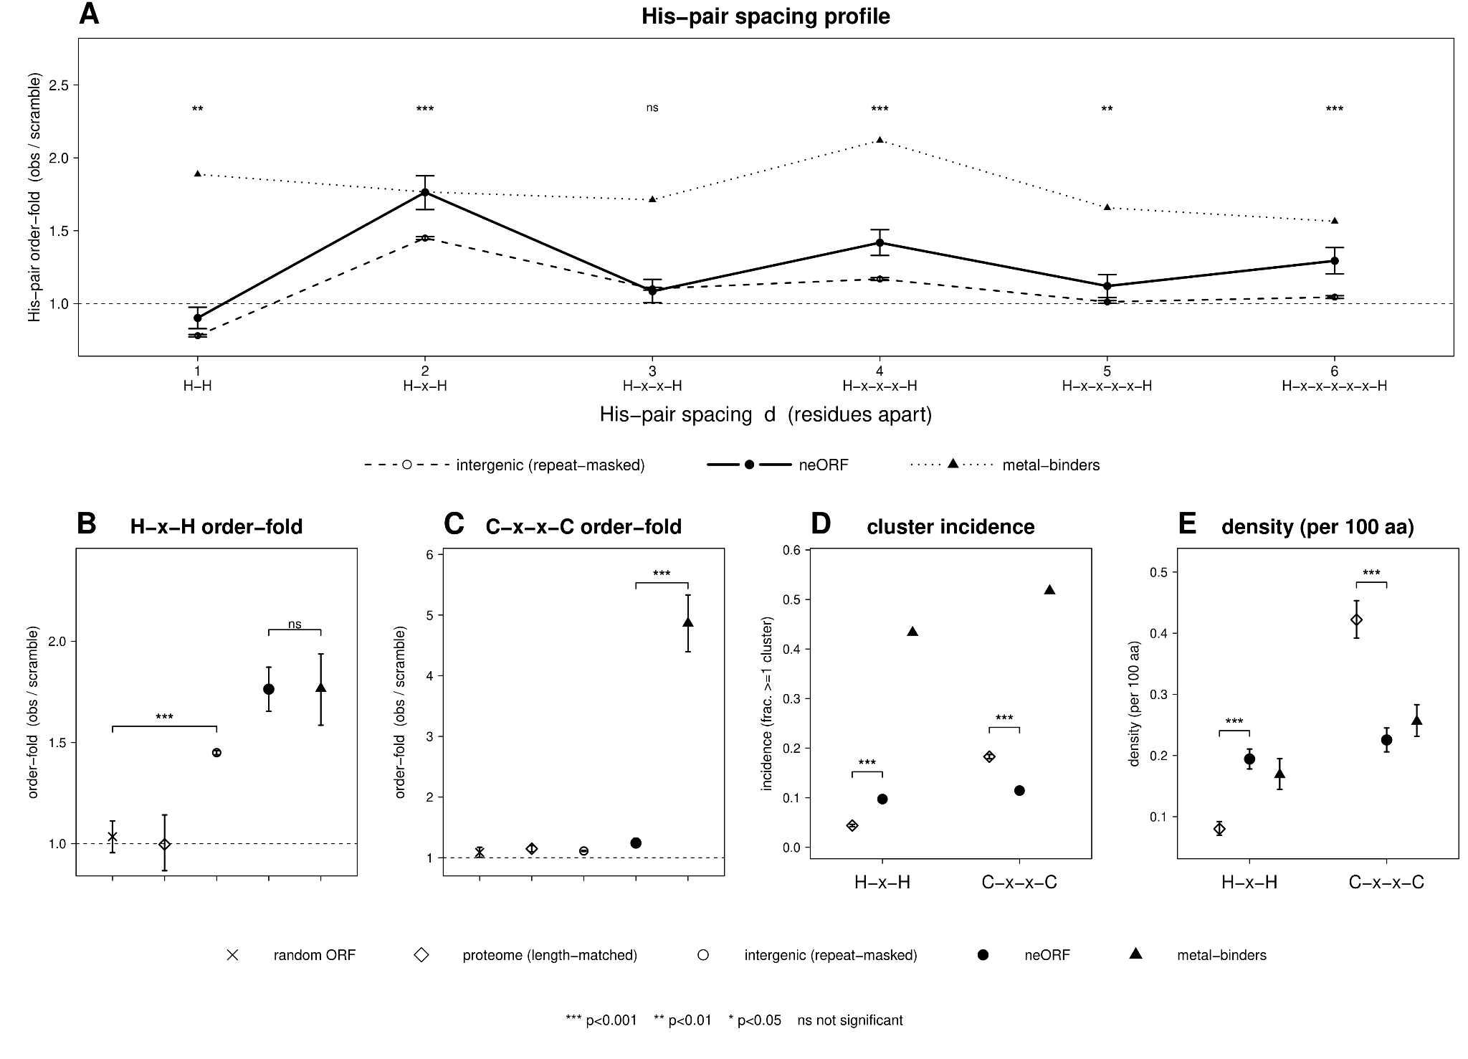

Figure 1: neORFs are enriched for H-x-H configurations but depleted of C-x-x-C configurations. (A) Relative number of H-(x)n-H configurations by gene class: neORFs (N=7,849), randomly selected intergenic, repeat-masked ORFs (N=1,472,446), and known metal-binding proteins (N=856). Raw numbers of configuration counts were divided by a bootstrapped distribution (k=3000) for each gene class. P-values were calculated between neORFs and intergenic ORFs using a two-sample, unpaired bootstrap test of difference between pooled order-fold ratios. Relative number of (B) H-x-H and (C) C-x-x-C configurations, and (D) cluster incidence and (E) density for H-x-H and C-x-x-C motifs in GC- and length-matched random ORFs, the length-matched Drosophila proteome, intergenic repeat-masked ORFs, neORFs, and known metal-binding proteins is shown.

(CA)n dinucleotide repeats drive potential neORF bis-histidine coordinate chemistry
While the consequences of H-x-H appearance are consistent with a selectable function via chelation (see Discussion), the H-x-H motif is not among the top 15 differentially prevalent SLiM present in the Eukaryotic Linear Motif database (Kumar et al. 2024)(Figure S1). Additionally, while neORFs are enriched for histidine residues when compared to the length-matched proteome sample, neORFs are even more significantly enriched for cysteine than for histidine, thus providing an inadequate explanation for the simultaneous prevalence of the H-x-H but not the C-x-x-C motif (Figure S2). One possibility is that H-x-H motifs arise via the activation and lengthening of ORFs containing (CA)n repeats, the most highly abundant dinucleotide repeat found in the Drosophila melanogaster genome (Table 1). Specifically, the sequence (CA)5 = CAC ACA CAC ANN, translates to His-Thr-His-(...). To test this hypothesis, I compared codon usage in the 2,036 histidines contained in H-x-H motifs to the 17,546 total histidines contained in neORFs, as histidine can be produced using either the CAC or CAT codon. This analysis revealed that histidines within H-x-H motifs were strongly biased towards utilizing the CAC codon over the CAT codon (56.9% vs 43.1%), consistent with (CA)n origination. This stands in contrast to codon usage across all neORF histidines, where codon usage was reversed (48.3% vs 51.7%)(two-sided permutation shuffle test, k=5000, p = 2.0 × 10⁻⁴, Figure 2A). To further understand this phenomenon, I examined the relative frequency of amino acid usage for the middle position of the H-x-H motif. Consistent with the (CA)n hypothesis, I found that threonine was the most prevalent amino acid utilized in the middle position. When compared to background, threonine produced a 4.2x elevation over expectation (two-sided nonparametric bootstrap)(k=5000, p = 4.0 × 10⁻⁴), suggesting that (CA)n dinucleotide repeats were the likeliest source of H-x-H motifs in neORFs. Note that while RepeatMasker was applied prior to later analyses, most (CA)n repeats from n=7 to n=9 typically are not masked due to their short length.

min copies of (CA)n | AC/CA tracts | per Mb rate | % of length-matched dinucleotide microsatellites
≥5 | 16,126 | 120 | 52%
≥6 | 10,161 | 76 | 55%
≥8 | 4,997 | 37 | 58%
≥10 | 2,254 | 17 | 57%
Table 1: Relative abundance of AC/CA dinucleotide microsatellites in the D. melanogaster genome.

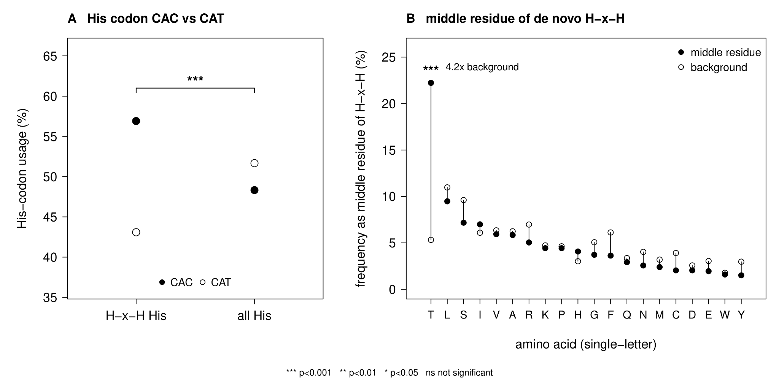
Figure 2: (CA)n dinucleotide repeats alter codon usage and amino acid positioning. (A) Histidine codon usage in both H-x-H motifs and all histidine residues found in Drosophila neORFs. Notably, histidines in H-x-H configurations are highly biased towards CAC usage. This trend is reversed when considering the set of all histidines found in neORFs. (B) Amino acid usage for middle residues (x) in bis-histidine motifs (H-x-H). The 4.2x elevation of Thr usage in the middle position is highly suggestive of (CA)n origins.
A (CA)n-to-His-x-His spine converts microsatellite expansion into recurrent bis-histidine chemistry
The codon-usage and central-residue data point to a single, mechanistically explicit route from DNA to bis-histidine chemistry (Figure 3A). Read on the sense strand, (CA)n microsatellites present the repeating codons CAC·ACA·CAC·ACA…, translating as His-Thr-His-Thr…, where histidine residues fall at every second residue, with the intervening position fixed as threonine. Each additional CA unit that remains in frame thus appends one His-Thr pair and lengthens the run, whereas an out-of-frame unit shifts the reading frame and abolishes the motif, suggesting a single mechanism underlies the detected CAC-codon bias, the fourfold threonine enrichment at the central position, and the odd n-spacing (H-x-H, H-x-x-x-H) periodicity (Figures 1 and 2), without invoking selection at any individual locus. Note that translation of the complementary strand of the same tract reads TGT·GTG·TGT… = Cys-Val-Cys, a C-x-C register.
This pattern is readily apparent in the candidate chelation neORF zmeygorynych (ZMEG) (Figure 3B), which was identified as the second most highly expressing H-x(odd)-H neORF in a reanalysis of S2R+ expression data (see “Segregating neORFs are expressed in S2R+ cells”). Additionally, an analysis of ZMEG sequence shows that it originated by utilizing a His-Thr-His-Thr-His triple at positions His32/His34/His36 embedded within a five-histidine run (His27, His29, His32, His34, His36). Across the uniquely translated neORF set, 762 (9.7%) carry at least one H-x-H motif and 130 (1.7%) contain a poly-(H-x-H) His run of the kind produced by an in-frame (CA)n tract (Figure 3C). ZMEG lies in this poly-(H-x-H) tail. As a result,
zmeygorynych, a 55-codon open reading frame on chromosome arm 3R, was named after the mythological Eastern Slavic dragon Zmey Gorynych and chosen to reflect a number of traits unique to ZMEG: 1) ZMEG was originally identified in an iso-female line of Ukrainian origin (Grandchamp et al. 2023), 2) dragons are known for their propensity to hoard metals, 3) like ZMEG's 3x H-x-H motif occurrences, Zmey Gorynych is typically described as possessing not one, but three heads, and 4) Zmey Gorynych’s autochthonous origins is reminiscent of ZMEG’s origination from ancestrally non-coding DNA.

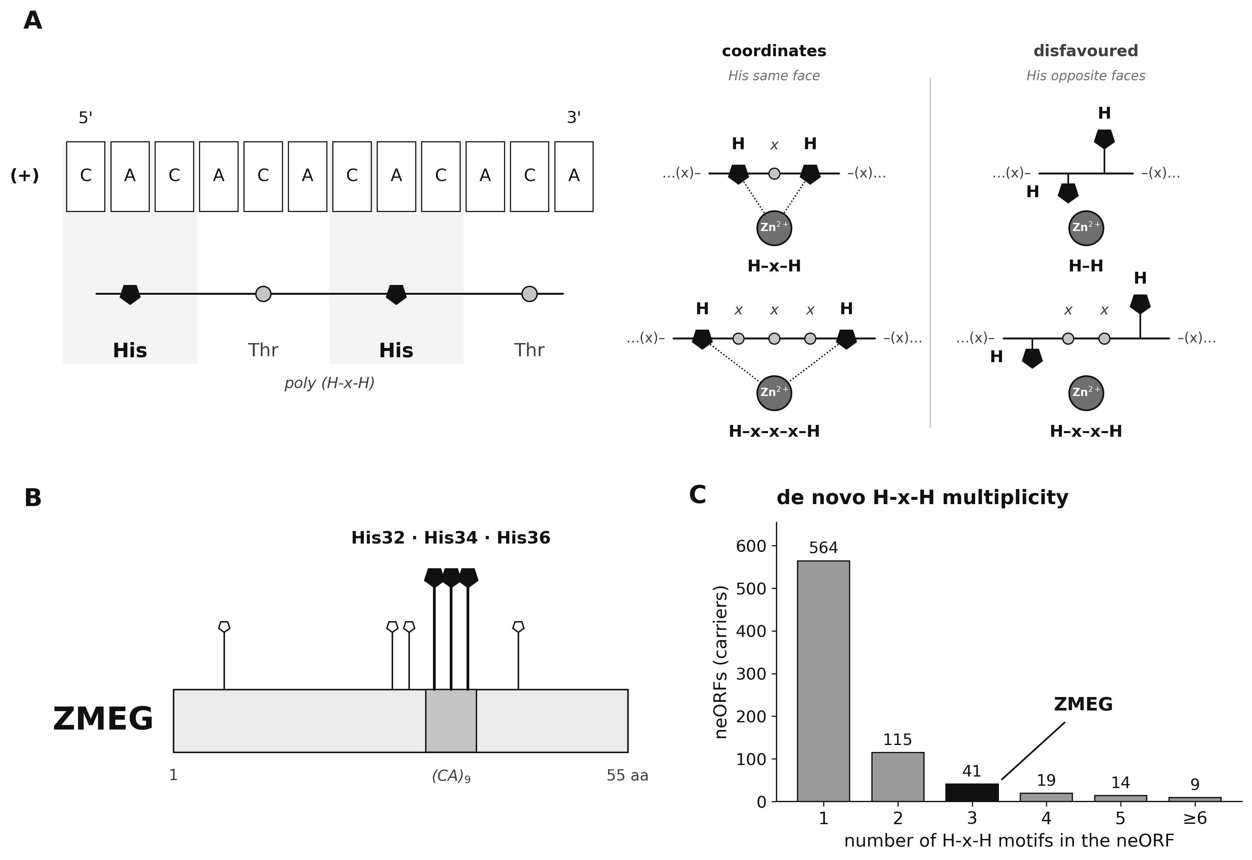
Figure 3: (CA)n microsatellite origins for ZMEG. (A) Illustration of (CA)n translation and cartoon of bis-histidine coordinate chemistry. (B) A genomic (CA)9 tract translates in frame to the His32/His34/His36 triple within a five-histidine run (His27–His36) contained in ZMEG. (C) H-x-H motif multiplicity across the uniquely translated neORF set (n = 7,849), with ZMEG indicated, demonstrates de novo proteins’ latent capacity for bis-histidine coordinate chemistry.

Segregating neORFs are expressed in S2R+ cells
One necessary (but insufficient) prerequisite for presenting (CA)n microsatellites’ latent bis-histidine chemistry to selection is the transcription of these open reading frames in relevant tissue types. Given the association between innate immune response and Zn/Mn chemistry (see “De novo genes as a potential zinc regulator”), I therefore quantified neORF expression in Drosophila S2R+ cells using a publicly available RNA-seq series in which cells were exposed to control, zinc, and manganese conditions (GSE99332; Mohr et al. 2018). Two quality-control steps proved essential. First, a subset of neORFs annotated as intergenic and non-overlapping in fact overlapped annotated features or repeats, or lay in low-mappability regions where multi-mapping reads inflate apparent expression. Second, restriction to uniquely mapping reads and to loci passing a per-base mappability filter yielded 267 high-confidence, uniquely mappable, non-overlapping de novo ORFs (Materials and Methods)(Figure 4A, B).
This analysis revealed that de novo ORFs are transcribed, but at characteristically low levels (Grandchamp et al. 2023). 31% (84/267) of these neORFs reached a mean expression of ≥0.1 TPM (transcripts per million), compared with 57% of annotated genes, while 69% of neORFs were effectively undetected (<0.1 TPM) (Figure 4A). Only a handful of neORFs exceeded 1 TPM (Figure 4B). Expression was nonetheless constitutive rather than sporadic, as detected neORFs were expressed across replicates and conditions. Thus, the low absolute levels reflect weak, pervasive transcription rather than tight, condition-specific regulation. Notably, the most highly expressed neORFs were not H-x-H carriers (Table S1).
Interestingly, ZMEG is expressed at low levels (mean ≈0.9 TPM across conditions, ≈0.5 TPM in controls) and rises under manganese (≈1.5 TPM), an apparent ~2.8-fold uptick (DESeq2 maximum-likelihood log₂ fold-change ≈ +1.5). Intriguingly, a second de novo neORF bearing an H-x-H motif was expressed at appreciably higher levels than ZMEG (≈4.8 TPM; Table S1), but lacked the signature H-T-H motif. Regardless, ZMEG is not significantly differentially expressed between conditions (Materials and Methods)(adjusted p = 0.24). More importantly, manganese is a broad, strong stressor in these data: 3,900 genes are differentially expressed under manganese versus 859 under zinc (roughly 4.5-fold more), with classic proteotoxic and metal-detoxification programs (Hsp70, metallothioneins) strongly induced. ZMEG's modest rise is therefore best read as part of a general stress-mobilization wave that broadens the pool of transcribed cryptic and de novo loci, not as a dedicated manganese response (see Discussion).
Consistent with cryptic rather than dedicated transcription, ZMEG's promoter-proximal region contains no canonical core promoter (no TATA box) and shows no enrichment of MTF-1 metal-response elements (MREs) above intergenic background, in contrast to the bona fide MTF-1 targets MtnA–E, whose promoters are strongly MRE-enriched (Materials and Methods). ZMEG is thus not an MTF-1/MRE-regulated locus, reinforcing the interpretation that its expression, along with its manganese-associated uptick, reflects pervasive, stress-amplified transcription rather than a locus-specific metal-response circuit.
In order to confirm that ZMEG's expressed sequence is genuine and matches its assembly, I reconstructed the ORF directly from the S2R+ reads, rather than from the reference alignment. This analysis recovered a sequence identical to the Grandchamp et al. (2023) assembly, including the in-frame (CA)9 tract and the His32/34/36 triple. Additionally, because dinucleotide tracts are prone to alignment artifacts, tract length and reading frame were read by eye from the raw reads for ZMEG and its comparators throughout (Materials and Methods).
To determine whether ZMEG is representative or exceptional, I compared the neORF’s two key properties ((CA)n-derived poly-(H-x-H) signature and stress-associated expression) across the de novo set, revealing a decoupling of these two properties. Indeed, the latent (CA)n-to-H-x-H reservoir is genomically pervasive. In the full uniquely translated neORF set (n = 7,849), 762 loci (9.7%) carry at least one H-x-H motif and 130 (1.7%) poly-(H-x-H) runs (Figure 3C). Expression, however, remains limiting, as further analysis of the 267 uniquely mappable, non-overlapping neORFs quantified in S2R+ cells shows that only 34 carry an H-x-H motif and 4 poly-(H-x-H) runs (Figure 4B). Of these four poly-(H-x-H) loci, ZMEG is the only one detectably expressed under metal stress (Table S1), suggesting that transcription serves as a significant barrier for the activation of individual neORFs.
ZMEG arose de novo in the melanogaster lineage from conserved ancestral sequence
To validate ZMEG’s de novo origins and to reconstruct how its metal-relevant chemistry arose, the locus was traced across nine Drosophila species spanning roughly 50 My of divergence (Materials and Methods)(Figure 4C,D, Table S2). Critically, the ZMEG locus is syntenic in all nine genomes, where the region lies in the same intergenic interval flanked by the conserved single-copy anchors Gr93 and glec, and the upstream sequence is largely shared across lineages. This observation confirms ZMEG’s in-situ origination, positively excluding the possibility that ZMEG is an orphan gene.
This analysis also revealed that the ATG and the immediately following N-terminal codons are conserved across the melanogaster group and into D. pseudoobscura (~25 My), which shares ZMEG's N-terminal peptide (MYNIFAHLTSG…). However, this ORF terminates after 16 codons upstream of the (CA)n tract. Importantly, the syntenic locus itself is recoverable in the most distant outgroup, D. virilis (~40–50 My), establishing a deep nucleotide-level anchor. However, D. virilis translates only a short, divergent N-terminal peptide and encodes no ancestral ZMEG protein. These results confirm that the full-length ORF and its bis-histidine chemistry are derived solely within the melanogaster lineage in concordance with its identification as a segregating neORF (Grandchamp et al. 2023), and was not inherited from an ancient protein.
Critically, polarizing character states on the tree resolves a stepwise, microsatellite-driven birth mechanism for ZMEG (Figure 4C). In the two most distant outgroups the ancestral ZMEG reading frame terminates before the (CA)n tract. On the melanogaster-group stem, the ancestral ZMEG reading frame extends past this ancestral early stop codon, opening and elongating the nascent ORF. Interestingly, an in-frame (CA)n tract seeds a poly-histidine motif within the melanogaster sub-group. Finally, the tract reaches (CA)9 in D. melanogaster and D. mauritiana, translating to the full poly-(H-x-H) run with the His32/34/36 triple in a mature 55-codon ORF. Crucially, this mature state is tract-length-dependent and hypervariable in D. simulans ((CA)6, 43 codons) and D. sechellia ((CA)7, 41 codons), as the same complex carries poly-histidine as a shorter, frame-labile ORF. Alternatively, D. yakuba and D. erecta carry poly-histidine at intermediate tract lengths.
The same lability is evident within D. melanogaster, where the tract segregates between 6 and 10 units across iso-female strains studied in (Grandchamp et al. 2023), with in-frame deletions and frameshifting indels that lengthen, shorten, or disrupt the His run (Table S2). The (CA)n tract is thus a reservoir in flux rather than a fixed feature. Notably, ZMEG arises directly in-frame, with no clear evidence of an intervening functional-RNA stage, suggesting that its origin did not proceed through a cultivated ancestral noncoding-RNA intermediate (Lee et al. 2024b).
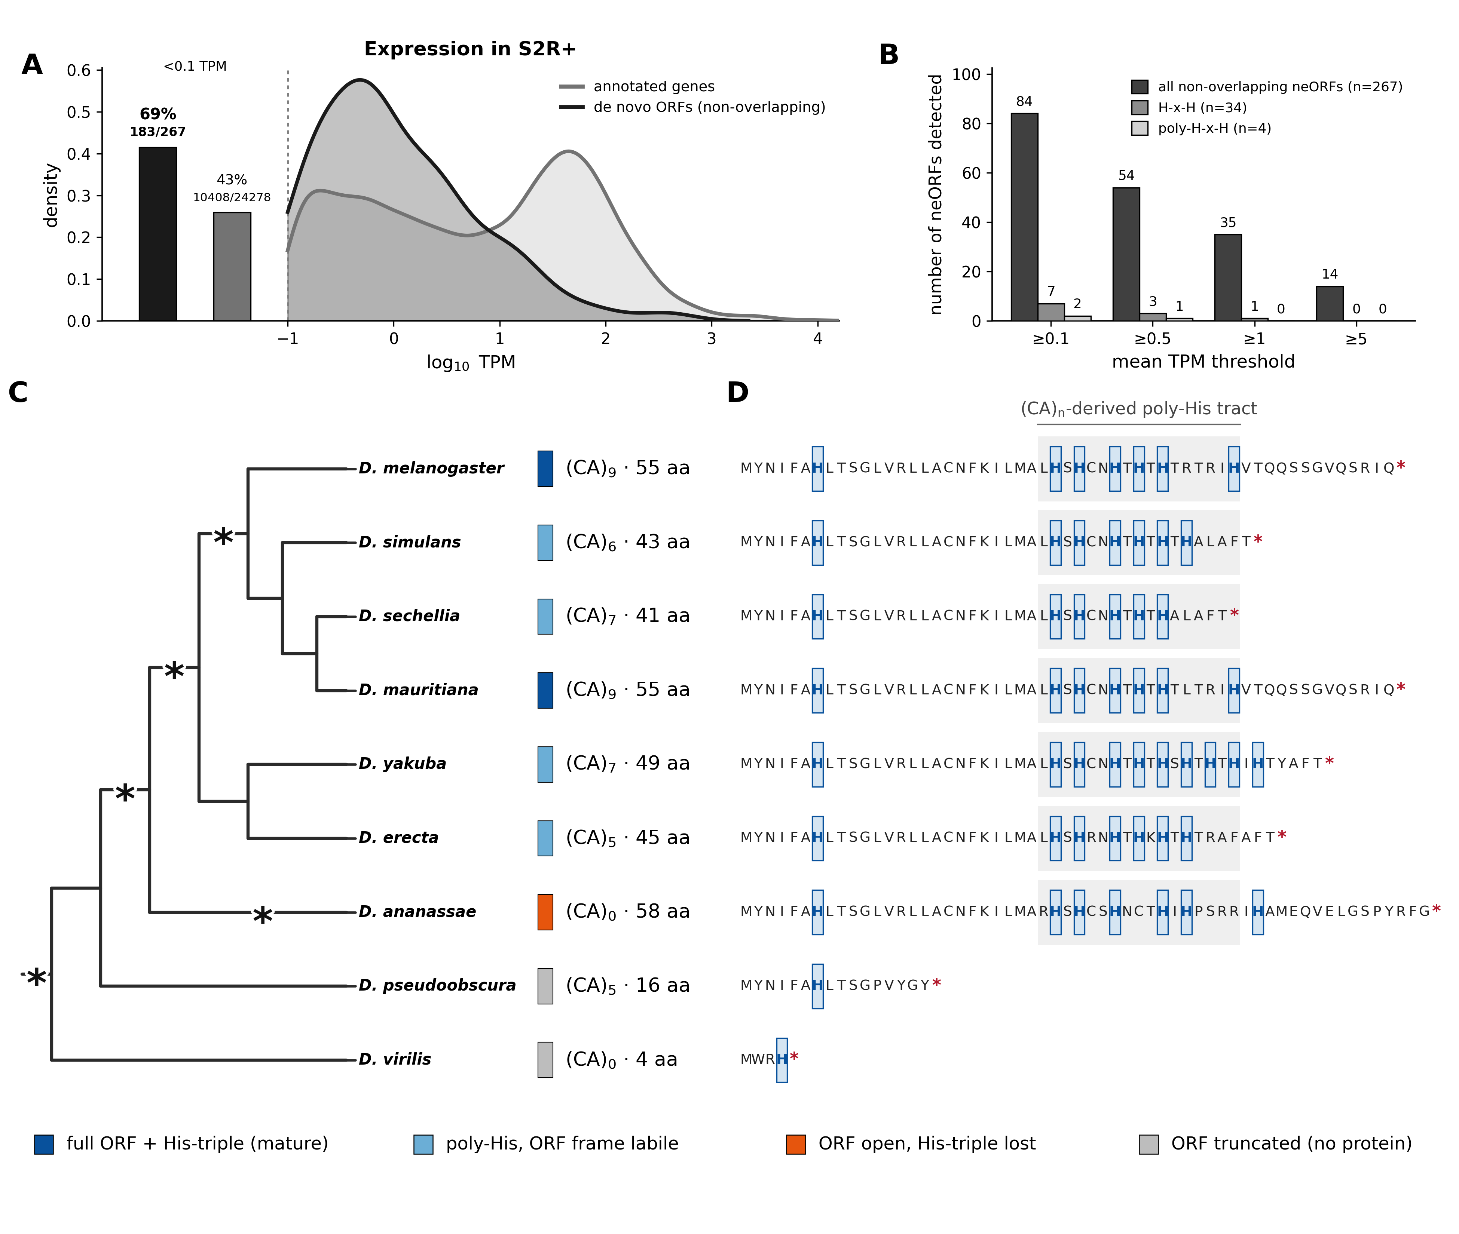
Figure 4: De novo neORF transcription and the origins of ZMEG. (A) Expression (mean TPM across all conditions) of uniquely mappable, non-overlapping de novo ORFs (n = 267) versus annotated genes in S2R+ cells. Left bars provide the fraction of undetected transcripts (<0.1 TPM). (B) Number of de novo ORFs transcribed at increasing mean-TPM thresholds for all neORFs and for the H-x-H (n = 34) and poly-(H-x-H) (n = 4) subsets. (C) De novo origin and activation trajectory of ZMEG across nine Drosophila species (branch lengths not to scale), including (CA)n tract length, ORF length to the first stop, and His-motif status mark. Asterisks indicate polarized evolutionary events described in the main text. (D) ORF translations (ATG to first stop) aligned across all nine species: histidines are boxed and (CA)n-derived poly-histidine tracts are shaded.
ZMEG's His32–His36 pair is a candidate bis-histidine metal site
Three independent lines of evidence converge on a single candidate site formed by His32 and His36 (Figure 5). First, the above joint evolutionary-mechanistic analysis indicated that the His32/34/36 triple is the direct in-frame translation product of the (CA)9 tract, so the site sits exactly where the (CA)n spine predicts bis-histidine chemistry should appear. Second, geometry: an analysis of ZMEG’s ESMFold-predicted structure (Materials and Methods)(Lin et al. 2023) models the His32 and His36 side chains residing 4.63 Å apart (imidazole-nitrogen separation), within the range spanned by two-histidine metal sites, and a modeled Zn²⁺ sits 2.31 Å from each coordinating nitrogen (Figure 5A). Third, a learned zinc-site predictor, Metal3D (Materials and Methods)(Dürr et al. 2023), places its highest-probability voxel for ZMEG 0.8 Å from the midpoint of the His32–His36 pair (Figure 5B). While such structure predictions do not fully establish the existence of metal bonding, the convergence of two structural predictors operating on the predicted fold, together with the independent evolutionary argument, yields a specific and falsifiable prediction: that ZMEG’s putative chelating function lies in the His32–His36 pair’s capacity for bis-histidine coordinate chemistry. Notably, unlike the idealized β-strand register of the (CA)n schematic (Figure 3A), ZMEG's predicted fold is helical, and the coordinating histidines are related by an i,i+4 spacing (His32→His36) consistent with same-face presentation on a helix (Figure 5A,C).
Notably, the intervening residue at ZMEG’s His-x-His positions is threonine, within the substrate tolerance of the histidine methyltransferase METTL9. This raises the possibility of a post-translational “off” switch (see De novo genes as a potential zinc regulator).
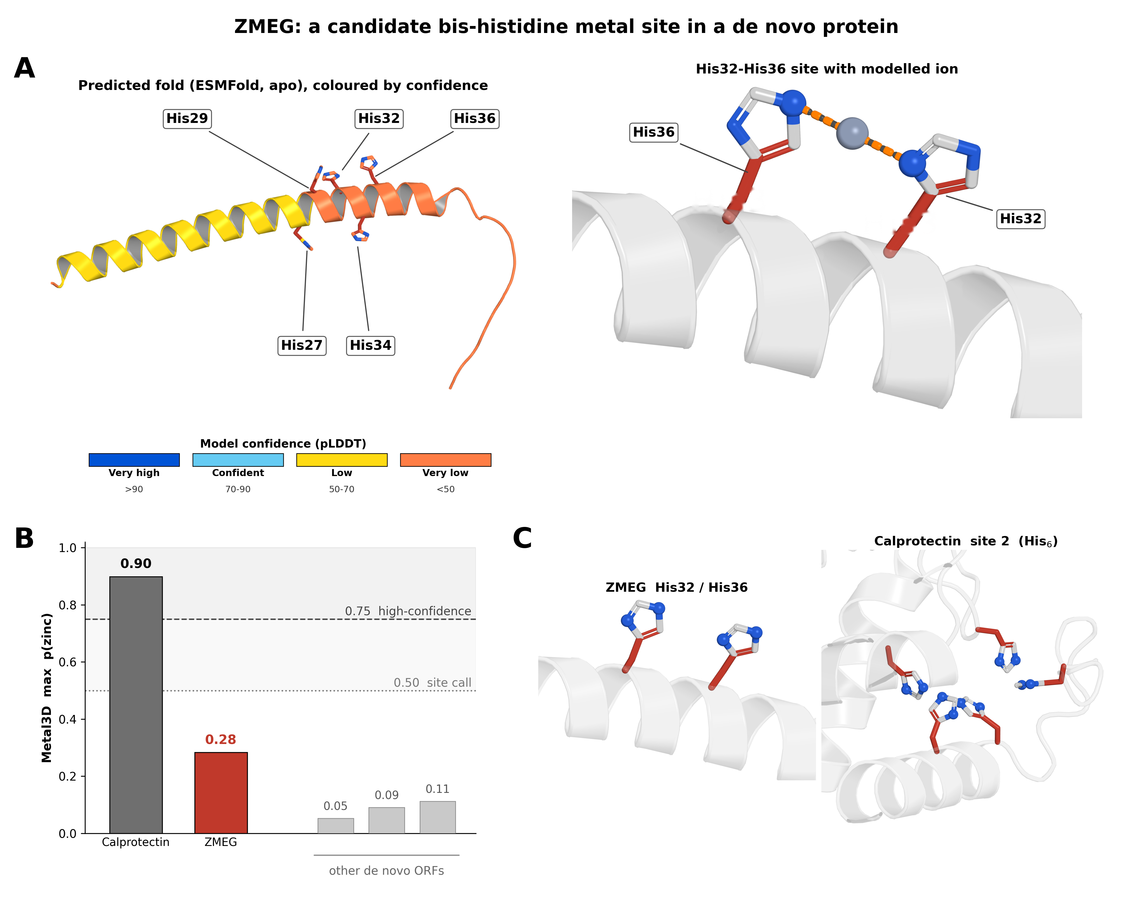
Figure 5: A candidate bis-histidine metal site in ZMEG. (A) ZMEG predicted fold (ESMFold, apo; colored by pLDDT model confidence) with the His27/29/32/34/36 run indicated, and a close-up of the His32–His36 site with an illustrative modeled Zn²⁺ (apo prediction; imidazole-nitrogen separation 4.63 Å, metal–nitrogen 2.31 Å). (B) Maximum predicted zinc-site probability (Metal3D): ZMEG (0.28) versus a calprotectin S100A8/S100A9 positive control (0.90) and other de novo ORFs (0.05–0.11); dashed lines mark the tool's 0.5 and 0.75 confidence thresholds. For ZMEG the highest-probability voxel lies 0.8 Å from the His32–His36 midpoint. (C) Structural comparison of ZMEG's loose two-histidine pair with calprotectin's six-histidine metal cage.

Discussion
This work connects, for the first time, a single de novo protein-coding gene with an explicitly connected evolutionary and molecular mechanism. By bridging de novo gene origination, zinc handling in Drosophila, and concrete biochemistry, this work introduces the possibility of broader generalization of ligand-binding activity as a driver of de novo protein origination. Importantly, the evolutionary (CA)n-to-H-x-H axis makes this connection tractable because the same microsatellite that can be polarized on a phylogeny also specifies, through the reading frame, the chemistry of the resulting peptide, so that evolutionary history and candidate function are encoded in a single feature.
De novo genes as a potential zinc regulator
METTL9 is a methyltransferase that has been recently demonstrated to play a key part in post-translational regulation of a broad range of substrate proteins via pervasive 1-methylhistidine modification (Davydova et al. 2021). METTL9 tolerates only a limited set of residues at the intervening (x) position, including threonine, which is the most common residue for (x) found in this analysis. As METTL9 does not specifically prefer threonine over other members of the A-N-G-S-T motif (Davydova et al. 2021), the enrichment of threonine in particular reflects (CA)n origins rather than co-adaptation to METTL9. Notably, mammalian METTL9 methylates a histidine within the H-x-H motif to install Nπ 1-methylhistidine, which acts as a post-translational off-switch by decreasing the metal-binding capability of target proteins. This has been shown to be the mechanism for calprotectin, the mammalian anti-bacterial S100A8/S100A9 heterodimer, of which the short, disordered S100A9 (MRP14) subunit is the methylation target (Figure 5C)(Daitoku et al. 2021). Structurally, calprotectin’s manganese/zinc “site 2” is a hexahistidine cage assembled across both subunits (S100A8 His17/His27 and S100A9 His91/His95/His103/His105; Damo et al. 2013), whose six histidine donors far exceed ZMEG’s single candidate two-histidine pair. While calprotectin is conserved between humans and mice (Marenholz et al. 2004), no S100/calprotectin orthologue is annotated in Drosophila. Nπ-methylation of S100A9 His107 weakens its zinc affinity roughly sixfold (the dissociation constant rises from ~14.3 to ~90.9 µM) (Cao et al. 2024). Notably, upon S. aureus infection, the methylation of S100A9 His107 is reduced (Cao et al. 2024). This loss of methylation thus increases local sequestration of zinc, which starves S. aureus of metal ions and clears the infection. In line with this, METTL9-KO mice with constitutively unmethylated S100A9 were found to be more resistant to S. aureus infection, consistent with calprotectin’s zinc-sequestration function as the causal mechanism of resistance (Cao et al. 2024).

In Drosophila, the METTL9 ortholog (mettl9/CG5339) is also an Nπ 1-methylhistidine His-methyltransferase, though this regiochemistry is inferred by orthology and has not been directly confirmed for the fly enzyme. Importantly, Drosophila melanogaster has a known metal response pathway, where copper, cadmium, silver, and zinc ingestion upregulates the MTF-1 transcriptional pathway (Günther et al. 2012; Egli et al. 2003) that regulates known copper transporters, e.g. Ctr1B and ATP7 (Selvaraj et al. 2005), and known metallothioneins, e.g. MtnA–E (Egli et al. 2006). However, these metallothionein proteins are cysteine-rich, not histidine-rich. Additionally, unlike copper, cadmium, and silver, zinc only weakly induces the metallothionein arm of the MTF-1 response, whereas the transporter arm, e.g. ZnT35C, is robustly zinc-induced and MTF-1-dependent (Yepiskoposyan et al. 2006).

On the other hand, zinc regulation in Drosophila melanogaster remains relatively understudied (Yepiskoposyan et al. 2006), where “little is still known about local redistribution and availability of Zn within… the cell.” (Navarro & Schneuwly 2017). What is currently known about Zn response in fruit flies is mostly limited to zinc transporters such as ZnT35C (Yepiskoposyan et al. 2006), not direct zinc chelators. Concurrently, while zinc sequestration is well-characterized in the previously reported mouse infection model, S100A9/calprotectin is a vertebrate-specific innovation as previously noted, with no identifiable homolog in Drosophila. However, previous work has noted that fruit flies nonetheless mount a Transferrin-1–mediated nutritional-immune response during infection (Iatsenko et al. 2020). As of publication, there are currently no known dedicated histidine-rich zinc-sequestration or buffering proteins in Drosophila, suggesting that this key biological function may be served by the collective action of an entire family of mutually unrelated, strain-specific neORF zinc chelators, rather than a more traditional duplication-based expansion of a known gene family.

Interestingly, recent work has demonstrated that Drosophila mettl9/CG5339 has altered binding affinities for known human METTL9 targets. Combined with S100A9/calprotectin’s known zinc-binding function in mammals, and METTL9’s known mechanism of H-x-H methylation, my results suggest that Drosophila melanogaster’s zinc response may potentially be acting through a separate, yet undercharacterized pathway, via the entire class of de novo H-x-H proteins. Such interactions would be consistent with the documented Drosophila-specific evolution of mettl9 binding, where substitutions in flanking and -x- residues were found to be less tolerated than with human METTL9 (Schroer et al. 2025). In that study, the authors demonstrated how Drosophila mettl9 had increased stringency in activity, preferring to bind A, G, S, C, or T residues, rather than N, Q, H, and P in the middle position. ZMEG provides a concrete candidate for this logic: its central (x) residue is threonine, which lies within the more stringent D. melanogaster METTL9 acceptor set (A/G/S/C/T; Schroer et al. 2025), so Nπ-methylation of a histidine in its H-x-H motif would offer a plausible post-translational off-switch on a candidate de novo chelator, mirroring METTL9's demonstrated control of calprotectin's zinc affinity (Cao et al. 2024).

Promiscuous expression presents de novo H-x-H motifs to selection
For the latent metal-coordinating chemistry of a de novo H-x-H peptide to be visible to natural selection, its open reading frame must be transcribed and translated. Notably, however, neither step requires locus-specific regulation. Pervasive, low-level transcription of intergenic sequence is a general feature of eukaryotic genomes (Struhl 2007) and is the very property by which the neORFs analyzed here were identified as transcribed loci (Grandchamp et al. 2023). Noncanonical and short ORFs are similarly engaged by ribosomes at appreciable rates (Ruiz-Orera et al. 2014; Ingolia et al. 2014). This promiscuous transcription and translation is expected to intensify under physiological stress as transcriptional and translational specificity relaxes. For example, previous work has shown that translational fidelity and start-site selection loosen during metal stress (Mohler & Ibba 2017). Under such conditions, the pool of expressed de novo ORFs transiently broadens, sampling from a large reservoir of (CA)n-derived H-x-H peptides without any single locus having evolved a dedicated promoter.
This supplies the missing bridge between motif supply and selectable function. Specifically, (CA)n expansion can generate the latent capacity for H-x-H motif emergence in neORFs. Subsequently, promiscuous, stress-amplified expression then presents these nascent peptides and their bis-histidine coordinate chemistry to selection, which can retain and quantitatively tune those whose metal-coordinating activity proves beneficial. Critically, this route requires no sequence-specific regulatory innovation at any individual locus: a general, non-specific expression mechanism suffices to expose a compositional property (histidine spacing) to selection. This parallels the adaptive, evolutionarily tuned phase behavior of stress-responsive proteins, whose selectable function is a bulk sequence property realized without site-specific regulation (Riback et al. 2017; Wallace et al. 2015), and the broader pre-adaptation view in which function can precede and drive the establishment of de novo genes (Wilson et al. 2017).
Because it is a general property rather than a locus-specific adaptation, the transcriptional signature of this mechanism is expected to be diffuse and non-motif-specific. This is consistent with, though not resolved by, existing metal-challenge transcriptomic studies (see “Segregating neORFs are expressed in S2R+ cells”), and would be most directly testable by ribosome profiling under acute metal stress. However, it should be noted that pervasive, non-specific low levels of translation are abundant as well. As such, ribosome profiling still would not provide a “smoking gun” demonstration of the chelation hypothesis, as observed levels of non-specific translation would remain indistinguishable from noise. Consistent with this general, non-specific reading, the metal-challenge data analyzed here show a strongly asymmetric response, as manganese, a broad stressor, differentially regulates roughly 4.5-fold more genes than zinc (3,900 versus 859). Here, ZMEG's own manganese uptick is not individually significant (adjusted p = 0.24), consistent with the diffuse, non-locus-specific signature this model predicts (Table S1).

De novo genes as an evolvable plasticity mechanism
Emergence bias is a critical feature underlying the dynamics of genome evolution (Fuqua & Vakirlis 2026). Specifically, natural selection can only select for features that are presented to it in the order of emergence. That is to say, natural selection cannot select for variants that have not yet appeared in a population. In species with high effective population sizes such as Drosophila melanogaster, this evolvability problem is amplified, as near-neutral variants are more effectively purged in such populations, preventing “tunneling” behavior between selectively beneficial states (Weissman et al. 2009). This crucial detail is a defining aspect that separates the study of evolutionary genetics and the study of random peptides and/or directed evolution.

The emergence of H-x-H motifs, potentially in connection with the prevalence of (CA)n dinucleotides in Drosophila, offers the tantalizing possibility that a subset of de novo proteins have independently but collectively evolved to act in a module-like manner. Such collective transcription and translation could allow for the potential quantitative tuning of zinc response via alteration of the mutational target size of plastic response to metal consumption or bacterial infection. Such mutational target size, and thus the relative mutation rate of genic vs epigenetic responses to environmental shifts, has been shown to play a role in determining the long-term fate of plasticity (Lee et al. 2022). Notably, a significant fraction of dinucleotide repeats in Drosophila melanogaster are CA motifs (Table 1), despite being in a highly AT-rich genome. Unlike humans, these repeats also typically occur in 7-9 unit tracts in Drosophila (Bachtrog et al. 1999; Ross et al. 2003; Katti et al. 2001; Tóth et al. 2000), yielding approximately 2-3 His-Thr repeats. This well-documented prevalence of (CA)n microsatellite repeats in Drosophila thus produces His-Thr-His upon translation of the (+) strand, and Cys-Val-Cys (but not the chemically active Cys-Cys or Cys-x-x-Cys motifs) on the (-) strand . While the evolutionary forces underlying the limited appearance of only 7-9 unit (CA)n tracts remain a mystery (Kruglyak et al. 1998), one outcome of these repeats is the likely rapid appearance of a wide class of intrinsically disordered proteins with the ability to sequester metal, related not by direct descent via duplication, but the repeat, independent origination of hundreds or thousands of the same protein subunit – again, arising de novo and not through duplication.

The possibility of such independent origination highlights the key role of evolvability in natural selection – this a mechanism is plausible only when such events are heavily biased to emerge (Fuqua & Vakirlis 2026). Similar effects arising from functional repeat units accelerating the evolution of genic solutions to fluctuating environments have been previously observed in bacterial promoters (Barnett et al. 2025). As a dinucleotide repeat, it is important to note that expansion of this highly labile repeat is also likely to produce frameshifts within open reading frames, causing the H-x-H motif to be both highly evolvable but similarly easy to lose. As the mutation rate of such dinucleotide repeats is much higher than more commonly studied single nucleotide substitutions (Schug et al. 1997, 1998; Harr & Schlötterer 2000), this may allow H-x-H motifs from (CA)n repeats to potentially serve a secondary function as a favored launchpad for generating further protein coding diversity.
A latent reservoir and the limits of a genomic lens
Two important limitations must be acknowledged in framing this study. First, the metal-challenge series analyzed here may not reach the concentrations, duration, or cellular context of a physiologically relevant metal-stress episode, so the absence of a strong, ZMEG-specific transcriptional response in these data does not bound the reservoir's potential. Instead, it may simply indicate that the relevant regime was never sampled. Second, ZMEG is expressed at a level that would be diluted below detection in whole-animal RNA-seq, averaged across the many tissues in which it is silent. Notwithstanding ZMEG’s original identification in (Grandchamp et al. 2023), such expression became visible when expression was assayed in a defined cell population (S2R+ cells). The capacity for (CA)n-derived bis-histidine chemistry may sit in a latent, genomic reservoir (Rutherford and Lindquist, 1998), as demonstrated through a single ORF (ZMEG) that had previously gone unnoticed in published data sets. Here, I have shown that ZMEG’s conversion into a transcribed, candidate metal-binding peptide is not merely feasible but, given the genomic prevalence of the underlying microsatellite, plausibly recurrent.
This same genomic reservoir is, paradoxically, extraordinarily difficult to interrogate through a genomic lens. If the mechanism proposed herein is a general, stress-amplified broadening of expression rather than a locus-specific circuit, then its signature in transcriptomic and/or translatomic data is expected to be indistinguishable from noise. Accordingly, sequencing cannot by itself distinguish a functionally engaged de novo chelator from incidental pervasive expression/translation. The two questions that would settle function are not genomic at all: does ZMEG actually bind metal inside the cell? and does genetically deactivating the (CA)n reservoir measurably shift intracellular metal levels? Neither is answerable by sequencing alone, highlighting the need for further experimentation. Beyond just a mere caveat, this work highlights, rather than weakens, the value of this work: the entire evolutionary-to-molecular account assembled here, including origin, mechanism, and a testable candidate site, was recovered from a handful of publicly available datasets (a single focal species, eight outgroup genomes, and one previously published RNA-seq dataset), for a gene effectively invisible to standard genomic pipelines. Crucially, a motif-first search also would not have found ZMEG: one would have had to known the yet unannotated (ELM database)(Figure S1) H-x-H signature in advance, whereas here, the evolutionary analysis drove and surfaced the underlying chemistry. I highlight that this inversion is the broader thesis this work is meant to advance, demonstrating that comparative and population-level study of how sequences arise and change can serve not only as a post-hoc historical description of molecular history, but as a discovery tool for uncovering new biochemistry and biophysics.

Materials and Methods
New expressed open reading frame (neORF) dataset
7,894 neORFs from Grandchamp et al. (2023) were retrieved from the associated data archive (Zenodo record 7322757). Because the published protein sequences appended stop-codon-derived nucleotides as C-terminal residues, neORFs were re-translated from their nucleotide entries in frame, terminating at the first in-frame stop. Re-translations were de-duplicated by amino-acid sequence, yielding 7,849 unique D. melanogaster-specific neORFs (median length ℓ₀.₅ = 64 aa). Following Grandchamp et al., neORFs are the de novo ORFs segregating in fewer than 7 of 7 independent iso-female lines, where neORFs are young, transcriptionally supported, population-level ORFs throughout.
Comparator sequence sets
neORFs were compared to four reference sets. (i) Intergenic, repeat-masked ORFs (N = 1,472,446; ℓ₀.₅ = 22 aa): six-frame, stop-to-stop ORFs (≥10 aa, no ambiguous residue, de-duplicated) extracted from the complement of (annotated genes ∪ RepeatMasker intervals) on the D. melanogaster autosome arms (dm6 + UCSC dm6 RepeatMasker track with manual coordinate verification). (ii) GC- and length-matched random ORFs: sequences generated at the intergenic GC content (0.413) and matched to the neORF length distribution, providing a genetic-code null that lacks genuine DNA structure. (iii) Length-matched proteome (N = 7,849): each neORF was matched with a nearest-length protein from the D. melanogaster proteome (FlyBase release dmel r6.61; dm6/BDGP6). (iv) Known metal-binding proteins (N = 856; ℓ₀.₅ = 538 aa): UniProt reviewed D. melanogaster proteins annotated with the Metal-binding keyword (KW-0479) (FlyBase release dmel r6.61, dm6/BDGP6)(Gramates et al. 2022).
Bis-histidine spacing (order-fold)
For each set, H-(x)ₙ-H configurations (two histidines separated by n intervening residues, n = 1…6) were counted across all sequences. To isolate residue order from amino-acid composition, the observed pooled count was divided for each n by the mean count over a bootstrap of composition-preserving per-sequence scrambles (each sequence's own residues permuted; k = 3,000), giving a per-class "relative number" (order-fold). Significance between neORFs and intergenic ORFs was assessed with a two-sample, unpaired bootstrap test of the difference between pooled order-fold ratios. The identical procedure was applied to C-(x)ₙ-C configurations (C-x-x-C).
Motif incidence and density
For H-x-H and C-x-x-C motifs, incidence (fraction of proteins with ≥1 motif) and density (motifs per residue, i.e. length-normalized) were computed and reported across the random, length-matched-proteome sample, intergenic, neORF, and metal-binder sets. Because the sets differ ~25-fold in median length, the incidence/density split separates per-protein occurrence from per-length rate (Data S1).
Codon usage and the (CA)ₙ mechanism
As histidine is encoded by CAC or CAT, codon usage was compared in the 2,036 histidines contained within H-x-H motifs to the 17,546 total histidines across neORFs, with significance assessed by a two-sided permutation shuffle test (k = 5,000). Relative amino-acid frequency at the central (x) position of H-x-H motifs was compared to background composition, with significance by a two-sided nonparametric bootstrap (k = 5,000). RepeatMasker was applied before ORF extraction, and short (CA)ₙ tracts (n ≈ 7–9) were manually verified to escape masking due to length.
Short linear motifs and composition
neORFs and the length-matched proteome were scanned for the Eukaryotic Linear Motif (ELM) classes using the ELM regular-expression catalog (Kumar et al. 2024), ranking classes by the difference in per-length density between neORFs and the proteome (Figure S1); H-x-H is not itself an ELM class. Per-class amino-acid composition (histidine, cysteine, aspartate, glutamate, and the full 20-residue profile) was computed across all sequence sets (Figure S2).
RNA-seq data and analysis
Expression was quantified from a publicly available Drosophila S2R+ RNA-seq series comprising control, zinc-, and manganese-exposed samples (GSE99332; Mohr et al. 2018). Reads were aligned to the D. melanogaster genome (dm6/BDGP6)(Hoskins et al. 2015) with STAR (Dobin et al. 2013), retaining only uniquely mapped reads, and were counted over neORF and annotated-gene intervals with featureCounts (Liao et al. 2014). Counts were then converted to TPM using ORF length. Two quality-control filters guarded against microsatellite- and repeat-driven mapping artifacts. First, neORFs nominally annotated as intergenic and non-overlapping were re-checked against gene and repeat annotations, and those overlapping annotated features or repeats were excluded. Second, per-base unique-mappability was computed across each locus, and low-mappability loci were removed. These filters yielded 267 uniquely mappable, non-overlapping de novo ORFs used for all expression estimates.
Differential expression between metal-exposed and control samples was assessed with DESeq2 (Love et al. 2014) under a genotype-plus-condition design, with independent filtering and Benjamini–Hochberg correction; manganese-versus-control and zinc-versus-control were tested as separate contrasts, and the genome-wide breadth of differential expression was recorded for each. For ZMEG, the S2R+-expressed sequence was reconstructed directly from the mapped reads and compared to the reference assembly. Because dinucleotide microsatellites are prone to alignment-induced indel artifacts, the (CA)n tract length and the open reading frame were determined by manual inspection of the raw reads rather than from the reference alignment. Upstream regulatory content was assessed by scanning 1,200-bp windows around each candidate for MTF-1 metal-response elements (MRE core TGCRCNC, both strands) and canonical core-promoter motifs, calibrated against a null distribution of random intergenic windows and against the metallothionein (MtnA–E) promoters as positive controls.
Structure and metal-site prediction
The ZMEG open reading frame, and the S100A9 subunit of human calprotectin as a control, were folded with ESMFold (Lin et al. 2023) in the apo state (Figure S3); per-residue confidence is reported as pLDDT. Candidate metal sites and per-voxel zinc-binding probability were predicted with Metal3D (Dürr et al. 2023), and the maximum predicted probability p(zinc) and the distance from the highest-probability voxel to the His32–His36 midpoint were recorded. Inter-histidine and metal–nitrogen distances were measured on the apo model with a Zn²⁺ placed for illustration only. Calprotectin was also analyzed identically.
Comparative synteny and de novo origin trajectory
Orthologous ZMEG loci were recovered in eight outgroup Drosophila genomes (D. simulans, D. sechellia, D. mauritiana, D. yakuba, D. erecta, D. ananassae, D. pseudoobscura, and D. virilis) (NCBI assemblies GCF_016746395.2, GCF_004382195.2, GCF_004382145.1, GCF_016746365.2, GCA_047116545.1, GCF_017639315.1, GCF_009870125.1, and GCF_030788295.1, respectively) by anchored synteny to the flanking single-copy genes Gr93 and glec, followed by local alignment of the intervening region (BLAST, Altschul et al. 1990; MAFFT, Katoh & Standley 2013). For each species, the ORF from the conserved ATG to the first in-frame stop, its length, histidine content, and (CA)n tract length were extracted directly from the assembly; because these genomes are single assemblies and microsatellite length is assembly-sensitive, non-reference tract lengths and their resulting frames are reported as provisional. Character states ((CA)n length, ORF length, and His-motif status) were polarized on the accepted Drosophila species topology to order the events shown in Figure 4C, and upstream sequence was aligned and polarized to distinguish ancestral from lineage-derived positions. Within D. melanogaster, the (CA)n tract was additionally genotyped across the iso-female founder strains and its length and frame consequence (in-frame deletion versus frameshift) tabulated (Table S2).

References
Alberts IL, Nadassy K, Wodak SJ. 1998. Analysis of zinc binding sites in protein crystal structures. Protein Sci 7(8):1700–1716.
Altschul SF, Gish W, Miller W, Myers EW, Lipman DJ. 1990. Basic local alignment search tool. J Mol Biol 215(3):403.
Bachtrog D, et al. 1999. Distribution of dinucleotide microsatellites in the Drosophila melanogaster genome. Mol Biol Evol 16(5):602.
Barnett M, Meister L, Rainey PB. 2025. Experimental evolution of evolvability. Science 387(6736):eadr2756.
Bergthorsson U, Andersson DI, Roth JR. 2007. Ohno's dilemma: evolution of new genes under continuous selection. Proc Natl Acad Sci USA 104:17004.
Bode W, Gomis-Rüth FX, Stöckler W. 1993. Astacins, serralysins, snake venom and matrix metalloproteinases exhibit identical zinc-binding environments (HEXXHXXGXXH and Met-turn) and topologies and should be grouped into a common family, the 'metzincins'. FEBS Lett 331(1-2):134.
Brangwynne CP, et al. 2009. Germline P granules are liquid droplets that localize by controlled dissolution/condensation. Science 324:1729.
Cao D, Lv M, Hu C, Li S, Wang S, Xu C, Pan W. 2024. METTL9-catalyzed histidine methylation of S100A9 suppresses the anti-Staphylococcus aureus activity of neutrophils. Protein Cell 15(3):223. doi:10.1093/procel/pwad047.
Carvunis A-R, et al. 2012. Proto-genes and de novo gene birth. Nature 487:370.
Daitoku H, et al. 2021. siRNA screening identifies METTL9 as a histidine Nπ-methyltransferase that targets the proinflammatory protein S100A9. J Biol Chem 297:101230.
Damo SM, Kehl-Fie TE, Sugitani N, Holt ME, Rathi S, Murphy WJ, Zhang Y, Betz C, Hench L, Fritz G, Skaar EP, Chazin WJ. 2013. Molecular basis for manganese sequestration by calprotectin and roles in the innate immune response to invading bacterial pathogens. Proc Natl Acad Sci USA 110(10):3841.
Davydova E, et al. 2021. The methyltransferase METTL9 mediates pervasive 1-methylhistidine modification in mammalian proteomes. Nat Commun 12:891. doi:10.1038/s41467-020-20670-7.
Dobin A, Davis CA, Schlesinger F, Drenkow J, Zaleski C, Jha S, Batut P, Chaisson M, Gingeras TR. 2013. STAR: ultrafast universal RNA-seq aligner. Bioinformatics 29(1):15.
Dürr SL, Levy A, Rothlisberger U. 2023. Metal3D: a general deep learning framework for accurate metal ion location prediction in proteins. Nat Commun 14:2713.
Egli D, et al. 2003. Knockout of the metal-responsive transcription factor MTF-1 in Drosophila. EMBO J 22(1):100.
Egli D, et al. 2006. A family knockout of all four Drosophila metallothioneins reveals a central role in copper homeostasis and detoxification. Mol Cell Biol 26(6):2286.
Fomenko DE, Gladyshev VN. 2003. Identity and functions of CxxC-derived motifs. Biochemistry 42(38):11214.
Fukaya T, Lim B, Levine M. 2016. Enhancer control of transcriptional bursting. Cell 166(2):358.
Fuqua T, Vakirlis N. 2026. Emergence biases in molecular evolution. Genome Biol Evol evag195. doi:10.1093/gbe/evag195.
Gramates LS, Agapite J, Attrill H, et al. 2022. FlyBase: a guided tour of highlighted features. Genetics 220(4):iyac035. doi:10.1093/genetics/iyac035.
Grandchamp A, et al. 2023. Population genomics reveals mechanisms and dynamics of de novo expressed open reading frame emergence in Drosophila melanogaster. Genome Res 33:872–890.
Greil F, de Wit E, Bussemaker HJ, van Steensel B. 2007. HP1 controls genomic targeting of four novel heterochromatin proteins in Drosophila. EMBO J 26(3):741.
Günther V, Lindert U, Schaffner W. 2012. The taste of heavy metals: gene regulation by MTF-1. Biochim Biophys Acta 1823(9):1416.
Harr B, Schlötterer C. 2000. Long microsatellite alleles in Drosophila melanogaster have a downward mutation bias and short persistence times, which cause their genome-wide underrepresentation. Genetics 155(3):1213.
Hooper NM. 1994. Families of zinc metalloproteases. FEBS Lett 354(1):1.
Hoskins RA, Carlson JW, Wan KH, et al. 2015. The Release 6 reference sequence of the Drosophila melanogaster genome. Genome Res 25(3):445. doi:10.1101/gr.185579.114.
Iatsenko I, et al. 2020. Transferrin 1 mediates nutritional immunity in Drosophila. Proc Natl Acad Sci USA 117(13):7317.
Ingolia NT, Brar GA, Stern-Ginossar N, et al. 2014. Ribosome profiling reveals pervasive translation outside of annotated protein-coding genes. Cell Rep 8(5):1365.
Johnstone CP, Galloway KE. 2022. Supercoiling-mediated feedback rapidly couples and tunes transcription. Cell Rep 41:111492.
Karlin S, Zhu Z-Y. 1997. Classification of mononuclear zinc metal sites in protein structures. Proc Natl Acad Sci USA 94(26):14231–14236.
Katoh K, Standley DM. 2013. MAFFT multiple sequence alignment software version 7: improvements in performance and usability. Mol Biol Evol 30(4):772.
Katti MV, Ranjekar PK, Gupta VS. 2001. Differential distribution of simple sequence repeats in eukaryotic genome sequences. Mol Biol Evol 18(7):1161.
Keller SH, Deng H, Lim B. 2023. Regulation of the dynamic RNA Pol II elongation rate in Drosophila embryos. Cell Rep 42(10):113225. doi:10.1016/j.celrep.2023.113225.
Kruglyak S, et al. 1998. Equilibrium distributions of microsatellite repeat length resulting from a balance between slippage events and point mutations. Proc Natl Acad Sci USA 95(18):10774.
Kumar M, Michael S, Alvarado-Valverde J, et al. 2024. ELM—the Eukaryotic Linear Motif resource: 2024 update. Nucleic Acids Res 52(D1):D442.
Lee U, Mortola EN, Kim EJ, Long M. 2022. Evolution and maintenance of phenotypic plasticity. BioSystems 222:104791. doi:10.1016/j.biosystems.2022.104791.
Lee U, Arsala D, Xia S, et al. (Long M). 2024a. The three-dimensional genome drives the evolution of asymmetric gene duplicates via enhancer capture-divergence. Sci Adv 10(51):eadn6625. doi:10.1126/sciadv.adn6625.
Lee U, Mozeika SM, Zhao L. 2024b. The cultivator model of de novo gene origination. Genome Biol Evol 16(6):evae103. doi:10.1093/gbe/evae103.
Lee U, Li C, Langer CB, Svetec N, Zhao L. 2025. Comparative single-cell analysis of transcriptional bursting reveals the role of genome organization in de novo transcript origination. Proc Natl Acad Sci USA 122(18):e2425618122. doi:10.1073/pnas.2425618122.
Levine MT, Jones CD, Kern AD, Lindfors HA, Begun DJ. 2006. Novel genes derived from noncoding DNA in Drosophila melanogaster are frequently X-linked and testis-biased. Proc Natl Acad Sci USA 103(26):9935.
Leyes Porello EA, et al. 2026. Enhancer placement impacts transcriptional dynamics in Drosophila embryos. Nat Commun 17(1):6155. doi:10.1038/s41467-026-72618-y.
Liao Y, Smyth GK, Shi W. 2014. featureCounts: an efficient general purpose program for assigning sequence reads to genomic features. Bioinformatics 30(7):923.
Lin Z, Akin H, Rao R, Hie B, Zhu Z, Lu W, et al. 2023. Evolutionary-scale prediction of atomic-level protein structure with a language model. Science 379(6637):1123.
Love MI, Huber W, Anders S. 2014. Moderated estimation of fold change and dispersion for RNA-seq data with DESeq2. Genome Biol 15(12):550.
Marenholz I, Heizmann CW, Fritz G. 2004. S100 proteins in mouse and man: from evolution to function and pathology (including an update of the nomenclature). Biochem Biophys Res Commun 322(4):1111.
Mohler K, Ibba M. 2017. Translational fidelity and mistranslation in the cellular response to stress. Nat Microbiol 2:17117.
Mohr SE, Rudd K, Hu Y, Song WR, Gilly Q, Buckner M, Housden BE, Kelley C, Zirin J, Tao R, Amador G, Sierzputowska K, Comjean A, Perrimon N. 2018. Zinc detoxification: a functional genomics and transcriptomics analysis in Drosophila melanogaster cultured cells. G3 (Bethesda) 8(2):631. doi:10.1534/g3.117.300447.
Navarro JA, Schneuwly S. 2017. Copper and zinc homeostasis: lessons from Drosophila. Front Genet 8:223.
Näsvall J, Sun L, Roth JR, Andersson DI. 2012. Real-time evolution of new genes by innovation, amplification, and divergence. Science 338:384.
Pavletich NP, Pabo CO. 1991. Zinc finger-DNA recognition: crystal structure of a Zif268-DNA complex at 2.1 Å. Science 252(5007):809.
Peng J, Zhao L. 2024. The origin and structural evolution of de novo genes in Drosophila. Nat Commun 15:810. doi:10.1038/s41467-024-45028-1.
Peng J, Zhao L. 2026. A predicted structural interactome reveals binding interference from intrinsically disordered regions. PLoS Comput Biol 22(1):e1013899. doi:10.1371/journal.pcbi.1013899.
Riback JA, Katanski CD, Kear-Scott JL, et al. 2017. Stress-triggered phase separation is an adaptive, evolutionarily tuned response. Cell 168(6):1028.
Ross BD, et al. 2013. Stepwise evolution of essential centromere function in a Drosophila neogene. Science 340(6137):1211.
Ross CL, et al. 2003. Rapid divergence of microsatellite abundance among species of Drosophila. Mol Biol Evol 20(7):1143.
Ruiz-Orera J, Messeguer X, Subirana JA, Albà MM. 2014. Long non-coding RNAs as a source of new peptides. eLife 3:e03523.
Rutherford SL, Lindquist S. 1998. Hsp90 as a capacitor for morphological evolution. Nature 396:336–342.
Schroer L, et al. 2025. Orthologues of the human protein histidine methyltransferase METTL9 display distinct substrate specificities. J Biol Chem 301:110318. doi:10.1016/j.jbc.2025.110318.
Schug MD, et al. 1997. Low mutation rates of microsatellite loci in Drosophila melanogaster. Nat Genet 15:99.
Schug MD, et al. 1998. The mutation rates of di-, tri- and tetranucleotide repeats in Drosophila melanogaster. Mol Biol Evol 15:1751.
Seligmann H, Pollock DD. 2004. The ambush hypothesis: hidden stop codons prevent off-frame gene reading. DNA Cell Biol 23(10):701.
Selvaraj A, et al. 2005. MTF-1 handles copper load and copper starvation. Genes Dev 19(8):891.
Struhl K. 2007. Transcriptional noise and the fidelity of initiation by RNA polymerase II. Nat Struct Mol Biol 14(2):103.
Sundberg RJ, Martin RB. 1974. Interactions of histidine and other imidazole derivatives with transition metal ions in chemical and biological systems. Chem Rev 74(4):471.
Tautz D, Domazet-Lošo T. 2011. The evolutionary origin of orphan genes. Nat Rev Genet 12:692.
Tóth G, Gáspári Z, Jurka J. 2000. Microsatellites in different eukaryotic genomes. Genome Res 10(7):967.
Vakirlis N, Carvunis A-R, McLysaght A. 2020a. De novo emergence of adaptive membrane proteins from thymine-rich genomic sequences. Nat Commun 11:781.
Vakirlis N, Carvunis A-R, McLysaght A. 2020b. Synteny-based analyses indicate that sequence divergence is not the main source of orphan genes. eLife 9:e53500.
Vallee BL, Auld DS. 1990. Zinc coordination, function, and structure of zinc enzymes and other proteins. Biochemistry 29(24):5647.
Van Oss SB, Carvunis A-R. 2019. De novo gene birth. PLoS Genet 15(5):e1008160.
Wallace EWJ, Kear-Scott JL, Pilipenko EV, et al. 2015. Reversible, specific, active aggregates of endogenous proteins assemble upon heat stress. Cell 162(6):1286.
Weisman CM, Murray AW, Eddy SR. 2020. Many, but not all, lineage-specific genes can be explained by homology detection failure. PLoS Biol 18(11):e3000862.
Weissman DB, Desai MM, Fisher DS, Feldman MW. 2009. The rate at which asexual populations cross fitness valleys. Theor Popul Biol 75(4):286.
Wilson BA, Foy SG, Neme R, Masel J. 2017. Young genes are highly disordered as predicted by the preadaptation hypothesis. Nat Ecol Evol 1:0146.
Wilson BA, Masel J. 2011. Putatively noncoding transcripts show extensive association with ribosomes. Genome Biol Evol 3:1245.
Yepiskoposyan H, et al. 2006. Transcriptome response to heavy metal stress in Drosophila reveals a new zinc transporter that confers resistance to zinc. Nucleic Acids Res 34(17):4866.
Zhang B, Egli D, Georgiev O, Schaffner W. 2001. The Drosophila homolog of MTF-1 activates transcription in response to heavy metals. Mol Cell Biol 21(14):4505.
Zhang J. 2003. Evolution by gene duplication: an update. Trends Ecol Evol 18(6):292.
Zhao L, Saelao P, Jones CD, Begun DJ. 2014. Origin and spread of de novo genes in Drosophila melanogaster populations. Science 343(6172):769.

Data Availability Statement
All analysis and figure-generation code, a single run-all wrapper, and intermediate result tables are provided in the accompanying code release (submission/code); raw inputs are retrieved by the included fetch_data.sh from Zenodo record 7322757 (neORFs), FlyBase (proteome/annotation), UniProt (metal-binding proteins), and UCSC dm6 (genome, RepeatMasker), and the eight outgroup assemblies from NCBI (accessions in Materials and Methods).

Acknowledgments
U.L. was funded by the National Science Foundation Fellowship 2410289. U.L. acknowledges the use of Claude Opus 4.8 to assist in data retrieval, analysis, figure-generation code, and editing.

Competing Interests
The author declares no competing interests.

Supplementary Material

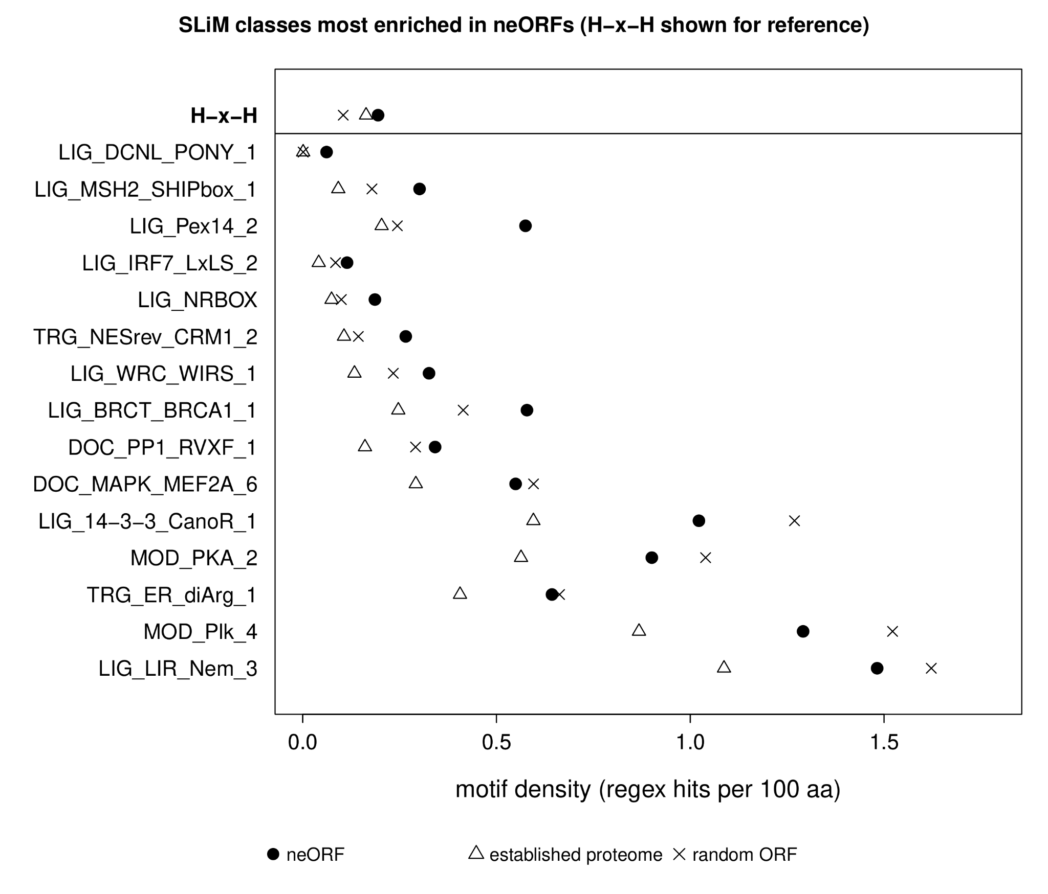
Figure S1. Top 15 most enriched SLiM in neORFs and H-x-H motif prevalence. Motif density for SLiM (ELM catalog) showing largest difference between neORFs and a length-matched proteome sample. Top row shows H-x-H, which was not present in ELM SLiM.

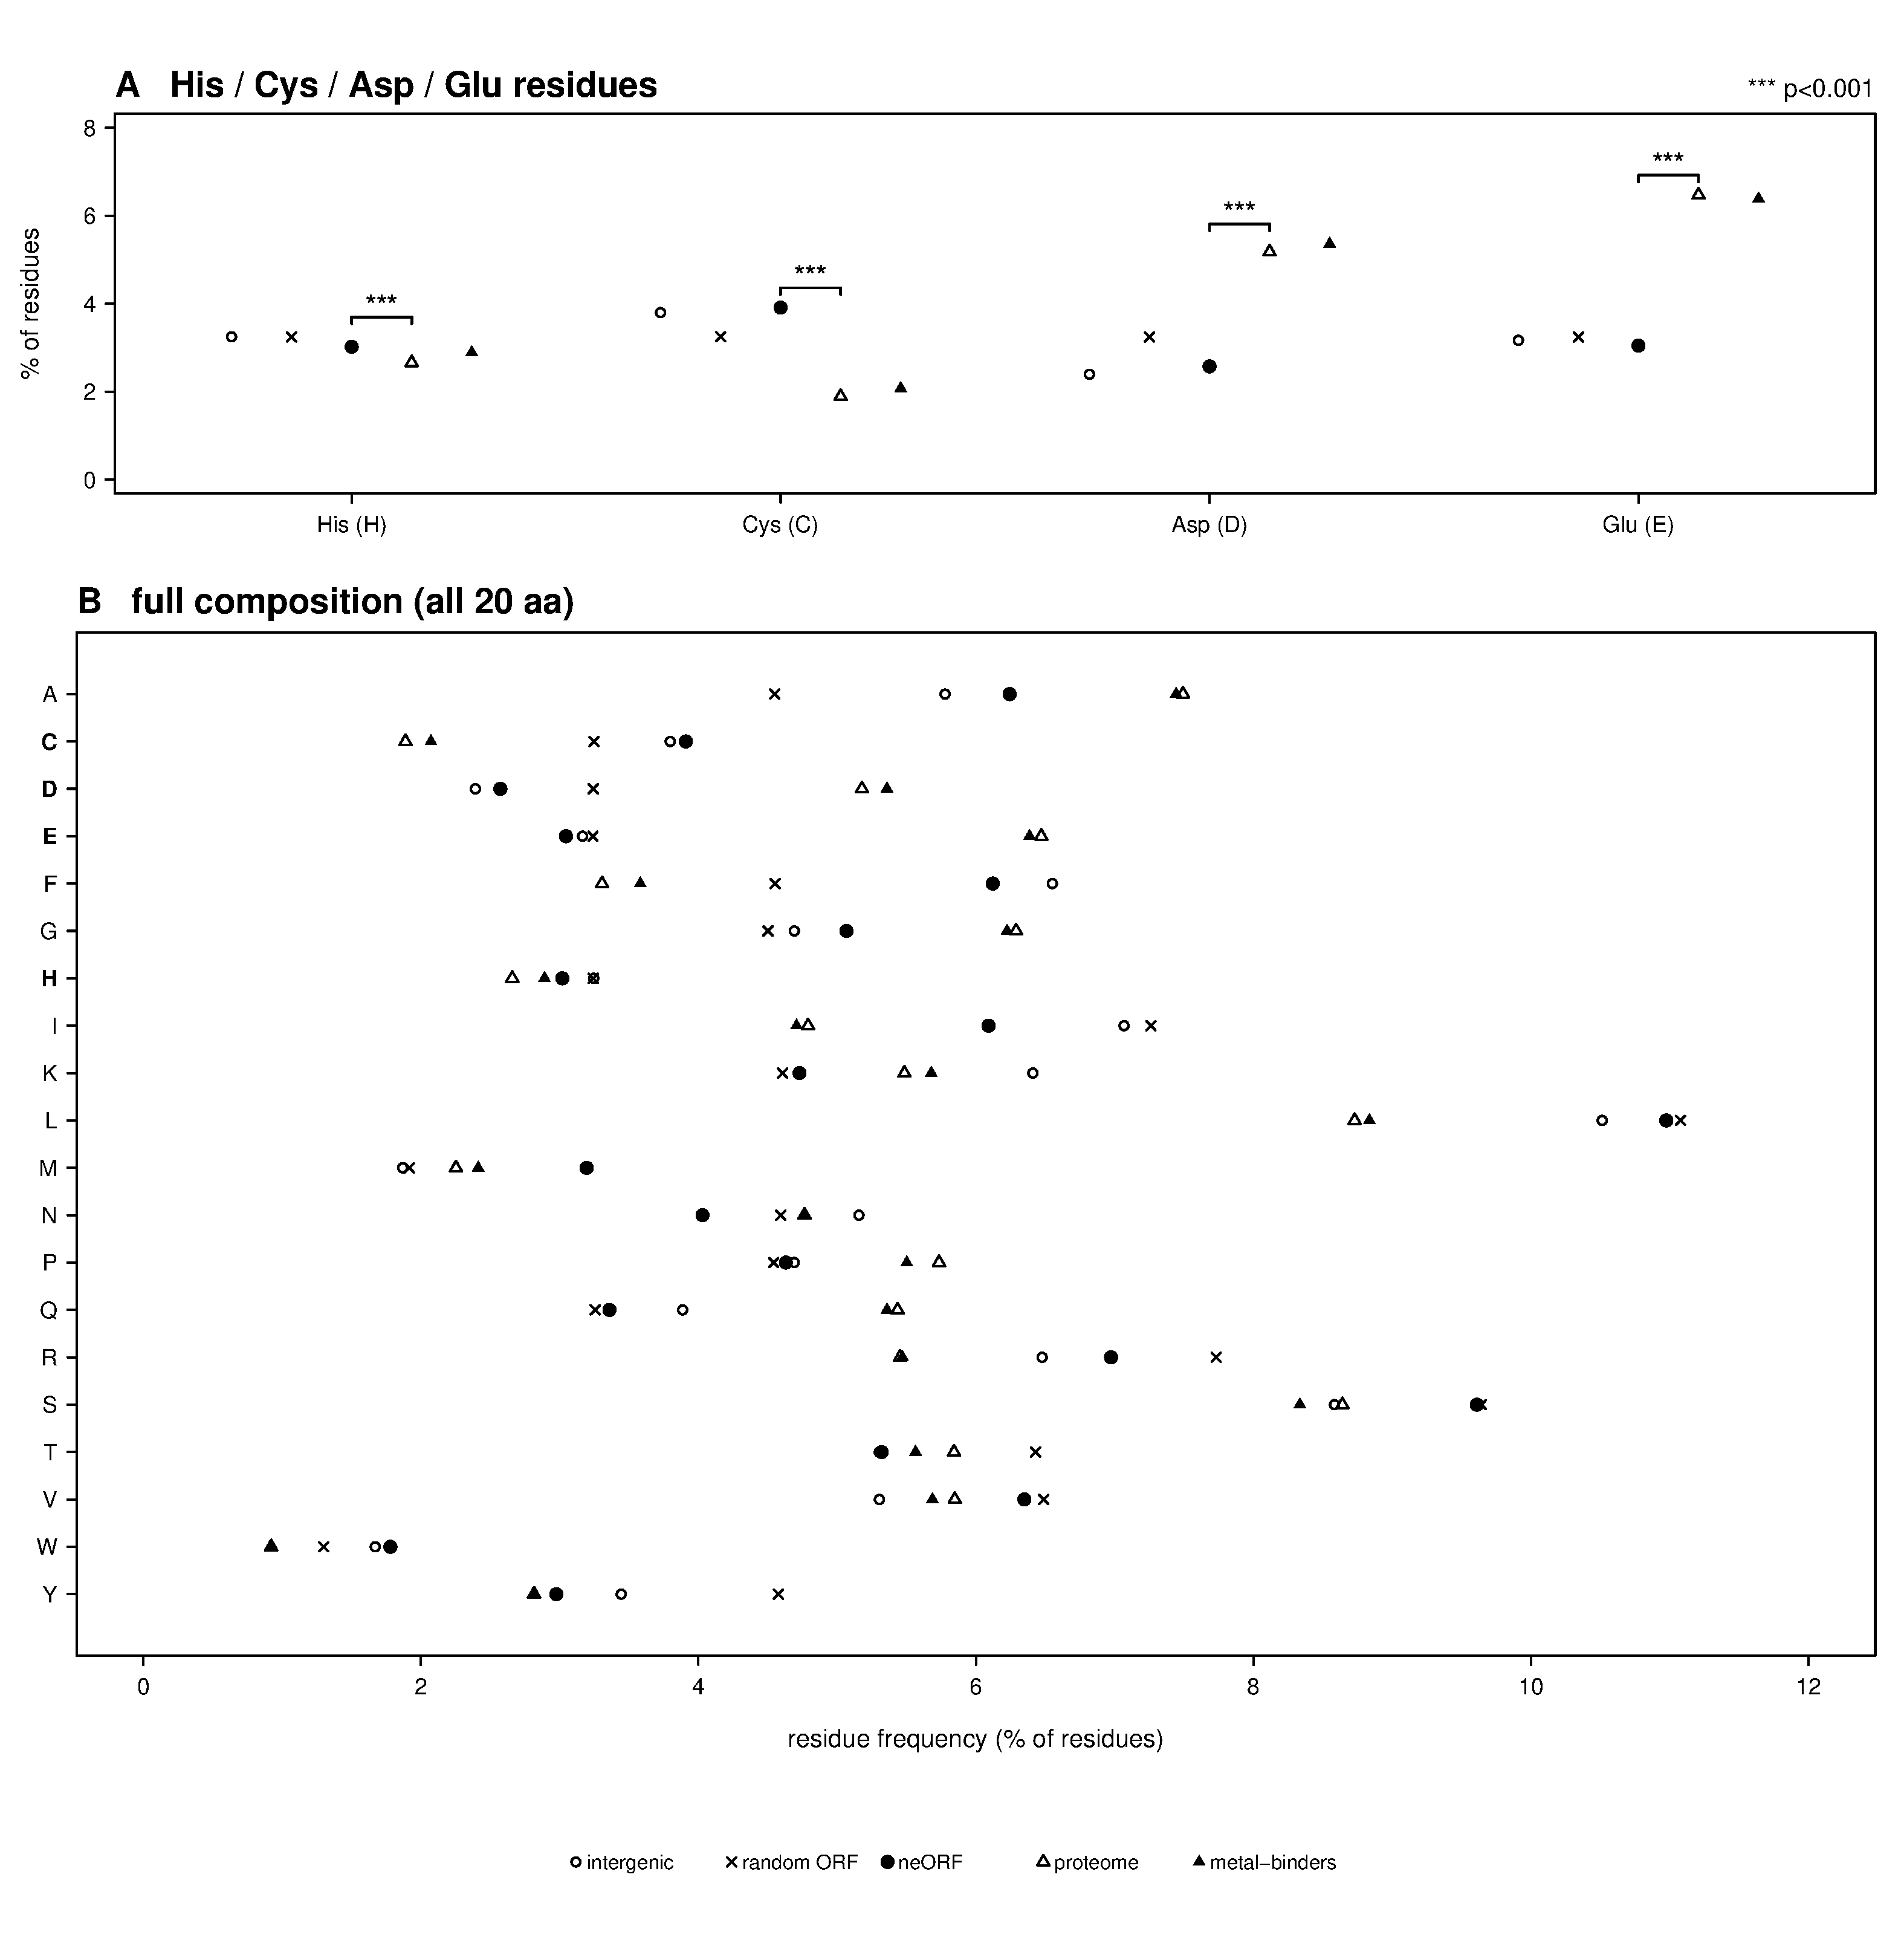

Figure S2. Histidine is not particularly enriched or prevalent in neORFs. Percentage of residues calculated for (A) histidine, cysteine, aspartic acid, glutamic acid, and (B) all amino acids across all gene classes.
Data S1: per-protein H-x-H / C-x-x-C cluster counts and codon usage for neORFs, the Drosophila melanogaster proteome, and random ORFs.
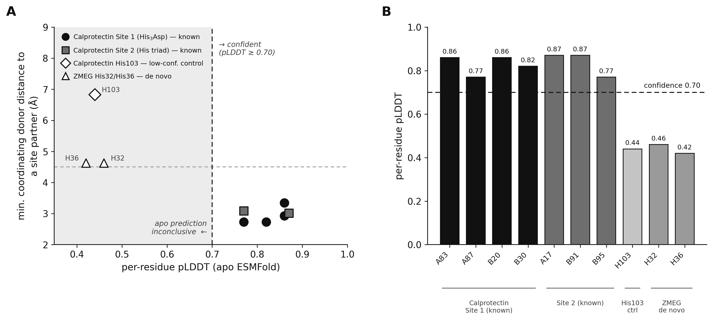
Figure S3. Apo structure prediction does not, on its own, recover calprotectin's metal site or known coordinating geometry for the S100A9 subunit of calprotectin, whose zinc/manganese site is experimentally established.
Table S1. Per-replicate expression (TPM) of all 267 uniquely mappable, non-overlapping de novo neORFs in S2R+ cells across control, zinc, and manganese conditions and three genotypes, with H-x-H motif content and dm6 coordinates.

Strain / species | (CA)n units | H-x-H | Note
Within D. melanogaster (strains)
D. melanogaster dm6 (ISO1, ref.) | 9 | Y | reference assembly
OreR / w1118 (lab) | 9 | Y | identical to reference
Denmark (DK) | 6 | Y | 6-bp in-frame deletion (tract shortened)
Spain (ES) | 8 | Y‡ | 2- & 1-bp indels (frameshift)
Finland (FI) | 6 | Y | 6-bp in-frame deletion (tract shortened)
Sweden (SE) | 10 | Y‡ | 2-bp deletion (frameshift)
Turkey (TR) | 8 | Y‡ | 2- & 1-bp indels (frameshift)
Ukraine (UA) | 9 | Y | identical to reference
Zambia (ZI) | 8 | Y‡ | 2- & 1-bp indels (frameshift)
Across Drosophila (species)
D. melanogaster | 9 | Y | ~0 Mya; reference
D. simulans | 6 | Y | ~3-5 Mya; strong
D. sechellia | 7 | Y | ~3-5 Mya; strong
D. mauritiana | 9 | Y | ~3-5 Mya; strong
D. yakuba | 7 | Y | ~10-13 Mya; strong
D. erecta | 5 | Y | ~10-13 Mya; strong
D. ananassae | 0 | N | ~15-20 Mya; moderate; tract collapsed
D. pseudoobscura | 5 | N | ~25 Mya; partial; ORF truncated pre-tract
D. virilis | 0 | N | ~40-50 Mya; fragmentary; ORF truncated pre-tract

Table S2. (CA)n tract length and His-motif status at the ZMEG locus within D. melanogaster and across Drosophila. ‡, His motif present but the (CA)n tract is frameshifted (in-frame His run disrupted).

