# RCGT Hiver 2014RCGTCanadian Journal of Tropical Geography Revue Canadienne de Géographie Tropicale

**CJTG (Online) / RCGT (En ligne) ISSN: 2292-4108**

**Vol. 8 (2):51-57**

**https://revuecangeotrop.ca**

# Innovations in land and water resources management: Trends and implications in the Bangourain community, Cameroon

***Innovations dans la gestion des ressources en terre et en eau : Tendances et implications dans la communauté de Bangourain, Cameroun***

#### Desmond Forbah TAFUH & Jude Ndzifon KIMENGSI

@ 2021 CJTG-RCGT All rights reserved / Tous droits réservés

**Abstract**:

Natural resources are essential for the survival of human communities, despite the rising imbalance between population growth and their utilization. There is little research work on natural resources innovation in rural Cameroon. This paper provides empirical evidence on the trends, and implications of innovations in the management of land and water resources in the Bangourain community. One hundred and six farmers were randomly sampled. Data generated was analysed using descriptive and inferential statistics with the help of SPSS21. Linear regression analysis reveals that a single unit increase in innovations was accompanied by a 0.394 increase in the management of land and water resources (β = 0.394, t = 4.705, P ˂ 0.05). The study concludes that changes in the trends of innovation have contributed significantly in the management of land and water resources for agriculture.

**Résumé:**

Les ressources naturelles sont essentielles à la survie de toute communauté humaine, malgré le déséquilibre croissant entre la croissance démographique et leur utilisation. Il existe peu de travaux de recherche sur les innovations en matière de ressources naturelles dans les zones rurales du Cameroun. Cet article fournit des preuves empiriques sur les tendances et les implications des innovations dans la gestion des ressources en terre et en eau dans la communauté de Bangourain. Cent six agriculteurs ont été échantillonnés au hasard. Les données générées ont été analysées en utilisant la statistique descriptive et les inférences statistiques à l'aide du logiciel SPSS21. L'analyse de régression linéaire révèle qu'une augmentation d'une unité des innovations s'est accompagnée d'une augmentation de 0,394 de la gestion des ressources en terre et en eau (β = 0.394, t = 4.705, P ˂ 0.05). L'étude conclut que les changements dans les tendances de l'innovation ont contribué de manière significative à la gestion des ressources en terre et en eau dans le domaine agricole.

#### Keywords / Mots clés

*Innovations, land, water, Bangourain Innovations, terre, eau, Bangourain*

*Article history/Histoire de l’article*

***Received /Reçu****: Août 15, 2021* ***Accepted/Accepté****: Octobre 18, 2021* ***Published online/Publié en ligne****: December 25, 2021*

# Introduction

The sustainability of natural resources worldwide has gained attention since the 1970s (IUCN, 2020; Kimengsi et al., 2022). Natural resources are fundamental elements of development (Washington et al., 2017). Land and water resources underpin the foundation of human activity as individuals and organizations consume vast amounts of these resources without much cognizance of their continued availability in the future (Gerard et al., 2015). Human activities require coordination, in order to support natural resource innovation and biodiversity management in the face of rapidly transforming environments, characterised by the loss of biodiversity (Rands et al., 2010; Kimengsi et al., 2020). Natural resources are, unevenly distributed across countries and can strongly influence a country’s industrial specialization (WTO, 2010). Societal reliance on the consumption of natural resources grows unabated such that the discussion of sustainability of natural resources has taken primacy in policy and executive concerns (George et al., 2015).

Under green technological innovation, the level of natural resources utilization efficiency is relatively higher and the change trend is increasing

(Miao et al., 2017). In Africa, many farmers continue to face complex challenges in adopting innovations in the management of natural resources for agriculture (Shiferaw et al., 2009). Despite the growing attention to the relationship between economic development and natural resources management, innovation and technological change for growth on its part has received limited attention (Allan et al., 2018). The theoretical lens in which the study made use of is the diffusion of innovation theory that explained the spread of new or modern ways of utilizing and managing natural resources. Tortsen Hagerstrand, a Swedish Geographer in 1953, introduced the theory. He described how agricultural innovations spread over a rural milieu (Rogers, 1995). The theory was further explained in 2003 by Everett M. Rogers in which he analysed the diffusion of several agricultural innovations in a rural community in Iowa. Such innovations are required to bolster natural resource management in sub-Saharan Africa, including Cameroon.

Cameroon has a population of close to 27million and the natural growth rate of this population is about 2.7% (UN, 2021). This population relies significantly on it natural resources, especially for agriculture which is the backbone of the economy (World Bank, 2019). Despite the enormous

CJTG/RCJT, Sudbury, Ontario, P3E 2C6, Canada. ISSN: 2292-4108. Vol. 8(2): 51-57. December 25, 2021. Copyright @ 2021 CJTG-RCGT, All rights reserved/Tous droits

JT, Sudbury, Ontario, P3E 2C6, Canada. ISSN: 2292-4108. Vol. 8(2): 51-57. December 25, 2021. Copyright @ 2021 CJTG-RCGT, All rights reserved/Tous droits réservés.

CJTG/RC

51

réservés.

natural and human potentials trapped within the triangle of 475442 km2, Cameroon has not witnessed significant economic growth. Successful management of land and water resources for agriculture is the greatest challenge facing the future of Cameroon. Seemingly, several innovations such as irrigation farming, crop rotation and intercropping, cover crop practices, conservative tillage, application of organic and inorganic manure, spray farming and improved pastures have been introduced in Bangourain. The trends of these innovations are equally not clear in the case of Bangourain as it has not been proven scientifically if it is creating a positive or negative change. Even recent studies in the context of Bangourain emphasised on innovations in the fishery sector (Kimengsi et al. 2021). It is against these challenges that there is need to examine scientifically the trends and implications of innovations in the utilization and management of natural resources.

# Materials and Methods

Bangourain Sub Division is located between latitude 5o5’ North of the equator and longitude 11o13’ east of the Greenwich Meridian. It is located some 35km from its Divisional headquarter Foumban in the West Region of Cameroon and has a surface area of 992 Km2 (Linjouom, 2018). It shares boundaries with Jakiri sub division to the North, Foumban sub division to the South and Galim and Babessi Sub divisions to the West. Figure 1 shows location of Bangourain Sub Division in the West Region of Cameroon. Bangourain Sub Division had a population of 30877 inhabitants in 2005 (BUCREP, 2005) with an estimated increase of 12845 inhabitants in 2021 using the population growth rate of Cameroon, that is 2.6% (Table 1). These populations depend only on natural resources such as land and water resources for agriculture, which is the main economic activity in the area. The study made use of simple random sampling technique to select 106 farmers that adopted innovations in the utilization and management of land and water resources for agriculture.

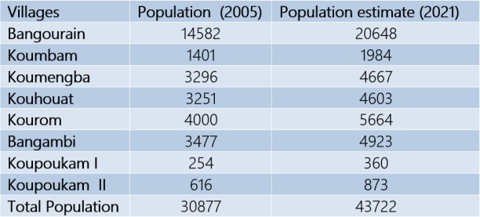

*Source: BUCREP, 2005 & Fieldwork, 2021*

Table 1: Population distribution and projections from 2005 to 2021 in Bangourain sub-division

The main instrument developed for data collection was structured questionnaires. However, both qualitative and quantitative data came from this main tool of data collection. Interviews were conducted concerning the contribution of innovations in the utilization and management of natural resources for agriculture in Bangourain Sub Division. These include interviews with the Sub Divisional Delegate of Ministry of Agriculture and Rural development (MINADER), Ministry of Livestock’s and Fisheries (MINEPIA) and the Mayor of Bangourain Sub Divisions on activities pertaining to innovation dynamics in the utilization and management of natural resources for agriculture. From these discussions, quantitative data was collected on innovations trends in the utilization and management of natural resources for agriculture in Bangourain Sub Division. Field observations, aimed at having a first-hand appraisal on the types of innovations in the utilization and management of natural resources.

The data collected from the field were analysed using both descriptive and inferential statistical tools. Descriptively, data collected from the field through questionnaires and interview was sorted and computed using statistical package for social sciences vision 21 (SPSS21) and Microsoft Excel 2016 in which the data were treated. Simple linear regression analysis was performed to analyse the data. The general formula for regression analysis applied in this study is:

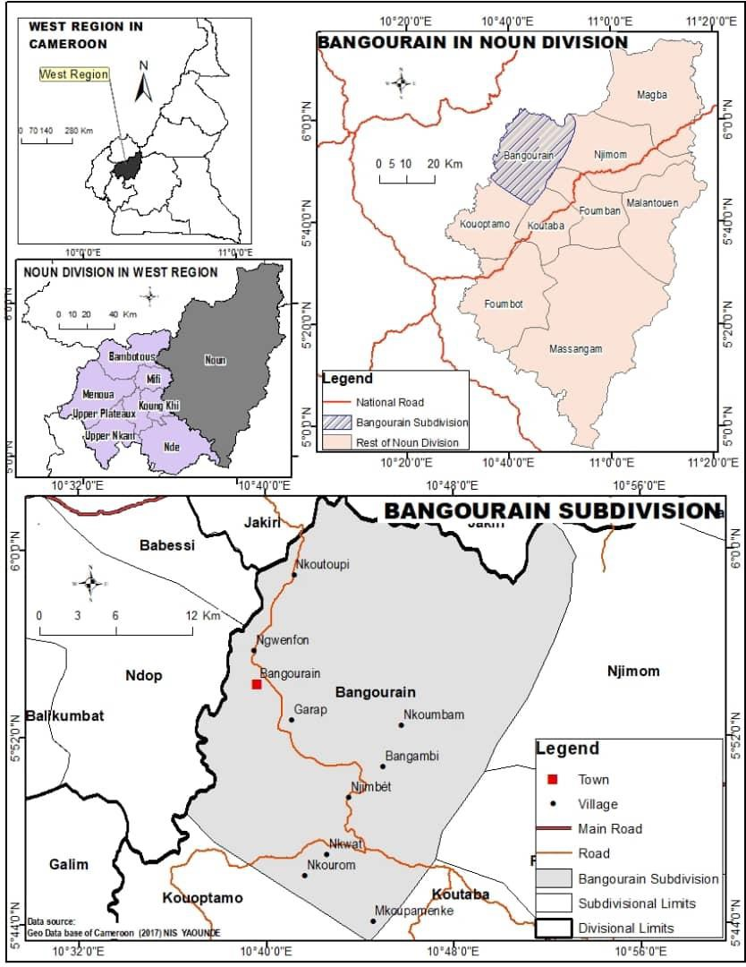

*Source: Geo Data base of Cameroon NIS Yaoundé (2017)*

Figure 1: Location of Bangourain Sub Division in the West Region of Cameroon.

Ŷ = bօ + b(1)X(1)+ b(2)X(2)+⋯ b(p)X(p)

Where:

Ŷ = is the predicted or predicted value of the dependent variable, X1 through X (p) = distinct independent variables

Bo = the value of Y when all the independent variables are equal to zero B1 through bp = estimates of regression coefficients

NB. Each regression coefficient represented the amount of change in Y relative to one-unit change in the independent variable.

The researchers used simple linear regression to examine how changes in innovations affect the management of land and water resources.

This was specified as:

CITMLWR =B0 +B1X1+B2X2+B3X3+B4X4+B5X5+B6X6+ B7X7+Ei… (e)

Where:

CITMLWR = Changes in innovations and the management of land and water resources

X1= Innovation trends and changes in population

X2= Innovations in the management of natural resources X3=Innovations in the utilization of land resources for crop production

X4= Innovations in the utilization of land resources for livestock production X5= Innovations of water resources for crop production

X6= Functions of technologies in controlling conflict in the utilization and management of natural resources

X7= Functions of technologies in reducing environmental degradation Ei= Each regression coefficient

e= other variables

The Durbin-Watson test was run to ensure that the assumption of no auto- correlation was met whereas the ANOVA table of standardised residuals on standardised predicted values were examined to ensure that the assumptions of linearity, homoscedasticity and normal distribution were met.

# Results

## Evolution of innovations in the management of land and water resources for agriculture

Natural resource management policy in Bangourain is as old as Cameroon itself. Before the arrival of the first colonial administrators in 1900, natural resources were managed according to the people's law (family law) as the village chiefs were the main administrators of natural resources. During this period, when hunting parties returned to a village, all the animals killed were brought to the chief whose duty was to distribute the meat to all the villagers. Figure 2 shows past innovations in the utilization and management of land and water resources in Bangourain.

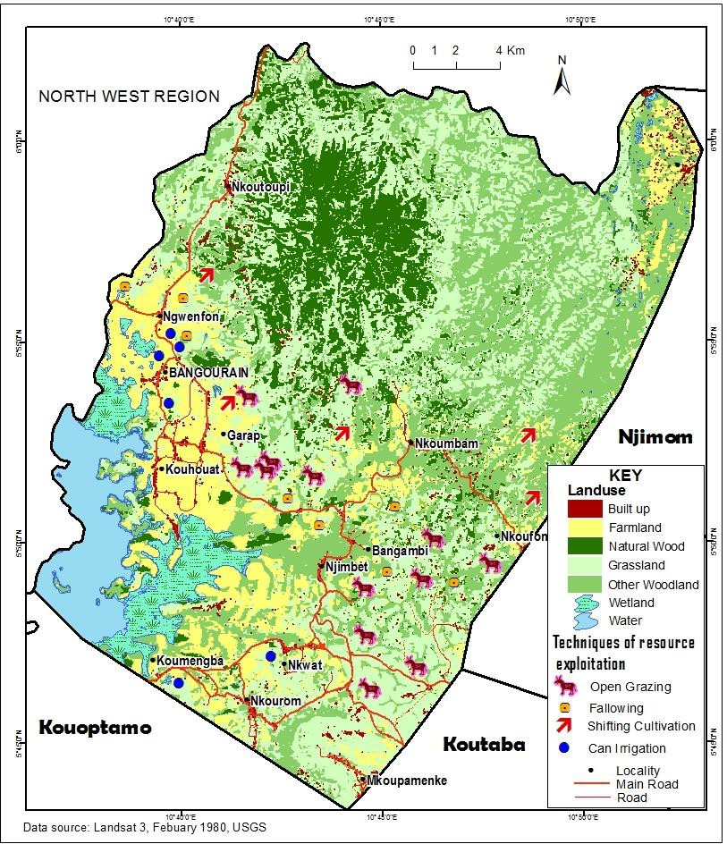

*Source: Landsat 3 USGS, (1980)*

Figure 2: Past innovations in the utilization and management of land and water resources

When French colonization began, they created hunting reserves and educated the population about planting exotic plants such as teak (Tectona grandis) in the savanna zone, Neem trees (Azadirachta indica), and Eucalyptus (Eucalyptus grandis). During this time, the population received education about resource tenure showing that all resources belonged to the state. Anyone requiring use of natural resources was required to apply for a permit. From 1970 to 2021 natural resources management have been under the responsibility of different Sub Ministries of Cameroon including the Ministry of Livestock, Fisheries and Animal Husbandry, Ministry of Agriculture and rural development and the Ministry of Environment, nature protection and Sustainable development. Figure 3 shows innovations in the utilization and management of land and water resource in 2000.

The tools used in the cultivation of the soil for agriculture were sticks, axes, hoe and cutlass. In the utilization and management of water resources for agriculture, they relied on rain fed agriculture without any management practices of water resources. Before 1990, the pressure on the utilization of natural resources was not significant. With the continuous increase in population from 1990 to 2000, pressure in the utilization and management of land and water resources for agriculture continued. During this period, the rate of natural resource utilization increased especially that of land and water resources. Figure 4 shows land use changes link to innovations in the utilization and management of land and water resources for agriculture in the year 2021.

Limited space for farming as well as fertile soils and it availability influenced the rate of innovation diffusion and adoption in the utilization of land resources for agriculture.

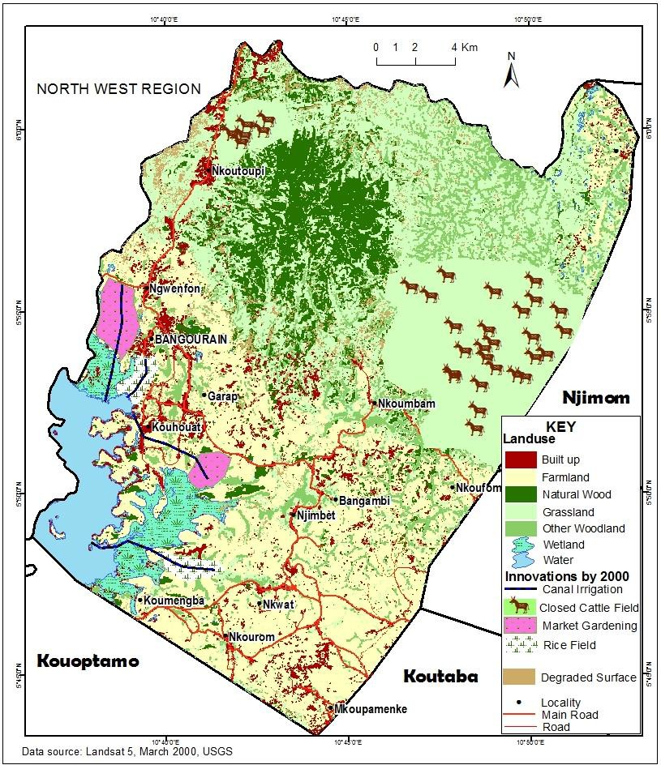

*Source: Landsat 5 USGS, (2000)*

Figure 3: Innovations in the utilization and management of land and water resources in the year 2000 in Bangourain Sub Division.

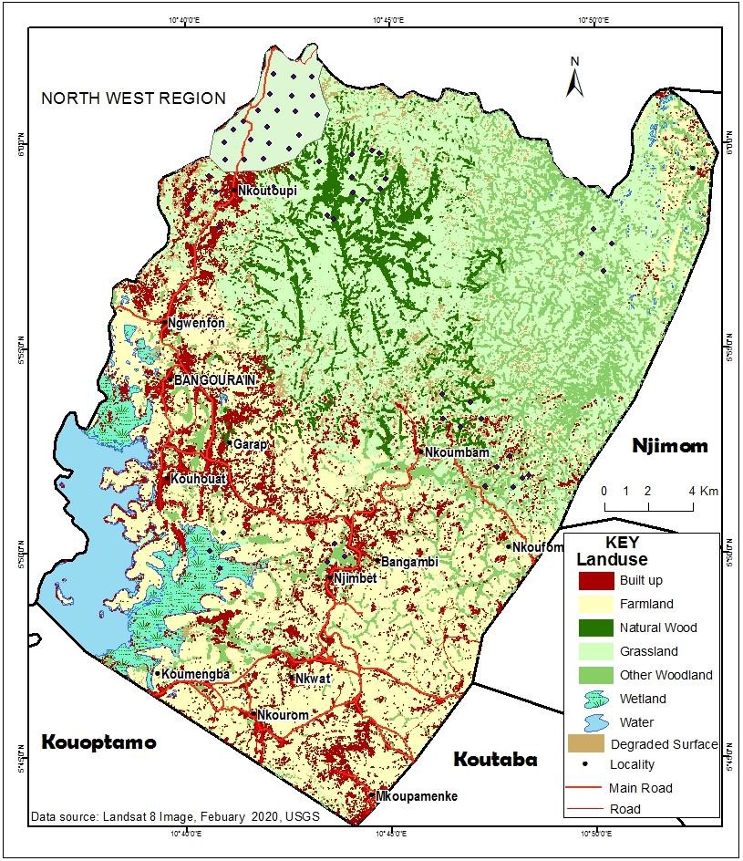

*Source: Landsat 8 USGS, (2020)*

Figure 4: Land use changes linked to innovations in the utilization and management of land and water resources in 2021.

These include the utilization of land resources with the use of new techniques such as the use of tractors in tilling the soil for agriculture. In the process of innovation in the management of land, resources for agriculture farmers use innovations such as the application of organic manure to maintain soil fertility. Innovations in the management of water

resources for agriculture were done by channelling water into rice farms around wetland areas through local canalisation. According to the population census of 2005, the population of Bangourain was estimated to be 30877 and this population was estimated to be 43722 in 2021 putting additional pressure in the utilization and management of land and water resources for agriculture. This led to rapid increase in Built up areas and farmland from 2000 to 2021. From this period, there has been rapid innovation in the utilization and management of land and water resources for agriculture. Innovation in the utilization of land resources for agriculture involved the use of chemicals in spraying farmlands, use of both organic and inorganic manure for crop production. On the other hand, innovations in the management of land resources is through conservative agriculture with the practice of mixed cropping especially leguminous crops such as soya beans and groundnuts that helps in increasing soil fertility.

## Innovations trends in the utilization and management of land resources for agriculture

### Innovation trends in the utilization of land resources for crop production

In Bangourain, farmers are encouraged to protect and conserve their agricultural land through innovations in the utilization of land resources for crop production. Table 2 shows innovations in the utilization and management of land resources for crop production. Crop rotation and intercropping as well as contour farming are highly used technologies in the utilization and management of land resources for crop production. Crop rotation and intercropping ensures different nutrients uptake and uses in the process of land resource utilization for agriculture. This is usually between maize and sorghum such as beans, groundnuts and cowpeas to enhance soil fertility.

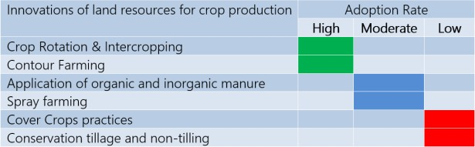

*Source: Sub Divisional Delegation of MINADER Bangourain, (2021)*

Table 2: Innovations in the utilization and management of land resources for crop production

The used of organic fertilizers such as compost and animal manure that have the capacity to increase soil fertility as one of the techniques in the utilization and management of land resources for crop production is still moderate in Bangourain. In addition, the use of inorganic manure or chemical fertilizer is moderate but highly used by farmers who practice marketing gardening. Furthermore, the use of chemicals in spraying farms by preparing farmlands for planting rather than clearing and tilling with the use of machetes and hoe is still moderate. Cover crop practices and conservation tillage are not highly use in the utilization and management of land resources for crop production. Cover crop practices has helped to reduce the loss of grains due to attack from pest while conservation tillage and non-tilling provide opportunities for increasing soil water retention. Figure 5 shows Innovation trends in the utilisation and management of land resources for crop production in respect to conservation tillage and non- tillage. Innovation trends in conservation tillage and non-tillage have not been on a high increasing since 2010. The innovation has not been highly adopted since 2010 to 2020 as it decreases from 14% to 5% between 2012 and 2014 as well as to 4% between 2014 and 2016. The situation changes positively to 14% between 2016 and 2018 with a continuous increase of 25% between 2018 and 2020. The increasing trends of farmers who highly adopted conservation tillage in the utilization and management of land resources for crop production shows a steady increase though it is relatively small, as most of the farmers have not implemented the innovation since 2010. On the other hand, high proportion of farmers rarely and did not implemented conservation tillage in the utilization and management of land resources for crop production.

From 2010 to 2012, about 39% of the farmers rarely adopted the use of conservation tillage while 57% never adopted conservation tillage in the

utilization of land resources. The number of farmers who rarely adopted conservation tillage decreased to 27% between 2012 and 2014 in which the situation changed in 2014 and 2016 by increasing to 44% and decreasing to 42% in 2016 and 2018 while between 2018 and 2020 it increased to 45%.

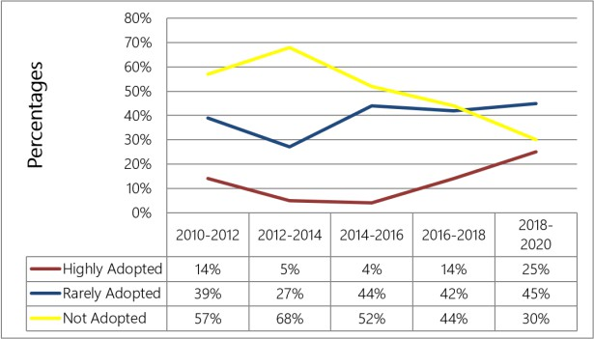

*Source: Bangourain Sub Divisional Delegation of MINADER, (2021)*

Figure 5: Innovation trends in Conservation tillage and non-tillage

Those who did not adopt the use of conservation tillage in the utilization and management of land resources for crop production have been decreasing from 2012 to 2020 even though with high proportion of farmers. It changed from 68% between 2012 and 2014 to 52% in 2014 and 2016. This

trend continued to decrease to 44% between 2016 and 2018 to 30% in 2018 and 2020. The decrease in proportion of those who did not adopt the use of conservation tillage was triggered by the rapid increase in population that led to high demand of land for agriculture. Kassam et al. (2015) approves that from 1973 the adoption of conservation tillage and non- tillage has been intense mainly in North and South America as well as in Australia and Asia while in 2015 the situation in Europe and Africa were on an increase. This is similar to the situation in Centre Africa and particularly Bangourain in the West Region of Cameroon where there has been an increase in the adoption of conservation and non-conservation tillage from 14% in 2016 to 25% in 2020.

### Innovation trends in the utilization and management of land resources for livestock production

Natural resources in the form of rich mixed grasslands located in mountainous and low land areas are used for livestock activities such as cattle, horse, pigs, goats and sheep rearing. The main livestock activity practice is cattle rearing by Fulani grazers and some natives engaged in the activity before 1980 in which they relied only on natural pasture for grazing. In the past, cattle rearing was mainly done in the open field and this often led to transhumance in which headers had only one option to move with their cattle to wetlands in search of pastures during the dry season and back uphill during the rainy season. They also practice rotation grazing. With this type of grazing, herders move their cattle uphill from one area to another allowing regeneration period for the grass to grow before the animals were taken back to the same location for grazing. Figure 6 shows Innovations in the utilization of land resources for cattle rearing.

The innovations include the use of paddocks that changes from the use of open grassland for cattle rearing to the use of a confined area where fodder crops are cultivated for cattle rearing especially on highlands areas such as Nkoutoupi. Figure 7 shows that 40% of livestock practices are cattle rearing and 20% is the rearing of goats as well as 11% for sheep rearing and 7% is the rearing of horse while 18% is poultry farming and 4% is the practice of pig farming. The main livestock activity that has experience innovations in the utilization and management of land resource is cattle rearing. Based on figure 8 high proportion of grazers did not adopt the use of improve pastures for cattle rearing.

From 1975 to 1985, the proportion of grazers that did not adopt the use of improved pasture for cattle rearing were high with about 62% and decreased to 44% between 1985 to 1995 as well as 39% between 1995 and 2005. This change between 2005 and 2015 with an increase of 47% as well as between 2015 and 2021 with a continuous increase of 58% in the proportion of cattle grazers who did not adopted the use of improved pastures for cattle rearing. The proportion of grazers who rarely adopted the use of improve pasture in cattle rearing was moderate with 29%

between 1975 and 1985 while between 1985 and 1995 it decreased to 25% but increases to 34% between 1995 and 2005. The proportion reduced back to 28% between 2005 and 2015 but increased again to 31% from 2015 to

2021.

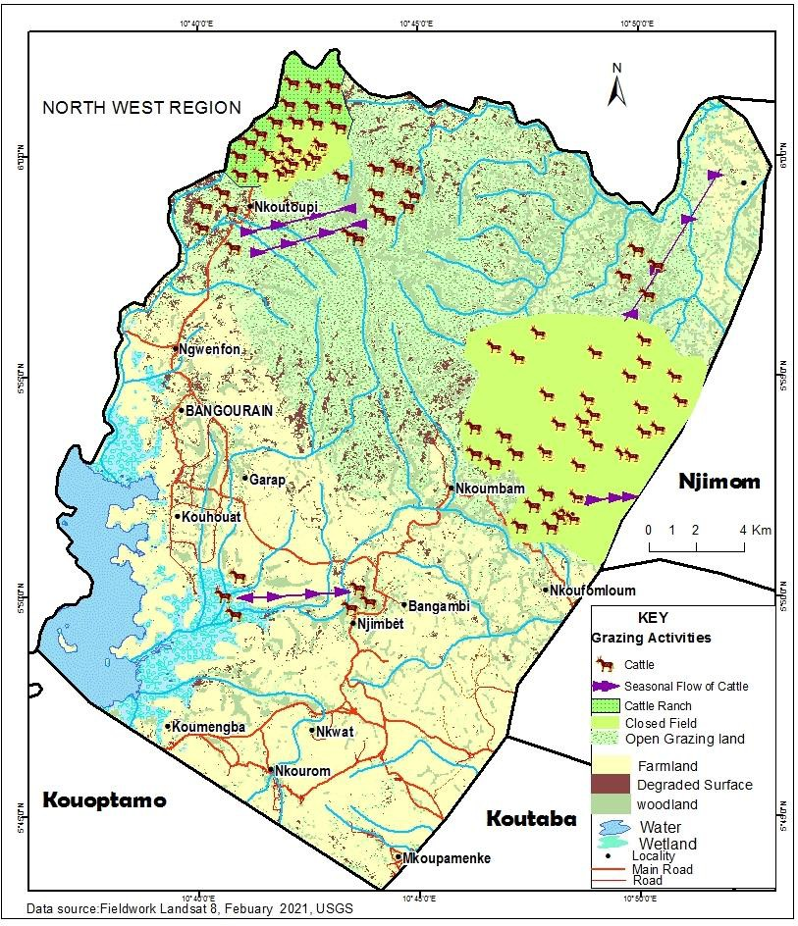

*Source: Landsat 8 USGS, (2021)*

Figure 6: Innovations in the utilization of land resources for cattle rearing from open field to closed field with improved pastures.

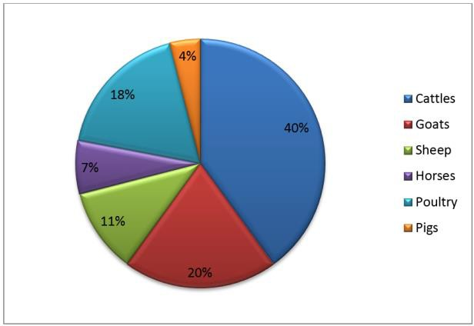

*Source: Bangourain Sub Divisional Delegation of MINEPIA, (2021)*

Figure 7: Proportion of different livestock production

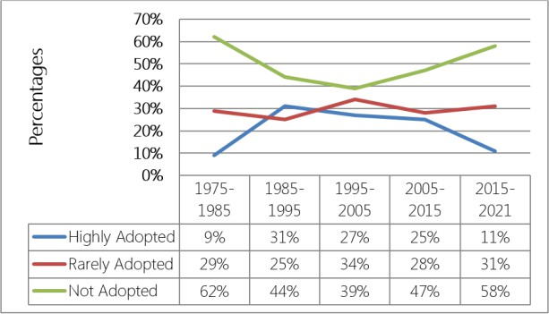

*Source: Bangourain Sub Divisional Delegation of MINADER, (2021)*

Figure 8: Innovation trends with respect to improvement in pasture

In addition, the proportion of grazers who highly adopted the use of improve pasture is low as only 9% of the grazers adopted the use of improve pasture for cattle rearing between 1975 and 1985 as well as 31% between 1985 and 1995. Innovation trends in the proportion of grazers who highly adopted the use of improve pasture continue to change from 1995 and 2005 with 27% and 25% between 2005 and 2015 as well as between

2015 and 2021 that decreases to 11%.

### Innovation trends in water resource utilization and management for agriculture

Water resources are one of the main natural resources that make life possible in Bangourain. This resource has experienced some Innovations in terms of water resources utilization and management for agriculture. Innovations in the utilization and management of water resources for agricultural activities in Bangourain are carried out through irrigation engineering. As a result, this has made food crop production not to depend only on rain fed agriculture as farmer’s uses irrigation techniques in cultivating food crops all year round. Figure 9 shows Innovations in the utilization of water resources used for irrigation practices.

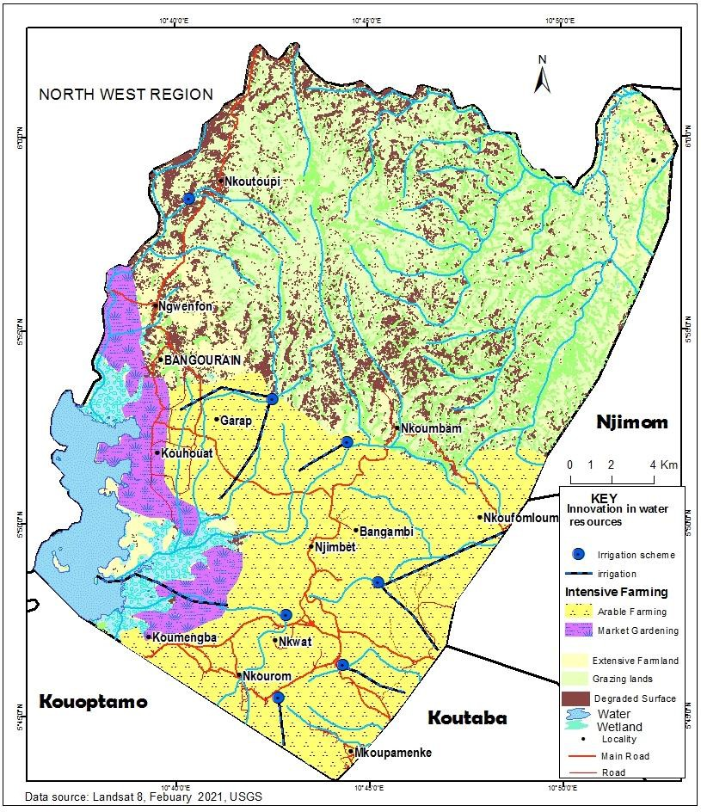

*Source: Landsat 8 USGS, (2021)*

Figure 9: Innovations in the utilization of water resources used for irrigation practices

Irrigation takes place in Bangourain Sub Division in both the rainy and the dry season. During the rainy season, irrigation activities through canalisations are being done for rice cultivation. High rainfall of about 2000 to 2500mm during this period still need effective canalization for the plot to be flooded with water to facilitate the growth of rice. Sources of water for this form of irrigation in Bangourain Sub Division during the rainy season are streams and rivers. In the dry season, the used of water resources for irrigation activities are mainly for the cultivation of market gardening crops such as cucumber, water melon, tomatoes and vegetables in Bangourain Sub Division. Rapid increase in the population of Bangourain Sub Division made market gardening the highest consumer of surface water resources during the dry season. In dry season, the demand for these food crop continues to increase not only for home market but to export to other national markets like Bafoussam, Douala, Yaounde and Bamenda as well as international markets such as Nigeria, Equatorial Guinea and Gabon.

Technology has played a great role in the utilization and management of natural resources conflict between farmers and grazers. Conflict on the utilization and management of natural resources between farmers and grazers in the past years was mainly over land and water resources in

Bangourain. In the past farmer, grazer conflicts over natural resources of land and water always led to the destruction of crops by cattle during the dry season as herders move with their cattle in search of pasture around wetlands. These cattle movements were not well coordinated, organized and controlled in Bangourain, and it always created conflict between farmers and grazers as their cattle destroyed food crops such as rice, beans, maize and vegetables. With innovations in the use of a closed field system that involves the cultivation of fodder crops, this conflict in the utilization and management of land resources has been under control. In Bangourain, conflict zones that still experience all year round conflict are cultivable lands around Nkoumbam and Bagambi. Conflicts between farmers were also common in the past but this has greatly reduced with new technology in the utilization of land resources for agriculture with land cover techniques, tillage and non-tillage and small scale intensive farming. Table 3 shows functions of technology in the Utilization and management of Natural Resources in Bangourain.

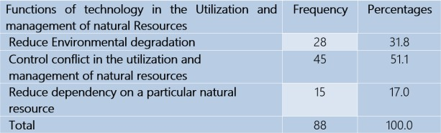

*Source: Fieldwork, (2021)*

Table 3: Functions of technology in the Utilization and management of Natural Resources

Table 2 shows that innovations in the utilization and management of natural resources plays a great function in reducing environmental degradation (31.8%) in Bangourain. Innovations contribute about 51.1% in controlling conflict in the utilization and management of natural resources between farmers and grazers, farmer and farmer, farmer and consumer as well as grazers and consumers. Innovations in the utilization and management of natural resources have reduced conflict between farmers and grazers over wetland resources during the dry season in Bangourain. In the past it was experienced in mixed farming areas known as all year round conflict zones in the utilization of natural resources for agriculture but with innovations, it has greatly reduced to a seasonal conflict zones and gradually to an extent a non-conflict zone as fodder crops are being cultivated uphill’s for cattle’s rearing during the dry season. Simple linear regression was used to verify the hypothesis statistically which states that changes in the trends of innovation have contributed significantly in the management of land and water resources for agriculture in Bangourain. It was used because it shows the relationship between single independent and dependent variables that could be illustrated using the model summary, ANOVA and coefficients of the simple linear regression analysis was run in SPSS to test the influence of changes in innovation trends on the management of land and water resources for agriculture in Bangourain. Table 3 illustrates model Summary showing the relationship between changes in innovation trends and the management of land and water resources for agriculture.

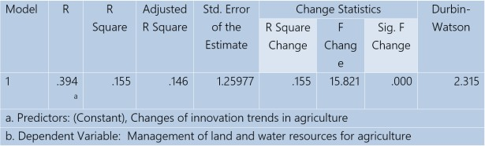

*Source: Fieldwork (2021), Computed using SPSS version 21*

Table 4: Model Summary showing the relationship between changes in innovation trends and the management of land and water resources for agriculture.

Based on table 4, changes of innovation trends in agriculture is responsible for 15.5% (R2 = 0.155) variance in the management of land and water resources for agriculture while other factors are responsible for 84.5%. In addition, the meagre difference (0.015) between the R2 value and adjusted R2 value imply that the results can be generalised to the entire population from the sample that was collected. Table 5 shows ANOVA table for

changes in innovation trends and the management of land and water resources for agriculture.

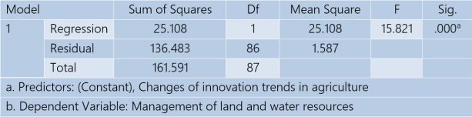

*Source: Fieldwork (2021), Computed using SPSS version 21*

Table 5: ANOVA table for changes in innovations and the management of land and water resources

Table 5 shows that using a simultaneous entry simple linear regression, there was a significant model (F = 15.821,df = 1,p = 0.000) for the relationship between ratings of changes in innovation trends in agriculture and the management of land and water resources for agriculture in Bangourain. The P-value of less than 0.05 shown on table 4 implies that at one degree of freedom, the model reached significant level in predicting the outcome variable. Where ANOVA is equal to Analysis of variance and F is variance ratio while Df is the degree of freedom as well as P is the probability value. Table 5 shows Coefficients table for changes in the trends of innovation and the management of land and water resources for agriculture in Bangourain.

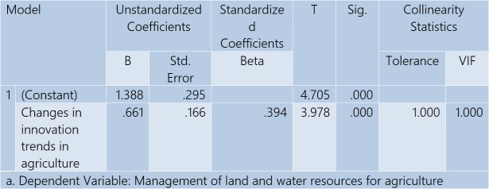

*Source: Fieldwork (2021), Computed using SPSS version 21*

Table 6: Coefficients table for changes in innovations trends and the management of land and water resources for agriculture.

Table 6 reveals even more insightful relationships between the variables. According to the table, a single unit increased in the standard deviation of changes in innovation trends in agriculture is accompanied by 0.394 effective management of land and water resources for agriculture (β = 0.394,t = 4.705,P ˂ 0.05). These findings imply that changes in innovation trends in agriculture significantly influence the management of land and water resources for agriculture in Bangourain.

# Conclusion

Field observations revealed that there is a significant relationship between changes in innovation and the management of land and water resources in Bangourain. The indicators used to capture changes in innovation (the independent variable) are historical development of innovations as well as evolution of innovations. In addition, management of land and water resources for agriculture (the dependent variable) was viewed in the light of conservation agriculture and irrigation farming. This led to descriptive analysis, which showed that innovations in the utilization and management of land and water resources played a great function in reducing environmental degradation (31.8%) and contributed about 51.1% in controlling conflict in the utilization and management of land and water resources. Inferential analysis was also used which illustrated that a single unit increased in innovations is accompanied by 0.394 increased in the management of land and water resources for agriculture. This implies that changes in the trends of innovation in agriculture have contributed significantly in the management of land and water resources in Bangourain. Garg & Balodi (2014) confirm that innovation trends in the utilization and management of land and water resources for agriculture are inevitable as they increase the production and productivity of agriculture to meet growing food demands in the World. The results concluded that changes in the trends of innovation have contributed significantly in the management of land and water resources for agriculture in Bangourain. Based on the conclusion, it is recommended that the government and other actors should plan periodic workshops to educate the inhabitants on the

benefits of appropriate techniques in the utilization and management of natural resources as an effective means to restrain natural resource conflicts and environmental degradation. Government’s guiding principles aimed at training the community on new innovations in the utilization and management of natural resources is essential to guarantee innovation diffusion. Composts and organic manure should be highly used by the community for crop cultivation.

# References

Andersen, A. D., Marìn, A. and Simensen, E. O. (2018). Innovation in natural resource-based industries: a pathway to development? Introduction to special issue, Innovation and Development, 8:1, 1-27, DOI: 10.1080/2157930X.2018.1439293

BUCREP (2005). Third General Population and Housing Census: 3è RGPH, Rapport De Présentation des Résultats Définitif; Résumé, 2010.

Garg, A. and Balodi, R. (2014). Recent trends in agriculture: vertical farming

World Bank (2019). The World Bank’s Country Partnership Strategy in Cameroon focuses on increasing the country’s competitiveness and improving service delivery. https:[//www.worldbank.org/en/country/cameroon/overview](http://www.worldbank.org/en/country/cameroon/overview)

WTO. (2010). World Trade Report: Trade in natural resources.

##### To cite this article Electronic reference

Desmond Forbah TAFUH & Jude Ndzifon KIMENGSI (2021). « Innovations in land and water resources management: Trends and implications in the Bangourain community, Cameroon ». Canadian journal of tropical geography/Revue canadienne de géographie tropicale [Online], Vol. (8) 2. Online December 25, 2021, pp. 51-57. URL: https://revuecangeotrop.ca

##### Authors

and organic farming. Adv Plants Agric Res. 142-144. DOI: 10.15406/apar.2014.01.00023

Gerard, G., Schillebeeckx, S., and Teng, L. (2015). The Management of Natural Resources: An Overview and Research Agenda. The Academy of Management Journal. 58. 1595-1613. 10.5465/amj.2015.4006.

IUCN (2020). Guidance for using the IUCN Global Standard for Nature- based Solutions. A user-friendly framework for the verification, design and scaling up of Nature-based Solutions.

Kassam, A., Friedrich. T, Derpsch, R. and Kienzle, J. (2015). Overview of the Worldwide Spread of Conservation Agriculture, Field Actions Science Reports [Online], Vol. 8 | 2015, Online. URL : <http://journals.openedition.org/factsreports/3966>

Kimengsi, J. N., Owusu, R. and Balgah, R. A. (2022). Nexus approach and environmental resource governance in Sub-Saharan Africa: A systematic review, Sustainability Science (Springer).

Kimengsi, J. N., Tafuh, D. F. and Kometa, S. S. (2021). Innovation diffusion in the utilization of fish resources in Bangourain, West Region of Cameroon: Environmental impact and sustainability, International Journal of Environment and Climate Change 11(7): 68-79.

Kimengsi, J. N. and Mukong, A. K. and Balgah, R. A. (2020). Livelihood diversification and household well-being: Insights and policy implications for forest-based communities in Cameroon, Society and Natural Resources, 33(5), 1-21, https://doi.org/10.1080/08941920.2020.1769243

Linjouom, Z. (2018). Exploitation and Management of Surface Water Resources in Bangourain: Western Region Cameroon. Unpublished DIPES II Thesis, The University of Bamenda.

Miao, C., Fang, D., Sun, L. and Qiaoling, L. (2017). Natural resources utilization efficiency under the influence of green technological innovation. Resources, Conservation and Recycling. 126. 153-161. 10.1016/j.resconrec.2017.07.019

Rands, M., William, A., Bennun, L., Stuart, B., Andrew, C., Coomes, D., Entwistle, A., Hodge, I., Kapos, V., Scharlemann, J., Sutherland, W. and Bhaskar, V. (2010). Biodiversity Conservation: Challenges Beyond 2010. Science (New York, N.Y.). 329. 1298-303. 10.1126/science.1189138.

Rogers, E. M. (2003). Diffusion of innovations (5th Ed.). New York: Free Press (Book)

Shiferaw, B.A., Okello, J. and Reddy, R.V. (2009). Adoption and adaptation of natural resource management innovations in smallholder agriculture: reflections on key lessons and best practices. Environ Dev Sustain 11, 601– 619. https://doi.org/10.1007/s10668-007-9132-1

UN (2021). Population estimate of Cameroon. https:[//www.worldometers.info/world-population/cameroon-population](http://www.worldometers.info/world-population/cameroon-population)

Washington, H., Guillaume, C., Helen, K., Joe, G. and John, P. (2017). Foregrounding ecojustice in conservation https:[//www.sciencedirect.com/science/article/pii/S000632071830](http://www.sciencedirect.com/science/article/pii/S000632071830) 5020.

Desmond Forbah TAFUH

Department of Geography & Planning University of Bamenda, Cameroon Email: [tafuhdesmond@gmail.com](mailto:tafuhdesmond@gmail.com)

Jude Ndzifon KIMENGSI Department of Geography University of Bamenda, Cameroon Email: [kimengsi.jude@uniba.cm](mailto:kimengsi.jude@uniba.cm)