

Primate Conservation, Incorporated
Project Proposal

PROJECT: Molecular Phylogeny of East African Dwarf Galagos (Galagidae; Galagoides)

PRICIPAL INVESTIGATOR(S): Mr Johan Karlsson; Professor Simon K. Bearder (Academic Advisor and Project Supervisor)

ADDRESS: Nocturnal Primate Research Group, Dept of Anthropology & Geography, Oxford Brookes University, Oxford OX3 0BP, United Kingdom

TELEPHONE/FAX/E-MAIL: 0046706754923/00441865483937/johan.karlsson@minmail.net

PROJECT PERIOD: May – September 2011
TOTAL BUDGET: US$ 40 474
AMOUNT REQUESTED FROM PCI: US$ 5 000
SUPPORT FROM OTHER SOURCES (NOTE IF PENDING):
- National Geographic Society Research and Exploration Grant (pending)
- Mohammed bin Zayed Species Conservation Fund (submission of proposal 15 March 2011)
- Oxford Brookes University Equipment Fund (received)

ACADEMIC ADVISOR SIGNATURE____Simon K. Bearder______________________________
ABSTRACT: Non-human primate species belong to a group of generally well-studied mammals, but there are exceptions. The rarely seen but often heard nocturnal African bushbaby or galago is one such exception. Their cryptic appearance still confounds understanding of their true species diversity, especially amongst the smallest of them all - the dwarf galagos (genus Galagoides). All eight species known to science reside within the East African Coastal Forests, Eastern Arc Mountains and Southern Rift Biodiversity Hotspots. This unique area represents a shifting mosaic of “islands” of various ages, intersected by rivers and open landscapes that create barriers to migration, resulting in an unusually rich array of species.
Given that small mammal species, such as dwarf galagos, tend to be quite sedentary, information on the genetic distance between populations at clime shifts and geological barriers would provide valuable information on the historical importance of these migration impediments for the evolution of small mammal species. We therefore propose a survey of specific localities in the aforementioned Biodiversity Hotspots of East Africa to collect genetic material from all known and all presumptive dwarf galago species.
With a portfolio of newly compiled genetic data combined with described behavioral and morphological data we hope to settle the taxonomic status of dwarf galago populations. Furthermore, we aim to establish a complete record of their molecular phylogenetic relationships. Our findings will identify priority populations for conservation and management plans.

Please do not write below this line.

Prior PCI support: N/A
PCI project number___________________________________________________
Recommendation_____________________________________________________

Molecular phylogeny of East African dwarf galagos
Objective
Non-human primate species belong to a group of generally well studied mammals ¹. One of the more pertinent exceptions is the rarely seen but often heard African nocturnal primate, the dwarf galago (genus Galagoides)². As with many nocturnal animals, dwarf galagos have a cryptic morphology that confounds full understanding of their true species diversity^{3,4} To fully quantify the extent of the taxonomic variety of the genus, it is necessary to conduct an assessment of the genetic diversity in an evolutionary perspective^{4,5}, i.e. create a genetically based phylogeny. However, current records of dwarf galago DNA are very patchy and are mostly derived from captive populations^{6,7}, leaving incomplete phylogenetic understanding^{8,9}. We therefore suggest a survey of specific localities in Biodiversity Hotspots of East Africa to collect genetic material from all known and all presumptive dwarf galago species. The intent is to construct the most comprehensive molecular phylogeny made to date. We believe the results from this study will prove pivotal for future research and conservation prioritizing of dwarf galagos.
Research Design
This project includes two major sections: first, collection of genetic material from wild populations; second, laboratory extraction of the genetic material for phylogenetic analyses.
- Field work
There are currently eight dwarf galago species described to science⁴. All taxa can be found at or nearby the Eastern Afromontane Biodiversity Hotspots comprised of Kenya, Tanzania, Malawi and Mozambique^{2,4}. We have pinpointed a range of locations within this area previously described as dwarf galago habitat^{4,10-15}. The locations (see Table 1 and Survey Map) were chosen not only to include as many species and unique populations as possible, but also with the intent to cover distinct inter-species boundaries and potential hybrid zones⁴.
The main goal of the surveys is to collect hair samples for genetic analyses. Hence, the primary focus at each study site is to confirm presence or absence of the target species. We have no intent to conduct population density estimates. The set-up allows us to implement a rapid survey methodology developed by the Nocturnal Primate Research Group (NPRG). The methodology encompasses non-random transects on established trails and paths starting at dusk and ending at dawn ¹⁶. Individuals are detected through their vocalizations and/or reflective eye shine¹⁷. Detected individuals’ specific identity is determined indirectly through their advertizing call³ and directly through visual recognition of facial masks and body features⁵. Once it is established that target species are present, we will set up a network of traps for catching galagos to allow genetic sampling of the resident population.
- Lab work
Inference of evolutionary relationships among the different species will be accomplished through DNA sequence analyses of different markers. It is now widely recognized that a reliable species phylogeny should be based on both mitochondrial and nuclear loci¹⁸. Consequently we will analyze two nuclear loci: (1) intron 11 of the von Wildebrand Factor, vWF; (2) a portion of the gene coding for the interphotoreceptor retinoid binding protein, IRBP; and (3) four mtDNA markers: cytochrome oxidase II (COII), cytochrome b (cytb), 12S and 16S ribosomal DNA. The phylogenetic inference (as detailed in the next section) will be conducted on the specimens collected and on specimens from related taxa, whose sequence data are available in public repositories such as GenBank.

Methodology
We will detail and justify both field and lab work methodologies relevant to the different stages of project implementation.
Field work
Logistics
  - Transportation
To enable coverage of a wide geographical area in shortest time possible we will use a 4x4 Toyota Land Cruiser. Though local transportation is readily available in both Tanzania and Malawi, it is considered vital for the project that we have full access and control over our own transportation. The reasons for this need are plentiful; for example:
- Limited time to conduct the project;
- Safety – we will be visiting remote areas;
- Practicality - we will be carrying field equipment for at least 4 people and up to 20 small mammal traps with us at all times.
The vehicle will be leased by our project collaborator, the Tanzania Forest Conservation Group (TFCG).

  - Survey calendar
We will conduct a five-month field survey during May – October 2011. We aim to visit two sites per month totaling ten study locations (Table 1). Detailed planning of the order in which field sites will be visited, in combination with the collected experience and knowledge of the survey team, give us confidence that time will be sufficient for the set task.
  - Subsistence
Provisions such as dry goods will brought along in bulk, and the supply will continuously be replenished as needed. Fresh produce will be purchased locally at each study site.
Data collection
Since dwarf galagos are small (< 120 grams), agile, arboreal and nocturnal², it is practically impossible to collect genetic material through indirect and non-invasive methods (e.g. feces, urine, shed hair). The only feasible way to collect genetic material requires direct extraction from captured individuals. This method allow collection of genetic material with better quality, containing both nuclear and mitochondrial DNA, than would be possible through non-invasive methods¹⁹.
The best way to capture dwarf galagos is to set up Chardonneret box traps in trees where galagos are known to occur¹⁷. Traps will be checked every half-hour to prevent unnecessary stress induced by capture. While some species can be readily captured, others are notoriously hard to capture²⁰. Flexibility of the survey team will therefore be of the essence. If enough individuals are caught and genetically sampled before the scheduled time at one location, we will switch location ahead of schedule and vice-versa.
Once captured, the animal will be handled with protective gloves to reduce the risks of disease transmission between researcher and animal, as well as to minimize contamination of the researcher on sampled genetic material¹⁹. The least invasive method with the highest potential yield of high-quality nuclear and mitochondrial DNA is from follicles of plucked hair²¹. Hair extraction will be conducted with sterilized tweezers from the posterior dorsal (back) side, just anterior the tail. Samples will be stored in sterilized 2 ml sample tubes filled with the medium RNAlater®²².
Notes will be taken on sex, pelage coloration, facial markings and approximate age of the caught individuals. We will also take measurements of body weight; head-body, tail, hind-foot and penis length; and maximal vertical and horizontal ear length. These morphological characteristics are important diagnostic cues for species determination in dwarf galagos^{5,23}.
Digital recordings, using high quality recorders and directional condenser microphones, will be made of each population’s vocalizations. Since dwarf galago species display unique vocal repertoires, recordings will provide important information on taxonomic identity of sampled populations³ . The acoustic properties of the calls will be compared both qualitatively and quantitatively to reference recordings available at the NPRG Sound Laboratory at Oxford Brookes University. Further, we will keep a detailed log of geographic position, habitat and vegetation type of each field site; the date, time, weather, temperature, humidity, wind and lunar phase at any research related event.
Laboratory work
All laboratory work will be conducted under the hospice of Dr. Cristiano Vernesi and staff at the Centro di Ecologia Alpina, Fondazione E. Mach, Trento, Italy. Upon their arrival, samples will be stored at – 80 °C. DNA will be extracted and purified from hair follicles using an appropriate commercial kit (QiaGen) in an automated DNA extractor so to minimize risk of contamination and carry over across different samples. To To get adequate amounts of DNA, and to reduce the potential for amplifying nuclear insertion of mitochondrial DNA into the nuclear genome (the so called numts²⁴, at least four-five follicles will be used. Sequence analyses of the four mtDNA selected markers: COII, cytb, 12S and 16S, and the two nuclear markers: vWF and IRBP, will be accomplished via PCR amplification of the target loci and cycle sequencing with automated sequencer, in both directions, of the target amplicons. When necessary, to resolve ambiguities, the PCR product will be cloned in plasmid vectors and about ten different amplicons will be sequenced. To carefully check for contamination, both during extraction and amplification, blanks (i.e. samples containing only reagent, no DNA) will be regularly analyzed together with dwarf galago specimens.
Sequences will be aligned with dedicated software packages (e.g. Clustal X) and re-checked by eye. Inference of phylogeny by simply concatenating the different sequences has often proven misleading ²⁵. We will therefore follow analytical approaches explicitly tailored to estimate species trees from multilocus data: algorithms such as those implemented in the software programs STEM²⁶, BEST²⁷ and *BEAST ²⁸will be used. This methodology would allow a better understanding of the evolutionary relationships among the different taxa.
Project outcome
Differences between species are often hard to discern, especially when it comes to cryptic species such as dwarf galagos². Morphology and behavior cannot always be used to differentiate between species ²⁹ and cannot, with any high accuracy, reveal ancestral relationships between species^{4,23}. We are facing a difficult eminent threats of extinction imposed upon many species in East Africa³⁰. It is therefore more important than ever to get a full understanding of the true species diversity displayed³¹. The implications of an extensive molecular study on dwarf galagos would help us to establish basic but mandatory information about how many species there are³², and deepen our understanding of the evolutionary forces responsible for current species diversity³³. More importantly, it will provide us with new tools to target unique and especially vulnerable populations³⁴ for setting conservation initiatives at regional levels³⁵ within this the most biodiverse of hotspots³⁶.
Table 1. Study species and suggested localities.
Species | Habitat | Study site | Code | Coordinates | Country
G. cocos | Coastal stripe & floodplain forests | Mgambo Forest Reserve, East Usumbara Mountains | MFR | 4°55’01’’S;38°38’48’’E | Tanzania
G. demidovii | Lowland secondary forest | Kikuru Forest Reserve | KFR | 1° 4'60"S; 31°37'60"E | Tanzania
G. granti | Natural, lowland evergreen, semi-evergreen forest, areas of dry coastal forest, thicket and scrub | Kichi Hills, South of Rufiji River; Northern boundary | KHS | 8°11'60"S; 38°40'00"E | Tanzania
G. nyasae* | Tropical montane, lowland and secondary forest | Tea Research Foundation Forest, Blantyre | TRFF | 16°6'00"S; 35°37'38"E | Malawi
G. orinus | Sub-montane and montane evergreen Eastern Arc Forest forests | Ulangambi Forest Reserve | UFR | 8°1'60"S; 35°55'00"E | Tanzania
G. rondoensis | Coastal evergreen, dry and scrub forests | Rondo Forest Reserve | RFR | 10° 8'00"S; 39°12'0"E | Tanzania
G. thomasi | Tropical forest mid-to high canopy | Kikuru Forest Reserve | KFR | 1° 4'60"S; 31°37'60"E | Tanzania
G. zanzibaricus | Bush, low forest, groundwater forest, coconut groves, and coral rag thicket | Somewhere just north of Rufiji River | SRR |  | Tanzania
G. sp. nov. 1 | Forest and semi-evergreen transition woodland | Nkuwadzi Forest Reserve | NKF | 11°41'16"S; 34°15'01" | Malawi
Mt Rungwe galago (Misuku Hills galago) | Sub-montane and montane evergreen forests | Mt Rungwe | MTR | 9°7'45"S; 33°40'11"E | Tanzania
Misuku Hills galago | Montane rainforest | Mughese Forest Reserve, Misuku Hills | MIH | 9°39’08’’S; 33°32’32’’ | Malawi
Taita Hills galago | Cloud forest | Taita Hills | TAH | 3°25'31"S; 38°20'09"E | Kenya

Table 2 Approximate time schedule for field surveys (site abbreviations from Table 1).
Site | Week (2011)
Site | 1-2 | 3-4 | 5-6 | 7-8 | 9-10 | 11-12 | 13-14 | 15-16 | 17-18 | 19-20
Site | May |  | June |  | July |  | August |  | September
MFR
KFR
KHS
TRF
UFR
RFR
SRR
MUR
MTR
MIH
TAH

Budget
- Total budget for project - $40 474
- Funds already available - $2 000 (equipment grants, Oxford Brookes University); $450 (own funds)
- Grants applied for from other sources (supplemental to PCI):
  - National Geographic Society Research and Exploration Grant: $19 524 (pending);
  - Mohammed bin Zayed Species Conservation Fund: $12 500
- Funds requested from Primate Conservation Inc.: $5 000
Item details | Justification (only detailed for money applied from PCI) | PCI funds | Other sources
Technical assistance
Field assistance at $250/month |  |  | $1 250
Salaries |  |  | $15 390
Travel/Subsistence
Flights (return flight Stockholm & London - Dar es Salaam) | Return airfares for Professor Bearder and Mr. Karlsson from London to Dar es Saalam -- source for prices are British Airways website www.britishairways.com |  | $2 200
Flights (3 return flight Dar es Salaam - Blantyre) |  | $ 2 100
4x4 wheel Land Cruiser, TFCG |  |  | $5 000
Car fuel, maintenance and repair, insurance per month @ $250 |  |  | $1 250
Fieldwork subsistence, 5 workers @ $5 per diem - 175 days | Daily essentials including food, water, sanitary equipment. | $2 900 | $1 475
Field Equipment
Globalstar Satellite Phone for emergencies |  |  | $999
Field camp equipment |  |  | $700
Contingency |  |  | $600
Permits
Research permits (TAWIRI $920; COSTECH $290) |  |  | $1 210
Administration fees |  |  | $400
Genetic analyses (CEA) |  |  | $5 000
Total: |  |  | $40 474
Amount requested from Primate Conservation Inc. |  | $5 000
Amount requested from other sources: |  |  | $35 474
References

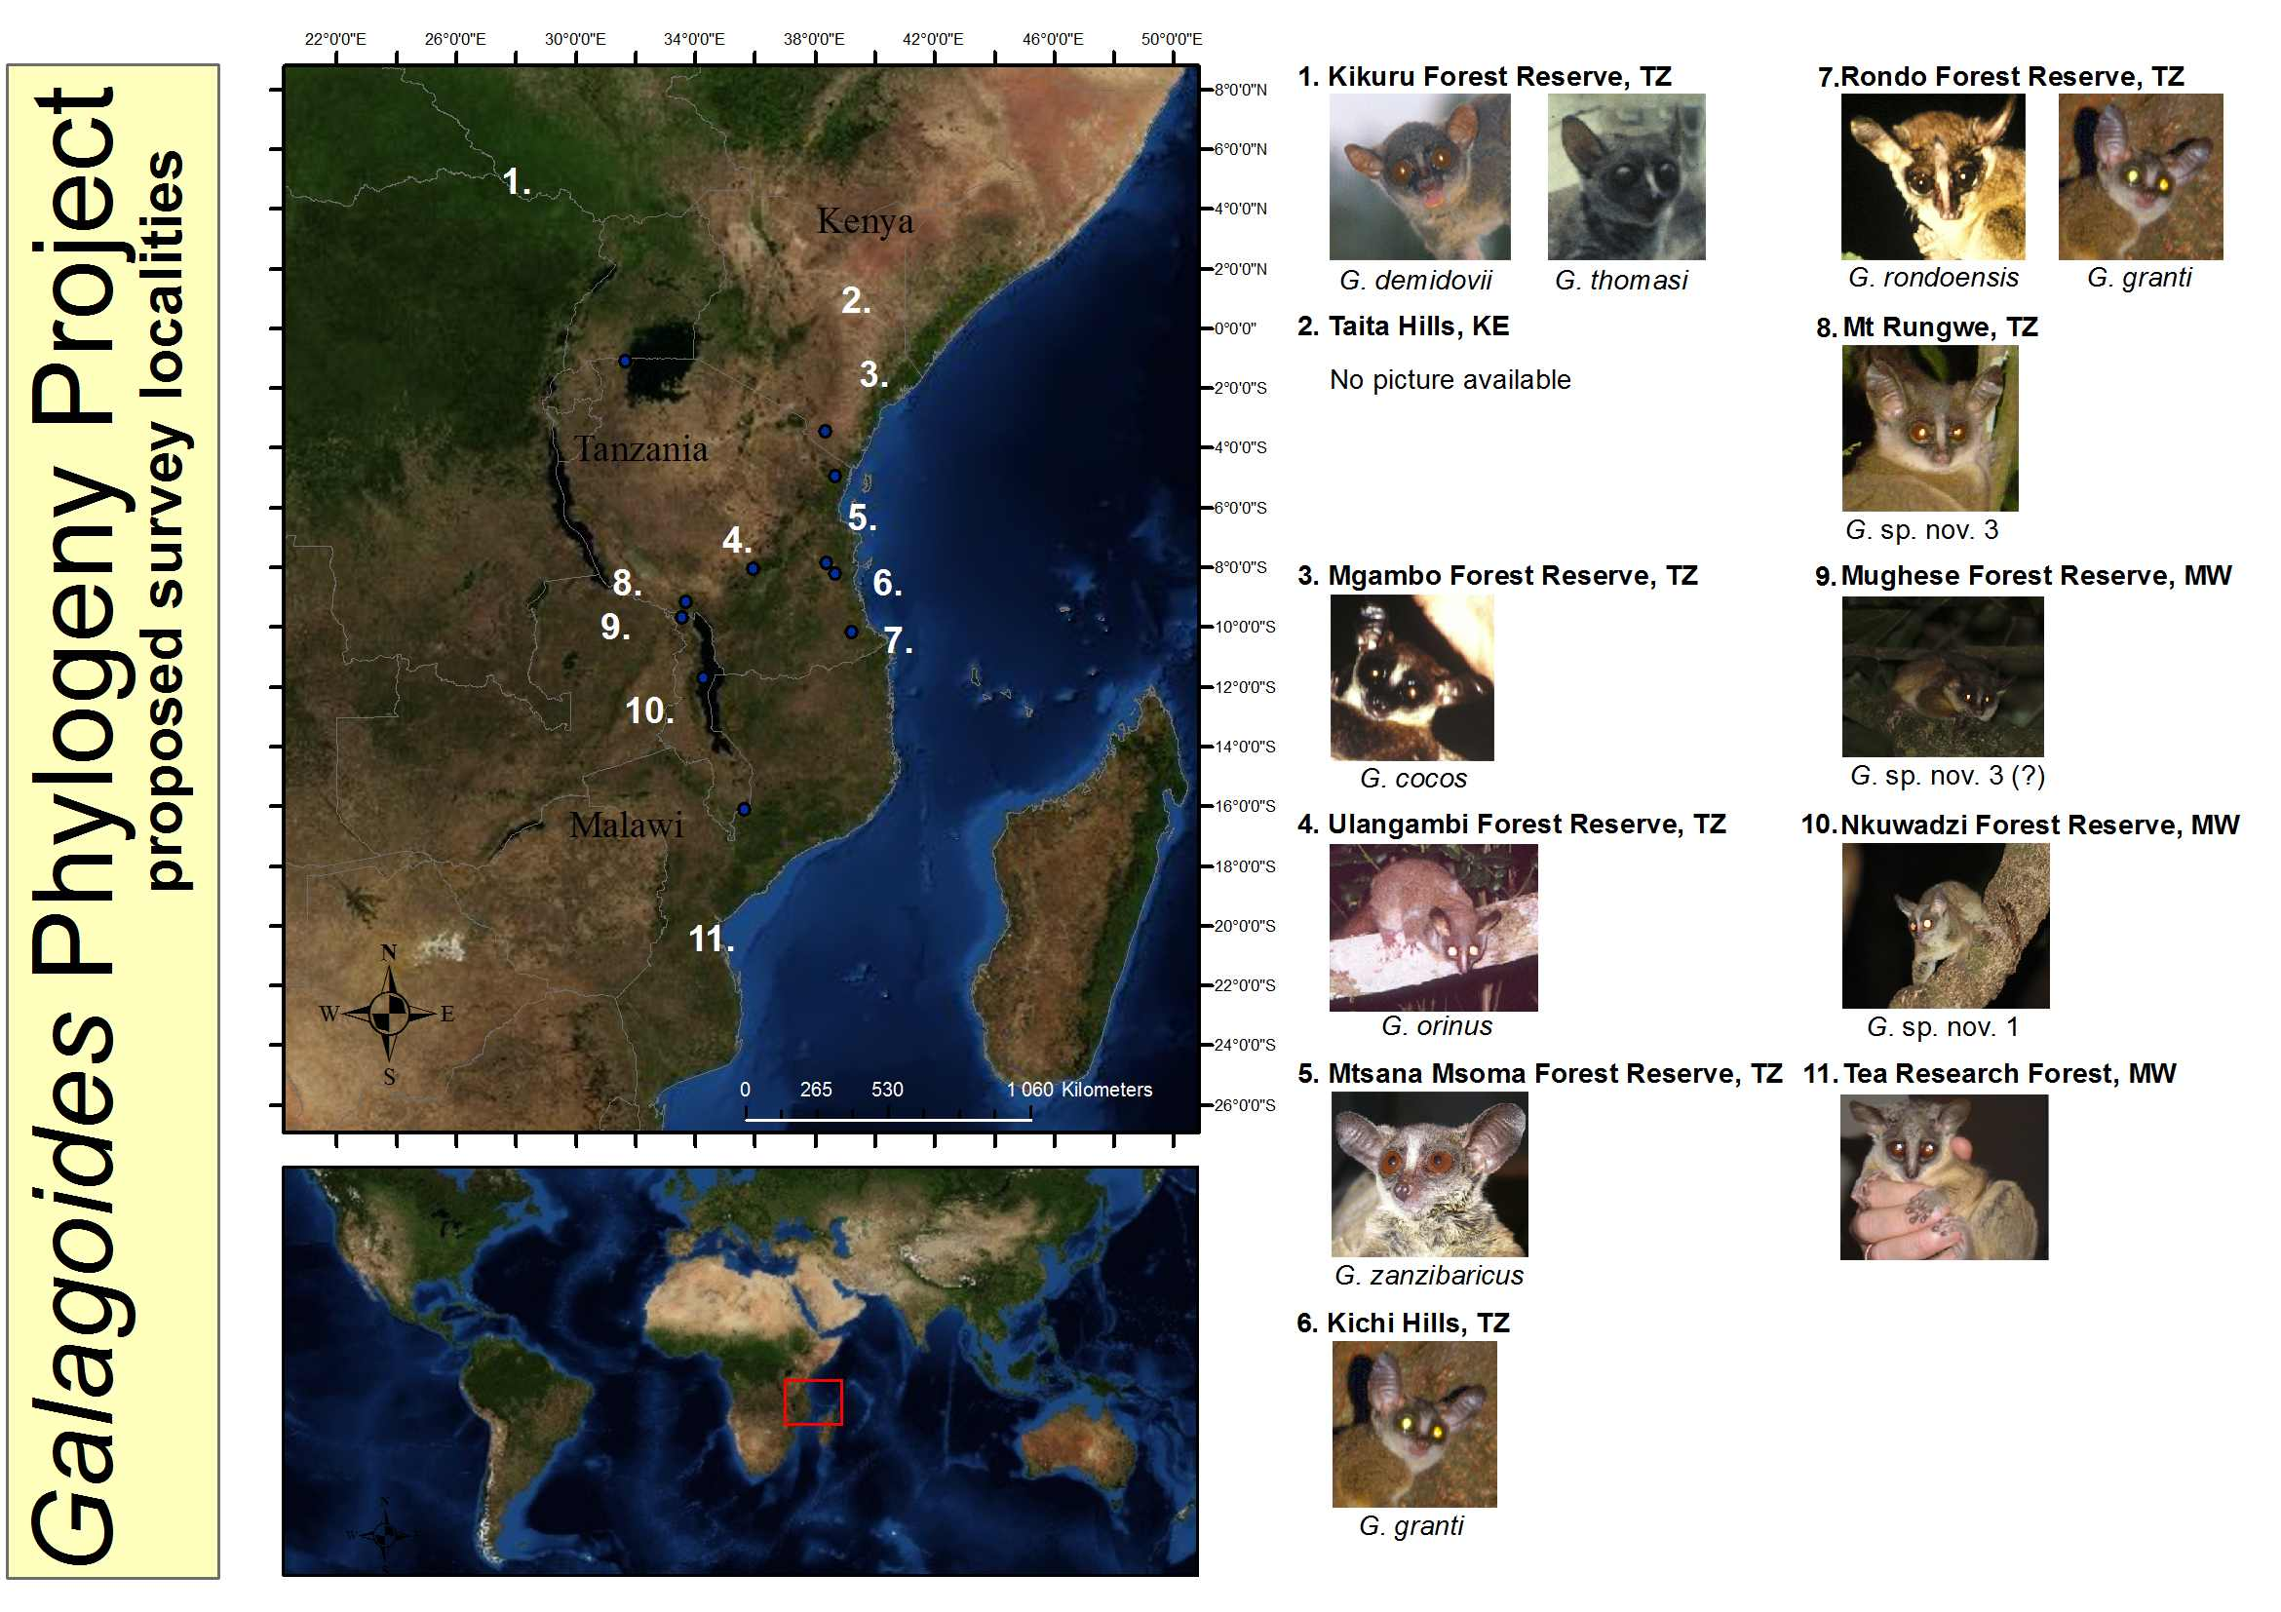
Staffing
Principal investigator of the project is Mr. Johan Karlsson with Professor Simon K. Bearder as co-investigator and also participant in the field work (see attached CVs for qualifications of the investigators). Further, Mr. Andrew Perkin, Tanzania Forest Conservation Group, and Dr. Cristiano Vernesi, Centro di Ecologia Alpina, Fondazione E. Mach, Trento, Italy will assist with the field work and laboratory work respectively.
Permits
Research permits will be obtained from appropriate authorities before the project commence, both from the U.K. and from host countries. Mr. Perkin, since living in and working in Tanzania, will assist with permits for both Tanzania and Kenya. Research permits for Malawi will be obtained though assistance by Ms. Tiwonge Mzumura who kindly helped Mr. Karlsson and Professor Bearder on their survey of the Malawian dwarf galagos 2009.
Names and addresses of 3 people qualified to review the proposal.
Dr Caroline S. Harcourt
Dept of Veterinary Clinical Service
Leahurst
Chester High Road, Neston
Wirral CH64 7TE
UNITED KINGDOM
charcourt@btinternet.com

Dr Thomas M. Butynski
Conservation International
Africa & Madagascar Division
P. O. Box 68200 - 00200
Nairobi
KENYA
tbutynski@aol.com

Dr. John D. Polk
University of Illinois at Urbana-Champaign
Department of Anthropology
109 Davenport Hall
607 Mathews
M/C 148
Urbana, IL 61801
USA
jdpolk@illinois.edu

