5.1.b) Derive a test suite that satisfies branch coverage. Please use a table with input,
branch and expected results as depicted in the lecture.

TestCase | Str | StripChars | A | B | C | D | E | F | G | H | I | J | Result
1 | Null | "" | X |  |  |  |  |  |  |  |  |  | null
2 | " abc" | null |  | X | X |  | X | X |  |  |  |  | "abc"
3 | "abc" | "" |  | X |  | X |  |  | X |  |  |  | "abc"
4 | "yzabc" | "xyz" |  | X |  | X |  |  |  | X | X | X | "abc"

One can note that all branches are covered. There could be other cases where while loop would not be executed, yet, with less test cases, all the branches can be covered, nevertheless.

5.1.c) Implement the tests using Junit 5. Measure the coverage of your tests via JaCoCo. It is already configured, and you can invoke it via Maven by running mvn clean test. You can generate a HTML report via mvn jacoco:report. The report is then stored at target/site/jacoco.

class StringHelperTest {
@Test
void branch1A() {
assertEquals( null, StringHelper.stripFromStart(null, ""));
}

@Test
void branch1B2C3E3F() {
assertEquals( "abc", StringHelper.stripFromStart(" abc", null));
}

@Test
void branch1B2D3G() {
assertEquals( "abc", StringHelper.stripFromStart("abc", ""));
}

@Test
void branch1B2D3H3J3I() {
assertEquals( "abc", StringHelper.stripFromStart("yzabc", "xyz"));
}
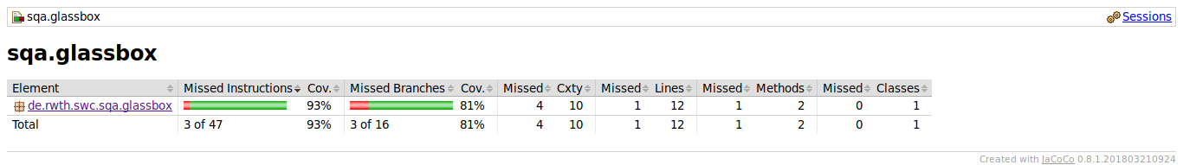
}

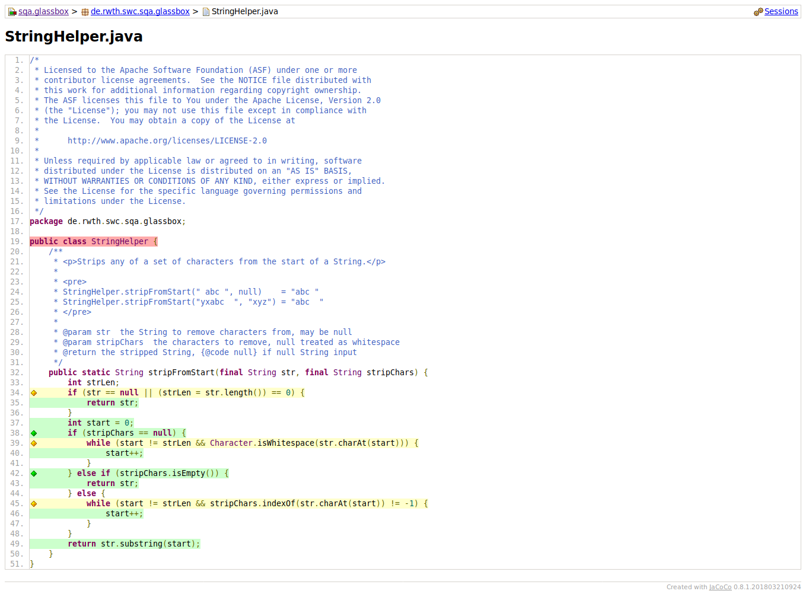
It is stated that in cases below:
- if (str == null || (strLen = str.length()) == 0)
- while (start != strLen && Character.isWhitespace(str.charAt(start)))
- while (start != strLen && stripChars.indexOf(str.charAt(start)) != -1)
that we have missed 1 of 4 branches.

Searching for this interesting state of coverage, I have found that the JVM optimizes non-singular logic cases (such as (a && b) and (a || b)) in the following way:
- given a case of (X && Y), if X is false, JVM does not execute Y case, as this expression of (X && Y) would eventually evaluate to false, without looking at the truth value of Y.
- same applies for (X || Y), if X is true, JVM declares this whole (X || Y) expression to be true.

Seeing that all our branch misses occur in non-singular cases, we can say that our branch coverage is full.

One other thing that could have been done is to convert source code so JVM does not optimize. (for example, convert (X || Y) to !(!X && !Y) so to avoid JVM from optimizing, or nesting if statements instead of using them in a non-singular logic cases.

While cannot be considered as a source for information, one can check:
https://stackoverflow.com/questions/15493094/eclemma-says-1-of-4-branches-not-covered-but-which-branch-is-it
5.1.d) Analyze your test suite if it already satisfies boundary interior coverage. Discuss whether or not it is already satisfied. If it is not satisfied, derive a new test suite to satisfy boundary interior coverage. Document the changes you made.

My test suite does not satisfy boundary interior coverage. For example, I did not include the case(s) in which while loops are not executed at all (no-loop test cases of boundary interior coverage, I do not have them in my test cases.)

For this matter, I thought it would be best to generate all the test cases that boundary interior coverage demands, and add them to the previous branch coverage test suite altogether (as boundary interior does NOT subsume branch coverage!).

class StringHelperTest {

@Test
void branch1A() {
assertEquals( null, StringHelper.stripFromStart(null, ""));
}

@Test
void branch1B2C3E3F() {
assertEquals( "abc", StringHelper.stripFromStart(" abc", null));
}

@Test
void branch1B2D3G() {
assertEquals( "abc", StringHelper.stripFromStart("abc", ""));
}

@Test
void branch1B2D3H3J3I() {
assertEquals( "abc", StringHelper.stripFromStart("yzabc", "xyz"));
}

// Boundary Interior - no loop

@Test
void branch1B2C3F_noloop() {
assertEquals( "abc", StringHelper.stripFromStart("abc", null));
}

@Test
void branch1B2D3H3I_noloop() {
assertEquals( "yzabc", StringHelper.stripFromStart("yzabc", "x"));
}

// Boundary Interior - one loop (boundary)

@Test
void branch1B2C3E3F_oneloop() {
assertEquals( "abc", StringHelper.stripFromStart(" abc", null));
}

@Test
void branch1B2D3H3J3I_oneloop() {
assertEquals( "zabc", StringHelper.stripFromStart("yzabc", "y"));
}

// Boundary Interior - at least two loop (interior)

@Test
void branch1B2C3E3F_atleasttwoloop() {
assertEquals( "abc", StringHelper.stripFromStart(" abc", null));
}

@Test
void branch1B2D3H3J3I_atleasttwoloop() {
assertEquals( "abc", StringHelper.stripFromStart("yzabc", "yz"));
}
}

Newly added test cases to the main suite to satisfy the boundary interior coverage:

TestCase | Str | StripChars | Result
1 | "abc" | null | "abc" | No-loop case (for one of the while loops)
2 | "yzabc" | "x" | "yzabc" | No-loop case (for the other while loop)
3 | " abc" | null | "abc" | One-loop case (for one of the while loops)
4 | "yzabc" | "y" | "zabc" | One-loop case (for the other while loop)
5 | " abc" | null | "abc" | At-least-two-loop case (for one of the while loops)
6 | "yzabc" | "yz" | "abc" | At-least-two-loop case (for the other while loop)

