1)chage====> try to modify the parameters

2)lock a user-> passwd -l user1

status of a user-> cat shadow

unlock a user ->passwd -u user1

3)add a group-> groupadd -g 1002 aa

change gid for the group groupmod-> -g 1001 aa

change the name for that group-> groupmod -n aa ulhas1

add a user ->usermod -g ulhas1 username

add another group

add the second group as a secondary group same user ->id ulhas1

4)add a user

change the uid of that user-> usermod -u 607 ulhas1

change the username-> usermod -l ulhas ulhas1

5) create a directory ->mkdir

touch files in it -> touch file1 file2 file3

ls -l ==> owner ,permissions,group

chown and assign user & group to the files & directory chown root:permission file1

6) create a 3 files

check the permissions (ls -l) === preserve this permissions

change the permissions to 455,777,755 ->chmod 777 file1

permissions to be changed again back

7) change ownership->chown sachin:permission2 file1

) chage group & assign diffrent froup

Screenshots:

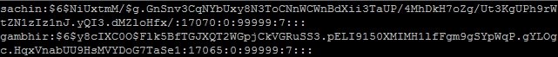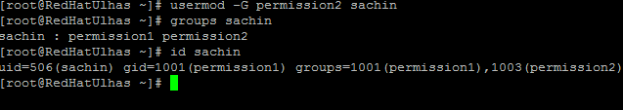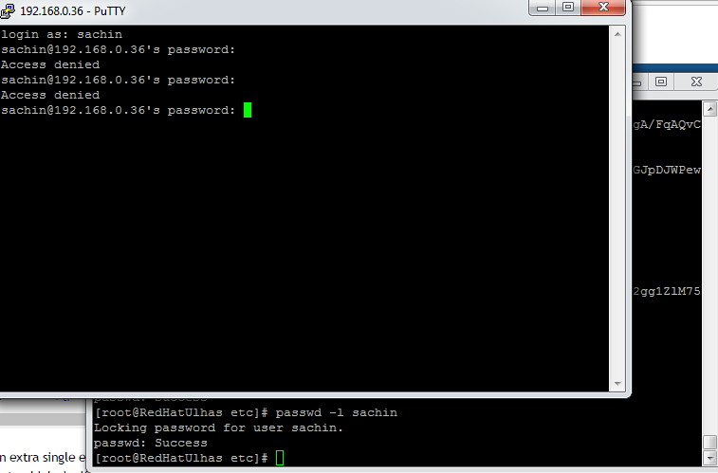C:\Users\Ulhas\Desktop\LinuxScreenshots\New folder (2)\locaedUser.PNGC:\Users\Ulhas\Desktop\LinuxScreenshots\New folder (2)\GroupNameChanged.PNGC:\Users\Ulhas\Desktop\LinuxScreenshots\New folder (2)\GroupId.PNG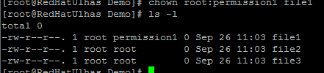C:\Users\Ulhas\Desktop\LinuxScreenshots\New folder (2)\ChangeUserName.PNG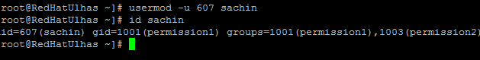C:\Users\Ulhas\Desktop\LinuxScreenshots\New folder (2)\ChangeNameOfGroup.PNGC:\Users\Ulhas\Desktop\LinuxScreenshots\New folder (2)\ChangedGroupId.PNGC:\Users\Ulhas\Desktop\LinuxScreenshots\New folder (2)\AddUserTo Group.PNG