ServiceNtpd

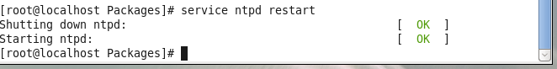

Ntpq -p

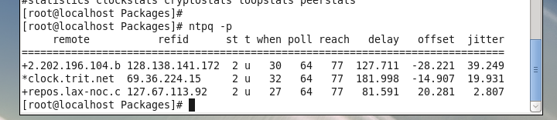

Ntpdate -u

