/etc/hosts file:

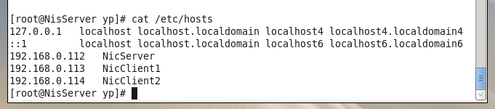

/etc/sysconfig/network file:

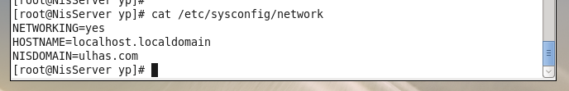

/etc/yp.conf file

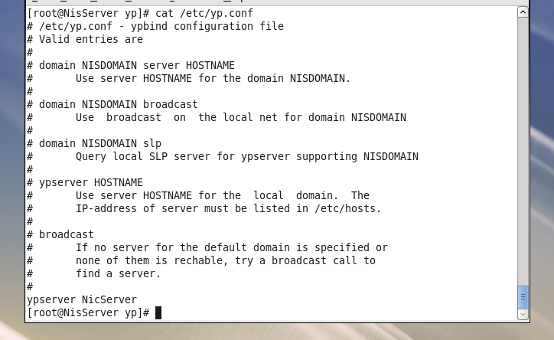

Df-h server

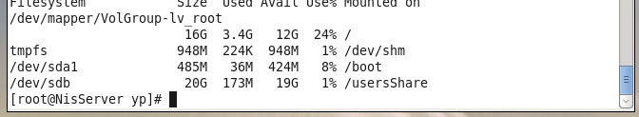

Showmount -e server:

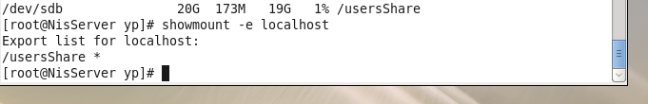

/etc/shadow:server

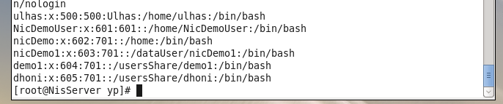

CLIENT1

/etc/fstab file

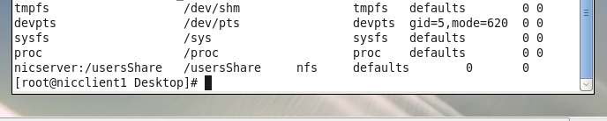

Login client1:

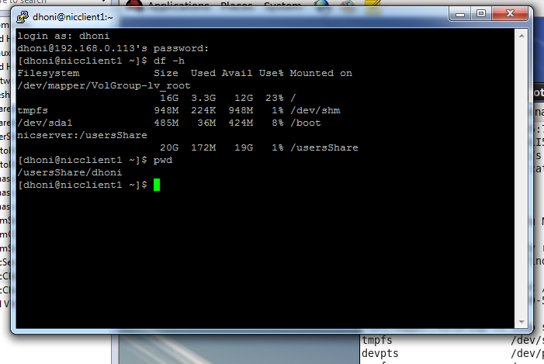

CLIENT2:

/etc/hosts file

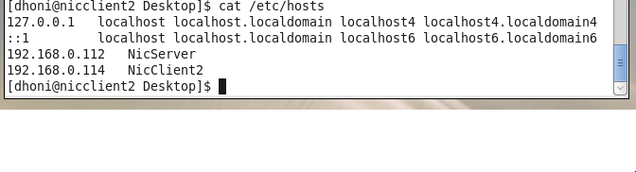

/etc/sysconfig/network file:

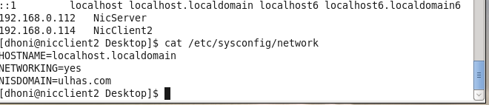

Yp.conf file:

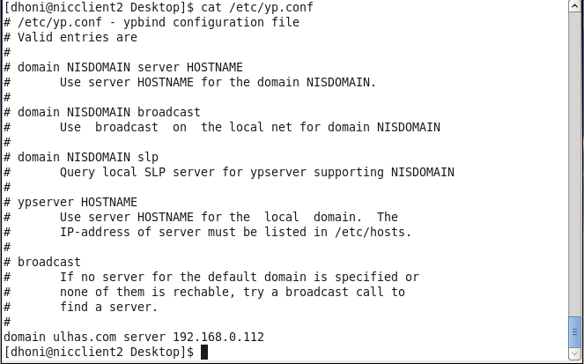

/etc/passwd file

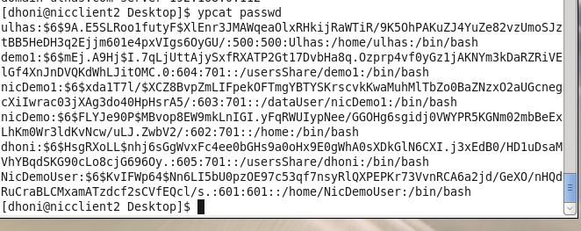

Auto.master and auto.client1 file

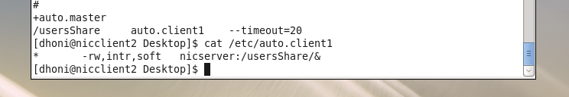

Login from client2:

