/etc/samba/smb.conf

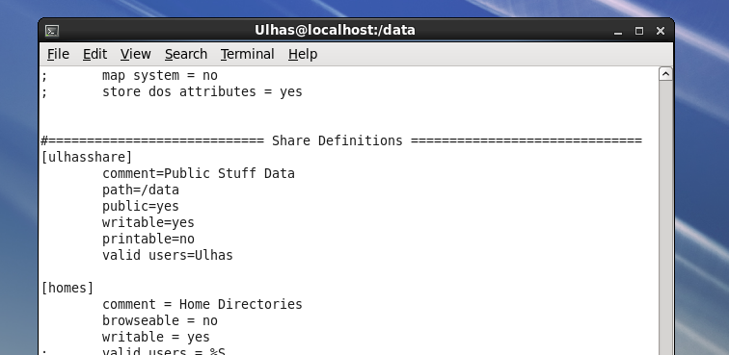

Testparm

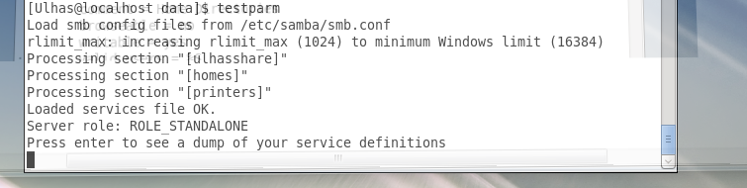

Get&setEnforce

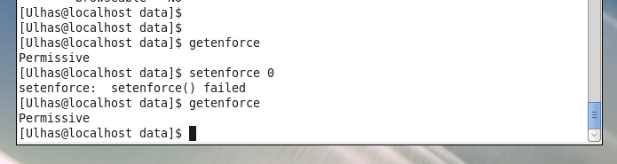

Run

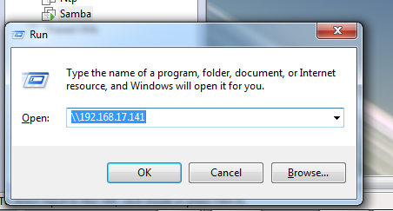

Shareddata:

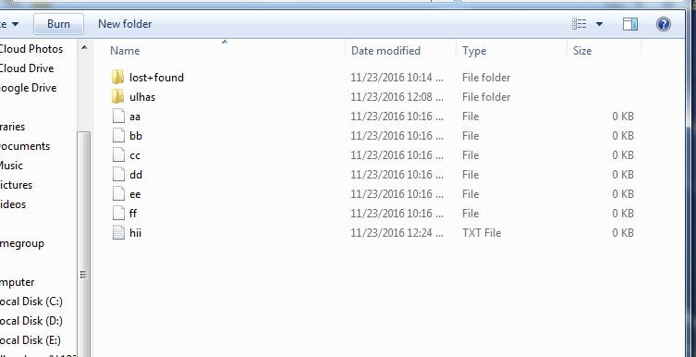

Mappeddrive

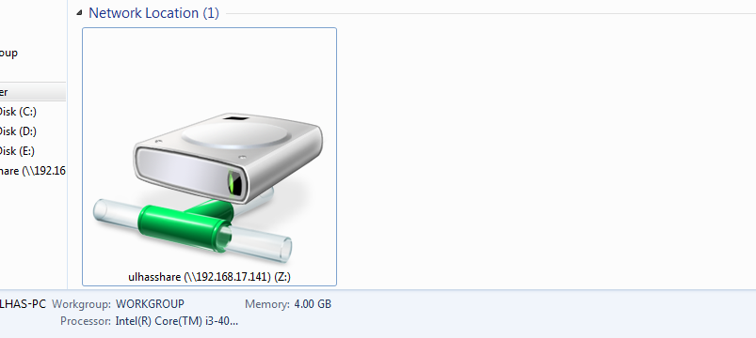

Shareddata:

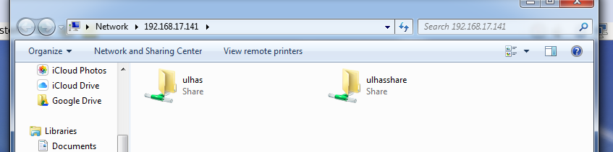

WindowstoLinux

