**Assignment ShareUser:**

Df-h on clientside

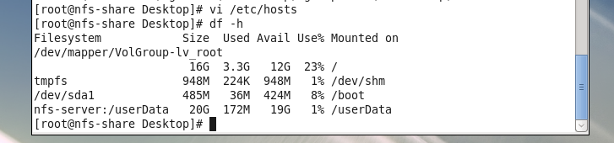

/etc/fstab on clientside

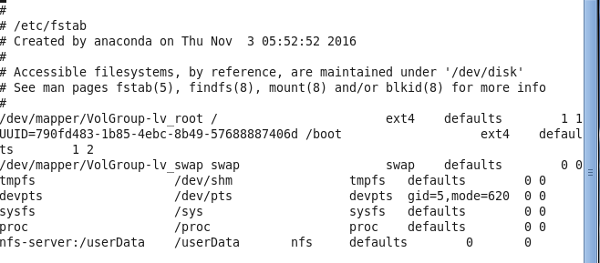

/etc/hosts

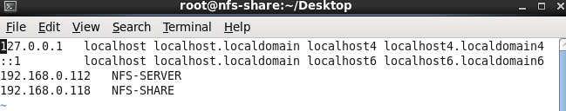

User share:

