SERVER SIDE:

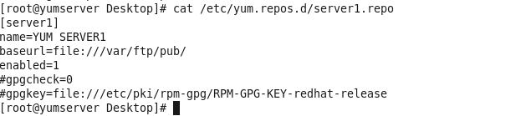

E:\StudyAll\LinuxScreenshots\YUMINSTALL\vsftpdstart.PNG

CLIENT SIDE:

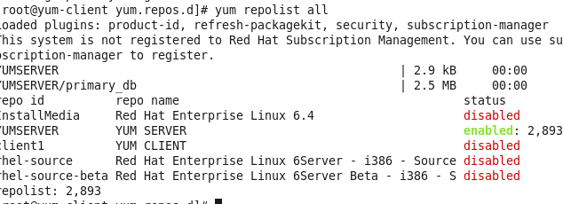

INSTALLATION OF SAMBA :

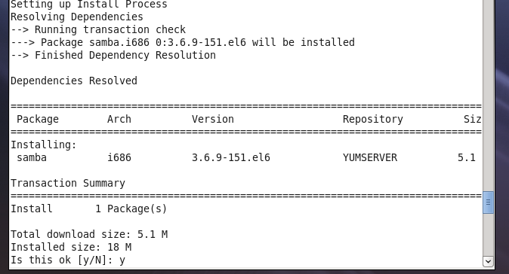

LIST

