DHS 2017
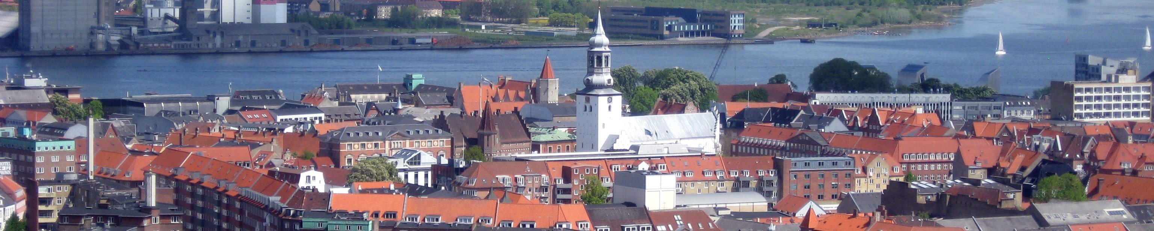

International Workshop on

Methods and Tools for Distributed Hybrid Systems

Aalborg, Denmark, 26 August 2017
Associated with MFCS 2017

http://dhs.gforge.inria.fr

Program

Abstracts of invited talks

Martin Fränzle
Carl von Ossietzky Universität Oldenburg, Germany
Indecision and delays are the parents of failures
The advent of systems of cooperative cyber-physical systems draws attention to a central problem of networked and distributed control systems: the ubiquity of delay in feedback loops between logically or spatially distributed components, which is not adequately reflected in traditional models of hybrid-state dynamics based on ordinary differential equations and immediate transitions. Occurrence of feedback delays may significantly alter a system's dynamic response. Unmodeled delays in a control loop consequently have the potential to invalidate any stability and safety certificate obtained on a related delay-free model, which is current practice in hybrid-system analysis. In this talk, we will present various approaches to the analysis and correct-by-construction design of dynamical systems subject to delayed information exchange, as pertinent to distributed hybrid systems. We will explain automatic verification procedures for invariance properties and bounded temporal-logic based on constraint-solving or rigorous generalization from simulations. This analytical view will be complemented by a constructive one based on a notion of delayed games and corresponding strategy synthesis algorithms.
Rafael Wisniewski
Aalborg Universitet, Denmark
Safety verification of stochastic hybrid systems
I will define the notion of safety both for deterministic and stochastic systems. As for stability of dynamical systems, we associate a function to the dynamical systems and study its properties. A barrier certificate is such a function. If we additionally assume that this function is polynomial, we arrive at an algebraic test. In short, we check if a function and its directional derivative is positive on certain sets. To this end, one can use the sum of squares and associated toolboxes in Matlab. I will extend the concept of barrier certificates from dynamical systems to stochastic hybrid systems.
Two hybrid systems will be discussed: a switching diffusion process and piecewise deterministic Markov process. A switching diffusion process is a family of diffusions coupled by a random switching process - a compound Poisson process. The random switching process models sporadic switches between continuous subsystems. The second object of interest is Davis’ piecewise deterministic Markov process. A piecewise deterministic Markov process consists of deterministic dynamical systems that alternate with random discrete transitions. Randomness of the discrete transitions (jumps) is characterised by stochastic time of jumps, and stochastic jump-destinations.
This work has been done in collaboration with Manuela L. Bujorianu (Strathclyde).
Kim G. Larsen
Aalborg Universitet, Denmark
Synthesis and optimization for cyber-physical systems
UPPAAL SMC offers a highly scalable statistical model checking engine supporting performance analysis of stochastic hybrid automata, and the recent UPPAAL STRATEGO supports synthesis (using machine learning) of near-optimal yet safe strategies for stochastic hybrid games. In the talk I will present the underlying formalisms (stochastic hybrid automata and games) used by the tools, and demonstrate their concerted application to a selection of cyber-physical examples including safe and optimal cruise control, optimal floor heating as well as intelligent traffic control.
Abstracts of invited talks

Alessandro Abate
Oxford University, United Kingdom
Hybrid models for heterogeneous populations of photovoltaic panels on the grid
In recent years, in view of growing environmental concerns and fostered by the Kyoto protocol, the Paris Agreement, and the so called 2-degrees challenge, industry and academia alike have increased their interest and attention on renewable energy sources, with a focus on new technologies for power generation. In the field of renewables, many studies are now focused on photovoltaics (PV- or solar panels), which is nowadays the third most important renewable energy source in terms on total installed capacity, after hydro and wind power. Devices producing such renewable energy are typically distributed over a large region, rather than being concentrated in a small area, which leads to consider the issue of distributed generation.
PV panels produce electrical current from solar irradiation by virtue of the photovoltaic effect in semiconductor materials. Although models for a single PV cell or panel are well known in literature, a model dealing with distributed generation of power in a large area is still missing, and there has not been any modelling effort describing the connection between a population of solar panels and the grid.
We present a new framework for modelling and abstraction of a large population of heterogeneous PV panels. We firstly analyse the behaviour of a single physical PV device when connected to the grid (through its frequency), and argue it is naturally described as a hybrid model. Thereafter, in order to encompass the heterogeneity of a population of solar panels, we present two models, one closer to the physical population, the other more abstract, which are then connected to the dynamics of the network: this provides an extended quantitative description of the whole system, for which stability properties are studied.
The talk concludes with ongoing efforts, and with a call for feedback on an enticing issue we have encountered, dealing with hybrid and timed models.
Martin Raussen
Aalborg Universitet, Denmark
Topological models for spaces of executions in HDA
Higher dimensional automata (HDA) are powerful models for concurrency in terms of expressiveness. They can be described using cubical complexes which makes the topic amenable to a combinatorial/topological analysis. An execution corresponds to a directed path (d-path) in such a (time-flow directed) state space, and a d-homotopy (preserving the directions) of d-paths has equivalent computations as a result. This is why we started investigating the space of all executions (d-paths between given end points) in an HDA from a topological perspective. The determination of path components is particularly important for applications.
Getting to grips with the effects of the non-reversible time-flow is essential, and one needs to "twist" methods from ordinary algebraic topology in order to make them applicable. I will discuss particular directed spaces arising from Higher Dimensional Automata (HDA). There are various methods identifying the homotopy type of the space of executions between two states in such an automaton with some finite complex: in simple cases as prodsimplicial complex - with products of simplices as building blocks - or as a configuration space living in a product of simplices. In several interesting cases, it is possible to calculate homology groups and other topological invariants of execution spaces. We sketch a method recently devised by Ziemiański identifying - for a general HDA - a space of directed paths with a prodpermutahedral complex arising by glueing various permutahedra along their boundaries.
Saturday 26 August

8:30 Registration opens
9:00 Welcome
9:10 Invited talk
Martin Fränzle
Indecision and delays are the parents of failures
10:10 Break
10:30 Invited talk
Martin Raussen
Topological models for spaces of executions in HDA
11:30 B.Martin, O.Mullier
Rigorous computation of viability kernel
12:00 Lunch
13:30 Invited talk
Kim G. Larsen
Synthesis and optimization for cyber-physical systems
14:30 Invited talk
Alessandro Abate
Hybrid models for heterogeneous populations
of photovoltaic panels on the grid
15:30 Break
16:00 Invited talk
Rafael Wisniewski
Safety verification of stochastic hybrid systems
17:00 Discussion
17:30 DHS ends


