DHS 2019

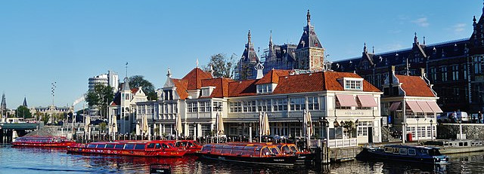
Third International Workshop on

Methods and Tools for Distributed Hybrid Systems

Amsterdam, The Netherlands, 26 August 2019
Associated with CONCUR 2019

http://dhs.gforge.inria.fr

Program

Abstracts of invited talks

Majid Zamani
University of Colorado Boulder, United States
Compositional synthesis of interconnected control systems
In this talk, I will propose a design approach for interconnected control systems, in which the controllers are synthesized compositionally from high-level logic requirements in a push-button and formal manner. Examples of such requirements include those expressed as linear temporal logic (LTL) formulae. In particular, I will leverage decomposition and abstraction as two key tools to tackle the design complexity, by either breaking the design object into semi-independent parts or by aggregating components and eliminating unnecessary details. I will illustrate the effectiveness of the proposed results on some case studies. I will show that our proposed results can handle large-scale systems, which would not have been possible to tackle using existing techniques.

Hervé de Forges
Kopadia, Paris, France
Underwater robotics: past, present, and future
Demographic and economic developments require more and more resources, but onshore possibilities are limited. Naturally, oceans, covering 72% of our planet, appear as the solution to provide food, minerals or energy. Most of countries consider these domains as a key for the future. For example, the European commission supports the "blue growth strategy" to develop high-potential sectors such as aquaculture, tourism, biotechnology, energy or seabed mining.
Most of the seas must still be considered unknown areas. The French oceanic institute (IFREMER) consider that only 10% of the sea bed is well known. Out of these areas lives a huge and quite unknown biodiversity (scientists estimate knowing only 24000 species out of several millions – without bacteria). Most of these ecosystems live out of continental shelves, in more than 200m depth and their organization and equilibrium are poorly known.
Here appears the tremendous challenge to withdraw resources from this environment by preserving its environmental balances and the need for intensive exploration and monitoring solutions for these areas.
Access to the deep sea is extremely difficult, due to the complexity of high sea operation organization (distance from port, communications, cost, etc.) but also due to sea water specificity: no air, viscosity pressure, no magnetic waves... This has, up to now, prevented a complete exploration, but after pioneering ages, autonomous underwater robotics starts a revolution in the access to the abyss.

Abstracts of invited talks

In this talk, we will see why and how people have continuously searched to go deeper and to last longer undersea. We will start from the early ages of assisted diving to offshore robotics for oil & gas deep seas operations and the latest developments in autonomous robot. The end of the talk will deal with the future of underwater autonomous solutions into an exploration perspective and particularly on what coordinated distributed systems can provide to our ocean knowledge.

Xavier Urbain
Université Lyon 1, France
Swarms of mobile robots, towards safety with versatility
Swarms of mobile robots introduced by Suzuki and Yamashita in their seminal paper of 1999 have enjoyed ever since a constant growth in popularity, based on the various applications they promise, and the numerous variants this model supports.
Characterized by the Look-Compute-Move cycle of robots, they are suitable for different universes, either discrete or continuous, various capabilities of the agents and their sensors. The power given to the adversarial environment plays an important role in this diversity, allowing or not for faults, and several kinds of synchrony.
Serving the versatility of such swarms, the variants add also to the tremendous intricacy of proving the soundness of results in this context, that is proving that a task can be achieved or, to the contrary, that it is impossible to realise. As potential applications may be critical, formal methods are of invaluable help to certify protocol correctness, and theorem soundness.
This presentation will give an overview of some possibilities given by this Look-Compute-Move model, with an emphasis on formal aspects, definitions and proofs.

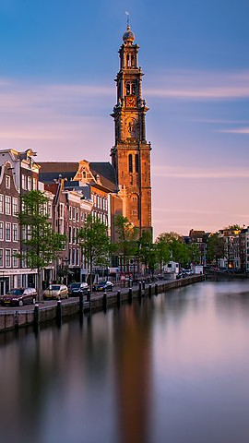
Monday 26 August

8:45 Welcome
9:00 Invited talk: Majid Zamani
Compositional synthesis of interconnected control
systems
10:00 Break
10:30 M. Mazo Jr., G. Gleizer, G. Delimpaltadakis, P. Schaalwijk
Timed automata as synchronization abstractions for
aperiodic control systems
11:00 J. Kolčák, I. Hasuo, J. Dubut, S. Katsumata, D. Sprunger,
A. Yamada
Relational differential dynamic logic
11:30 Invited talk: Hervé de Forges
Underwater robotics: past, present, and future
12:30 Lunch
13:30 E. Kamburjan, S. Mitsch, M. Kettenbach, R. Hähnle
Hybrid active objects
14:00 H.-D. Tran, L. V. Nguyen, P. Musau, W. Xiang,
T. T. Johnson
Decentralized real-time safety verification for
distributed cyber-physical systems
14:30 E. B. Abdelwahab
Delayed hybrid systems
15:00 Break
15:30 E. Ardeshir-Larijani, A. Farhadi, F. Arbab, M. Izadi
Simulation of hybrid Reo connectors
16:00 Invited talk: Xavier Urbain
Swarms of mobile robots, towards safety with versatility
17:00 Discussion
17:30 DHS ends

