
High Performance Computing

Job-Shop Scheduling Problem

Students:
Fernando Acúrcio - 9950
Rafael Silva - 21089
Ulisses Ferreira - 4561

Problem Description

In a job-shop environment, multiple jobs need to be processed, each consisting of several operations that must be performed in a specified order. Each operation is assigned to a specific machine and has a fixed processing time. The challenge is to schedule these operations on the available machines in such a way that the overall completion time is minimized, and the following constraints are met:
Job Sequence Constraint: The operations of each job must be performed in a predefined sequence.
Machine Availability Constraint: Each machine can only process one operation at a time.
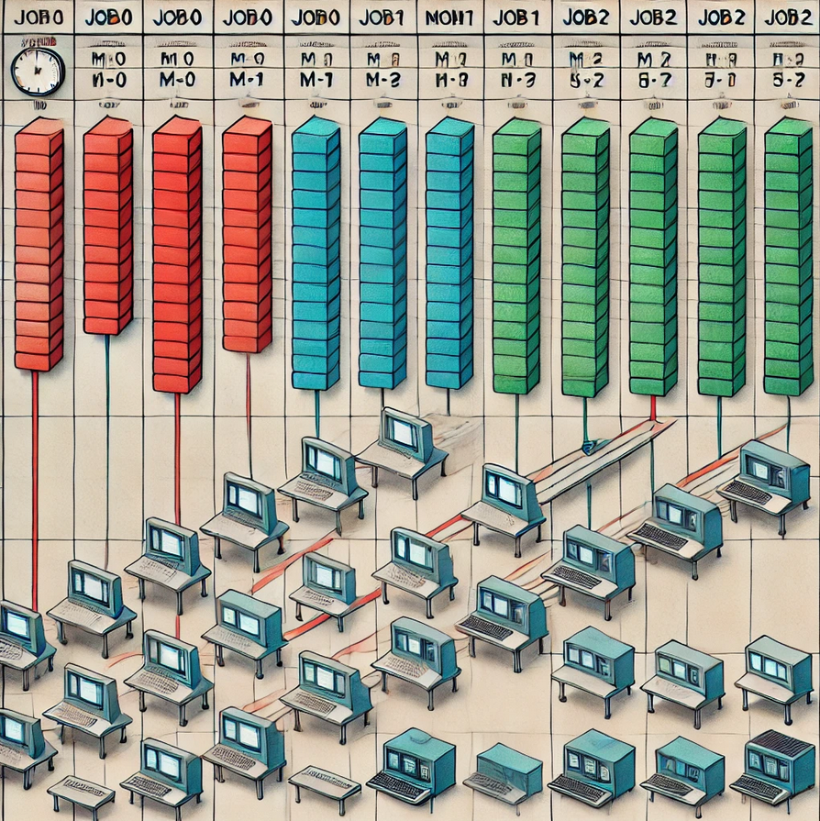
A – Sequential Implementation
The algorithm chosen for scheduling the operations in a job shop problem is a simple greedy approach. The primary idea is to assign the earliest possible start time to each operation while ensuring that no two operations overlap on the same machine. The steps of the algorithm are as follows:
Initialization:
- Read the number of machines and jobs from the input.
- Parse the operations for each job, which includes the machine ID and the duration for each operation.
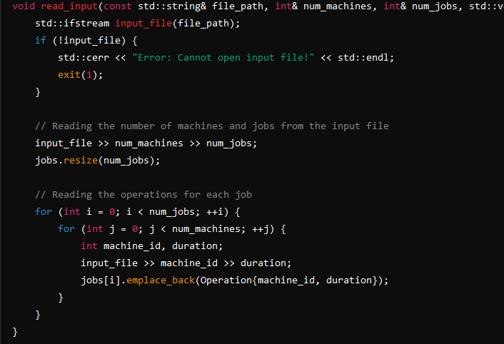
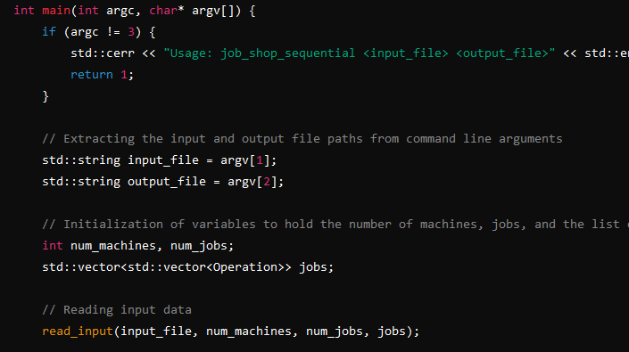

Scheduling:
- Maintain an array machine_end_time to keep track of the latest end time for each machine.
- For each job, initialize current_time to zero.
- For each operation in the job, calculate the start_time as the maximum of the current_time and the end time of the machine (machine_end_time[machine_id]).
- Update the current_time to start_time + duration and update the machine_end_time for the machine.
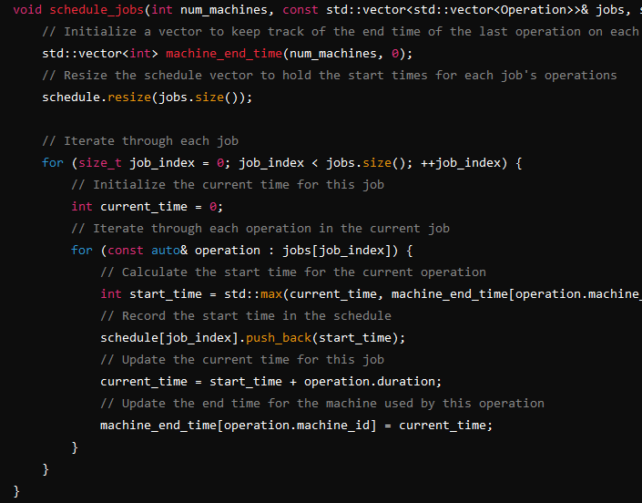

Output:
- Write the calculated start times for each job's operations to an output file.
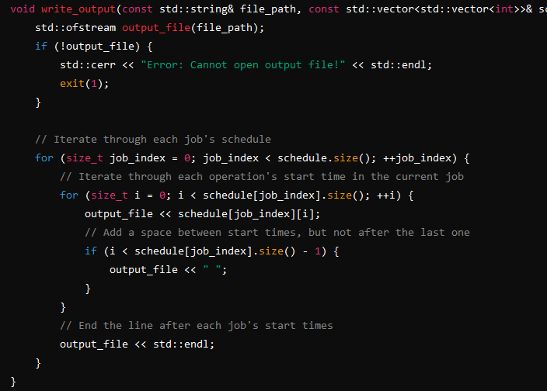

B. Parallel Implementation with Memory Sharing

Which global variables are shared (read-only and read/write), and the local (private) variables of each thread?
SHARED GLOBAL VARIABLES
Read-Only Variables
jobs: This vector holds the operations for each job and is passed to each thread as a pointer. It is read-only for the threads.
Read/Write Variables
pq_mutex: A mutex used to ensure mutual exclusion when accessing the priority queue pq.
pq: The priority queue that holds the nodes to be processed. This is shared among all threads and needs to be accessed in a thread-safe manner using pq_mutex.
best_cost: An atomic variable that stores the best cost (makespan) found so far. This is updated by multiple threads and does not require a mutex due to its atomic nature.
best_mutex: A mutex used to ensure mutual exclusion when updating best_cost and best_schedule.
best_schedule: A vector that stores the best schedule found so far. This is updated by multiple threads and needs to be accessed in a thread-safe manner using best_mutex.
done: An atomic boolean flag that indicates whether the computation is complete. This is checked and updated by multiple threads to signal termination.
Local Variables (per Thread)
node: A local copy of the current node being processed by the thread.
lower_bound: A local variable to store the lower bound calculated for the current node.
children: A local vector to store the child nodes generated from the current node.

Identification of Critical Sections and Variables Involved

Accessing the Priority Queue (pq)
Variables Involved: pq, pq_mutex
Explanation: The priority queue pq is a shared resource accessed and modified by multiple threads. To ensure the integrity and consistency of the priority queue, operations such as checking if the queue is empty, removing the top element, and inserting new elements must be performed atomically. This is achieved through the use of the mutex pq_mutex, which enforces mutual exclusion.
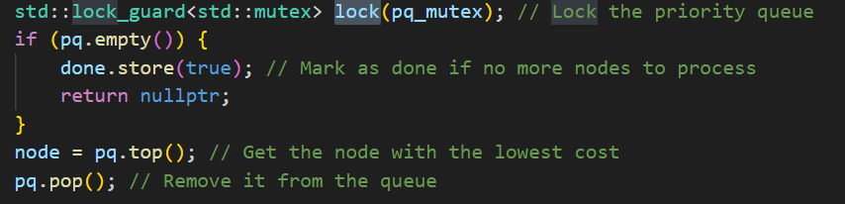
Code Snippet:
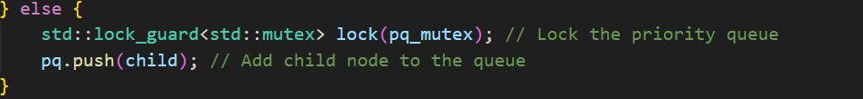
Code Snippet:

Updating the Best Cost (best_cost) and Best Schedule (best_schedule)
Variables Involved: best_cost, best_schedule, best_mutex
Explanation: The variables best_cost and best_schedule are shared among all threads and store the best (minimum) cost and corresponding schedule found so far. When a thread identifies a potentially better solution, it updates these variables. To prevent race conditions and ensure atomic updates, a mutex best_mutex is used.
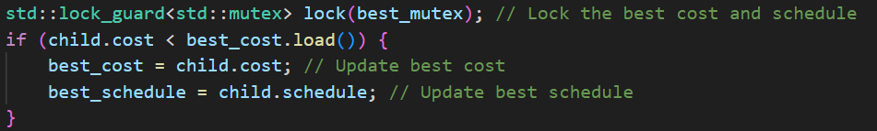
Code Snippet:

Detailed Explanation of Critical Sections
Accessing the Priority Queue (pq)
Potential Race Condition: Multiple threads may attempt to access or modify the priority queue simultaneously, potentially leading to inconsistent states or corrupted data.
Critical Sections:
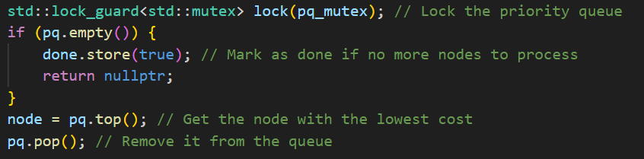
Checking if the queue is empty and removing the top element:


Inserting a new child node into the queue:
Updating the Best Cost (best_cost) and Best Schedule (best_schedule)
Potential Race Condition: Multiple threads may simultaneously identify and attempt to update the best cost and schedule, leading to data corruption or inconsistent updates.
Critical Section:
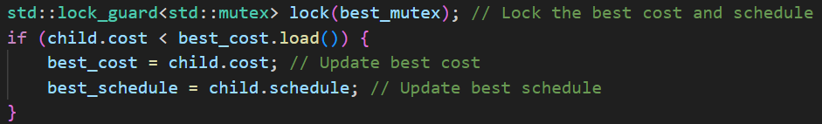
Updating the best cost and schedule

By employing std::lock_guard with pq_mutex and best_mutex, the program ensures that only one thread can access these critical sections at a time, thereby preventing race conditions and maintaining data integrity.

Mutual Exclusion Techniques Employed
To ensure the correctness and determinism of the parallel job shop scheduling algorithm, the program employs several mutual exclusion techniques. These techniques prevent race conditions and ensure that shared resources are accessed safely by multiple threads.
Mutexes
Standard Mutex (std::mutex)
The primary technique used for mutual exclusion in this program is the standard mutex (std::mutex). Mutexes are used to protect critical sections of the code where shared resources are accessed or modified. By locking a mutex before entering a critical section and unlocking it upon exit, the program ensures that only one thread can execute that section at a time. This prevents race conditions and ensures data consistency.
Usage in the Program:
Priority Queue (pq): The priority queue, which holds nodes representing partial solutions, is accessed and modified by multiple threads. To prevent concurrent access issues, the mutex pq_mutex is used. This ensures that operations such as checking if the queue is empty, popping the top element, and pushing new elements are performed atomically.

Code Example:
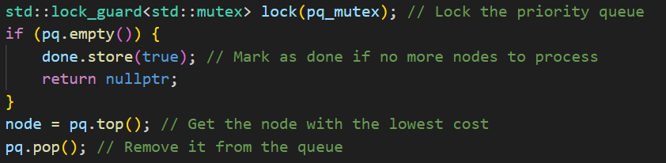
Another section for pq
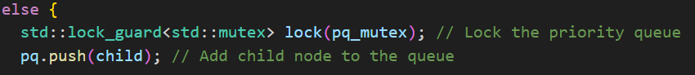
Best Cost (best_cost) and Best Schedule (best_schedule): The best cost and best schedule found so far are shared variables updated by multiple threads. To ensure these updates are done safely, the mutex best_mutex is employed. This guarantees that when a thread updates these variables, no other thread can access them simultaneously.
Code Example:
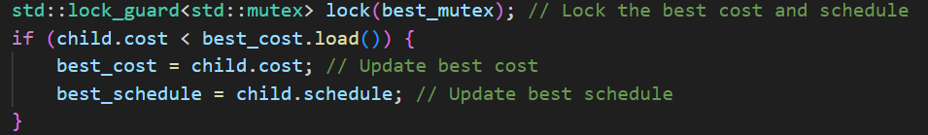

Atomic Variables
Atomic Operations (std::atomic)
The program also utilizes atomic variables to manage certain shared data without the need for explicit locking mechanisms. Atomic operations are inherently thread-safe as they are guaranteed to be executed without interruption.
Usage in the Program:
Best Cost (best_cost): The best_cost variable is an atomic integer that tracks the lowest cost found by any thread. Using an atomic variable for best_cost ensures that updates to this variable are performed atomically, preventing race conditions without requiring a mutex for every access.
Code Example:
Completion Flag (done): The done flag is an atomic boolean used to signal when the computation is complete. By making this flag atomic, the program ensures that its value can be safely updated and checked by multiple threads.
Code Example:
The mutual exclusion techniques used in the program include:
Standard Mutex (std::mutex): Employed to protect critical sections involving the priority queue (pq) and the best cost and schedule variables (best_cost and best_schedule). The mutexes pq_mutex and best_mutex ensure that these shared resources are accessed in a thread-safe manner.
Atomic Variables (std::atomic): Used for the best_cost variable and the done flag to provide lock-free thread-safe operations. Atomic operations guarantee that updates to these variables are executed atomically, ensuring consistency without the overhead of mutex locking.
By implementing these mutual exclusion techniques, the program ensures the correctness and determinism of the parallel execution, preventing race conditions and maintaining data integrity.

C. Performance Analysis

In this study, our primary objective is not to achieve the optimal solution to the Job-Shop Scheduling Problem but rather to demonstrate the implementation of scheduling algorithms. Due to this focus, the performance improvement gained from parallelizing the algorithm is minimal. The nature of the problem and our chosen approach result in only marginal differences in execution time between the sequential and parallel implementations.
As a result, we did not find it meaningful to compute the speedup value, which typically quantifies the performance enhancement achieved through parallelization. The speedup value is particularly relevant when significant efficiency gains are observed, which is not the case in our current scope. Therefore, we have opted to exclude this metric from our analysis, as it would not provide additional insights into the effectiveness or efficiency of our implemented algorithms.

Sequential
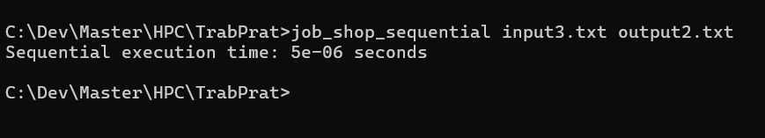

Parallel
