

Mortality and violence against LGBT+ people in Brazil: what public data allow us to claim
An audit of sources and indicators, 2010 to 2026

Carlos Ulisses Flores
Codex Hash Research Laboratory
ORCID: 0000-0002-6034-7765

Date: November 3, 2026

Abstract
Brazilian debate on violence against lesbian, gay, bisexual, and transgender (LGBT+) people opposes two stock phrases: that the country kills the most, and that the numbers are invented. In the 2019 National Health Survey (PNS; Instituto Brasileiro de Geografia e Estatística [IBGE], 2022a), 14.70% of lesbian, gay, bisexual, or other non-heterosexual (LGB+) adults reported physical violence, against 3.82% of heterosexuals. The adjusted ratio is 2.82 (95% interval, 2.16 to 3.68). For sexual violence, rates were 4.86% against 0.68%. Repeating this sample would give 80% power only for a relative increase of 60.7% or more in physical violence. Police reports of homophobia and transphobia rose from 783 to 3,481 (Fórum Brasileiro de Segurança Pública [FBSP], 2026). The series measures recording and fits both more violence and more reporting. Without sexual orientation and gender identity on death certificates, no national LGBT+ mortality rate exists (Ministério da Saúde, 2022). In England and Wales, linked Census and deaths show LGB+ mortality at 1.31 times the heterosexual rate (95% interval, 1.28 to 1.33; Office for National Statistics [ONS], 2026a), without measuring homicide. Of 160 cases sampled from the Grupo Gay da Bahia (GGB, 2020) list, 50 were confirmed in news reports on the case itself. The list is neither rate nor total, and unverified cases are not invented. Measuring trends requires a repeated survey; counting deaths requires the field on the death certificate or a registry linkage.
Keywords: violence; LGBT+; mortality; underreporting; public statistics; human rights.

1. Introduction
The debate over violence against lesbian, gay, bisexual, and transgender (LGBT+) people in Brazil pits two statements against each other. One side says that the country kills more LGBT+ people than any other and that hatred has risen. The other side says that the numbers are invented. In the 2019 National Health Survey (PNS), adults who were lesbian, gay, bisexual, or of another non-heterosexual orientation (LGB+) reported more assaults than heterosexual adults (Instituto Brasileiro de Geografia e Estatística [IBGE], 2022a; Vasconcelos et al., 2023). Here we use LGB+ for sources that cover sexual orientation only, such as the PNS (IBGE, 2022b), and LGBT+ when trans people are included.
Separating what the data prove from what they do not show matters for people and for public policy. Without good data, no one can measure the real danger of daily life. Policymakers also cannot tell where to focus protection or whether a law has reduced assaults. Campbell (1979) showed that an indicator used to make decisions and to hold people accountable can change because of that very use: the recorded crime rate, for example, varies with recording effort without any change in crime itself. For this reason, our question has two parts of equal weight: what the public data show and what they do not show. The same yardstick applies to every claim in circulation, whether it comes from activism or from denial.
To avoid reading description as proof of cause, this study divides the analysis into four levels. Saying that someone died because they were LGBT+ mixes the perpetrator’s intent, the victim’s perception, and the effect of prejudice. An attribute that cannot be manipulated is not a cause in the experimental sense (Holland, 1986), and Greiner and Rubin (2011) shift the question to how the decision-maker perceives the attribute. The first level measures occurrence: how many people suffer violence or die, in proportion to the group. The second level checks whether the difference persists, but the difference that remains after accounting for age, race/color, education, and region is not the share caused by discrimination (VanderWeele & Robinson, 2014). The third level describes the context of the assault: who assaulted the victim and where it happened. The fourth level looks for the motive and asks whether there was prejudice, information that is almost always missing from the country’s databases.
The study answers three central questions about violence in the country. The first question is whether LGB+ people report more violence, which we measure in the PNS (IBGE, 2022a; Appendix C). The second question is whether deaths of LGBT+ people in Brazil can be counted. At present the death certificate omits sexual orientation and gender identity (Ministério da Saúde, 2022). We contrast this gap with the linkage between census and death records in England and Wales (ONS, 2026a; Zachry et al., 2025). In addition, we audit a sample of the Grupo Gay da Bahia (GGB) list (GGB, 2020). The third question is whether a rise in records means a rise in violence. We test this in police reports (FBSP, 2026), in Disque 100 (federal human-rights hotline; Ministério dos Direitos Humanos e da Cidadania [MDHC], 2026), and in health notification forms (Departamento de Informação e Informática do Sistema Único de Saúde [DATASUS], 2026b).
Because the debate links deaths to governments and ideologies, we also look at governments, Congress, and history. In Brazil, we track overall homicide rates by federal and state term (DATASUS, 2026a; Tribunal Superior Eleitoral [TSE], 2026). This describes each period but does not prove a party’s causal effect. The search for acts in the six recent federal terms, carried out with the same 60 queries, is reported in Appendix H, because it measures reported acts, not crimes. Finally, we also look at the persecution of homosexuals under opposing regimes and at unsourced statistics in Congress (Câmara dos Deputados, 2026; Senado Federal, 2026).
The rest of the article has five sections. Section 2 presents the sources in plain language, the four levels, the calculation that separates what occurred from what was recorded, and the verification criteria. Section 3 opens with the table of claims and presents the findings on reported violence, records, deaths, the GGB list, homicides by government, and state acts. Section 4 discusses the findings in comparison with other countries and answers three objections. Section 5 brings together the study’s shared limitations. Section 6 presents the four conclusions, what would change each answer, and the research needed.

2. How to Read Numbers Like These

2.1. The Sources, in Plain Language
The sources in this study are public, but none of them alone explains violence against lesbian, gay, bisexual, travesti, and transgender (LGBT+) people. Table 1 brings together the ten databases used and separates what each one counts from what it leaves out. When reading it, it is worth noting the difference between surveying people in their homes and adding up only the cases that were recorded. The household survey reaches people who never filed a complaint, but it does not identify trans people (Instituto Brasileiro de Geografia e Estatística [IBGE], 2022b, p. 7). The death certificate, in turn, records neither sexual orientation nor gender identity (Ministério da Saúde, 2022, p. 10). What a source lacks is a limit, never an assumption.
Table 1
Data sources: what they count and what they do not say
Source | What it counts | What it does not say | Where the article uses it
National Health Survey 2019 (PNS), from IBGE | Violence suffered in the past 12 months, reported by 88,531 adults sampled in households | Homicide, gender identity (trans people), the perpetrator’s motive, and trends over time | Section 3.1
Mortality Information System (SIM), from the Ministério da Saúde | The country’s death certificates, with cause, sex, race or color, age, and municipality | Sexual orientation, gender identity, and the motive for the crime, which are absent from the form | Sections 3.3, 3.5, and 3.6
Sistema de Informação de Agravos de Notificação (Sinan, notifiable conditions system), from the Ministério da Saúde | Notification forms for violence treated in health services, from 2015 to 2025 | People who did not seek care, the total amount of violence, and the motive in nearly half of the forms | Section 3.2
Police reports in the Anuário (yearbook) of the Fórum Brasileiro de Segurança Pública (FBSP) | State police records of racism on grounds of homophobia or transphobia | Total violence that occurred, judicially proven motive, and direct comparison between states | Section 3.2
Annual reports of the Grupo Gay da Bahia (GGB) | Violent deaths of LGBT+ people reported in the press, including suicide and robbery-​murder (latrocínio) | Population rate, actual coverage, proven motive, and the named list for 2023 to 2025 | Section 3.5
Dossiers of the Associação Nacional de Travestis e Transexuais (ANTRA) | Deaths of trans people reported in the press (up to 2016, it repeats the GGB) | Population rate, coverage of the news reports, and a named list open to audit | Sections 3.5 and 3.7
Atlas da Violência, from the Instituto de Pesquisa Econômica Aplicada (IPEA) and FBSP | Homicide series and estimates for Brazil calculated from the SIM | Sexual orientation and gender identity of victims, because it inherits the SIM’s limit | Section 3.6
Disque Direitos Humanos (Disque 100, federal human-rights hotline), in federal open data | Complaints recorded in 23 public files, from 2011 to September 2026 | Confirmed facts, unique victims (no individual key), and a continuous series without breaks | Section 3.2
Tribunal Superior Eleitoral (TSE) and the ideological score of parties | Party of each elected governor and an ideological score from 0 to 10 | Policies actually carried out in the state or any direct measure of violence | Section 3.6
Open data from the Câmara dos Deputados and the Senado Federal | Parliamentary speeches on the floor: 258,011 speeches from 2015 to October 2026 | Truthfulness of the statements made on the floor or any real rate of violence | Section 3.7
Note. In the health forms, community violence or violence outside the family against men aged 20 to 59 is notifiable only in situations of vulnerability, among them belonging to the LGBT population. Adapted from the sources listed in the table and from Ministério da Saúde (2024, p. 1222).

2.2. Four Levels of Question
This study separates four levels of question so that a number does not answer what it does not measure. The first level measures the crude occurrence of the harm in each group (IBGE, 2022a). In the household survey, 14.70% of lesbian, gay, bisexual, or other non-heterosexual (LGB+) adults reported physical violence in the 12 months before the interview, compared with 3.82% of heterosexual adults. The second level tests whether the difference remains after accounting for age, sex, color, education, region, and urban or rural residence. Even with this adjustment, physical violence is 2.82 times higher in the LGB+ group (95% confidence interval [95% CI], 2.16 to 3.68; reanalysis in Appendix C). The adjustment shows that the difference persists after accounting for the measured characteristics, but it does not measure direct prejudice (VanderWeele & Robinson, 2014). The third level looks at the context of the event, such as the relationship with the perpetrator and the place. Among victims of physical violence, the share whose perpetrator was a family member shows no firm difference between the groups (ratio 1.62; 95% CI, 0.96 to 2.72; reanalysis in Appendix C). However, the risk of reporting an assault and naming a family member as the perpetrator, measured in the population, is higher in the LGB+ group (Section 3.1). The fourth level concerns the motive for the crime, which mixes the perpetrator’s intent, the victim’s perception, and the effect of prejudice on risk (Greiner & Rubin, 2011; Holland, 1986). In the Grupo Gay da Bahia (GGB) sample, the news reports pointed to hate in only 3 of the 74 confirmed violent deaths (GGB, 2020).
Separating these four levels makes it possible to apply the same yardstick to both sides of the public debate. Saying that Brazil is the country that kills the most LGBT+ people requires comparing deaths across countries, as a rate or as a total, with equivalent counts. The search in this study found only comparisons of reported deaths of trans people, without common coverage across countries. In Parliament, only 1 of 49 speeches containing that phrase cited a primary source (Câmara dos Deputados, 2026; Senado Federal, 2026; Appendix J). When the other side says that activist lists are invented, the same check applies. Of the 160 cases sampled from the 2019 list, in 50 the news report on the case itself confirms the violent death of an LGBT+ person (GGB, 2020; Appendix F). In those cases, this contradicts the idea of an invented list. In the others, the news report was not found or does not confirm both points, and the case remains unverified. Because it is a list built from news reports, with no denominator, it is also neither a rate nor a total.

2.3. What Occurred and What Was Recorded
A simple formula summarizes the distance between the real event and the official data.
R = I × p (1)
Here, R is the total number of cases in police reports, health forms, complaints, or news reports. The term I is the real incidence, that is, the assaults or deaths that actually occurred. And p is the recorded share, that is, the fraction of cases that enters the final count. Because we see only the product R, the series alone does not separate the violence (I) from the recording (p). The formula assumes that R and I count the same unit, such as people or episodes; repetitions and changes in classification also alter the record. Police reports of homophobia and transphobia, for example, rose from 783 in 2022 to 3,481 in 2025 (Fórum Brasileiro de Segurança Pública [FBSP], 2026). In Section 3.2, this same curve is consistent with flat violence, violence rising 15% a year, or violence falling 5% a year. Moreover, using the record as a target changes the agency’s own effort to record (Campbell, 1979). Figure 1 shows this filter by source.
Figure 1
The path of the data, from the event to the published count
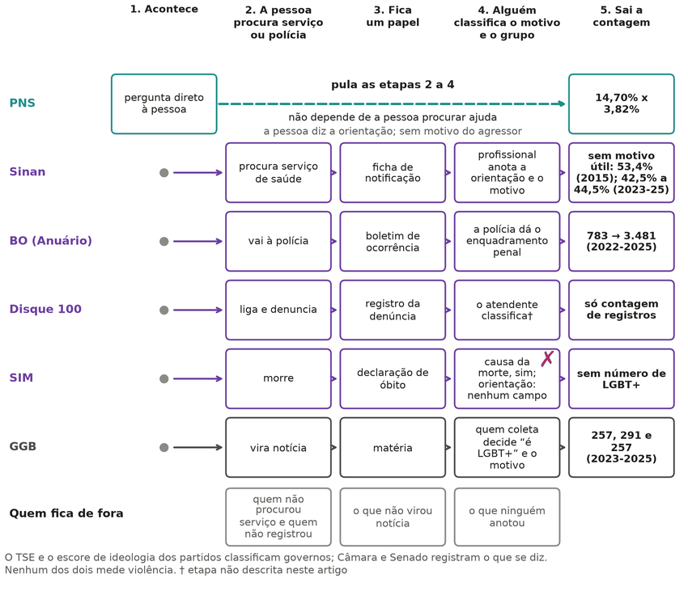
Note. The diagram shows where cases are lost between the event and the data (R = I × p; adapted from Table 1). Labels in Portuguese: Acontece = happens; procura serviço = seeks a service; Fica um papel = a record remains; classifica o motivo = classifies the motive; contagem = count; fica de fora = left out.

2.4. How to Check That Nothing Was Altered
To avoid ad hoc choices, the search and analysis rules were recorded before the results were seen. When the research called for new rules, they were added as dated addenda, without changing the initial text (Appendix B). Each protocol received a SHA-256 fingerprint of the file, which changes entirely if even a single comma is altered. This mark proves that the text remains unchanged, but on its own it does not prove the date without an external timestamp. For this reason, the article serves as a readable summary, while the complete proof is openly available in the project’s public repository. In that repository, open-source programs reproduce the numbers, tables, and figures of the following sections from the files derived from the official databases. Full reproduction from the raw microdata was carried out for the 2019 PNS; for the SIM and Sinan, the aggregates come from programs stored in the repository, without a fresh run on the raw data (Appendix M). The exception is the link between each case on the Grupo Gay da Bahia (GGB) list and its news report, which requires the named list, withheld for privacy reasons. On GitHub, where the code is hosted online, an automated check reruns the calculations and flags any discrepancy.

2.5. Literature Search and Statistics
The search covered seven databases (PubMed, Crossref, OpenAlex, SciELO, Europe PMC, LILACS, and Dialnet), in addition to general search engines and official statistics websites. Collection took place from October 10 to 25, 2026, and the sources recorded are in 11 languages (Appendix B). In the household survey, Poisson regression with sampling weights tests the difference after adjusting for profile (Appendix C). In the registry series, Equation 1 is applied with three trajectories that fit the data equally well (Appendix D). For deaths, age standardization and the Kitagawa (1955) decomposition compare deaths without age-related distortion (Appendix E). In the news lists, random sampling with a Wilson interval measures the fraction of confirmed cases. Capture-recapture, in turn, estimates totals under assumptions about the dependence between sources (Feldman et al., 2017; Lum et al., 2013; Appendix F). For governments and homicides, two-way fixed-effects panel models describe whether party changes accompany variations in deaths, without attributing cause. This estimator can weight comparisons poorly when the effect changes over time (Goodman-Bacon, 2021), and for that reason the analysis includes other tests. Event studies and permutation tests complete this analysis (Appendix G). Cohen’s kappa and Fisher’s exact test assess the classification of speeches (Appendix J). Finally, a power calculation sets the sample size for future studies (Appendix K).

2.6. The Role of Language Models
Language models supported the search, the code, the drafting, the review, and the double reading of speeches (Appendices J and M). This version was also written by language models: Gemini 4 Argon for sections 1 and 2 and Claude Opus 5.5 for the rest. The rewriting followed written rules that prohibit any number or citation outside the verified material, and a program checked each number and each citation before the author’s review. Afterward, three models (GPT-6 Astra, Gemini 4 Argon, and Grok 4.7) reviewed the entire article, without seeing one another’s reports in the first round. No model invented an observation or a numerical estimate. Models did, however, take part in coding the speeches and in checking the 160 GGB cases, with a second coder from another model family for some of the cases (section 5). In the GGB check, 23 cases were double-coded, with 21 valid pairs for the variables below. Agreement was high for the victim’s LGBT+ status (κ = 0.91) and moderate for the confirmation of violent death (κ = 0.46; Appendix F). In the 6 cases with disagreement, a third coder from another model family, blind to the first two, broke the ties between the readings. Only one case changed: confirmed violent deaths went from 73 to 74, and the 50 verifiable cases did not change (Appendix F). Every number comes from programs run on the public databases or from documents saved in the study’s repository. Each citation was checked against the source, as was each page and speech label; works read only in abstract form are marked in the text. Models from different families reviewed the text, but source checking, method, and authorship rest with the author alone. This translation from the Brazilian Portuguese original was produced by Claude Sonnet 5.5 and reviewed sentence by sentence by Claude Opus 5.5; a program checked that every number, link and table matches the original. The Portuguese text is the version of record.

3. What the Data Allow Us to Say
This section traces the distance between the violent event, the record it leaves, and what that record allows one to conclude. It follows two axes. The first is what can be measured of the violence suffered by LGBT+ people. The second is how far each source allows us to go: attributing motive, counting deaths, or seeing a trend. Table 2 summarizes the statements from the public debate, what the data show about each, and what they do not show. The first row answers the question that motivated the study: none of the public sources examined allows estimating how many cases of violence motivated by LGBTphobia occur, or comparing those cases over time and across groups. There are records of motive that can be counted, but none meets that criterion. Sections 3.1 to 3.5 show what each source measures instead, and each ends with what is concluded and what remains undetermined.
Table 2
Statements in the debate, what the data show, and what they do not show
No. | Statement in the debate | What the data show | What they do not show | Section
1 | There is a reliable indicator of violence motivated by LGBTphobia in Brazil | None of the public sources examined allows estimating how many motivated cases occur or comparing those cases over time and across groups | Does not say whether the motive is rare or frequent | 3.1 to 3.5
2 | Lesbian, gay, bisexual, or other non-​heterosexual adults report more physical violence than heterosexual adults | LGB+ adults report much more physical violence: 14.70% versus 3.82% in 12 months, adjusted ratio 2.82 | The overall ratio does not identify the type of perpetrator or the motive; the named perpetrator is analyzed separately | 3.1
3 | They also report more sexual and psychological violence | They also report more sexual (4.86% versus 0.68%) and psychological (40.03% versus 16.73%) violence | Does not measure motive; does not identify trans people | 3.1
4 | Physical violence against LGB+ people comes mainly from strangers | Most victims, in both groups, name an acquaintance as the perpetrator (81.4% of LGB+ victims); the risk from a stranger is also higher for LGB+ people | Does not state the motive or the perpetrator’s orientation | 3.1
5 | Family members assault LGB+ people more | In the population, LGB+ people name a family member as the perpetrator more often (adjusted ratio 4.79); among victims, the family’s share shows no firm difference | Does not say why: the PNS does not ask about motive | 3.1
6 | The difference in physical violence is explained by people’s profile (age, marital status, interview mode, and other measured factors) | The difference persists in separate adjustments: for sex, age, skin color, education, region, and urban or rural residence, 2.82; adding marital status, 2.65; spouse in the household, 2.64; or interview mode, 2.68 | What remains does not measure discrimination or way of life | 3.1
7 | It is possible to know whether violence against LGB+ people is rising | There is a single edition of the PNS (2019); a new round would have 80% power only for a relative increase of 60.7% or more | Does not say that violence is stable | 3.1
8 | The 2019 PNS describes trans people | The PNS did not ask about gender identity and does not identify trans people | Says nothing about trans people | 3.1
9 | Gay people suffer more violence, according to complaints | Complaints measure who sought out the channel; there is no person identifier, and the unit of count changes twice in 2020 | Does not say that gay people suffer less | 3.2
10 | LGBT complaints to Disque 100 (federal human-rights hotline) grew a lot | Complaints with an LGBT line went from 1,367 (2021) to 9,346 (2025), while the channel as a whole grew 2.9-fold | Does not say that violence grew | 3.2
11 | Police reports of homophobia and transphobia exploded, so violence exploded | The reports went from 783 (2022) to 3,481 (2025), and the same series is consistent with violence that is flat, rising, or falling | Does not say that violence stayed flat | 3.2
12 | SUS (Unified Health System) notification forms measure LGBTphobic violence | Motive lacks useful information in 42.5% to 44.5% of the forms from 2023 to 2025, and LGBTphobia appears in 0.4% to 0.5% | Does not say that LGBTphobic violence is rare | 3.2
13 | LGBT+ people die more in Brazil | The death certificate records neither sexual orientation nor gender identity, and so no national rate exists | Does not say that they die in the same proportion | 3.3
14 | When the death certificate records the attribute, Brazil measures lethal inequality | Where the death certificate records race and sex, the inequality appears: 51.7 versus 2.6 assault deaths per 100,000 | Does not measure orientation or gender identity; does not show that creating the field is enough | 3.3
15 | LGB+ people die more outside Brazil | In England and Wales, those who declared themselves LGB+ in the Census had 31% higher all-cause mortality (ratio 1.31) | It is not homicide; it applies only where the Census was linked to death records, and it does not apply to Brazil | 3.4
16 | Sexual minorities live 12 years less where there is prejudice | The figure comes from a retracted study; where an official calculation exists, the difference at age 20 is about 1 year | Does not say that mortality is equal | 3.4
17 | The Grupo Gay da Bahia (GGB) figures are fabricated | In 50 of the 160 randomly sampled cases from 2019, the news report supported a violent death and an LGBT+ victim; 74 of 88 news reports on the case itself confirm a violent death | Does not say that the list is complete | 3.5
18 | The GGB list measures how many LGBT+ people are murdered because of prejudice | The list attributes hate, according to its own cited source, in 3 of 74 violent deaths, and it is a count of news reports with no denominator | Does not say that prejudice is rare | 3.5
19 | NGO lists that agree confirm one another | From 2013 to 2018, 72% to 94% of Brazilian TDoR records cited the GGB itself as a source | Does not say that the lists are wrong | 3.5
20 | Crimes against LGBT+ people rose (or fell) under government X | No series separates violence from recording: the LGBT+ series also rise and fall with changes in channel, form, and news coverage | Does not say that violence stayed the same | 3.6
21 | The homicide rate fell (or rose) under government X | The overall homicide rate rose under Dilma and fell under Temer, Bolsonaro, and Lula through 2024; the decline began in 2018, and recording worsened | Does not say that the government caused the change | 3.6
22 | A right-wing (or left-wing) government changes homicide levels | The analyses found no association between the governor’s party and overall homicide (from −12.3% to +12.4%) | Does not prove that the government is irrelevant | 3.6
23 | State persecution of homosexuals comes from one side of the ideological spectrum | Right-wing dictatorships, communist regimes, a religious government, and a democracy persecuted homosexuals through state laws | Does not rank regimes by severity | 3.7
24 | Brazil is the country that kills the most LGBT+ people | The search found only comparisons of reported deaths of trans people, with no common coverage across countries; in Parliament, 1 of 49 speeches using this phrase cites a primary source | Does not say that Brazil kills few | 3.7
25 | Trans people live 35 years on average | No calculation of trans people’s life expectancy in Brazil was located; the figure that circulates comes from citations with no calculation, and the age of those who were murdered is not life expectancy | Does not say that trans people live as long as others | 3.7
Note. Each row summarizes what the sources examined show; the justification, the intervals, and the sources are in the section indicated. The search on acts of the federal government is in Appendix H. Data from the sources cited in sections 3.1 to 3.7.

3.1. Reported Violence
The household survey shows that LGB+ adults report much more violence than heterosexual adults. In the 2019 National Health Survey (PNS), 14.70% of LGB+ adults reported physical violence in the previous 12 months (95% interval, 10.72 to 18.67), against 3.82% of heterosexual adults (IBGE, 2022a). That is about one person in seven, against one in 26. Physical violence, here, includes a slap, push, punch, or kick; an attempt or act of strangulation, suffocation, or burning; and a threat or injury with a weapon or object. The sample includes 1,554 interviewed LGB+ adults. The reanalysis of the microdata reproduces the prevalences published by Vasconcelos et al. (2023) without divergence. The ratios in this article, however, are prevalence ratios, not the odds ratios published in that work. Without adjustment, the ratio is 3.84. The unadjusted ratio is also reported because education, region, and residence may lie on the pathway between orientation and violence, not only before it. After accounting for sex, age, color or race, education, region, and urban or rural residence, physical violence remains 2.82 times higher in the LGB+ group (95% interval, 2.16 to 3.68; Appendix C). The adjustment uses the 85,913 adults who declared a heterosexual or LGB+ orientation; another 849 answered that they did not know and 1,769 refused. By age group, the crude ratio is above 1 at ages 18 to 29 (2.93) and 30 to 44 (2.27). At ages 45 to 59, the ratio of 1.61 has an interval that includes equality (0.79 to 3.31). At ages 60 and older, it is 5.80, with a very wide interval (1.93 to 17.36) and only 88 LGB+ respondents. The age groups have unequal precision, and the study does not test whether the ratio changes with age.
The same pattern appears in the other types of violence. Sexual violence affected 4.86% of LGB+ adults and 0.68% of heterosexual adults. After adjustment, the ratio is 5.00 (95% interval, 3.17 to 7.89). Psychological violence, which includes shouting, name-calling, and humiliation, affected 40.03% against 16.73%, with an adjusted ratio of 1.87 (95% interval, 1.66 to 2.11). At least one type of violence was reported by 41.63% of LGB+ adults and 17.61% of heterosexual adults, with an adjusted ratio of 1.84 (95% interval, 1.64 to 2.07). Figure 2 shows the prevalences and the size of the ratios before and after adjustment.
Figure 2
Violence reported over 12 months by LGB+ and heterosexual adults
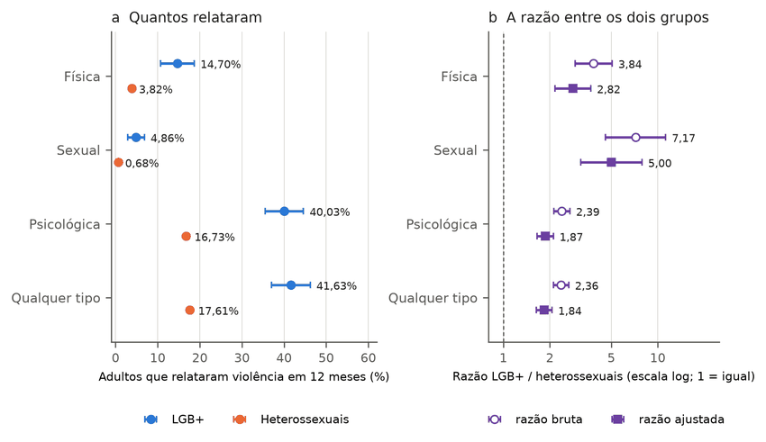
Note. In panel a, each point is the 12-month prevalence, with a 95% interval (blue, LGB+; orange, heterosexual adults). In panel b, the hollow circle is the crude ratio and the filled square is the adjusted ratio; the line at 1 marks equality. Data from IBGE (2022a); reanalysis in Appendix C. Labels in Portuguese: Quantos relataram = how many reported; razão = ratio; dois grupos = two groups; meses = months; igual = equal; Heterossexuais = heterosexuals; bruta = crude; ajustada = adjusted.
These numbers measure how much each group reports suffering, not why it suffers. The survey’s violence module asks who assaulted the respondent and where, but it does not ask the motive or the sexual orientation of the perpetrator (IBGE, 2022a). The difference therefore does not show that heterosexual people assaulted LGB+ people out of prejudice. It does not rule out that hypothesis either, because the data simply do not extend to the motive. Interpreting the difference as a motive appears even in the literature. Szwarcwald et al. (2025) refer in the title to victimization motivated by sexual orientation, but the abstract describes an association between declared orientation and violence, using the same microdata. Only the abstract of that article was read, because the full text was not accessible.
When we look at who the perpetrator was, the image of a street attack by a stranger does not describe the typical case. Among victims of physical violence, 81.4% of LGB+ people named someone they knew as the perpetrator (IBGE, 2022a; Appendix C). Among heterosexual victims, the figure was 72.6%. The survey asks for a single answer about who assaulted, even from people who suffered more than one assault. Known, here, means partner or ex-partner, family member, friend, colleague, neighbor, employee, employer, or boss. The difference between the groups in these aggregate shares, however, is not firm, because the sample has only 179 LGB+ victims. This holds for the share of strangers, 16.3% against 23.0%, and for that of family, 31.2% against 19.2%. Figure 3 shows two readings of the same data: the share among victims and the risk in the population.
Figure 3
Who assaulted: risk by type of perpetrator among LGB+ and heterosexual adults
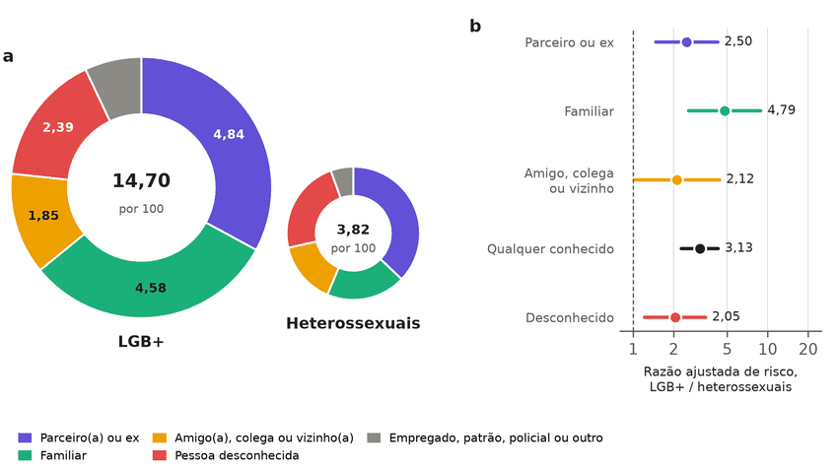
Note. In panel a, the area of each ring is proportional to the fraction of adults physically assaulted in 12 months (14.70 and 3.82 per 100), and each slice is the risk by type of perpetrator. Panel a shows unadjusted risks; the gray slice combines employee, employer or boss, police officer, and other. In panel b, which includes only the categories for which the adjusted ratio was estimated, each point is the LGB+/heterosexual risk ratio adjusted for the same profile as the 2.82 ratio, with a 95% interval; the line at 1 marks equality. Data from IBGE (2022a); reanalysis in Appendix C. Labels in Portuguese: Parceiro(a) = partner; Familiar = relative; Amigo(a), colega ou vizinho(a) = friend, colleague, or neighbor; desconhecida = stranger; Empregado, patrão = employee, employer; Razão ajustada = adjusted ratio; Heterossexuais = heterosexuals.
The share among victims is not the risk for each person. The risk of reporting physical violence and naming a given type of perpetrator is the prevalence times that perpetrator’s share. Because the LGB+ group has almost four times as many victims per inhabitant, a smaller share can still mean more people assaulted. This is what happens with strangers, named by 2.39 LGB+ adults and 0.88 heterosexual adults per 100. The crude ratio is 2.72 and, with the same adjustment as the 2.82 ratio, it is 2.05 (95% interval, 1.22 to 3.45). For someone known to the victim, the figures are 11.97 against 2.78 adults per 100, with a crude ratio of 4.31 and an adjusted ratio of 3.13 (95% interval, 2.28 to 4.29). For assault by a police officer, the ratio does not differ firmly and has a very wide interval. Among the aggregate categories, only the difference in the police officer share has an interval that excludes zero (smaller among LGB+ victims), but it rests on 5 LGB+ victims in the sample. In the subcategories, the share of current spouse or partner is also smaller among LGB+ victims, 5.05% against 20.21% (Appendix C). These ratios by type of perpetrator come from an analysis conducted after seeing the results. The survey records a single perpetrator per victim, the one in the most serious episode, and therefore underestimates the risk of each type when the same person suffered assaults from more than one source during the year. With the presence of a spouse or partner in the household added to the adjustment, the ratio for family members is 4.31 (95% interval, 2.33 to 7.99). As with marital status, only the ratio for friend, colleague, or neighbor is no longer firm (Appendix C). The adjusted ratio was not estimated where there were fewer than 10 LGB+ victims, a criterion also defined after seeing the data. The intervals are nominal, without correction for the number of comparisons. Table 3 gives the share and the risk for each type of perpetrator.
Table 3
Perpetrator named by victims of physical violence in 12 months: share among victims and risk in the population
Perpetrator | Share, heterosexual (%) | Share, LGB+ (%) | Risk per 100, heterosexual | Risk per 100, LGB+ | Crude ratio (95% CI) | Adjusted ratio (95% CI)
Partner or ex-partner | 37.1 | 32.9 | 1.42 | 4.84 | 3.41 (2.01 to 5.79) | 2.50 (1.48 to 4.25)
Family member | 19.2 | 31.2 | 0.74 | 4.58 | 6.22 (3.26 to 11.90) | 4.79 (2.58 to 8.90)
Friend, colleague, or neighbor | 15.2 | 12.6 | 0.58 | 1.85 | 3.20 (1.59 to 6.42) | 2.12 (1.02 to 4.39)
Employee, employer, or boss | 1.1 | 4.7 | 0.04 | 0.70 | 16.52 (3.78 to 72.23) | —
Any known person (subtotal) | 72.6 | 81.4 | 2.78 | 11.97 | 4.31 (3.10 to 5.99) | 3.13 (2.28 to 4.29)
Stranger | 23.0 | 16.3 | 0.88 | 2.39 | 2.72 (1.63 to 4.53) | 2.05 (1.22 to 3.45)
Police officer | 2.2 | 0.6 | 0.08 | 0.09 | 1.07 (0.35 to 3.25) | —
Other | 2.2 | 1.7 | 0.08 | 0.24 | 2.93 (1.01 to 8.51) | —
Note. Adults aged 18 or older; each victim names one perpetrator in the survey question. The mutually exclusive shares add up to 100% in each group; the subtotal row is not part of that sum. The risk is the share times the prevalence (14.70 and 3.82 per 100). The adjusted ratio uses the same adjustment as the 2.82 ratio (sex, age, color or race, education, region, and urban or rural residence); where there are few cases, it was not estimated. Among the categories in the table, only the difference in the police officer share has an interval that excludes zero; it is smaller in the LGB+ group and rests on 5 LGB+ victims. In the subcategories, the share of current spouse or partner is also smaller in the LGB+ group (5.05% against 20.21%). The intervals are nominal, without correction for the number of comparisons. The crude ratios for “employee, employer, or boss” and for “other” each rest on 5 LGB+ victims, and the one for “other” has a lower limit of 1.01. Analysis conducted after seeing the results. The survey does not ask the motive or the sexual orientation of the perpetrator. Data from IBGE (2022a); reanalysis with the sampling design in Appendix C.
LGB+ people, therefore, name family members as perpetrators more often when risk in the population is measured, with two caveats. In the population, 4.58 LGB+ adults per 100 named a family member as the perpetrator in the past year, against 0.74 heterosexual adults. The crude ratio is 6.22, and the adjusted ratio is 4.79 (95% interval, 2.58 to 8.90). With marital status also in the adjustment, it is 4.43 (95% interval, 2.38 to 8.26). Among victims, the family share does not differ firmly between the groups (ratio 1.62; 95% interval, 0.96 to 2.72). Moreover, the survey does not say why the family member assaulted, and attributing these cases to prejudice would be to claim what the data do not measure. The home as the location appears in 44.1% of LGB+ cases and in 55.2% of heterosexual cases, but this difference is not firm either.
The difference persists after adjustment for the measured characteristics, including marital status. This analysis was conducted after seeing the results and should be read as a sensitivity analysis. Marital status matters because 84.9% of LGB+ adults declare themselves single, against 40.8% of heterosexual adults (IBGE, 2022a). Declared marital status, however, is not the same as living together: 29.49% of LGB+ adults live with a spouse or partner, against 62.39% of heterosexual adults. Single people report more violence in both groups. Even among single people, however, physical violence affects 15.99% of LGB+ adults and 5.43% of heterosexual adults. With marital status in the adjustment, the ratio goes from 2.82 to 2.65 (95% interval, 2.04 to 3.46; Appendix C). The result barely changes when the presence of a spouse in the household is used instead, with a ratio of 2.64. With marital status, only the ratio for friend, colleague, or neighbor is no longer firm. The difference also persists when we consider who filled in the violence module. The share who declare themselves LGB+ is 3.51% when residents fill it in themselves and 1.38% when the interviewer fills it in. Even so, the crude ratio is similar in the two modes, 3.21 and 3.84, and the ratio adjusted for mode is 2.68 (95% interval, 2.05 to 3.49). This adjustment compares the groups within each mode and does not correct for those who refrained from declaring themselves LGB+, an effect that was not estimated. The ratio that remains after any adjustment does not measure discrimination or way of life, because the data do not separate the two explanations (VanderWeele & Robinson, 2014).
The data also do not say whether this violence is rising or falling. The 2019 PNS is a single edition, and a trend requires the same question repeated over time. With the size of this sample, a new independent round would detect, with 80% power and a two-sided test at 5%, only relative increases of 60.7% or more in physical violence. For decreases, the threshold is different and was not calculated here (Appendix K). Finally, the survey does not identify trans people, because it did not collect gender identity (IBGE, 2022b, p. 7).
In sum, this section tested what the household survey allows us to say about violence against LGB+ adults. The result is a large and persistent difference in reported violence, with most victims naming people they know as perpetrators. The motive for the assaults, the trend over time, and the situation of trans people remain undetermined.

3.2. Complaints, Police Reports, and Notification Forms
Complaints to the Disque Direitos Humanos (Disque 100, the federal human-rights hotline) grew sharply, but they measure use of the channel, not violence. When complaints with at least one row in the LGBT module are counted, the series rose from 1,367 in 2021 to 9,346 in 2025 (Ministério dos Direitos Humanos e da Cidadania [MDHC], 2026). That is a 6.8-fold increase, while the whole channel grew 2.9-fold. The LGBT share stayed between 1.4% and 1.5% of complaints from 2022 to 2025. There were, therefore, more complaints, which does not mean more violence. The count also depends on the rule. Since the second half of 2022, the group can vary within the same complaint, and requiring all rows to belong to the LGBT module reduces 2025 to 39 complaints (MDHC, 2026; Appendix D). Figure 4 shows the two series and the changes in file format.
Figure 4
LGBT-module complaints and complaints to the whole Disque 100 channel
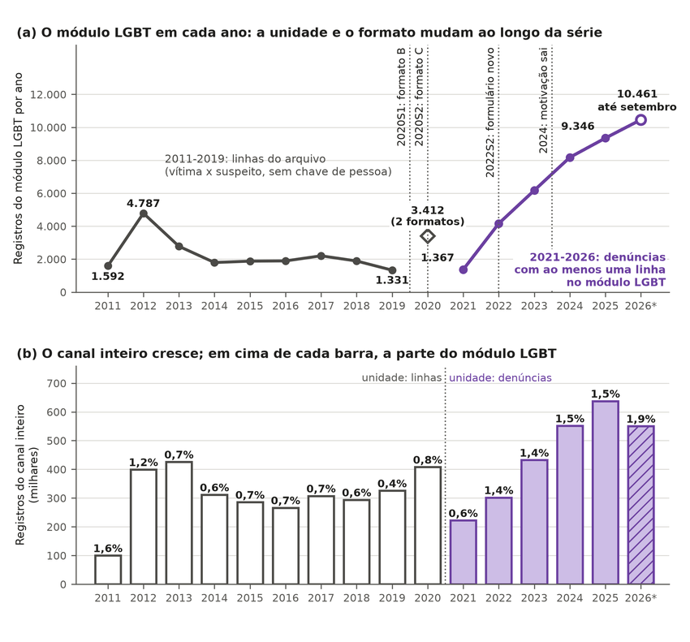
Note. In panel a, the gray line counts LGBT-module rows through 2019, and the purple line counts complaints from 2021 onward; the dotted vertical lines mark format changes. In panel b, each bar is the whole channel, with the LGBT share above it. Data from MDHC (2026). Labels in Portuguese: ano = year; mudam = change; canal inteiro cresce = whole channel grows; em cima = above; cada barra = each bar; parte = share; Registros = records; milhares = thousands.
Nor can the complaints tell us whether gay people suffer more violence than other groups. The 23 open files, from 2011 to September 2026, come in three formats, and none carries a key that identifies the person (MDHC, 2026). The counting unit changes twice in 2020. Through 2019, each row of the file pairs one victim with one suspect from a given call. In the first half of 2020, the unit is the victim–suspect pair, and from the second half on, it is the complaint. In 2024, the category for motivation based on orientation or identity was removed from the form, which is not the same as an absence of motivation. Moreover, those who file complaints are not a sample of the population.
Police reports of homophobia or transphobia rose from 783 in 2022 to 3,481 in 2025, a 4.4-fold increase (FBSP, 2026). This does not allow us to say that violence exploded. These reports use the racism classification adopted after the Supremo Tribunal Federal (STF, Brazil’s Supreme Court) ruled on the Legislature’s failure to criminalize homophobia and transphobia (STF, 2019). The series gathers records from state secretariats compiled by a civil-society organization. Silva et al. (2026), who describe the same series from 2021 to 2025, also write that these data do not allow all of the growth to be attributed to an increase in incidence. The Anuário (the FBSP yearbook) itself revises the series: the year 2023 had 2,090 reports in the 2024 edition and 1,633 in the following one. Equation 1 in Section 2.3 shows the problem, because three different stories produce the same series. In each story, the violence rate was fixed, and the registration rate is the one that best fits the four years, not the rate between the first and the last count. In the first, violence stays flat and registration rises 63.7% a year. In the second, violence rises 15% a year and registration, 42.3%. In the third, violence falls 5% a year and registration rises 72.3% (Appendix D). The three trajectories produce the same fitted curve, with the same error, although none passes exactly through all the points. Figure 5 shows that the three lines coincide with one another and follow the police reports. Only data from outside the registration process can separate these stories, such as a repeated victimization survey.
Figure 5
Three trajectories of violence and registration that produce the same series of police reports
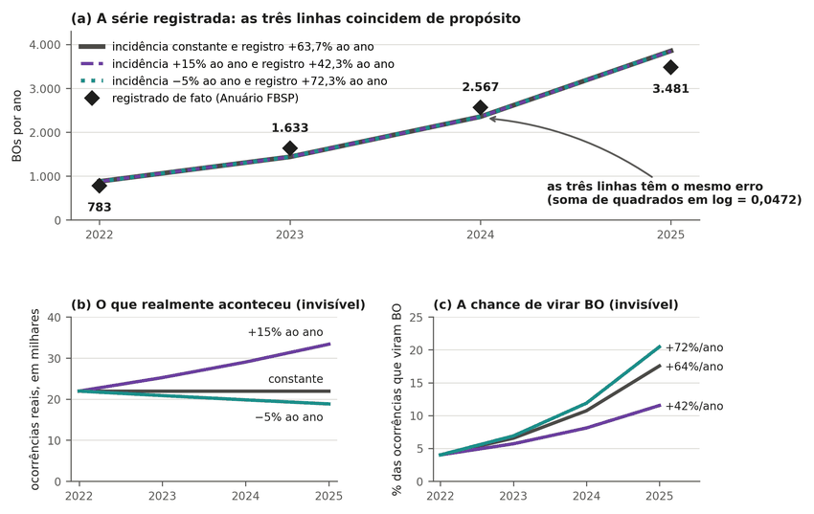
Note. In panel a, the diamonds are the recorded police reports, and the lines are what each trajectory predicts. Panels b and c show the violence and the propensity to register that each trajectory assumes. Data from FBSP (2026); simulation in Appendix D. Labels in Portuguese: registrada = recorded; linhas coincidem de propósito = lines coincide deliberately; realmente aconteceu = actually happened; virar = become; milhares = thousands; ao ano = per year.
Notification forms for violence in health services also do not measure LGBTphobic violence. The Sistema de Informação de Agravos de Notificação (Sinan, the notifiable conditions system) gathers these forms (Departamento de Informação e Informática do Sistema Único de Saúde [DATASUS], 2026b). In the 2015 forms not marked as self-inflicted violence, the motive field had no useful information in 53.4% of them. The count combines motives marked as ignored, left blank, or marked as not applicable. From 2023 to 2025, this lack of information stayed between 42.5% and 44.5%. LGBTphobia appears as the motive in 0.4% to 0.5% of notifications. With almost half of the motives lacking information, this figure does not measure incidence. The notification rule also differs by group. The Guia de Vigilância em Saúde (Health Surveillance Guide) waives notification of community violence against men aged 20 to 59, “except under conditions of vulnerability” (our translation), among them belonging to the LGBT population (Ministério da Saúde, 2024, p. 1222). This rule alone can increase the presence of LGBT+ people in the forms. The series also tracks the network of notifying services. For trans people, Marinho Neto et al. (2024) show that notifications fell from 2015 to 2022, while the number of notifying municipalities grew 45.8%. Reading this series as a trend in violence is therefore risky; this conclusion is drawn by this article, not by those authors. Figure 6 shows the composition of the motive field year by year.
Figure 6
Motive for the violence in notification forms, 2015 to 2025
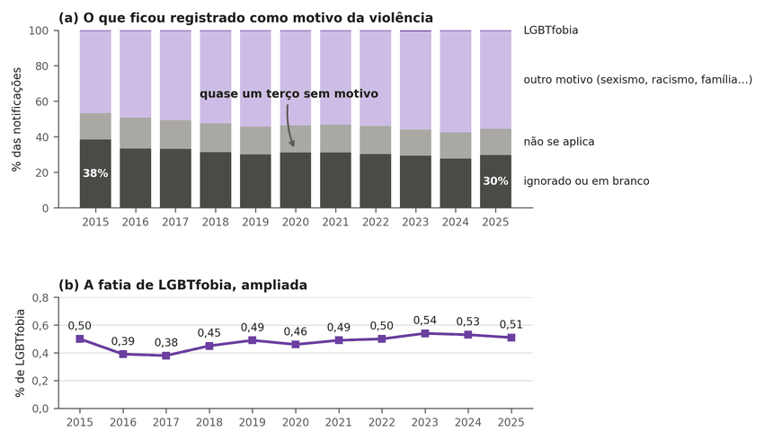
Note. Each column in panel a adds up to 100% of the year’s violence forms not marked as self-inflicted; dark gray is motive ignored or blank. Panel b zooms in on LGBTphobia. Data from DATASUS (2026b). Labels in Portuguese: registrado = recorded; motivo = motive; fatia = share; ampliada = enlarged; LGBTfobia = LGBTphobia; outro = other; não se aplica = not applicable; ignorado = unknown; em branco = blank.
In sum, this section tested whether complaints, police reports, and notification forms measure violence against LGBT+ people. The result is that all three series grow, but each also measures who seeks the service, who records, and how they classify. How much of the growth is violence and how much is registration remains undetermined.

3.3. Deaths in Brazil
We cannot know whether LGBT+ people die at higher rates in Brazil, because the death certificate does not record sexual orientation or gender identity. The death certificate form has 59 variables in 9 blocks, and none addresses these attributes (Ministério da Saúde, 2022, p. 10). The microdata files of the Mortality Information System (SIM) for 2023 and 2024 also lack these variables (DATASUS, 2026a). Without the field, there is no numerator for a rate. The problem is not only Brazilian. In the United States, 84.5% of the deaths in the national violent death reporting system have sexual orientation missing or unknown (K. A. Clark & Blosnich, 2024).
Studies that link different registries do not fill this gap. Luis et al. (2026) matched notifications of violence against trans people with SIM deaths and found 563 deaths from violent causes. These deaths are 42.5% of the matched deaths, not of the notifications. The study describes trans people already notified for violence, without a population denominator, and used identifying data that are not publicly available. For this reason, it produces neither a rate nor a ratio between trans and cisgender people.
Much of the limitation lies in the certificate field, not in the registration system. When the certificate carries the attribute, lethal inequality appears clearly, and this is the positive control of the argument. Averaged over 2022 to 2024, the age-standardized assault death rate was 51.7 per 100,000 among Black men (DATASUS, 2026a; IBGE, 2026). Among non-Black women, it was 2.6 per 100,000, 19.9 times lower (Appendix E). This contrast combines sex and race: the ratio between men and women is 10.8, and between Black and non-Black people, 2.56. The 2023 and 2024 populations were projected from the 2022 Census. This shows that the system measures inequality when the variable is filled in. It does not show that creating the field would suffice: in the United States, the field exists and remains empty or unknown for most of the deaths in that system.
In sum, this section tested whether deaths of LGBT+ people in Brazil can be counted. The result is that the certificate lacks the field, although the system measures inequality when the field exists. Whether LGBT+ people die at higher rates in the country remains undetermined.

3.4. Deaths Outside Brazil
Outside Brazil, the clearest data on mortality among LGB+ people come from England and Wales. There, the national statistics office linked 2021 Census responses to deaths registered from March 2021 to November 2024 (ONS, 2026a). The analysis includes everyone aged 16 or older who answered the sexual orientation question for themselves, both LGB+ and heterosexual. These people make up 59.0% of the population of that age, and those who did not answer for themselves may differ in health from those who did. After age standardization, all-cause mortality was 31% higher in the LGB+ group (ratio 1.31; 95% interval, 1.28 to 1.33).
The office itself calls this calculation descriptive (ONS, 2026a). It does not say that orientation causes death, it does not address homicide, and it does not describe Brazil. In the same design, the age-standardized suicide rate, which includes deaths of undetermined intent, was 50.3 versus 23.1 per 100,000 between March 2021 and December 2023, about 2.2 times as high (ONS, 2025). The office’s remaining figures are in Appendix E.
Under the rule written before the analysis, which admitted only articles from first-quartile journals, the statement “LGB+ people die more outside Brazil” was rated partial. A complementary rule, defined after recent studies were found and therefore not prospective, admitted official data from record linkage. With it, the statement is confirmed, with a caveat (Appendices B and E). The excess is clear where the Census was linked to deaths. That result, however, does not hold on its own for other countries or for other study designs. Earlier evidence varies by cause of death, population, and period. Trans people are a separate case, because studies identify them by hospital diagnosis or legal gender change, as in Denmark (Erlangsen et al., 2023). Table 4 shows how the excess changes from one study to another and that none measures homicide by sexual orientation in the population.
Table 4
Mortality outside Brazil in studies with a defined population
Study | Population | Outcome | Measure and type (95% interval)
ONS (2026a) | Aged 16 or older; England and Wales | All causes | Age-​standardized rate ratio: 1.31 (1.28 to 1.33)
Zachry et al. (2025) | Review of 43 studies; several countries | Several causes | Count of studies, not an effect measure: 14 support; 28 in part; 1 does not
Frisch and Brønnum-​Hansen (2009) | Men in same-sex marriage; Denmark | All causes | Standardized mortality ratio: 2.25 (2.01 to 2.50) in 1989 to 1995; 1.33 (1.04 to 1.68) after 1995
Cochran and Mays (2015) | Same-sex partner; United States | All causes, men | Risk ratio: 1.04 (0.82 to 1.31)
Erlangsen et al. (2023) | Trans people in a register; Denmark | All causes; suicide | Adjusted rate ratio: 2.0 (1.7 to 2.4); 3.5 (2.0 to 6.3)
Dinno (2017) | Trans people; United States | Homicide | Rate per 100,000, under scenarios: 3.66 to 110
Note. The measures are not comparable with one another. In Dinno (2017), the range of rates combines prevalence and undercount scenarios; separately, 8 of 12 risk-ratio scenarios comparing trans and cisgender people fall below 1. Data from the studies cited in the first column.
No row of Table 4 is a national homicide rate by sexual orientation. The English office does not publish this ratio for the population as a whole (ONS, 2026a). For trans people in the United States, most of the homicide risk-ratio scenarios fall below equality (Dinno, 2017).
The caveat remains because the studies do not say the same thing. The review by Zachry et al. (2025) does not arrive at a single ratio, because each study defines the population differently. According to that review, no government records sexual orientation and gender identity in a standardized way at death. In Denmark, the excess of deaths among men married to men fell after 1995 (Frisch & Brønnum-Hansen, 2009). The decline coincides with the treatment that came to control AIDS, but the study does not report the cause of death. In the U.S. survey, the interval for men includes equality (Cochran & Mays, 2015). Narrower cohorts point the same way and do not change this conclusion. Among U.S. nurses, lesbian and bisexual women died earlier (McKetta et al., 2024). Three cohorts of trans people identified through registers, in Australia, Taiwan, and Sweden, also find excess all-cause mortality (K. D. Clark et al., 2026; Hsu et al., 2025; Saxby et al., 2026). In Taiwan, however, the excess disappears in the sibling comparison, except for suicide. These cohorts are described in Appendix E.
The claim that sexual minorities live 12 years less where there is prejudice is not supported by the data. The figure comes from a study that was retracted because of a coding error (Hatzenbuehler et al., 2014). Once the error is corrected, the association with mortality disappears in the full sample (Hatzenbuehler et al., 2020). It appears only among those who had a same-sex partner in the past year, with a risk ratio of 1.95 (95% interval, 1.14 to 3.31). The reanalysis does not estimate years of life lost. Numbers also change as they pass from one text to another. McKetta et al. (2026) write that LGB people in the United States are twice as likely to die by suicide and cite Zachry et al. (2025). That review, however, reports no pooled ratio, and the only value close to double is the crude rate of one cohort of veterans. Where an official calculation exists, the difference in life expectancy at age 20 is about 1.2 years for men (ONS, 2026b). For women, in the same calculation, it is 0.9 year. This is an experimental statistic, without a formal significance test, and according to the office itself it tends to overestimate life expectancy (ONS, 2026b).
In summary, this section tested what studies from other countries allow us to say about mortality. The result is an excess of all-cause mortality in England and Wales and in narrower cohorts, which is neither homicide nor valid for Brazil. Homicide by sexual orientation remains undetermined in any population studied.

3.5. The GGB List
The Grupo Gay da Bahia (GGB) list is not a national homicide rate. The organization builds the series from news stories, search alerts, and correspondence, without systematic cross-checking against a police investigation, a medico-legal institute, or a court case (GGB, 2026). The inclusion criterion is broad and covers suicide, robbery-murder, and the death of a trans sex worker on the job. The organization also says that many cases do not reach the list. It estimates the LGBT+ population at more than 10%, compared with 1.89% of LGB+ adults in the PNS (GGB, 2026; IBGE, 2022a).
The article that makes the most use of the series is not an external audit either. Mendes and Silva (2020) work with data provided by the GGB and reviewed with a staff member of the organization. This does not validate the list against an independent source.
Among the cases that can be verified, the 2019 check contradicts the idea that the numbers are invented. It drew a sample of 160 cases from the only year with a named list and with the source of each case (GGB, 2020). Of the 106 news stories retrieved, 88 were the story of the case itself. In 74 of them, the story confirms a violent death, or 84.1% of those stories. In 50 of the sampled cases, the story confirms the violent death of an LGBT+ person, which gives 31.3% (95% interval, 24.6% to 38.8%). This interval measures only sampling uncertainty, not error in the classification of the cases (Appendix F). In the other 24 confirmed violent deaths, the story does not state the victim’s LGBT+ status. In 40 of the 50, the match is strict, with the victim’s name. A case with no story found is not an invented case, but a case that cannot be verified today. From 2023 to 2025, the organization did not publish a named list, and those totals cannot be audited in the same way (GGB, 2026). The recount of the labels is public (Appendix F), but linking each case to its source requires the named list, which is not distributed for privacy reasons.
Figure 7 shows how many of the 160 cases passed each step and why the others dropped out.
Figure 7
Verification of the 160 sampled cases from the 2019 list
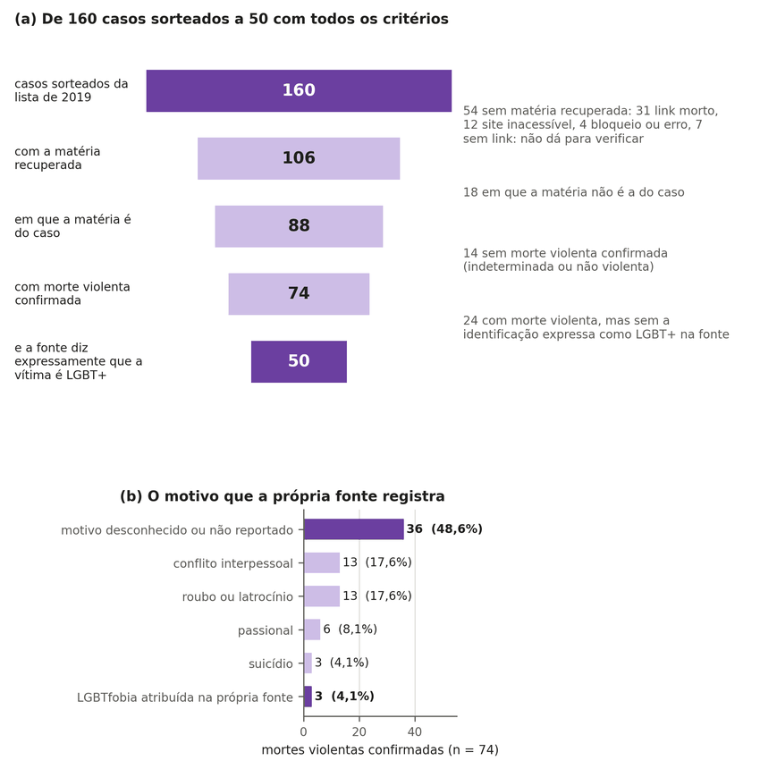
Note. In the first panel, each bar is a step; in the second, the motive is the one recorded by the news story, the police, or the family. Data from the GGB (2020); the check is in Appendix F. Labels in Portuguese: casos sorteados = sampled cases; todos os critérios = all criteria; motivo = motive; própria fonte registra = source itself records; mortes violentas confirmadas = confirmed violent deaths; matéria = news story.
The list also does not measure how many LGBT+ people are killed because of prejudice. Of the 74 confirmed violent deaths, the source itself attributes 3 to prejudice against LGBT+ people, and in 36 the motive is unknown. The absence of a stated motive does not prove that there was no prejudice. Robbery, an intimate relationship, and prejudice can, moreover, coexist in the same case. The list also includes heterosexual people, who numbered 6 in 2024 (GGB, 2026). For this reason, it does not serve as a rate or as a national total. Lists of documented cases describe victims, not risk, in other countries as well. Halliwell et al. (2025) compile 229 documented violent deaths of trans women in the United States and state that the sample does not represent the country.
A critical check made outside the organization also finds few cases with a documented motive. The Liga Humanista Secular do Brasil re-examined the 2016 list case by case and published the spreadsheet, with the source of each case (Vieira et al., 2019). Of the 347 cases, the spreadsheet marks evidence of prejudice in 31, or 8.9%, and leaves 159 as inconclusive, or 45.8%. The page title says the statistics are false and counts as errors both the cases without evidence and the inconclusive ones. An inconclusive case, however, is not a case without prejudice. Almost all cases were read by a single reviewer, with no measure of agreement: only 3 had two, and 14 have no reviewer recorded. One of the authors had already published criticisms of the list. The check therefore also does not measure the motive or show that the true number is low. The other criticisms of the list that the search found appear in newspaper columns and provide no data of their own. The search found no peer-reviewed article by an author critical of the list, and why this is so was not measured (Appendix F).
What the list does allow is an order-of-magnitude calculation. Appendix F calculates how many assault deaths would be expected if LGB+ adults had the same risk as people of the same sex, race, and age. The published count falls below this expected number, and further below as the assumed risk rises. The ratio indicates scale, not actual coverage, because the death risk of LGB+ people has not been measured. The list also mixes in minors, trans people, and heterosexual people, and the PNS does not identify trans people (IBGE, 2022b). Merging two lists of news stories, as is also done in Appendix F, does not produce the national total.
Lists from organizations that repeat the same total do not confirm one another. From 2013 to 2018, the Brazilian records of the Dia da Memória Trans (Transgender Day of Remembrance [TDoR]) cited the GGB itself as the source in 72% to 94% of cases (Appendix F). In 2019, that citation fell to 0.7% of the records. ANTRA reports that, until 2016, its count of trans people was the GGB’s (Benevides, 2026). In those years, the agreement between the lists was a repetition of the same collection.
In summary, this section tested what the GGB list measures. The result is that, in the verifiable cases from 2019, the list rests on real news stories, but it is not a rate, a total, or a measure of motive. How many deaths are missing from the list and how many were motivated by prejudice remains undetermined.

3.6. Violence and Records by Government
The question the debate asks of each government is whether crimes against LGBT+ people rose or fell. The available data do not answer it. The PNS, the only source that surveys the population, had a single edition, in 2019, and the death certificate does not record sexual orientation or gender identity (sections 3.1 and 3.3). All the LGBT+ series that span governments are records. Figure 8 brings together the four that exist, alongside homicide in the whole population, with presidential inaugurations marked.
Figure 8
Overall homicide and records of violence against LGBT+ people by federal government period
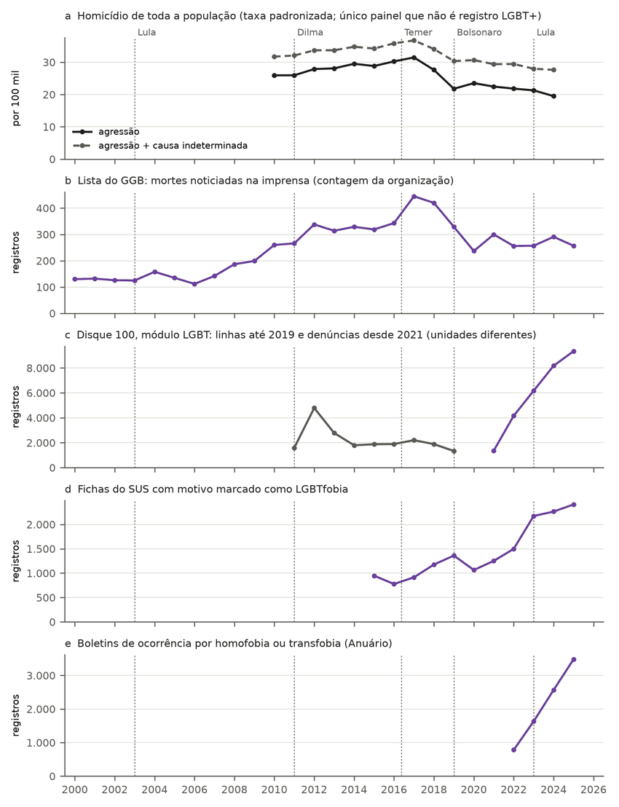
Note. Panel a is the age-standardized rate of assault deaths per 100,000, with and without deaths of undetermined cause. Panels b to e are record counts: the Grupo Gay da Bahia (GGB) list, Disque 100, SUS notification forms with the motive marked as LGBTphobia, and police reports of homophobia or transphobia. For Disque 100, rows are counted through 2019 and, from 2021 on, complaints with at least one row in the LGBT module; 2020 mixes formats and is left out. Dashed lines mark inaugurations. Data from DATASUS (2026a, 2026b), IBGE (2026), GGB (2020, 2026), MDHC (2026), and FBSP (2026); annual series in Appendix G. Labels in Portuguese: taxa padronizada = standardized rate; agressão = assault; linhas = rows; denúncias = complaints.
Each series counts a different thing and changes for its own reasons. The GGB list depends on how many deaths become news and on who collects them. Disque 100 changes its unit in 2020 and its form in 2022. The SUS forms grow along with the notifying network, and the police reports begin only in 2022, after the STF (Supremo Tribunal Federal, Brazil’s Supreme Court) brought homophobia and transphobia under the racism law. Under Equation 1, none of them separates violence from its recording. For this reason, it is not possible to know whether crimes against LGBT+ people rose or fell under any government.
What can be measured by government is homicide in the whole population, and even that counts as a description of the period, never as a cause. The comparison uses the last year before the inauguration and the last complete year of each term (DATASUS, 2026a; IBGE, 2026). The standardized rate rose 11.1% under the Dilma Rousseff government, from 2010 to 2015, and fell 4.2% under the Michel Temer government, from 2015 to 2018. The year 2016, split between the two, is counted in Temer’s period. The rate fell 21.0% under the Jair Bolsonaro government, from 2018 to 2022. In the first two years of the third Luiz Inácio Lula da Silva government, from 2022 to 2024, it declined 10.6% (Appendix G).
Two facts prevent reading the recent decline as an effect of the change of president. The first is the deterioration of recording. Among assault deaths and deaths of undetermined intent, the share of undetermined deaths rose from 18.0% in 2018 to 30.1% in 2024 (DATASUS, 2026a). The Atlas da Violência also points out that part of the recorded decline may come from this deterioration (Instituto de Pesquisa Econômica Aplicada [IPEA] & FBSP, 2025). When undetermined causes are added to assaults, the decline becomes 13.7% under the Bolsonaro government and 6.1% under the Lula government. With the same sum, the change becomes +7.9% under the Dilma government and −0.4% under the Temer government (Appendix G). The second fact is the timing of the decline. The level change estimated for 2019 is −17.0% (95% interval, −29.5% to −2.4%). The decline appears before the inauguration in the values themselves: the standardized rate fell from 31.47 in 2017 to 27.61 in 2018. A sensitivity test, using the whole series with the breaks shifted one year back, gives −21.8% in 2018 (95% interval, −37.4% to −2.4%), which shows that the estimate depends on the chosen date. The national decline began before the inauguration and later became entangled with the pandemic, disputes between criminal factions, and the deterioration of recording (IPEA & FBSP, 2025).
At the state level, the analyses found no association between the governor’s party and overall homicide. The panel from 2012 to 2024 matches each state’s deaths with the party of the elected governor (Tribunal Superior Eleitoral [TSE], 2026). The model uses the logarithm of the rate, with state and year fixed effects, and the interval comes from a wild bootstrap clustered by state, with test inversion, suited to the 27 clusters (Appendix G). The ideological position of each party comes from the scale of Bolognesi et al. (2023), with the data of Bolognesi et al. (2025). On this scale, about five points separate the Partido dos Trabalhadores (PT) from the Partido Liberal. This distance corresponds to a change of −12.3% to +12.4% in the homicide rate (95% interval), and the result is replicated with another ideology scale (Zucco & Power, 2023). Across the 67 party changes in the states, the relative rate declined in 36 cases and rose in the rest (DATASUS, 2026a; TSE, 2026). The test has low power and does not prove that state government is irrelevant.
In sum, the section tested whether it is possible to say that violence against LGBT+ people rose or fell under a government. The result is that only overall homicide has a population series, and it describes periods without attributing cause. For LGBT+ people, the answer remains undetermined until a repeated survey or a field on the death certificate exists.

3.7. Parliament and History
The search for federal government acts in favor of or against LGBT+ people, from 2003 to 2026, is in Appendix H. It measures reported acts, not crimes, and for this reason does not answer the question of the previous section.
In comparative history, persecuting homosexuals was not the mark of a single ideological side. Right-wing dictatorships, communist regimes, a religious government, and a democracy persecuted homosexuals with laws and state agencies (Appendix I). Nazi Germany made about 100,000 arrests under paragraph 175 of the Penal Code and sent thousands of men to concentration camps (United States Holocaust Memorial Museum [USHMM], 2021). West Germany, already a democracy, kept the same provision and recorded about 64,000 convictions (Deutscher Bundestag, 2017). In the Soviet Union, from 1946 to 1991, there were more than 38,000 judicial convictions under the article that punished relations between men (Kondakov, 2022; Valodzin, 2020). The series counts convictions, not people, and Valodzin (2020) estimates that about half involved rape or minors. Cases from Francoist Spain and Chechnya are in Appendix I (España, 2022; Fernández Turuelo, 2024; Tribunal Europeu dos Direitos Humanos, 2023). Table 5 brings together six regimes of different types and what the state did in each.
Table 5
State persecution of homosexuals in six regimes of different types
Regime and period | What the state did | Source
Nazi Germany, 1933 to 1945 | Arrests under paragraph 175 (about 100,000) and 5,000 to 15,000 men sent to concentration camps | USHMM (2021)
West Germany (democracy), 1949 to 1994 | Paragraph 175 kept in force, with about 64,000 criminal convictions | Deutscher Bundestag (2017)
Soviet Union, 1946 to 1991 (law since 1934) | Criminal convictions for relations between men (more than 38,000 judicial convictions from 1946 to 1991, about half for rape or involving minors, not counting the Gulag) | Kondakov (2022); Valodzin (2020)
Cuba, 1965 to 1968 | Internment in Military Units to Aid Production, with no measure of how many of those interned were homosexual | Comisión Interamericana de Derechos Humanos [CIDH] (1983); Tahbaz (2013)
Brazil, military dictatorship, 1964 to 1985 | Dismissals (15 diplomats purged in 1969, 7 for “practice of homosexualism” [our translation]), censorship, and police sweeps, with no formal policy of extermination | Comissão Nacional da Verdade [CNV] (2014)
Iran, since 1979 | Death penalty prescribed by law for sexual relations between men | Islamic Penal Code of the Islamic Republic of Iran, Books I and II (2013, art. 234)
Note. Illustrative historical cases; the counts measure different units (arrests, convictions, general internments, and dismissals) and do not allow the regimes to be ranked. Data from the sources in the last column; full table in Appendix I.
The claim that Brazil is the country that kills the most LGBT+ people has no comparative basis. The search found only cross-country comparisons of reported deaths of trans people, and Brazil’s position changes depending on whether the total or the rate per population is used (Appendix F). None of them has the common coverage and definitions that would measure the real total or the risk of death of LGBT+ people, and the Brazilian count is a list of news reports. The study checked how this claim circulates in Parliament from 2015 to October 2026 (Câmara dos Deputados, 2026; Senado Federal, 2026). Among the 258,011 speeches downloaded from the Chamber of Deputies and the Senate, 49 speeches assert or repeat this supposed world record (Appendix J). The collection has coverage gaps in both Houses, described in the same appendix. Only one of them cites a primary source, such as an official document or a study with author and year, and none does under the original coding. For the cited-source variable, the agreement between the two coders was κ = 0.66, with an interval of 0.31 to 0.93, which includes values below the 0.60 threshold set beforehand. To find out whether the lack of a source was specific to this topic, a baseline of 60 speeches with other numbers was randomly drawn. Of the 38 that asserted a statistic, only 2 cited a locatable primary source (Appendix J). Because this baseline was coded by a different coder, the comparison is indicative. With the second coder in both groups, 1 of 50 versus 2 of 38, the difference remains indistinguishable from chance (p = 0.58). Even so, it suggests that asserting a number without a source is common on the floor.
The claim that trans people live an average of 35 years in Brazil does not come from a life-expectancy calculation. In Congress, 11 speeches attribute to this population a shorter average lifespan, between 27 and 36 years, and none cites a primary source (Appendix J). The figure of 35 years is the one ANTRA publishes. In the 2019 dossier, the organization writes that there are no systematic studies on the life expectancy of this population and attributes the number to Antunes (2013, as cited in Benevides & Nogueira, 2020, p. 32). Further on, the same dossier attributes the number to a news story by Agência Brasil (Martins, 2018, as cited in Benevides & Nogueira, 2020, p. 77). What the dossier calculates is a different measure, the average age of murder victims, 29.7 years in 2019 (Benevides & Nogueira, 2020, p. 30). The age of those who were murdered is not life expectancy, because it leaves out those who were not killed. In the most recent dossier, the 35-year figure reappears without the caveat (Benevides, 2026).
In sum, the section tested where two claims that circulate in the debate come from and whether state persecution of homosexuals belongs to a single side. The result is that neither claim has a primary comparison source, and that regimes with opposite labels persecuted homosexuals. What remains undetermined is the real frequency of deaths of trans people, which no public source measures.

4. Discussion

4.1. What This Means
The firmest fact that Brazilian data support is the difference in nonfatal violence. LGB+ adults report physical violence far more often than heterosexual adults, and the ratio remains at 2.82 after adjusting for profile (section 3.1). The prevalence comes from an official institute, with no intermediary, and it is reproduced in the public microdata (Vasconcelos et al., 2023); the adjusted ratio comes from this reanalysis. The study adds two things to it. The first is who assaulted: 81.4% of LGB+ victims of physical violence named someone they knew as the perpetrator, such as a partner, ex-partner, relative, or colleague. The second is the risk by type of perpetrator, which is higher for LGB+ people in most of the categories estimated. In an analysis conducted after the results were seen, the excess persists after adjustment when the perpetrator named is a partner or ex-partner, a relative, or a stranger, also with marital status in the model. For a friend, colleague, or neighbor, it appears only without marital status in the model.
This picture shifts the focus of the debate. Most LGB+ victims name someone they know as the perpetrator, as is the case for everyone, but the risk is much higher. Policies designed only for street attacks by strangers do not reach the perpetrator named by most victims, who is an acquaintance. A study of notifications of violence against trans people in Brazil points in the same direction. According to its abstract, most recorded perpetrators were men, often with an emotional bond with the victim (Marinho Neto et al., 2024). That study describes notifications, not the population.
The second firm fact is a negative one. The Brazilian public databases contain no numerator of deaths with a compatible denominator for LGBT+ people. For this reason, no rate, trend, or international ranking of homicide for this population holds up (sections 3.3 to 3.5). The third fact answers the question that motivated the study. There is no reliable indicator of violence motivated by LGBTphobia: there are records of motive that can be counted, but none makes it possible to estimate how many cases occur or to compare those cases over time and across groups. The perpetrator’s motive, the bias perceived by the victim, and the causal effect of discrimination are different questions (Greiner & Rubin, 2011). The study does not estimate how much of the violence is due to LGBTphobia, and this does not deny documented cases or effects of discrimination.
The registry series illustrate Campbell’s (1979) warning. The effort that expands a registry’s coverage can, at the same time, prevent comparison over time. The international literature meets the same obstacle, because policy changes alter the recording of hate crimes without violence being separated from recording (Levy & Levy, 2017; Pettis et al., 2022). There is also a risk in how the numbers are read. In an experiment in the United States, greater numeracy increased polarization: among the most numerate, the gap in accuracy between those who agreed and those who disagreed politically with the correct answer was larger (Kahan et al., 2017). Extending this finding to violence figures is an analogy made in this article. If it holds, it holds for both sides of the debate and justifies always publishing the opposing source and the interval.

4.2. How Other Countries Measure
Countries that separate violence from recording do so with a victimization survey run in parallel with police records. In England and Wales, the survey estimates, as a three-year average, 176,000 hate incidents per year, of which 44% come to the attention of the police (Home Office, 2025). Police records, in turn, count crimes, not estimated incidents: in the year ending March 2025, they totaled 137,550 hate crimes for all motives, 18,702 of them related to sexual orientation. In New Zealand, the victimization survey measures 38% of LGBTQ+ adults as victims of at least one crime, compared with 28% overall (Ministry of Justice, 2025). In the European Union, the online survey of more than 100,000 LGBTIQ people, which does not use a probability sample, finds 13% to 14% of respondents attacked over five years (European Union Agency for Fundamental Rights [FRA], 2024).
Police records exist in many countries, but they record motive poorly. In Canada, the police recorded 4,882 hate crimes in 2024, with coverage above 99% (Statistics Canada, 2026). In 46 States of the Organization for Security and Co-operation in Europe, official hate crime data are sent to the organization’s human rights office (Office for Democratic Institutions and Human Rights [ODIHR], 2025). In Germany, however, only 17.6% of the audited police reports state the motive explicitly (Henningsmeier et al., 2025, p. 99). There, the national survey by the federal criminal police office measures a reporting rate of 2.6% for violence based on sexual orientation (Bundeskriminalamt, 2026).
Brazil differs at both ends. It has no regular victimization survey, and sexual orientation was measured only once, in the 2019 PNS, without gender identity (IBGE, 2022b). On the other hand, its health notification form has a mandatory motive field, which was not found in any other country in the inventory of official sources (Appendix L). The weakness of this field is its completeness, not its existence. For trans people, the broadest international measure is lifetime violence. In a review of 94 studies, nine made it possible to estimate that 64.23% of trans and gender-diverse adults had experienced physical or sexual violence in their lifetime (95% interval, 47.38% to 78.17%; McLellan et al., 2026).

4.3. Three Objections
The first objection holds that the lack of official records is neglect and that an imperfect civil-society count is better than none. D’Ignazio et al. (2022) document this role in feminicide counterdata. The argument supports the existence of the count and the need for official data. It does not, however, support the rate and ranking statements built on it. Treated as a total, the GGB count falls below the assault deaths expected for adults of the same sex, race, and age (section 3.5). This scale calculation does not decide between undercounting and lower risk (Appendix F). The incompatibility comes from elsewhere: the list records cases found mainly in news reports, with unknown coverage, and includes minors and heterosexuals, as well as trans people whom the PNS does not identify; these universes were not harmonized with the denominator.
The second objection comes in two opposite versions. One says that if most assaults come from acquaintances, then it is not LGBTphobia. The other says that if the family assaults more, then it is rejection driven by prejudice. Neither follows from the data. A known perpetrator does not exclude prejudice, and an unknown perpetrator does not prove it. The survey does not ask about motive. The risk is higher for LGB+ people for almost every type of perpetrator estimated, and the excess persists after adjustment for partner or ex-partner, relative, and stranger, also with marital status (section 3.1). For a friend, colleague, or neighbor, it appears only without marital status in the model. What can be claimed is the difference in risk and the relationship with whoever assaulted, not the reason for the assault.
The third objection holds that counts by activist organizations have an incentive to grow and that, for this reason, the disproportionate violence is invented. The argument supports the point that the count is neither a rate nor a proven hate crime. It does not support the absence of disproportionate violence, because the official survey, reanalyzed here, gives the ratio of 2.82. In the 2019 list, duplicates made up 0.3%, which does not indicate fabrication, although the test does not cover the years 2023 to 2025 (section 3.5).
This study also does not measure false allegations of LGBTphobia. No national measure was located, and what exists for other populations is in Appendix L.

5. Limitations
The first limitation is the measure of violence. It is self-report by adults, classified by the sexual orientation they declared in a single edition of the PNS. The survey does not identify trans people, does not include minors, does not ask about motive, and does not allow trend analysis (IBGE, 2022b). Declared orientation may be underestimated where stigma exists. The mode of completion also matters: the LGB+ share is 3.51% when residents fill in the module themselves and 1.38% when the interviewer does so (IBGE, 2022a). The violence ratio, however, is similar in the two modes (section 3.1), although those who fill it in alone may differ from those who respond to the interviewer. The PNS counts victimized persons, not the number of episodes, and the question on who assaulted them allows only a single answer. Another explanation that the data do not separate out is that one group fails to report certain perpetrators more often than the other.
The second limitation is the size of the sample of victims. There are only 179 LGB+ victims of physical violence, so the shares by type of perpetrator have wide intervals. Among the aggregated categories, only the difference in the share attributed to police officers has an interval that excludes zero, with 5 LGB+ victims, and the difference is small. Among the subcategories, the share attributed to a current spouse or partner is also lower in the LGB+ group, at 5.05% versus 20.21%. The intervals are not corrected for the number of comparisons. The analysis of risk by type of perpetrator and the adjustments for marital status and for mode of completion were done after seeing the results, during the revision of this text. They should be read as exploratory analyses, not as planned tests.
The third limitation is causality. No adjusted ratio measures discrimination, because the adjustment does not separate prejudice from other differences in life circumstances between the groups (VanderWeele & Robinson, 2014). The analyses by government describe what happened and do not attribute cause. Changes of government coincide with the pandemic, gun policy, criminal factions, and the worsening of death registration (IPEA & FBSP, 2025). A causal reading of the state panel would require parallel trends across states, which cannot be proved, and so the panel only describes association.
The fourth limitation is the reach of the foreign sources and of the literature. Mortality studies from outside Brazil hold for the populations and periods in which they were conducted, and they do not provide estimates for Brazil. Identifying trans people through registries selects those who reached a hospital or a civil registry office. Only the abstract of Szwarcwald et al. (2025) was read, because the full text was not accessible. The full text of part of the mortality literature also could not be obtained through legitimate means, and none of these works decides any conclusion in the claims table (Appendix B).
The fifth limitation is the coding done with the support of language models. The second coder of the speeches was from a different model family and did not see the labels. On the sentence about the country that kills the most, it agreed with the first coder, with a stance κ of 0.73 (95% interval, 0.46 to 0.92) and a source κ of 0.66 (0.31 to 0.93). On the sentence about governments that kill or persecute, agreement fell below the 0.60 threshold, and those percentages were kept as indicative, under a rule written in advance (Appendix J). The search for government acts, in Appendix H, had one coder and identical queries for each period, which does not guarantee equal press coverage in each period, and the sensitivity of this search was not measured.
The sixth limitation is proof of priority and access to data. The SHA-256 fingerprint of the protocols proves that the text did not change, but it does not by itself prove the date, because there is no external timestamp. The raw microdata are not redistributed, and the lists of victims’ names are left out for privacy reasons. For this reason, the link between each GGB case and its source cannot be reconstructed by third parties (GGB, 2020).

6. Conclusion and Next Steps
The sources examined support an inequality in nonlethal violence reported by LGB+ adults, including in the exploratory analysis by relationship to the perpetrator. They do not, however, allow that inequality to be turned into a measure of LGBTphobic motivation, nor allow the records to be combined into a comparable national rate of deaths of LGBT+ people. The contribution of the study is to show and test these boundaries, and to indicate what information would allow them to be crossed.
Four conclusions summarize the study. The first is that LGB+ adults report physical violence much more often than heterosexual adults. Most victims name a known person as the perpetrator. In an analysis done after seeing the results, the adjusted risk is higher for LGB+ people when the perpetrator named is a partner or ex-partner, a family member, or a stranger, also when marital status is included in the adjustment (section 3.1). For a friend, colleague, or neighbor, the higher risk appears only when marital status is not adjusted for. The second is that public data do not allow estimating a rate, an excess, or a trend of deaths of LGBT+ people in Brazil, in either direction, because the death record does not capture sexual orientation or gender identity (section 3.3). Documented cases exist, but they do not form a rate. The third is that there is no reliable indicator of violence motivated by LGBTphobia. The series of complaints, police reports, and notification forms measure recording, and Equation 1 shows why they do not separate violence from recording (section 3.2). The fourth is that it is not possible to say whether crimes against LGBT+ people rose or fell under any government; by government, only homicide in the total population has a series, and that series describes periods without attributing cause (section 3.6).
Three changes would alter these answers. For nonlethal violence, a repeated victimization survey would be needed, with questions on sexual orientation, gender identity, and the motive perceived by the victim. For deaths, orientation and identity would have to be recorded on the death certificate, or deaths would have to be linked to a source that records them and has a denominator. In Rio de Janeiro, probabilistic linkage between Sinan notification forms and deaths has already shown an accuracy of 93.3%, without producing an LGBT+ mortality rate (Rafael et al., 2024). For motive, international standards separate the motive from the context of the crime (United Nations Office on Drugs and Crime [UNODC], 2015). They also call for bias indicators documented in each record (ODIHR, 2014).
A victimization survey has a known cost. Table 6 compares three designs, all with the design effect measured in the 2019 PNS. The costs are scenarios calculated from public documents, not budgets (Ministério da Justiça e Segurança Pública & IBGE, 2021; Ministério da Saúde & IBGE, 2023). An annual module in the Pesquisa Nacional por Amostra de Domicílios Contínua (PNAD Contínua, the continuous national household sample survey) would detect, with 80% power, a relative increase of 31.7% in physical violence, at a reference cost of R$ 6.85 million per cycle. The dedicated round in Table 6 assumes 114,278 adults, more than the 2019 sample, and therefore detects an increase of 50.7%, not 60.7%.
Table 6
Capacity and cost of one cycle of three victimization survey designs (2026 R$)
Design | Adults | LGB+ | Detectable relative increase (physical / any) | Reference cost
Annual module in the PNAD Contínua | 275,573 | 5,212 | 31.7% / 12.2% | R$ 6.85 million
Dedicated round similar to the PNS | 114,278 | 2,161 | 50.7% / 19.0% | R$ 29.0 million
Probability-​based internet panel or survey | 114,278 | 2,161 | 50.7% / 19.0% | R$ 42.0 million
Note. Detectable relative increase with 80% power, a two-sided test at the 5% level, and independent rounds. The design effect is the one measured in the 2019 PNS for each outcome, larger for physical violence than for any violence, and it is the same in the three designs because no design-specific measure is available. The number of LGB+ adults is a planning assumption, using the PNS prevalence of 1.89%. Among all adults in each PNS mode, the fraction who declared themselves LGB+ was 1.35% with an interviewer and 3.26% with self-completion. With these fractions, the PNAD Contínua module would detect an increase of 37.9% or 23.8% in physical violence (Table K2). The difference between modes may come from who responded in each one, and the completion mode is a choice to be tested in a pilot study. In a panel that interviews the same people, the correlation between rounds may reduce the detectable variation, an effect not calculated here. Costs are marginal costs to the funder, excluding the institute’s permanent payroll. There is no public Brazilian price for the internet panel. Its cost is the reference cost of a British contract (Gambling Commission, 2025), converted at the exchange rate of October 20, 2026 (Banco Central do Brasil, 2026); the full ranges of scenarios are in Appendix K. Data from Ministério da Justiça e Segurança Pública and IBGE (2021), Ministério da Saúde and IBGE (2023), and IBGE (2026).
Some steps depend only on data that are already forthcoming. The 2023 Pesquisa Nacional de Demografia e Saúde (National Demography and Health Survey) asked about sexual orientation and gender identity in 133,000 households and has not yet published the results (IBGE, 2023). If its violence questions and target population are comparable to those of the PNS, it will allow a second measure, as well as the first measure for trans people. Other steps depend on an institutional mandate, such as linking deaths, notification forms, and police reports with a protected key, which would allow estimating totals from three lists, under explicit assumptions about the dependence among them (Lum et al., 2013). Until that exists, the honest answer about deaths and motive is that the country does not yet measure what the debate asserts.

Data and Code Availability
The derived data, the code, the protocols with their fingerprints, and the material in Appendices B to M are in the study’s public repository, version 1.0.0 (Flores, 2026). The link between each Grupo Gay da Bahia (GGB) case and its news report is the exception, because it requires the list of names. The deposit has the permanent identifier https://doi.org/10.5281/zenodo.23873858, which always resolves to the latest version. The official microdata are not redistributed, but the scripts in the repository download them from the sources and verify each file. The lists of victims’ names are not distributed, for privacy reasons.

References
Asal, V., Sommer, U., & Harwood, P. G. (2013). Original sin: A cross-national study of the legality of homosexual acts. Comparative Political Studies, 46(3), 320–351. https://doi.org/10.1177/0010414012453693
Banco Central do Brasil. (2026). Cotações de fechamento PTAX: libra esterlina, 20 de outubro de 2026 [Conjunto de dados]. https://olinda.bcb.gov.br/olinda/servico/PTAX/versao/v1/odata/
Benevides, B. G. (2026). Dossiê: Assassinatos e violências contra travestis e transexuais brasileiras em 2025. Associação Nacional de Travestis e Transexuais. https://antrabrasil.org/wp-content/uploads/2026/01/dossie-antra-2026.pdf
Benevides, B. G., & Nogueira, S. N. B. (Orgs.). (2020). Dossiê dos assassinatos e da violência contra travestis e transexuais brasileiras em 2019. Expressão Popular; Associação Nacional de Travestis e Transexuais; Instituto Brasileiro Trans de Educação. https://antrabrasil.files.wordpress.com/2020/01/dossic3aa-dos-assassinatos-e-da-violc3aancia-contra-pessoas-trans-em-2019.pdf
Big data, 331 deaths. (2019, 22 de novembro). The Boston Globe. https://www.bostonglobe.com/2019/11/22/opinion/big-data-331-deaths/
Bolognesi, B., Codato, A., Ribeiro, E., & Silva, B. F. (2025). Database on the ideological classification of all Brazilian political parties (2018-2022) [Conjunto de dados]. Harvard Dataverse. https://doi.org/10.7910/DVN/MFIXKW
Bolognesi, B., Ribeiro, E., & Codato, A. (2023). Uma nova classificação ideológica dos partidos políticos brasileiros. Dados, 66(2), Artigo e20210164. https://doi.org/10.1590/dados.2023.66.2.303
Brasil. (2026). Lei nº 15.380, de 6 de abril de 2026: Altera a Lei nº 11.340, de 7 de agosto de 2006 (Lei Maria da Penha), quanto à audiência de retratação. Presidência da República. https://www.planalto.gov.br/ccivil_03/_ato2023-2026/2026/lei/l15380.htm
Bundeskriminalamt. (2026). Sicherheit und Kriminalität in Deutschland (SKiD) 2024: Ergebnisbericht. https://skid.bka.de/assets/files/SKiD2024_Ergebnisbericht.pdf
Câmara dos Deputados. (2026). Dados abertos da Câmara dos Deputados: API, versão 2 [Interface de dados abertos; discursos em plenário de 2015 a outubro de 2026]. Recuperado em 22 de outubro de 2026, de https://dadosabertos.camara.leg.br/api/v2
Campbell, D. T. (1979). Assessing the impact of planned social change. Evaluation and Program Planning, 2(1), 67–90. Reimpresso em Journal of MultiDisciplinary Evaluation, 7(15), 3–43, 2011. https://doi.org/10.56645/jmde.v7i15.297
Cerqueira, D., & Coelho, D. S. C. (2017). Democracia racial e homicídios de jovens negros na cidade partida (Texto para Discussão nº 2267). Instituto de Pesquisa Econômica Aplicada. https://www.ipea.gov.br/portal/images/stories/PDFs/TDs/td_2267.pdf
Clark, K. A., & Blosnich, J. R. (2024). Limitations of sexual orientation and gender identity information as reported in the National Violent Death Reporting System. LGBT Health, 11(3), 173–177. https://doi.org/10.1089/lgbt.2022.0297
Clark, K. D., White, R. A., Jackson, S. S., Skalkidou, A., Frisell, T., & Papadopoulos, F. C. (2026). Nationwide estimates of all-cause and cause-specific mortality among individuals with gender dysphoria in Sweden, 2001-2023: A register-based cohort study. eClinicalMedicine, 98, Artigo 104088. https://doi.org/10.1016/j.eclinm.2026.104088
Cochran, S. D., & Mays, V. M. (2015). Mortality risks among persons reporting same-sex sexual partners: Evidence from the 2008 General Social Survey-National Death Index data set. American Journal of Public Health, 105(2), 358–364. https://doi.org/10.2105/ajph.2014.301974
Comisión Interamericana de Derechos Humanos. (1983). Informe sobre la situación de los derechos humanos en Cuba (OEA/Ser.L/V/II.61, Doc. 29 rev. 1). Comisión Interamericana de Derechos Humanos, Organización de los Estados Americanos. https://www.cidh.oas.org/countryrep/Cuba83sp/capitulo10.htm
Comissão Nacional da Verdade. (2014). Relatório: Volume II, textos temáticos (Texto 7, Ditadura e homossexualidades). https://web.archive.org/web/20181011151123/http://cnv.memoriasreveladas.gov.br/images/pdf/relatorio/volume_2_digital.pdf
Departamento de Informação e Informática do Sistema Único de Saúde. (2026a). Sistema de Informações sobre Mortalidade (SIM): Microdados de óbitos por residência, 2010 a 2024 [Conjunto de dados]. Departamento de Informática do Sistema Único de Saúde, Ministério da Saúde. Recuperado em 22 de outubro de 2026, de https://ftp.datasus.gov.br/dissemin/publicos/SIM/CID10/DORES/DOBR2024.dbc
Departamento de Informação e Informática do Sistema Único de Saúde. (2026b). Sistema de Informação de Agravos de Notificação (Sinan): Microdados de violência interpessoal e autoprovocada, 2015 a 2025 [Conjunto de dados]. Departamento de Informática do Sistema Único de Saúde, Ministério da Saúde. Recuperado em 11 de outubro de 2026, de https://datasus.saude.gov.br/transferencia-de-arquivos/
Deutscher Bundestag. (2017). Entwurf eines Gesetzes zur strafrechtlichen Rehabilitierung der nach dem 8. Mai 1945 wegen einvernehmlicher homosexueller Handlungen verurteilten Personen und zur Änderung des Einkommensteuergesetzes (Drucksache 18/12038). https://dserver.bundestag.de/btd/18/120/1812038.pdf
D’Ignazio, C., Cruxên, I., Suárez Val, H., Martinez Cuba, A., García-Montes, M., Fumega, S., Suresh, H., & So, W. (2022). Feminicide and counterdata production: Activist efforts to monitor and challenge gender-related violence. Patterns, 3(7), Artigo 100530. https://doi.org/10.1016/j.patter.2022.100530
Dinno, A. (2017). Homicide rates of transgender individuals in the United States: 2010-2014. American Journal of Public Health, 107(9), 1441–1447. https://doi.org/10.2105/ajph.2017.303878
Encarnación, O. G. (2014). Gay rights: Why democracy matters. Journal of Democracy, 25(3), 90–104. https://doi.org/10.1353/jod.2014.0044
Erlangsen, A., Jacobsen, A. L., Ranning, A., Delamare, A. L., Nordentoft, M., & Frisch, M. (2023). Transgender identity and suicide attempts and mortality in Denmark. JAMA, 329(24), 2145–2153. https://doi.org/10.1001/jama.2023.8627
España. (1970). Ley 16/1970, de 4 de agosto, sobre peligrosidad y rehabilitación social. Boletín Oficial del Estado. https://www.boe.es/buscar/doc.php?id=BOE-A-1970-854
España. (1979). Ley 77/1978, de 26 de diciembre, de modificación de la Ley de Peligrosidad y Rehabilitación Social y de su Reglamento. Boletín Oficial del Estado, 10, 658-659. https://www.boe.es/buscar/doc.php?id=BOE-A-1979-700
España. (2022). Ley 20/2022, de 19 de octubre, de Memoria Democrática. Boletín Oficial del Estado. https://www.boe.es/buscar/act.php?id=BOE-A-2022-17099
European Union Agency for Fundamental Rights. (2024). LGBTIQ equality at a crossroads: Progress and challenges. https://fra.europa.eu/en/publication/2024/lgbtiq-equality-crossroads-progress-and-challenges
Feldman, J. M., Gruskin, S., Coull, B. A., & Krieger, N. (2017). Quantifying underreporting of law-enforcement-related deaths in United States vital statistics and news-media-based data sources: A capture-recapture analysis. PLOS Medicine, 14(10), Artigo e1002399. https://doi.org/10.1371/journal.pmed.1002399
Ferguson, C. E., & Malouff, J. M. (2016). Assessing police classifications of sexual assault reports: A meta-analysis of false reporting rates. Archives of Sexual Behavior, 45(5), 1185–1193. https://doi.org/10.1007/s10508-015-0666-2
Fernández Turuelo, M. (2024). Homosexuales inductores del delito: Peligrosidad social y protección de la comunidad en el Valladolid tardofranquista (1971-1972). Revista Historia Autónoma, 24, 111–132. https://doi.org/10.15366/rha2024.24.006
Flores, C. U. (2026). Dados de replicação, código e material complementar para: Mortalidade e violência contra pessoas LGBT+ no Brasil: O que os dados públicos permitem afirmar (Versão 1.0.0) [Conjunto de dados e software]. Codex Hash Research Laboratory. https://doi.org/10.5281/zenodo.23873858
Fórum Brasileiro de Segurança Pública. (2026). Anuário Brasileiro de Segurança Pública 2026. https://forumseguranca.org.br/wp-content/uploads/2026/07/anuario-2026.pdf
Frisch, M., & Brønnum-Hansen, H. (2009). Mortality among men and women in same-sex marriage: A national cohort study of 8333 Danes. American Journal of Public Health, 99(1), 133–137. https://doi.org/10.2105/ajph.2008.133801
Gambling Commission. (2025, 4 de novembro). Gambling Survey for Great Britain [Aviso de contrato adjudicado, referência 25-017]. Contracts Finder. https://www.contractsfinder.service.gov.uk/Notice/380ef02e-39ac-4210-8d17-375ec5697b11
Goodman-Bacon, A. (2021). Difference-in-differences with variation in treatment timing. Journal of Econometrics, 225(2), 254–277. https://doi.org/10.1016/j.jeconom.2021.03.014
Greiner, D. J., & Rubin, D. B. (2011). Causal effects of perceived immutable characteristics. Review of Economics and Statistics, 93(3), 775–785. https://doi.org/10.1162/rest_a_00110
Grupo Gay da Bahia. (2020). Mortes violentas de LGBT+ no Brasil, 2019: Relatório do Grupo Gay da Bahia. https://grupogaydabahia.com.br/wp-content/uploads/bsk-pdf-manager/2024/02/relatorio-2019.pdf
Grupo Gay da Bahia. (2026). Release: Observatório de mortes violentas de LGBT+ no Brasil, 2025. https://grupogaydabahia.com.br/wp-content/uploads/2026/01/RELEASE-Mortes-Violentas-de-LGBT%5EM%5EJ-2025-GGB.pdf
Halliwell, P., Blumenthal, J., Kennedy, R., Lahn, L., & Smith, L. R. (2025). Characterizing the prevalence and perpetrators of documented fatal violence against Black transgender women in the United States (2013-2021). Violence Against Women, 31(14), 3756–3779. https://doi.org/10.1177/10778012241289425
Hatzenbuehler, M. L., Bellatorre, A., Lee, Y., Finch, B. K., Muennig, P., & Fiscella, K. (2014). Structural stigma and all-cause mortality in sexual minority populations [Artigo retratado]. Social Science & Medicine, 103, 33–41. https://doi.org/10.1016/j.socscimed.2013.06.005
Hatzenbuehler, M. L., Rutherford, C., McKetta, S., Prins, S. J., & Keyes, K. M. (2020). Structural stigma and all-cause mortality among sexual minorities: Differences by sexual behavior? Social Science & Medicine, 244, Artigo 112463. https://doi.org/10.1016/j.socscimed.2019.112463
Henningsmeier, I., Dreißigacker, A., Witthuhn, J., Bartsch, T., & Meier, B.-D. (2025). Strafrechtliche Verfolgung von Vorurteilskriminalität. Nomos. https://doi.org/10.5771/9783748963455
Holland, P. W. (1986). Statistics and causal inference. Journal of the American Statistical Association, 81(396), 945–960. https://doi.org/10.1080/01621459.1986.10478354
Home Office. (2025). Hate crime, England and Wales, year ending March 2025. UK Government. https://www.gov.uk/government/statistics/hate-crime-england-and-wales-year-ending-march-2025/hate-crime-england-and-wales-year-ending-march-2025
Hsu, C.-W., Chen, Y.-C. B., Wang, L.-J., Chen, M.-H., Yang, Y.-H., Liang, C.-S., Chen, P.-Y., & Lai, E. C.-C. (2025). Mortality among transgender persons: A Taiwan matched-population and sibling-comparison cohort study. The Lancet Regional Health: Western Pacific, 64, Artigo 101715. https://doi.org/10.1016/j.lanwpc.2025.101715
Human Rights Watch. (2017). “They have long arms and they can find me”: Anti-gay purge by local authorities in Russia’s Chechen Republic. https://backend.hrw.org/sites/default/files/report_pdf/chechnya0517_web.pdf
ILGA World. (2020). State-sponsored homophobia 2020: Global legislation overview update. International Lesbian, Gay, Bisexual, Trans and Intersex Association. https://ilga.org/downloads/ILGA_World_State_Sponsored_Homophobia_report_global_legislation_overview_update_December_2020.pdf
Instituto Brasileiro de Geografia e Estatística. (2022a). Pesquisa Nacional de Saúde 2019: Microdados (Versão de 25 de maio de 2022) [Conjunto de dados]. https://ftp.ibge.gov.br/PNS/2019/Microdados/Dados/PNS_2019_20220525.zip
Instituto Brasileiro de Geografia e Estatística. (2022b). Pesquisa Nacional de Saúde 2019: Orientação sexual autoidentificada da população adulta. https://biblioteca.ibge.gov.br/visualizacao/livros/liv101934.pdf
Instituto Brasileiro de Geografia e Estatística. (2023). Lançamento da Pesquisa Nacional de Demografia e Saúde 2023 [Apresentação]. https://agenciadenoticias.ibge.gov.br/media/com_mediaibge/arquivos/db450d396a021e9bebabb1b436dcd7f8.pdf
Instituto Brasileiro de Geografia e Estatística. (2026). Sistema IBGE de Recuperação Automática (SIDRA): Tabelas 9514, 6579, 7307, 1737 e 9606 [Interface de dados]. Recuperado em 21 de outubro de 2026, de https://apisidra.ibge.gov.br/values/t/9514/n3/all/v/93/p/2022
Instituto de Pesquisa Econômica Aplicada & Fórum Brasileiro de Segurança Pública. (2025). Atlas da Violência 2025. Instituto de Pesquisa Econômica Aplicada e Fórum Brasileiro de Segurança Pública. https://repositorio.ipea.gov.br/handle/11058/17165
Islamic Penal Code of the Islamic Republic of Iran, Books I and II (2013) (Iran Human Rights Documentation Center, Trad., 2014). https://iranhrdc.org/english-translation-of-books-i-ii-of-the-new-islamic-penal-code/
Kahan, D. M., Peters, E., Dawson, E. C., & Slovic, P. (2017). Motivated numeracy and enlightened self-government. Behavioural Public Policy, 1(1), 54–86. https://doi.org/10.1017/bpp.2016.2
Kitagawa, E. M. (1955). Components of a difference between two rates. Journal of the American Statistical Association, 50(272), 1168–1194. https://doi.org/10.1080/01621459.1955.10501299
Kondakov, A. S. (2022). Violent affections: Queer sexuality, techniques of power, and law in Russia. UCL Press. https://doi.org/10.14324/111.9781800082939
Levy, B. L., & Levy, D. L. (2017). When love meets hate: The relationship between state policies on gay and lesbian rights and hate crime incidence. Social Science Research, 61, 142–159. https://doi.org/10.1016/j.ssresearch.2016.06.008
Luis, M. A., Mota, J. C., D’Oliveira, C. A. F. B., Vasconcelos, C. H., Silva, R. P., Dantas Junior, A. B., Regina, F. L., Lima, C. M., Sá, N. B., & Cardoso, L. O. (2026). Fatores associados à mortalidade de pessoas trans por causas violentas: Estudo transversal, Brasil, 2014-2022. Epidemiologia e Serviços de Saúde, 35, Artigo e20240748. https://doi.org/10.1590/S2237-96222026v35e20240748.pt
Lum, K., Price, M. E., & Banks, D. (2013). Applications of multiple systems estimation in human rights research. The American Statistician, 67(4), 191–200. https://doi.org/10.1080/00031305.2013.821093
Marinho Neto, K. R. E., Tomazelli, J., & Girianelli, V. R. (2024). Temporal trend and characteristics of notifications of self-inflicted and interpersonal violence in the transgender population in Brazilian municipalities, 2015-2022. Epidemiologia e Serviços de Saúde, 33(spe1), Artigo e2024296. https://doi.org/10.1590/s2237-96222024v33e2024296.especial.en
McKetta, S., Hoatson, T., Hughes, L. D., Everett, B. G., Haneuse, S., Austin, S. B., Hughes, T. L., & Charlton, B. M. (2024). Disparities in mortality by sexual orientation in a large, prospective cohort of female nurses. JAMA, 331(19), 1638–1645. https://doi.org/10.1001/jama.2024.4459
McKetta, S., Hughes, L. D., Anderson, A. M., Barzilay, R., Rahman, B., & Clark, K. A. (2026). Sexual orientation-related differences in alcohol use and suicide death. JAMA Network Open, 9(1), Artigo e2554680. https://doi.org/10.1001/jamanetworkopen.2025.54680
McLellan, C., Yeh, P. T., Kennedy, C. E., Barré-Quick, M., Rich, A. J., Poteat, T., & Cooney, E. E. (2026). Global burden of violence against transgender and gender-diverse adults: A systematic review and meta-analysis. JAMA Network Open, 9(1), Artigo e2552953. https://doi.org/10.1001/jamanetworkopen.2025.52953
Mendes, W. G., & Silva, C. M. F. P. (2020). Homicídios da população de lésbicas, gays, bissexuais, travestis, transexuais ou transgêneros (LGBT) no Brasil: Uma análise espacial. Ciência & Saúde Coletiva, 25(5), 1709–1722. https://doi.org/10.1590/1413-81232020255.33672019
Ministério da Cidadania. (2019). Portaria nº 1.576, de 20 de agosto de 2019. Diário Oficial da União, seção 1, p. 30. https://www.in.gov.br/web/dou/-/portaria-n-1.576-de-20-de-agosto-de-2019-211680778
Ministério da Justiça e Segurança Pública & Instituto Brasileiro de Geografia e Estatística. (2021). Termo de Execução Descentralizada nº 02/2021: Plano de trabalho. Aspectos da vitimização e da segurança (módulos da Pesquisa Nacional por Amostra de Domicílios Contínua). Instituto Brasileiro de Geografia e Estatística. https://www.ibge.gov.br/np_download/novoportal/documentos_institucionais/Termo_de_Execucao_Descentralizada_02_2021_MJ_IBGE_Plano_de_Trabalho.pdf
Ministério da Saúde. (2022). Declaração de Óbito: Manual de instruções para preenchimento. Secretaria de Vigilância em Saúde. https://www.gov.br/saude/pt-br/centrais-de-conteudo/publicacoes/svsa/vigilancia/declaracao-de-obito-manual-de-instrucoes-para-preenchimento.pdf
Ministério da Saúde. (2024). Guia de Vigilância em Saúde (6ª ed. rev., Vol. 3). Secretaria de Vigilância em Saúde e Ambiente. https://www.gov.br/saude/pt-br/centrais-de-conteudo/publicacoes/svsa/vigilancia/guia-de-vigilancia-em-saude-volume-3-6a-edicao
Ministério da Saúde & Instituto Brasileiro de Geografia e Estatística. (2023). Plano de trabalho do Termo de Execução Descentralizada nº 119/2023: Pesquisa Nacional de Saúde 2024 [Minuta]. Instituto Brasileiro de Geografia e Estatística. https://www.ibge.gov.br/np_download/novoportal/documentos_institucionais/ted/Plano_de_Trabalho_TED_119_2023_PNS.pdf
Ministério dos Direitos Humanos e da Cidadania. (2026). Dados abertos do Disque Direitos Humanos (Disque 100): Microdados de 2011 a 2026 [Conjunto de dados]. Recuperado em 24 de outubro de 2026, de https://www.gov.br/mdh/pt-br/acesso-a-informacao/dados-abertos/disque100
Ministry of Justice. (2025). New Zealand Crime and Victims Survey: Key results, cycle 8 (2025). New Zealand Government. https://www.justice.govt.nz/assets/Documents/Publications/NZCVS-2025-Key-Results-Cycle-8.pdf
Office for Democratic Institutions and Human Rights. (2014). Hate crime data-collection and monitoring mechanisms: A practical guide. https://www.osce.org/files/f/documents/3/a/124533.pdf
Office for Democratic Institutions and Human Rights. (2025). 2024 hate crime data findings. https://hatecrime.osce.org/sites/default/files/2025-11/2024%20Hate%20Crime%20Data%20Findings_FINAL_0.pdf
Office for National Statistics. (2025). Self-harm and suicide by sexual orientation, England and Wales: March 2021 to December 2023 [Boletim estatístico]. https://www.ons.gov.uk/peoplepopulationandcommunity/healthandsocialcare/mentalhealth/bulletins/selfharmandsuicidebysexualorientationenglandandwales/march2021todecember2023
Office for National Statistics. (2026a). All-cause and cause-specific mortality by sexual orientation, England and Wales: March 2021 to November 2024 [Boletim estatístico e conjunto de dados]. https://www.ons.gov.uk/peoplepopulationandcommunity/healthandsocialcare/healthinequalities/bulletins/allcauseandcausespecificmortalitybysexualorientationenglandandwales/march2021tonovember2024
Office for National Statistics. (2026b). Life expectancy by sexual orientation, England and Wales: March 2021 to March 2024 [Boletim estatístico; estatística experimental]. https://www.ons.gov.uk/peoplepopulationandcommunity/healthandsocialcare/healthandlifeexpectancies/bulletins/lifeexpectancybysexualorientationenglandandwales/march2021tomarch2024
Organization for Security and Co-operation in Europe. (2018). Report under the Moscow Mechanism on alleged human rights violations and impunity in the Chechen Republic of the Russian Federation (Relator W. Benedek). https://www.osce.org/files/Moscow%20Mechanism%20Document_ENG.pdf
OutRight Action International. (2015, 24 de agosto). First-ever UN Security Council briefing on violence against LGBTI people focuses on ISIS. https://outrightinternational.org/press-release/first-ever-un-security-council-briefing-violence-against-lgbti-people-focus-isis-0
Pettis, R. W., Valencia, Z., & Williams, B. J. (2022). Pride and prejudice: Same-sex marriage legalization announcements and hate crimes. The Journal of Law and Economics, 65(4), 811–835. https://doi.org/10.1086/721700
Rafael, R. M. R., Silva, K. P., Santos, H. G. S., Depret, D. G., Caravaca-Morera, J. A., & Breda, K. M. L. (2024). Accuracy, potential, and limitations of probabilistic record linkage in identifying deaths by gender identity and sexual orientation in the state of Rio de Janeiro, Brazil. BMC Public Health, 24(1), Artigo 1475. https://doi.org/10.1186/s12889-024-19002-x
Reynolds, A. (2013). Representation and rights: The impact of LGBT legislators in comparative perspective. American Political Science Review, 107(2), 259–274. https://doi.org/10.1017/S0003055413000051
Saxby, K., Bailey, S., Petrie, D., & Nolan, B. J. (2026). All-cause and cause-specific mortality among transgender and gender diverse people: A nationwide cohort study in Australia. The Lancet Regional Health: Western Pacific, 67, Artigo 101813. https://doi.org/10.1016/j.lanwpc.2026.101813
Senado Federal. (2026). Dados abertos do Senado Federal: Serviços de pronunciamentos em plenário [Interface de dados abertos]. Recuperado em 22 de outubro de 2026, de https://legis.senado.leg.br/dadosabertos
Siegel, S., & Wang, Y. A. (2018). Broken rainbows: The partisan politics of marriage equality in Europe. European Politics and Society, 19(4), 377–395. https://doi.org/10.1080/23745118.2018.1429195
Silva, M. B. D., Magalhães, P. H., Carvalho, M. V., Reis, S. H. C. C., Mendes, E. T. B., Leite, A. C. C. B., Dables, J. K. O., & Magalhães, C. R. (2026). Registros de injúria racial, racismo e racismo por homofobia ou transfobia no Brasil: Evolução temporal e desigualdades territoriais, 2021-2025. Revista DCS, 23(94), Artigo e6713. https://doi.org/10.54899/dcs.v23i94.6713
Silva, R. P., & Pazin-Filho, A. (2026). Desigualdades raciais e regionais nos homicídios no Brasil: Uma análise geoestatística e de escore de propensão. Ciência & Saúde Coletiva, 31(1), Artigo e00252024. https://doi.org/10.1590/1413-81232026311.00252024
Sleath, E., & Smith, L. L. (2017). Understanding the factors that predict victim retraction in police reported allegations of intimate partner violence. Psychology of Violence, 7(1), 140–149. https://doi.org/10.1037/vio0000035
Statistics Canada. (2026). Police-reported hate crime in Canada, 2024 [The Daily, 30 de março de 2026]. https://www150.statcan.gc.ca/n1/daily-quotidien/260330/dq260330a-eng.pdf
Supremo Tribunal Federal. (2019). Ação Direta de Inconstitucionalidade por Omissão 26/DF (Relator: Min. Celso de Mello; Plenário, acórdão de 13 de junho de 2019; inteiro teor, 566 p.). https://portal.stf.jus.br/processos/downloadPeca.asp?id=15344606459&ext=.pdf
Szulc, L. (2016). Operation Hyacinth and Poland’s pink files. LSE Research Online. https://researchonline.lse.ac.uk/id/eprint/86934
Szulc, L. (2018, 22 de abril). Was homosexuality illegal in communist Europe? Public Seminar. https://publicseminar.org/2018/04/was-homosexuality-illegal-in-communist-europe/
Szwarcwald, C. L., Souza Júnior, P. R. B., Almeida, W. S., & Castilho, E. A. (2025). Sexual orientation-motivated violent victimizations in Brazil: Using representative data from the 2019 National Health Survey. Journal of Interpersonal Violence, 40(23-24), 5377–5401. https://doi.org/10.1177/08862605241303957
Tahbaz, J. (2013). Demystifying las UMAP: The politics of sugar, gender, and religion in 1960s Cuba. Delaware Review of Latin American Studies, 14(2). https://www1.udel.edu/LAS/Vol14-2Tahbaz.html
Tribunal Europeu dos Direitos Humanos. (2023). Lapunov v. Russia (Petição nº 28834/19, acórdão de 12 de setembro de 2023). Conselho da Europa. https://hudoc.echr.coe.int/app/conversion/pdf/?library=ECHR&id=001-226449&filename=CASE%20OF%20LAPUNOV%20v.%20RUSSIA.pdf
Tribunal Superior Eleitoral. (2026). Repositório de dados eleitorais: Consulta de candidatos, 2010, 2014, 2018 e 2022 [Conjunto de dados]. Recuperado em 21 de outubro de 2026, de https://cdn.tse.jus.br/estatistica/sead/odsele/consulta_cand/consulta_cand_2022.zip
United Nations Assistance Mission for Iraq & Office of the United Nations High Commissioner for Human Rights. (2015). Report on the protection of civilians in the armed conflict in Iraq: 11 December 2014 - 30 April 2015. http://www.ohchr.org/Documents/Countries/IQ/UNAMI_OHCHR_4th_POCReport-11Dec2014-30April2015.pdf
United Nations Office on Drugs and Crime. (2015). International Classification of Crime for Statistical Purposes (ICCS), version 1.0. https://www.unodc.org/documents/data-and-analysis/statistics/crime/ICCS/ICCS_English_2016_web.pdf
United States Holocaust Memorial Museum. (2021). Persecution of homosexuals in the Third Reich. Em Holocaust Encyclopedia. https://encyclopedia.ushmm.org/content/en/article/persecution-of-homosexuals-in-the-third-reich
Valodzin, U. (2020). Criminal prosecution of homosexuals in the Soviet Union (1946-1991): Numbers and discourses (EUI Working Paper HEC 2020/02). European University Institute. https://cadmus.eui.eu/server/api/core/bitstreams/ac4b5322-0c04-5bc4-b9eb-2978414ac243/content
VanderWeele, T. J., & Robinson, W. R. (2014). On the causal interpretation of race in regressions adjusting for confounding and mediating variables. Epidemiology, 25(4), 473–484. https://doi.org/10.1097/ede.0000000000000105
Vasconcelos, N. M., Alves, F. T. A., Andrade, G. N., Pinto, I. V., Soares Filho, A. M., Pereira, C. A., & Malta, D. C. (2023). Violence against LGB+ people in Brazil: Analysis of the 2019 National Survey of Health. Revista Brasileira de Epidemiologia, 26(Supl. 1), Artigo e230005. https://doi.org/10.1590/1980-549720230005.supl.1
Vieira, E., Mano, C., Reynaldo, D., Agape, D., & Bigaran, V. (2019, 1º de maio). Principais estatísticas brasileiras de morte por homofobia são falsas, conclui checagem independente. Liga Humanista Secular do Brasil. https://lihs.org.br/sociedade/homofobia/
Zachry, C. E., O’Brien, R. P., Clark, K. A., Ding, M. L., & Blosnich, J. R. (2025). Mortality among sexual and gender minority populations: A systematic review. PLOS ONE, 20(2), Artigo e0307688. https://doi.org/10.1371/journal.pone.0307688
Zucco, C., & Power, T. (2023). Replication data for: The ideology of Brazilian parties and presidents: A research note on coalitional presidentialism under stress [Conjunto de dados]. Harvard Dataverse. https://doi.org/10.7910/DVN/6KVTUV

Appendix A — Glossary
Table A1
Technical terms and acronyms used in the article
Term | Meaning in the article
Cohen’s κ | agreement between two coders, corrected for chance (1 = perfect; 0 = chance)
Wild-cluster bootstrap | resampling suited to few clusters (here, 27 federative units), used for the p-value and, by test inversion, for the interval
Bootstrap | resampling of the data themselves, repeated thousands of times, to measure the uncertainty of an estimate
Capture-​recapture | estimate of the total from the overlap between two or more lists; the estimator used is Chapman’s
Undetermined cause | death whose intent (assault, accident, or suicide) was not established (ICD-10 Y10-Y34)
Design effect | how much cluster sampling and weights increase the variance relative to a simple random sample
Minimum detectable effect | smallest effect that an analysis would detect with 80% probability; smaller effects have a detection probability below 80%; not to be confused with the confidence interval, which gathers the values compatible with the data
Two-way fixed effects | regression that compares each state with itself over time and with the others in the same year (unit and year fixed effects)
GGB | Grupo Gay da Bahia, an LGBT+ activist civil-society association that counts deaths of LGBT+ people reported in the news
Identifiability | whether two causes, here violence and recording, can be told apart from the observed data
95% confidence interval (95% CI) | range of values compatible with the data, given sampling error
LGB+ and LGBT+ | LGB+: lesbian, gay, bisexual, and other non-​heterosexual orientations, when the source measures orientation only; LGBT+: includes trans people
OpenAlex and TGEU | OpenAlex: open bibliographic database; TGEU: Transgender Europe, an organization that maintains a list of deaths of trans people
Age standardization | calculation of the rate as if the groups had the same age distribution, so that they can be compared
PNS | National Health Survey (Pesquisa Nacional de Saúde), a household sample survey by the Instituto Brasileiro de Geografia e Estatística (IBGE); the 2019 edition asked about sexual orientation, not gender identity
Pre-​registration | analysis rules written and sealed before the results were seen; later changes go into a dated addendum
Recording propensity | share of the violence that occurs which ends up being recorded
Prevalence ratio | how many times larger the proportion of people affected in one group is than in the other
SHA-256 | 64-character fingerprint of a file, which changes entirely if a single comma changes; it verifies the content, not the date on which it was written
SIM | Mortality Information System (Sistema de Informações sobre Mortalidade), the Ministério da Saúde’s national death registry, fed by the death certificate
Sinan | Sistema de Informação de Agravos de Notificação (notifiable conditions system); here, the violence notification form filled out by the health service that treats the victim
Fisher’s exact test | test of the difference between two proportions suited to small numbers
Note. Source: prepared by the author.

Appendix B — Protocol: Periods Covered, Pre-Registrations, Rules, and Deviations
Appendices B to M bring together the details to which the article refers. Figures and tables are numbered by appendix (for example, Table C1). The works cited appear in the article’s single reference list.

Literature Search and Evidence Rules
The literature search consulted seven databases (PubMed, Crossref, OpenAlex, SciELO, Europe PMC, LILACS, and Dialnet), in addition to general search engines and official statistics websites, from October 10 to 25, 2026; each source was recorded with an identifier, language, type, address, and access date, and the recorded sources are in 11 languages (this study). Three rules govern what counts as evidence. The first, fixed in the pre-registration, admits to the verdict on mortality only a journal article from the first quartile (Q1, the top 25% of the field in the SCImago Journal Rank, in the 2023 to 2025 triennium, checked against a local table) whose full text has been read; a journal without a verified quartile appears with a warning and does not decide. The cutoff is an eligibility criterion, not proof of validity. The second rule requires that every claim of absence be written as “not located in the enumerated search space,” with the space declared, because absence in a search space is not the same as nonexistence; when there is a positive control, that is, a query that should find something and did, it is recorded. The third fixes a single verdict vocabulary for claims in any direction: “supported,” “partial,” “contradicted by the evidence at a given level,” “not supported by what was measured,” and “not testable”; the word “false” is not used for a claim about motivation or mortality.
A complementary eligibility rule was defined on October 24, 2026, after recent mortality studies were identified that the original rule did not admit; for that reason it is not prospective. Under the complementary rule, official results obtained by record linkage, such as those of the United Kingdom’s Office for National Statistics (ONS; ONS, 2026a), fall into the category of official document read, without a quartile, and the Q1 quartile of the journals JAMA and JAMA Network Open was checked on SCImago pages saved with a SHA-256 fingerprint, obtained through a page-extraction service rather than a browser. The quartile is bibliometric information, and the substantive appraisal of each study considers design, identification, measurement, and applicability. Appendix E presents the verdict under both rules, so that the effect of the broadening is visible.

Hypotheses, Outcomes, and Methods
Table B1 links each hypothesis to the outcome measured, the source, the method, and the section in which the result appears. The hypotheses about the perpetrator’s motivation (level N4) have no estimable outcome with the sources consulted, and for that reason they appear as a limitation of each result, not as a hypothesis of their own.
Table B1
Hypotheses, outcomes, sources, methods, and where the result appears
Hypothesis | Outcome or variable | Source | Method | Where
1. Higher nonfatal victimization among LGB+ adults | prevalence of physical, sexual, psychological, and any violence in 12 months; perpetrator and place | PNS 2019 (IBGE, 2022a) | prevalences with complex survey design; crude and adjusted prevalence ratios | section 3.1; Appendix C
2. Higher mortality among LGB+ or trans people | orientation and identity fields on the death record; mortality ratios in defined-​population studies; standardized rates by sex and race as a positive control | SIM (DATASUS, 2026a); ONS (2025, 2026a, 2026b); journals | reading of the file and the form; synthesis by cause, population, and estimator; age standardization | sections 3.3 and 3.4; Appendix E
3. The GGB count as a rate or total, or as fabrication | verifiable fraction, attributed motive, duplicates, dependence between lists, ratio of the count to expected deaths | GGB (2020, 2026); SIM; PNS | random sample of 160 cases; capture-​recapture; indirect standardization under assumptions | section 3.5; Appendix F
4. Growth of records as growth of violence | series of police reports; completeness of the motive field; Disque 100 series | FBSP (2026); DATASUS (2026b); MDHC (2026) | identifiability model; description of completeness and of breaks | section 3.2; Appendix D
5. Government ideology associated with homicide | log of the recorded homicide rate by state and year; national rate by term | SIM; TSE; ideology score | two-way fixed effects; event study; descriptive exposure by government | section 3.6; Appendix G
6. Persecution of LGBT+ people by agents of the State | episodes by type of government act, 2003 to 2026; persecution documented under other regimes | press and official documents; reports of international bodies | pre-​registered symmetric search; reading of primary documents | section 3.7; Appendices H and I
7. Circulation of “the country that kills the most” without a primary source | proportion of statements with a primary source | Câmara dos Deputados (2026); Senado Federal (2026) | dictionary-​based count; coded sample; second coder; Fisher’s exact test | section 3.7; Appendix J
Note. The contextual results are in Appendix L (false claims and retraction; measurement systems of other countries) and in Appendix K and section 6 (statistical power of a victimization survey). Source: prepared by the author.

Pre-Registrations and Deviations
SHA-256 is the fingerprint of a file: a 64-character code computed from the entire content, which changes completely if a single comma changes. It verifies that a text is the same one that was registered; precedence, that is, that the text was written before the analysis, depends on independent temporal evidence, and, without an external timestamp, the times in Table B2 are a declaration in the author’s protocol. Pre-registration, here, is the text of the analysis rules written a priori, that is, before any classification or script that read the outcome, and sealed by SHA-256; what changed afterward was recorded in dated addenda, without rewriting the original text. Eight components of the analysis were pre-registered (Table B2). Where the specification was chosen after seeing results, this is stated in the paragraph reporting that result, and Table B3 lists the deviations. The types of government act are referred to by name in the text, because the two documents that define them use different numberings (Table B3).
Table B2
Pre-registrations and frozen criteria: declared time (UTC) and fingerprint of the original text
Component | Recorded at | SHA-256 (first 16 digits) | What it fixes
Mortality by sexual orientation | 2026-10-22T21:19:32Z | a17cf2f7d994ccf4 | only a first-​quartile journal with the full text read decides the verdict
Governments and persecution | 2026-10-22T21:29:37Z | dc231b3f9cf016ed | types of government act, severity levels, and search space
Media and discourse | 2026-10-22T21:37:13Z | 1d1856c0286acb4c | the four phrases in circulation, search dictionary, and random draw
Symmetric search of government acts, Cuba, and second coder | 2026-10-23T19:43:24Z | b11fc8f95f872985 | 6 leaders x 10 queries; intercoder agreement below 0.60 makes the result indicative
Reanalyses from the adversarial review | 2026-10-23T19:46:07Z | c3113104e6932d93 | reading of the event study, falsification, direct interval, GGB count
Change of president | 2026-10-24T20:06:38Z | f48b1ee4172ea087 | interaction between the governor’s ideology and the president’s; national series with placebo
Panel interval by test inversion (form of the analysis) | 2026-10-24T20:38:08Z | c6f07e2c0391c117 | grid, resampling, and rule for reading the inverted interval
Exposure by government | 2026-10-24T20:43:46Z | 83c4ef0f7e73bce2 | terms, windows, chance reference, and groups
Note. The full texts and the complete fingerprints are in the repository (Appendix M). Source: this study.

Statistical Methods
The 2019 PNS was analyzed using the complex sampling design (574 strata, 8,027 primary sampling units, and calibrated weights), with 95% confidence intervals (95% CI), that is, the range of values compatible with the data given sampling error, computed by Taylor linearization and checked by primary-sampling-unit jackknife (IBGE, 2022a). The prevalence ratio, which says how many times larger the proportion of victims is in one group than in the other, was adjusted for sex, age group, skin color, education, region, and urban or rural residence in a weighted Poisson regression with design-robust variance; the adjusted disparity is conditional on these covariates and is not a share attributable to discrimination (VanderWeele & Robinson, 2014). The share of LGB+ people among victims was estimated as a ratio of weighted totals. The design effect, which measures how much cluster sampling and weights inflate variance relative to a simple random sample, was measured for each outcome and by bootstrap of primary sampling units, with 500 replicates (this study).
The governor panel compares each state with itself over time and with the other states in the same year, by means of federative-unit and year fixed effects (two-way fixed effects). The dependent variable is the logarithm of the assault death rate per 100,000 inhabitants of the group, in 351 state-year combinations from 2012 to 2024 (DATASUS, 2026a), and the explanatory variable is the ideology score of the governor’s party (Bolognesi et al., 2023). The standard error is clustered by state, and the p-value comes from a wild-cluster bootstrap, a resampling method suited to few clusters (27 federative units). The intervals describe the association under the model, which assumes parallel trends and a constant effect over time, and are reported by three methods: the normal interval (estimate plus or minus 1.96 standard errors), the interval obtained by inverting the wild-cluster test, whose form was pre-registered (Table B2), and the interval based on the t distribution with 26 degrees of freedom. The Goodman-Bacon (2021) decomposition, formulated for a binary treatment with staggered adoption, does not apply literally to a continuous and reversible regressor; as a descriptive diagnostic, we computed the fraction of observations with a negative ideology residual. A stacked event study, in a window from three years before to three years after each switch, was read with rules written beforehand. The percentage change for a 5-point shift in ideology uses the exact conversion 100·[exp(5b) − 1] applied to the interval bounds.
The exposure-by-government analysis compares the age-standardized national rate in the last full year before each term with that in the last full year within it, with an interval that measures only count uncertainty (Poisson); for the states, it compares the change in the state’s rate with that of Brazil between the three years before and the three years after each of the 67 changes in the governor’s party, against a chance reference formed by the states with no change in the same year, with 9,999 resamples paired by year (DATASUS, 2026a; TSE, 2026). The analysis of the change of president estimates, in the same panel, the interaction between the governor’s and the president’s ideology scores, because the effect of the president per se is absorbed by the year fixed effect, and, in the national series from 2010 to 2024, the level shift at each change, compared with the same model with the breaks shifted one year earlier (this study).
The identifiability of the police series, that is, the possibility of separating violence from recording using the observed data, was examined with a model in which the number recorded in year t, R_{t}, follows a Poisson distribution with mean I_{t}·p_{t}, with incidence I_{t} = I₀(1 + g)^{t} and recording propensity p_{t} = p₀(1 + h)^{t}, capped at 1 (FBSP, 2026). The validation of the Grupo Gay da Bahia (GGB) list used a simple random sample of 160 of the 329 cases from 2019 (seed 20261021), with the Wilson interval for proportions, and capture-recapture, which estimates the total from the overlap of two lists, using the Chapman estimator between the GGB list and the Transgender Day of Remembrance (TDoR) list, following the design of Feldman et al. (2017) and with the same fragile assumption of independence between the lists (Lum et al., 2013). The scale test of the GGB count computes the ratio C = N/(E₀·RR), where N is the count, E₀ is the number of assault deaths expected if LGB+ adults had the same risk as people of the same sex, race, and age group, and RR is the assumed relative risk (GGB, 2026; DATASUS, 2026a). Intercoder agreement was measured by Cohen’s κ, which discounts the agreement expected by chance, with a bootstrap interval, and differences in proportions with small n use Fisher’s exact test. Death rates by sex and race were age-standardized, with the 2022 population as the standard and 17 age groups, and the crude difference was decomposed into an age-composition effect and a rate effect by the Kitagawa (1955) method: with c_{a} the fraction of the group’s population in age group a and r_{a} the rate in that age group, the difference between two groups is the sum, across age groups, of (r_{1a} − r_{2a})(c_{1a} + c_{2a})/2, the rate effect, and of (c_{1a} − c_{2a})(r_{1a} + r_{2a})/2, the composition effect (DATASUS, 2026a; IBGE, 2026).

Deviations From the Pre-Registrations
The deviations were recorded in dated addenda, without rewriting the text of any pre-registration; the SHA-256 fingerprint of each original text matches the recorded one (Table B2; this study).
Table B3
Deviations from the pre-registrations and the stated effect of each
Component | Deviation | Stated effect
Media | search dictionary revised after seeing the first count from Parliament | only reduces counts (keeps 21% to 61% of the counts of the original dictionary, which are preserved)
Media | news aggregator in place of the planned series, inaccessible because the server refused access (HTTP 429) | the press count becomes a minimum number, without a series, by headline only
Media | first collection from the encyclopedia discarded, with the raw files of that collection deleted during the automated collection | numbers from that collection not used
Media | Parliament sample drawn from the revised dictionary; unblinded recoding of 20 items | sample from the original dictionary kept separately, outside the statistics
Media | literal codebook rule (1 of 49) adopted as the main analysis; rule applied by the original coder (0 of 49) as a sensitivity analysis | both codings published with Fisher’s exact test (p = 0.58 and p = 0.19); nothing recoded
Governments (symmetric search) | reading rule broadened in an addendum after seeing the first group of results | applied equally to the six terms
Governments (symmetric search) | two secondary readings outside the fixed number of queries, one for each side of the ideology scale, chosen by the author | appear only in the text, not in Table H1
Governments (symmetric search) | Cuba decided by a route outside the queries (Inter-​American Commission index in a web archive) | caveats of the report recorded in Appendix I
Governments | two numberings of act types: in the governments pre-​registration, type 4 is a protective action; in the symmetric-​search criteria, which governed the search, it is a hostile administrative act | the text uses only the names; no classification changes
Mortality | complementary eligibility rule, defined after the studies it admits were known | analysis under the original rule preserved (“partial”); under the complementary rule, “supported in defined populations” outside Brazil
Reanalysis | first hash of the criteria generated before two transparency lines | no script ran before the current hash
Reanalysis | assumption that race recorded as unknown would be more frequent among deaths of undetermined intent, not confirmed (4.1% and 3.7%) | no effect on the verdicts
Reanalysis | the criteria’s assumption that the ratio of the GGB count would lie between that of numerator B and that of A does not hold, because B is a subtraction scenario, not a lower bound | criteria intact; dated note in the repository; scenarios from the published marginals in Table F2
Panel | main specification chosen after seeing the variants | all variants give the same result
Panel | interval by inversion of the wild-cluster test added, with a pre-​registered form, after the interval with the t distribution with 26 degrees of freedom was known | normal interval kept; the three methods published side by side (Table G1)
Exposure by government | observation made after the calculation: the reference formed by the states with no change is small and not neutral | declared in an addendum and in Appendix G; p treated as anticonservative
Change of president | the interpretation as reclassification or chance for the cell of Black women in 2019 was made after the rule | labeled as an interpretation, not as a mechanism
Note. Source: dated addenda to the pre-registrations, in the repository (this study).

Appendix C — Reanalysis of the 2019 PNS: Prevalences, Ratios, Who Assaulted, Adjustments, and Cohabitation

Nonlethal Victimization Among LGB+ and Heterosexual Adults
The reanalysis of the 2019 PNS microdata reproduces the six prevalences in Table 2 of Vasconcelos et al. (2023) with zero divergence at a tolerance of 0.05 percentage points (IBGE, 2022a; this study). Among adults, physical violence in the past 12 months affects 14.70% of LGB+ adults (95% CI 10.72 to 18.67) and 3.82% of heterosexual adults (3.57 to 4.08), that is, about 1 in 7 versus about 1 in 26 (Figure C1). Sexual violence affects 4.86% versus 0.68%, and any violence, 41.63% versus 17.61% (Figure C2). Without any adjustment, the prevalence ratio is 3.84 (95% CI 2.92 to 5.06) for physical violence, 7.17 (4.57 to 11.26) for sexual violence, and 2.36 (2.11 to 2.65) for any violence; after adjustment for covariates, it is 2.82 (2.16 to 3.68), 5.00 (3.17 to 7.89), and 1.84 (1.64 to 2.07). The observed sample comprises 1,554 interviewed LGB+ adults (796 men and 758 women); using the calibrated weights, they correspond to about 3.01 million adults and about 442,000 victims of physical violence in the past 12 months (95% CI of approximately plus or minus 132,000). The full estimates and the subgroup estimates are in Tables C1 to C5.
Figure C1
Proportion of adults who experienced physical violence in the past 12 months, LGB+ and heterosexual, Brazil, 2019
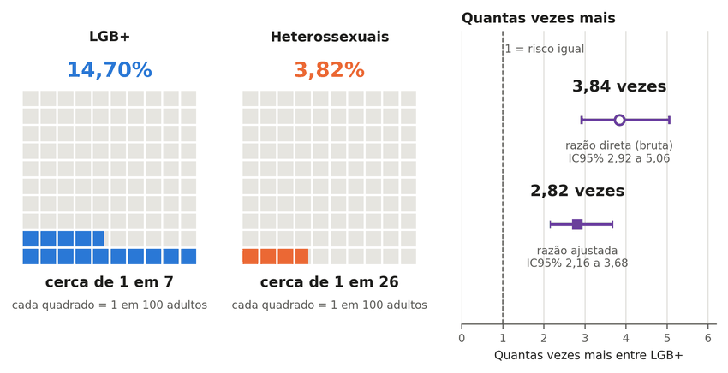
Note. Each grid has 100 squares; the colored squares show how many adults in every 100 experienced physical violence in the past 12 months (blue, LGB+; orange, heterosexual): 14.70% and 3.82%. On the right, the prevalence ratio, where 1 indicates equality: the hollow circle is the crude ratio, 3.84, and the filled square is the ratio adjusted for sex, age, color or race, education, region, and urban or rural residence, 2.82 (95% CI 2.16 to 3.68). Source: IBGE (2022a), 2019 PNS microdata; author’s calculation (this study). Labels in Portuguese: Heterossexuais = heterosexuals; Quantas vezes mais = how many times more; cerca de = about; cada quadrado = each square; igual = equal; razão = ratio; bruta = crude; ajustada = adjusted.
Figure C2
Prevalence ratio of physical violence, sexual violence, and any violence, LGB+ relative to heterosexual adults, crude and adjusted
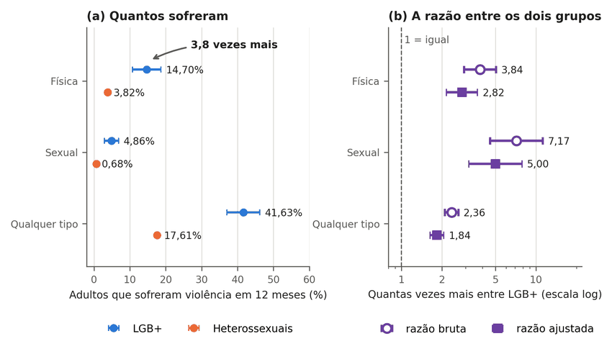
Note. In panel (a), each point is the prevalence of violence in the past 12 months in the group (blue, LGB+ adults; orange, heterosexual adults), with 95% CI. In panel (b), the prevalence ratio between the groups, on a logarithmic scale: the hollow circle is the crude ratio, and the filled square is the adjusted ratio; the dashed line at 1 marks equality between the groups. Source: IBGE (2022a); author’s calculation (this study). Labels in Portuguese: Quantos sofreram = how many experienced it; razão = ratio; meses = months; Quantas vezes mais entre = how many times more among; Heterossexuais = heterosexuals; bruta = crude; ajustada = adjusted.
Age composition alone does not explain the disparity. Although 57% of LGB+ adults are aged 18 to 29, the ratio for physical violence is above 1 in the age groups 18 to 29 (2.93; 95% CI 2.08 to 4.13), 30 to 44 (2.27; 1.37 to 3.76), and 60 or older (5.80; 1.93 to 17.36, with 88 LGB+ respondents and a wide interval); the interval includes 1 only in the 45 to 59 age group (1.61; 0.79 to 3.31) (Table C2). At the context level, among the 179 LGB+ victims of physical violence, the perpetrator was a partner or former partner in 32.9% of cases (heterosexual adults, 37.1%), a family member in 31.2% (19.2%; ratio of 1.62, 95% CI 0.96 to 2.72), and an unknown person in 16.3% (23.0%), and the place was the home in 44.1% (55.2%) (Table C4).
The results refer to adults classified by their answers on sexual orientation in a single edition of the PNS. The survey does not separately identify trans people, does not include minors or homicide, does not ask about the perpetrator’s motivation, and does not allow trends to be estimated (IBGE, 2022b). It therefore supports the victimization disparity (levels N1 and N2), but it does not support the claim that the violence is motivated by sexual orientation (N4), nor that the group dies more, nor any homicide rate. Szwarcwald et al. (2025) address the same topic in the 2019 PNS; the article was read only through its title and abstract, and none of its numbers is used.

Supplementary Results Tables
The tables in this appendix are copied by script from the repository files, with no number typed by hand; only the decimal separator and the category labels change. Table F1 uses the label “B” for the subtraction scenario of the numerator of the Grupo Gay da Bahia (GGB) count, and Table J1 reproduces the speech sample with the rule applied by the original coder, whose comparison with the literal rule of the codebook is in Table J2 (this study).
Table C1
Violence in the past 12 months by sexual orientation, adults, 2019 PNS
outcome | heterosexual | LGB+ | gay or lesbian | bisexual | PR LGB+/​heterosexual [CI] | difference LGB+ − heterosexual (p.p.)
physical | 3.82% [3.57; 4.08] | 14.70% [10.72; 18.67] | 12.85% [8.33; 17.38] | 18.27% [10.59; 25.96] | 3.84 [2.92; 5.06] | +10.9 [+6.9; +14.8]
sexual | 0.68% [0.55; 0.80] | 4.86% [2.87; 6.84] | 2.85% [0.85; 4.85] | 8.58% [4.29; 12.88] | 7.17 [4.57; 11.26] | +4.2 [+2.2; +6.2]
psychological | 16.73% [16.20; 17.26] | 40.03% [35.48; 44.58] | 35.24% [29.89; 40.58] | 48.66% [40.49; 56.82] | 2.39 [2.12; 2.69] | +23.3 [+18.7; +27.9]
any | 17.61% [17.08; 18.15] | 41.63% [37.06; 46.20] | 37.21% [31.77; 42.64] | 49.78% [41.67; 57.89] | 2.36 [2.11; 2.65] | +24.0 [+19.4; +28.6]
Note. Values copied without alteration from the file data/pns/seguro_pns2019.md in the repository; the file uses decimal commas, shown here as decimal points. Source: this study.
Table C2
Physical violence in the past 12 months, LGB+ and heterosexual adults, by subgroup
subgroup | n LGB+ | heterosexual | LGB+ | PR [95% CI] | difference p.p.
Men | 796 | 3.71% [3.38; 4.04] | 13.45% [7.95; 18.95] | 3.62 [2.39; 5.50] | +9.7
Women | 758 | 3.92% [3.53; 4.32] | 15.84% [10.20; 21.47] | 4.04 [2.81; 5.80] | +11.9
Black (Black + brown) | 916 | 4.58% [4.24; 4.92] | 18.48% [12.26; 24.70] | 4.03 [2.87; 5.67] | +13.9
Non-Black | 637 | 2.90% [2.56; 3.23] | 9.81% [6.05; 13.57] | 3.39 [2.27; 5.05] | +6.9
Age 18-29 | 697 | 6.66% [5.97; 7.35] | 19.54% [13.19; 25.90] | 2.93 [2.08; 4.13] | +12.9
Age 30-44 | 506 | 4.28% [3.81; 4.74] | 9.69% [4.94; 14.44] | 2.27 [1.37; 3.76] | +5.4
Age 45-59 | 263 | 3.02% [2.61; 3.43] | 4.87% [1.42; 8.32] | 1.61 [0.79; 3.31] | +1.9
Age 60+ | 88 | 1.49% [1.23; 1.75] | 8.63% [0.00; 17.96] | 5.80 [1.93; 17.36] | +7.1
Low education | 188 | 3.63% [3.24; 4.02] | 26.04% [13.68; 38.40] | 7.18 [4.42; 11.64] | +22.4
Middle education | 669 | 4.41% [4.02; 4.79] | 18.13% [11.43; 24.83] | 4.11 [2.84; 5.96] | +13.7
High education | 697 | 2.93% [2.40; 3.47] | 7.58% [4.46; 10.70] | 2.58 [1.64; 4.06] | +4.6
North region | 256 | 4.17% [3.67; 4.68] | 15.18% [6.76; 23.61] | 3.64 [2.06; 6.41] | +11.0
Northeast region | 458 | 4.25% [3.84; 4.66] | 14.27% [8.15; 20.39] | 3.36 [2.17; 5.21] | +10.0
Southeast region | 403 | 3.55% [3.07; 4.04] | 16.87% [9.54; 24.20] | 4.75 [3.04; 7.42] | +13.3
South region | 232 | 3.65% [3.11; 4.19] | 11.66% [5.84; 17.48] | 3.19 [1.89; 5.40] | +8.0
Central-West region | 205 | 3.89% [3.27; 4.50] | 7.13% [3.21; 11.05] | 1.83 [1.04; 3.24] | +3.2
Urban | 1,427 | 3.96% [3.67; 4.25] | 14.07% [9.99; 18.15] | 3.55 [2.64; 4.77] | +10.1
Rural | 127 | 2.97% [2.57; 3.37] | 23.86% [7.20; 40.51] | 8.02 [4.01; 16.05] | +20.9
Note. Values copied without alteration from the file data/pns/seguro_pns2019.md in the repository; the file uses decimal commas, shown here as decimal points. Black adults are Black and brown (codes 2 and 4 of variable C009, color or race) and non-Black adults are White, Asian, and Indigenous (codes 1, 3, and 5), following the rule in data/pns/seguro_pns2019.py; 1 LGB+ adult has unknown color or race (code 9) and is in neither row, hence 916 + 637 = 1,553 of the 1,554. In the regressions, however, the Black indicator is zero for unknown color or race, which falls in the reference category with non-Black adults. Without the adults of unknown color or race (8 heterosexual and 1 LGB+), the adjusted ratios change by at most 0.02 (Table C12). Source: this study.
Table C3
Prevalence ratio adjusted for sex, age, color or race, education, region, and urban or rural residence
outcome | crude PR | adjusted PR [95% CI]
physical | 3.84 | 2.82 [2.16; 3.68]
sexual | 7.17 | 5.00 [3.17; 7.89]
psychological | 2.39 | 1.87 [1.66; 2.11]
any | 2.36 | 1.84 [1.64; 2.07]
Note. Values copied without alteration from the file data/pns/seguro_pns2019.md in the repository; the file uses decimal commas, shown here as decimal points. Source: this study.
Table C4
Who assaulted and where, among victims of physical violence (context level, nonlethal)
category | heterosexual | LGB+
Who assaulted (V018) | n heterosexual = 3,112 | n LGB+ = 179
Spouse/​live-​in partner | 20.21% [16.29; 24.12] | 5.05% [1.25; 8.85]
Ex-​spouse/​former live-in partner | 12.63% [10.65; 14.61] | 16.17% [2.63; 29.72]
Dating partner/​boyfriend/​girlfriend/​ex | 4.26% [3.27; 5.26] | 11.70% [3.95; 19.45]
Father/​mother/​stepfather/​stepmother | 3.70% [2.38; 5.02] | 13.01% [3.73; 22.28]
Child/​stepchild | 2.81% [2.00; 3.63] | no cases (interval not estimable)
Sibling | 4.71% [3.57; 5.85] | 15.90% [0.23; 31.56]
Other relative | 8.02% [6.28; 9.77] | 2.27% [0.00; 5.12]
Friend/​colleague/​neighbor | 15.15% [12.77; 17.54] | 12.60% [4.25; 20.96]
Employee | 0.38% [0.13; 0.62] | 0.61% [0.00; 1.57]
Employer/boss | 0.73% [0.27; 1.18] | 4.13% [0.00; 10.63]
Unknown person | 23.02% [20.28; 25.77] | 16.29% [8.06; 24.52]
Police officer | 2.19% [1.32; 3.07] | 0.61% [0.00; 1.26]
Other | 2.18% [1.24; 3.12] | 1.67% [0.00; 3.33]
Where (V019) | n heterosexual = 3,112 | n LGB+ = 179
Home | 55.19% [51.79; 58.59] | 44.11% [29.05; 59.18]
Work | 6.52% [5.11; 7.92] | 8.92% [1.03; 16.81]
School/​college | 1.42% [0.73; 2.11] | 2.10% [0.13; 4.07]
Bar/​restaurant | 4.92% [3.72; 6.12] | 9.47% [1.89; 17.05]
Street/public place | 29.05% [26.08; 32.02] | 34.22% [19.68; 48.77]
Other | 2.90% [1.77; 4.04] | 1.18% [0.00; 2.70]
Note. Values copied from the file data/pns/seguro_pns2019.md in the repository, except for the cell with no cases, which appears there as 0.00% [0.00; 0.00]; the file uses decimal commas, shown here as decimal points. Source: this study.
Table C5
Share of LGB+ adults among adult victims of physical violence, direct estimate from the microdata
base | breakdown | victims (n) | LGB+ (n) | % LGB+ | design-based 95% CI (Taylor)
(a) all adult victims | total | 3,440 | 179 | 6.70 | [4.80; 8.60]
(a) all adult victims | 18-29 | 1,123 | 106 | 12.54 | [8.23; 16.84]
(a) all adult victims | 30-44 | 1,229 | 52 | 3.73 | [1.83; 5.64]
(a) all adult victims | 45+ | 1,088 | 21 | 1.46 | [0.57; 2.35]
(a) all adult victims | men | 1,572 | 81 | 6.40 | [3.64; 9.16]
(a) all adult victims | women | 1,868 | 98 | 6.95 | [4.33; 9.58]
(b) heterosexual or LGB+ only (same orientation subset as Sinan) | total | 3,291 | 179 | 7.12 | [5.11; 9.13]
(b) heterosexual or LGB+ only (same orientation subset as Sinan) | 18-29 | 1,047 | 106 | 13.82 | [9.15; 18.50]
(b) heterosexual or LGB+ only (same orientation subset as Sinan) | 30-44 | 1,194 | 52 | 3.85 | [1.89; 5.82]
(b) heterosexual or LGB+ only (same orientation subset as Sinan) | 45+ | 1,050 | 21 | 1.52 | [0.59; 2.45]
(b) heterosexual or LGB+ only (same orientation subset as Sinan) | men | 1,505 | 81 | 6.87 | [3.92; 9.81]
(b) heterosexual or LGB+ only (same orientation subset as Sinan) | women | 1,786 | 98 | 7.34 | [4.58; 10.09]
Note. Values copied without alteration from the file data/pns/c05_razao_direta.csv in the repository; the file uses decimal commas, shown here as decimal points. The % LGB+ column is the ratio of totals weighted by the sampling-design weight; the n columns are unweighted sample counts, and the ratio between them does not reproduce the percentage. Source: this study.

Who Assaulted and Risk by Type of Perpetrator
The analyses in this section were carried out after the results were seen, with the script data/pns/agressor_risco_pns2019.py. Complex survey design; 95% intervals. The PNS does not ask about the perpetrator’s motive or sexual orientation. Victims of physical violence in 12 months: 3,112 heterosexual and 179 LGB+ (sample n).
The six shares published in data/pns/seguro_pns2019.md are reproduced with no discrepancy at a tolerance of 0.01 percentage point.

1. Among Victims of Physical Violence: Who Assaulted (Share, %)
Table C6
Who assaulted, among victims of physical violence (share, %)
Perpetrator | Heterosexual | LGB+ | Difference LGB+ − heterosexual (p.p.) | Is the difference firm?
Partner or ex-partner | 37.10 (33.23 to 40.97) | 32.92 (18.42 to 47.43) | −4.2 (−19.1 to +10.8) | no (the interval includes zero)
Family member | 19.25 (16.79 to 21.70) | 31.17 (15.38 to 46.96) | +11.9 (−4.0 to +27.8) | no (the interval includes zero)
Friend, colleague, or neighbor | 15.15 (12.77 to 17.54) | 12.60 (4.25 to 20.96) | −2.5 (−11.2 to +6.1) | no (the interval includes zero)
Employee, employer, or boss | 1.10 (0.59 to 1.61) | 4.74 (0.00 to 11.31) | +3.6 (−3.0 to +10.2) | no (the interval includes zero)
Known person (all of the above) | 72.60 (69.66 to 75.55) | 81.43 (72.85 to 90.02) | +8.8 (−0.2 to +17.8) | no (the interval includes zero)
Unknown person | 23.02 (20.28 to 25.77) | 16.29 (8.06 to 24.52) | −6.7 (−15.4 to +1.9) | no (the interval includes zero)
Police officer | 2.19 (1.32 to 3.07) | 0.61 (0.00 to 1.26) | −1.6 (−2.7 to −0.5) | yes
Other | 2.18 (1.24 to 3.12) | 1.67 (0.00 to 3.33) | −0.5 (−2.4 to +1.4) | no (the interval includes zero)
Note. “Firm” here means a nominal 95% interval that excludes zero, with no correction for the number of comparisons; the police category rests on 5 LGB+ victims in the sample. Source: IBGE (2022a), PNS 2019 microdata; author’s calculation (this study).

2. Risk in the Population: Adults Physically Assaulted in 12 Months by Each Type of Perpetrator (per 100 Adults)
Table C7
Adults physically assaulted in 12 months, by type of perpetrator (per 100 adults)
Perpetrator | Heterosexual | LGB+ | LGB+/​heterosexual ratio
Partner or ex-partner | 1.42 (1.23 to 1.61) | 4.84 (2.34 to 7.34) | 3.41 (2.01 to 5.79)
Family member | 0.74 (0.63 to 0.84) | 4.58 (1.64 to 7.52) | 6.22 (3.26 to 11.90)
Friend, colleague, or neighbor | 0.58 (0.48 to 0.68) | 1.85 (0.60 to 3.11) | 3.20 (1.59 to 6.42)
Employee, employer, or boss | 0.04 (0.02 to 0.06) | 0.70 (0.00 to 1.67) | 16.52 (3.78 to 72.23)
Known person (all of the above) | 2.78 (2.55 to 3.01) | 11.97 (8.09 to 15.85) | 4.31 (3.10 to 5.99)
Unknown person | 0.88 (0.77 to 0.99) | 2.39 (1.21 to 3.57) | 2.72 (1.63 to 4.53)
Police officer | 0.08 (0.05 to 0.12) | 0.09 (0.00 to 0.18) | 1.07 (0.35 to 3.25)
Other | 0.08 (0.05 to 0.12) | 0.24 (0.01 to 0.48) | 2.93 (1.01 to 8.51)
Note. Source: IBGE (2022a), PNS 2019 microdata; author’s calculation (this study).

3. Adjusted Prevalence Ratio of Physical Violence, Without and With Marital Status
Table C8
Adjusted prevalence ratio of physical violence, without and with marital status
Adjustment | LGB+/​heterosexual ratio | n
sex, age, color, education, region, urban/rural | 2.82 (2.16 to 3.68) | 85913
the same + marital status (married, separated, widowed, single) | 2.65 (2.04 to 3.46) | 85913
the same + spouse or partner lives in the household | 2.64 (2.02 to 3.44) | 85913
Note. Source: IBGE (2022a), PNS 2019 microdata; author’s calculation (this study).
Table C9
Prevalence of physical violence by marital status
Marital status | Heterosexual | LGB+ | n LGB+
married | 2.48 (2.09 to 2.88) | 7.23 (2.15 to 12.31) | 165
separated | 4.66 (3.82 to 5.50) | 9.41 (1.86 to 16.96) | 74
widowed | 2.23 (1.55 to 2.91) | no cases (interval not estimable) | 15
single | 5.43 (5.00 to 5.85) | 15.99 (11.43 to 20.56) | 1300
Note. Source: IBGE (2022a), PNS 2019 microdata; author’s calculation (this study).
Proportion of adults who are single: heterosexual 40.79%, LGB+ 84.91%.
Interpretation: the ratio that remains after any adjustment is not a portion caused by discrimination, nor one caused by “lifestyle”; the data do not separate the two explanations (VanderWeele & Robinson, 2014).

4. Adjusted Risk Ratio by Type of Perpetrator
Outcome: having suffered physical violence in 12 months and having named that type of perpetrator in V018 (one answer per person). Adjusted columns: the first with the same adjustment as the 2.82 ratio; the second with marital status added; the third with spouse or partner in the household added. The n is the same in all three.
Table C10
Adjusted risk ratio by type of perpetrator
Perpetrator | Crude | Adjusted (sex, age, color, education, region, urban/rural) | Adjusted + marital status | Adjusted + spouse in the household | n
Partner or ex-partner | 3.41 (2.01 to 5.79) | 2.50 (1.48 to 4.25) | 2.42 (1.43 to 4.10) | 2.42 (1.44 to 4.07) | 85913
Family member | 6.22 (3.26 to 11.90) | 4.79 (2.58 to 8.90) | 4.43 (2.38 to 8.26) | 4.31 (2.33 to 7.99) | 85913
Friend, colleague, or neighbor | 3.20 (1.59 to 6.42) | 2.12 (1.02 to 4.39) | 1.87 (0.90 to 3.89) | 1.85 (0.89 to 3.83) | 85913
Known person (all of the above) | 4.31 (3.10 to 5.99) | 3.13 (2.28 to 4.29) | 2.93 (2.14 to 4.01) | 2.91 (2.13 to 3.98) | 85913
Unknown person | 2.72 (1.63 to 4.53) | 2.05 (1.22 to 3.45) | 1.93 (1.14 to 3.27) | 1.91 (1.12 to 3.26) | 85913
Note. Source: IBGE (2022a), PNS 2019 microdata; author’s calculation (this study).

5. Who Completed the Violence Module (V00101) and Sample Flow
• the resident themself: n = 21,669; LGB+ among those who declared a heterosexual or LGB+ orientation = 3.51%; physical violence LGB+ 16.74 (10.48 to 22.99), heterosexual 5.21 (4.53 to 5.88); crude ratio 3.21 (2.18 to 4.74); n LGB+ = 677
• interviewer: n = 66,862; LGB+ among those who declared a heterosexual or LGB+ orientation = 1.38%; physical violence LGB+ 12.75 (7.74 to 17.76), heterosexual 3.32 (3.08 to 3.56); crude ratio 3.84 (2.58 to 5.73); n LGB+ = 877
• Adjusted ratio with the mode of completion in the adjustment: 2.68 (2.05 to 3.49); n = 85913
Flow: 88,531 adults answered module V; 85,913 declared a heterosexual or LGB+ orientation (excluded: don’t know 849, refused 1,769, no response 0); analytic n of the adjustment = 85,913 (with age group, education, and region known).

6. Victims in the Sample (Unweighted) by Type of Perpetrator
Criterion for omitting the adjustment by type of perpetrator: fewer than 10 LGB+ victims in the category.
Table C11
Victims of physical violence in the sample (unweighted), by type of perpetrator
Perpetrator | Heterosexual victims | LGB+ victims
Partner or ex-partner | 1163 | 69
Family member | 606 | 33
Friend, colleague, or neighbor | 452 | 23
Employee, employer, or boss | 39 | 5
Known person (all of the above) | 2260 | 130
Unknown person | 726 | 39
Police officer | 66 | 5
Other | 60 | 5
Note. Source: IBGE (2022a), PNS 2019 microdata; author’s calculation (this study).

7. Lives With a Spouse or Partner in the Household (C01001), by Group and Marital Status (Weighted)
• heterosexual: live with a spouse 62.39% (61.73 to 63.05); among those whose marital status is single, 41.36% (40.35 to 42.37); n with a response = 84,359
• LGB+: live with a spouse 29.49% (25.40 to 33.57); among those whose marital status is single, 21.38% (17.47 to 25.29); n with a response = 1,554

8. Adjusted Ratios Without Adults of Unknown Color or Race
In the article’s adjustment, people whose color or race is unknown (C009 = 9) fall into the reference category, together with non-Black respondents: 8 heterosexual and 1 LGB+ adults in the sample. Here they are excluded from the adjustment.
Table C12
Adjusted prevalence ratios with and without adults of unknown color or race
Outcome | Adjusted (as in the article) | Adjusted without unknown color or race | n without unknown color
Physical violence | 2.82 (2.16 to 3.68) | 2.82 (2.16 to 3.68) | 85904
Sexual violence | 5.00 (3.17 to 7.89) | 5.02 (3.18 to 7.92) | 85904
Psychological violence | 1.87 (1.66 to 2.11) | 1.87 (1.66 to 2.11) | 85904
Any violence | 1.84 (1.64 to 2.07) | 1.84 (1.64 to 2.07) | 85904
Physical violence by partner or ex-partner | 2.50 (1.48 to 4.25) | 2.50 (1.48 to 4.25) | 85904
Physical violence by family member | 4.79 (2.58 to 8.90) | 4.79 (2.58 to 8.90) | 85904
Physical violence by friend, colleague, or neighbor | 2.12 (1.02 to 4.39) | 2.12 (1.02 to 4.39) | 85904
Physical violence by known person (all of the above) | 3.13 (2.28 to 4.29) | 3.13 (2.28 to 4.29) | 85904
Physical violence by unknown person | 2.05 (1.22 to 3.45) | 2.05 (1.22 to 3.45) | 85904
Note. Source: IBGE (2022a), PNS 2019 microdata; author’s calculation (this study).
Interpretation: the difference between the two columns is the influence of the coding rule for unknown color or race on the adjusted ratios.

Appendix D — Administrative Records: SUS Forms, Police Reports, Disque 100, and Trajectories

Administrative Records: Health Forms, Police Reports, and Complaints
In the violence notification forms of health services, among 197,779 notifications of interpersonal physical violence against adults in 2023 and 202,416 in 2024, sexual orientation was filled in with a usable value in 75.7%, and among those, homosexual and bisexual people make up 4.12% and 4.08% (DATASUS, 2026b). In the PNS, among adult victims of physical violence who declared a heterosexual or LGB+ orientation, the LGB+ share weighted by the sample design is 7.1% (design-based 95% CI 5.1 to 9.1), with Taylor and jackknife estimates in agreement; in the unweighted sample, the figure is 179 of 3,291 victims, a ratio that does not reproduce the weighted percentage (IBGE, 2022a; Table C5). Both shares lie above the 1.89% that LGB+ people represent in the adult population, but they describe different universes, and neither validates or invalidates the other (Figure D1): the PNS describes victimized people, whether or not they sought a service, and Sinan describes notifications, which depend on whether care was received, on form completion, on possible repetition of the same person, and on an eligibility rule that is not the same for everyone. The Guia de Vigilância em Saúde (Health Surveillance Guide) excludes from notification community or extrafamilial violence against men aged 20 to 59, “except under conditions of vulnerability” (our translation), among which it lists the LGBT population, and it requires notification of homophobic violence at all ages (Ministério da Saúde, 2024, p. 1222); this rule can, by itself, over-represent LGBT+ people on the forms, before any difference in care. The PNS share has a strong age gradient: 13.8% at ages 18 to 29, 3.9% at 30 to 44, and 1.5% above 45.
Figure D1
LGB+ share among adult victims of physical violence in the household survey and in the health-service forms, and in the adult population
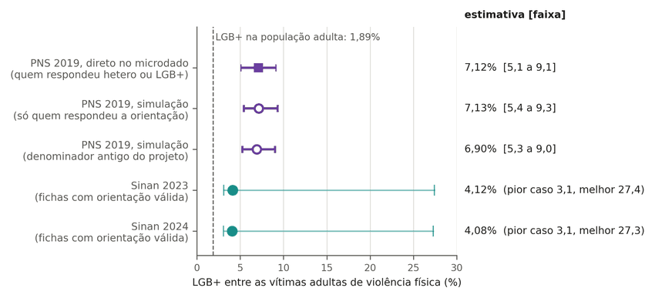
Note. Each line is the LGB+ share among adult victims of physical violence in a different universe: victimized people, whether or not they sought a service, in the PNS, and notifications eligible under the notification rule, in Sinan; the dashed line marks the LGB+ share in the adult population. Both shares lie above the dashed line and differ in magnitude; in Sinan, the thin bar shows the possible range when forms with no recorded orientation are allocated under the worst and the best case. Because the universes and the entry rules differ, one line neither validates nor contradicts the other. Source: IBGE (2022a) and DATASUS (2026b); author’s calculation (this study). Labels in Portuguese: entre as vítimas adultas = among adult victims; violência física = physical violence; estimativa [faixa] = estimate [range]; fichas = forms; pior caso = worst case; melhor = best; direto = directly.
Field 55 of the form, which records the reason for the violence as reported, had no useful information, counting unknown, blank, and “not applicable” together, in 53.4% of the forms not marked as self-inflicted violence in 2015 and in 42.5% to 44.5% from 2023 to 2025; the “not applicable” share stayed stable at about 15%, and LGBTphobia appears as the reason in 0.4% to 0.5% of notifications (Figure D2; DATASUS, 2026b). In the same forms, the share of unknown or blank reasons ranged, in 2023, from 11.0% in Roraima to 54.2% in Mato Grosso do Sul. Sinan makes it possible to describe the notifications and their changes; inferring population victimization requires additional assumptions about eligibility, care, and recording. Marinho Neto et al. (2024) document, for trans people, a municipal notification coverage that rises while the series of notifications falls; the reading that this prevents treating the series as a trend in violence is this article’s, not the authors’.
Figure D2
Composition of the violence-reason field in the notification forms, Sinan, 2015 to 2025
Note. Each column of panel (a) sums to 100% of the year’s notifications not marked as self-inflicted violence; dark gray is the reason field coded unknown or blank, and LGBTphobia, enlarged in panel (b), barely appears. Because the reason has no useful information in 42.5% to 53.4% of the forms, depending on the year, and completion varies across years, the number of cases recorded as LGBTphobia does not measure incidence. In 2025, the reason was unknown or blank in 30% of the forms, and 44.5% when “not applicable” is added; LGBTphobia, in about 0.5%. Source: DATASUS (2026b); author’s calculation (this study). Labels in Portuguese: registrado = recorded; motivo = motive; fatia = share; ampliada = enlarged; LGBTfobia = LGBTphobia; outro = other; não se aplica = not applicable; ignorado = unknown; em branco = blank.
There is no evidence of net agreement between health and police data by state (Figure D3). The Spearman correlation between the state counts of LGBTphobia notifications in Sinan and of police reports in the Anuário (the Anuário Brasileiro de Segurança Pública, the Brazilian Public Security Yearbook) ranges from 0.53 to 0.74 depending on the year and falls when state size is controlled for: the partial correlation lies between 0.14 and 0.32, with a 95% interval that includes zero in every year (pooling the years, 0.20; −0.13 to 0.50; 22 to 23 states per year) (DATASUS, 2026b; FBSP, 2026).
Figure D3
LGBTphobia notifications in Sinan and police reports by state, crude and partial correlation
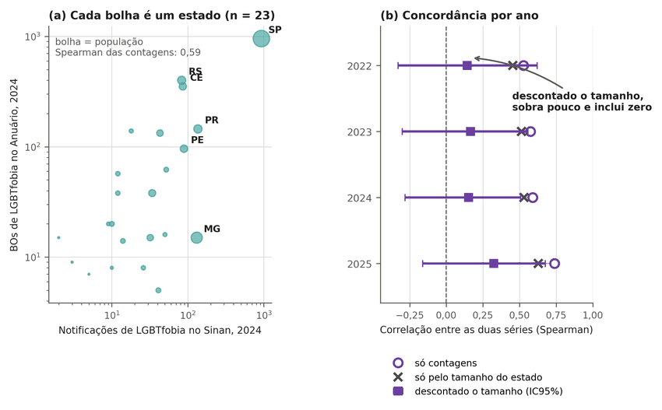
Note. In panel (a), each bubble is a state: the most populous have more records in both sources, and the counts rise together. In panel (b), by year, the open circle is the crude Spearman correlation, the x is the correlation expected from state size alone, and the filled square is the partial correlation after state size is discounted, between 0.14 and 0.32, with a range that includes zero in every year. Source: DATASUS (2026b) and FBSP (2026); author’s calculation (this study). Labels in Portuguese: bolha = bubble; estado = state; Concordância por ano = agreement by year; LGBTfobia = LGBTphobia; só contagens = counts only; tamanho = size; descontado = discounted; duas séries = two series.
The Anuário records 783; 1,633; 2,567; and 3,481 police reports of “racism by homophobia or transphobia” from 2022 to 2025, a 4.4-fold increase; these are records from the state secretariats compiled by a civil-society organization, and no equivalent official national series was located (FBSP, 2026). Each year comes from the most recent edition of the Anuário, which revises its own series: 2023 had 2,090 police reports in the 2024 edition and 1,633 in the 2025 edition, which marks the year as an update of the published information, and 2024 had 2,480 in the 2025 edition and 2,567 in the 2026 edition (this study). The number that reaches the statistics is the violence that exists multiplied by the share of it that someone records; if both grow at the same time, the result rises, and nothing in the number says which of them rose. Under the model of Equation 1 of the article, while p_{t} < 1, the expected recorded series is I₀·p₀·[(1 + g)(1 + h)]^{t}: for a given recorded growth, each growth g in incidence corresponds to a growth h in recording propensity, and a larger g requires a smaller h; the ceiling p_{t} = 1 constrains the projection only after the propensity saturates, which in the fitted scenarios occurs after 2025 (Figure D4). The Anuário itself describes the numbers received as “too low,” with “abnormal variations from one year to the next” (FBSP, 2026). The demonstration has five steps:
1. What is recorded is incidence times the propensity to record: R = I × p (Equation 1, Section 2.3 of the article).
2. If incidence grows by g per year and propensity by h per year, the recorded count grows by a factor of (1+g)(1+h) per year.
3. The series of 783; 1,633; 2,567; and 3,481 police reports (2022 to 2025) is fitted with the same error (sum of squares on the log scale of 0.0472) by three stories: incidence flat and recording growing 63.7% per year (1.00 × 1.637); incidence growing 15% and recording 42.3% (1.15 × 1.423 ≈ 1.636); incidence falling 5% and recording growing 72.3% (0.95 × 1.723 ≈ 1.637) (this study).
4. The product is practically the same, and so is the observed series; the result does not change for p₀ from 0.02 to 0.15 (Figure D4).
5. Only information external to the record fixes p and separates the stories: a victimization survey, a second list for capture-recapture, or a completeness audit (Section 6 of the article; Appendix K).
The result is structural, not a product of the simulation (Figure D4): without an external constraint on the recording propensity, the series alone is compatible with both the sentence “LGBTphobia has skyrocketed” and the sentence “it is just recording” and does not distinguish between the two.
Figure D4
Three trajectories of incidence and recording propensity that produce the same series of police reports for homophobia or transphobia, 2022 to 2025
Note. In panel (a), the diamonds are the recorded police reports, and the three lines are what each trajectory predicts: the lines coincide. Panels (b) and (c) show what each trajectory assumes: stable violence, rising 15% per year, or falling 5% per year, offset by a rising recording propensity. All three reproduce the same observed series, from 783 (2022) to 3,481 (2025); without an external measure, the data do not allow choosing among them. Source: FBSP (2026); author’s simulation (this study). Labels in Portuguese: registrada = recorded; linhas coincidem de propósito = lines coincide deliberately; realmente aconteceu = actually happened; virar = become; milhares = thousands; ao ano = per year.
Disque 100 (federal human-rights hotline) publishes its complaint records in 23 open files, from 2011 to September 2026 (MDHC, 2026). The files come in three formats, and none carries a key that identifies the person: the total number of unique victims cannot be calculated in any year, and what is counted is the record, one file row through 2019 and one complaint from 2021 on (2020 mixes the two units), which also rules out a rate, because the denominator of persons is missing and those who file complaints are not a sample of the population. The channel’s LGBT module totals 1,331 to 4,787 rows per year from 2011 to 2019 and, from 2021 to 2025, 1,367 to 9,346 complaints with at least one row in the module, 1.4% to 1.5% of the channel’s complaints from 2022 to 2025; in 2026 there are 10,461 through September, 1.9% of the channel (Figure D5). Requiring all rows of the complaint to belong to the LGBT module reduces 2025 from 9,346 to 39 complaints. The whole channel nearly tripled over the same period, from 222,000 to 638,000 complaints, and the series has four breaks: the first and second halves of 2020; the second half of 2022, when a new form allows the group to vary within the same complaint; and 2024, when the category for motivation based on orientation or identity ceases to exist on the form, which is not an absence of motivation. More complaints, therefore, do not mean more violence: the series does not separate violence from publicity, new channels, and form changes, and it is one more record whose recording propensity no source measures.
Figure D5
Complaints of the LGBT module and of the whole Disque 100 channel, 2011 to September 2026
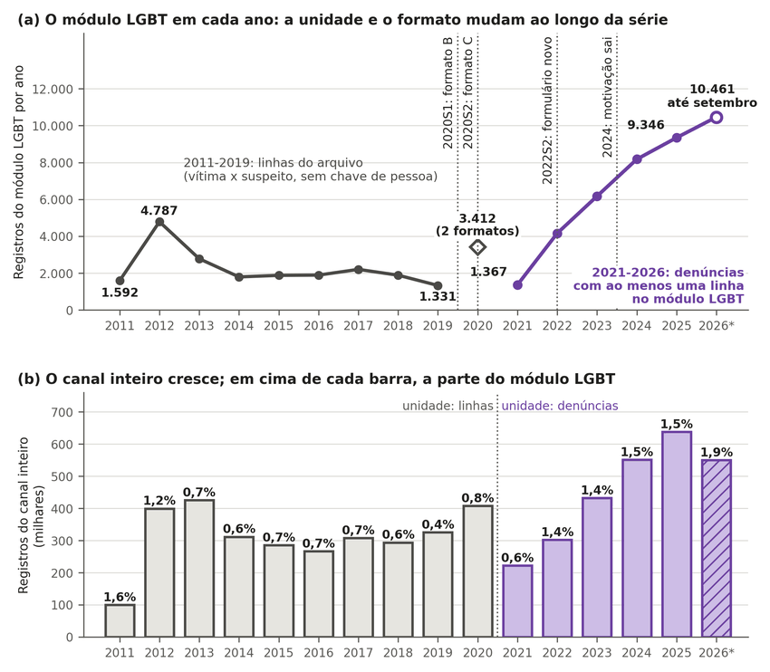
Note. In panel (a), the gray line is the number of rows of the LGBT module in the 2011 to 2019 files (each row is a victim–suspect pair in a call, not a person); the purple line, from 2021 on, counts complaints with at least one row of the module; the diamond is 2020, which mixes two formats. The vertical dotted lines mark changes in the file or form format, across which the series is not continuous. In panel (b), each bar is the whole channel, in the same unit as panel (a), and the number above it is the LGBT module’s share. From 2021 to 2025, the LGBT module went from 1,367 to 9,346 complaints (6.8 times) and the whole channel from 222,000 to 638,000 (2.9 times); 2026 runs through September. More complaints do not indicate more violence. Source: MDHC (2026); author’s count (this study). Labels in Portuguese: ano = year; mudam = change; canal inteiro cresce = whole channel grows; em cima = above; cada barra = each bar; parte = share; Registros = records; milhares = thousands.

Appendix E — Mortality: International Evidence, Positive Control by Sex and Race, Kitagawa

Mortality by Sexual Orientation and Gender Identity
In Brazil, the question cannot be tested with public data. According to the official completion manual, the death certificate form has 59 variables in 9 blocks, and none of them records sexual orientation or gender identity (Ministério da Saúde, 2022, p. 10). The header of the 2023 and 2024 microdata files of the Mortality Information System (SIM) also has no orientation or identity variable, as checked in the file itself (DATASUS, 2026a). Rafael et al. (2024) report the same limitation and show that probabilistic linkage between Sinan (notifiable conditions system) notification forms and SIM deaths in Rio de Janeiro has an accuracy of 93.3%, without producing a population rate. The published national linkage has the same limitation. Luis et al. (2026) matched the Sinan notifications of violence against trans people (36,452 cases from 2014 to 2022, reorganized into individual records) to the SIM and found 1,325 deaths, of which 563 (42.5% of the matched deaths, not of the notifications) were from violent causes, a category that combines homicide, suicide, and undetermined intent. The study population is trans people who had already been the subject of a violence notification, and there is no denominator. The study describes factors associated with violent death within this group, not a rate or a ratio between trans and cisgender people. The matching used name, mother’s name, and date of birth, which the authors obtained by request under a confidentiality agreement, so it cannot be reproduced with open data. Outside Brazil, K. A. Clark and Blosnich (2024) show that 84.5% of the deaths in the U.S. violent death reporting system have sexual orientation missing or unknown.
Outside Brazil, the data published between 2023 and 2026 support excess all-cause mortality in well-defined populations (Table E1 and Figure E1). The ONS (the UK Office for National Statistics) linked the 2021 Census to death records for England and Wales. Between March 21, 2021, and November 30, 2024, among 28,659,465 people aged 16 or older who answered the orientation question themselves (59.0% of people aged 16 or older in the Census; 94.6% of the Census was linked to the National Health Service register and 90.2% of deaths were linked, with post-stratification weights for the linkage loss), the age-standardized all-cause mortality rate was 982.8 per 100,000 in the LGB+ group and 752.6 per 100,000 among heterosexual people, a ratio of 1.31 (95% CI 1.28 to 1.33). For gay and lesbian people the ratio was 1.31 (1.28 to 1.35), for bisexual people 1.33 (1.28 to 1.38), and for gay men alone 1.23 (1.20 to 1.27) (ONS, 2026a). The rates cover the whole period and are not annual. The standardization uses the age distribution of the LGB+ group, which is younger, so the heterosexual rate is the rate heterosexual people would have if they had the age distribution of the LGB+ group. The ONS itself writes that the analysis is descriptive and does not allow one to say whether orientation is a causal factor (ONS, 2026a). In the same design, the standardized suicide rate, which includes deaths of undetermined intent, was 50.3 versus 23.1 per 100,000 between March 2021 and December 2023, about 2.2 times as high (ONS, 2025). Life expectancy at age 20, an experimental estimate without a formal significance test, was 1.2 years lower for LGB+ men (59.4 versus 60.7) and 0.9 years lower for LGB+ women (63.0 versus 64.0). The differences were calculated on unrounded values, in experimental estimates that, according to the ONS itself, tend to overestimate life expectancy (ONS, 2026b).
Table E1
Mortality and violence by sexual orientation or gender identity, Brazilian and international evidence published from 2023 to 2026: population, outcome, measure, and result of each study
Study | Population and country | Outcome | Measure | Result | Source type
ONS (2026a) | aged 16 or older, 2021 Census linked to deaths; England and Wales | all causes | ratio of standardized rates, LGB+/​heterosexual | 1.31 (1.28 to 1.33) | official document
ONS (2025) | same base, 2021 to 2023 | suicide (including undetermined intent) | standardized rates per 100,000 | 50.3 and 23.1 | official document
ONS (2026b) | same base, 2021 to 2024 | all causes | life expectancy at age 20 | −1.2 years (men); −0.9 years (women) | official document; experimental statistics
McKetta et al. (2024) | nurses, United States | all causes | acceleration factor (less than 1 = earlier death) | 0.74 (0.64 to 0.84) | Q1 journal
Erlangsen et al. (2023) | trans people identified through registries, Denmark | all causes; suicide | adjusted rate ratio | 2.0 (1.7 to 2.4); 3.5 (2.0 to 6.3) | Q1 journal
Zachry et al. (2025) | review of 43 studies, several countries | several | count of studies | 14 support, 28 in part, 1 does not | Q1 journal
Luis et al. (2026) | trans people notified in Sinan and matched to the SIM, Brazil | death from violent causes | proportion among matched deaths | 563 of 1,325 (42.5%); no denominator | journal, quartile not checked
McLellan et al. (2026) | trans and gender-​diverse adults, meta-analysis of 94 studies, several countries | lifetime physical or sexual violence, nonfatal; homicide | pooled prevalence | 64.23% (47.38% to 78.17%; 9 studies); no homicide study identified | Q1 journal
Note. The measures are different and are neither added together nor compared on a single risk axis. No row estimates homicide by sexual orientation, and the McLellan et al. (2026) row measures nonfatal violence. The Q1 quartile of McKetta et al. (2024), Erlangsen et al. (2023), and McLellan et al. (2026) was checked under the complementary rule of Appendix B; that of Zachry et al. (2025), under the original rule. Source: studies cited in the first column.
Figure E1
Mortality and violence against LGB+ and trans people, Brazilian and international evidence published from 2023 to 2026, by study and measure
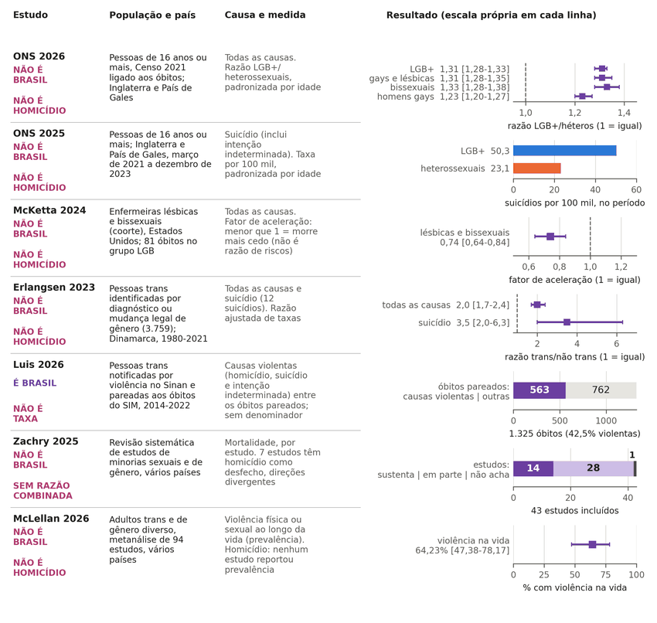
Note. Each row is a study, and each panel has its own scale, because the measures (rate ratio, rate per 100,000, acceleration factor, count of studies, and prevalence) are different and do not form a single risk. The labels in the first column indicate what the study is not: it is not Brazil, it is not homicide, it is not a rate, or it has no pooled ratio. Only the study by Luis et al. (2026) is Brazilian, and it reports no rate, for lack of a denominator. Source: ONS (2025, 2026a, 2026b), McKetta et al. (2024), Erlangsen et al. (2023), Luis et al. (2026), Zachry et al. (2025), and McLellan et al. (2026). Labels in Portuguese: país = country; medida = measure; escala própria = own scale; NÃO É = not; razão = ratio; fator de aceleração = acceleration factor; óbitos = deaths; na vida = lifetime.
Two cohorts in first-quartile journals point in the same direction in narrower populations. Among 90,833 U.S. nurses born from 1945 to 1964, lesbian and bisexual women died earlier, with an adjusted acceleration factor of 0.74 (0.64 to 0.84), a measure of how much earlier death occurs that is neither a risk ratio nor a percentage of life expectancy, based on 81 deaths in the group over 27 years (McKetta et al., 2024). In Denmark, 3,759 trans people identified by hospital diagnosis or legal gender change had an adjusted ratio of 2.0 (1.7 to 2.4) for all-cause mortality and 3.5 (2.0 to 6.3) for suicide, the latter based on 12 suicides, between 1980 and 2021. Administrative identification selects the part of the trans population that reached the hospital or the registry office (Erlangsen et al., 2023). Three recent cohorts of trans people identified through registries, in Australia (Saxby et al., 2026), Taiwan (Hsu et al., 2025), and Sweden (K. D. Clark et al., 2026), read in the text available in HTML, also find excess overall mortality, which in Taiwan disappears in the sibling comparison, except for suicide. The quartiles of these journals were not checked, and the three studies are left out of the verdict. The systematic review by Zachry et al. (2025), read in full text, concludes that no government collects sexual orientation and gender identity at death through a standardized process and that the heterogeneity of definitions prevents a pooled ratio. Of the 43 studies included, 14 support higher mortality in sexual and gender minorities, 28 support it in part (for example, for one cause but not another), and 1 finds no excess. The authors’ synthesis is that the findings, although mixed, suggest elevated mortality.
For homicide, which is the form in which the question circulates in Brazil, none of the sources read produces a population ratio by sexual orientation. This is the result of an enumerated search, not a claim that none exists. The ONS does not publish a homicide rate by orientation. Homicide appears only in the table of leading causes, in the strata where it is among the top ten, and the LGB+ group appears there only among women aged 16 to 24, with 5 deaths, in counts rounded to multiples of five (ONS, 2026a). The meta-analysis by McLellan et al. (2026), with 94 studies published in 137 articles, estimates a prevalence of lifetime physical or sexual violence of 64.23% (9 studies; 47.38% to 78.17%) among trans and gender-diverse adults, but it identified no study reporting a prevalence of homicide. The erratum published in April 2026 swapped the labels of one figure and restored a supplementary figure, without changing the estimates cited. Of the studies in the review by Zachry et al. (2025), 7 have homicide as an outcome, with divergent directions. Lists of documented cases describe victims, not risk. Halliwell et al. (2025) compile 229 documented violent deaths of trans women in the United States between 2013 and 2021, 78.6% of them Black, drawn from organizational databases and from the press, and they state that the sample is not nationally representative. For homicide of trans people, Dinno (2017) obtains rates of 3.66 to 110 per 100,000 depending on the assumed prevalence and undercount, but 8 of 12 risk-ratio scenarios comparing trans and cisgender people fall below 1, with a numerator drawn predominantly from the media. These are scenarios from a single study, not independent studies.
The evidence from before 2023 varies by cause, population, and period. Among men in same-sex marriages in Denmark, the all-cause standardized mortality ratio was 2.25 (2.01 to 2.50) from 1989 to 1995 and 1.33 (1.04 to 1.68) after 1995, with a marriage indicator that covers 1% to 6% of gay men. The excess of deaths fell from 9.63 to 1.53 per 1,000 person-years, a drop that coincides in time with antiretroviral therapy, and the study has no cause-of-death data (Frisch & Brønnum-Hansen, 2009). In the General Social Survey, the risk ratio was 1.04 (0.82 to 1.31) for men, 6.28 (1.45 to 27.22) for suicide among women with a female partner, and 1.29 (0.47 to 3.51) for HIV, with an interval that includes 1 (Cochran & Mays, 2015). Citations also change along the way. McKetta et al. (2026) write that LGB people in the United States are twice as likely to die by suicide and cite Zachry et al. (2025), but the review reports no pooled ratio, and the only 2.18-fold value for suicide in it is the crude rate of a cohort of veterans (82.5 versus 37.7 per 100,000 person-years). The claim that sexual minorities in communities with a high level of prejudice live 12 fewer years comes from a retracted article (Hatzenbuehler et al., 2014). Once the coding was redone, the association with mortality disappears in the full sample and appears only among those who had a same-sex partner in the past year (risk ratio 1.95; 95% CI 1.14 to 3.31; Hatzenbuehler et al., 2020). The appropriate measure of life expectancy, where it exists, shows differences on the order of one year at age 20 (ONS, 2026b).
The verdict depends on the eligibility rule only outside Brazil. Under the original pre-registration rule, the worldwide evidence is Zachry et al. (2025), Frisch and Brønnum-Hansen (2009), Cochran and Mays (2015), and Dinno (2017), and the claim that LGB+ people die at higher rates than heterosexual people is “partial” for all-cause mortality: the review is mixed, although it suggests excess, and the older studies vary by cause and period. With the complementary rule, which admits official data obtained by linkage and the quartile checked on the SCImago pages, the claim becomes “supported” for all-cause mortality in defined populations: people who declared themselves LGB+ in the Census of England and Wales (ONS, 2026a), a cohort of lesbian and bisexual nurses in the United States (McKetta et al., 2024), and trans people identified in registries in Denmark (Erlangsen et al., 2023), with different estimators and without causal identification. The ONS alone is enough to support the change. Under both rules, the claim is not supported as a universal statement, has no population ratio for homicide in any source read, and is not testable in Brazil.

Assault Deaths by Sex and Race: The Level Measured When the Record Contains the Attribute
When the death record contains the attribute, level N1 is measured; the result serves as a positive control for the argument in Section 3.3 of the article, because it shows that the limit for LGBT+ people is the absence of the field, not of the system (DATASUS, 2026a). In the 2022 to 2024 average, the age-standardized assault death rate ranges from 2.6 per 100,000 among non-Black women to 51.7 among Black men (Table E2 and Figure E2); the ratio of men to women is 10.8, and the ratio of Black to non-Black people is 2.56 (2.42 to 2.60, depending on how deaths with unknown race are allocated). The Kitagawa (1955) decomposition attributes 89% to 99% of the crude difference to age-specific rates rather than to age composition. The ordering of the rates is the same in every year from 2012 to 2024 (Table E3); the 2023 and 2024 denominators were extrapolated from the 2022 Census by geometric interpolation (IBGE, 2026), which affects the levels, and sensitivity to alternative denominators was not tested. For race, the residual conditional disparity appears in both studies reviewed, neither of which controls for income and neither of which was published in a first-quartile journal: in Rio de Janeiro in 2010, Black people had 23.5% higher odds of homicide (Cerqueira & Coelho, 2017), and in Brazil in 2022 the odds ratio among deaths ranges from 1.49 to 2.29, measured among those who died and not as population risk (Silva & Pazin-Filho, 2026).
Table E2
Age-standardized assault death rate (ICD-10 X85-Y09), by sex and race, Brazil, 2022 to 2024 average, per 100,000
Group | Standardized rate | Ratio to non-Black women
Non-Black women | 2.6 | 1.0
Black women | 4.3 | 1.7
Non-Black men | 20.0 | 7.7
Black men | 51.7 | 19.9
Note. Standard: population of Brazil in 2022; 2023 and 2024 denominators extrapolated. Descriptive comparison of marginal ratios, not a measure of causal importance. Source: DATASUS (2026a) and IBGE (2026); author’s calculation (this study).
Figure E2
Age-standardized assault death rate, by sex and race, Brazil, 2022 to 2024 average
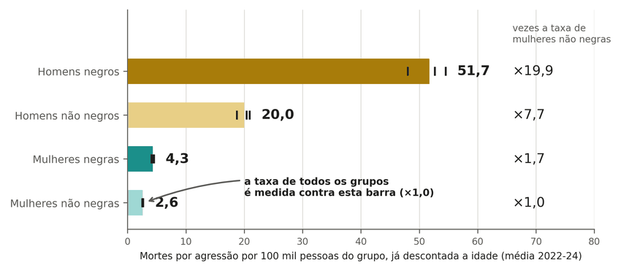
Note. Each bar is the 2022 to 2024 average, and each vertical tick is one of the three years. The right-hand column expresses each group’s rate as a multiple of the rate for non-Black women, taken as the reference: the rate for Black men is 19.9 times that for non-Black women. Populations for 2023 and 2024 estimated from the 2022 Census. Source: DATASUS (2026a) and IBGE (2026); author’s calculation (this study). Labels in Portuguese: Mortes por agressão = assault deaths; já descontada a idade = age-adjusted; vezes a taxa = times the rate; Homens = men; Mulheres = women; negros = Black; não = non.
Table E3
Age-standardized assault death rate, by year, per 100,000
group | 2012 | 2016 | 2020 | 2022 | 2023 | 2024
Brazil | 27.9 [27.6; 28.1] (crude 29.3) | 30.3 [30.0; 30.5] (crude 31.3) | 23.5 [23.3; 23.7] (crude 23.8) | 21.8 [21.6; 22.0] (crude 21.8) | 21.3 [21.1; 21.5] (crude 21.2) | 19.5 [19.3; 19.7] (crude 19.3)
Men | 51.9 [51.5; 52.4] (crude 55.0) | 56.8 [56.4; 57.3] (crude 59.3) | 44.1 [43.6; 44.5] (crude 45.0) | 40.7 [40.3; 41.1] (crude 41.1) | 39.6 [39.2; 40.0] (crude 39.8) | 36.2 [35.9; 36.6] (crude 36.2)
Women | 4.7 [4.6; 4.8] (crude 4.8) | 4.6 [4.4; 4.7] (crude 4.6) | 3.7 [3.6; 3.8] (crude 3.7) | 3.6 [3.5; 3.8] (crude 3.6) | 3.7 [3.6; 3.8] (crude 3.7) | 3.4 [3.3; 3.5] (crude 3.4)
Black people | 38.0 [37.6; 38.3] (crude 41.2) | 41.4 [41.1; 41.8] (crude 44.4) | 32.3 [32.0; 32.6] (crude 34.0) | 29.3 [29.0; 29.6] (crude 30.5) | 28.5 [28.2; 28.8] (crude 29.5) | 25.9 [25.7; 26.2] (crude 26.7)
Non-Black people | 16.5 [16.2; 16.8] (crude 16.7) | 16.6 [16.3; 16.8] (crude 16.5) | 11.8 [11.6; 12.0] (crude 11.5) | 11.4 [11.2; 11.6] (crude 11.0) | 11.1 [10.9; 11.3] (crude 10.6) | 10.2 [10.0; 10.4] (crude 9.7)
Black men | 70.0 [69.3; 70.7] (crude 76.4) | 77.2 [76.4; 77.9] (crude 83.2) | 60.2 [59.5; 60.8] (crude 63.8) | 54.5 [53.9; 55.1] (crude 57.2) | 52.7 [52.1; 53.2] (crude 55.0) | 48.0 [47.5; 48.6] (crude 49.9)
Non-Black men | 30.8 [30.3; 31.3] (crude 31.2) | 31.1 [30.5; 31.6] (crude 31.0) | 21.8 [21.4; 22.3] (crude 21.4) | 20.9 [20.5; 21.3] (crude 20.2) | 20.4 [19.9; 20.8] (crude 19.6) | 18.7 [18.3; 19.1] (crude 17.9)
Black women | 5.9 [5.7; 6.1] (crude 6.2) | 5.8 [5.6; 6.0] (crude 5.9) | 4.6 [4.4; 4.8] (crude 4.7) | 4.4 [4.2; 4.5] (crude 4.5) | 4.5 [4.3; 4.7] (crude 4.6) | 4.1 [3.9; 4.3] (crude 4.2)
Non-Black women | 3.4 [3.2; 3.6] (crude 3.4) | 3.2 [3.1; 3.4] (crude 3.2) | 2.6 [2.4; 2.7] (crude 2.5) | 2.7 [2.5; 2.8] (crude 2.6) | 2.6 [2.5; 2.8] (crude 2.5) | 2.5 [2.4; 2.7] (crude 2.4)
Note. Values copied from the file data/sim/asr_brasil.md in the repository; the file uses decimal commas, shown here as decimal points. Source: this study.
Table E4
Standardized ratios and allocation of unknown race, 2022-2024
ratio | value | remark
men / women (standardized) | 10.8 | rates 38.8 and 3.6 per 100,000
Black / non-Black (standardized, unknown race redistributed) | 2.56 | rates 27.9 and 10.9
Black / non-Black: scenario (unknown race discarded) | 2.56
Black / non-Black: extreme A (all unknown race → Black) | 2.60 | upper bound, the most favorable possible to higher exposure among Black people
Black / non-Black: extreme B (all unknown race → non-Black) | 2.42 | lower bound
Black men / Non-Black women (standardized) | 19.9 | rates 51.7 and 2.6
Non-Black men / Non-Black women (standardized) | 7.7 | rates 20.0 and 2.6
Black women / Non-Black women (standardized) | 1.7 | rates 4.3 and 2.6
Black men / Non-Black men (standardized) | 2.6 | rates 51.7 and 20.0
Note. Values copied from the file data/sim/asr_brasil.md in the repository; the file uses decimal commas, shown here as decimal points. Source: this study.

Appendix F — Grupo Gay da Bahia (GGB) List: Verifiability, Scale, Numerators, and Dependence Among Lists

The Grupo Gay da Bahia Count: Verifiability, Dependence Among Lists, and Scale
The GGB is a civil-society association engaged in LGBT+ activism. Its series of deaths comes from newspaper and internet reports, search alerts, and correspondence, with no systematic verification against police inquiries, forensic medical institute (instituto médico-legal) records, or court cases. Its inclusion criterion is explicitly broad: suicide, robbery-murder (latrocínio), and every trans sex worker killed “on the street” (“na pista”; our translation) are included in the count. The organization itself estimates the LGBT+ population at “more than 10%,” against 1.89% of LGB+ adults in the PNS (GGB, 2026; IBGE, 2022a). The organization acknowledges underreporting. A broad criterion and underreporting coexist, so neither bias is the only one at work. Mendes and Silva (2020), the article that makes the most use of the series, work with data supplied by the GGB and reviewed with a GGB technician, which does not amount to independent validation.
The 2019 validation, the only year with a named list and a source for each case in the annual reports (GGB, 2020), followed the 160 sampled cases through successive steps (Figure F1). For 106 the news article was retrieved, and for 54 it was not, because of a dead link, an inaccessible site, blocking, or a missing link. In 88 the article was about the case itself. In 74 a violent death was confirmed; of the remaining 14, 12 had an unreported cause or unresolved circumstances and 2 were people struck by vehicles with no indication of intent, outside the criterion that the GGB itself declares. Of the 74, 50 expressly identified the victim as LGBT+. The 50 cases (31.3%; Wilson interval 24.6 to 38.8) are the fraction verifiable today, which bounds the total neither from below nor from above. Ten of them match only partially, by city, date, and profile, because the article does not give the victim’s name; with strict matching the fraction is 40 of 160 (25.0%) (this study). Conditional on the source being the article about the case (88 of 160), the verifiable fraction is 56.8% (46.4 to 66.7), and a violent death is confirmed in 84.1% (74 of 88). Among the 74 confirmed violent deaths, the source itself attributes the crime to LGBTphobia in 3 (4.1%; 1.4 to 11.3) and leaves the motive unknown in 36 (48.6%). The absence of any mention of motive does not equate to the absence of bias, and robbery, an intimate relationship, and LGBTphobia can coexist. Duplication amounts to 1 probable pair among 329 cases (0.3%), which does not support the hypothesis of fabrication. The recount of the labels is public; the link between case and source is not reproducible from the repository, because it requires the named list, which is not distributed for privacy reasons (this study). The counts for 2023 to 2025 (257, 291, and 257) have no published named list and are not auditable (GGB, 2026).
Figure F1
Verification steps for the 160 cases sampled from the 2019 Grupo Gay da Bahia list
Note. In panel (a), each bar is the number of cases that passed a verification step, and the text on the right describes those that dropped out; a case with no retrieved article or outside the criterion is a non-verifiable case, not an invented one. In the end, 50 cases (31.3%) are verifiable under the article’s criteria, 40 of them with strict matching. Panel (b) shows, among the 74 confirmed violent deaths, the motive recorded by the source itself (article, police, or family), not by the coder; LGBTphobia appears in 3. No case is identified. Source: GGB (2020); author’s verification (this study). Labels in Portuguese: casos sorteados = sampled cases; todos os critérios = all criteria; motivo = motive; própria fonte registra = source itself records; mortes violentas confirmadas = confirmed violent deaths; matéria = news story.
Capture-recapture is estimable only for trans people in 2019. The Chapman estimate of the total is 186 (175 to 198), and, under the estimator’s assumptions, the GGB’s 118 trans cases correspond to about 63% (60% to 68% by the interval for the total) of that year’s news coverage of deaths of trans people (Feldman et al., 2017). The rule for matching records across the lists matters more than the interval: with strict matching, only by article URL or by two parts of the name, the total rises to 221 and the GGB’s share falls to 53%, and across the six scenarios calculated the total ranges from 151 to 221 and the share from 53% to 69% (this study). The statistical interval does not represent all of the uncertainty: both lists are media-based, positive dependence between them tends to underestimate the total, and lists of this kind yield a lower bound on the true total only when matching is perfect and capture is homogeneous, an assumption that generally does not hold (Lum et al., 2013). The media series are not independent before 2019: the text of the TDoR records cites the GGB in 72% to 94% of the cases from 2013 to 2018 (0.7% in 2019), and ANTRA itself states, in its 2017 dossier, that until 2016 the count of trans people was the GGB’s (Benevides, 2026; this study). Agreement among the GGB, ANTRA, and TDoR in this period repeats the same data collection. Against the SIM, no co-variation of the annual changes is detected (r = 0.20; 95% CI −0.37 to 0.60; 24 years; bootstrap with 20,000 replicates), although from 2017 to 2024 the series fall together (GGB −34.6%, SIM −37.3%, ANTRA −31.8%) (DATASUS, 2026a).
By state, in 2019, the GGB count per million inhabitants rises with the general homicide rate: in a Poisson model that also includes internet access, each additional standard deviation of homicide corresponds to a count 1.33 times higher (95% CI 1.13 to 1.57), and the association with the internet is imprecise, with an interval that includes 1 (0.98; 0.83 to 1.16); the negative correlation between internet and count (ρ = −0.43) no longer holds once homicide enters the model, in which the association with the internet is imprecise (Figure F2; IBGE, 2026; GGB, 2020). This is an association across 27 states in a single year, not causation: the pattern is compatible with a count that tracks violence in general, and it supports neither the reading that the count reflects internet access nor the reading that it measures a violence rate specific to LGBT+ people.
Figure F2
Grupo Gay da Bahia count per million inhabitants and homicide rate, by state, 2019
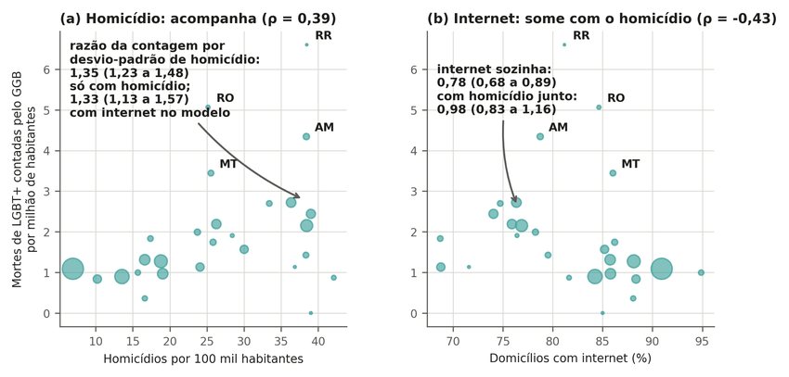
Note. Each bubble is a state, with area proportional to population. In panel (a), states with a higher homicide rate have a higher count: 1.33 times per standard deviation of homicide (95% CI 1.13 to 1.57). In panel (b), the proportion of households with internet is associated with a lower count when it enters the model alone, but the association becomes imprecise (0.98; 0.83 to 1.16) when homicide enters with it. This is an association across 27 states, not causation; 2019 is the only year with state-level data in the repository. Source: GGB (2020), DATASUS (2026a), and IBGE (2026); author’s calculation (this study). Labels in Portuguese: acompanha = tracks; some com o homicídio = vanishes once homicide is included; Mortes = deaths; contadas pelo = counted by; milhão = million; habitantes = inhabitants; Domicílios = households.
The scale test answers a bounded question: if LGB+ adults had the same risk of dying by assault as other people of the same sex, race, and age group, how many deaths would be expected, and what share of them would the GGB count represent (Figure F3)? The calculation follows five steps:
1. LGB+ adults in 2023 are estimated at 1.89% of projected adults, or 3,025,764 people (IBGE, 2022a; IBGE, 2026).
2. In each sex, race, and age-group cell, the assault death rate of the cell’s adults (DATASUS, 2026a) is multiplied by the number of LGB+ adults estimated in it according to the composition of the 2019 PNS; the sum gives 1,122 expected deaths in 2023 and 1,013 in 2024 under risk equal to that of peers.
3. The ratio of declared to expected deaths is 257/1,122 = 22.9% in 2023 and 291/1,013 = 28.7% in 2024 (GGB, 2026).
4. With alternative numerators, numerator A (homicides plus robbery-murders: 221 in 2023 and 269 in 2024) and numerator B, a scenario that subtracts from A all trans people in the identity table (94 and 167), the ratio lies between 8.4% and 19.7% in 2023 and between 16.5% and 26.6% in 2024.
5. If the risk were 2.82 times that of peers, the 2023 expected count would rise to 3,165, and, in both years, the ratio would not exceed 10.2% (Table F1).
Numerator B is not a lower bound, because the GGB includes heterosexuals (6 in 2024), does not cross-tabulate cause by identity, and includes minors. From the published marginal totals, cisgender LGB people within numerator A number between 100 and 118 in 2023 (ratio of 8.9% to 10.5%) and between 164 and 168 in 2024 (16.2% to 16.6%); for example, 269 minus 99 trans people and 6 heterosexuals gives 164, below the 167 of numerator B (Table F2). For the assault cause, with a prevalence of 1.89% and across the years 2023 and 2024 and all scenarios, the ratio under equal risk runs from 8.2% (2023, also excluding the age group up to 18 years; Table F2) to 28.7% (declared total for 2024), and under a risk 2.82 to 3.84 times higher it does not exceed 10.2% (Table F1); adding the undetermined cause, or using the prevalence of 1.96%, the ratios become smaller (Table F1). These ratios do not estimate real coverage, because the risk of death of LGB+ people was not measured, and the prevalence ratio for nonlethal violence does not determine the risk of death. The calculation can be inverted: the count would equal 100% of the expected number only if the risk of LGB+ adults were 0.08 to 0.29 times that of peers, depending on the year and the numerator (RR* = N/E₀, a hypothetical calculation and not an estimate; Figure F4).
Figure F3
Ratio of the Grupo Gay da Bahia count to expected assault deaths, by year, numerator, and assumed risk
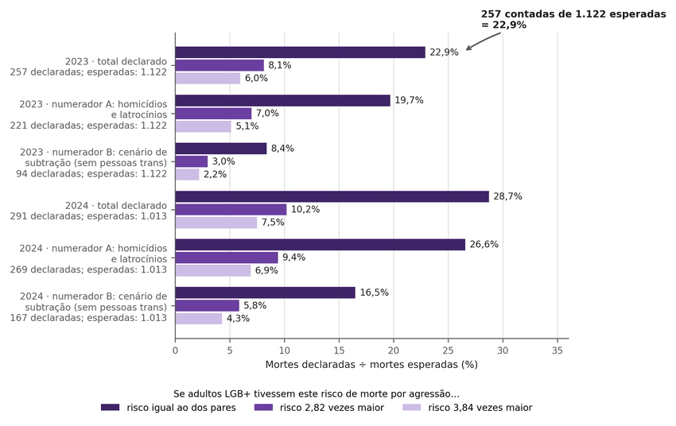
Note. Each group of three bars compares the GGB count with the assault deaths expected if LGB+ adults died by assault at the same rate as people of the same sex, race, and age (equal risk) or 2.82 and 3.84 times more. A short bar indicates a count far from the expected deaths. The ratio measures scale and does not count deaths of LGB+ people; in the scenarios shown, it reaches 28.7% and does not estimate real coverage; numerator B is a subtraction scenario, not a lower bound. Source: GGB (2026), DATASUS (2026a), IBGE (2022a, 2026); author’s calculation (this study). Labels in Portuguese: Mortes declaradas = declared deaths; esperadas = expected; tivessem este risco = had this risk; morte por agressão = assault death; pares = peers; vezes maior = times higher.
Figure F4
Relative risk that would make the Grupo Gay da Bahia count equal the expected deaths
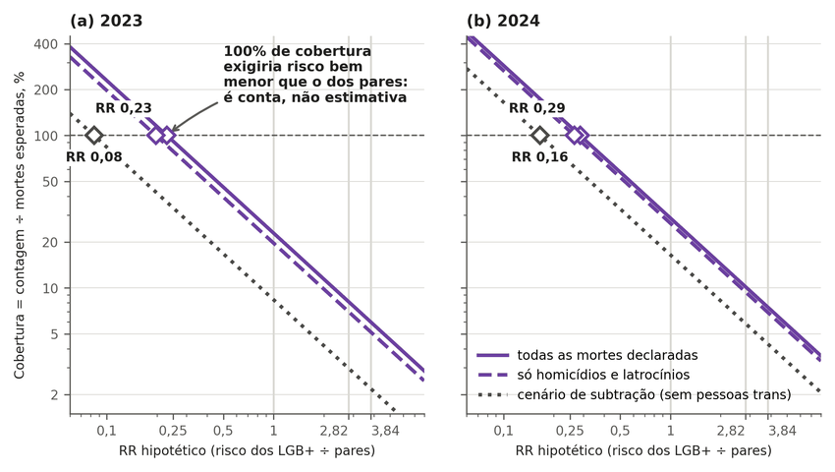
Note. The higher the relative risk assumed for LGB+ adults, the more deaths would be expected and the lower the coverage of the count; on the vertical axis, 100% indicates a count equal to the expected deaths. Each diamond marks the relative risk at which coverage would reach 100%: with the declared total, 0.23 to 0.29 times the risk of peers; in the subtraction scenario, 0.08 and 0.16. This is a hypothetical calculation, worked backward to show the scale, and not an estimate of the risk, which was not measured; the light vertical lines mark risks 1, 2.82, and 3.84. Source: GGB (2026), DATASUS (2026a), IBGE (2022a, 2026); author’s calculation (this study). Labels in Portuguese: Cobertura = coverage; contagem = count; mortes esperadas = expected deaths; pares = peers; declaradas = declared; só = only; latrocínios = robbery-murders; cenário de subtração = subtraction scenario; sem = without.
The ratio cannot be read as an estimate of LGB+ deaths, because the numerator includes minors, who fall outside the adult denominator, heterosexuals included by the GGB, and trans people, whom the 2019 PNS does not identify: trans people who declared an LGB orientation are in the denominator, without identification (IBGE, 2022b). The ratio is inversely proportional to the assumed prevalence: with 3% it falls to 14% and 18% under equal risk, and with 1.35%, the LGB+ fraction among all adults interviewed by another person (Tables 6 and K2; 1.38% among those who declared a heterosexual or LGB+ orientation, Section 3.1 of the article), the highest value in the table would rise to about 40% (28.7% × 1.89/1.35). Three bases for the adult LGB+ population appear in the article, all with the same prevalence of 1.89% and therefore consistent: about 3.01 million using the calibrated weight of the 2019 PNS (Appendix C), 3,025,764 applied to the adults projected for 2023, and 2.92 million applied to the 154.3 million adults in the 2022 Census (IBGE, 2026). For the same reason, the “rate” of 8.8 and 10.0 per 100,000, obtained by dividing the GGB count by 2.92 million LGB+ adults, 2.4 to 3 times lower than the general adult rate (26.4 and 24.2), does not indicate that LGB+ people die at lower rates: it indicates that a media numerator and a population denominator are incompatible.
Table F1
Ratio of the Grupo Gay da Bahia count to expected deaths, by year, numerator, prevalence, and assumed risk
outcome | year | prevalence | numerator | n | expected (RR 1) | ratio RR 1 | RR 2.82 | RR 3.84 | year without SIM (proxy)
assault | 2023 | 1.89% | declared total | 257 | 1,122.2 | 22.9% | 8.1% | 6.0% | no
assault | 2023 | 1.89% | A: homicide + robbery-​murder | 221 | 1,122.2 | 19.7% | 7.0% | 5.1% | no
assault | 2023 | 1.89% | B: subtraction scenario (A without trans people) | 94 | 1,122.2 | 8.4% | 3.0% | 2.2% | no
assault | 2023 | 1.96% | declared total | 257 | 1,161.8 | 22.1% | 7.8% | 5.8% | no
assault | 2023 | 1.96% | A: homicide + robbery-​murder | 221 | 1,161.8 | 19.0% | 6.7% | 5.0% | no
assault | 2023 | 1.96% | B: subtraction scenario (A without trans people) | 94 | 1,161.8 | 8.1% | 2.9% | 2.1% | no
assault | 2024 | 1.89% | declared total | 291 | 1,012.7 | 28.7% | 10.2% | 7.5% | no
assault | 2024 | 1.89% | A: homicide + robbery-​murder | 269 | 1,012.7 | 26.6% | 9.4% | 6.9% | no
assault | 2024 | 1.89% | B: subtraction scenario (A without trans people) | 167 | 1,012.7 | 16.5% | 5.8% | 4.3% | no
assault | 2024 | 1.96% | declared total | 291 | 1,048.4 | 27.8% | 9.8% | 7.2% | no
assault | 2024 | 1.96% | A: homicide + robbery-​murder | 269 | 1,048.4 | 25.7% | 9.1% | 6.7% | no
assault | 2024 | 1.96% | B: subtraction scenario (A without trans people) | 167 | 1,048.4 | 15.9% | 5.6% | 4.1% | no
assault | 2025 | 1.89% | declared total | 257 | 1,014.8 | 25.3% | 9.0% | 6.6% | yes
assault | 2025 | 1.89% | A: homicide + robbery-​murder | 221 | 1,014.8 | 21.8% | 7.7% | 5.7% | yes
assault | 2025 | 1.89% | B: subtraction scenario (A without trans people) | 154 | 1,014.8 | 15.2% | 5.4% | 4.0% | yes
assault | 2025 | 1.96% | declared total | 257 | 1,050.6 | 24.5% | 8.7% | 6.4% | yes
assault | 2025 | 1.96% | A: homicide + robbery-​murder | 221 | 1,050.6 | 21.0% | 7.5% | 5.5% | yes
assault | 2025 | 1.96% | B: subtraction scenario (A without trans people) | 154 | 1,050.6 | 14.7% | 5.2% | 3.8% | yes
assault + undetermined | 2023 | 1.89% | declared total | 257 | 1,297.6 | 19.8% | 7.0% | 5.2% | no
assault + undetermined | 2023 | 1.89% | A: homicide + robbery-​murder | 221 | 1,297.6 | 17.0% | 6.0% | 4.4% | no
assault + undetermined | 2023 | 1.89% | B: subtraction scenario (A without trans people) | 94 | 1,297.6 | 7.2% | 2.6% | 1.9% | no
assault + undetermined | 2023 | 1.96% | declared total | 257 | 1,343.3 | 19.1% | 6.8% | 5.0% | no
assault + undetermined | 2023 | 1.96% | A: homicide + robbery-​murder | 221 | 1,343.3 | 16.5% | 5.8% | 4.3% | no
assault + undetermined | 2023 | 1.96% | B: subtraction scenario (A without trans people) | 94 | 1,343.3 | 7.0% | 2.5% | 1.8% | no
assault + undetermined | 2024 | 1.89% | declared total | 291 | 1,245.0 | 23.4% | 8.3% | 6.1% | no
assault + undetermined | 2024 | 1.89% | A: homicide + robbery-​murder | 269 | 1,245.0 | 21.6% | 7.7% | 5.6% | no
assault + undetermined | 2024 | 1.89% | B: subtraction scenario (A without trans people) | 167 | 1,245.0 | 13.4% | 4.8% | 3.5% | no
assault + undetermined | 2024 | 1.96% | declared total | 291 | 1,288.9 | 22.6% | 8.0% | 5.9% | no
assault + undetermined | 2024 | 1.96% | A: homicide + robbery-​murder | 269 | 1,288.9 | 20.9% | 7.4% | 5.4% | no
assault + undetermined | 2024 | 1.96% | B: subtraction scenario (A without trans people) | 167 | 1,288.9 | 13.0% | 4.6% | 3.4% | no
assault + undetermined | 2025 | 1.89% | declared total | 257 | 1,248.5 | 20.6% | 7.3% | 5.4% | yes
assault + undetermined | 2025 | 1.89% | A: homicide + robbery-​murder | 221 | 1,248.5 | 17.7% | 6.3% | 4.6% | yes
assault + undetermined | 2025 | 1.89% | B: subtraction scenario (A without trans people) | 154 | 1,248.5 | 12.3% | 4.4% | 3.2% | yes
assault + undetermined | 2025 | 1.96% | declared total | 257 | 1,292.6 | 19.9% | 7.1% | 5.2% | yes
assault + undetermined | 2025 | 1.96% | A: homicide + robbery-​murder | 221 | 1,292.6 | 17.1% | 6.1% | 4.5% | yes
assault + undetermined | 2025 | 1.96% | B: subtraction scenario (A without trans people) | 154 | 1,292.6 | 11.9% | 4.2% | 3.1% | yes
Note. Values copied without alteration from the file data/ggb/c08_numeradores.csv in the repository; the file uses decimal commas, shown here as decimal points. Source: this study.
Table F2
Numerator of the Grupo Gay da Bahia count: scenarios compatible with the published marginals
year | scenario | n | expected (RR 1) | ratio RR 1
2023 | A: homicide + robbery-​murder (includes trans and heterosexual people) | 221 | 1,122.2 | 19.7%
2023 | B: subtraction scenario (A minus all trans people in the published table) | 94 | 1,122.2 | 8.4%
2023 | cis LGB within A: minimum compatible with the marginals | 100 | 1,122.2 | 8.9%
2023 | cis LGB within A: maximum compatible with the marginals | 118 | 1,122.2 | 10.5%
2023 | minimum compatible minus the entire age band up to 18 years in the release (age scenario; unreported age is kept) | 92 | 1,122.2 | 8.2%
2024 | A: homicide + robbery-​murder (includes trans and heterosexual people) | 269 | 1,012.7 | 26.6%
2024 | B: subtraction scenario (A minus all trans people in the published table) | 167 | 1,012.7 | 16.5%
2024 | counterexample: 269 - 99 trans (102 - 3 suicides) - 6 heterosexuals | 164 | 1,012.7 | 16.2%
2024 | cis LGB within A: minimum compatible with the marginals | 164 | 1,012.7 | 16.2%
2024 | cis LGB within A: maximum compatible with the marginals | 168 | 1,012.7 | 16.6%
2024 | minimum compatible minus the entire age band up to 18 years in the release (age scenario; unreported age is kept) | 148 | 1,012.7 | 14.6%
Note. Values copied unchanged from the file data/ggb/c08_cenarios_marginais.csv in the repository; the file uses decimal commas, shown here as decimal points. Source: this study.

Agreement in the Check of the 160 Cases From 2019
The check of the 160 sampled cases was coded by a language model (Claude Sonnet 5.5), with a second blinded coder from another model family (Gemini 3.8 Flash) on 23 cases, using the same codebook and with the victims’ names masked. Table F3 gives the agreement by variable (file analysis/ggb-audit/dados/kappa.json in the repository).
Table F3
Agreement between the two coders in the 2019 check (23 cases with double coding)
Variable | Valid pairs | Agreement | Cohen’s κ
Match between news report and case | 23 | 91.3% | 0.64
Violent death confirmed | 21 | 90.5% | 0.46
Type of death | 21 | 85.7% | 0.73
Victim’s LGBT+ status | 21 | 95.2% | 0.91
Basis of LGBT+ identification | 21 | 95.2% | 0.92
Motive | 21 | 90.5% | 0.85
Outcome | 21 | 95.2% | 0.92
Note. Confirmation of violent death is the most fragile item: the 2 disagreements on this variable are cases of a person found dead with no cause reported (one coder marked undetermined cause; the other, violent death); counting all variables, 6 cases had some disagreement. The Wilson interval for the 50 of 160 measures only the uncertainty of the draw, not classification error; it does not apply the finite-population correction (160 of 329 cases), which would narrow it to 26.3% to 36.6% if inference is restricted to the 2019 list. The 23 cases are those with a recovered source among the 32 drawn in advance for double coding. The 6 cases with disagreement were reread by a third blinded coder, from another model family (GPT-6 Astra), with the full news story and without seeing the codes of the first two. The final code is the one assigned by two of the three, checked by the author (file analysis/ggb-audit/dados/adjudicacao.json in the repository). Only one case changes the counts: the person found dead at home, whom the police are investigating as a murder, moves from undetermined cause to homicide, and confirmed violent deaths go from 73 to 74. The 50 verifiable cases do not change, and the agreement in the table remains that of the first two coders.

Critical Checks of the List and Search for Counterpoints
The search looked, in Portuguese, English, and Spanish, for studies, datasets, or counts by authors critical of the LGBT+ movement that challenged the GGB list, the ANTRA dossier, Disque 100, the Atlas da Violência, or the statement that Brazil is the country that kills the most LGBT+ people. The sources searched were the open web, OpenAlex, Crossref, SciELO, and the Biblioteca Digital Brasileira de Teses e Dissertações (Brazilian Digital Library of Theses and Dissertations). The search matrix, the record of each source, and the verification of the identifiers are in analysis/counterpoint/ in the repository.
The only counter-dataset with open data is the check of the 2016 list published by the Liga Humanista Secular do Brasil (Vieira et al., 2019). The authors searched for each name and place, retrieved the news reports, and classified each case by motive, with the criterion “there was homophobic motivation if there are indications of homophobic motivation” (our translation). The public spreadsheet, retabulated by this study, yields Table F4.
Table F4
Classification of motive in the check of the 2016 list (347 cases)
Classification | Cases | % of 347
With an indication of prejudice (“Yes”) | 31 | 8.9%
No indication (“No”) | 127 | 36.6%
Inconclusive | 159 | 45.8%
Not located | 23 | 6.6%
Death abroad | 6 | 1.7%
Duplicate | 1 | 0.3%
Note. Retabulation of the Motivacao_Homof column of the authors’ public spreadsheet, downloaded on 2026-10-30 (SHA-256 0dc25783bfc422ec635826009fbdfbda4efc41ecd7dca0fa05fc469a9179d5ad). The copy is not distributed because it contains the names of victims and of accused persons; the repository keeps the address, the SHA-256, and the tabulation.
Limits of the check:
• Almost all cases have a single reviewer; 3 of the 347 have two, 14 have no recorded reviewer, and there is no measure of agreement.
• The authors’ page treats the sum of “no” and “inconclusive” in the subset of 258 homicides as errors (227, or 88%, versus 31, or 12.0%, with an indication). In the full spreadsheet, of 347 cases including suicides and cases not located, the two categories sum to 286 (82.4%), versus 31 (8.9%) with an indication. Inconclusive is not absence of prejudice, so 8.9% and 12.0% are floors under the authors’ criterion, not estimates of the true fraction.
• One of the authors had already been publishing criticism of the list, and two others founded an agency that produces dossiers. These backgrounds are possible sources of intellectual bias and deserve to be disclosed; there is no documented link between the authors and the production of the list, unlike Mendes and Silva (2020), who worked with data reviewed together with a GGB staff member.
• No GGB response to the check was found.
Earlier and later reviews. An individual author reviewed the 2013 list in a self-published PDF from 2016 (313 deaths, 9 classified by that author as homophobic crime), with no spreadsheet. The figures from 2017 (“6%”) and from the lesbicide dossier (“2 of 126”) that circulate in the press could not be traced to a primary version and were not used. The remaining criticisms found appear in newspaper columns, between 2019 and 2023, and present no dataset of their own. Journalistic fact-checks of the phrase “country that kills the most” classified it as impossible to prove, untenable, or imprecise, and none as false. The comparisons between countries that the search found are all of reported deaths of trans people, drawn from the Trans Murder Monitoring count of the organization Transgender Europe, which, according to the press’s reproduction of its limits, states that it cannot estimate the real number (“Big Data, 331 Deaths”, 2019); in them Brazil leads in absolute numbers but not in the rate per estimated population, and none has coverage and definitions common across countries.
The search found no peer-reviewed article by an author critical of the movement on these statistics, nor any criticism of Disque 100 or the Atlas da Violência from that side. Outside Brazil, it also found no source on that side with its own auditable data on violence or mortality among LGBT+ people; the strongest methodological criticism comes from authors outside that camp (for example, Dinno, 2017). Why this work is lacking in Brazil was not measured: there is no survey of the political positions of Brazilian faculty, and the possible explanations (action through Parliament and the media, lack of research infrastructure, or absence of work on the topic outside activism) were not tested.

Appendix G — Governments and Homicide: Governor Panel, Federal Exposure, and Series by Government

Governor Ideology and Homicides: State Panel and Event Study
The panel estimates associations between the ideology score of the governor’s party and registered overall homicides. None of its outcomes identifies LGBT+ people, and an effect specific to that group might not show up in the aggregate rate (DATASUS, 2026a). Across the 351 state-year combinations, none of the 72 estimated coefficients (five continuous variants of the score and one binary variant, six outcomes, and two versions of party) is distinguishable from zero (this study). In the main specification, the wild-cluster bootstrap p ranges from 0.66 to 0.97 (Table G3). For a change of governor from the Partido dos Trabalhadores (Workers’ Party, PT; score 2.97) to the Democratas or the Partido Liberal (about 8), that is, a 5-point change on the Bolognesi et al. (2023) scale, holding the model’s state and year effects fixed (ceteris paribus), the normal interval runs from −10.8% to +13.1% for the total rate, from −10.1% to +10.5% for women, from −16.3% to +11.3% for Black people, and from −16.2% to +20.4% for firearm deaths (Table G1 and Figure G1). With the inversion of the wild-cluster test, which respects the 27 states, the ranges are −12.3% to +12.4% (total), −12.3% to +10.5% (women), −18.2% to +9.9% (Black people), and −19.5% to +19.7% (firearm). With the t distribution with 26 degrees of freedom, the range for the total is −11.3% to +13.7%. All contain zero. The result is an absence of evidence of a large association between the governor’s party and the registered rate, in either direction. It does not demonstrate an absence of effect: the ranges comprise the values compatible with the data under the model, and associations within them cannot be distinguished from zero with these data. The main specification, party at election as recorded by the TSE and score by period, was chosen after seeing the variants, and all of them give the same result (TSE, 2026; Bolognesi et al., 2025).
Table G1
Governor panel: change in the registered homicide rate associated with a 5-point change in ideology, by three interval methods (%)
Group | Normal (estimate ± 1.96 standard error) | Wild-cluster bootstrap inversion | t with 26 degrees of freedom | Wild p
Total | −10.8 to +13.1 | −12.3 to +12.4 | −11.3 to +13.7 | 0.94
Men | −11.3 to +13.4 | −12.9 to +12.8 | −11.9 to +14.0 | 0.97
Women | −10.1 to +10.5 | −12.3 to +10.5 | −10.5 to +11.0 | 0.95
Black people | −16.3 to +11.3 | −18.2 to +9.9 | −16.9 to +12.1 | 0.66
Non-Black people | −16.1 to +17.3 | −18.2 to +17.0 | −16.8 to +18.3 | 0.91
Firearm | −16.2 to +20.4 | −19.5 to +19.7 | −16.9 to +21.4 | 0.97
Note. 351 state-year combinations, 2012 to 2024; 9,999 resamples, seed 20261024. The ranges vary by outcome, and the range for women is narrower than that for the total. Source: DATASUS (2026a), TSE (2026), and Bolognesi et al. (2023); author’s calculation (this study).
Figure G1
Association between governor ideology and the registered homicide rate, by group: what the panel can rule out
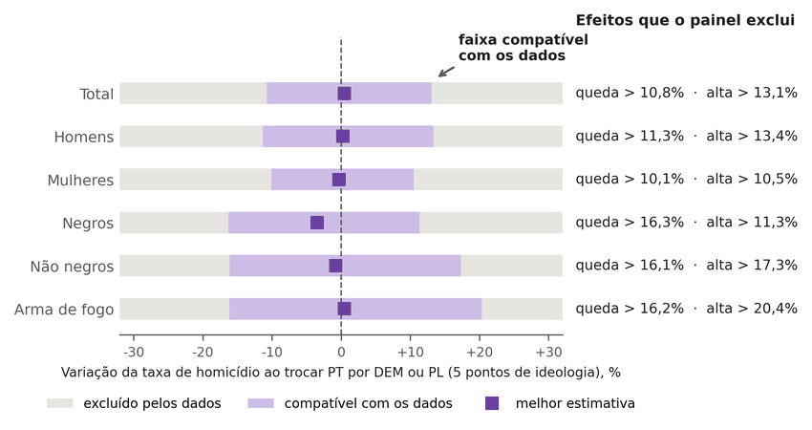
Note. The light bar is the range of associations compatible with the data, from a decline to an increase, and the gray is what the panel rules out. Because all the intervals include zero, the result is an absence of detectable association, not an absence of association: small associations within the light band remain compatible with the data. The figure draws the normal interval (total: −10.8% to +13.1%); with the wild-cluster bootstrap inversion, the total is −12.3% to +12.4% (Table G1). Source: DATASUS (2026a), TSE (2026), and Bolognesi et al. (2023); author’s calculation (this study). Labels in Portuguese: exclui = rules out; Variação da taxa = change in rate; ao trocar = when replacing; pontos = points; excluído = ruled out; dados = data; melhor estimativa = best estimate.
Two tests delimit this reading. The falsification test adds deaths of undetermined cause (Y10-Y34) to assaults. No group is distinguishable from zero (total: a 5-point change gives between −9.1% and +14.0%). Nor is any association detected between ideology and the share of undetermined deaths, 13.4% of the sum of assaults and deaths of undetermined intent (+0.15 percentage point per score point; 95% CI −0.57 to +0.86; wild p 0.68). The range of reclassification bias calculated from this, −4.9% to +3.4%, is conditional on the formula and composition adopted and does not bound all classification bias (Table G3). The ideology residuals are negative in 46.2% of the observations, and the slopes estimated only with the positive-residual observations and only with the negative-residual ones do not differ from zero. This describes the residualization and does not demonstrate an absence of heterogeneous effects (Goodman-Bacon, 2021; Figure G2).
Figure G2
Homicide rate and governor ideology after removing the fixed differences between states and between years
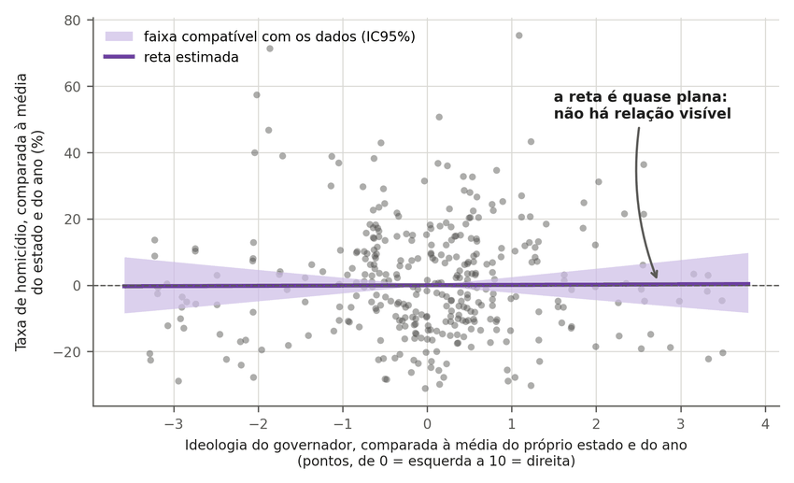
Note. Each point is a state in a year (351 combinations). The horizontal axis shows how far to the right or left of the usual level for that state the governor was, and the vertical axis shows how far above or below the usual level the homicide rate was. The cloud has no direction (slope of 0.0009 per ideology point), and the light band, which admits lines sloping in both directions, indicates that the panel cannot distinguish the slope from zero. Source: DATASUS (2026a), TSE (2026), and Bolognesi et al. (2023); author’s calculation (this study). Labels in Portuguese: faixa = band; dados = data; reta estimada = fitted line; Taxa = rate; comparada = compared; média = average; estado = state; ano = year; esquerda = left; direita = right.
The stacked event study, which compares states that changed governor with states that did not, is inconclusive (Figure G3 and Table G5). After switches in both directions, the registered rate falls relative to controls: −20% for rightward shifts in the score (95% CI −30% to −8%; 9 events) and −19% for leftward shifts (−31% to −4%; 10 events). A shift is any change of party that moves the score, including between parties of the same bloc; the switch between blocs is in Table G7. The anticipation effects, that is, the difference already present before the switch, are distinguishable from zero in two of the four specifications (p = 0.009 and p = 0.028), and the same sign in both directions does not point to an ideology effect. With 10 distinct control states in each direction (15 and 16 states in the set for each analysis), the design cannot separate selection of the controls, prior trend, and the effect of any change of government. The international literature runs into the same recording obstacle at another scale. In the United States, the announcement of the legalization of same-sex marriage is associated with a drop of about 30% in anti-LGBT hate crimes registered per county and quarter, which dissipates within about a year and ceases to be significant when state trends are included (Pettis et al., 2022), and the recognition of unions increases the registered incidence without the authors being able to decide between more violence and more recording (Levy & Levy, 2017). In Brazil, the gap between estimated and registered homicides rose from 1.8 to 2.6 per 100,000 after 2018, which indicates that part of the registered decline may come from worsening recording, a share that was not quantified (IPEA & FBSP, 2025).
Figure G3
Governor panel with and without the undetermined cause (a) and stacked event study by direction of the switch (b)
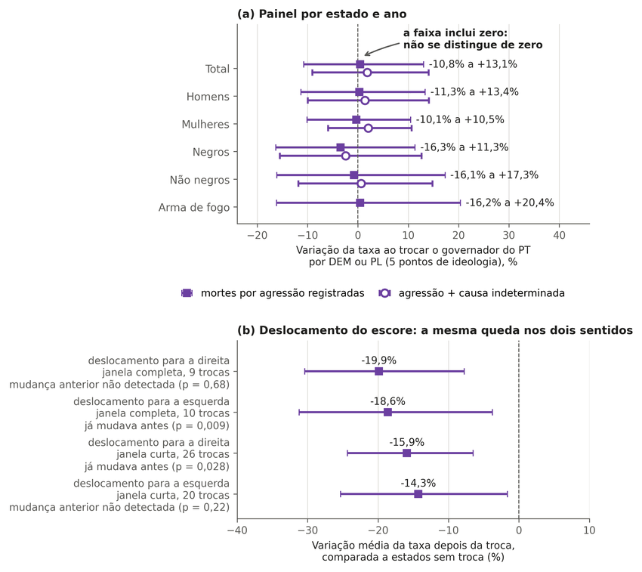
Note. In panel (a), each point is the estimate and the bar is the interval compatible with the data, with and without the undetermined cause; an interval that crosses zero indicates an association not distinguishable from zero (these are the normal intervals of Figure G1). In panel (b), the rate in the years before and after each switch, by direction of the switch: after the switch, the registered rate fell in both directions, and in two of the four analyses the rate was already changing before the switch, which prevents reading the decline as an effect of the governor. Source: DATASUS (2026a) and TSE (2026); author’s calculation (this study). Labels in Portuguese: Deslocamento do escore = score shift; queda = decline; dois sentidos = both directions; Variação = change; taxa = rate; troca = switch; agressão = assault; estado = state; ano = year.

Exposure: What the Homicide Rate Did When the Government Changed
This section describes what the recorded homicide rate did when the government changed; attributing the change to the government is not possible with this design and is not done. The rules were fixed in a pre-registration before any script read the outcomes (Table B2), and the outcomes are homicides in general recorded in the SIM, which does not record sexual orientation, gender identity, or motive (DATASUS, 2026a).
At the federal level, Table G2 and Figure G4 compare the age-standardized national rate in the last full year before each term with that in the last full year within it. The assault rate rose 11.1% under the Dilma Rousseff government (2010 to 2015) and fell 4.2% under the Michel Temer government (2015 to 2018), 21.0% under the Jair Bolsonaro government (2018 to 2022), and 10.6% in the first two years of the third Luiz Inácio Lula da Silva government (2022 to 2024, term in progress). The intervals measure only count uncertainty, not trend or cause. Of assault deaths and deaths of undetermined intent combined, the undetermined share rose from 18.0% in 2018 to 25.9% in 2022 and 30.1% in 2024, and for that reason the decline measured by adding assault and undetermined cause is always smaller (−13.7% under the Bolsonaro government). The trend in the three years before each inauguration is included as descriptive context, not as a counterfactual: the rate had been rising 3.4% before the Temer government, falling 4.2% before the Bolsonaro government, and stable (+0.2%) before the third Lula government. The Lula government of 2007 to 2010 does not appear because the SIM series used begins in 2010, the Census year that anchors the denominators by sex, color, and age, interpolated up to the 2022 Census. The sex and color groups and firearm deaths are in Table G6; under the Bolsonaro government, for example, the rate for Black women fell 22.4% for assault and 6.1% when the undetermined cause is added.
Table G2
National recorded homicide rate (assault, age-standardized, per 100,000) at the start and end of each federal government
Government | Years compared | Rate | Change [count interval] | Adding undetermined cause | Three years before taking office (context)
Dilma Rousseff | 2010 to 2015 | 25.93 to 28.81 | +11.1% [+9.8; +12.5] | +7.9% | not available
Michel Temer | 2015 to 2018 | 28.81 to 27.61 | −4.2% [−5.3; −3.0] | −0.4% | +3.4%
Jair Bolsonaro | 2018 to 2022 | 27.61 to 21.81 | −21.0% [−22.0; −20.0] | −13.7% | −4.2%
Luiz Inácio Lula da Silva (ongoing, 2 of 4 years) | 2022 to 2024 | 21.81 to 19.50 | −10.6% [−11.8; −9.4] | −6.1% | +0.2%
Note. The year 2016 was split between the Dilma Rousseff (until May 11) and Michel Temer governments; 2023 and 2024 denominators were extrapolated from the 2022 Census. A description of what occurred under each government, with no attribution of cause. Source: DATASUS (2026a) and IBGE (2026); author’s calculation (this study).
Figure G4
National recorded homicide rate, age-standardized, 2010 to 2024, by federal government
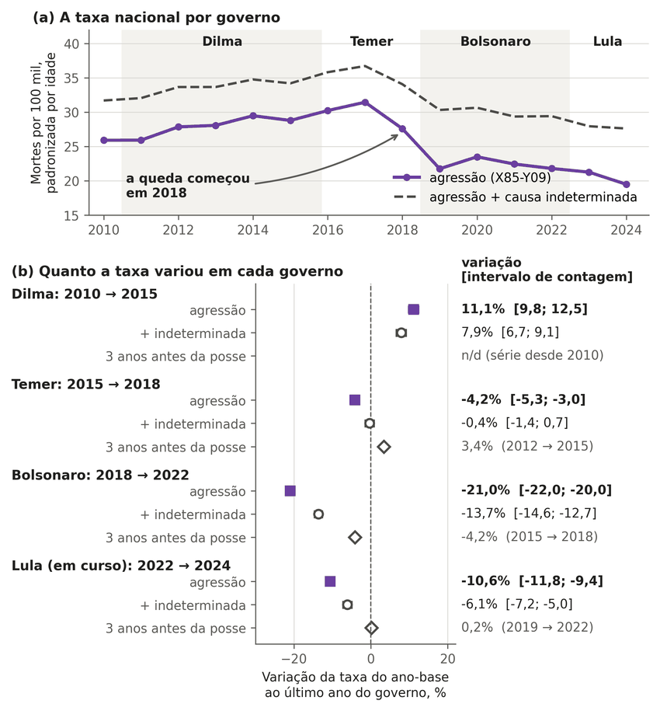
Note. In panel (a), each alternating band, gray or white, is a government, and the line is the rate per 100,000. In panel (b), the square is the change in the rate between the year before taking office and the last full year of the government; the open circle does the same calculation adding deaths of undetermined cause; the diamond shows the trend in the three years before taking office, as context. A 21.0% decline between 2018 and 2022 (13.7% adding the undetermined cause), beginning in 2018. The figure describes what occurred during each government and does not attribute cause; the death certificate does not record sexual orientation. Source: DATASUS (2026a) and IBGE (2026); author’s calculation (this study). Labels in Portuguese: taxa = rate; governo = government; variou = changed; Mortes = deaths; padronizada por idade = age-standardized; ano-base = base year; último ano = final year; agressão = assault; contagem = count.
In the national series from 2010 to 2024, the rate shows an estimated level drop of 17.0% in 2019 (95% CI −29.5% to −2.4%), but the same model with the three breaks shifted one year back, fitted to the whole series, gives −21.8% in 2018 (−37.4% to −2.4%): the estimate depends on the date chosen, and the decline already appears in the observed values, from 31.47 in 2017 to 27.61 in 2018; for that reason it cannot be attributed to the change of president (Figure G5 and Table G8). In 2016 the change was +2.6% (−9.1% to +15.9%), and in 2023, −3.9% (−17.1% to +11.3%); with 15 points and autocorrelation not addressed in the classical standard error, the minimum detectable effects lie between ±15% and ±25%. Adding the undetermined cause, the 2019 decline is 9.6%. In the state panel, the interaction between the governor’s and the president’s ideology scores was not distinguishable from zero (β = −0.00214; wild p = 0.459). For the contrast specified in the protocol, a governor 5 points further to the right and a president moving from the PT to the Partido Social Liberal (PSL), the normal 95% interval corresponds to −18.3% to +9.6%, and with the t distribution with 26 degrees of freedom, to −18.9% to +10.4%; the minimum detectable effect at 80% power, that is, the smallest effect the analysis would see with 80% probability, is −18.9% or +23.3% (Figure G6 and Table G9). The ideological distance between governor and president (−5.4% to +11.1%) and the governor belonging to the same party as the president (−9.8% to +12.5%) are distinct operationalizations, presented separately. The national effect of the Presidency is absorbed by the year fixed effects in the panel, and in the national series the three changes are confounded with the decline that began in 2018, the COVID-19 pandemic, gun policy, criminal factions, and the worsening of death registration (IPEA & FBSP, 2025). Not detecting an association in the specified interaction does not demonstrate that the Presidency does not matter. Under the pre-registered rule, 1 of the 36 cells of the by-group series coincides with the change: Black women in 2019, −19.7% (−30.2% to −7.6%), a pattern that becomes imprecise, with an interval that includes zero, when the undetermined cause is included (−6.1%; −15.3% to +4.1%); with 36 tests, up to about 1.8 cells with an interval excluding zero would be expected by chance if no effect existed, and the rule, which also requires an undetectable placebo, expects fewer than that, and the reading of reclassification or chance is a post hoc interpretation, not a demonstrated mechanism.
Figure G5
Level change in the national homicide rate at each change of president and with the breaks shifted one year back, 2010 to 2024
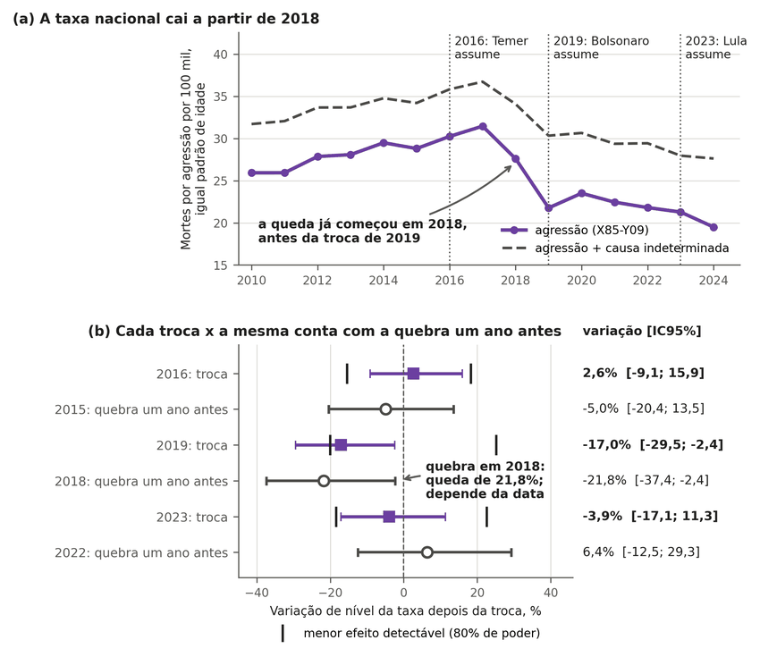
Note. In panel (a), the line is the rate per 100,000, and the dotted lines mark the changes of president. In panel (b), the square is the estimated level change after each change, and the open circle is the same calculation with the breaks shifted one year back and the whole series (date-sensitivity test, called a placebo in the code); a similar decline shows that the estimate depends on the date and does not by itself locate the decline before the change. The vertical ticks mark the minimum detectable effect. The 2019 decline is distinguishable from zero (−17.0%; 95% CI −29.5% to −2.4%; p = 0.030), but the test with the breaks shifted to 2018 also gives a decline (−21.8%; −37.4% to −2.4%), which shows dependence on the date, and the decline already appears in the observed values for 2017 and 2018; for that reason it cannot be attributed to the change; the changes of 2016 and 2023 are not distinguishable from zero, with low power. Source: DATASUS (2026a); author’s calculation (this study). Labels in Portuguese: taxa = rate; cai = falls; troca = switch; conta = calculation; quebra = break; antes = earlier; agressão = assault; padrão = standard; menor efeito detectável = minimum detectable effect.
Figure G6
Interaction between the governor’s ideology and the president’s: estimates and minimum detectable effect
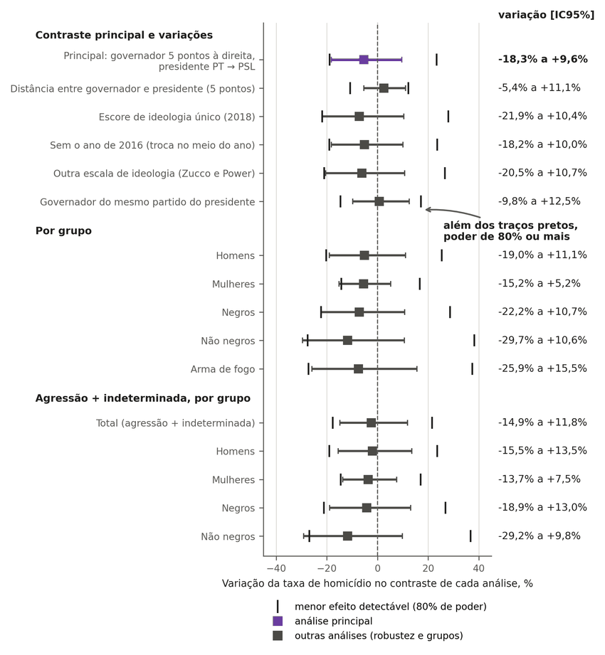
Note. Each square is the estimate, and the bar is the interval compatible with the data; all intervals cross zero (main: −18.3% to +9.6%). The vertical ticks mark the minimum detectable effect, the smallest effect the analysis would detect with 80% probability (−18.9% and +23.3% in the main analysis); smaller effects have a detection probability below 80%, and the bar, not the tick, indicates the values compatible with the data. The effect of the president as such is absorbed by the year effect, and the result does not indicate that the president does not matter. Source: DATASUS (2026a), TSE (2026), and Bolognesi et al. (2023); author’s calculation (this study). Labels in Portuguese: principal = main; Variação = change; Por grupo = by group; Agressão = assault; taxa = rate; menor efeito detectável = minimum detectable effect; poder = power; outras = other.
In the states, across the 67 changes of governor’s party between 2013 and 2024, the change in the state rate minus the national change, between the three years before and the three years after, rose in 31 changes and fell in 36 (median −0.7%; quartiles −9.4% and +12.1%) (Figure G7 and Table G7). The windows lie within 2012 to 2024, with at least one year on each side: 47 of the 67 changes have three years before and three after, and in the 20 changes of 2013, 2014, 2023, and 2024 the window is shorter. In the states with no change in the same year, the reference median lay between +0.8% and +7.8% (95%), with p = 0.016 (0.073 with Holm’s correction for the six groups). The reference uses the same window as each change; with only the 47 complete windows, the relative rate rose in 20 changes and fell in 27 (median −0.8%; reference between +0.8% and +11.0%, 95%; p = 0.008). Adding the undetermined cause, the difference ceases to be distinguishable from the reference: 34 changes rose and 33 fell, median +0.5%, p = 0.54. From left to right, the relative rate rose in 8 of 12 changes (median +9.5%, p = 0.36), and from right to left, in 5 of 8 (median +3.5%, p = 0.74); in both directions, the result is not distinguishable from what occurs in states that did not change government in the same year. The reference is formed by few states (3 to 15 per year; in 2018 and 2019, 9 states, 7 of them in the Northeast) and is not neutral, so a difference may reflect region, and the p-value, which measures only the random draw within that fixed group, is anticonservative; this limitation was observed after the calculation and recorded in a dated addendum to the pre-registration (Appendix B). Overlapping changes in the same state are not independent (DATASUS, 2026a; TSE, 2026).
Figure G7
Change in the state homicide rate relative to Brazil’s across the 67 changes of governor’s party, 2013 to 2024
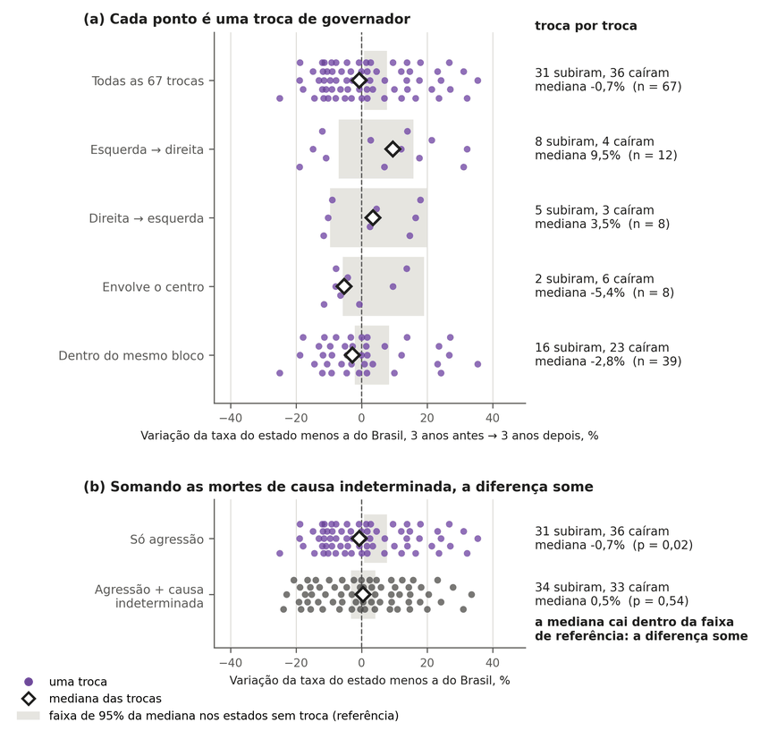
Note. Each dot is a change of governor and indicates whether the state rate, relative to Brazil’s, ended up higher (to the right) or lower (to the left) after it; the diamond is the median of the changes, and the gray band is the interval within which the median would fall by chance in states with no change in the same year. The relative rate rose in 31 changes and fell in 36 (median −0.7%); in panel (b), adding the undetermined cause, the median becomes +0.5% (34 rose, 33 fell) and falls within the reference band. The reference is formed by few states (3 to 15 per year), not neutral ones. A description, not proof of cause. Source: DATASUS (2026a) and TSE (2026); author’s calculation (this study). Labels in Portuguese: ponto = dot; troca = switch; Somando = adding; diferença some = difference disappears; taxa = rate; estado = state; menos = minus; antes = before; depois = after; faixa = band.
Table G3
Governor panel (two-way fixed effects) and falsification test with the undetermined cause
group | outcome | b per point | 95% CI | 5-point change (%) | wild p
total | log recorded rate (X85-Y09) | 0.0009 | [−0.0228; 0.0246] | −10.8 to 13.1 | 0.94
men | log recorded rate (X85-Y09) | 0.0005 | [−0.0240; 0.0251] | −11.3 to 13.4 | 0.97
women | log recorded rate (X85-Y09) | −0.0007 | [−0.0213; 0.0199] | −10.1 to 10.5 | 0.95
Black | log recorded rate (X85-Y09) | −0.0070 | [−0.0356; 0.0215] | −16.3 to 11.3 | 0.66
non-Black | log recorded rate (X85-Y09) | −0.0016 | [−0.0352; 0.0320] | −16.1 to 17.3 | 0.91
firearm | log recorded rate (X85-Y09) | 0.0009 | [−0.0353; 0.0371] | −16.2 to 20.4 | 0.97
total | log assault + undetermined rate | 0.0036 | [−0.0190; 0.0263] | −9.1 to 14.0 | 0.77
total | undetermined share (p.p. per point) | 0.1451 | [−0.5742; 0.8645] | n/a | 0.68
men | log assault + undetermined rate | 0.0027 | [−0.0209; 0.0264] | −9.9 to 14.1 | 0.83
men | undetermined share (p.p. per point) | 0.1323 | [−0.5356; 0.8001] | n/a | 0.69
women | log assault + undetermined rate | 0.0040 | [−0.0122; 0.0203] | −5.9 to 10.7 | 0.64
women | undetermined share (p.p. per point) | 0.1418 | [−0.9092; 1.1928] | n/a | 0.78
Black | log assault + undetermined rate | −0.0050 | [−0.0337; 0.0238] | −15.5 to 12.6 | 0.78
Black | undetermined share (p.p. per point) | 0.1189 | [−0.6291; 0.8669] | n/a | 0.76
non-Black | log assault + undetermined rate | 0.0012 | [−0.0252; 0.0277] | −11.9 to 14.8 | 0.92
non-Black | undetermined share (p.p. per point) | 0.0758 | [−0.8716; 1.0231] | n/a | 0.87
Note. Values copied without alteration from the file data/painel/c02_indet_resultados.csv in the repository; the file uses decimal commas, shown here as decimal points. Source: this study.
Table G4
Governor panel: 5-point change under three interval methods
group | b (SE) | normal (%) | inverted wild (%) | t26 (%) | grid p(0) | wild p (bootstrap)
total | 0.00090 (0.01208) | −10.8 to +13.1 | −12.3 to +12.4 | −11.3 to +13.7 | 0.945 | 0.943
men | 0.00052 (0.01253) | −11.3 to +13.4 | −12.9 to +12.8 | −11.9 to +14.0 | 0.968 | 0.970
women | −0.00067 (0.01052) | −10.1 to +10.5 | −12.3 to +10.5 | −10.5 to +11.0 | 0.946 | 0.951
Black people | −0.00705 (0.01456) | −16.3 to +11.3 | −18.2 to +9.9 | −16.9 to +12.1 | 0.659 | 0.661
non-Black people | −0.00160 (0.01712) | −16.1 to +17.3 | −18.2 to +17.0 | −16.8 to +18.3 | 0.920 | 0.911
firearm | 0.00087 (0.01846) | −16.2 to +20.4 | −19.5 to +19.7 | −16.9 to +21.4 | 0.963 | 0.970
Note. Values copied from the file data/painel/r6_ic_wild_invertido.csv in the repository; the file uses decimal commas, shown here as decimal points. Source: this study.
Table G5
Stacked event study, main panel, four outcomes
design | direction | outcome | events | groups (states) | post-period mean (%) [95% CI] | p anticipation | p post
strict | rightward shift | total | 9 | 15 | −19.9 [−30.4; −7.8] | 0.685 | 0.055
strict | rightward shift | women | 9 | 15 | −19.5 [−29.0; −8.7] | 0.209 | 0.026
strict | rightward shift | Black people | 9 | 15 | −24.7 [−35.1; −12.6] | 0.719 | 0.011
strict | rightward shift | firearm | 9 | 15 | −28.6 [−42.6; −11.1] | 0.715 | 0.061
strict | leftward shift | total | 10 | 16 | −18.6 [−31.2; −3.7] | 0.009 | 0.142
strict | leftward shift | women | 10 | 16 | −20.4 [−34.2; −3.6] | 0.062 | 0.002
strict | leftward shift | Black people | 10 | 16 | −18.7 [−33.1; −1.2] | 0.003 | 0.272
strict | leftward shift | firearm | 10 | 16 | −25.5 [−39.4; −8.5] | 0.002 | 0.064
truncated | rightward shift | total | 26 | 27 | −15.9 [−24.4; −6.5] | 0.028 | 0.031
truncated | rightward shift | women | 26 | 27 | −9.9 [−17.2; −2.0] | 0.573 | 0.073
truncated | rightward shift | Black people | 26 | 27 | −18.7 [−27.5; −8.8] | 0.057 | 0.017
truncated | rightward shift | firearm | 26 | 27 | −23.9 [−35.7; −9.9] | 0.041 | 0.034
truncated | leftward shift | total | 20 | 27 | −14.3 [−25.3; −1.6] | 0.219 | 0.264
truncated | leftward shift | women | 20 | 27 | −16.2 [−27.4; −3.3] | 0.449 | 0.051
truncated | leftward shift | Black people | 20 | 27 | −14.3 [−28.3; 2.4] | 0.571 | 0.455
truncated | leftward shift | firearm | 20 | 27 | −19.7 [−33.0; −3.8] | 0.273 | 0.140
Note. Values copied from the file data/painel/c03_event_pesos_resultados.csv in the repository; the file uses decimal commas, shown here as decimal points. Source: this study.
Table G6
Federal exposure: national standardized rate by administration, group, and outcome
administration | group | outcome | years | rate | change % [count interval] | 3 years before (%)
Dilma Rousseff | Brazil | assault | 2010 to 2015 | 25.93 to 28.81 | +11.1 [+9.8; +12.5] | n/a
Dilma Rousseff | Brazil | assault + undetermined | 2010 to 2015 | 31.72 to 34.22 | +7.9 [+6.7; +9.1] | n/a
Dilma Rousseff | Black women | assault | 2010 to 2015 | 5.43 to 5.67 | +4.5 [−0.9; +10.1] | n/a
Dilma Rousseff | Black women | assault + undetermined | 2010 to 2015 | 7.88 to 8.32 | +5.6 [+0.9; +10.6] | n/a
Dilma Rousseff | Non-Black women | assault | 2010 to 2015 | 3.44 to 3.34 | −2.9 [−9.3; +3.9] | n/a
Dilma Rousseff | Non-Black women | assault + undetermined | 2010 to 2015 | 6.53 to 5.82 | −10.8 [−15.2; −6.2] | n/a
Dilma Rousseff | Black men | assault | 2010 to 2015 | 65.52 to 72.97 | +11.4 [+9.7; +13.0] | n/a
Dilma Rousseff | Black men | assault + undetermined | 2010 to 2015 | 75.49 to 82.96 | +9.9 [+8.4; +11.4] | n/a
Dilma Rousseff | Non-Black men | assault | 2010 to 2015 | 29.12 to 30.26 | +3.9 [+1.4; +6.5] | n/a
Dilma Rousseff | Non-Black men | assault + undetermined | 2010 to 2015 | 36.85 to 36.76 | −0.3 [−2.4; +2.0] | n/a
Dilma Rousseff | Firearm | assault | 2010 to 2015 | 17.81 to 20.44 | +14.7 [+13.1; +16.4] | n/a
Michel Temer | Brazil | assault | 2015 to 2018 | 28.81 to 27.61 | −4.2 [−5.3; −3.0] | +3.4
Michel Temer | Brazil | assault + undetermined | 2015 to 2018 | 34.22 to 34.09 | −0.4 [−1.4; +0.7] | +1.6
Michel Temer | Black women | assault | 2015 to 2018 | 5.67 to 5.62 | −0.9 [−5.8; +4.2] | −3.8
Michel Temer | Black women | assault + undetermined | 2015 to 2018 | 8.32 to 8.48 | +1.9 [−2.4; +6.3] | −3.6
Michel Temer | Non-Black women | assault | 2015 to 2018 | 3.34 to 2.95 | −11.8 [−17.9; −5.2] | −1.5
Michel Temer | Non-Black women | assault + undetermined | 2015 to 2018 | 5.82 to 6.03 | +3.5 [−1.6; +8.9] | −7.7
Michel Temer | Black men | assault | 2015 to 2018 | 72.97 to 70.92 | −2.8 [−4.2; −1.4] | +4.2
Michel Temer | Black men | assault + undetermined | 2015 to 2018 | 82.96 to 82.36 | −0.7 [−2.0; +0.6] | +3.3
Michel Temer | Non-Black men | assault | 2015 to 2018 | 30.26 to 26.10 | −13.8 [−15.9; −11.6] | −1.7
Michel Temer | Non-Black men | assault + undetermined | 2015 to 2018 | 36.76 to 34.60 | −5.9 [−7.9; −3.7] | −3.6
Michel Temer | Firearm | assault | 2015 to 2018 | 20.44 to 20.20 | −1.2 [−2.5; +0.2] | +5.1
Jair Bolsonaro | Brazil | assault | 2018 to 2022 | 27.61 to 21.81 | −21.0 [−22.0; −20.0] | −4.2
Jair Bolsonaro | Brazil | assault + undetermined | 2018 to 2022 | 34.09 to 29.44 | −13.7 [−14.6; −12.7] | −0.4
Jair Bolsonaro | Black women | assault | 2018 to 2022 | 5.62 to 4.36 | −22.4 [−26.3; −18.2] | −0.9
Jair Bolsonaro | Black women | assault + undetermined | 2018 to 2022 | 8.48 to 7.96 | −6.1 [−9.9; −2.1] | +1.9
Jair Bolsonaro | Non-Black women | assault | 2018 to 2022 | 2.95 to 2.68 | −8.9 [−15.7; −1.7] | −11.8
Jair Bolsonaro | Non-Black women | assault + undetermined | 2018 to 2022 | 6.03 to 6.32 | +4.8 [−0.2; +10.1] | +3.5
Jair Bolsonaro | Black men | assault | 2018 to 2022 | 70.92 to 54.49 | −23.2 [−24.3; −22.0] | −2.8
Jair Bolsonaro | Black men | assault + undetermined | 2018 to 2022 | 82.36 to 67.86 | −17.6 [−18.7; −16.5] | −0.7
Jair Bolsonaro | Non-Black men | assault | 2018 to 2022 | 26.10 to 20.91 | −19.9 [−22.1; −17.6] | −13.8
Jair Bolsonaro | Non-Black men | assault + undetermined | 2018 to 2022 | 34.60 to 30.70 | −11.3 [−13.4; −9.2] | −5.9
Jair Bolsonaro | Firearm | assault | 2018 to 2022 | 20.20 to 15.59 | −22.8 [−23.9; −21.6] | −1.2
Luiz Inácio Lula da Silva | Brazil | assault | 2022 to 2024 | 21.81 to 19.50 | −10.6 [−11.8; −9.4] | +0.2
Luiz Inácio Lula da Silva | Brazil | assault + undetermined | 2022 to 2024 | 29.44 to 27.63 | −6.1 [−7.2; −5.0] | −3.0
Luiz Inácio Lula da Silva | Black women | assault | 2022 to 2024 | 4.36 to 4.11 | −5.7 [−10.8; −0.4] | −2.7
Luiz Inácio Lula da Silva | Black women | assault + undetermined | 2022 to 2024 | 7.96 to 7.79 | −2.2 [−6.2; +1.9] | −1.3
Luiz Inácio Lula da Silva | Non-Black women | assault | 2022 to 2024 | 2.68 to 2.51 | −6.6 [−13.9; +1.3] | +3.5
Luiz Inácio Lula da Silva | Non-Black women | assault + undetermined | 2022 to 2024 | 6.32 to 6.44 | +1.9 [−2.9; +6.9] | +4.4
Luiz Inácio Lula da Silva | Black men | assault | 2022 to 2024 | 54.49 to 48.03 | −11.9 [−13.3; −10.4] | −1.5
Luiz Inácio Lula da Silva | Black men | assault + undetermined | 2022 to 2024 | 67.86 to 62.32 | −8.2 [−9.5; −6.8] | −5.6
Luiz Inácio Lula da Silva | Non-Black men | assault | 2022 to 2024 | 20.91 to 18.69 | −10.6 [−13.3; −7.8] | +0.8
Luiz Inácio Lula da Silva | Non-Black men | assault + undetermined | 2022 to 2024 | 30.70 to 29.15 | −5.0 [−7.4; −2.7] | −1.7
Luiz Inácio Lula da Silva | Firearm | assault | 2022 to 2024 | 15.59 to 13.46 | −13.7 [−15.0; −12.3] | +3.0
Note. Values copied from the file figures/fontes/c10_e1_federal.csv in the repository; the file uses decimal commas, shown here as decimal points. Source: this study.
Table G7
State exposure: 67 governor changes, state rate relative to Brazil, by direction and group
direction | group | changes | rose | fell | median % [p25; p75] | 95% reference range for the median | p median | Holm p
all | total | 67 | 31 | 36 | −0.7 [−9.4; +12.1] | +0.8 to +7.8 | 0.016 | 0.073
all | men | 67 | 32 | 35 | −0.5 [−9.9; +12.4] | +0.4 to +6.9 | 0.034 | 0.073
all | women | 67 | 35 | 32 | +0.4 [−8.3; +10.7] | −0.0 to +10.7 | 0.151 | 0.151
all | Black people | 67 | 33 | 34 | −0.1 [−10.1; +12.3] | +1.4 to +8.8 | 0.018 | 0.073
all | non-Black people | 67 | 30 | 37 | −1.4 [−10.7; +9.6] | −0.9 to +9.2 | 0.013 | 0.073
all | firearm | 67 | 28 | 39 | −1.9 [−12.9; +13.9] | −0.9 to +9.8 | 0.012 | 0.073
all | total, assault + undetermined | 67 | 34 | 33 | +0.5 [−10.6; +10.6] | −3.2 to +4.2 | 0.538 | n/a
direction: rightward | total | 38 | 17 | 21 | −0.4 [−10.3; +11.5] | −0.7 to +9.3 | 0.063 | 0.250
direction: rightward | men | 38 | 18 | 20 | −0.3 [−10.0; +10.7] | −1.4 to +9.3 | 0.100 | 0.299
direction: rightward | women | 38 | 20 | 18 | +0.3 [−8.4; +13.1] | −0.4 to +11.3 | 0.271 | 0.299
direction: rightward | Black people | 38 | 18 | 20 | −1.7 [−9.9; +9.8] | −1.3 to +9.2 | 0.048 | 0.241
direction: rightward | non-Black people | 38 | 15 | 23 | −1.8 [−10.3; +5.6] | −3.0 to +9.7 | 0.101 | 0.299
direction: rightward | firearm | 38 | 14 | 24 | −2.9 [−13.1; +8.9] | −2.4 to +11.9 | 0.039 | 0.232
direction: rightward | total, assault + undetermined | 38 | 17 | 21 | −0.4 [−11.8; +12.2] | −4.1 to +4.8 | 0.948 | n/a
direction: leftward | total | 29 | 14 | 15 | −0.8 [−9.0; +13.9] | −2.1 to +11.9 | 0.117 | 0.587
direction: leftward | men | 29 | 14 | 15 | −2.3 [−8.8; +14.2] | −3.2 to +12.5 | 0.089 | 0.532
direction: leftward | women | 29 | 15 | 14 | +2.6 [−7.8; +10.1] | −2.7 to +11.7 | 0.795 | 0.795
direction: leftward | Black people | 29 | 15 | 14 | +0.7 [−10.1; +17.7] | −2.4 to +12.0 | 0.119 | 0.587
direction: leftward | non-Black people | 29 | 15 | 14 | +0.4 [−10.6; +11.4] | −0.9 to +11.3 | 0.284 | 0.596
direction: leftward | firearm | 29 | 14 | 15 | −0.0 [−11.8; +14.5] | −4.1 to +16.1 | 0.199 | 0.596
direction: leftward | total, assault + undetermined | 29 | 17 | 12 | +0.9 [−10.0; +9.0] | −7.3 to +5.8 | 0.682 | n/a
bloc: left to right | total | 12 | 8 | 4 | +9.5 [−11.2; +18.5] | −7.0 to +15.9 | 0.363 | 1.000
bloc: left to right | men | 12 | 8 | 4 | +8.8 [−11.9; +17.3] | −6.3 to +16.6 | 0.422 | 1.000
bloc: left to right | women | 12 | 9 | 3 | +15.0 [−1.9; +17.6] | −3.7 to +16.4 | 0.107 | 0.642
bloc: left to right | Black people | 12 | 8 | 4 | +6.1 [−13.8; +14.5] | −4.2 to +15.2 | 0.632 | 1.000
bloc: left to right | non-Black people | 12 | 6 | 6 | +2.3 [−13.8; +17.2] | −8.5 to +22.9 | 0.998 | 1.000
bloc: left to right | firearm | 12 | 8 | 4 | +11.8 [−16.7; +22.6] | −5.5 to +23.2 | 0.461 | 1.000
bloc: left to right | total, assault + undetermined | 12 | 5 | 7 | −0.3 [−8.2; +14.7] | −7.1 to +10.2 | 0.904 | n/a
bloc: right to left | total | 8 | 5 | 3 | +3.5 [−9.3; +15.1] | −9.6 to +19.9 | 0.742 | 1.000
bloc: right to left | men | 8 | 5 | 3 | +3.0 [−9.3; +17.4] | −9.5 to +20.6 | 0.773 | 1.000
bloc: right to left | women | 8 | 6 | 2 | +10.0 [+0.2; +10.9] | −7.7 to +16.3 | 0.545 | 1.000
bloc: right to left | Black people | 8 | 4 | 4 | +0.6 [−10.6; +10.0] | −8.0 to +18.6 | 0.515 | 1.000
bloc: right to left | non-Black people | 8 | 5 | 3 | +9.5 [−6.2; +22.6] | −8.1 to +32.8 | 0.498 | 1.000
bloc: right to left | firearm | 8 | 4 | 4 | +2.8 [−9.5; +16.4] | −11.6 to +26.7 | 0.783 | 1.000
bloc: right to left | total, assault + undetermined | 8 | 5 | 3 | +2.5 [−6.2; +6.6] | −11.7 to +14.4 | 0.751 | n/a
bloc: involves the center | total | 8 | 2 | 6 | −5.4 [−7.9; +1.9] | −5.8 to +19.1 | 0.058 | 0.208
bloc: involves the center | men | 8 | 2 | 6 | −4.7 [−7.0; +2.1] | −6.6 to +19.7 | 0.105 | 0.208
bloc: involves the center | women | 8 | 2 | 6 | −4.9 [−7.9; −1.8] | −1.8 to +17.5 | < 0.001 | 0.001
bloc: involves the center | Black people | 8 | 3 | 5 | −5.1 [−8.5; +3.4] | −5.2 to +18.9 | 0.052 | 0.208
bloc: involves the center | non-Black people | 8 | 2 | 6 | −11.0 [−15.6; −4.7] | −7.1 to +37.8 | 0.023 | 0.115
bloc: involves the center | firearm | 8 | 3 | 5 | −4.9 [−9.6; +3.3] | −7.6 to +26.7 | 0.086 | 0.208
bloc: involves the center | total, assault + undetermined | 8 | 4 | 4 | +0.9 [−10.5; +11.7] | −8.3 to +11.2 | 0.895 | n/a
bloc: same bloc | total | 39 | 16 | 23 | −2.8 [−9.4; +5.2] | −2.1 to +8.4 | 0.028 | 0.142
bloc: same bloc | men | 39 | 17 | 22 | −2.8 [−9.9; +6.8] | −1.9 to +8.0 | 0.047 | 0.189
bloc: same bloc | women | 39 | 18 | 21 | −0.7 [−11.4; +6.2] | −3.6 to +9.9 | 0.155 | 0.189
bloc: same bloc | Black people | 39 | 18 | 21 | −2.9 [−9.7; +14.3] | −2.4 to +9.2 | 0.021 | 0.128
bloc: same bloc | non-Black people | 39 | 17 | 22 | −1.4 [−7.1; +8.8] | −1.8 to +9.2 | 0.090 | 0.189
bloc: same bloc | firearm | 39 | 13 | 26 | −3.2 [−13.1; +4.6] | −3.5 to +11.8 | 0.054 | 0.189
bloc: same bloc | total, assault + undetermined | 39 | 20 | 19 | +0.5 [−10.8; +10.0] | −7.4 to +4.8 | 0.490 | n/a
Note. Values copied from the file figures/fontes/c10_e2_resumo.csv in the repository; the file uses decimal commas, shown here as decimal points. Source: this study.
Table G8
Change of president: national series, level change at each change of president, and test with the breaks placed one year earlier (full series)
series | outcome | change | level change [95% CI] | break one year earlier (year) [95% CI] | pre-​registered interpretation
Brazil | assault | 2016 | +2.6% [−9.1; +15.9] | −5.0% (2015) [−20.4; +13.5] | not distinguishable from zero
Brazil | assault | 2019 | −17.0% [−29.5; −2.4] | −21.8% (2018) [−37.4; −2.4] | not attributable to the change (the break one year earlier yields the same sign)
Brazil | assault | 2023 | −3.9% [−17.1; +11.3] | +6.4% (2022) [−12.5; +29.3] | not distinguishable from zero
Brazil | assault + undetermined | 2016 | +2.7% [−4.0; +9.8] | −3.5% (2015) [−10.5; +4.1] | not distinguishable from zero
Brazil | assault + undetermined | 2019 | −9.6% [−17.3; −1.2] | −13.2% (2018) [−21.1; −4.5] | not attributable to the change (the break one year earlier yields the same sign)
Brazil | assault + undetermined | 2023 | −3.4% [−11.0; +4.7] | +5.0% (2022) [−3.4; +14.1] | not distinguishable from zero
Black men | assault | 2016 | +3.9% [−9.1; +18.8] | −4.3% (2015) [−20.6; +15.3] | not distinguishable from zero
Black men | assault | 2019 | −17.9% [−31.4; −1.8] | −23.0% (2018) [−39.0; −2.8] | not attributable to the change (the break one year earlier yields the same sign)
Black men | assault | 2023 | −4.9% [−19.2; +11.9] | +4.6% (2022) [−14.8; +28.4] | not distinguishable from zero
Black men | assault + undetermined | 2016 | +3.7% [−4.6; +12.8] | −2.9% (2015) [−11.2; +6.1] | not distinguishable from zero
Black men | assault + undetermined | 2019 | −11.0% [−20.4; −0.4] | −15.9% (2018) [−24.7; −5.9] | not attributable to the change (the break one year earlier yields the same sign)
Black men | assault + undetermined | 2023 | −3.6% [−13.0; +6.7] | +4.8% (2022) [−4.9; +15.6] | not distinguishable from zero
Non-Black men | assault | 2016 | +0.5% [−8.8; +10.8] | −5.0% (2015) [−19.1; +11.6] | not distinguishable from zero
Non-Black men | assault | 2019 | −13.4% [−24.0; −1.4] | −19.5% (2018) [−34.3; −1.5] | not attributable to the change (the break one year earlier yields the same sign)
Non-Black men | assault | 2023 | −2.2% [−13.1; +10.1] | +12.1% (2022) [−6.1; +33.9] | not distinguishable from zero
Non-Black men | assault + undetermined | 2016 | +1.0% [−4.8; +7.1] | −4.2% (2015) [−10.4; +2.5] | not distinguishable from zero
Non-Black men | assault + undetermined | 2019 | −6.4% [−13.4; +1.2] | −9.4% (2018) [−16.8; −1.5] | not distinguishable from zero
Non-Black men | assault + undetermined | 2023 | −2.2% [−8.9; +5.0] | +7.2% (2022) [−0.5; +15.4] | not distinguishable from zero
Black women | assault | 2016 | −0.2% [−10.1; +10.8] | −6.9% (2015) [−22.1; +11.4] | not distinguishable from zero
Black women | assault | 2019 | −19.7% [−30.2; −7.6] | −16.6% (2018) [−33.4; +4.3] | coincides with the change (descriptive; not causal)
Black women | assault | 2023 | +2.5% [−9.8; +16.3] | +7.4% (2022) [−11.8; +30.8] | not distinguishable from zero
Black women | assault + undetermined | 2016 | −0.6% [−8.0; +7.4] | −4.4% (2015) [−11.9; +3.7] | not distinguishable from zero
Black women | assault + undetermined | 2019 | −6.1% [−15.3; +4.1] | −4.7% (2018) [−14.0; +5.6] | not distinguishable from zero
Black women | assault + undetermined | 2023 | −3.0% [−11.7; +6.5] | +2.6% (2022) [−6.2; +12.3] | not distinguishable from zero
Non-Black women | assault | 2016 | −4.3% [−14.0; +6.4] | −7.5% (2015) [−16.8; +2.8] | not distinguishable from zero
Non-Black women | assault | 2019 | −11.5% [−23.2; +2.0] | −13.7% (2018) [−24.4; −1.4] | not distinguishable from zero
Non-Black women | assault | 2023 | −1.9% [−13.8; +11.5] | +12.1% (2022) [−0.1; +25.9] | not distinguishable from zero
Non-Black women | assault + undetermined | 2016 | −0.6% [−5.5; +4.5] | −2.1% (2015) [−8.9; +5.1] | not distinguishable from zero
Non-Black women | assault + undetermined | 2019 | −3.1% [−9.4; +3.6] | +4.9% (2018) [−4.1; +14.7] | not distinguishable from zero
Non-Black women | assault + undetermined | 2023 | −5.2% [−10.8; +0.7] | +1.8% (2022) [−5.9; +10.1] | not distinguishable from zero
Brazil | firearm | 2016 | +4.1% [−10.0; +20.2] | −5.1% (2015) [−24.2; +18.8] | not distinguishable from zero
Brazil | firearm | 2019 | −21.7% [−35.4; −5.0] | −25.6% (2018) [−43.9; −1.4] | not attributable to the change (the break one year earlier yields the same sign)
Brazil | firearm | 2023 | −6.4% [−21.4; +11.6] | +6.9% (2022) [−16.4; +36.9] | not distinguishable from zero
Brazil | share of undetermined deaths (pp) | 2016 | −0.1 pp [−5.5; +5.3] | +1.2 pp (2015) [−7.5; +9.9] | not distinguishable from zero
Brazil | share of undetermined deaths (pp) | 2019 | +6.5 pp [−0.6; +13.7] | +8.3 pp (2018) [−2.6; +19.2] | not distinguishable from zero
Brazil | share of undetermined deaths (pp) | 2023 | +0.4 pp [−6.1; +6.9] | −1.0 pp (2022) [−10.6; +8.6] | not distinguishable from zero
Note. Values copied from the file figures/fontes/c09_d1_resultados.csv in the repository; the file uses decimal commas, shown here as decimal points. Source: this study.
Table G9
Change of president: interaction between the governor’s ideology and the president’s ideology in the panel
analysis | group | outcome | b [95% CI] | effect on the contrast [95% CI] | wild p | minimum detectable effect
main | total | log of the recorded rate | −0.00214 [−0.00786; 0.00357] | −18.3% to +9.6% | 0.459 | −18.9% / +23.3%
S1: ideological distance | total | log of the recorded rate | 0.00497 [−0.01108; 0.02101] | −5.4% to +11.1% | 0.526 | −10.8% / +12.1%
S2: by group | men | log of the recorded rate | −0.00206 [−0.00822; 0.00410] | −19.0% to +11.1% | 0.493 | −20.2% / +25.4%
S2: by group | women | log of the recorded rate | −0.00223 [−0.00642; 0.00197] | −15.2% to +5.2% | 0.289 | −14.3% / +16.6%
S2: by group | Black | log of the recorded rate | −0.00292 [−0.00979; 0.00395] | −22.2% to +10.7% | 0.404 | −22.3% / +28.7%
S2: by group | non-Black | log of the recorded rate | −0.00489 [−0.01370; 0.00392] | −29.7% to +10.6% | 0.265 | −27.6% / +38.2%
S2: by group | firearm | log of the recorded rate | −0.00303 [−0.01168; 0.00562] | −25.9% to +15.5% | 0.480 | −27.2% / +37.4%
S3: assault + undetermined | total | log of the assault + undetermined rate | −0.00096 [−0.00626; 0.00434] | −14.9% to +11.8% | 0.714 | −17.7% / +21.5%
S3: assault + undetermined | men | log of the assault + undetermined rate | −0.00081 [−0.00656; 0.00495] | −15.5% to +13.5% | 0.780 | −19.0% / +23.5%
S3: assault + undetermined | women | log of the assault + undetermined rate | −0.00146 [−0.00575; 0.00282] | −13.7% to +7.5% | 0.481 | −14.5% / +17.0%
S3: assault + undetermined | Black | log of the assault + undetermined rate | −0.00170 [−0.00817; 0.00477] | −18.9% to +13.0% | 0.597 | −21.1% / +26.8%
S3: assault + undetermined | non-Black | log of the assault + undetermined rate | −0.00490 [−0.01342; 0.00363] | −29.2% to +9.8% | 0.249 | −26.9% / +36.7%
S3: share of undetermined deaths | total | share of undetermined deaths (pp) | 0.08777 [−0.04236; 0.21790] | −1.1 pp to +5.6 pp | 0.182 | −4.8 pp / +4.8 pp
S3: share of undetermined deaths | men | share of undetermined deaths (pp) | 0.09641 [−0.01829; 0.21110] | −0.5 pp to +5.4 pp | 0.097 | −4.2 pp / +4.2 pp
S3: share of undetermined deaths | women | share of undetermined deaths (pp) | 0.04378 [−0.22332; 0.31087] | −5.7 pp to +8.0 pp | 0.752 | −9.8 pp / +9.8 pp
S3: share of undetermined deaths | Black | share of undetermined deaths (pp) | 0.09246 [−0.03162; 0.21654] | −0.8 pp to +5.6 pp | 0.141 | −4.6 pp / +4.6 pp
S3: share of undetermined deaths | non-Black | share of undetermined deaths (pp) | 0.00206 [−0.17565; 0.17977] | −4.5 pp to +4.6 pp | 0.986 | −6.5 pp / +6.5 pp
S4: single ideology score | total | log of the recorded rate | −0.00288 [−0.00960; 0.00384] | −21.9% to +10.4% | 0.396 | −21.9% / +28.0%
S5: excluding 2016 | total | log of the recorded rate | −0.00205 [−0.00781; 0.00372] | −18.2% to +10.0% | 0.469 | −19.1% / +23.6%
S6: alternative ideology scale (Zucco and Power) | total | log of the recorded rate | −0.04432 [−0.15908; 0.07045] | −20.5% to +10.7% | 0.450 | −21.0% / +26.6%
S7: same party as the president | total | log of the recorded rate | 0.00738 [−0.10338; 0.11814] | −9.8% to +12.5% | 0.895 | −14.6% / +17.1%
Note. Values copied from the file figures/fontes/c09_d2_resultados.csv in the repository; the file uses decimal commas, shown here as decimal points. Source: this study.

Series by Government Period (Figure 8 of the Article)
Figure 8 of the article is generated by the script data/exposicao/fig_series_por_governo.py. The annual values plotted come from data/sim/asr_brasil.csv, analysis/ggb-series/series/painel_mortes_lgbt.csv, data/disque100/saidas/d100_serie_anual.csv, data/sinan/serie_campo55_uf_ano.csv, and data/anuario/anuario_lgbtfobia_uf_ano_v2.csv. The 2022 total from the Grupo Gay da Bahia (GGB) is derived from the 2023 report.

Appendix H — Symmetric Search of Federal Government Acts, 2003 to 2026

Government Acts Against LGBT+ People in Brazil, 2003 to 2026
The symmetric search applied the same number of queries, the same descriptors, and the same reading rule to the six presidential terms from 2003 to 2026: ten queries per term, five descriptors in Portuguese and in English, 60 in total, with 51 of 55 useful pages read (Table H1). The pre-registered criteria define five types of act: hostile rhetoric by the head of government personally, when the statement ridicules, morally disparages, or attacks homosexuals or LGBT+ people as persons or as a group; omission or policy cut, such as suspension of a program, a funding cut, or documented silence in the face of an event involving LGBT+ people; hostile administrative act, that is, a decree, ordinance, veto, order, or censorship that restricts the rights of LGBT+ people or expressly targets them; persecution or extermination by state agents, such as a police or military operation, mass arrest, institutionalization, or an elimination order, with state authorship attested in a source; and protection or expansion of rights (this study).
Persecution or extermination of LGBT+ people by state agents was not found, within the search space, in any of the six terms; the queries use the name of each president, and state or local agents, such as the police forces, were not inventoried. Omission or policy cut was found in five of the six terms, with 8 episodes, and protection or expansion of rights in four, with 10 episodes. Hostile rhetoric by the head of government and hostile administrative act with an express target each had one episode, both in 2019: the statement of April 25, 2019, reported by journalists who were present and published by the press, with no official transcript found, and the order to suspend funding for films and scripts with LGBT+ themes, from August 2019, reported after a statement on a live broadcast and classified, within the 60 queries, on the basis of the news report rather than the normative instrument, which was read later (Ministério da Cidadania, 2019; Table H1). The pre-registered reading rule, which requires an episode of hostility or omission in governments on both sides of the ideological scale in order to conclude that the list exists on both sides, is met by the omission or cut episodes.
Table H1
Episodes found in the symmetric search of government acts, by presidential term and type of act, 2003 to 2026
Term | Queries | Useful pages read / selected | Pages published during the term | Hostile rhetoric by the head of government | Omission or policy cut | Hostile administrative act | Persecution or extermination | Protection or expansion
Lula, 1st term (2003 to 2006) | 10 | 6/8 | 0/6 | 0 | 0 | 0 | 0 | 1
Lula, 2nd term (2007 to 2010) | 10 | 7/8 | 1/7 | 0 | 1 | 0 | 0 | 5
Dilma Rousseff (2011 to 2016) | 10 | 10/10 | 6/10 | 0 | 2 | 0 | 0 | 3
Michel Temer (2016 to 2018) | 10 | 8/9 | 6/8 | 0 | 2 | 0 | 0 | 0
Jair Bolsonaro (2019 to 2022) | 10 | 10/10 | 7/10 | 1 | 2 | 1 | 0 | 0
Lula, 3rd term (2023 to 2026) | 10 | 10/10 | 3/10 | 0 | 1 | 0 | 0 | 1
Total | 60 | 51/55 | 23/51 | 1 | 8 | 1 | 0 | 10
Note. Hostile rhetoric by a minister or ally was counted separately, with zero episodes in all terms; the queries were designed for the head of government, not for ministers, and this zero is a limit of the search space, not an absence of episodes. Two episodes of doubtful classification as omission (one in the Temer government and one in the Bolsonaro government) are not included in the total. The classification of the rhetoric and hostile-act episodes comes from the press; the instrument of the 2019 act was read later in the Diário Oficial (official gazette), and its text does not mention LGBT content (Ministério da Cidadania, 2019). The search engine’s coverage is uneven over time: only 1 of the 13 useful pages on Lula’s first two terms was published during the term, and the absence of hostility in those years is a limit of the search space, not proof of equivalence. Source: pre-registered search (Table B2), with the web address, excerpt, and SHA-256 of each episode in the repository (this study).

Reading the Acts by Period of Government
The data for 2003 to 2026 also do not support the claim that federal governments persecuted LGBT+ people. The search used the same 60 queries for the six periods of government, and the reading covered 51 useful pages (Table H1). Each finding was classified as persecution, hostile official act, hostile statement by the president, omission or policy cut, or protection. No case of police persecution, mass arrest, or extermination ordered by the federal government appeared. Because the queries used the name of each president, actions by state and municipal police forces were left out. Omissions or policy cuts totaled 8 cases in 5 terms, half in PT governments and half outside them.
Nor does the evidence support the claim that the federal Executive’s protection was equal across parties. Within the space of these 60 queries, the 10 episodes classified as protection or expansion of rights all fell in the 4 PT periods of government (Table H1). The classification had a single coder and is indicative. The search, however, started from the president’s name in the press, whose digital coverage differs across eras, and so it does not measure the size of the difference. In the opposite direction, the search found one hostile statement by the president and one hostile official act, both in 2019. The act is Portaria nº 1.576, an ordinance of the Ministério da Cidadania (Ministry of Citizenship), dated August 20, 2019, read in the Diário Oficial after the search (Ministério da Cidadania, 2019). The text suspends the entire call for proposals for public TV stations for 180 days in order to reconstitute the steering committee and does not mention LGBT content. The hostile character comes from the president’s statements and from press coverage, which also reported the lawsuit filed by the Ministério Público Federal (Federal Prosecution Service) and the preliminary ruling that upheld it (Table H1).

Appendix I — Regimes: Complete Table

State Violence Against Homosexual People in Regimes of Different Types
The same severity scale applies to regimes of any political orientation: the pre-registration for the analysis of governments classifies as level 3 imprisonment, internment, or forced labor documented by an international body, a court, or an official report (this study). The level measures the type of document that records the act, not the certainty of the fact or the originality of the investigation. The version of Hypothesis 6 that holds persecution to be specific to a single type of regime circulates in Parliament: of the 33 statements in family F3 that assert persecution, 10 attribute it to foreign regimes or groups (Appendix J; this study). Official documents and academic research record state persecution of homosexual people under opposing political labels, including in democracies, and the cases gathered in Table I1 are illustrative, not a sample of the world. In Nazi Germany, there were about 100,000 arrests and 5,000 to 15,000 men sent to concentration camps (United States Holocaust Memorial Museum, 2021); in the territory of former West Germany, by then democratic, an estimate of about 64,000 convictions between 1949 and 1994 was adopted in a federal government bill (Deutscher Bundestag, 2017). For the Brazilian military dictatorship (1964 to 1985), the Comissão Nacional da Verdade (National Truth Commission) records dismissals, censorship, and police operations, such as the 1980 sweeps in downtown São Paulo against travestis, prostitutes, and homosexual people; it writes that the regime’s ideology “clearly contained a homophobic perspective, which linked homosexuality to the left and to subversion” (our translation) and adds the caveat that “there was no formalized State policy” of extermination (Comissão Nacional da Verdade, 2014, pp. 301, 307). In Franco’s Spain, the 1970 social dangerousness law provided for internment for re-education; acts of homosexuality were removed from that law in January 1979, and the persecution was recognized in the 2022 democratic memory law (España, 1970, 1979, 2022; Fernández Turuelo, 2024). In the Soviet Union, which criminalized relations between men in 1934 (Kondakov, 2022), the court statistics compiled by Valodzin (2020) add up to more than 38,000 convictions from 1946 to 1991, not counting the Gulag courts; by the author’s rough estimate, about half of the cases involved coercion or minors, and the years 1934 to 1945 are not covered.
In Cuba, the Military Units to Aid Production are said to have interned about 35,000 people between 1965 and 1968, according to an estimate by two former intelligence agents cited by Tahbaz (2013), who cautions that the accounts of former internees do not allow the proportion of homosexuals among them to be known; in the sources read, there is no reliable estimate of the number of homosexual people interned. The report of the Inter-American Commission on Human Rights names homosexuals among those sentenced to these units, which corresponds to level 3, with the caveats that the report relies on secondary sources, gives an end date for the units that diverges from the literature, and was read from a web archive copy (CIDH, 1983). In Iran, the death penalty is provided for by law, with executions reported sporadically (ILGA World, 2020); in 2015, the United Nations documented executions in Mosul, carried out by the Islamic State, of men accused of homosexuality, the Islamic State being an armed organization with de facto territorial control (United Nations Assistance Mission for Iraq [UNAMI] & Office of the United Nations High Commissioner for Human Rights [OHCHR], 2015); and, in Chechnya, the Organization for Security and Co-operation in Europe (OSCE) concluded that there was “overwhelming evidence” of serious violations in 2017, with detention and torture also recognized in a case decided by the European Court of Human Rights, and with reported deaths that Human Rights Watch could not independently verify (OSCE, 2018; Human Rights Watch, 2017; Tribunal Europeu dos Direitos Humanos, 2023). Regimes in the same camp diverged: communist Poland had not criminalized consensual acts since 1932, although Operation Hyacinth compiled about 11,000 police files between 1985 and 1987 (Szulc, 2016, 2018).
Table I1
Selected historical cases of state persecution for homosexual practices or real or presumed sexual orientation
Regime and period | Documented act | Count cited and what it counts | Source
Nazi Germany, 1933 to 1945 | arrest and conviction under paragraph 175 of the Criminal Code; concentration camps | about 100,000 arrests; about 53,400 convictions; 5,000 to 15,000 in camps | United States Holocaust Memorial Museum (2021)
West Germany (democracy), 1949 to 1994 | retention of paragraph 175 | estimate of about 64,000 convictions (about 50,000 through 1969), adopted in a bill | Deutscher Bundestag (2017)
Francoist Spain and the transition, 1954 to 1979 | “dangerous state” and internment for re-education; acts of homosexuality removed from the law in January 1979 | no reliable national estimate; in Valladolid, 12 case files and 4 convictions in 1971 and 1972 | España (1970, 1979); Fernández Turuelo (2024)
Brazil, military dictatorship, 1964 to 1985 | dismissals, censorship, police sweeps | no reliable estimate; 15 diplomats purged in 1969, 7 of them for “practice of homosexualism” | Comissão Nacional da Verdade (2014)
Soviet Union, 1946 to 1991 (law since 1934) | article 154-a, later 121, of the criminal code of the Russian republic, with a penalty of up to five years | more than 38,000 convictions (court statistics, not counting the Gulag courts; about half for coercion or minors, rough estimate); 1934 to 1945 not covered | Valodzin (2020)
Cuba, 1965 to 1968 | Military Units to Aid Production, forced labor | about 35,000 interned in total (third-party estimate); no reliable estimate of the number of homosexual people | Tahbaz (2013); CIDH (1983)
Communist Poland, 1985 to 1987 | police registration (Operation Hyacinth) | about 11,000 files | Szulc (2016)
Iran, since 1979 | death penalty provided for; executions reported | no reliable estimate | ILGA World (2020)
Islamic State, 2015 | public executions in Mosul | two episodes documented by the United Nations; 30 alleged deaths for “sodomy and other morality crimes,” compiled by a nongovernmental organization | UNAMI and OHCHR (2015); OutRight Action International (2015)
Chechnya (Russia), 2017 | detention and torture | apparently more than 100 people affected; deaths reported, which Human Rights Watch could not independently verify | Human Rights Watch (2017); OSCE (2018)
Note. Illustrative compilation, with no claim to exhaustiveness. The counts have different units, coverage, and periods (arrests, convictions, internees, files, allegations) and do not allow regimes to be ranked by the intensity of persecution. “No reliable estimate” indicates that the sources consulted do not establish a verifiable total; it does not mean an absence of victims, records, or studies. The Islamic State is an armed organization with de facto territorial control. Source: prepared by the author from the sources in the last column.
The sources do not allow estimating the number of dead, ranking regimes by number of victims, or concluding that the government’s ideology is irrelevant to persecution (Table I1). The cross-national studies consulted, read from their abstracts, associate the criminalization of homosexuality and legal rights with democracy, religion, legal origin, and development (Asal et al., 2013; Encarnación, 2014); those that test government ideology have legal rights, not persecution, as the outcome, and obtain results that depend on the outcome and the measure (Reynolds, 2013; Siegel & Wang, 2018). Within the search space, no study was located that uses the government’s position on the left-right scale as a predictor of violent state persecution. The evidence read does not support the claim that state persecution of homosexual people is specific to a single type of regime, and the symmetry of the documentary criterion, with the same columns for all regimes, does not amount to symmetry of results. The Brazilian analyses in this article (section 3.6 and Appendices G and H) describe what accompanies a change of government, use the party ideology scale as a classification and not as a tested cause, and do not identify causal effects on violence against LGBT+ people.

Appendix J — Parliament and Press: Phrase Frequency, Cited Sources, Second Coder

Circulation of the Claims in Parliament and in the Press
The four phrases that circulate in the debate were treated as claim families: F1, “gays or LGBT people die more”; F2, “Brazil is the country that kills the most”; F3, “the government kills or persecutes”; and F4, “there is no specific violence, or the data are made up.” The most comprehensive corpus is Parliament, with 219,562 speeches from the Câmara dos Deputados (the lower house) and 38,449 from the Senado Federal, 258,011 speeches from 2015 to October 2026, downloaded from the public open-data interfaces of the two houses, with up to 5.1% of the Câmara speeches missing the last page and full Senado text for only 375 candidates (Câmara dos Deputados, 2026; Senado Federal, 2026). The coded sample has 871 items, 60 per family and universe, or the census when there were fewer than 60 (Table J1). The pre-registered search dictionary inflated the counts because, for example, “trans” without a word boundary matched “transporte” (transport). The revised version, written after seeing the first count and recorded as a deviation (Appendix B), reduced the families from 23, 161, 692, and 4 to 14, 56, 148, and 2 speeches. The counts are the number of speeches retrieved, not the total said on the floor.
Of the 56 speeches on “the country that kills the most,” 49 assert or report the phrase (Figure J1). Three variables are distinct. A named source, meaning any source mentioned, appears in 8 of 49 speeches, 7 of them from civil-society organizations and 1 an official source with no traceable reference. A primary source, meaning an official document or a study with a traceable name and year, appears in 1 of 49 speeches under the literal codebook rule, adopted as the main analysis, and in 0 of 49 under the rule applied by the original coder, who treated a report with a title and year as an organizational source (sensitivity analysis). Here, a primary source is a documentary category of the codebook, defined by the origin of the document, not a measure of how close the source is to the fact. A source able to support the claim, that is, one that measures what the speech asserts, for example an international comparison of incidence, was not coded (Table J2). The citation chains of the organizational sources end in declared media counts. Of the 14 speeches in family F1, 13 deal with life expectancy, and 11 give 27 to 36 years for trans people, and none cites a primary source. The figure of 35 years comes from the 2019 ANTRA dossier, which says there are no systematic studies on the life expectancy of this population and attributes the number sometimes to Antunes (2013), sometimes to a news report (Martins, 2018), as cited in Benevides and Nogueira (2020, pp. 32 and 77). What the dossier calculates is the mean age of the victims, 29.7 years. In the most recent dossier, the number reappears without the caveat (Benevides, 2026).
Figure J1
Frequency of the four phrases in 258,011 speeches of the Câmara and the Senado (a) and proportion of speeches with a primary source (b), 2015 to 2026
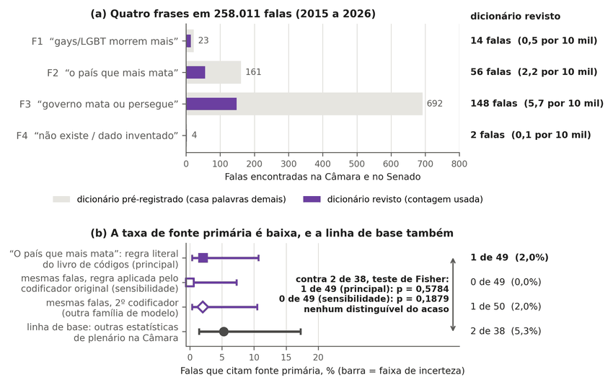
Note. In panel (a), the bars show how many speeches contain each phrase under the pre-registered dictionary (light bar) and under the revised dictionary (dark bar, the count used; deviation declared in Appendix B). In panel (b), the dot is the proportion of speeches that cite an official document or a study with author and year, and the bar is the Wilson 95% CI. Under the literal codebook rule (main analysis), 1 of 49; under the rule applied by the original coder (sensitivity), 0 of 49; baseline, 2 of 38. No difference is distinguishable from chance (Fisher’s exact test: p = 0.58 and p = 0.19). Source: Câmara dos Deputados (2026) and Senado Federal (2026); coding by the author (this study). Labels in Portuguese: frases = phrases; falas = speeches; fonte = source; linha de base = baseline; revisto = revised; casa palavras demais = matches too many; contagem usada = count used; incerteza = uncertainty.
The second coder, from another model family and blind to the labels, agrees with the original on family F2 in Parliament (stance κ 0.73, 95% CI 0.46 to 0.92; source κ 0.66, 0.31 to 0.93). Among the 50 speeches it classified as assertions, it finds 1 with a primary source, the same report that the literal rule classifies as primary. The baseline shows no distinguishable difference between topics in the absence of sources. Of 60 Câmara speeches drawn at random from those that carry a statistic outside the four topics, 22 fell outside the criterion, and of the 38 with an asserted statistic, 2 (5%; Wilson interval 1.5% to 17%) cite a primary source with name and year. The difference from 1 of 49 (Fisher’s exact test, p = 0.58) and from 0 of 49 (p = 0.19) is not distinguishable from chance, and with a small n this does not prove equivalence. Only the comparison of 1 of 50 against 2 of 38 (p = 0.58) uses the same coder on both sides (Table J2). In family F3, the stance κ is 0.43, and, by a rule written beforehand, the percentages for that family and those outside Parliament (source κ 0.47) are indicative (Table B2). In the press, only the headline was coded, and the count from the news aggregator is a minimum number with no time series. The series that would have served to assess a trend was inaccessible because the server persistently refused the requests (HTTP 429 response, too many requests), and an empty positive control was recorded as a failure, not as zero (this study).
Table J1
Coded speech sample: who asserts, who rebuts, and who cites a source
family | universe | N | sample | asserts+attributes | estimated N [95% CI] | rebuts | primary | cites GGB/​ANTRA/​TGEU/​UN
F1 | Parliament | 14 | 14 (census) | 14 | 14 | 0 | 0/14 | 0/14
F1 | Portuguese-​language press (headline) | 145 | 60 | 2 | 5 [1-16] | 0 | 0/2 | 0/2
F1 | world press (headline) | 691 | 60 | 5 | 58 [25-125] | 1 | 1/5 | 0/5
F1 | OpenAlex | 5,535 | 60 | 4 | 369 [145-881] | 0 | 4/4 (the study itself) | 0/4
F2 | Parliament | 56 | 56 (census) | 49 | 49 | 2 | 0/49 | 7/49
F2 | Portuguese-​language press (headline) | 1,005 | 60 | 13 | 218 [132-338] | 1 | 0/13 | 0/13
F2 | world press (headline) | 164 | 60 | 8 | 22 [11-40] | 0 | 0/8 | 1/8
F2 | OpenAlex | 270 | 60 | 11 | 50 [29-81] | 0 | 0/11 | 7/11
F2 | Wikipedia | 9 | 9 (census) | 9 | 9 | 0 | 0/9 | 0/9
F3 | Parliament | 148 | 60 | 33 | 81 [63-99] | 10 | 0/33 | 0/33
F3 | Portuguese-​language press (headline) | 566 | 60 | 0 | 0 [0-34] | 0 | n/a | n/a
F3 | world press (headline) | 361 | 60 | 7 | 42 [21-80] | 0 | 0/7 | 0/7
F3 | OpenAlex | 622 | 60 | 5 | 52 [22-112] | 0 | 1/5 | 0/5
F3 | Wikipedia | 197 | 60 | 1 | 3 [1-17] | 1 | 0/1 | 0/1
F4 | Parliament | 2 | 2 (census) | 2 | 2 | 0 | 0/2 | 0/2
F4 | Portuguese-​language press (headline) | 140 | 60 | 3 | 7 [2-19] | 2 | 0/3 | 0/3
F4 | OpenAlex / world press | 369 / 10 | 60 / 10 | 0 / 0 | 0 [0-22] / 0 | 0 | n/a | n/a
Note. Counts and estimates from the files analysis/discourse/midia/_estimativas.txt and analysis/discourse/midia/amostra_codificada.csv in the repository; the files use decimal commas, shown here as decimal points. Source: this study.
Table J2
Parliament: named source and primary source under the two coding rules, with Fisher’s exact test
variable | coding of the F2 speeches | F2 | baseline | same coder | p (Fisher)
primary source | original, rule as applied (report treated as NGO) | 0/49 | 2/38 | no | 0.1879
primary source | original, literal codebook rule (name + year) | 1/49 | 2/38 | no | 0.5784
primary source | second coder (model from another family) | 1/50 | 2/38 | yes | 0.5758
named source (any source) | original | 8/49 | 3/38 | no | 0.3350
named source (any source) | second coder (model from another family) | 5/50 | 3/38 | yes | 1.0000
Note. Values copied without alteration from the file analysis/robustness/simetria/r7_parlamento_sensibilidade.csv in the repository; the file uses decimal commas, shown here as decimal points. Source: this study.

Appendix K — Statistical Power and Sizing of a Victimization Survey

Statistical Power and Sizing of a Victimization Survey
To know whether nonlethal violence against LGB+ people is rising or falling, a sample of adults must be asked, repeatedly, whether they have experienced violence. A repeated victimization survey with a sexual orientation question provides this external constraint on the administrative record, whereas mortality requires its own design, with orientation identified and a compatible denominator (Home Office, 2025; ONS, 2026a). The design effect measured in the 2019 PNS microdata for physical violence among LGB+ adults is 5.1 (500-replicate bootstrap, 2.6 to 6.4), and a calculation based on simple random sampling underestimates the required sample size by that factor (IBGE, 2022a; this study). With this design effect, in a two-proportion test with a 5% two-sided significance level and 80% power, detecting a 30% increase between rounds requires about 5,787 LGB+ adults per round, or 305,955 adults screened (5,786.3 LGB+ adults divided by the unrounded prevalence of 1.8912%, with a single rounding at the end). The 2019 PNS, with 88,531 adults and 1,554 LGB+ adults interviewed, would have 80% power only for a relative increase of 60.7% or more in physical violence (Figure K1). The calculation combines the weighted prevalence (1.89%) with the PNS design effect. If the unweighted LGB+ fraction in the PNS (1.76% of respondents) is repeated in an identical design, the number of adults to be contacted rises to about 330 thousand (329,644). In a household design with no prior information about who lives at each address, oversampling does not reduce this number, because finding the same LGB+ adults requires contacting the same households. Auxiliary sampling frames or targeted household selection could reduce it, a possibility not assessed here.
Figure K1
Relative increase detectable with 80% power in physical violence against LGB+ adults between two rounds, by number of adults screened
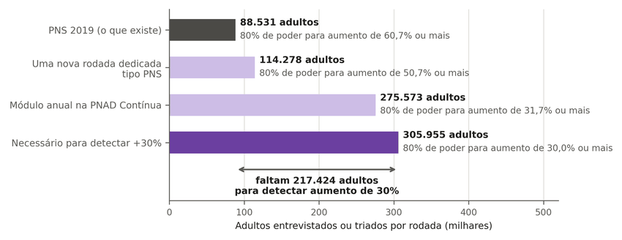
Note. Each bar is the number of adults interviewed in each design, and the text beside it is the smallest relative increase in physical violence between two rounds that this size detects with 80% power. The 2019 PNS detects, with 80% power, increases of about 61%. Detecting 30% would require about 306 thousand adults screened, because only a small fraction of adults are LGB+ and the sample is drawn by clusters, with unequal weights. Source: IBGE (2022a); author’s calculation (this study). Labels in Portuguese: entrevistados ou triados = interviewed or screened; rodada = round; milhares = thousands; o que existe = what exists; Necessário = needed; poder = power; aumento = increase; faltam = short by.
Table K1 compares three designs. All assume, for lack of their own measurement, a design effect equal to that of the 2019 PNS, an assumption that, under an untested hypothesis, overstates the size needed for the address-based panel. The costs are scenarios calculated from public documents, not budgets (Ministério da Justiça e Segurança Pública & IBGE, 2021; Ministério da Saúde & IBGE, 2023). The reference cost of the annual module in the Pesquisa Nacional por Amostra de Domicílios Contínua (PNAD Contínua, the continuous national household sample survey), R$ 6.85 million, comes from the official work plan for the victimization and security modules of that survey contracted in 2021 (total value of R$ 3,596,904 for one quarter of data collection). It is the sum of the information technology cost, paid once, and the variable cost per household visited (per diems, fuel, and fares) multiplied by the 337.6 thousand households in the design, with values updated by the Índice Nacional de Preços ao Consumidor Amplo (IPCA, the national consumer price index) through September 2026 (Ministério da Justiça e Segurança Pública & IBGE, 2021; IBGE, 2026). The 2023 Pesquisa Nacional de Demografia e Saúde (National Demography and Health Survey) asked about sexual orientation and gender identity in 133 thousand households (IBGE, 2023) and had not published the results as of October 11, 2026, the date of the last check.
Table K1
Capacity and cost of one cycle of three victimization survey designs (2026 R$; the internet panel cost comes from a British contract converted at the exchange rate of October 20, 2026)
Design | Adults | LGB+ | Relative increase detectable with 80% power (physical / any) | Reference cost
Annual module in the PNAD Contínua | 275,573 | 5,212 | 31.7% / 12.2% | R$ 6.85 million
Dedicated PNS-like round | 114,278 | 2,161 | 50.7% / 19.0% | R$ 29.0 million
Probability-​based internet panel or survey | 114,278 | 2,161 | 50.7% / 19.0% | R$ 42.0 million
Note. Marginal costs to the funder, excluding the institute’s permanent payroll. The reference cost is the scenario with the closest price precedent. The ranges (R$ 6.85 to 69.9, 25.3 to 32.7, and 42.0 to 89.1 million) add costlier scenarios: the module’s ceiling assumes a dedicated visit at the PNS cost per household, and the panel’s ceiling assumes the per-interview price of a foreign in-person survey. The reference value for the dedicated round divides the total value of the draft PNS work plan (R$ 22.29 million) by the number of households. Source: Ministério da Justiça e Segurança Pública and IBGE (2021), Ministério da Saúde and IBGE (2023), IBGE (2026), Gambling Commission (2025), and Banco Central do Brasil (2026); author’s calculation (this study).

The LGB+ Fraction by Response Mode
Table 6 of the article uses the fraction of adults who declared themselves LGB+ in the whole 2019 PNS, 1.89%. This fraction changes depending on who completes the violence module. Table K2 recalculates the capacity of the three designs with the fraction for each mode, computed over all adults in the mode, including those who did not declare an orientation. The design effect, the baseline prevalence, and the cost of each design remain those of Table 6.
Table K2
Capacity of one cycle of the three designs by LGB+ fraction in each response mode
Design | LGB+ fraction among adults | LGB+ | Relative increase detectable (physical / any)
Annual module in the PNAD Contínua | 1.89% (all modes) | 5,212 | 31.7% / 12.2%
Annual module in the PNAD Contínua | 1.35% (interviewer-​administered) | 3,723 | 37.9% / 14.4%
Annual module in the PNAD Contínua | 3.26% (self-​completed) | 8,976 | 23.8% / 9.3%
Dedicated PNS-like round | 1.89% (all modes) | 2,161 | 50.7% / 19.0%
Dedicated PNS-like round | 1.35% (interviewer-​administered) | 1,544 | 60.9% / 22.5%
Dedicated PNS-like round | 3.26% (self-​completed) | 3,722 | 37.9% / 14.4%
Probability-​based internet panel or survey | 1.89% (all modes) | 2,161 | 50.7% / 19.0%
Probability-​based internet panel or survey | 3.26% (self-​completed) | 3,722 | 37.9% / 14.4%
Note. Relative increase detectable with 80% power, two-sided test at 5%, and independent rounds. Among those who declared a heterosexual or LGB+ orientation, the fractions are 1.38% with an interviewer and 3.51% with self-completion (Appendix C). Here the denominator is all adults in the mode, as in Table 6. The difference between modes may come from who responded in each one, and not only from the mode. Besides the reference scenario (1.89%), the internet panel appears only with the self-completion fraction, because it has no interviewer. The source file also contains the panel row with an interviewer, a hypothetical scenario that the table does not use. Source: IBGE (2022a), 2019 PNS microdata; author’s calculation (this study), file analysis/survey-cost/opcoes_por_modo.csv in the repository.

Appendix L — False Allegations, Retraction, and Measurement Systems in Other Countries

False Allegations and Retraction
The literature separates three phenomena that the debate conflates: allegations proven false, unsubstantiated allegations, and retraction. For reports of adult sexual assault to the police in other countries, the meta-analysis by Ferguson and Malouff (2016) estimates 5.2% of allegations proven false (95% CI 3.0 to 8.9) under a strict definition, drawing on studies that range from 2.0% to 13.7%, with high heterogeneity (I² close to 95%). The estimate can be reproduced only by using the value in the article’s own table for one of the studies (13.7%), which diverges from the value in the text (4.5%; Ferguson & Malouff, 2016, Table 1 and p. 1189). Retraction is common: in intimate partner violence reported to the police, 21.6% of victims formally withdrew the complaint and 26.7% disengaged from the process, and, in the cases with a recorded reason, the most frequent reason was reconciliation (Sleath & Smith, 2017). These estimates concern other populations and procedures and do not estimate false allegations of LGBTphobia in Brazil; no national measure of the three phenomena was found in PubMed, Crossref, general searches in three languages, or official sources. Lei nº 15.380/2026 changed the retraction hearing under the Lei Maria da Penha (Brazil’s domestic violence law), a dated structural break that any future series will have to model (Brasil, 2026).

Measurement Systems in Other Countries
England and Wales, and New Zealand, measure perceived motivation in a probability-based victimization survey. In England and Wales, the survey estimates 176,000 hate incidents per year, of which 44% come to the attention of the police, while police records count 137,550 hate crimes, 18,702 related to sexual orientation and 3,809 related to transphobia, in the year ending March 2025 (Home Office, 2025). In Canada, police recorded 4,882 hate crimes in 2024, 11.9 per 100,000 population, with coverage above 99% (Statistics Canada, 2026). In New Zealand, the survey of 8,008 interviews finds that 38% of LGBTQ+ adults were victims of at least one offense, compared with an average of 28% (Ministry of Justice, 2025). In the European Union, the survey of LGBTIQ people by the European Union Agency for Fundamental Rights, with 100,577 respondents from a non-probability internet sample, finds that 13% to 14% of respondents were attacked over a five-year period (FRA, 2024), and 46 States of the Organization for Security and Co-operation in Europe submit official hate crime data to its human rights office (Office for Democratic Institutions and Human Rights [ODIHR], 2025). Where it has been audited, police recording of motivation is lax: in Germany, only 17.6% of the audited police reports state the motive explicitly, according to a study by the Lower Saxony criminology institute published in a book (Henningsmeier et al., 2025, p. 99), and the national survey of the federal criminal police measures a reporting rate of 2.6% for violence based on sexual orientation (Bundeskriminalamt, 2026). Brazil differs in having neither a regular victimization survey nor an official survey dedicated to the LGBT+ population, because the 2019 PNS measured sexual orientation only once, in a health module and without gender identity (IBGE, 2022b). By contrast, a mandatory motivation field in a health record such as Sinan’s was not found in any other country in the inventory consulted, which covers 47 official sources from the Americas, Europe, Asia, Africa, and Oceania, and its weak point is completeness (DATASUS, 2026b; this study).

Appendix M — Reproducibility and Location of Each Result in the Repository

Reproducibility
The public repository is the primary reference for this study, and the article is derived from it (this study; https://github.com/ulissesflores/lgbt-indicador-violencia). The repository holds the derived data, the code, the pre-registrations with their fingerprints, the reports of the adversarial review, and the tests that lock the published numbers. A provenance seal verifies the integrity of the set. The seal is a chain hash calculated from the SHA-256 of each file distributed in the repository, except the article, its PDF, and the tools that build it. It changes if any of those files changes, and it can be checked with a single command (Table M1). The seal of the current version changes whenever the sealed files are altered; it is in output/hash-chain.md and is checked with python3 -I make_provenance.py --verify. The article’s PDF is not part of the sealed set; its SHA-256 fingerprint is published in a separate file in the repository, so that readers can check that the PDF they are reading is the one derived from the version analyzed. The seal verifies that the files are the same; by itself, it does not verify when they were written.
Reproduction has two tracks (this study). The light track recalculates, in about six minutes, the numbers of the steps listed in the repository’s reproduction matrix; the remaining numbers, such as the sizing in Appendix K, are checked by tests. The heavy track starts from the official microdata and was run end to end for the 2019 PNS, whose file was downloaded from IBGE with its SHA-256 checked; this run reproduced four derived files byte for byte (IBGE, 2022a). The SIM and Sinan aggregates were not rerun from the raw data (DATASUS, 2026a, 2026b). The tables of Appendix C are copied by script from the repository files, with no number typed by hand. The figures are generated with deterministic output and checked by tests that compare the plotted values with the source files and fail when a plotted value is altered; this negative control has been exercised.
The following are not redistributed:
• the raw microdata of the SIM, Sinan, PNS, TSE, and Disque 100, which are large official files that can be downloaded by acquisition scripts with an expected SHA-256 (DATASUS, 2026a, 2026b; IBGE, 2022a; TSE, 2026; MDHC, 2026);
• third-party texts, because of copyright. For these, the repository keeps the web address, the access date, and, when the file was saved, the SHA-256;
• lists of victims’ names, for privacy. For this reason, the link between case and source in the validation of the 2019 Grupo Gay da Bahia (GGB) count cannot be reproduced publicly (GGB, 2020).
The complete inventory of sources and scripts, the index of what the repository contains, and the revision history of the text are in the repository itself (Table M1).

Location of Results and Verification Elements in the Repository
Table M1
Path, in the public repository, of each result and each verification element of this version
Result or element | Section, table, or figure | Path in the repository
Provenance seal and its verification | section 2.4 | output/​hash-​chain.​md; output/​provenance.​json; manifest/​SHA256SUMS.​txt; command python3 -I make_​provenance.​py --verify
Article PDF and its fingerprint | entire article | docs/​paper/​paper-​final.​pdf; docs/​paper/​SHA256SUMS.​txt
Figures, plotted values, and figure texts | Figures 1 to 8; figures of Appendices C to K | figures/​article/​; figures/ (make_​figures.​py, valores_​plotados.​json, textos_​fora_​da_​imagem.​json, fontes/​SOURCES.​tsv); data/​exposicao/​fig_​caminho_​v05.​py; data/​pns/​fig_​pns_​v05.​py; data/​pns/​fig_​agressor_​pns2019.​py; data/​disque100/​fig_​disque_​v05.​py; data/​exposicao/​fig_​series_​por_​governo.​py
Tests that lock the published numbers | section 2.4 | tests/
Nonlethal victimization and who assaulted (PNS) | section 3.1; Table 3; Tables C1 to C12 | data/pns/
Health notification forms and agreement with police reports | section 3.2; Figure 6 | data/sinan/; data/​concordancia/
Disque 100 | section 3.2; Figure 4; Figure D5 | data/​disque100/
Identifiability and sizing of a survey | sections 2.3 and 6; Figure 5; Table 6; Tables K1 and K2 | analysis/​simulation/​; analysis/​survey-​cost/
Standardized SIM rates and series by government term | sections 3.3 and 3.6; Figure 8; Tables E2 to E4; Tables G2, G6, and G7 | data/sim/; data/​exposicao/
Mortality outside Brazil | section 3.4; Table E1; Figure E1 | figures/​fontes/​estudos_​mortalidade.​tsv; analysis/​discourse/​mortalidade/
GGB list: 2019 verification, agreement, scale, and critical checks | section 3.5; Figure 7; Tables F1 to F4 | data/ggb/; figures/​fontes/​ggb_​validacao_​resumo.​json; analysis/​ggb-​audit/​; analysis/​ggb-​series/​; analysis/​counterpoint/
Governor panel, event study, and change of president | section 3.6; Tables G1 and G3 to G9 | data/painel/; data/​ideologia/​; data/​presidencia/
Symmetric search for government acts | sections 1 and 3.7; Table H1 | analysis/​robustness/​simetria/
State violence under different types of regime | section 3.7; Table 5; Table I1 | data/regimes/
Circulation in Parliament and the press | section 3.7; Tables J1 and J2 | analysis/​discourse/​; analysis/​robustness/​simetria/
Pre-​registrations and addenda | section 2.4; Tables B2 and B3 | preregistrations/​; analysis/​robustness/​reanalise/​; analysis/​robustness/​simetria/​; data/​painel/​R6-​PREREGISTRO-​FORMA.​md; data/​presidencia/​; data/​exposicao/
Inventory of sources and scripts | section 2.5 | manifest/​INVENTARIO-​PUBLICO.​md; manifest/​MANIFESTO-​FONTES.​csv; sources/
Acquisition of the official microdata | section 2.4 | scripts/ (acquisition scripts with expected SHA-256)
Note. Paths are relative to the root of the repository https://github.com/ulissesflores/lgbt-indicador-violencia. Source: this study.

