

Does a mayor improve a city beyond chance? Missing data at a change of mayor makes the test say yes
Gap stitching, serial correlation, and the size of Berry and Fowler’s permutation test in a panel of Brazilian municipalities

Carlos Ulisses Flores
Codex Hash Research Laboratory
ORCID: 0000-0002-6034-7765

Date: November 7, 2026

Abstract
Berry and Fowler’s (2021) randomization inference for leader effects (RIFLE) compares how much the true tenures explain an outcome with how much tenures of the same length in shuffled order would explain, and has become the direct way to ask whether a ruler matters “beyond chance”. For years without data, the original article and the default of the official Stata package (Berry & Fowler, 2018) drop the missing observations and stitch the remaining blocks into a contiguous time index. This paper shows that, under modest serial correlation, stitching makes the test detect leader effects that do not exist when, in the municipal panel examined, the gap falls next to a mayor transition (the return of the same mayor after the gap can reverse the effect), and that the size of the error grows with the number of units in the panel. The evidence comes from simulations under the null on the real tenure structure of 5,468 Brazilian municipalities (2005-2024), run on a translation of the default path of the official code and registered in a hash chain before each run. With a one-half-term gap right after the election (in 62.3% of the 5,468 municipalities it separates different mayors) and autoregressive noise with coefficient 0.217, rejection at 5% reaches 76.6% in the full panel and 89.4% when the gap borders a transition; with 50 municipalities it ranges from 6.8% to 8.2%, and only the cell next to a transition is still compatible with 5%. With the real availability mask of the study’s index, rejection is 34.8%. Without serial correlation, the period-9 gap gives 6.4%, compatible with 5%. With the package’s own nostitch option, the inflation of tens of points goes away: 4.6% with 1,000 municipalities, 3.6% with the real mask, and 1.2% to 2.0% in the full panel, a conservative test, though above the 0.2% the package rejects with no gap at all; in the 1,000-municipality cells where power was measured, with no blocks dropped and without equalizing test size, it was similar to the no-gap control. With the gap in the middle of a long tenure, the test became conservative, but the sign depends on the position of the gap relative to tenure boundaries. The package help recommends turning stitching off for “a long gap” or for some other, unspecified reason; the results indicate that length is not enough and that the position of the gap relative to leader transitions must enter the diagnosis. The paper does not claim that any published result by Berry and Fowler is wrong, and does not present the fix as new: it already exists in the package. The case that motivated the investigation, a preregistered study of Brazilian mayors, ended with no evidence of a mayor effect and with equivalence not demonstrated.
Keywords: randomization inference; leader effects; missing data; serial correlation; preregistration; mayors

1. Introduction
To ask whether a ruler matters is to ask whether the outcome changes with the person, and RIFLE tests this by comparing the real history with shuffled histories. Jones and Olken (2005) showed that the death of heads of state in office alters growth, and revived a line of work that seeks to separate the effect of the person from the effect of the context. Berry and Fowler (2021) proposed a more direct procedure for the “beyond chance” question: regress the outcome on leader indicators, keep the R², and compare it with the distribution of the R² obtained when the order of each unit’s tenures is shuffled, keeping the length of each. If the true tenures explain more than almost all shuffles, the hypothesis of a null effect is rejected. The authors applied the test to heads of state, governors and mayors in the United States, company executives and sports coaches, and released it as a Stata module (Berry & Fowler, 2018). This paper shows that, when years are missing in the middle of the series, the default way of handling the gap can make the test detect a leader who does not exist.
The procedure depends on a choice that looks like a backstage detail: what to do with the years without data. The original article is explicit: “we drop those observations and stitch together blocks of time, coding a new time variable so that we have a single, contiguous stretch of time with complete data for each unit” (Berry & Fowler, 2021). The package does the same by default and offers the nostitch option, described in the help as the one to be used “if there is a long gap between periods or some other reason not to comprate [sic] observations across missing periods” (Berry & Fowler, 2018). None of the authors’ size simulations combines gaps and serial correlation: those with 20 units by 20 periods, with weight 0 or 0.2 on the previous period, have no gaps; those with endogenous leader turnover, with the number of units and periods of each application, chain the simulated outcome in row order, sorted by calendar but applying the correlation to the previous row even when the year jumps, according to the replication code (Berry & Fowler, 2020), and therefore do not produce the mismatch between calendar and stitched time that this paper is about; the power simulations, which with zero effect measure about 5% rejection, use independent noise; and those in the supplementary material deal with transition costs in complete panels, without serial correlation.
This paper grew out of a preregistered study that applied RIFLE to Brazilian mayors, with an index of school test scores, own-source revenue and infant mortality, from 2005 to 2024. In the pilot phase, before any computation with the true mayors, the test with stitching rejected the true null in 64.0% of 200 simulations in the municipalities with an interior gap, when the correct figure would be 5% (Section 5.6). The study stopped and was redone, and the question became a different one: what, in the gap, misleads the test?
The answer has four parts, all measured in a faithful port of the official code:
- In the municipal panel examined, the default stitching over-rejects when the gap falls next to a change of mayor and the outcome has positive serial correlation (Section 5.1); when the same mayor returns after the gap, the sign can reverse (Section 3.2).
- The length of the gap is not enough to assess the risk. A short gap, of a single period per municipality, can already distort under serial correlation, and the sign of the distortion depends on where the gap falls relative to tenure boundaries; in the cell tested, the gap in the middle of a long tenure made the test conservative (Sections 3.2, 3.3 and 5.1).
- The error increases sharply in the larger panels examined: with 50 municipalities it ranges from 6.8% to 8.2% (only the cell next to a transition is still compatible with 5%) and reaches 89.4% with 5,468 (Section 5.2).
- The nostitch option, which already exists in the package, removes the inflation of tens of points in the cases tested; in the full panel, the test becomes conservative, and power, measured only with 1,000 municipalities, was similar to that of the no-gap control (Sections 5.1 to 5.3).
The package help already offers the option that restricts the shuffle to contiguous stretches; parts 1 to 3 and the measurement in part 4 are not in the original article, in its supplementary material, in the authors’ replication code or in the help, and were not found in the other sources examined (Section 6.3). The paper does not claim the fix, which belongs to the authors; it claims the measurement of the problem, the examples of sign reversal and a diagnosis for deciding when to use it. Nor does it claim that any published result by Berry and Fowler is wrong (Section 6.2).

2. Related work
The question about leaders has been asked many times; in the sources examined, we did not find a measurement of test size when data are missing in the middle of the series. Variance decomposition by leader has a history of controversy over how much the “executive effect” exceeds chance. The Jones and Olken design identifies the effect through a few unexpected transitions, 57 in a panel of 130 countries since 1945 according to Berry and Fowler (2021), and RIFLE uses all transitions. Fitza (2014) showed that much of the variance attributed to company CEOs could be reproduced by luck; Quigley and Graffin (2017) replied that the effect is significant and larger than chance. RIFLE (Berry & Fowler, 2021) turned this discussion into a permutation test with a clear decision rule, and Smith and Gray (2021) extended it to long historical series and revalidated it on simulated data. Of the 42 records that cite Berry and Fowler in OpenAlex (October 31, 2026; some are versions of the same work), no title mentions gaps or test size; the screening is weak and did not retrieve Smith and Gray. This paper read only the abstract of that extension, which does not mention gaps; since historical series often have missing years, the full text may deal with the problem (see Section 6.3).
The validity of a permutation test comes from the symmetry of the data under the null, not from the null itself. Lehmann and Romano (2005) present the classical result: the test is exact when the joint distribution of the data is invariant under the group of permutations used. Winkler et al. (2014) discuss what happens when this exchangeability holds only within blocks and why restrictions on the shuffle may be needed. Canay, Romano and Shaikh (2017) treat randomization tests under only approximate symmetry. The common lesson is that “zero leader effect” does not by itself imply that all tenure orders are equally likely; that depends on the dependence structure of the outcome, and it is exactly this structure that stitching alters.
Resampling dependent data requires preserving the dependence that matters. The block bootstrap literature (Künsch, 1989; Politis & Romano, 1994; Lahiri, 2003) shows that contiguous blocks preserve the local dependence of stationary series and that the junctions between blocks are precisely where that dependence stops being reproduced; the stationary bootstrap joins blocks on purpose and remains consistent, because it treats the junctions as part of the design. RIFLE is not a bootstrap and the justifications are different, but the principle carries over: reordering blocks on a time index that does not correspond to the calendar compares partitions under covariances that are not the ones the data have.
In Brazil, the question about mayors has been asked with other designs. Akhtari, Moreira and Trucco (2022) showed, with close elections, that a change of party in control of the municipality replaces school principals and teachers and lowers student test scores; Brollo and Nannicini (2012) showed that mayors aligned with the president receive more discretionary transfers for infrastructure in pre-election years, which is why the preregistered study removed the effect of partisan alignment from the outcome. According to the survey carried out for this paper (Section 6.3), RIFLE had not been applied to Brazilian mayors, with the medium confidence stated there. The study followed the preregistration logic advocated by Nosek et al. (2018): decision rules recorded before the data, dated amendments, and nothing discarded after seeing the result.

3. The procedure, stitching and the mechanism

3.1 RIFLE and what stitching does
The test compares a real partition with shuffled partitions, and stitching changes which partitions are possible. For each unit m with periods t = 1, …, T, the outcome y is residualized on period effects. The real R² comes from the regression on leader indicators; each permutation shuffles the order of the unit’s tenures, keeping their length, and recomputes the R². The p-value is the fraction of permutations with an R² larger than the real one. In the official code (rifle.ado, Berry & Fowler, 2018), three details matter here:
- the outcome is residualized by period before dropping missing values, which, for a missing outcome, amounts to subtracting the period mean over the observed cells;
- the indicators are for the leader’s identity (absorb(leader)), so that the same person in two separate tenures forms a single group;
- the stint changes when the leader changes, in the order of the renumbered time, so that the same person on both sides of a stitched gap becomes a single stint.
With stitching, the period after the gap becomes a neighbor, on the time index, of the period before it. With nostitch, each contiguous stretch of observed periods becomes its own unit of shuffling, and a stretch with a single leader and two or more rows leaves the sample.

3.2 Two leaders are enough to see the mechanism
The covariance between two periods remains that of the calendar, not that of the stitched index. Let the outcome, under the null, be a stationary autoregressive process with variance $σ^{2}$ and covariance $σ^{2}ρ^{|t−s|}$ between calendar periods $t$ and $s$, with $0<ρ<1$. For a partition G into groups $g$ of size $n_{g}$, the explained sum of squares is, up to a term common to all partitions,
 | Q=g​1ngt∈g​yt2, | (1)

and the denominator of the R² is the same in all permutations of a given dataset. Ranking R² is therefore equivalent to ranking Q, whose expectation is
 | E[Q]=g​1ngt,s∈g​σ2ρ|t−s|. | (2)

Consider six periods with leader A in 1-2 and B in 3-6, and the only possible reordering, B before A.
- Gap next to the transition (period 3 missing): the real partition is {1, 2} | {4, 5, 6}; the reversed one, in the stitched sequence, is {1, 2, 4} | {5, 6}. The reversed partition puts the gap inside a group, where it reduces the within-group covariance. With $Q_{inv}$ the value for the reversed order, we get
 | $$E[Q_{real}−Q_{inv}]=\frac{2}{3}σ^{2}(ρ−ρ^{3})>0,$$ | (3)

- and the real fit is favored without any leader effect.
- Gap inside the tenure (period 4 missing): the real partition is {1, 2} | {3, 5, 6}, and the reversed one, {1, 2, 3} | {5, 6}. The roles swap:
 | $$E[Q_{real}−Q_{inv}]=−\frac{2}{3}σ^{2}(ρ−ρ^{3})<0,$$ | (4)

- and the mean difference goes in the conservative direction, in favor of the shuffle.
- Gap inside the tenure that still inflates (counterexample from the external review): with A in 1-4, B in 5-6 and period 2 missing, the real partition is {1, 3, 4} | {5, 6} and the reversed one, {1, 3} | {4, 5, 6}. Then
 | $$E[Q_{real}−Q_{inv}]=\frac{1}{3}σ^{2}ρ(1−ρ)(1−2ρ),$$ | (5)

- positive for ρ < 0.5 (about 0.032σ² with ρ = 0.217). The gap is inside A’s tenure, and the real fit is favored.
- Gap next to the transition with a negative mean difference (second counterexample from the external review): with A in 1-2, B in 3-4, A back in 5-6 and period 3 missing, the package shuffles three stints and pools A’s two stints into a single group; the average over the six orders gives
 | $$E[Q_{real}−Q_{perm}]=−\frac{1}{6}σ^{2}ρ^{2}(1−ρ)(2ρ^{2}+4ρ+3),$$ | (6)

- about −0.024σ² with ρ = 0.217. In this case the return of A already shifts the statistic in the conservative direction even with no gap at all (about −0.102σ² with all six periods complete, by the same enumeration), because A’s two stints are never adjacent in the real data and become adjacent in four of the six orders; the gap reduces this shift but does not reverse it. It is the same candidate cause of the package’s conservativeness without a gap (Section 5.1).
The examples use the calendar covariance before the subtraction of the period mean, which the test performs; with masks that differ across municipalities, this subtraction changes the covariance matrix and links the units, so that going from the examples to the panel is a heuristic argument, and the simulations apply the subtraction exactly. With ρ = 0 the four contrasts vanish. The sign therefore depends on how the gap is positioned relative to the boundaries of the real and shuffled groups, including the groups that pool a returning leader, and not only on whether it sits next to a transition or inside a tenure. These signs are of mean differences, not of rejection rates: in a panel of two municipalities with the structure of the second example, the mean difference is negative and, even so, the test rejects in 48.1% of 4,000 datasets (the real order has a larger R² than the reversed one in 47.3% of 400,000 datasets, with Gaussian noise and the subtraction of the period mean), because the residuals of the two municipalities are opposite, the three orders that are not the real one fall on the same side of it, and the exact p-value, counting only strictly larger orders, is 0 or 0.75; with 200 shuffles, the estimate oscillates around these two poles. This pathology of tiny panels with a strict tail exists even without a gap and without serial correlation, and is not the stitching mechanism. The derivation was proposed by the external review of this work (Section 4.4); the rejection rates were measured by simulation.

3.3 Why the large panel amplifies and length does not decide
The shift per unit is small, but it adds up; the dispersion of the test grows more slowly. If the mean shift per municipality in the difference between the real and the permuted explained sum of squares has a definite sign across the panel, positive when gaps next to transitions without a returning leader predominate, the sum over N independent units grows with N, while its dispersion under the null grows approximately with $\sqrt{N}$. In the R², which divides both sums by the total sum of squares, also proportional to N, the shift is of constant order and the dispersion falls with 1/$\sqrt{N}$; the ratio between the two grows with $\sqrt{N}$ in both cases. This is why the same per-unit bias is almost invisible with 50 units and decisive with thousands; in the simulations, each size uses a different subsample, and the growth agrees with the mechanism without isolating it. The length of the gap enters the lost covariance (the stitched pair goes from $ρ$ to $ρ^{L+1}$), but does not decide the sign: the same short gap shifts the statistic in favor of the real fit when it separates two different leaders who do not return, can shift it either way when it lies inside a tenure and, in the return cases computed here, shifts it in the conservative direction, according to the boundaries of Section 3.2.

4. Data and simulation design

4.1 The port of the official code and its limit
The headline numbers come from a port to Python of the default path of the rifle.ado distributed on SSC (the version with the controls and notrend options; the RIFLE.do copy in the replication code does not have them, but stitching and nostitch are identical), because Stata was not available; this is the paper’s main limitation. The port covers the R² without controls, stitching and nostitch; it does not implement the controls, growth and notrend options, and assumes that only the outcome has missing values (unit, leader and period always present, as in the simulations). It reproduces the steps cited in Section 3.1, with the corresponding line of the code annotated (code/rifle_ado.py in the replication package; Flores, 2026). It was checked against hand computations on small panels (three tests covering stitching, merging of the same person and the nostitch rules), against the exact enumeration of the 36 stint orders in a two-unit panel with a returning leader (the shuffle p-value gives 0.1103 with 200,000 permutations, against 0.1111 exact), against the same enumeration in a panel with nostitch, a dropped stretch, a one-row stretch and the same person in both stretches (0.7511 against 0.75 exact), against an independent reconstruction of the mean that includes the real row (equal up to the 12th decimal place and different from the mean without it), and against the study’s own engine on a panel with no returning mayor, where the two coincide on the value recorded in the chain (R² of 0.4777757). This does not replace a check against Stata, which the replication package leaves ready in the file stata/rifle_celulas.do for those who have it (Section 7).

4.2 The tenure structure
The structure is real; the outcome is synthetic. The mayors of each half-term (ten two-year periods, 2005-2024) were identified from the open data of the Superior Electoral Court, including supplementary elections, with the person identified by the validated CPF, the Brazilian individual taxpayer number (TSE, 2024). In the simulations, the leader’s identity is the municipality-person pair: someone who was mayor in two municipalities counts as two leaders, which prevents the package’s global grouping from merging different cities. The sample comprises 5,468 municipalities with an identified mayor in all ten periods and at least two different mayors. No real outcome enters the simulations, with two exceptions: the generator’s coefficient, calibrated from a statistic of the real index (Section 4.3), and, in Section 5.3, the information on which municipality-periods have the index observed.

4.3 The generator and the cells
The noise is first-order autoregressive in calendar time, with coefficient 0.217, and the gap is imposed after the noise is generated. The noise is Gaussian, stationary from the first period (variance 1 and innovations with variance 1 − ρ²) and independent across municipalities; in the power cells, each person receives a Gaussian effect with variance Prop/(1 − Prop), the same on both sides of a gap. The coefficient is that of the generator calibrated in the preregistered study: the autocorrelation measured in the real index after removing municipality and period was 0.084, a value biased downward by the demeaning in short series (Nickell, 1981), and 0.217 is the autoregressive coefficient whose autocorrelation, measured with the same demeaning on synthetic ten-period series, reproduces the 0.084 (method of moments, by bisection). Each cell has 500 datasets and 1,000 permutations per dataset; rejection rates at 5% come with exact 95% intervals (Clopper & Pearson, 1934). In each cell, the subsample of municipalities and the position of the gaps are drawn once and stay fixed across the 500 datasets; the intervals measure the Monte Carlo uncertainty within that design, not the variation across subsamples or masks. The cells vary:
- the position of the gap: none; period 9 (the first half-term after the 2020 election, the same one missing in the 2021 Saeb); a randomly drawn interior period; a period next to a transition; a period inside a tenure;
- the treatment: default stitching or nostitch;
- the number of municipalities: random subsamples of 50, 200 and 1,000, and the full panel;
- the coefficient: 0.217 or 0;
- the presence of an effect: no effect, or a per-person effect with 10% or 5% of the variance, to measure power.
The cells conditioned on the position of the gap only accept municipalities in which that position exists, and therefore have fewer municipalities than the 1,000 subsample; Table 1 gives the effective number for each. The same-sample controls (no gap, in the same 867 municipalities) and the nostitch cells in the full panel were added after the external review of the text: the module entered the hash chain before its output, and the reading rule was written in the paper’s preregistration before running, but outside any chain (Section 4.4).

Table 1
Cells of the faithful port: design and rejection at 5% (500 datasets, 1,000 permutations each)
Module | Municipalities | Observations used | Gap | Treatment | ρ | Effect (Prop) | Rejection (%) | Exact 95% CI (%)
diagnostico_​ado | 1,000 | 10,000 | none | stitching | 0.217 | 0% | 2.2 | 1.10 to 3.90
diagnostico_​ado | 1,000 | 9,000 | period 9 | stitching | 0.217 | 0% | 27.2 | 23.34 to 31.33
diagnostico_​ado | 867 | 7,803 | mid-term | stitching | 0.217 | 0% | 0.2 | 0.01 to 1.11
diagnostico_​ado | 1,000 | 9,000 | period 9 | stitching | 0.000 | 0% | 6.4 | 4.42 to 8.92
diagnostico_​ado | 1,000 | 9,000 | period 9 | nostitch | 0.217 | 0% | 4.6 | 2.94 to 6.82
diagnostico_​ado | 869 | 7,821 | random, 2+ mayors/block | nostitch | 0.217 | 0% | 6.2 | 4.25 to 8.69
diagnostico_​ado | 1,000 | 10,000 | none | stitching | 0.217 | 10% | 98.8 | 97.41 to 99.56
diagnostico_​ado | 867 | 7,803 | mid-term | stitching | 0.217 | 10% | 96.8 | 94.86 to 98.16
diagnostico_​ado_​juizes | 867 | 8,670 | none | stitching | 0.217 | 0% | 2.2 | 1.10 to 3.90
diagnostico_​ado_​juizes | 867 | 8,670 | none | stitching | 0.217 | 10% | 99.0 | 97.68 to 99.67
diagnostico_​ado_​juizes | 1,000 | 9,000 | period 9 | nostitch | 0.217 | 10% | 98.4 | 96.87 to 99.31
diagnostico_​ado_​juizes | 869 | 7,821 | random, 2+ mayors/block | nostitch | 0.217 | 10% | 99.0 | 97.68 to 99.67
diagnostico_​ado_​juizes | 1,000 | 10,000 | none | stitching | 0.217 | 5% | 55.0 | 50.52 to 59.42
diagnostico_​ado_​juizes | 1,000 | 9,000 | period 9 | nostitch | 0.217 | 5% | 61.0 | 56.57 to 65.30
diagnostico_​ado_​escala | 5,468 | — | period 9 | stitching | 0.217 | 0% | 76.6 | 72.64 to 80.24
diagnostico_​ado_​escala | 5,468 | — | next to mayor change | stitching | 0.217 | 0% | 89.4 | 86.36 to 91.96
diagnostico_​ado_​escala | 5,468 | — | random interior | stitching | 0.217 | 0% | 34.6 | 30.43 to 38.95
diagnostico_​ado_​juizes | 5,468 | 54,680 | none | stitching | 0.217 | 0% | 0.2 | 0.01 to 1.11
diagnostico_​ado_​juizes | 5,468 | 49,212 | period 9 | nostitch | 0.217 | 0% | 1.6 | 0.69 to 3.13
diagnostico_​ado_​juizes | 5,468 | 40,533 | next to mayor change | nostitch | 0.217 | 0% | 1.2 | 0.44 to 2.59
diagnostico_​ado_​juizes | 5,468 | 42,972 | random interior | nostitch | 0.217 | 0% | 2.0 | 0.96 to 3.65
diagnostico_​ado_​mascara_​real | 1,854 | — | real mask, interior gap | stitching | 0.217 | 0% | 34.8 | 30.63 to 39.16
diagnostico_​ado_​mascara_​real | 1,854 | — | real mask, interior gap | nostitch | 0.217 | 0% | 3.6 | 2.15 to 5.63
diagnostico_​ado_​mascara_​real | 707 | — | real mask, edge gap only | stitching | 0.217 | 0% | 3.8 | 2.30 to 5.87
Source: the study’s results.json (outputs with verified sha256). Municipality with no gap: 10 observations. The real-mask rows use only the information on which municipality-periods have the index; the outcome is synthetic. Effect = share of variance due to the mayor; 0% = true null. Observations used = municipality-periods that enter the test after the gap and, under nostitch, after dropping blocks with a single mayor; not recorded (—) in the scale and real-mask cells. In the cells with a period-9 gap and nostitch, the observations used include period 10, a one-row block that is never shuffled and does not contribute to the variation across permutations when its mayor does not appear in the other block. Municipalities = units that enter the cell before nostitch drops blocks.

4.4 Registration and review
Each experiment was recorded in a hash chain before running, and the thesis and the text went through independent reviewers. The modules, the seeds and the pass-or-stop rules of the main experiments were registered with SHA-256 before each run (the reading rules for the cells added during review stayed outside the chain, Section 4.3), in chained logs (manifest.jsonl) that the replication package publishes (Flores, 2026); the chaining guarantees the integrity and order of the records, but the timestamps come from the files’ modification dates, with no external timestamp, and therefore precedence is declared, not authenticated. The smoke tests used disposable seeds declared in the record itself. The thesis was reviewed by a council of language models (one of them found the nostitch option in the package help, which the earlier search had not read) and the text by three language models from different families, with the same instruction and without seeing each other’s report. Each critique received a recorded response.

5. Results

5.1 Where the gap falls decides
In the subsample of one thousand municipalities, the same short gap takes the test from 0.2% (867 municipalities) to 27.2% rejection depending on its position, against 2.2% with no gap. Figure 1 summarizes the cells of the 1,000-municipality subsample, with the effective number of each bar. With no gap, the package rejects 2.2% (interval from 1.10% to 3.90%), a slight conservativeness of the package itself whose cause was not isolated: the strict p-value would not explain it, and the candidate is mayors returning to office (Section 3.2). With the period-9 gap stitched, rejection rises to 27.2% (from 23.34% to 31.33%). With the gap inside a tenure, in the 867 municipalities that have one mayor for three consecutive periods, it falls to 0.2%, against 2.2% with no gap in these same municipalities.
The conservativeness of the gap inside the tenure does not erase power. With a per-person effect of 10% of the variance, in the same 867 municipalities, the test detects the effect in 96.8% of the datasets with a gap inside the tenure, against 99.0% with no gap. The deviation in the conservative direction matters under the null and hardly matters in the face of an effect of that size.
Without serial correlation, the covariance contrast of Section 3.2 disappears. With ρ = 0 and the period-9 gap, rejection is 6.4%, compatible with 5% at the precision of 500 datasets.
The option the package already offers removes the inflation of tens of points in the cases tested. With nostitch, the period-9 gap gives 4.6%, and a randomly drawn interior gap, with two or more mayors in both stretches, gives 6.2% (from 4.25% to 8.69%); both are compatible with 5% at the precision of 500 datasets, and the interval of the second does not rule out an inflation of a few points. The second cell reduces, without ruling out, the suspicion that nostitch only works by leaving stretches without a useful shuffle. With a mayor effect, nostitch detects 98.4% with 10% of the variance, against 98.8% with no gap, and 61.0% with 5%, against 55.0% with no gap; with the randomly drawn gap with two or more mayors per stretch and 10% of the variance, 99.0%. These comparisons have two limits: in these cells nostitch drops no stretch, and the no-gap control already rejects less under the null (2.2% against 4.6%). Power in the positions where nostitch drops stretches, such as the gap next to a transition (in the full panel, nostitch drops 17.6% of the cells that remain after the gap), and in the 5,468-municipality panel was not measured.
Figure 1
Rejection under the null in the 1,000-municipality subsample (effective N in each bar), by gap position and treatment (faithful port of the package; bars: exact 95% interval)
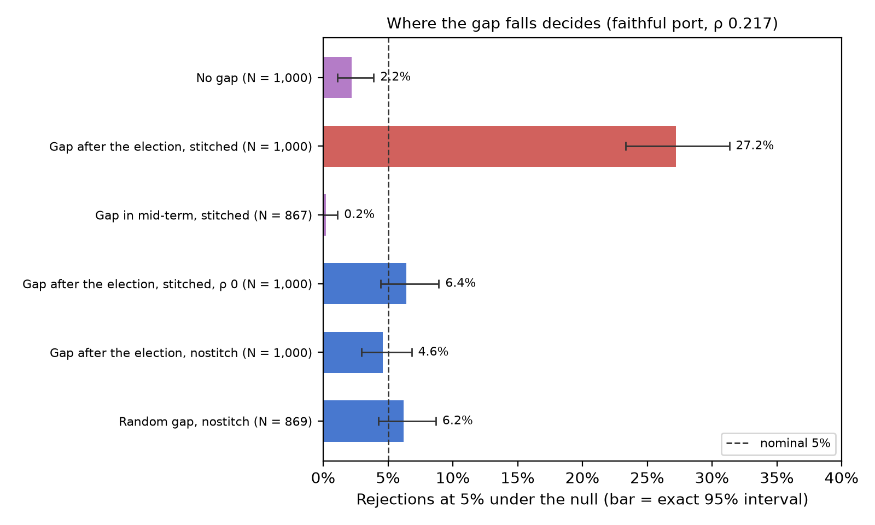

5.2 The large panel turns a small bias into a systematic error
From 50 to 5,468 municipalities, rejection with the gap next to a transition goes from 6.8% to 89.4%. Figure 2 shows the three gap positions under default stitching. With the gap next to a transition, rejection is 6.8% with 50 municipalities (from 4.75% to 9.37%, still compatible with 5%), 14.2% with 200, 35.2% with 1,000 and 89.4% with the full panel. With the period-9 gap, the values are 8.2%, 15.8%, 26.2% and 76.6%. With a randomly drawn interior gap, 7.8%, 7.6%, 14.4% and 34.6%.
A single-period gap, randomly drawn, already distorts. The package help says that stitching is advantageous when “a few years are missing idiosyncartically” [sic]. In Brazilian municipal tenures, 70.1% of the randomly drawn gaps fall next to a change of mayor, and rejection in the full panel reaches 34.6%. The case in which the help sees an advantage in stitching is not safe when tenures are short and the panel is large. The fraction of gaps next to a transition is a useful diagnostic, but not a sufficient rule: the magnitude also depends on the autocorrelation, the length of tenures, the return of leaders and the number of units.
The 26.2% with 1,000 municipalities and the gap in period 9 come from a different subsample and seed than the 27.2% of Section 5.1. The period-9 cell is a mixture: in 62.3% of the municipalities the gap separates different mayors and, in the rest, the same person is on both sides; the pure case of a gap between different mayors is the cell next to a transition, with 89.4%.
In the full panel, nostitch removes the inflation of tens of points and leaves a conservative test. With no gap at all, the package rejects 0.2% with the 5,468 municipalities, against 2.2% in the 1,000 subsample; since the number of units and the composition change together, and the cause of the conservativeness was not isolated, the comparison only shows that it is larger in the full panel. With nostitch, the three gap positions give 1.6% (period 9), 1.2% (next to a transition) and 2.0% (randomly drawn), against 76.6%, 89.4% and 34.6% with stitching. None of the three intervals contains 5%, and all three estimates lie above the no-gap baseline, like those with 1,000 municipalities (4.6% and 6.2% against 2.2%). The data do not separate what comes from the package’s conservativeness from what comes from the links between stretches discussed in Section 6.1.
Figure 2
Default stitching of the package (lines): rejection under the null by number of municipalities and gap position; points: nostitch and no-gap baseline, with 1,000 municipalities (the randomly drawn gap with nostitch uses 869 municipalities with two or more mayors in each stretch) and in the full panel (faithful port of the package; horizontal axis on a logarithmic scale, with points slightly offset so they do not overlap; bars: exact 95% interval)
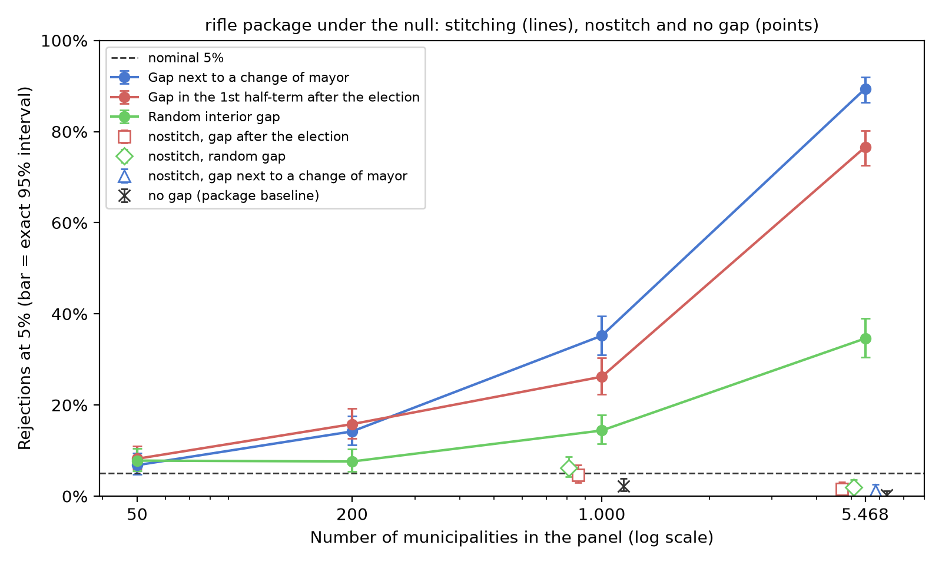

5.3 The real gaps repeat the pattern
With the gaps that the real index has, stitching rejects 34.8% and nostitch, 3.6%. Using only the information on which municipality-periods have an observed index in the preregistered study, and a synthetic outcome, the 1,854 municipalities with an interior gap reject 34.8% under stitching (from 30.63% to 39.16%) and 3.6% with nostitch. The 707 municipalities with a gap only at the beginning or end of the series reject 3.8% under stitching: an edge gap stitches nothing together and does not distort.

5.4 The study’s engine gave larger numbers
The study’s own engine, which labels each stint of a mayor as a group, gave larger rejection rates; the grouping is a possible explanation, not an isolated one. In that engine, the same cells give larger numbers: 98.2% with the period-9 gap in the full panel, 76.0% with the randomly drawn gap and 71.4% with a two-period gap. The merging of the same person on both sides of a stitched gap happens in both codes; only the package puts in the same group someone who returns to office after another mayor, but the codes also differ in the p-value comparison (greater than or equal in the engine, strictly greater in the package) and in the seeds. The two-period cell, which erases an entire tenure, is not used as evidence about length. The headline numbers of this paper come from the package; those of the engine remain as a sensitivity analysis.

5.5 The case that motivated the investigation
The preregistered study ended with no evidence of a mayor effect, and without being able to claim that the mayor does not matter. Redone with shuffling within contiguous stretches (analogous to nostitch, but with each stint of the mayor as its own group), with size confirmed at 5.2% in a pre-declared run of 2,000 datasets, the test was applied a single time to the real data. The R² of the true mayors fell below the mean of the shuffles in the three preregistered versions, with a p-value of 0.869 in the main sample, 0.488 with a lagged effect and 0.904 in the municipalities with 20,000 inhabitants or more. The preregistered equivalence rule produced “does not matter”, but an audit after the result showed that the threshold of that rule had been calibrated without differences between municipalities, and the study’s final record is: equivalence not demonstrated, inconclusive as to the exclusion of relevant effects.
The same audit found that very few own-source revenue series dominate the distribution of the test, and part of them were reporting errors. The standard deviation of the permutation distribution in the real data comes almost entirely from own-source revenue (Figure 3; contributions computed holding fixed the denominator of the full index): 0.0056 with it alone, against 0.0007 without it, out of a total of 0.0060. Among the most extreme cells were negative totals of own-source revenue in 2024, an impossible value: 34 municipalities, 31 of them in Tocantins, with IPTU (the municipal property tax) reported with a negative sign in the Annual Accounts Statement (Tesouro Nacional, 2025), with a median of about −19.6 million reais per municipality. Treating these values as missing, under a rule recorded before rerunning, did not change the result for the main sample, whose p-value stayed at 0.862. It did change in an exploratory sensitivity analysis, the one that includes single-period stints: the p-value fell from 0.129 to 0.028, below 5%. The preregistered decision rule looks at the main sample; this sensitivity analysis does not alter the confirmatory decision and is reported as an exploratory signal that calls for its own investigation.
Figure 3
Width of the permutation distribution in the study’s main sample: real data with and without own-source revenue, against two synthetic generators (same quantity: standard deviation conditional on the dataset; the bars for the real data with and without own-source revenue hold fixed the denominator of the full index)
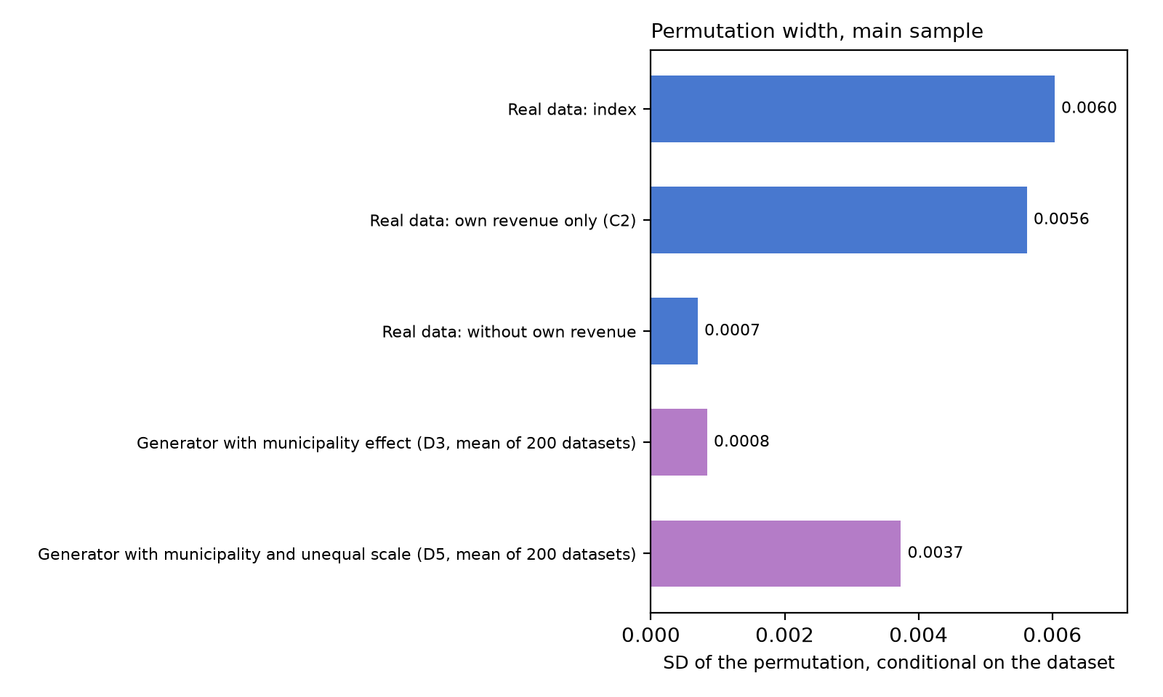

5.6 The first measurement, in the preregistered design
The number that stopped the study, 64%, is the size of the project’s preregistered test, not that of the package. In the pilot phase, with the study’s engine, stitching in the municipalities with an interior gap rejected 64.0% (from 56.93% to 70.65%) and in the municipalities with only an edge gap, 5.0%. This difference between edge and interior was the first evidence that the problem lay in the stitch. With the package, the same set of gaps gives 34.8% (Section 5.3). The two measurements are correct, each for its own procedure.

6. Discussion

6.1 What changes for those who use the test
In panels with many units and gaps in the middle of the series, default stitching should not be used without checking test size. The operational recommendation that the results support is to prefer nostitch when there are interior gaps, with the caveat that its power cost was only measured in cells where it drops no stretches, and, in any case, to report three numbers: the fraction of gaps next to a leader transition, the autocorrelation of the residual, and the test size in a simulation under the null with the real tenure structure. A systematic gap, such as that of an exam suspended during the pandemic, may be more problematic when it aligns in the same way with transitions in many units, a case that the cells of this paper do not isolate.
nostitch is not a universal guarantee. It removed the inflation of tens of points in the cells tested (the 6.2% one does not rule out a few points), but the port shows that the package still groups the same person across stretches, which leaves a residual covariance of order ρ² between the two sides of a gap when the same leader governs both. The same holds for the one-row stretch that the package keeps (period 10, with the gap in 9): it is never shuffled, but, when the same person appears in both stretches, it remains in that person’s group in the other stretch. The nostitch cells sit a few points above the package’s no-gap baseline (Section 5.2); these links are a compatible explanation, not an isolated one, and nothing guarantees the same behavior in panels with a different structure.

6.2 What does not change
No published result by Berry and Fowler was reanalyzed here. The size simulations of the original article remain valid for the no-gap designs they cover. A published rejection can only have been inflated by this mechanism if the sample used had interior gaps and serial correlation, and the direction of the effect depends on where the gaps fell relative to tenure boundaries. In the replication code (Berry & Fowler, 2020), all the rifle calls that generate Tables 2 to 4 use default stitching, and those for governors, mayors and CEOs also use the growth option, which computes the change only between consecutive periods: a single missing level in the middle of the series becomes a two-period gap in the series of changes (a block of L missing levels becomes L + 1 absent periods), and the autocorrelation changes when moving from levels to changes (this paper’s port does not implement that option). Whether those panels have interior gaps next to transitions, and of what size, was not verified here; answering that requires reanalyzing each application.

6.3 Limitations
The main limitations are the ported code, the autoregressive generator and a source that was not read.
- The port of the code was tested by hand, but not checked against Stata.
- The synthetic noise is first-order autoregressive; other dependence structures were not tested in the headline cells, although the preregistered study checked the size of the stretch-based test under six alternative generators: five came out between 4.6% and 6.2%, and the non-stationary one was conservative, at 1.2%.
- The literature sweep (OpenAlex, Semantic Scholar, Crossref, the first page of Google Scholar, the package help and code, and Berry and Fowler’s supplementary material and replication code) did not find the distortion documented, with medium confidence: Google Scholar blocked the following pages, and the full text of Smith and Gray (2021), the only methodological extension of RIFLE found, was not obtained: RePEc records no download restriction, but the publisher’s page denied access on November 1, 2026, and a new search on November 3, across 30 routes (publisher, open-access aggregators, repositories and the authors’ pages), found no open version. If that revalidation on historical series dealt with gaps, the part of this paper that says the problem was not documented falls; the quantification in this panel stands, and the originality of the diagnosis will depend on the comparison with that work.
- The first sweep did not read the package help and missed nostitch. The error was recorded and corrected before writing.

7. Conclusion
One missing period in the wrong place, repeated across many municipalities, is enough for the leadership test to find a mayor who does not exist. The gap stitching that Berry and Fowler’s (2021) original article describes, and that the official package applies by default, does not produce this bias when the gap is at the edge of the series or when the outcome has no serial correlation (with ρ = 0, the cell tested gave a size compatible with 5%). When the gap falls next to a transition, separating different mayors, and the outcome has a modest correlation such as the one calibrated from the study’s index, the test over-rejects in large panels: in the cell next to a transition, 6.8% with 50 municipalities (an interval that still includes 5%), 14.2% with 200 and 89.4% with 5,468. Gaps inside a tenure can push the statistic either way, and the return of the mayor after the gap, in the cases computed, toward the conservative side. The explicit criterion in the package help, a long gap or some other unspecified reason, does not name the position of the gap relative to transitions, and it is this position that must enter the diagnosis. The fix already exists and belongs to the authors: the nostitch option, which removed the inflation of tens of points in the cells tested, with power similar to that of the control where it was measured (Section 5.1). In the full panel, it leaves the test conservative, between 1.2% and 2.0%, above the package’s 0.2% with no gap.
Four directions remain open: (i) check the port against Stata itself, with the .do file that accompanies the replication package (Flores, 2026); (ii) measure, in the replication data that Berry and Fowler published and in other applications, how many interior gaps fall next to leader transitions; (iii) isolate the cause of the package’s conservativeness without a gap, which is larger in the full panel although the number of units and the composition have not been separated, and test other dependence structures and the effect of leaders who return to office; (iv) evaluate a variant of nostitch that treats each stint of the leader as its own group, removing from the explained sum the terms that link the same person across the gap (Section 6.1).

Data and code availability
The simulation code, the port of rifle.ado with its tests, the hashed outputs and the provenance chain are in this paper’s replication package (Flores, 2026), in the public repository https://github.com/ulissesflores/rifle-gap-bias and archived on Zenodo with the DOI https://doi.org/10.5281/zenodo.24044367, with the code under the Apache-2.0 license and the text and figures under CC BY 4.0. The replication package also includes a .do file to reproduce the central cells in Stata and an anonymized tenure panel (each mayor-municipality pair with a unique identifier across the full panel, without CPF, because the package groups leaders by identifier across all units at once, and periods numbered 1 to 10, because nostitch recognizes contiguity as period plus one). The source data are public: TSE (2024), Inep (2024), Tesouro Nacional (2025) and Ministério da Saúde (2025).

References
Akhtari, M., Moreira, D., & Trucco, L. (2022). Political turnover, bureaucratic turnover, and the quality of public services. American Economic Review, 112(2), 442-493. https://doi.org/10.1257/aer.20171867
Berry, C. R., & Fowler, A. (2018). RIFLE: Stata module to perform randomization inference for leader effects (Statistical Software Components S458461). Boston College Department of Economics. https://ideas.repec.org/c/boc/bocode/s458461.html
Berry, C. R., & Fowler, A. (2020). Replication data for: Leadership or luck? Randomization inference for leader effects in politics, business, and sports [Data set and code, Stata 16.1; files dated November 2020]. https://voices.uchicago.edu/fowler/research
Berry, C. R., & Fowler, A. (2021). Leadership or luck? Randomization inference for leader effects in politics, business, and sports. Science Advances, 7(4), eabe3404. https://doi.org/10.1126/sciadv.abe3404
Brollo, F., & Nannicini, T. (2012). Tying your enemy’s hands in close races: The politics of federal transfers in Brazil. American Political Science Review, 106(4), 742-761. https://doi.org/10.1017/S0003055412000433
Canay, I. A., Romano, J. P., & Shaikh, A. M. (2017). Randomization tests under an approximate symmetry assumption. Econometrica, 85(3), 1013-1030. https://doi.org/10.3982/ECTA13081
Clopper, C. J., & Pearson, E. S. (1934). The use of confidence or fiducial limits illustrated in the case of the binomial. Biometrika, 26(4), 404-413. https://doi.org/10.1093/biomet/26.4.404
Fitza, M. A. (2014). The use of variance decomposition in the investigation of CEO effects: How large must the CEO effect be to rule out chance? Strategic Management Journal, 35(12), 1839-1852. https://doi.org/10.1002/smj.2192
Flores, C. U. (2026). Does a mayor improve a city beyond chance? Missing data at a change of mayor makes the test say yes: Replication package (Version 1.0.0) [Software and data]. Codex Hash Research Laboratory. Zenodo. https://doi.org/10.5281/zenodo.24044367. Code repository: https://github.com/ulissesflores/rifle-gap-bias
Inep. (2024). Microdados e resultados do Saeb [Data set]. Instituto Nacional de Estudos e Pesquisas Educacionais Anísio Teixeira. https://download.inep.gov.br
Jones, B. F., & Olken, B. A. (2005). Do leaders matter? National leadership and growth since World War II. Quarterly Journal of Economics, 120(3), 835-864. https://doi.org/10.1162/003355305774268165
Künsch, H. R. (1989). The jackknife and the bootstrap for general stationary observations. The Annals of Statistics, 17(3), 1217-1241. https://doi.org/10.1214/aos/1176347265
Lahiri, S. N. (2003). Resampling methods for dependent data. Springer. https://doi.org/10.1007/978-1-4757-3803-2
Lehmann, E. L., & Romano, J. P. (2005). Testing statistical hypotheses (3rd ed.). Springer. https://doi.org/10.1007/0-387-27605-X
Ministério da Saúde. (2025). Sistema de Informações sobre Nascidos Vivos (Sinasc) e Sistema de Informações sobre Mortalidade (SIM) [Data set]. DataSUS. https://opendatasus.saude.gov.br
Nickell, S. (1981). Biases in dynamic models with fixed effects. Econometrica, 49(6), 1417-1426. https://doi.org/10.2307/1911408
Nosek, B. A., Ebersole, C. R., DeHaven, A. C., & Mellor, D. T. (2018). The preregistration revolution. Proceedings of the National Academy of Sciences, 115(11), 2600-2606. https://doi.org/10.1073/pnas.1708274114
Politis, D. N., & Romano, J. P. (1994). The stationary bootstrap. Journal of the American Statistical Association, 89(428), 1303-1313. https://doi.org/10.1080/01621459.1994.10476870
Quigley, T. J., & Graffin, S. D. (2017). Reaffirming the CEO effect is significant and much larger than chance: A comment on Fitza (2014). Strategic Management Journal, 38(3), 793-801. https://doi.org/10.1002/smj.2503
Smith, D. S., & Gray, T. R. (2021). Looking for leadership in historical context: An extension of the RIFLE method of randomization inference. Journal of Historical Political Economy, 1(2), 215-234. https://doi.org/10.1561/115.00000010
Tesouro Nacional. (2025). Siconfi: Declaração de Contas Anuais (DCA), Anexo I-C, exercícios 2013 a 2024 [Data set]. https://apidatalake.tesouro.gov.br/ords/siconfi/tt/dca
TSE. (2024). Repositório de dados eleitorais: candidatos e resultados, 2004 a 2020 [Data set]. Tribunal Superior Eleitoral. https://dadosabertos.tse.jus.br
Winkler, A. M., Ridgway, G. R., Webster, M. A., Smith, S. M., & Nichols, T. E. (2014). Permutation inference for the general linear model. NeuroImage, 92, 381-397. https://doi.org/10.1016/j.neuroimage.2014.01.060

