Uliya fatima
232098
cti
Lab 03
Configure KeyCloak and integrate it in the existing environment

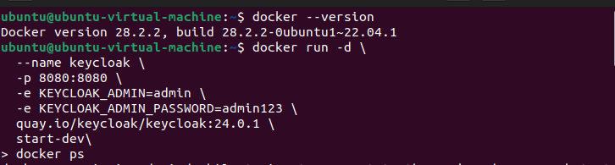

CYBER THREAT INTELLIGENCE
Technical Configuration Report
Keycloak Identity & Access Management Integration

Document Type | Technical Integration Guide
Subject | Keycloak SSO Configuration & Environment Integration
Classification | Confidential — Internal Use Only
Version | 1.0
Date | March 6, 2026

1. Executive Summary
This report provides a comprehensive, step-by-step guide for configuring Keycloak as an Identity and Access Management (IAM) solution and integrating it into an existing enterprise environment. Keycloak is an open-source IAM platform that provides Single Sign-On (SSO), OAuth 2.0, and OpenID Connect capabilities, enabling centralized authentication and authorization across multiple applications.

💡 Keycloak simplifies user authentication by providing a centralized identity broker that supports standard protocols such as SAML 2.0, OpenID Connect, and OAuth 2.0, allowing seamless integration with existing enterprise applications.

2. Prerequisites & Environment Requirements
Before beginning the Keycloak configuration, ensure the following prerequisites are met in your environment:

Component | Requirement
Java Runtime | Java 17 or later (OpenJDK recommended) installed on the host server
Network Access | Firewall rules allowing inbound traffic on ports 8080 (HTTP) and 8443 (HTTPS)
Database | PostgreSQL, MySQL, or MariaDB for production deployments (H2 for development)
DNS Configuration | Valid hostname or FQDN resolvable within the network
Administrative Credentials | Root or sudo access to the target server

3. Keycloak Installation & Initial Setup
The following screenshots document the complete installation and initial configuration process. Each step must be completed in sequence to ensure a successful deployment.

1 | Access the Keycloak Administration Console  Navigate to the Keycloak admin console URL and log in with administrator credentials to begin configuration.

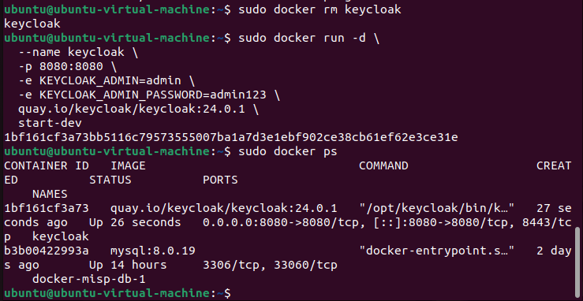
Figure 3.1 — Keycloak Administration Console Login

2 | Configure Realm Settings  Create or configure the realm that will serve as the top-level container for your IAM configuration, including clients, users, and roles.

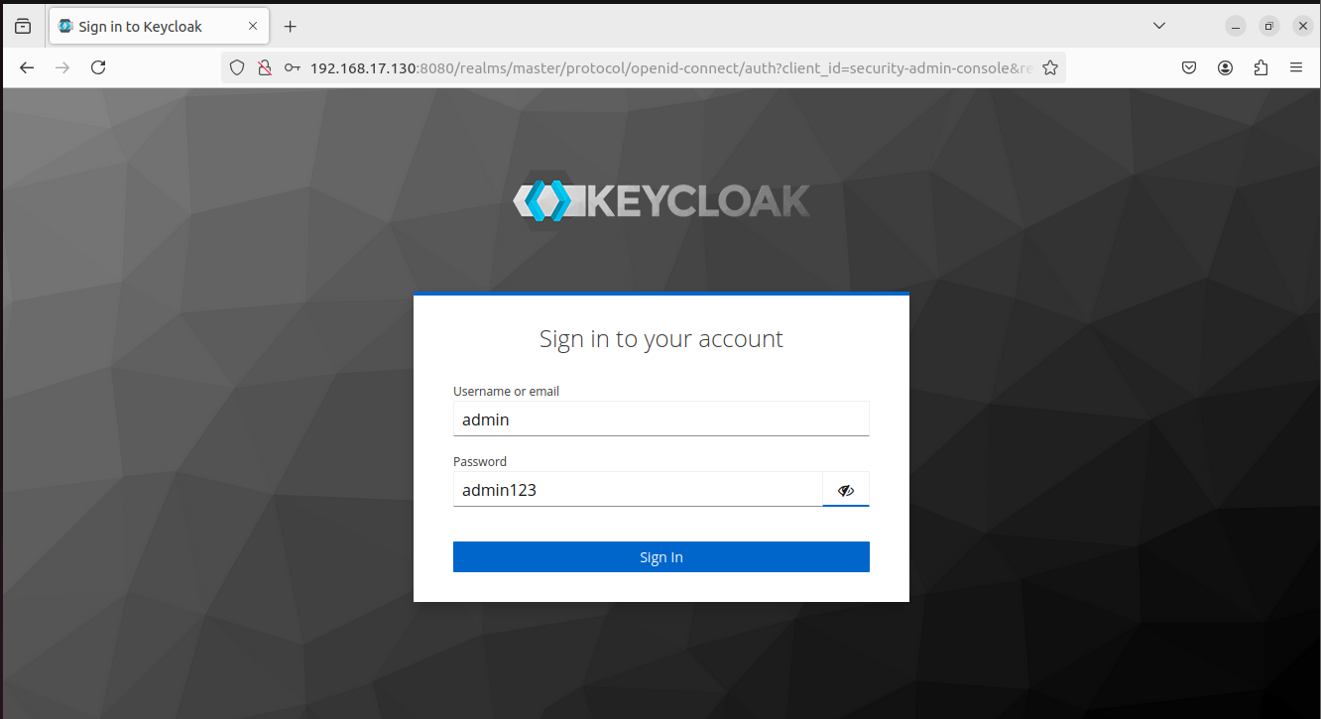
Figure 3.2 — Realm Configuration Dashboard

3 | Client Registration & Configuration  Register the target application as a client within Keycloak and configure the appropriate authentication protocol and redirect URIs.

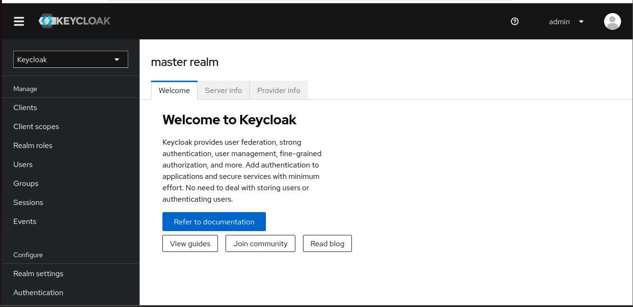
Figure 3.3 — Client Registration Settings

4. Integration Configuration
After completing the base installation, the following steps configure Keycloak for integration with your existing environment. This includes setting up identity providers, configuring client scopes, and establishing user federation where applicable.

4.1 Identity Provider Configuration
Configure identity providers to enable federated authentication, allowing users to authenticate using external identity sources such as Active Directory, LDAP, or social identity providers.

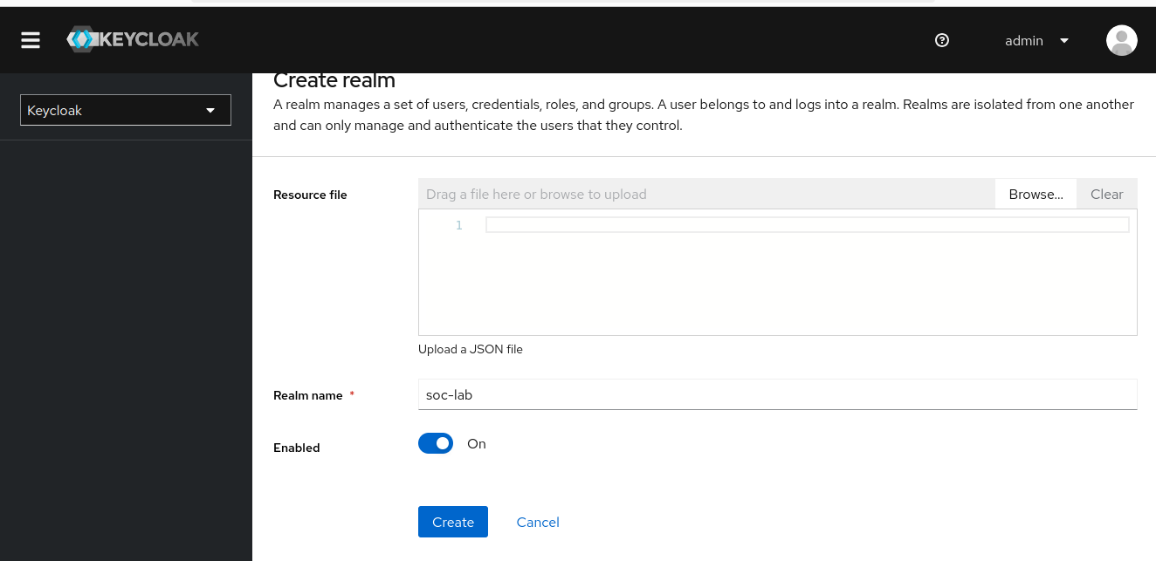
Figure 4.1 — Identity Provider Configuration

4.2 Authentication Flow Setup
Authentication flows define the sequence of authentication steps that users must complete. Configure custom flows to match your organizational security policies.

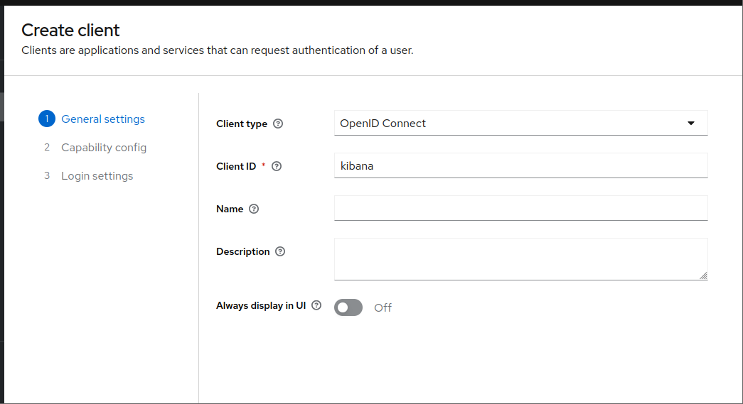
Figure 4.2 — Authentication Flow Configuration

4.3 User Federation & LDAP Integration
User federation enables Keycloak to synchronize users from external directories such as Active Directory or LDAP. This ensures centralized user management without requiring duplicate account creation.

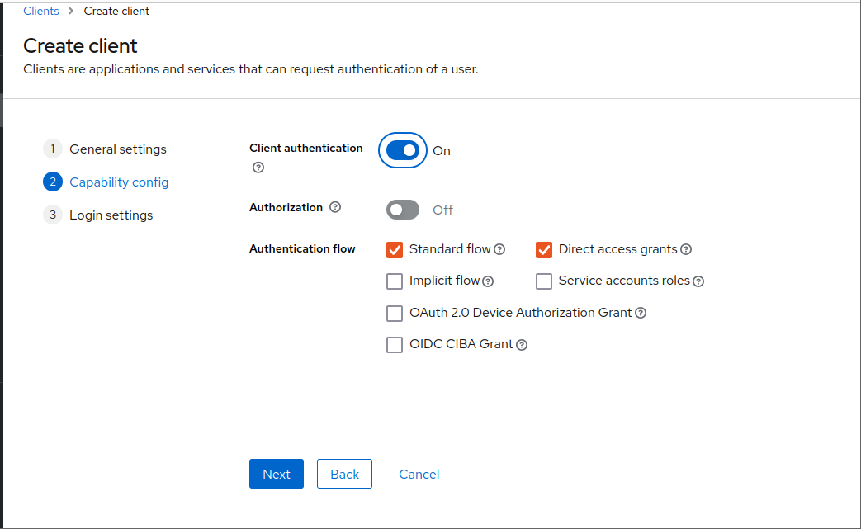
Figure 4.3 — User Federation Settings

4.4 Role & Group Management
Define roles and groups to control authorization. Keycloak supports realm-level roles, client-specific roles, and composite roles for granular access control.

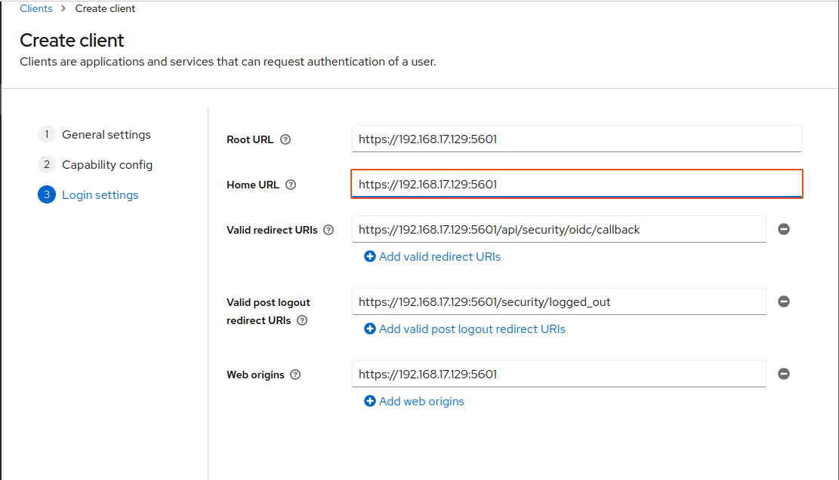
Figure 4.4 — Role Mapping and Group Configuration

5. Advanced Configuration & Token Settings
This section covers advanced configuration options including token lifespans, session settings, and protocol mapper configurations that tailor Keycloak behavior to specific integration requirements.

5.1 Token Configuration
Configure access token, refresh token, and session timeout values. Proper token lifetime configuration is critical for both security and user experience.

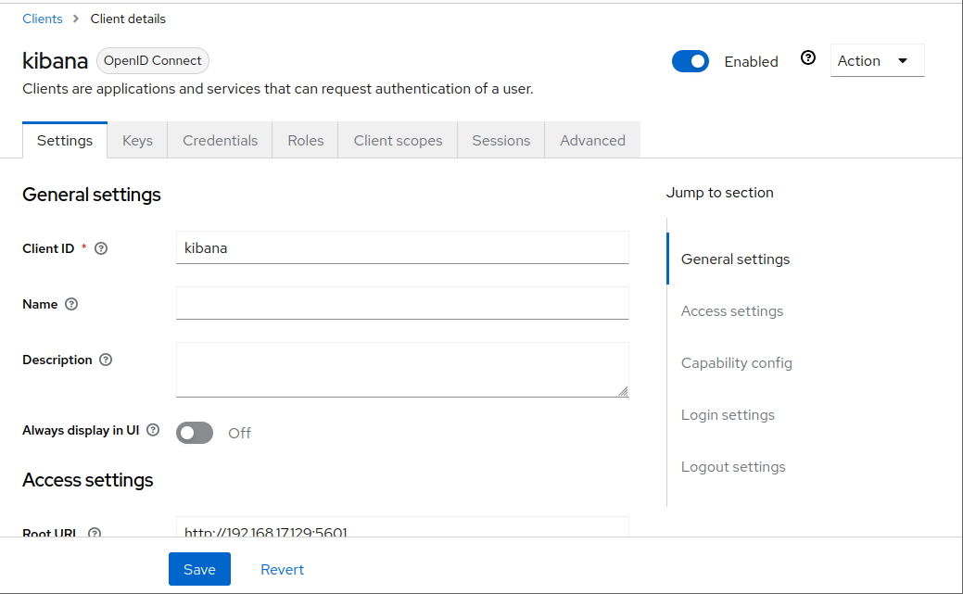
Figure 5.1 — Token Lifespan and Session Settings

5.2 Protocol Mapper Configuration
Protocol mappers transform user attributes and role information into token claims. Configure mappers to include the data required by your integrated applications.

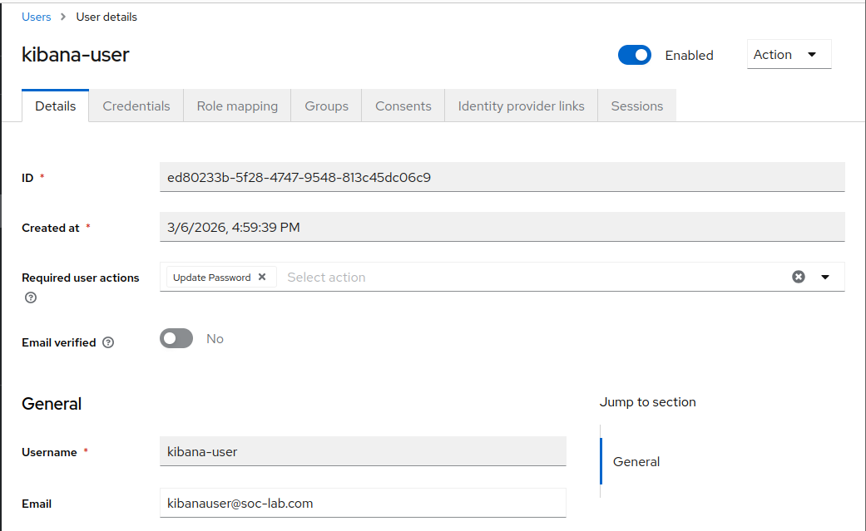
Figure 5.2 — Protocol Mapper Settings

6. Validation & Integration Testing
Once configuration is complete, validate the integration by performing the following verification steps. Successful completion of these tests confirms that Keycloak is correctly integrated into the existing environment.

6.1 SSO Login Flow Validation
Verify that the Single Sign-On flow operates correctly by testing authentication through the configured client application. Inspect the token response to confirm all expected claims are present.

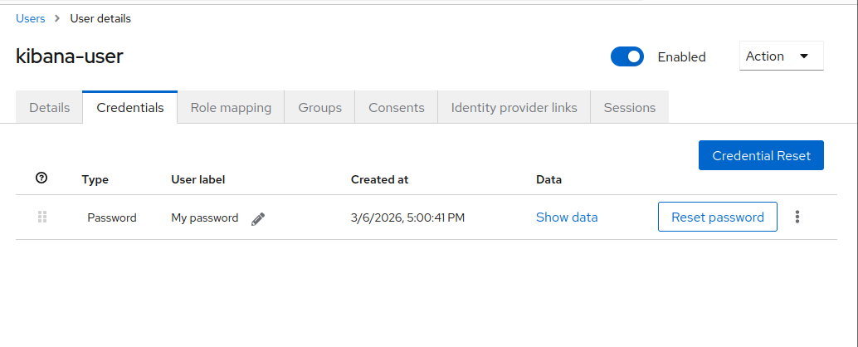
Figure 6.1 — SSO Authentication Flow Test

Figure 6.2 — Integration Status Indicator

6.2 Token Introspection & API Validation
Use the Keycloak token introspection endpoint to validate issued tokens. Confirm that the API gateway or resource server correctly validates bearer tokens.

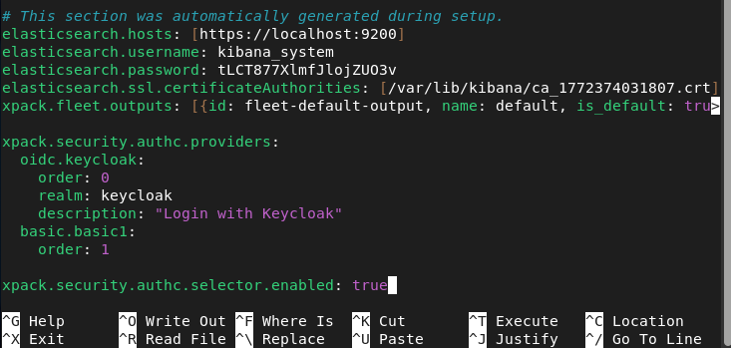
Figure 6.3 — Token Introspection Response

Figure 6.4 — Configuration Validation Status

6.3 User Authentication Test
Perform an end-to-end authentication test using test user credentials. Verify that the user is redirected correctly, the session is established, and authorization claims are correctly applied.

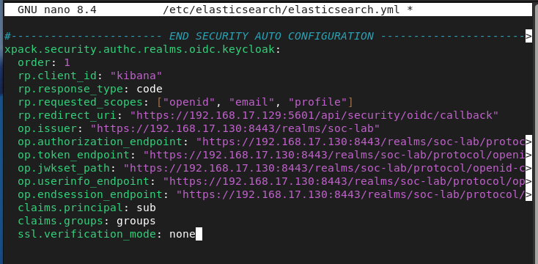
Figure 6.5 — End-to-End Authentication Test

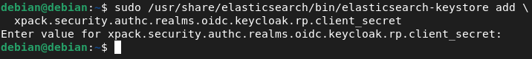
Figure 6.6 — Authentication Response Header

7. Event Monitoring & Audit Logging
Keycloak provides built-in event logging for authentication events, administrative actions, and errors. Enabling event logging is essential for security monitoring, compliance, and incident investigation.

7.1 Event Log Configuration
Configure Keycloak event listeners to capture login events, failed authentication attempts, token exchanges, and administrative changes. Events can be forwarded to external SIEM platforms via custom event listeners.

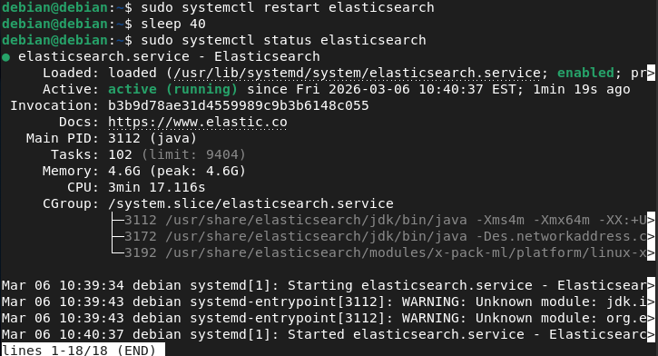
Figure 7.1 — Event Log Configuration

7.2 Admin Console Audit Trail
The Keycloak admin audit log records all administrative actions including realm changes, user creation, and role assignments. Review audit logs regularly to detect unauthorized configuration changes.

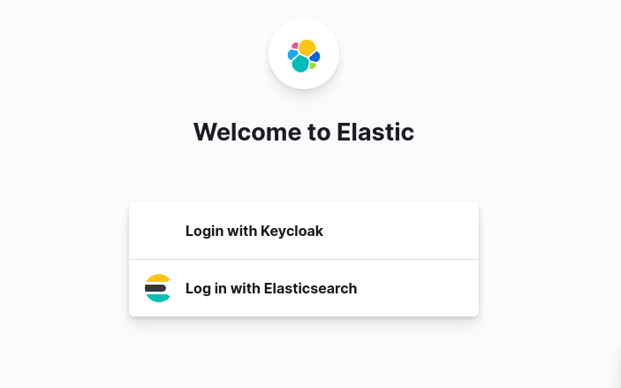
Figure 7.2 — Administrative Audit Log

8. Security Recommendations
Apply the following security hardening measures to ensure the Keycloak deployment meets enterprise security standards:

1 | Enable TLS/HTTPS  Configure Keycloak behind a reverse proxy (e.g., Nginx, Apache) with a valid TLS certificate. Never expose Keycloak over plain HTTP in production.

2 | Restrict Admin Console Access  Limit admin console access to specific IP ranges or internal networks. Consider disabling public admin console exposure entirely.

3 | Configure Brute Force Protection  Enable the built-in brute force detection to lock accounts after repeated failed login attempts.

4 | Set Appropriate Token Lifetimes  Use short-lived access tokens (5–15 minutes) combined with refresh tokens to minimize the impact of token compromise.

5 | Enable Audit Logging  Ensure all admin events and login events are logged and forwarded to your central SIEM or log management system.

6 | Regular Keycloak Updates  Subscribe to Keycloak security advisories and apply patches promptly to address known vulnerabilities.

9. Conclusion
This report has detailed the complete process for configuring Keycloak as a centralized Identity and Access Management solution and integrating it into the existing enterprise environment. By following the steps documented in this guide—from initial installation through to event monitoring—organizations can establish a robust, standards-compliant authentication infrastructure.

Keycloak's support for industry-standard protocols including OAuth 2.0, OpenID Connect, and SAML 2.0 ensures compatibility with a broad range of applications and services. Combined with the security hardening measures outlined in Section 8, this deployment provides a scalable and secure IAM foundation for the organization.

💡 For ongoing support and configuration updates, refer to the official Keycloak documentation at https://www.keycloak.org/documentation and monitor the Keycloak security advisories mailing list.

