AIR UNIVERSITY ISLAMABAD
Department of Cyber Security

Penetration Testing Lab
Lab 01: Setting Up Your Virtual Lab

Lab Engineer: Bilal Saleem
Student id 232098
Name uliya fatima

Lab Completion Summary
Task | Description | Status
Task 1 (15 Marks) | Install VMware & Setup Kali Linux VM | Completed
Task 2 (10 Marks) | Configure Network & Test Connectivity | Completed
Task 3 (15 Marks) | Install & Configure Nessus Scanner | Completed
Task 4 (15 Marks) | Create Windows XP SP3 Target VM | Completed
Task 7 (10 Marks) | Configure Static IP & Test VM-to-VM | Completed

TASK 1: Install VMware and Set Up Kali Linux VM
VMware Workstation was installed successfully. Kali Linux was imported and configured as a Virtual Machine. A newer version of Kali Linux was used which uses "kali" as the default username instead of "root" — this is the standard behavior in Kali Linux 2020 and later versions.

Screenshot: Kali Linux Login Screen
The following screenshot shows the Kali Linux login screen with username "kali" entered and the password field filled.
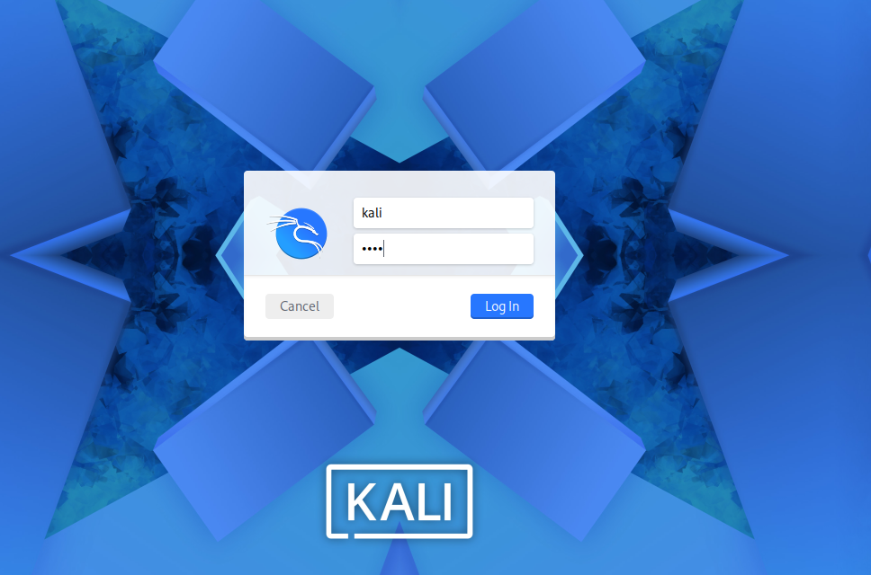
Figure 1.1 — Task1-KaliLogin.png

Screenshot: Kali Linux Desktop (After Login)
The following screenshot confirms successful login to the Kali Linux GUI, showing the desktop with the Applications menu open displaying all penetration testing categories.
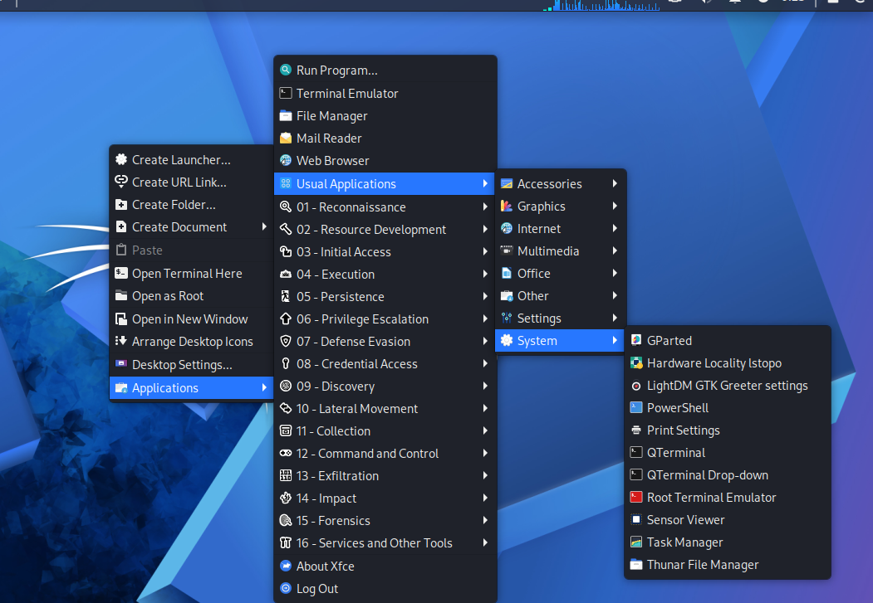
Figure 1.2 — Task1-KaliDesktop.png

TASK 2: Configure Network (Bridged Mode) & Test Connectivity
The Kali Linux VM was configured with Bridged Network Adapter mode to connect directly to the physical network. The ifconfig command confirmed a valid IPv4 address was assigned. Internet connectivity was verified by pinging Google's servers.

Screenshot: ifconfig Output
The eth0 interface shows IP address 192.168.17.128 with subnet mask 255.255.255.0 successfully assigned via the bridged network adapter.
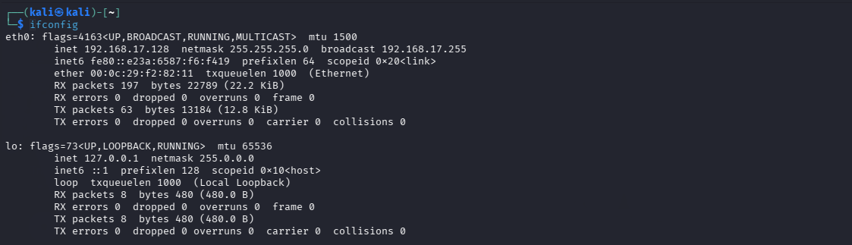
Figure 2.1 — Task2-ifconfig.png

Screenshot: Ping Test to Google
Successful ping replies received from www.google.com (142.251.150.119) confirming full internet connectivity with zero packet loss.
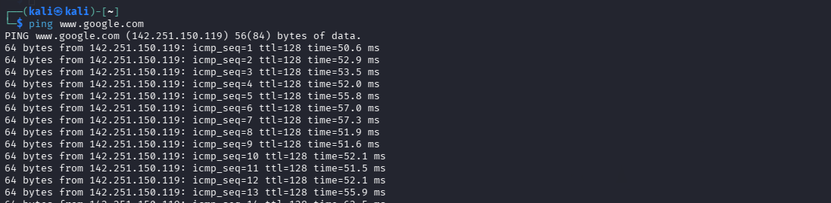
Figure 2.2 — Task2-ping.png

TASK 3: Install and Configure Nessus Home Vulnerability Scanner
Nessus version 10.11.2 was downloaded and installed on the Kali Linux VM. The Nessus Essentials (free) version was configured with an activation code obtained from Tenable's website. The web interface was accessed at https://localhost:8834/. Note: "Nessus has no plugins" message appears because plugin downloads are limited in the Essentials free version.

Screenshot: Nessus Installation & Setup Process
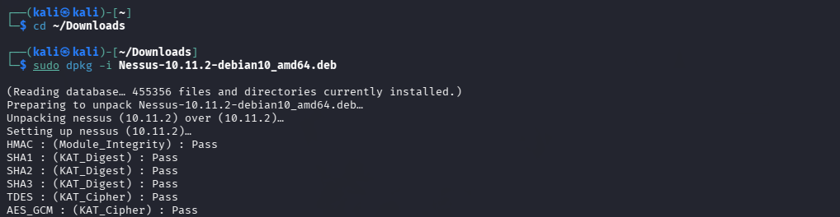
Figure 3.1 — Nessus Setup Screen

Screenshot: Nessus Login Screen
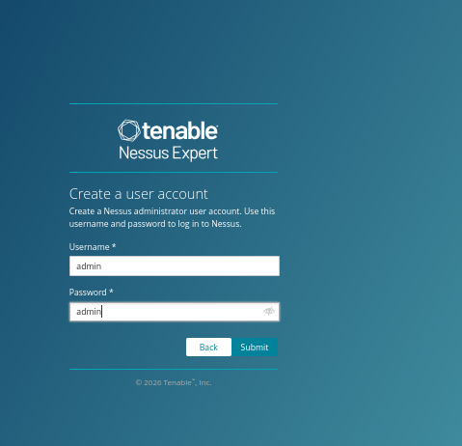
Figure 3.2 — Task3-NessusLogin.png

Screenshot: Nessus Dashboard
Successfully logged in to the Nessus Essentials dashboard as admin user. The My Scans folder is visible and ready for use.
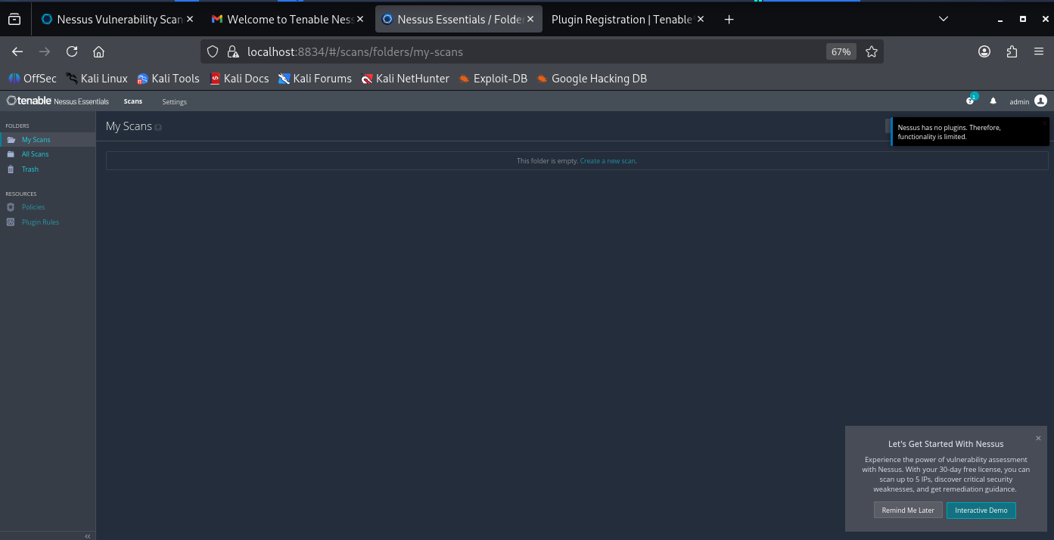
Figure 3.3 — Task3-NessusDashboard.png
TASK 4: Create and Configure the Windows XP SP3 Target VM
A Windows XP SP3 Virtual Machine was created in VMware with Bridged network adapter. Windows XP was installed and configured with Computer Name "Bookxp", Administrator password "password". Windows Firewall was disabled to allow penetration testing. User accounts were configured as per lab requirements.

Screenshot: Windows XP Desktop After Login
The Windows XP VM booted successfully and the classic Windows XP desktop with the Start taskbar is visible, confirming successful installation.
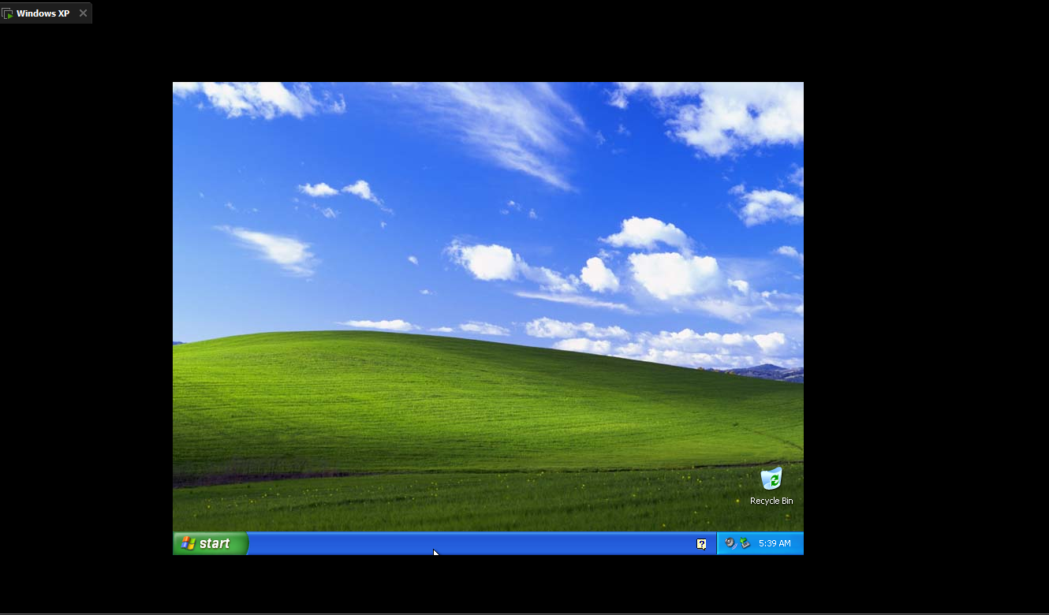
Figure 4.1 — Task6-XPDesktop.png

Screenshot: Windows Firewall Turned OFF
Windows Firewall was disabled via Control Panel > Security Center > Windows Firewall. The "Off (not recommended)" option was selected to allow unrestricted network access for penetration testing exercises.
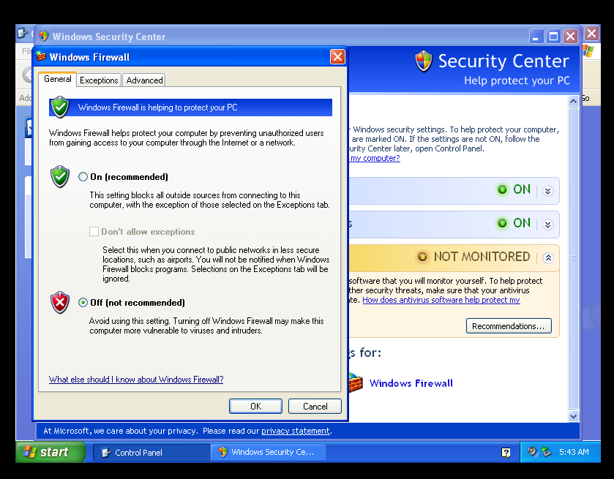
Figure 4.2 — Task6-FirewallOff.png
TASK 7: Configure Static IP & Test VM-to-VM Connectivity
The Windows XP VM IP address was noted using the ipconfig command (192.168.84.128). From the Kali Linux VM, a ping test was performed to the Windows XP static IP address to verify VM-to-VM communication over the bridged network.

Screenshot: Windows XP IP Configuration
The ipconfig command on Windows XP shows IP Address 192.168.84.128 with Subnet Mask 255.255.255.0 on the Local Area Connection.
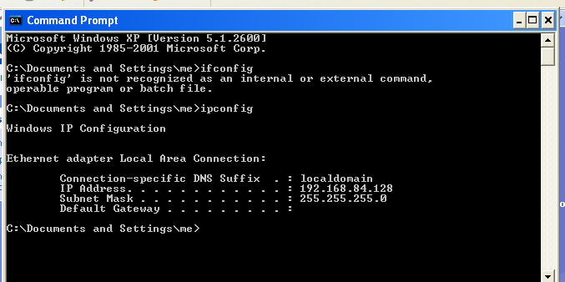
Figure 7.1 — Windows XP ipconfig Output

Screenshot: Successful Ping from Kali to Windows XP
The ping command from Kali Linux to Windows XP (192.168.84.128) shows successful replies with TTL=128, confirming proper VM-to-VM network connectivity. Zero packet loss observed across all 21 ICMP packets sent.
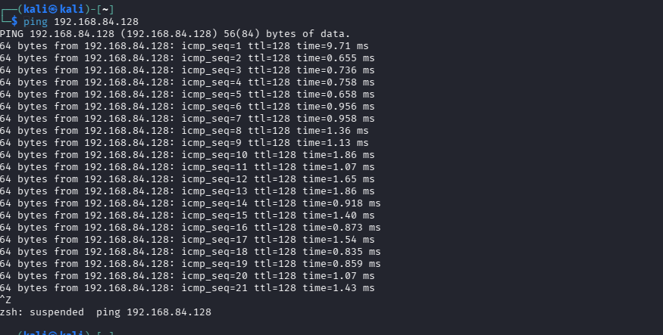
Figure 7.2 — Task7-PingXP.png

Conclusion
All tasks in Lab 01 were completed successfully. The virtual lab environment has been set up with:
- Kali Linux VM installed and running in VMware
- Bridged network configured with valid IP (192.168.17.128) and internet access confirmed
- Nessus Essentials vulnerability scanner installed and dashboard accessible
- Windows XP SP3 target VM created with firewall disabled
- VM-to-VM connectivity verified (Kali can reach Windows XP at 192.168.84.128)

The virtual lab is now fully operational and ready for the upcoming penetration testing exercises.

