**Fahri Ulkat**

**090220756**

**Problem Set 3 Answers**

**Question 1**

**a. Normal distribution and standard normal distribution:** A bell shaped and symmetric around the mean distribution with mean of 0 and variance of 1 in standart version.

**b. Chi-squared distribution:** A type of distribution used in hypotheses tests and sum of squared independent normal random variables.

**c. t distribution:** t distribution is like normal distribution but with fatter tails.

**d. F distribution:** The F distribution results from the ratio of two scaled chi-square distributions.

**e. Independently and identically distributed (i.i.d):** i.i.d refers to independent random variables with same probability distribution.

**f. Sampling distribution:** Sampling distribution s is the probability distribution of the statistics of many samples drawn from a population.

**g. Law of large number:** Law of Large number says that as size of sample increase, avarage of sample gets closer to the mean of population

**h. Central limit theorem:** Central limit theorem states that as size of sample increase, sample avarage distribution gets closer to the normal distribution.

**i. Consistency:** Consistency means that the closeness of an estimator to the truth increases as the sample size increases.

**j. Asymptotic distribution:** The asymptotic distribution describes the limiting behaviour of a succession of distributions as the sample size approaches infinity**.**

**Question 2**

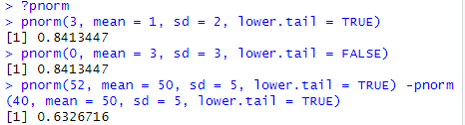

**Question 3**

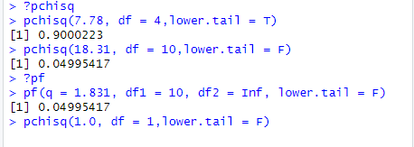

**Question 3 d.** Since F(df1, Inf) ≈ ChiSq(df1)/df1 and 1.831 = 18.31/10

**Quesiton 4**

**a.**

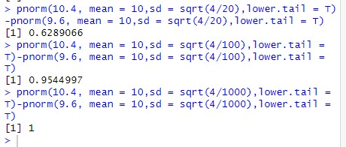

**b. and c.**